Zappos, July 2012 – August 2013: where to grow, how to price, and what reviews really do
MGT 634 Homework 2 · Michal Kozuchowski, Laila Lapins, Nick Giamalis, Raymond Chang, Sean Weller
Based on 13.5 million pairs sold ($1.17 billion), 61,433 products, 615 brands and the reviews of 21,242 products. Charts and methods follow on the next pages.
Bottom line. Zappos's business is women's shoes and winter boots, mostly sold at full price. Discounts pile up on the products customers like least, and star ratings mostly reflect how good a product already is rather than driving extra sales on their own. Growth will come from a better women's assortment (comfort), sharper seasonal planning and event-based promotions, not from constant markdowns or chasing higher star ratings.

1. Which customers and products to prioritize
- Women's shoes are the core business but the weakest experience. They are 55% of pairs and 63% of revenue at the highest average price ($98), yet they have the lowest ratings (4.38 vs 4.51 stars for men's), driven by comfort. Dress heels score just 4.0 out of 5 on comfort. A comfort-led women's assortment (better-fitting dress shoes, clearer fit information) is the biggest growth lever.
- Boots punch above their weight. Boots are 16% of pairs but 26% of revenue ($138 average). Their sales run at 2.5 times their yearly average in November–December and collapse by spring; sandals mirror this in May–June, while sneakers (the largest category, 35% of pairs) sell steadily all year. Inventory, marketing and markdown calendars should follow these seasons, with boot stock secured by October.
- Keep the wide catalog. UGG leads revenue and Nike leads pairs, and the top 10 brands bring in a third of revenue, but it takes 99 of 615 brands to reach 80%. Customers spread their spending across a long tail of brands, which is exactly the variety advantage of selling online (Quan & Williams).

2. Pricing and promotions
- Markdowns clear weak products rather than grow demand. 31% of pairs sell at a discount, averaging 21% off. Discounts are most common where ratings are lowest: 41% of heels and 35% of flats sell discounted, vs 24% of kids' shoes. Days with more discounting are not busier (correlation −0.29).
- Concentrated events work. Cyber Monday 2012 was the single biggest day (57,700 pairs, 43% discounted, $5.5 million). Fewer, bigger promotional events beat constant markdowns.
- One national price list is fine. The average price paid ranges only from $80 (Florida) to $92 (Washington DC), and 30–32% of sales are discounted in every US region.
- Time promotions by the hour. The hour of the day explains 86% of the hour-to-hour swings in orders; the day of the week and the month explain about 2% each. Mondays are the busiest day and Saturdays the quietest, so emails, flash sales and customer-service staffing should follow the daily clock.

3. How customer reviews relate to sales
- Ratings are high and stable: 4.3 stars overall, with looks (4.7) scoring well above comfort (4.3). Ratings did not rise or fall over the year.
- Good ratings mark good products more than they create sales. Across products, each extra star goes with about 26% more monthly sales. But when we compare the same product over time, a change in its rating has no measurable effect on its sales (−4%, not statistically different from zero). So invest in better products, especially comfort, rather than in pushing star ratings. To measure the true effect of ratings, Zappos could compare products just above and below the half-star rounding shown on the site, or randomly vary which reviews shoppers see first.
Caveats: these are patterns in sales data, not experiments. New review activity fades after January 2013, 9 days have recording gaps, and 4.8% of sales lack color-level product details.

Appendix A. Charts by assignment question
Every chart is produced by the notebook (analysis/hw2_zappos_analysis.ipynb); captions give the takeaway.

Q1–Q2. Brands and product characteristics
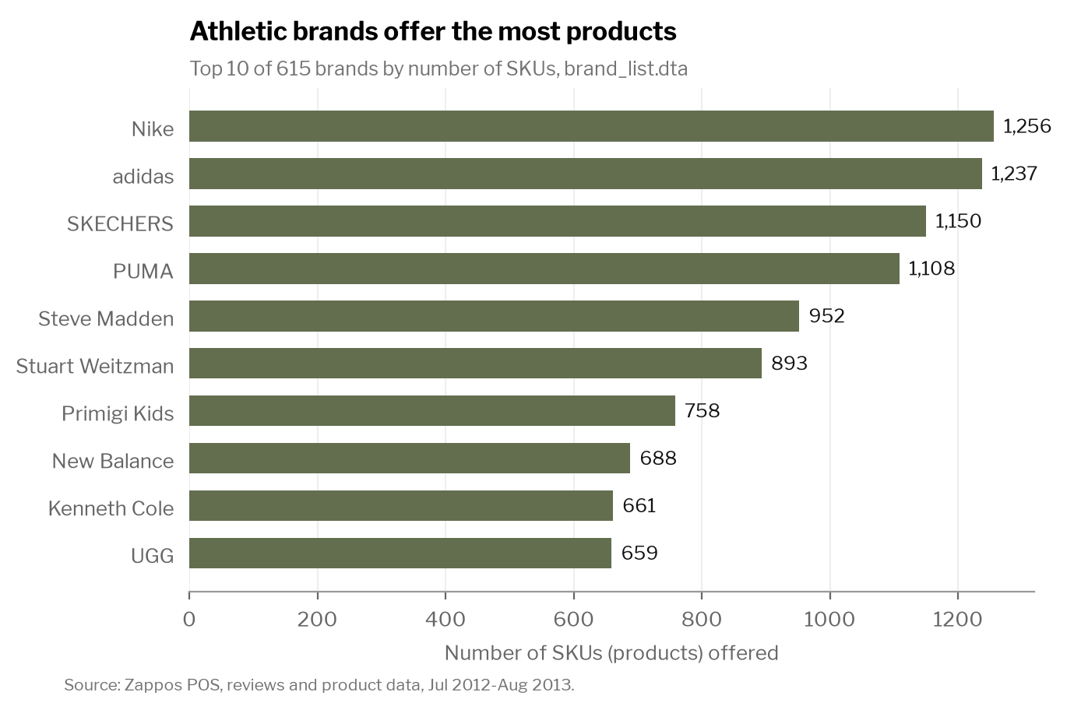 | 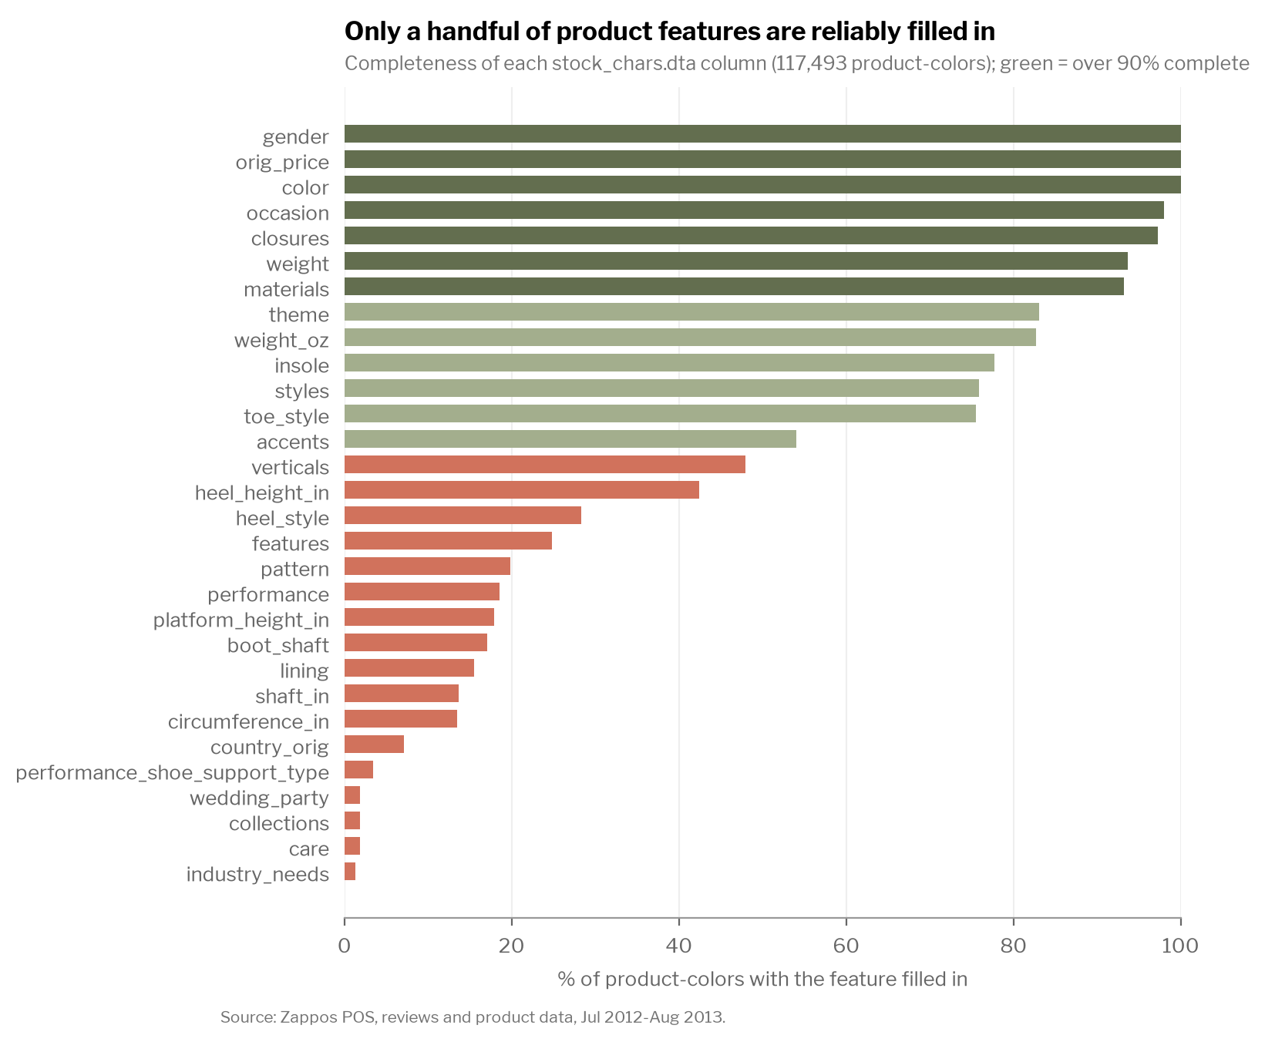
Q1. 615 parent brands (842 brand names in POS, which lists sub-lines such as "Nike Kids"). Merging brand_list onto POS by sku matches 100% of 13.5M sales rows. | Q2. Only gender, list price, color, occasion, closures, weight and materials are over 90% complete. We use gender, occasion and material.
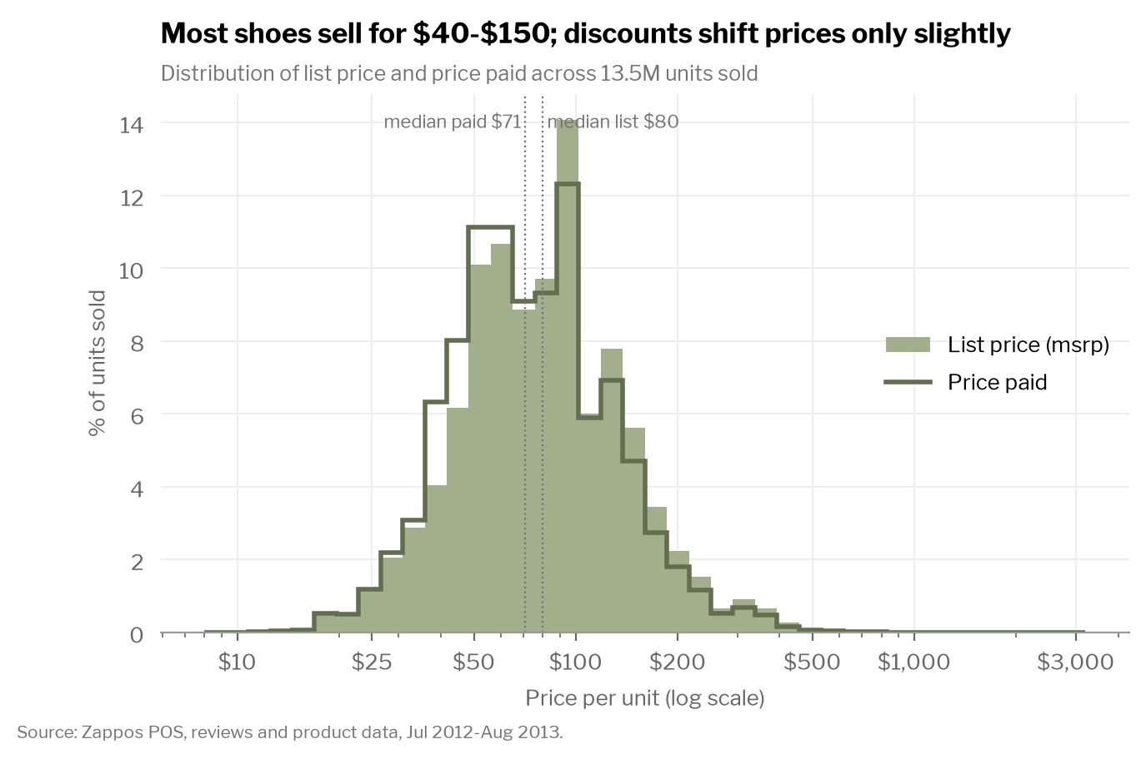 | 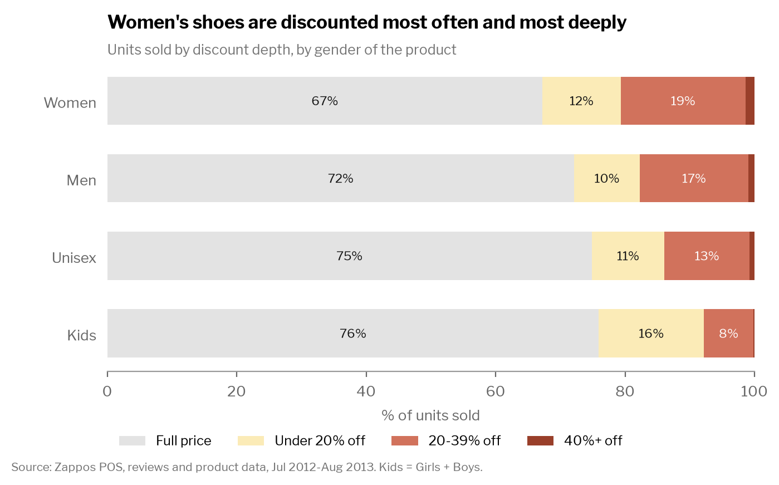
Q2. Price paid: mean $86.26, median $70.99, SD $56.00, range $8.49–$3,150. List price (msrp): mean $93.77, median $79.95, SD $62.81, range $10–$3,150. | Q2. Women's shoes are discounted most often (33%) and most deeply (23% off when discounted); kids' least (24%, 16% off). Highest-msrp brands: Roberto Cavalli, Giuseppe Zanotti, Alexander McQueen, Sergio Rossi, Bottega Veneta (all women's designer shoes, $786–$966).

Q3–Q4. Customer reviews
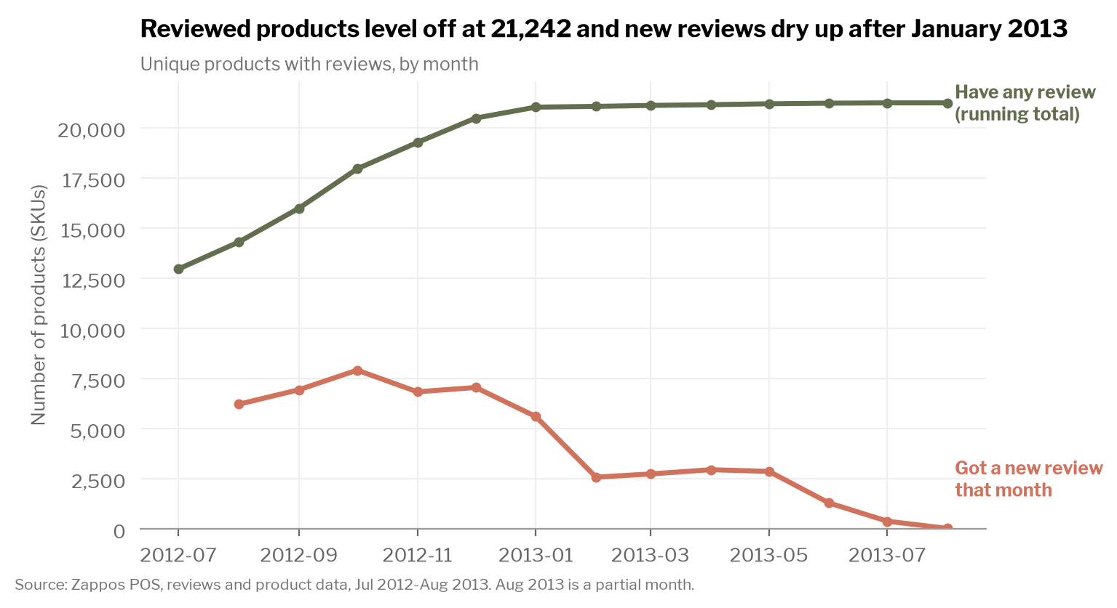 | 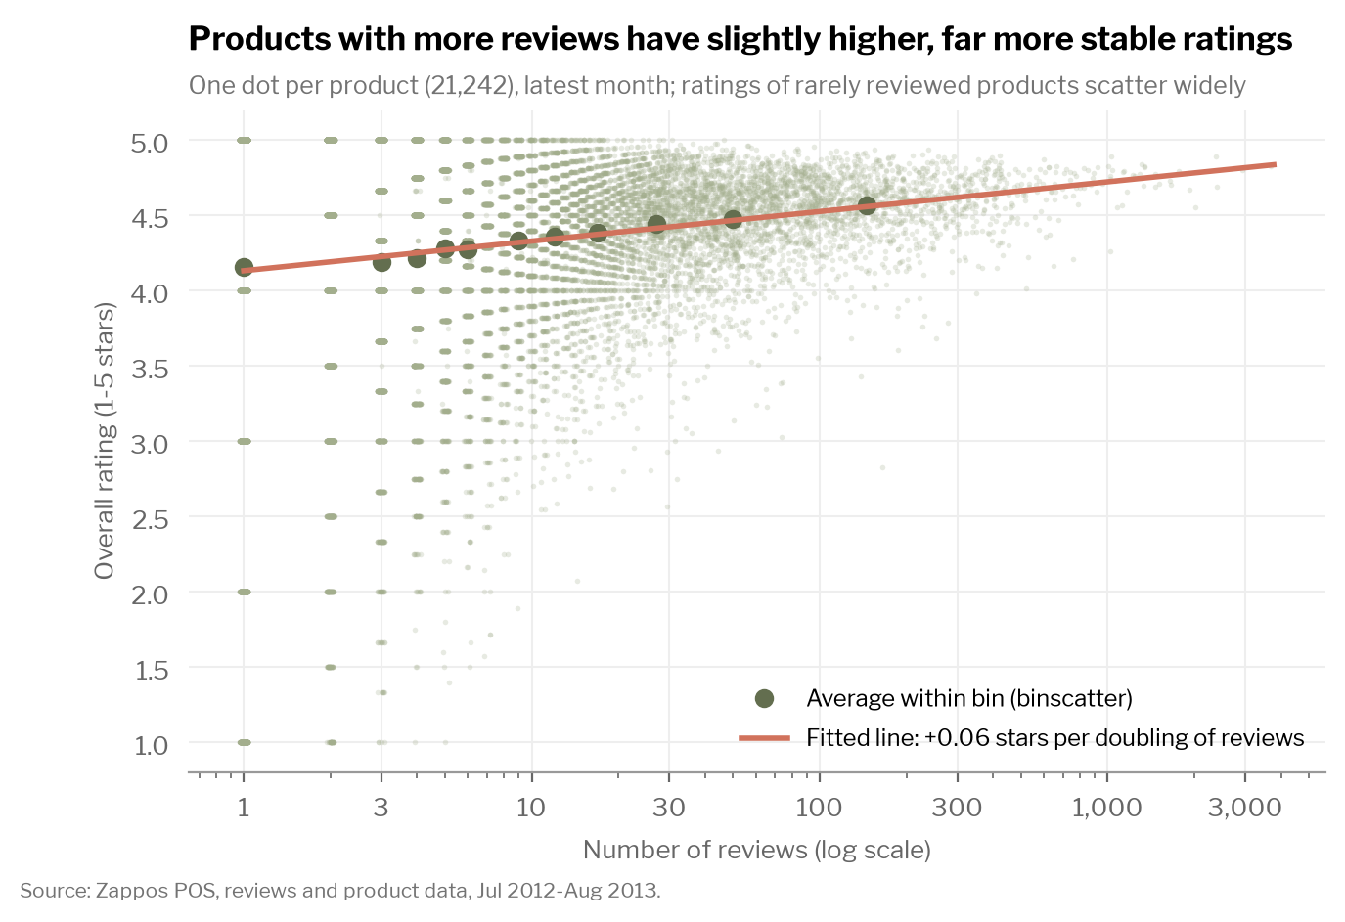
Q3. Products with reviews grow from 12,963 to 21,242, then level off; new reviews fade after January 2013 (a coverage limit of the data). | Q3. Average over product-months: overall 4.30, comfort 4.29, look 4.67 (highest). More reviews go with slightly higher (+0.06 stars per doubling) and far more stable ratings.
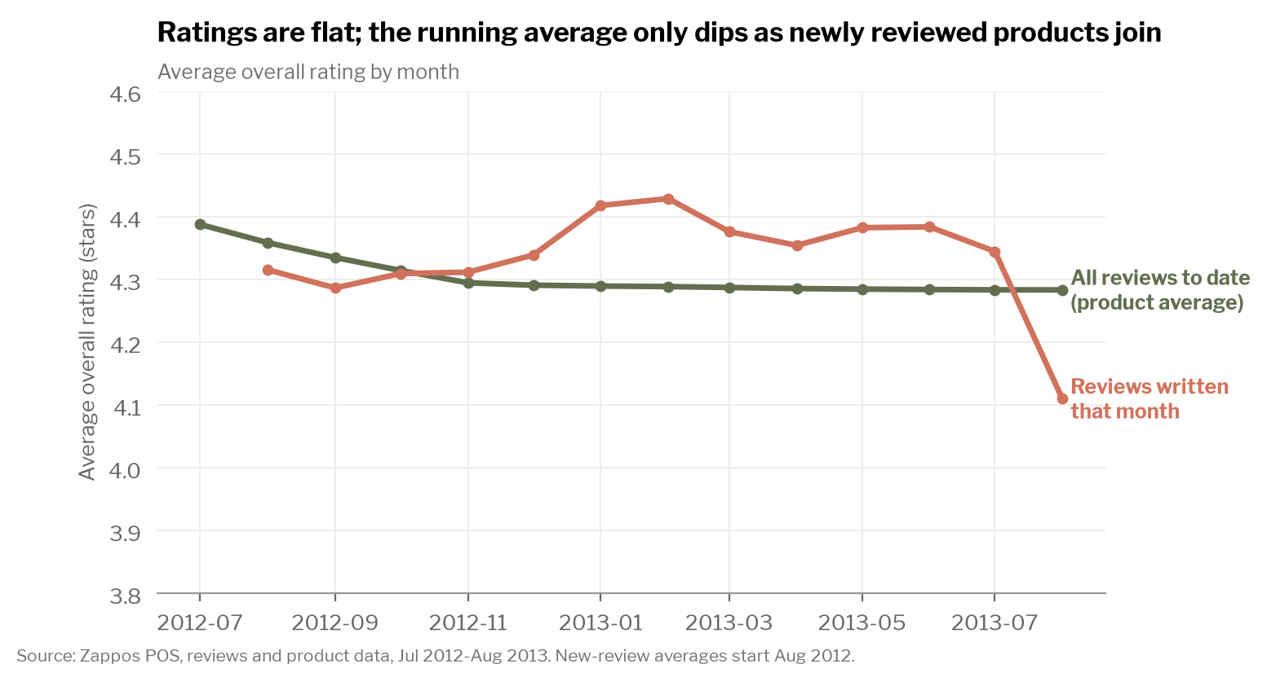 | 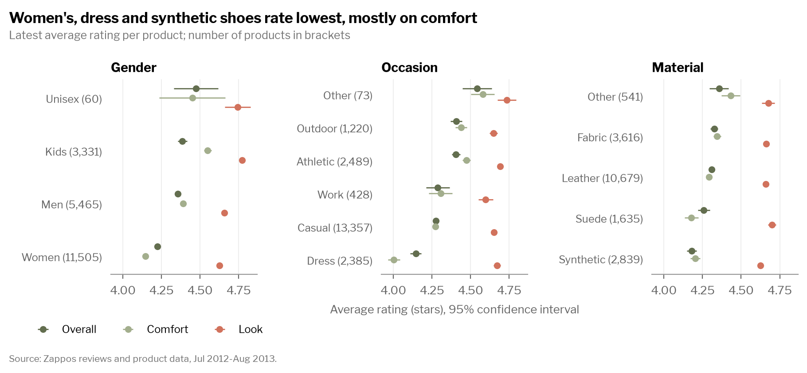
Q3. Ratings are flat: new reviews average 4.3–4.4 stars every month (trend −0.002 stars/month, not significant). The running average dips only because newly reviewed products join. | Q4. 95.9% of review records match our 3 features. Women's (4.22), dress (4.14) and synthetic (4.18) shoes rate lowest overall, mostly because of comfort; looks score 4.6–4.8 everywhere.

Q5. Transaction patterns
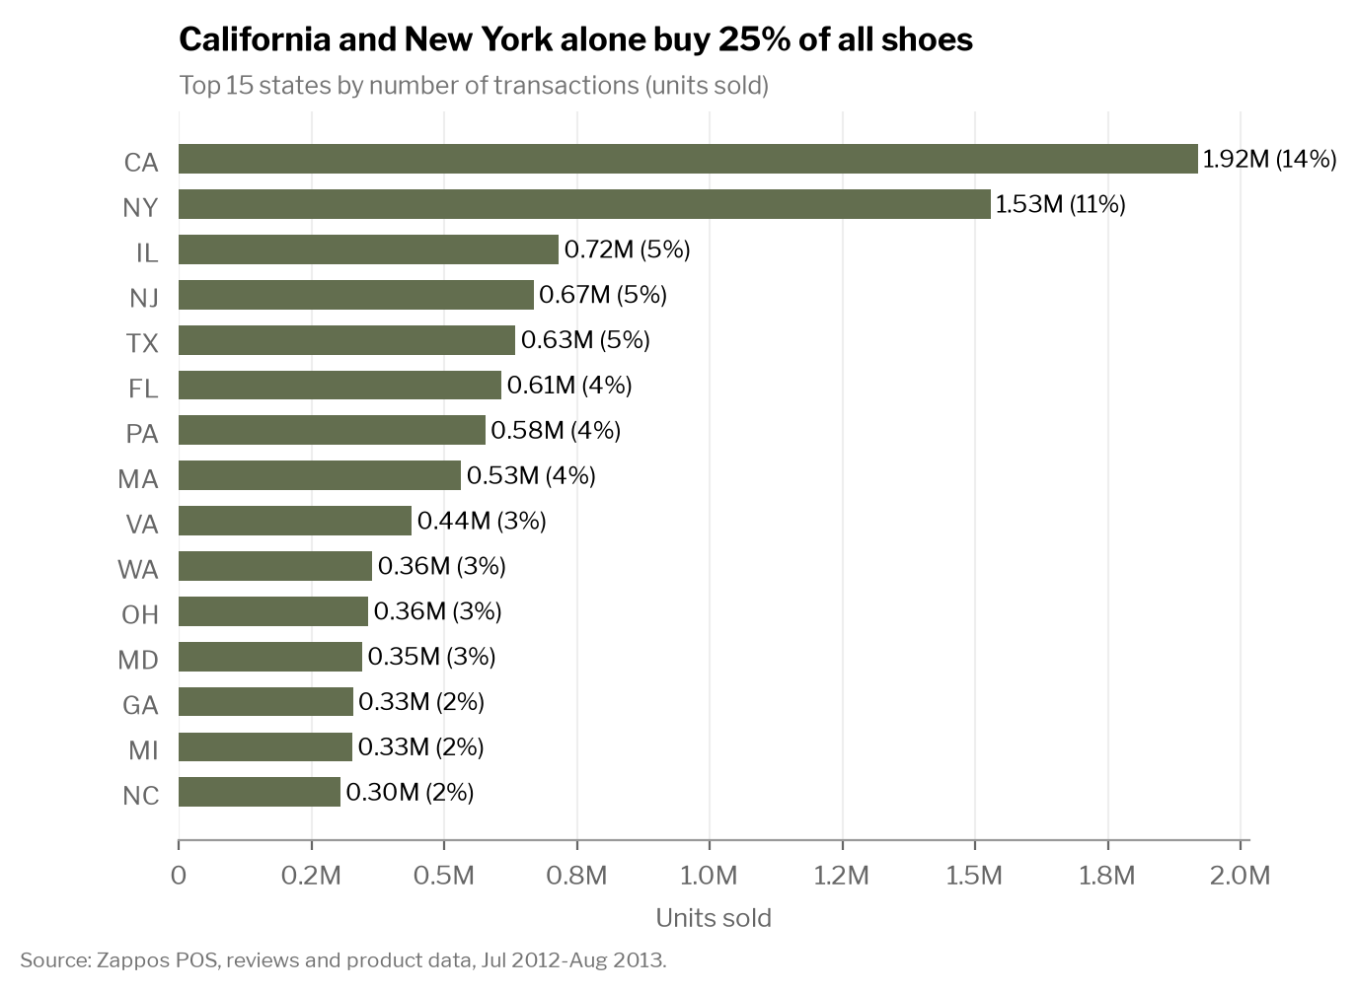 | 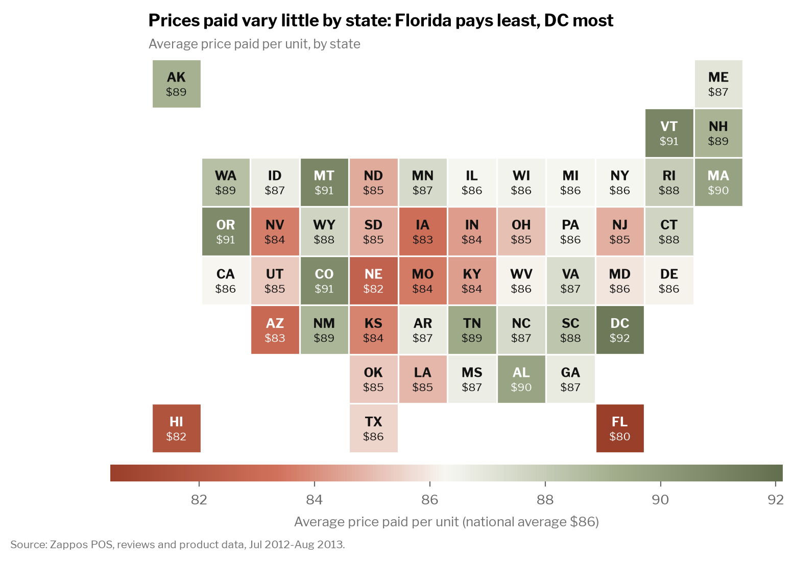
Q5. 13,546,258 transactions (pairs) from Jul 13, 2012 to Aug 15, 2013. California (14%) and New York (11%) lead; 0.7% of sales go to territories or military addresses. | Q5. Average price paid per pair by state: national $86; DC, Vermont, Montana, Oregon and Colorado pay the most ($91–$92), Florida and Hawaii the least ($80–$82).
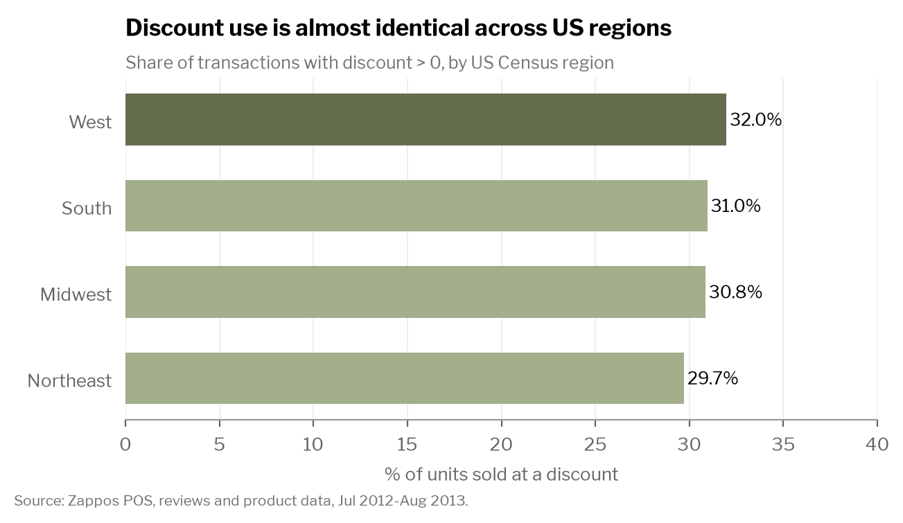 | 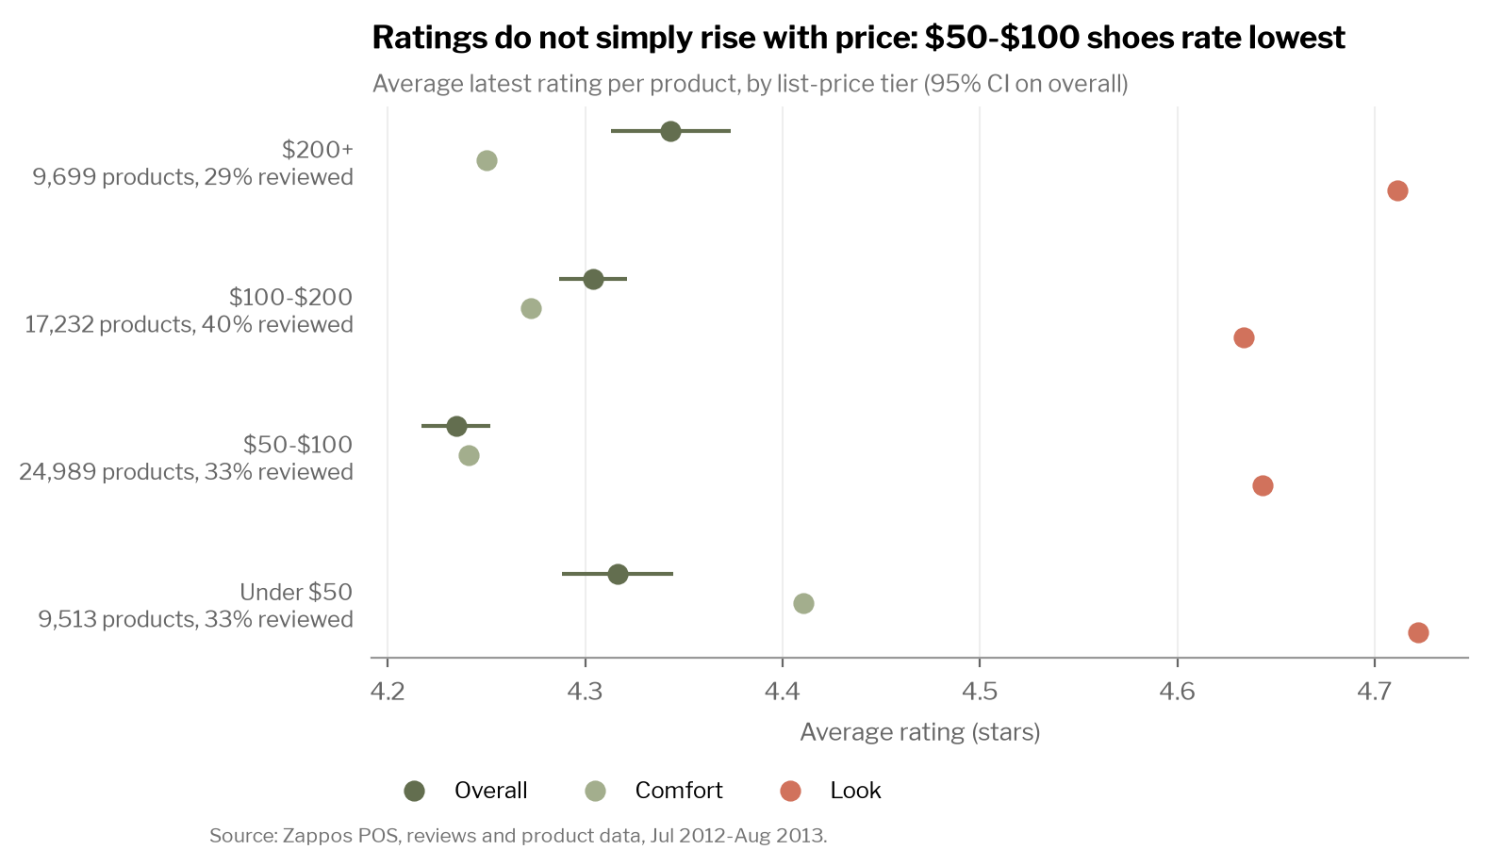
Q5. The share of discounted sales is 29.7% (Northeast) to 32.0% (West): almost no regional difference. | Q5. By list price, $50–$100 shoes rate lowest (4.24); under-$50 (4.32) and $200+ (4.34) rate highest. Ratings do not simply rise with price.

Q6–Q7. Brands and timing
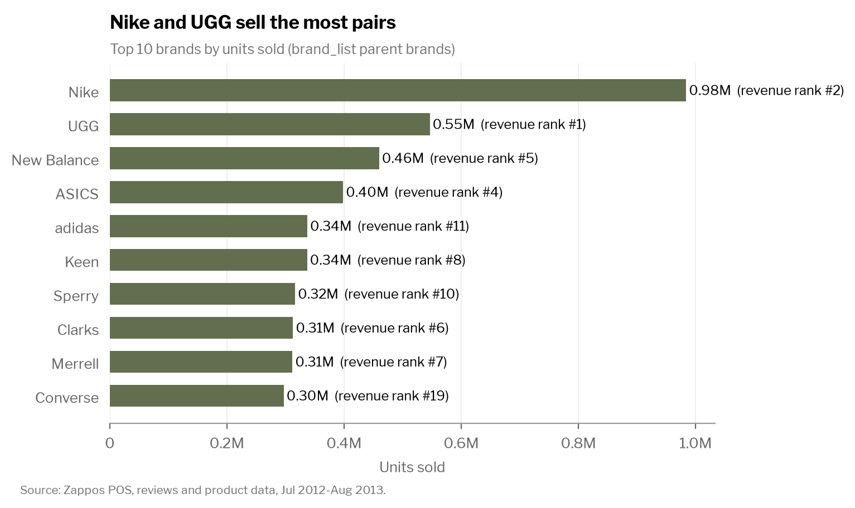 | 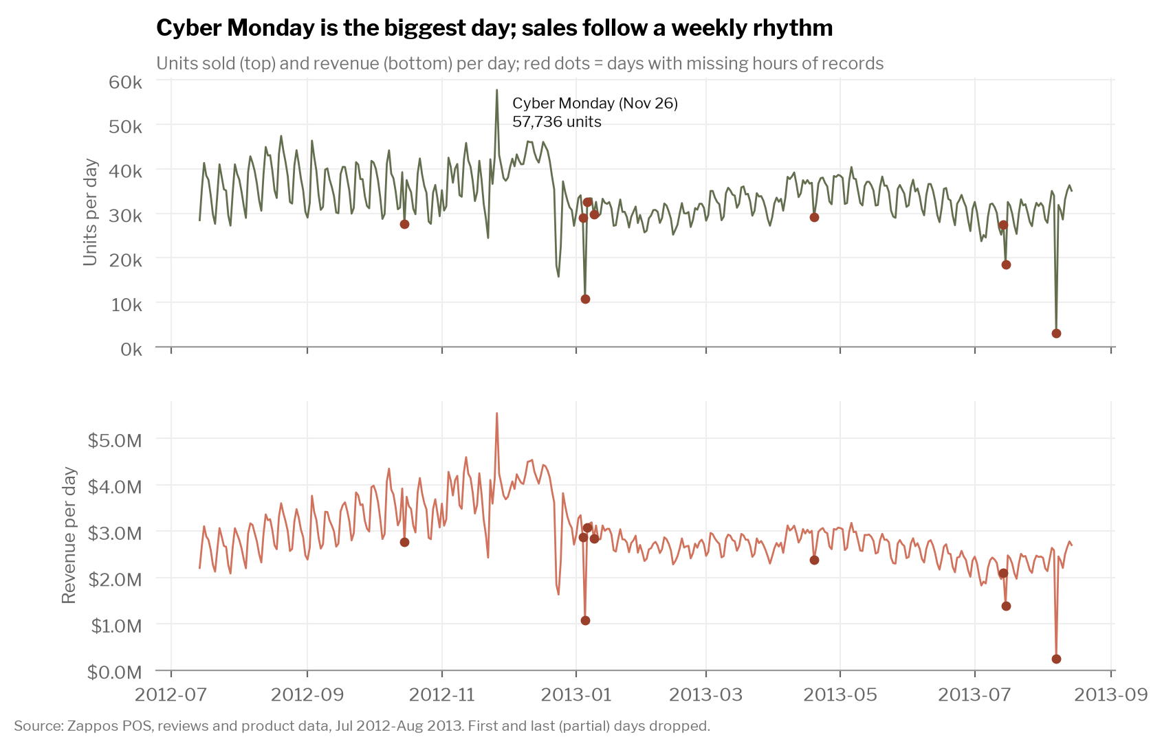
Q6. Nike sells the most pairs (984k) but UGG earns the most revenue ($75.9M) at twice Nike's average price. | Q7. A median day sells 33,500 pairs. Cyber Monday (Nov 26, 2012) is the peak; Mondays are the busiest weekday. Red dots mark the 9 days with missing hours of records.
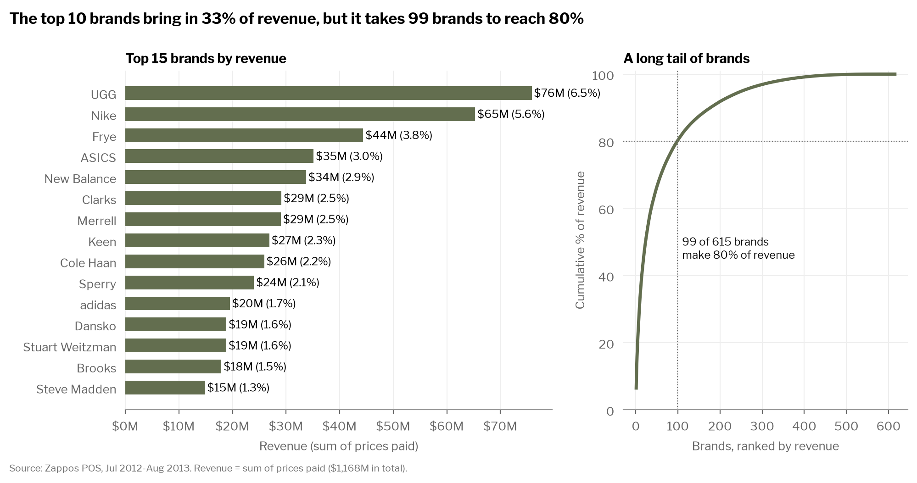
Q6. Total revenue $1,168M. UGG ($75.9M), Nike ($65.3M) and Frye ($44.4M) lead; the top 10 brands earn 33% of revenue and 99 brands earn 80%.
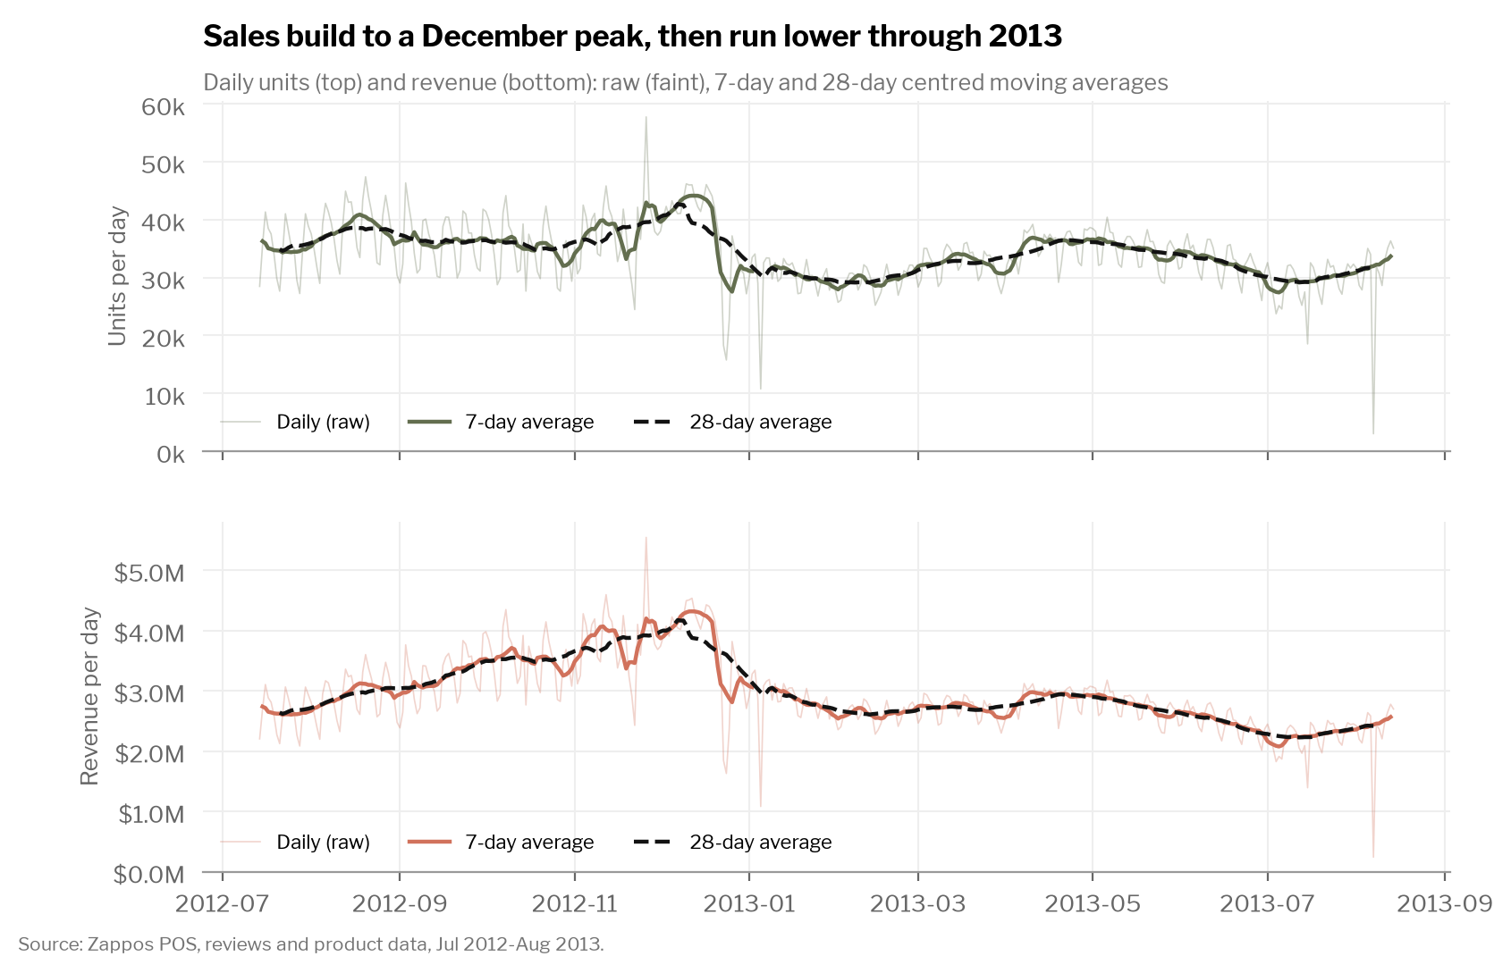 | 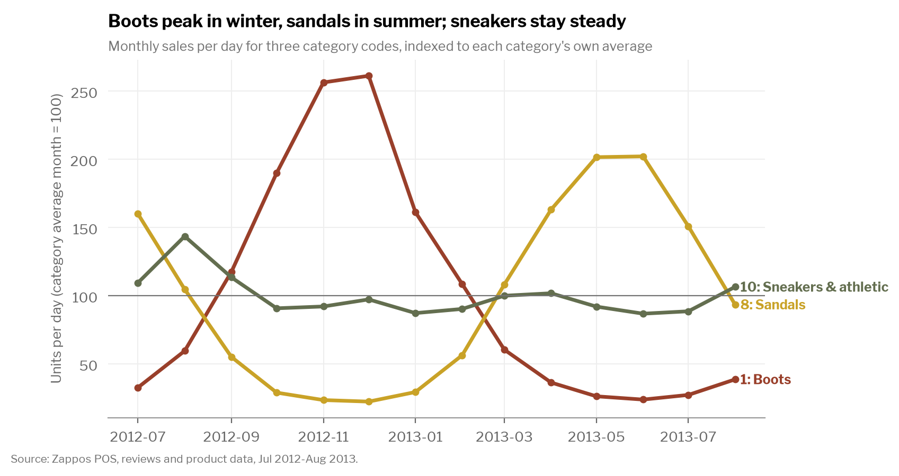
Q7. 7- and 28-day moving averages remove the weekly cycle: sales build to a December peak; daily revenue then runs 19% lower in Feb–Jul 2013 than in Jul–Nov 2012. | Q7. Category codes inferred from best sellers and features (e.g., 1 = boots: UGG Classic Short, 8 = sandals, 10 = sneakers). Boots and sandals have opposite seasons; sneakers are steady.
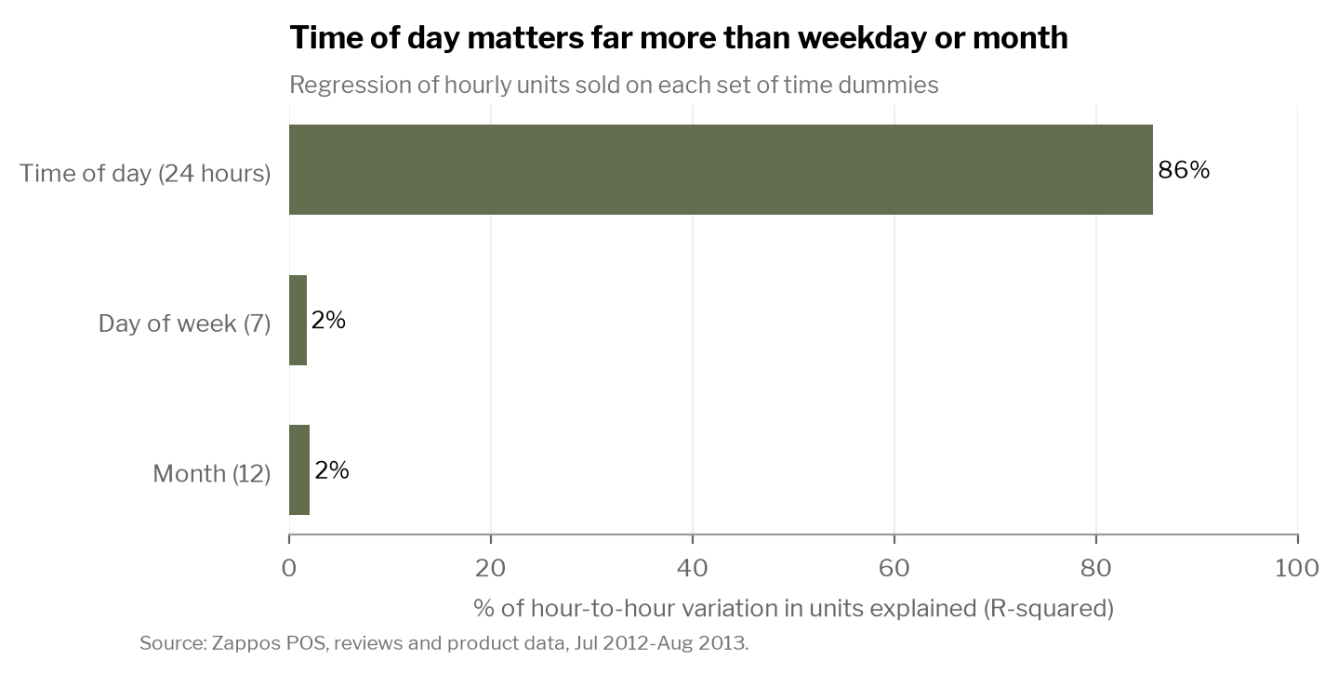
Q7. Time of day explains 86% of hourly variation in pairs sold; day of week 2% and month 2%. On daily totals, month (28%) and weekday (23%) matter similarly.

Appendix B. Data, cleaning and methods
- Files and levels. POS.dta: 13,546,258 rows, one per pair sold. brand_list.dta and categories.csv: one row per product (sku). stock_chars.dta: 117,493 rows, one per product × color (style_id). reviews.csv: 297,388 rows, one per product × month (21,242 products × 14 months).
- Never change the raw data. The 2.6 GB POS file is read in 1-million-row pieces and saved once as a compressed Parquet copy (309 MB); all large queries run in DuckDB SQL on that copy (Class 7). Raw files are fingerprinted (SHA-256) at the start and re-checked at the end.
- Checks on all 13.5M sales. No zero prices, no price above list price, discount always equals list price minus price paid, and the sale flag always agrees. No exact duplicate rows. date_* is the purchase time (local US time; the 2 am hour is missing on the daylight-saving day). 9 days with missing hours of records are flagged and excluded from smoothing and time-of-day models.
- Merges (rows before → after, match rate). POS × brand_list on sku: 13,546,258 → 13,546,258, 100%. POS × stock_chars on sku + color: rows unchanged, 95.2% matched (97.8% with the product-level fallback). reviews × product features on sku: 297,388 → 297,388, 95.9% matched. Every merge asserts a unique key and uses many-to-one validation, so no row can be duplicated.
- Definitions. Transaction = one pair sold. Revenue = sum of prices paid. Discounted = price below list price. Price tiers use each product's list price, so a temporary sale does not move it between tiers. Regions are US Census regions; territories and military addresses are excluded from state and region results. Reviews are running totals, so each month's new reviews are recovered from the change in totals.
- Ratings → sales regressions (product × month panel, 232,895 observations, standard errors clustered by product). Outcome: log(1 + pairs sold this month); key variable: last month's rating. Naive: +0.261 (SE 0.010). With controls and month fixed effects: +0.056 (0.008). With product and month fixed effects (within estimator, Class 8): −0.043 (0.024). The drop shows omitted-variable bias: product quality, brand and style raise both ratings and sales.
- Time-of-day vs weekday vs month. Hourly pair counts (388 complete days × 24 hours) regressed on hour, weekday and month dummies; R² 0.856, 0.017 and 0.021 respectively (0.895 together).

AI disclosure
We used Claude (Anthropic) through Claude Code, as the course requires, to plan the analysis, write and debug the Python code, and draft this summary. Every number was checked against the notebook output, and the notebook re-verifies 13 key values and the raw-file fingerprints on each run.

