NYC 311 Service Analytics: data assessment for the Mayor's Office
MGT 634 Lab Day 2 · Michal Kozuchowski, Laila Lapins, Nick Giamalis, Raymond Chang, Sean Weller
Data: 2,824 JSON files, 28,240,000 service requests, Jan 1 2010 – Nov 20 2021. Code: MGT634_Lab2_NYC311_v3.ipynb (one Run All reproduces every number, chart and the dashboard).

Q11. Executive summary (5 minutes with the Mayor)
Three critical findings
- The 311 data is not yet reliable enough to set budgets. 3.65M requests (13%) carry no time of day; 267,339 were closed before they were opened; agencies close thousands of requests in a single second (17,088 by DSNY at once); key fields hide missing values behind 'Unspecified'; hacking strings sit in the complaint-type field; and the last weeks of data (Oct–Nov 2021) are incomplete.
- Housing is where service is slowest and most concentrated. Landlord-responsibility complaints (heat, plumbing, paint, construction) take a median 6–9 days to close versus hours for most other complaints, and they make up 44% of all Bronx requests. Every 10°F drop in temperature adds about 283 heat complaints a day.
- Some districts wait longer for the same problems. Comparing like with like, Queens 13, Bronx 12 and Queens 5 are about 20% slower than the citywide norm for the same complaint types; HPD, DOB, DPR and DOHMH remain slow even after adjusting for how hard their complaints are.
Two immediate actions
- Weather-triggered staffing: use the 5-day forecast to surge HPD heat inspectors before cold snaps (and DEP / Parks crews before storms), since cold and rain predict which complaints will arrive.
- Fix data at intake: require borough, ZIP and a real timestamp; reject code-like text; keep administrative bulk closures out of the response-time KPI.
One long-term recommendation
- Publish a difficulty-adjusted response-time scorecard by community district and agency (built on our Q8 dashboard and one standard complaint-type list), and move resources to districts below the citywide standard.

Part 1: Data quality assessment

Q1. Missing values
We measured missingness three ways, because a blank is not the only way data goes missing:
- Truly empty (NULL). Mostly specialised fields: bridge/highway, taxi and vehicle fields are 99–100% empty, landmark 87.5%. Core location fields are mostly present: latitude/longitude 8.7% missing, ZIP 5.1%, address 16.9%.
- Disguised missing (looks filled, carries no information): park_facility_name 'Unspecified' 99.3%; facility_type 'N/A' 74%; open_data_channel_type 'UNKNOWN' 21%; community_board '0 Unspecified' 10.2%; borough 'Unspecified' 4.4%; plus impossible values (dates before 2003, coordinates of 0).
- Not applicable: many fields only matter for some of the 478 complaint-type spellings (vehicle_type is used by 2 types, taxi borough by 3). Judged only where they apply, address fields are 11–13% missing and coordinates 5% (vehicle_type stays 88% missing even where it applies: a real gap).
- Other issues: 267,339 closed before created; 3,654,438 created at exactly midnight; 38 test records ('Closed - Testing'); no duplicate request ids.
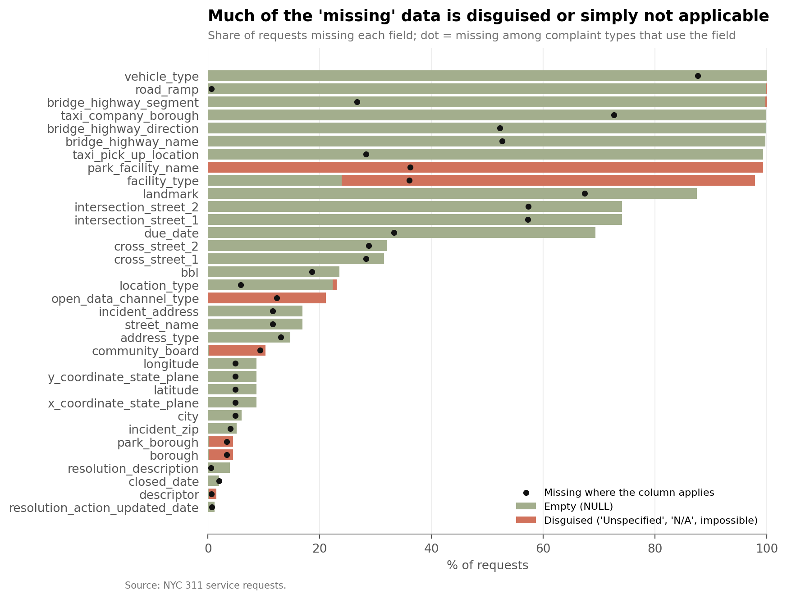
Figure 1. Missing share by field: empty (green), disguised (red); dot = missing where the field applies.

Q2. Consistency over time
- Daily volume (a): 4,342 days, none completely empty, but 90 days fall below half of the local 4-week median. The end of the file is incomplete: late Oct–Nov 2021 has days with 5–400 requests against ~5,500–7,900 normally. Spikes are real events: Tropical Storm Isaias (Aug 4–5, 2020: 24,415 requests, 2.3× normal) and the first cold snap each January (e.g. the Jan 7, 2014 polar vortex).
- Timestamp precision changed: 30–34% of requests in 2010–2014 have a date but no time (stamped midnight), 14% in 2015, under 2% from 2016. Hour-level analysis before 2016 is unreliable. Volume grew from 2.0M (2010) to 2.9M requests a year (2020).
- Closings (b): 5.78M closed at exactly midnight; 1.04M closed in the same second they were opened (automatic closures); 267k closed before opening; 5,921 have 1900 placeholder dates; 9 lie in the future; 335k took over a year. Batch closures are administrative clean-ups, not service: 18,033 DOB requests on Sep 10, 2019 and 17,088 DSNY requests in one second on Jun 20, 2023 (two years after the data ends). Real closing times peak at midday.
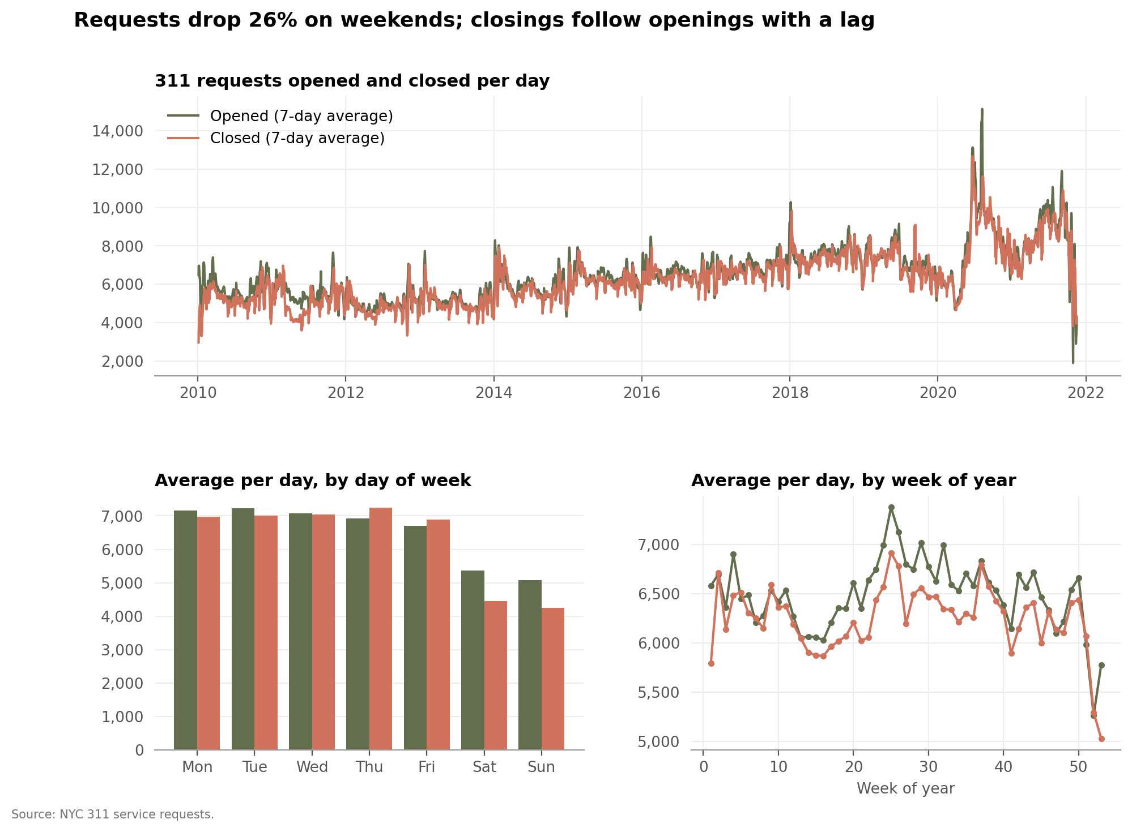
Figure 2 (c). Openings and closings over time, by day of week and by week of year.

Q3. Complaint-type consistency
- (a) Examples: 478 spellings reduce to 459 types after standardising. Same category, different names: HEATING vs HEAT/HOT WATER (2.4M requests), 'Traffic/Illegal Parking' vs 'Illegal Parking', upper vs lower case (PLUMBING / Plumbing, ELEVATOR / Elevator), 'Derelict Vehicle(s)', 'Dirty Condition(s)', 'Animal Abuse' vs 'Animal - Abuse', 'Hazardous Material(s)'. Unusual entries: 166 types with under 10 requests, many of them cyber-attack probes typed into the online form (SQL injection such as "';DECLARE @Q…" and 'WAITFOR DELAY', path attacks such as '%2fetc%2fpasswd'), all under agency DVS. 36 types (8.5% of requests) are service or information requests, not complaints.
- (b) Strategy: keep the raw field untouched and add (1) `standard_type` from an automatic normalizer (case, spacing, punctuation) plus a short alias table for known renames, and (2) `category` from keyword rules (building owner, city infrastructure, neighbors, nature/weather, information request). The mapping is exported as complaint_type_map.csv. New data runs through the same rules automatically; any new name is flagged by a similarity check for a one-line decision, code-like text is quarantined, and the detailed `descriptor` is kept.

Q4. Response times (time to closure)
Closed requests | Mean (days) | Median | SD | Q1 | Q3 | P90 | P99
27,413,243 | 23.6 | 1.43 | 148.4 | 0.1 | 7.0 | 25.2 | 466

- (a) 3.8M requests (13.9%) exceed the outlier fence (Q3 + 1.5×IQR = 17.4 days); the longest took 15.7 years. The mean is 16× the median, so medians are the right KPI.
- (b) Areas: we compare each district with the citywide median for the same complaint types (1.0 = typical). Slowest: Queens 13 (1.22), Bronx 12 (1.20), Queens 5 (1.20), Queens 1 (1.14). Queens is the slowest borough once the complaint mix is accounted for (1.06); Manhattan the fastest (0.94).
- (c) Agencies: a regression of log hours to close on agency, controlling for complaint category, borough, month, weekday and channel (about 380,000 randomly sampled requests), barely changes the ranking (R² 0.48 → 0.50), so slow agencies are not just handling harder problems. Fastest after adjustment: NYPD, DHS, DEP (excluding 311 itself); slowest: EDC, DOE, DPR, DOB, TLC, DOHMH, HPD. DOT drops from 6th to 9th once adjusted (from 44% faster than average to 13% slower) (its speed comes from easy complaints); DOF and DSNY improve. Caveat: NYPD's speed partly reflects quick 'no action needed' closures.

Part 2: Visualization and insights

Q5. Top 10 complaint types
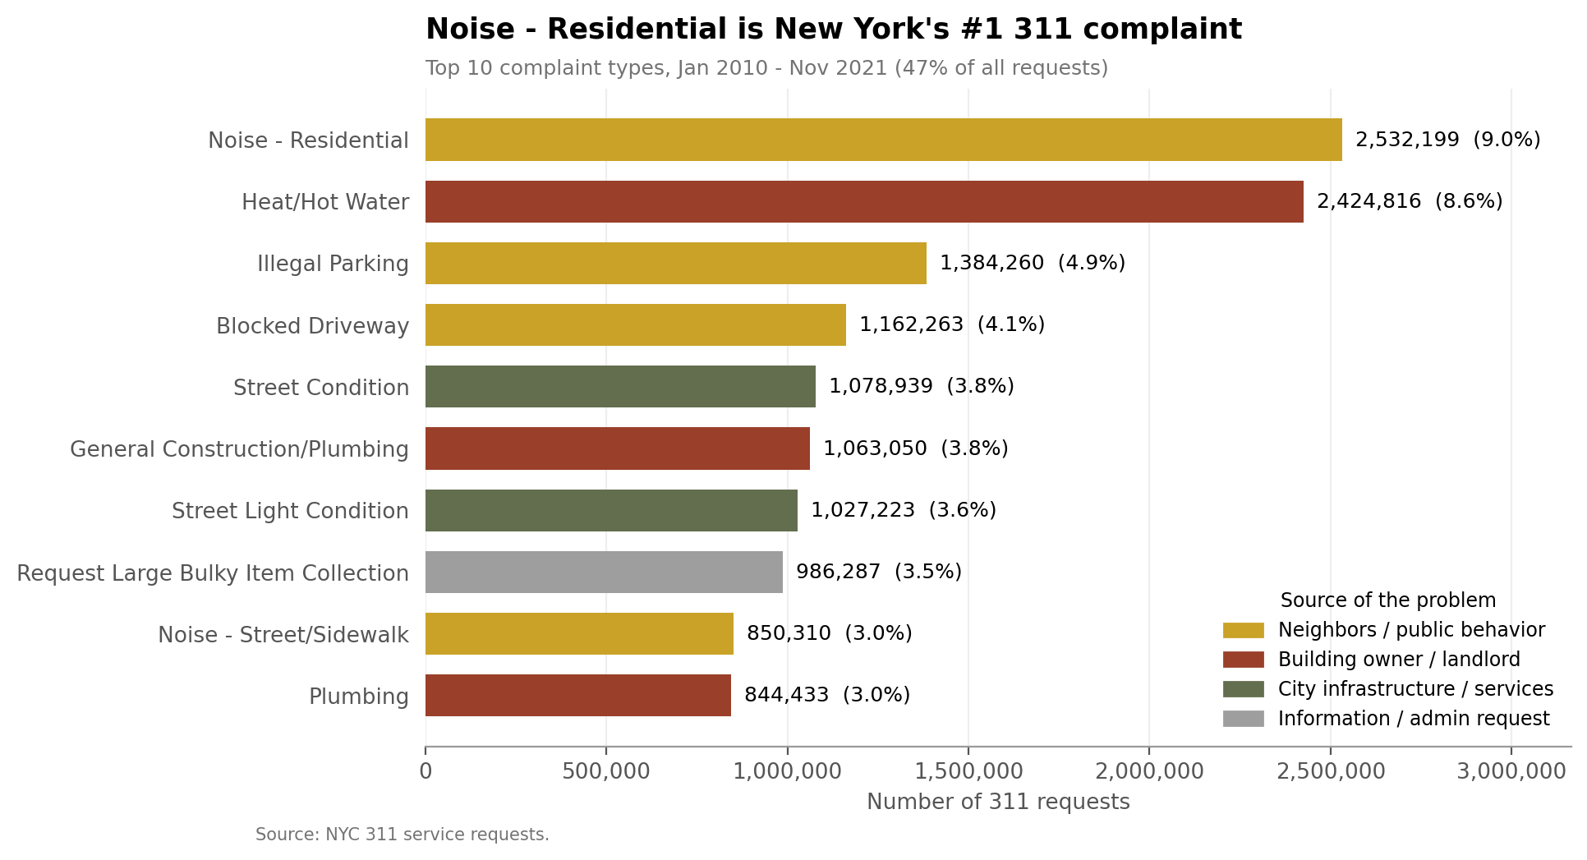
Figure 3. Residential noise (9.0%) and heat/hot water (8.6%) lead; the top 10 are 47% of all requests.

Q6. Complaints and the weather
We merged daily NYC weather (Open-Meteo historical archive: temperature, precipitation, snowfall) on date: 4,342 days before and after, 100% matched. Weather changes what people complain about more than how much: total daily volume barely moves (weather explains 0.4%), but the content shifts strongly:
- Heat/hot water: correlation −0.76 with the daily low; +283 complaints/day per 10°F colder.
- Sewer & water: +110 per inch of rain; trees: +105 per inch (storm damage, e.g. Isaias); noise rises in warm weather and falls ~300/day per inch of rain.
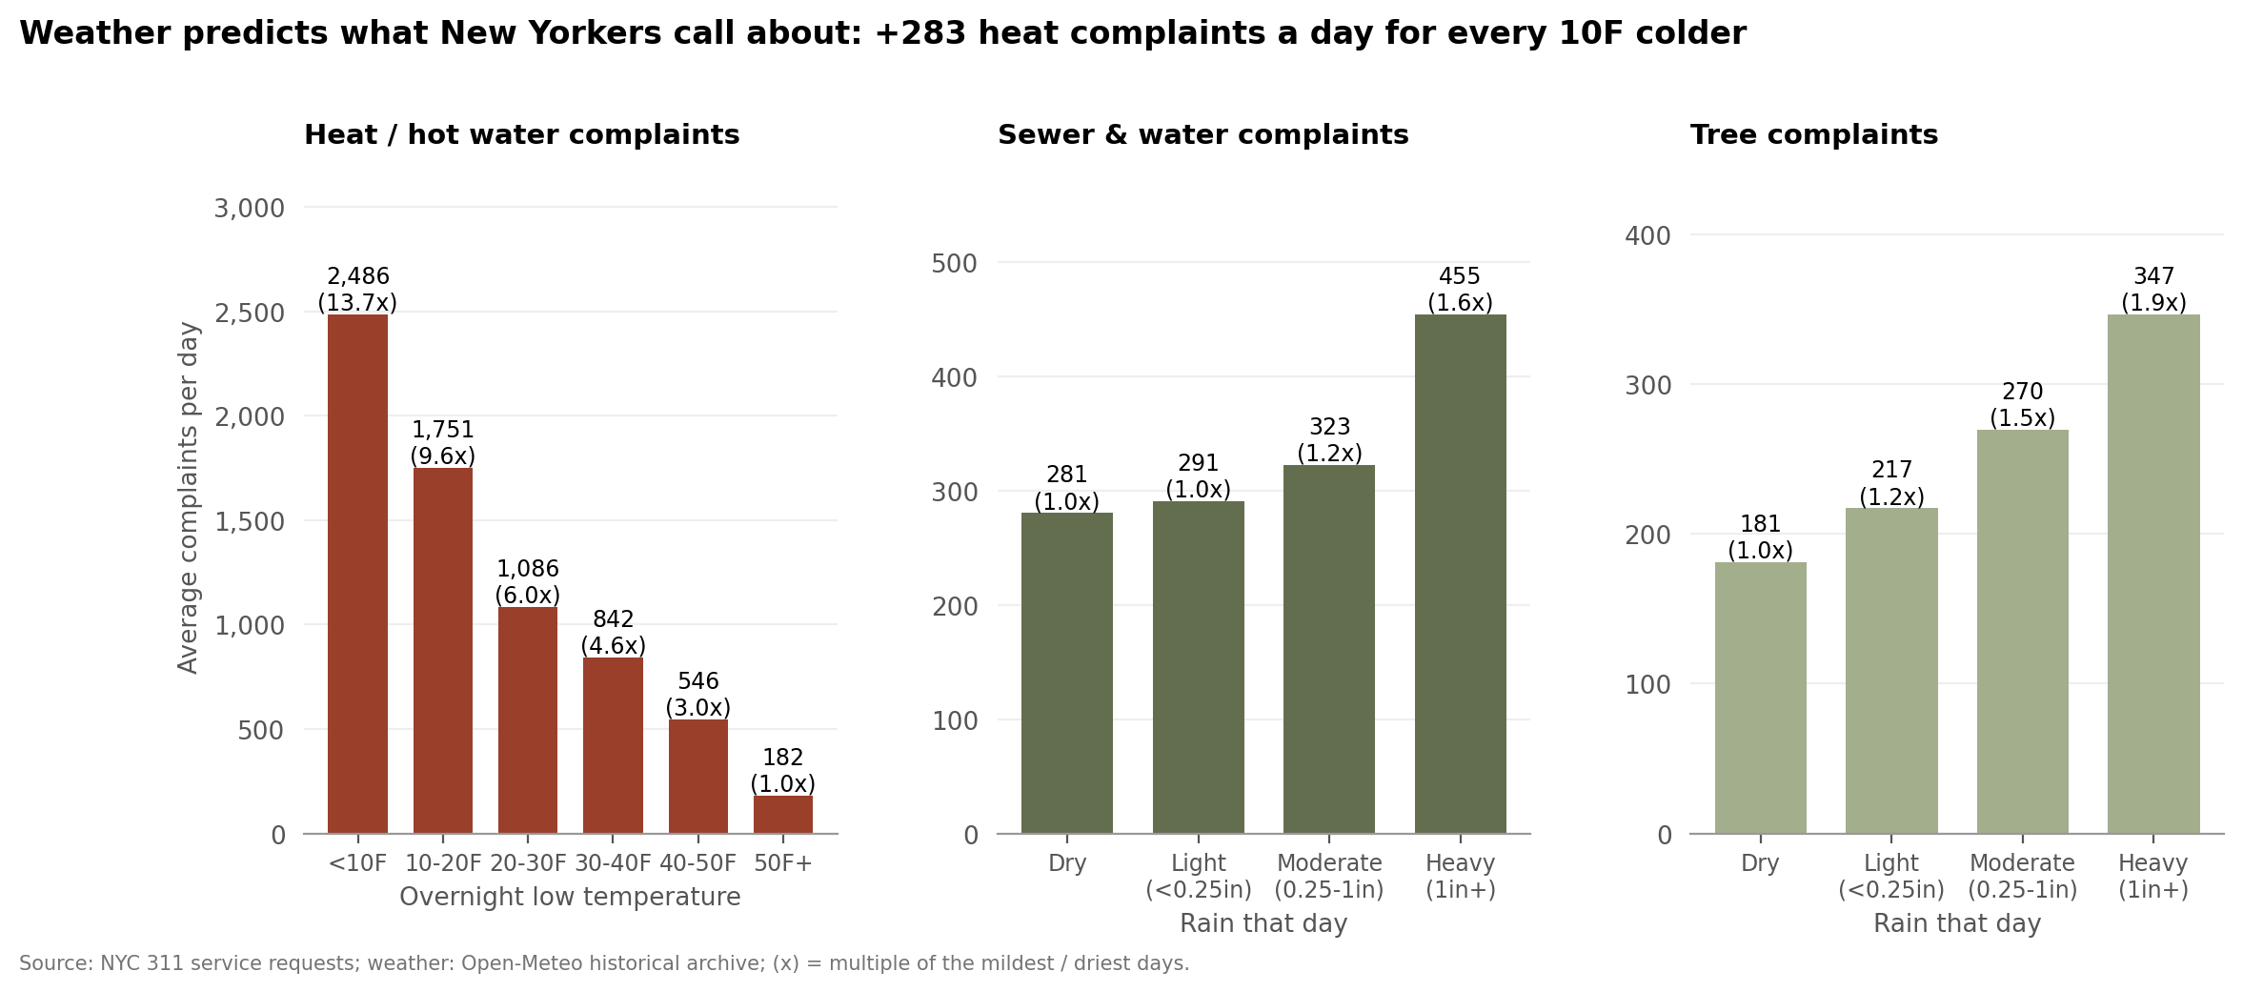
Figure 4. Average complaints per day by overnight low temperature (heat, Oct-May) and by rainfall (sewer, trees); (x) = multiple of the mildest / driest days.

Q7. Geographic disparities
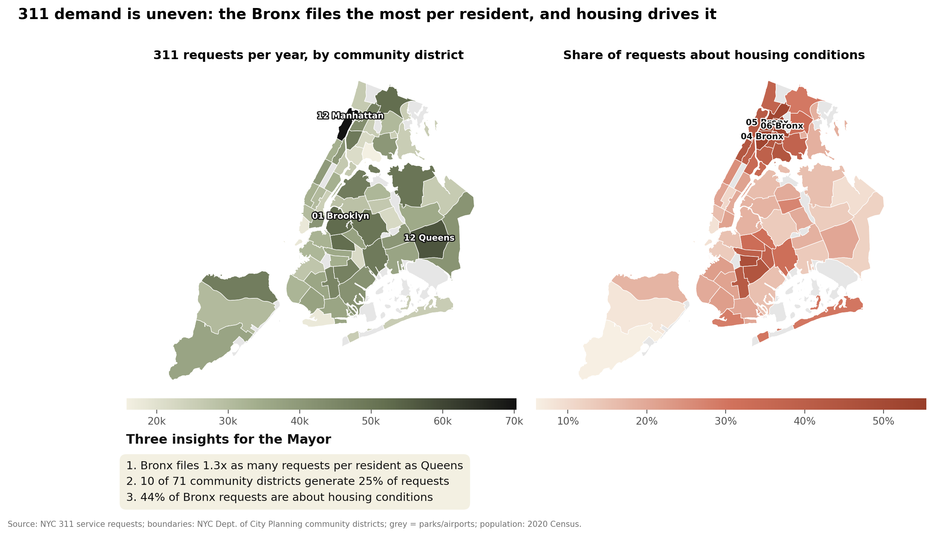
Figure 5. Map of the 59 community districts: requests per year (left) and share about housing conditions (right), with three insights.
- The Bronx files 1.3× as many requests per resident as Queens (305 vs 234 per 1,000 a year).
- 10 of 71 community districts generate 25% of requests.
- 44% of Bronx requests concern housing conditions, versus 19% in Queens and 13% in Staten Island.

Q8. Web dashboard
lab2_output/q8_dashboard.html is an interactive, zoomable map (Plotly) of 61,837 ~100 m cells. Colour = main source of complaints, size = volume; hovering shows the top complaint, community district, median days to close and share unresolved. Staff can zoom from borough to block level in a browser, with no software needed.

Part 3: Combined analysis and strategy

Q9. Equity in service delivery
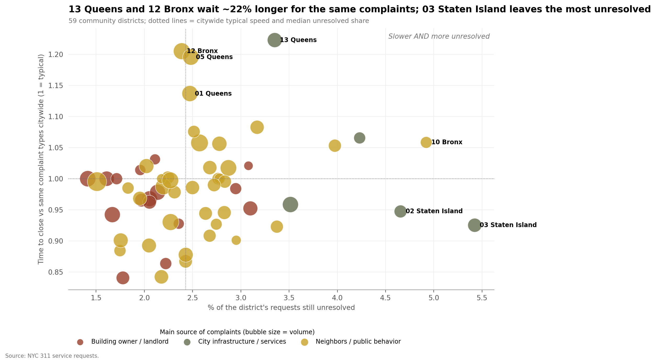
Figure 6. Community districts: share of requests unresolved vs time to close relative to the same complaint types citywide; colour = main source, size = volume.
- Unresolved: Staten Island districts 3, 1 and 2 hold the most unresolved requests (up to 5.4%), mainly street conditions; Queens 12 and 7 and Bronx 10 follow.
- Concentration by type and origin: Bronx problems come from landlords (2.3M housing requests); Queens and Staten Island from city infrastructure; Manhattan and Brooklyn from neighbors (noise, parking).
- Inequity: landlord-responsibility complaints take a median 6–9 days (8.8 on Staten Island, 8.0 in Queens) versus 0.1 days for neighbor complaints, so housing-heavy districts wait longer; and Queens 13 / Bronx 12 are ~20% slower even for identical complaint types, which points to capacity, not difficulty.

Q10. Features for a volume model
Feature (daily total volume) | R² alone
Last week's volume | 0.53
Day of week | 0.20
Month | 0.02
Weather (temperature, rain, snow) | 0.004
All together | 0.57

- Most valuable: recent volume (persistence) and day of week; weather and season matter for the mix of complaints (heat, sewer, trees), which is what staffing needs; add holidays and borough/category for local forecasts.
- Link to response times (daily): weekday (correlation −0.23) and cold (−0.20) are related; busier days close faster (−0.22 days per extra 1,000 requests), because they are dominated by quickly closed noise complaints (R² 0.31).

Method notes and AI disclosure
All 2,824 JSON files were read with DuckDB and converted once to Parquet (4 minutes on 4 cores / 32 GB); the raw files were never modified. Every merge reports rows before/after and its match rate. A first attempt to remove duplicate ids ran out of memory; a cheap check showed there were none (28,240,000 = 2,824 × 10,000), so that step is skipped unless duplicates exist. We used Claude (Anthropic) via Claude Code, as the course requires, to write and debug the code and draft this write-up; all numbers come from the notebook output.

