Exploring U.S. Emergency Department Visits: NHAMCS-ED 2015
MGT 634 Empirical Strategy with AI · Homework 1 · Michal Kozuchowski, Laila Lapins, Nick Giamalis, Raymond Chang, Sean Weller · September 2026
Summary. Weighted to the national level, the 2015 NHAMCS emergency department sample represents about 136.9 million U.S. ED visits. Arrivals follow a stable daily pattern: they rise from 7am, stay near their peak from 10am to 8pm, and are heaviest on Mondays. The median visit lasts about two and a half hours, so time in the department matters for crowding as much as arrival volume. Medicaid is the most common expected payer, and nearly half of visits with a completed chronic-condition section record at least one chronic condition. Triage level is strongly associated with admission, but recorded median waits differ little across levels 2-5.

1. Data, sample design and cleaning (Q1-Q2)
Q1(a): The file has 21,061 rows and 1,031 columns. Q1(c): each row is one sampled ED visit (one Patient Record Form), not a patient, so the same person can appear more than once. Hospital code plus patient code uniquely identifies every row, and the visits come from 248 EDs (a median of 94 sampled visits each). Q2(a): the unweighted count is 21,061 visits. Q2(b): summing the patient visit weight PATWT gives 136,943,181 estimated U.S. ED visits in 2015, the total NCHS reports (codebook p.28) and well above 100 million. The weights are uneven (117 to 42,002; the 10% of rows with the largest weights carry 28.7% of weighted visits), and the sample does not mirror the country: the Northeast is 20.4% of rows but 17.3% of weighted visits, the South 33.3% versus 37.8%. We therefore weight every total, share and rate. We report weighted point estimates only; we did not compute design-based standard errors (strata CSTRATM, clusters CPSUM), so small differences should not be over-read.
Missing values are mostly not stored as blanks. A standard pandas NaN count flags 600 columns, but those are largely unused drug-category text fields. NCHS records missing answers as negative codes: -9 (blank), -8 (unknown) and -7 (not applicable), as defined item by item in the codebook (p.37 onward). Q1(b): counting -9 and -8, 118 variables are more than 5% missing and 56 more than 20%. Among the variables we use, unimputed ethnicity is 24.2% blank, pain score 29.5%, triage level 22.2%, wait time 15.2% (plus 3.4% not applicable because the patient was not seen by a provider), expected payer 8.7% and length of visit 7.0%. We therefore use the imputed ethnicity (ETHIM, 0% missing). Intent (INTENT15) and hospital discharge status (HDSTAT) are asked only for injury visits and admitted patients, respectively, so their high missing shares are by design.
Missingness also varies with observed characteristics. Wait time is missing for 7-12% of visits at triage levels 1-5 but for 38-45% of visits where triage was blank, not performed or not offered, and it ranges from 9.8% of Midwest visits to 19.7% of Northeast visits. We cannot tell whether the missing waits are longer or shorter than recorded ones, so our wait-time results describe visits with a recorded wait and may not generalize to the rest.
Before computing any statistic we converted -9/-8/-7 to missing, recoded yes/no items to 0/1, and converted arrival time from military time to an arrival hour (1.3% blank). Length of visit reaches 5,732 minutes and waits reach 1,305 minutes, so we emphasize medians and report means both raw and winsorized at the 99.5th percentile (98 and 86 visits capped) rather than deleting records.
We used two kinds of checks. Externally, Table 1 compares our estimates with figures published in the NCHS documentation; all agree to rounding except wait-time missingness (15.2% vs 15.7%). Internally, the total-chronic-conditions count equals the sum of the 22 condition checkboxes on every answered visit, the medication count equals the number of filled medication slots on every visit, the weighted mean, median and correlation functions reproduce hand-computed results on test data, and a final end-to-end re-run of the notebook reproduces 20 key values recorded during the question-by-question review (a reproducibility check, not an external validation).
Table 1. Selected estimates compared with figures published by NCHS
Estimate | Our result | NCHS published | Agreement
Records in file | 21,061 | 21,061 (p.115) | Exact
Weighted U.S. ED visits | 136,943,181 | 136,943,181 (p.28) | Exact
Female share of visits (weighted) | 55.44% | 55.436% (p.115) | Rounding
Hispanic share of visits (weighted) | 16.49% | 16.493% (p.115) | Rounding
Medicaid as primary expected payer, all visits | 31.15% | 31.152% (p.116) | Rounding
Visits with no medications (weighted) | 20.94% | 20.943% (p.117) | Rounding
Weighted drug mentions | 340,550,921 | 340,550,921 (p.118) | Exact
BUN/creatinine test ordered, all visits | 6.67% | 6.7% (p.4) | Rounding
Missing: length of visit / expected payer | 7.0% / 8.7% | 7.0% / 8.7% (p.15) | Exact
Missing: wait time | 15.2% | 15.7% (p.15) | 0.5 points lower

2. Who comes to the ED, and how long they stay (Q3)
Table 2. Answers to Q3(a)-(d): descriptive statistics, unweighted and weighted
Statistic | Unweighted | Weighted
Q3(a) Age, mean / median (years; 93 = top-coded "93+") | 37.6 / 34 | 37.0 / 34
Q3(b) Female / Hispanic (imputed ETHIM) | 55.1% / 15.9% | 55.4% / 16.5%
Q3(c) Wait to see a provider, median (n = 17,153 with recorded wait) | 19 min | 18 min
Wait, mean (winsorized at 99.5th percentile) | 39.5 min | 38.7 min
Q3(d) Length of visit, mean raw / winsorized (n = 19,581) | 221.9 / 216.5 min | 213.7 / 209.8 min
Length of visit, median | 154 min | 154 min

The median visit is by a patient aged 34; 55% of visits are by women and 16.5% by Hispanic patients (weighted). Half of patients with a recorded wait saw a provider within 18 minutes, but the mean wait is roughly twice the median, so a minority of long waits pulls the average up. The median visit lasts 154 minutes (2.6 hours) and the mean about 214 minutes. That long right tail matters for capacity, because long stays occupy beds and staff time. As a rough illustration, Little's law (average patients present = arrival rate x average time in the department) implies about 55,700 patients in U.S. EDs at a typical moment, or roughly 12 per ED across the 4,820 EDs NCHS estimates (codebook p.120), assuming steady arrivals.
Weighting changes these statistics only slightly: mean age falls by 0.5 years, mean length of visit by about 8 minutes, and children's share of visits rises from 18.6% to 19.8%; the medians do not change. Weighting matters less for these headline figures than for volumes and subgroups: unweighted counts do not measure national volume (21,061 records versus 136.9 million visits), and the sample's regional mix differs from the country's.

3. When demand arrives (Q4)
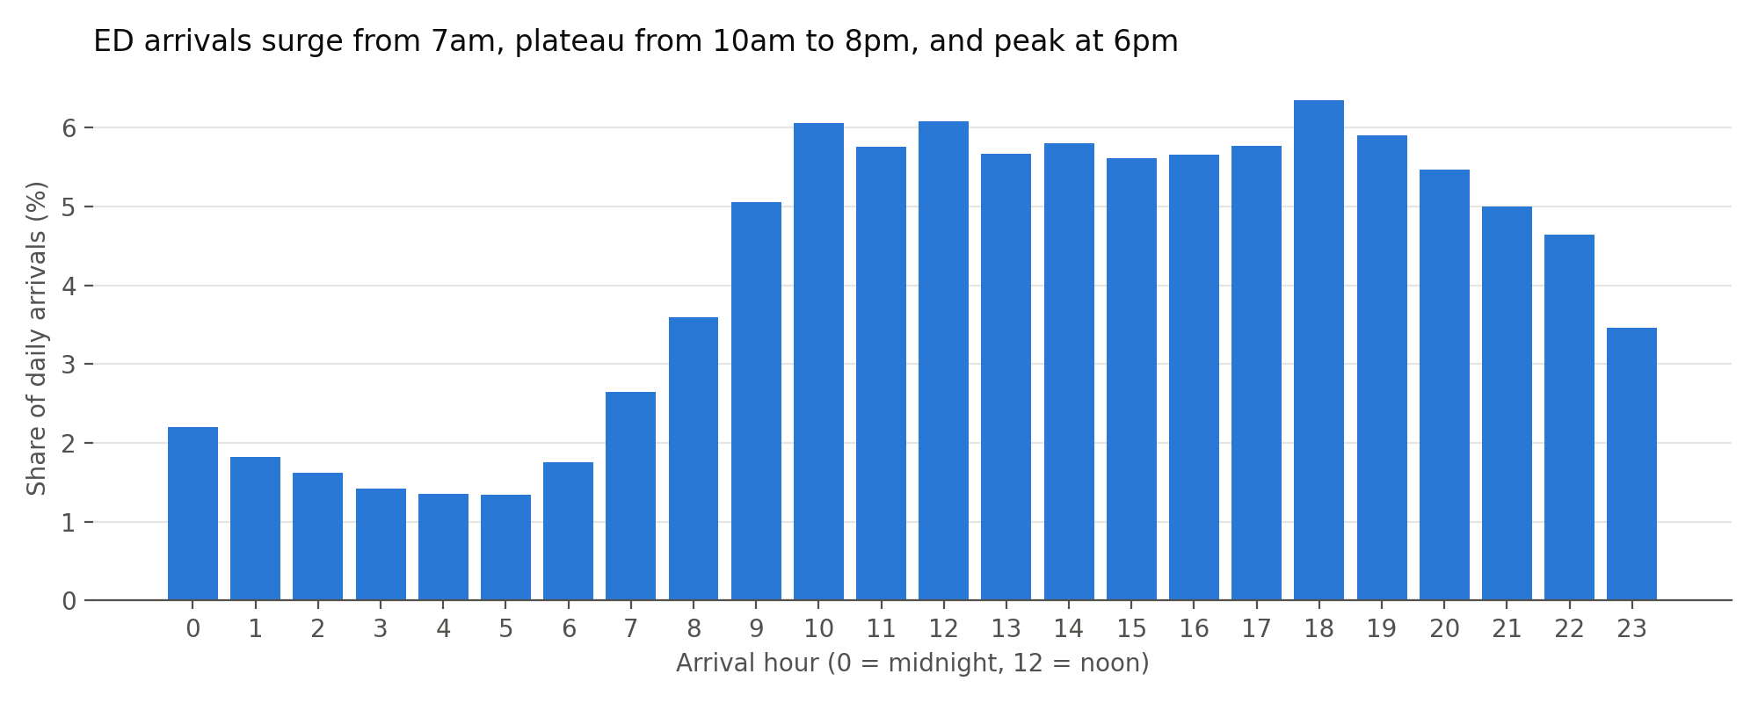 | 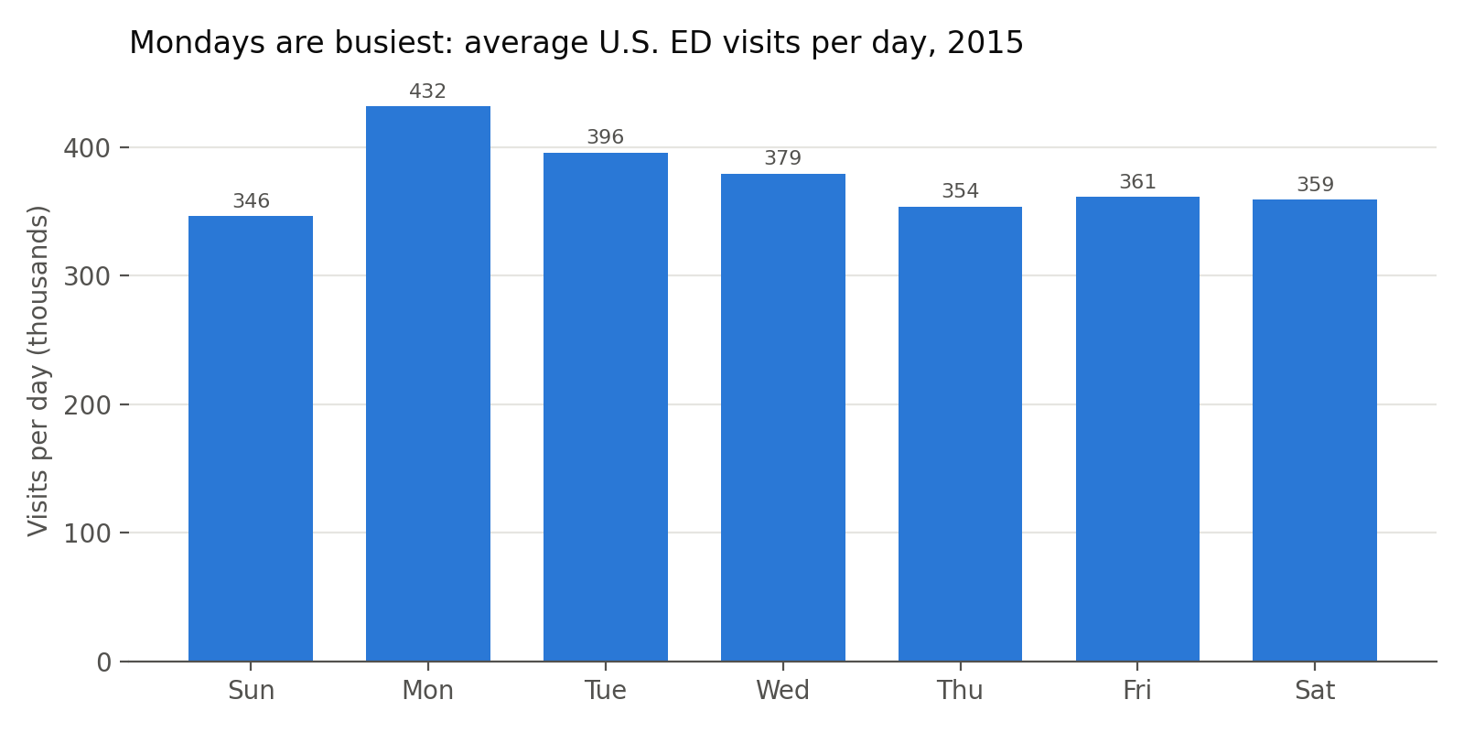
Figure 1. Weighted arrivals by hour, as a share of visits with a recorded arrival time (98.7% of records), and average weighted visits per day by weekday
Because 2015 had 53 Thursdays and 52 of every other weekday, we compare days as average visits per day. Q4(a): over the year, weighted visits total 22.45 million on Mondays and 18.00 million on Sundays; Figure 1 shows every weekday and every arrival hour. Q4(b): Monday is the busiest day (432,000 visits per day) and Sunday the quietest (346,000), a 25% difference; the busiest hour is 6pm (6.3% of arrivals, 8.59 million over 2015), within a plateau from 10am to 8pm. Volume declines from Monday through Thursday. Arrivals are lowest between 3am and 6am (about 1.3-1.4% of daily arrivals per hour) and climb from 7am; the peak hour receives 4.7 times as many arrivals as the quietest, and 69% of patients arrive between 10am and 10pm.
For staffing, this points to planning around a long daytime and evening plateau rather than a single rush. Because the median patient stays about 2.6 hours, the number of patients in the department probably peaks after arrivals do, so coverage decisions should consider occupancy, which NHAMCS does not measure directly. The Monday excess is consistent with demand deferred over the weekend, but these data cannot establish the reason.

4. Payer mix (Q5)
PAYTYPER is the primary expected source of payment, chosen by an NCHS hierarchy when a visit lists several; it is not a record of revenue actually collected. Q5(a): across all visits (weighted), Medicaid/CHIP is the expected payer for 31.2%, private insurance 27.6%, Medicare 17.7%, self-pay 9.0%, other 2.2%, no charge 0.8% and workers' compensation 0.7%; for a further 10.8% the payer is blank or unknown. Q5(b): among the 89.2% of visits with a known expected payer, Medicaid is 34.9%, private insurance 30.9%, Medicare 19.9% and self-pay 10.1%; Medicaid and Medicare together are 54.8% of known-payer visits and 48.9% of all visits. Self-pay and no charge together are 11.0% of known-payer visits. Age drives much of this mix (Figure 2): Medicaid is the expected payer for 65% of visits by children, Medicare for 78-87% of visits by patients 65 and older, and self-pay peaks at 17.5% among 25-44-year-olds.
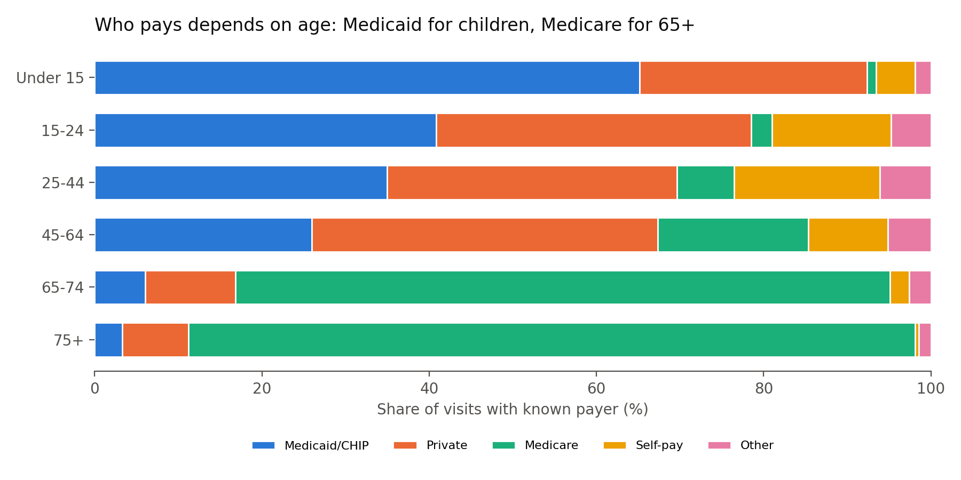
Figure 2. Primary expected payer by age group, weighted % of visits with a known expected payer
If public programs pay less per visit than private insurers, as is commonly the case, an ED whose mix resembles this national profile would earn less per visit than one serving more privately insured patients, and self-pay and no-charge visits carry a higher risk of unpaid bills. Because EDs must screen and stabilize patients regardless of ability to pay (EMTALA), hospitals have little control over this mix at the door. These data cannot measure the financial effect directly: actual revenue depends on contracts and collections that NHAMCS does not record, and 10.8% of visits lack a recorded payer.

5. Clinical profile (Q6-Q9)
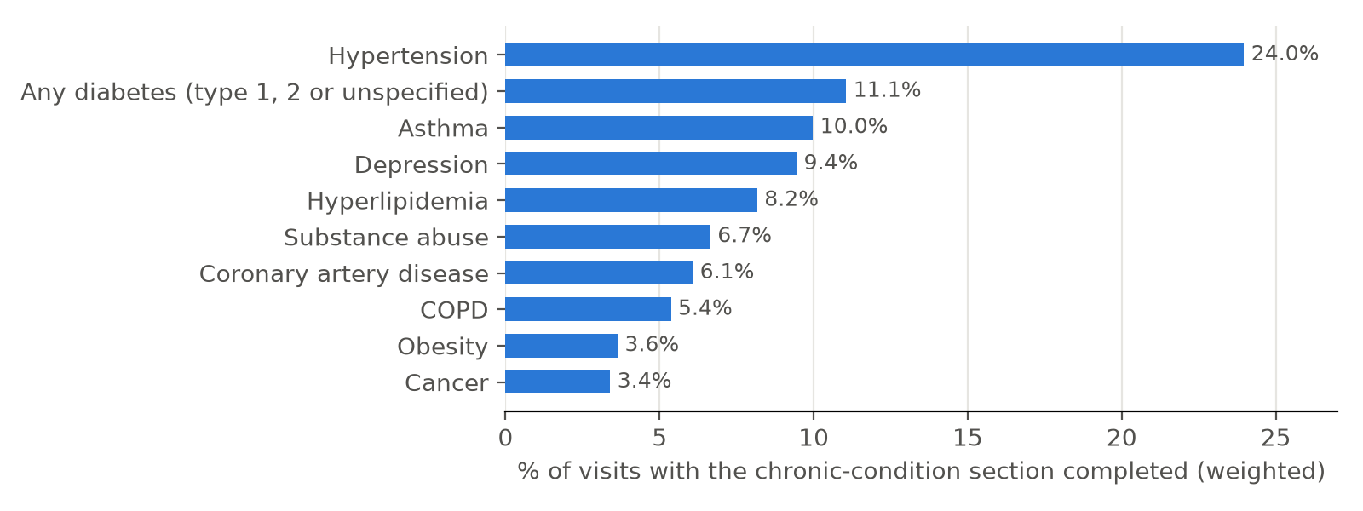
Figure 3. Hypertension and diabetes are the most commonly recorded chronic conditions: weighted % of visits with the chronic-condition section completed (98.4% of records). "Any diabetes" combines three checkboxes; type 2 alone is 4.7%.
Chronic conditions (Q6). Q6(a): among visits with the chronic-condition section completed (1.6% of records were blank), 47.6% record at least one chronic condition (weighted; 48.5% unweighted), and 14.9% record three or more. Q6(b): hypertension is the most prevalent (24.0%); of the other conditions named in the assignment, depression is 9.5%, type 2 diabetes 4.7% and obesity 3.6%. Diabetes is split across three checkboxes (type 1, type 2 and unspecified); counting any of them, 11.1% of visits record diabetes, making it second, ahead of asthma (10.0%). Obesity likely understates true prevalence because it depends on documentation. The share with a chronic condition rises from 13% of visits by children under 15 to 90% at 75 and older. These flags describe patients' conditions, not the reason for the visit, so they do not show whether visits were flare-ups or avoidable, only that ED clinicians routinely treat chronically ill patients.
Injuries (Q7). Q7(a): 33.1% of visits (weighted) are related to an injury (29.5%), an overdose or poisoning (1.4%) or an adverse effect of medical care (2.2%). Intent is recorded only for injuries and overdoses, and about a quarter of this combined group (25.7%, including every adverse-effect visit) has no intent recorded. Q7(b): among visits with known intent, 7.3% are intentional and 92.7% unintentional. Overdoses and poisonings are more often recorded as intentional (13.2%), and among visits with known intent the intentional share is highest at ages 15-24 (12.1%).
Diagnostic services (Q8). Q8(a): imaging is used at 47.0% of all visits (weighted): X-ray 33.7%, CT 16.5%, ultrasound 4.4% and MRI 0.7%. Use rises with age, from 29% of visits by children to 70% at 75 and older, and is higher for injury visits (54%) than other visits (44%). At least one blood test is ordered at 42.4% of visits. Q8(b): among those visits, a complete blood count is by far the most frequently ordered test (85.4%), followed by the comprehensive (55.3%) and basic (25.2%) metabolic panels, with 3.2 different tests per visit on average (the panels already include glucose and electrolytes).
Medications (Q9). Q9(a): the weighted mean is 2.49 medications per visit and the median is 2. Q9(b): 20.9% of visits involve none, 41.9% one or two and 37.2% three or more, matching NCHS (Table 1). On average 1.62 are given in the ED and 1.08 prescribed at discharge (a drug can be both, so these overlap). The count rises with complexity, from 2.0 with no recorded chronic condition to 3.8 with three or more, and peaks at 3.1 for ages 45-64, so medication reconciliation and interaction checking are routine ED work.

6. Correlations and outcomes (Q10)
We built about 20 cleaned variables (missing codes removed, wait and length of visit winsorized) and computed weighted Pearson correlations, each using the visits where both variables are present. Triage level runs from 1 (immediate) to 5 (nonurgent), so a negative correlation means more of something among more urgent patients. Q10: the strongest associations link age, chronic conditions and Medicare; testing intensity and chronic conditions are the strongest correlates of admission (r = 0.37 and 0.33); sex, ethnicity and pain score show little association with outcomes (Table 3). The correlations describe associations, not causal effects.
Table 3. Answer to Q10: selected weighted correlations
Pair | Weighted r | Interpretation
Age and Medicare as expected payer | 0.61 | Largely mechanical: Medicare eligibility at 65
Age and number of chronic conditions | 0.55 | Chronic conditions accumulate with age
Number of blood tests and admission | 0.37 | More extensive workups among admitted patients
Triage level and number of blood tests | -0.35 | More testing for more urgent patients
Number of chronic conditions and admission | 0.33 | Patients with more conditions admitted more often
Length of visit and number of blood tests | 0.31 | Longer visits involve more testing
Wait and length of visit | 0.28 | Longer waits accompany longer visits
Ambulance arrival and admission | 0.24 | Ambulance arrivals admitted more often
Sex, ethnicity or pain score and any outcome | about 0 | Little linear association

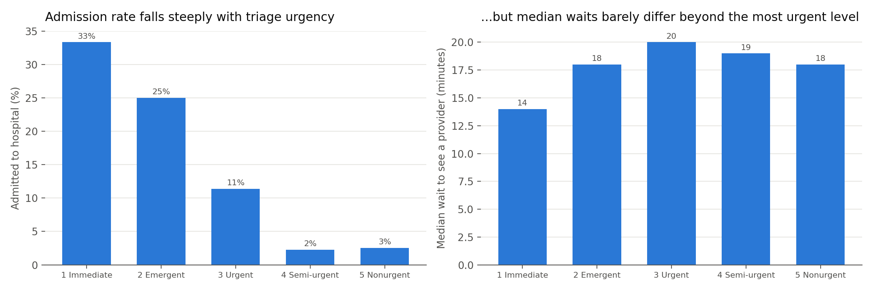
Figure 4. Weighted admission rate and median recorded wait by triage level (visits with triage levels 1-5; waits among visits with a recorded wait)
Admission falls from 33% at triage level 1 to 2-3% at levels 4-5 (9.0% overall), consistent with triage identifying sicker patients. Recorded median waits are 14 minutes at level 1 but 18-20 minutes at every other level. That comparison is descriptive: wait time is blank for 15.2% of sampled visits and not applicable (not seen by a provider) for another 3.4%, so 18.6% have no usable wait; missingness differs by triage status and region; and case mix and hospital differences are not controlled. Whether emergent (level 2) patients wait longer than intended is a question for hospital-level timestamp data rather than something these medians establish. Deaths are too rare to analyze by subgroup: the sample contains 28 ED deaths and 7 patients dead on arrival, below the 30-record threshold NCHS uses for reliable estimates (codebook pp.8-9). We therefore report only the overall weighted rates (0.10% and 0.04%) and treat them as unreliable. Among admitted patients with a known discharge status, 40 of 1,752 died in hospital (2.6% weighted); with no standard errors, we treat this as descriptive only.

7. Implications for hospital managers, and limitations
- Capacity and flow: plan for a 10am-8pm plateau and a Monday excess, treat time in the department (median 2.6 hours) as a planning variable, and check locally why emergent and nonurgent patients have the same recorded median wait.
- Finance: public programs are the expected payer for about half of all visits; the effect on margins depends on reimbursement and collections not captured here.
- Limitations: no design-based standard errors; wait-time missingness varies by triage status and region; rare outcomes fall below NCHS's reliability threshold; condition flags depend on documentation.
AI use. The course requires AI use. We used an AI coding assistant to write and debug the analysis code and to draft this report and the slides. We ran every step on the Yale HPC cluster, reviewed each output before continuing, and compared key estimates with figures published by NCHS, as described in Section 1.

