NORTHERN ILLINOIS UNIVERSITY

Do Dreams Reflect Our Culture? A Statistical Analysis on Dream Narratives

A Capstone Submitted to the

University Honors Program

In Partial Fulfillment of the

Requirements of the Baccalaureate Degree

With Honors

Department Of

Statistics & Actuarial Science

By

Michal Kuderski

DeKalb, Illinois

May 2026

Abstract

Dreams are often viewed as personal experiences, but they may also reflect cultural influences. This project investigates whether dream content varies across cultures by analyzing written dream reports from American, Japanese, and Peruvian college students using data from DreamBank.net. The study applies text analysis techniques to identify common themes and compares language patterns, including the use of ‘I’ and ‘We,’ to examine differences in self-focus. Statistical methods for count data are used to evaluate these patterns, along with resampling to address differences in sample size. Preliminary findings suggest that both dream themes and language use may vary by cultural background. These results highlight how data analysis can uncover broader patterns in human behavior and suggest that cultural influences may extend into how dreams are experienced and described.

Introduction

Most people think of their dreams as deeply personal, private experiences. However, I wanted to see if they might act as a mirror for the culture we live in. This project explores whether our societal background, specifically the difference between “Individualist” societies like the USA and “Collectivist” ones like Japan and Peru, shows up in our subconscious. By using data analysis to look at thousands of dream reports, I set out to identify “dream phenotypes,” or hidden patterns that might reveal where a dreamer is from just by looking at their descriptions.

Methodology

This study utilized a dataset of over 1,600 dream reports obtained from DreamBank.net, comparing American college students against cohorts from Japan and Peru.

- Text Processing: Reports were processed using R, a statistical software, where packages like rvest and tidytext were used to ensure data cleanliness.
- Privacy Protocols: In accordance with the ethical standard of “Contextual Integrity,” all personal identifiers were systematically removed prior to analysis.
- Topic Modeling: Latent Dirichlet Allocation (LDA) was used to objectively group recurring keywords into thematic categories.
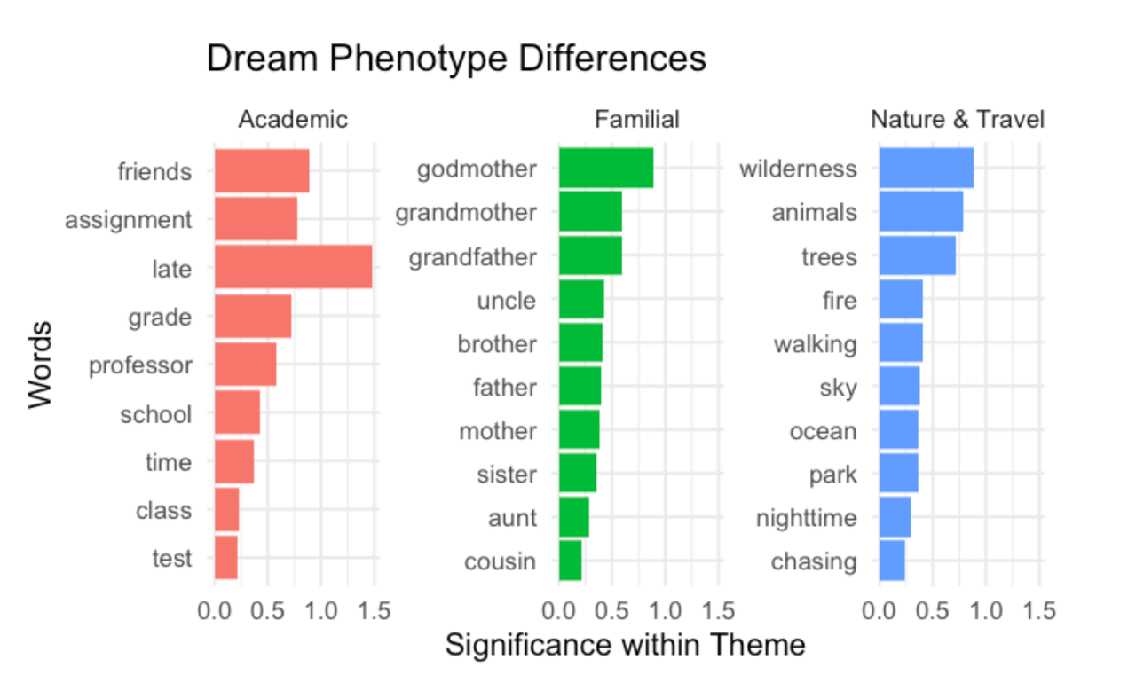

- Statistical Modeling: To evaluate differences in self-focus, the frequency of ‘I’ versus “We” pronouns was tracked.
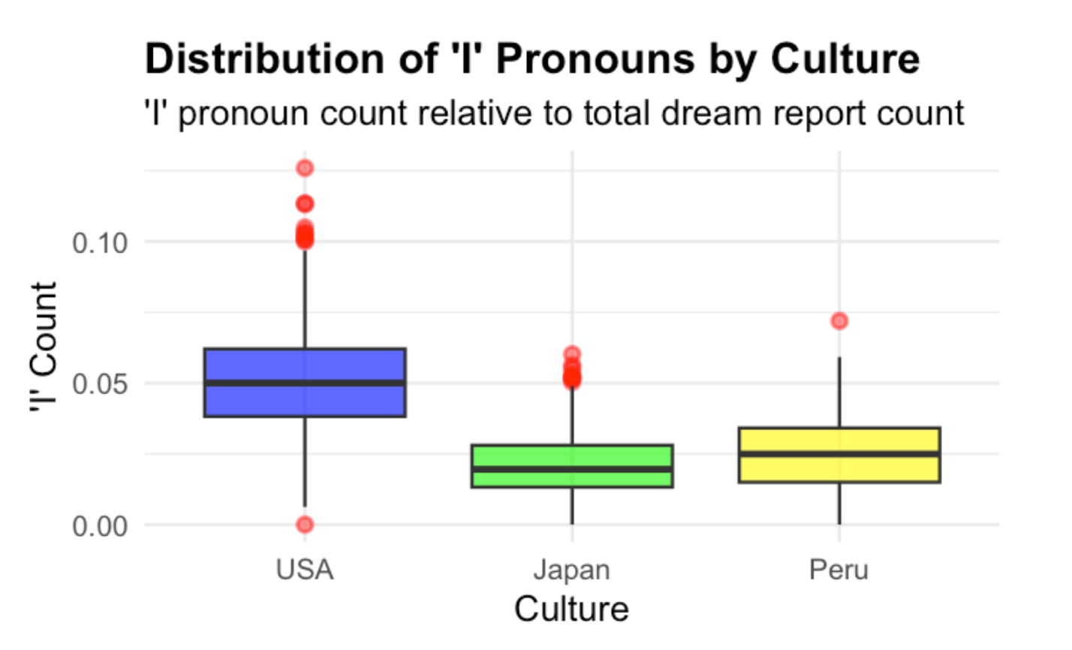
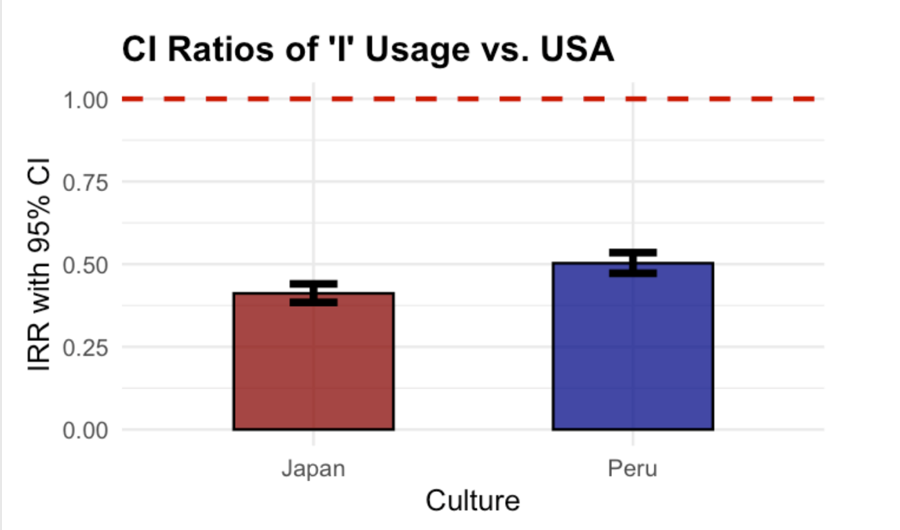
- Model Selection: A Poisson Regression model was applied to analyze count data and rates, addressing variations in dream report length that would invalidate standard t-tests.
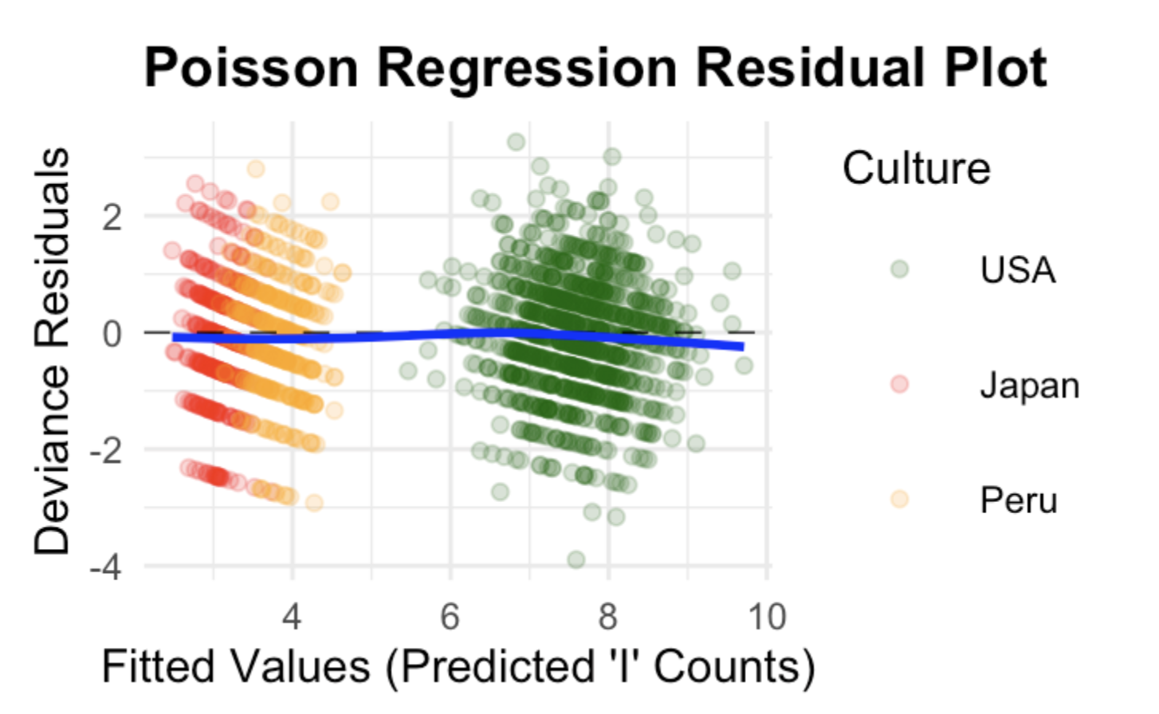

- Validation: To mitigate the impact of uneven sample sizes, a Permutation Test was used to verify the resulting p-values.

Results & Discussion

Statistical evaluation identified significant cultural variations in both thematic content and language patterns.

- Phenotype Distribution: The LDA algorithm isolated three primary dream phenotypes: Academic, Familial, and Nature & Travel.
- Pronoun Frequency: Analysis of ‘I’ pronoun distribution confirmed higher relative usage in the USA dataset compared to the Japanese and Peruvian samples.
- Model Fit: Diagnostic plots for the Poisson Regression model confirmed that the statistical framework accurately predicted counts based on fitted values.
- Linguistic Variance: Findings demonstrated significantly lower self-focus in Japanese and Peruvian dreams. This is evident in the Incident Rate Ratios (IRR), which show a marked reduction in ‘I’ usage relative to the American baseline.

Conclusion

Preliminary results suggest that cultural background significantly influences both the themes of dreams and the language used to describe them. The study indicates that the divide between Individualism and Collectivism is reflected in the subconscious. Furthermore, text mining and Natural Language Processing (NLP) proved effective in isolating regional linguistic patterns. Future research will explore the capacity of machine learning models to predict a dreamer's culture based on these identified phenotypes.

References
- DreamBank.net: Public repository of dream reports (dreams)
- Hall/Van de Castle Norms: Quantitative coding for dream content
- NIU’s Capstone and Poster Template Guidelines

