Advanced C# Project 2

# Michal Malujlo – ZHCL2Z3T1

# Book Club (2)

Notes

* The forgot password and edit profile submission do not work as the problem resides with the database being difficult when updating records. Please keep that in mind
* I did import bootstrap Styles for this project just to make it look better on the eyes.

Pages



Starting Page (Default.aspx)

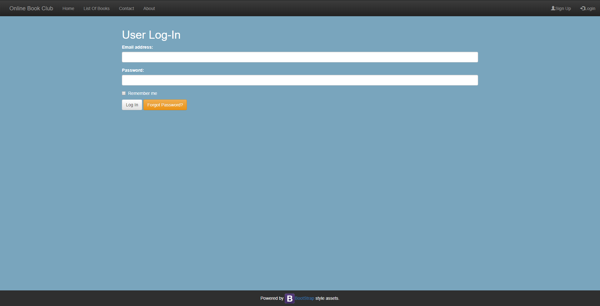

Log In Page

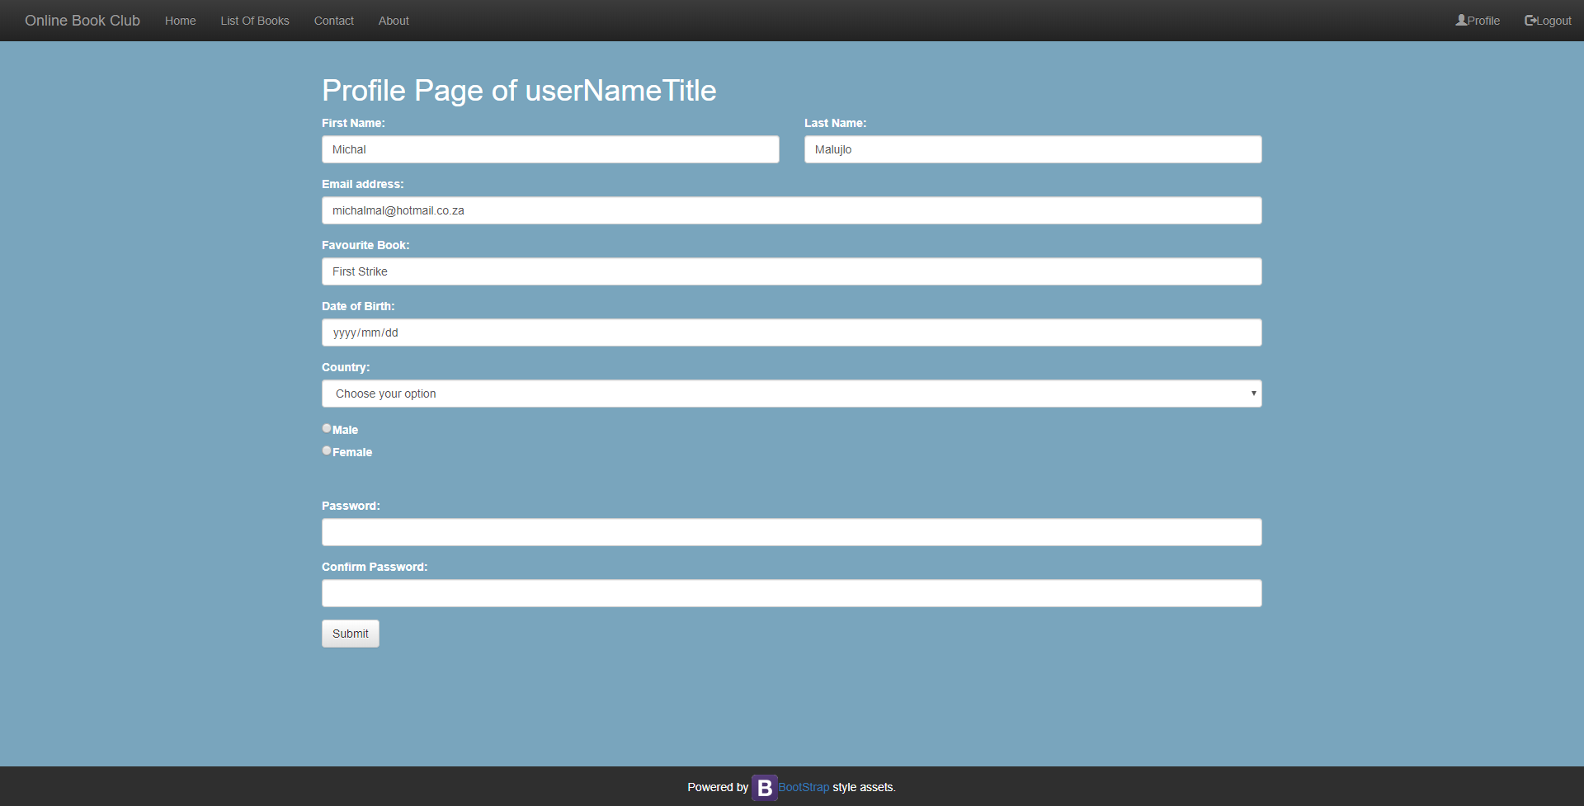

Profile Page to edit profile if you are logged in

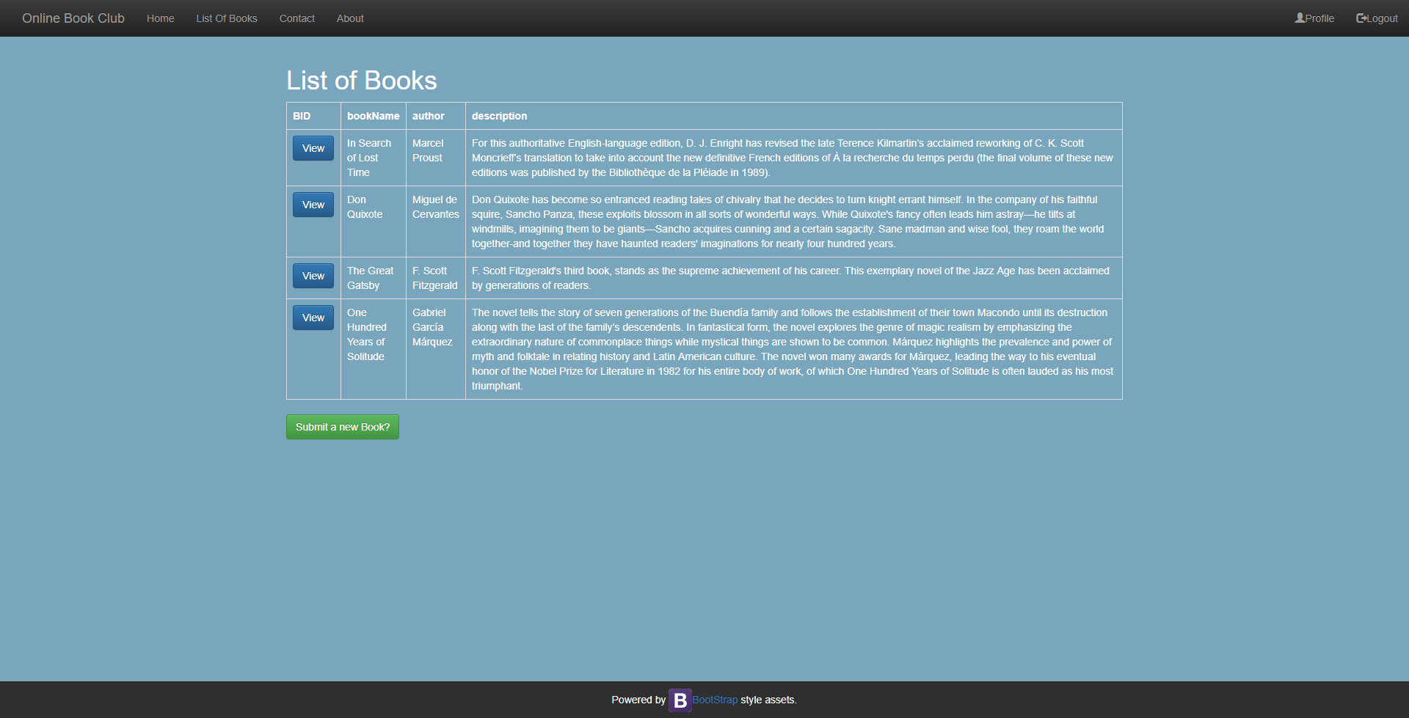

List of books Page

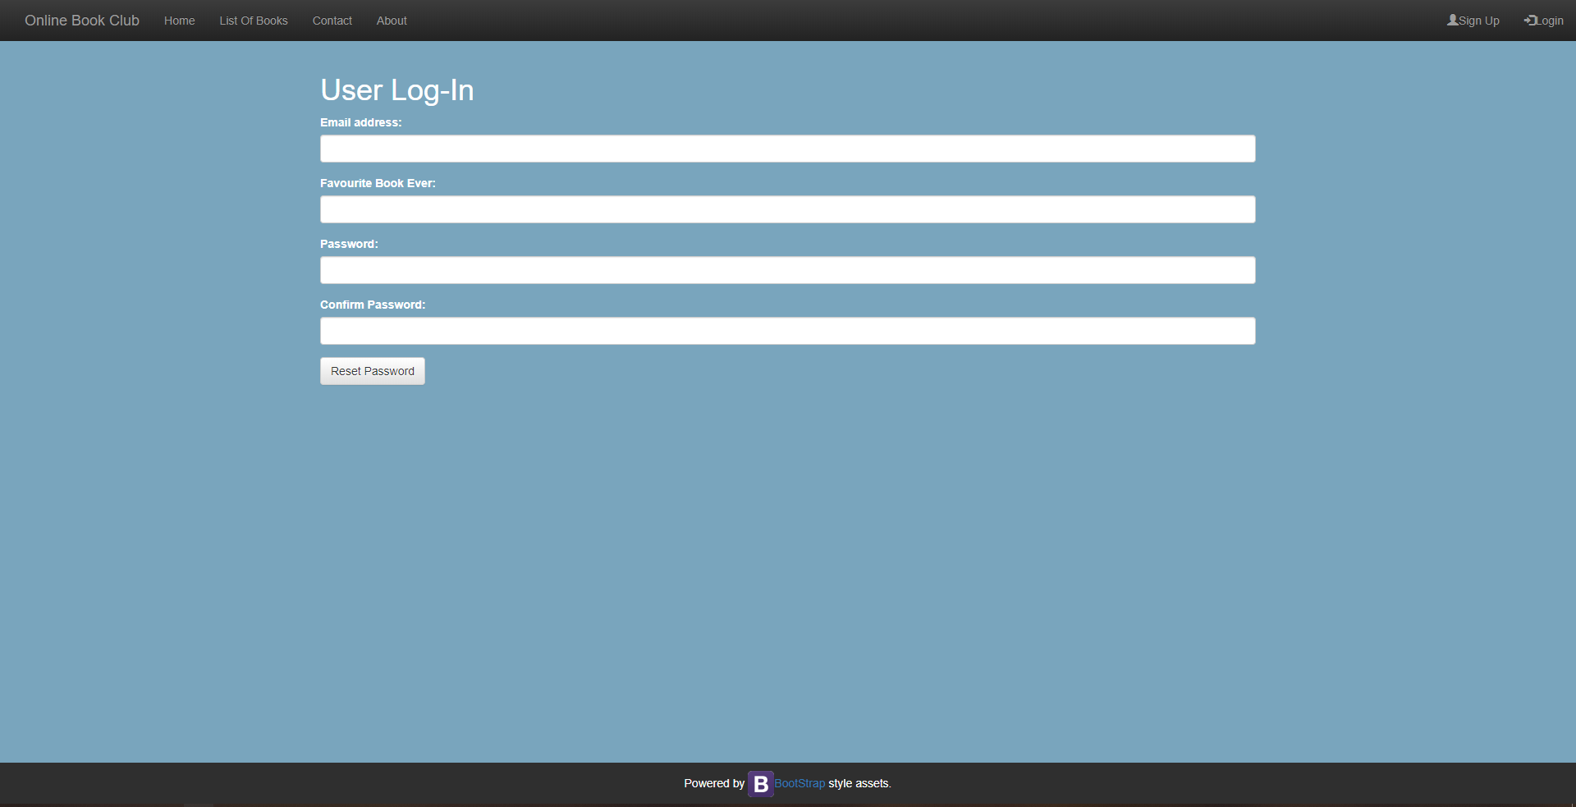

Forgot Password Page

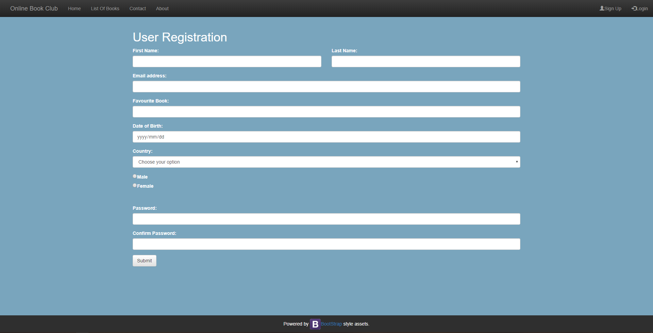

Register as New User Page

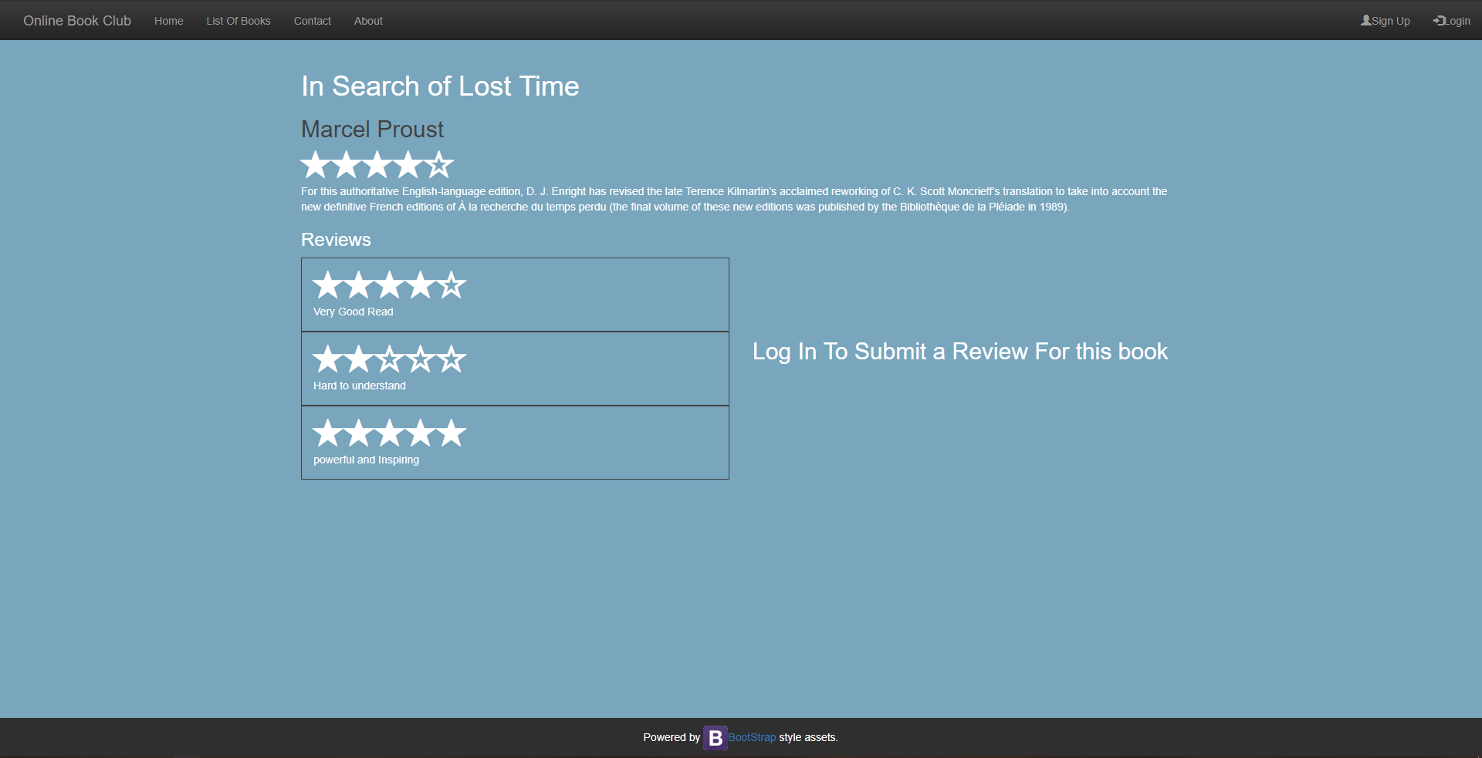

Book View if user is logged out

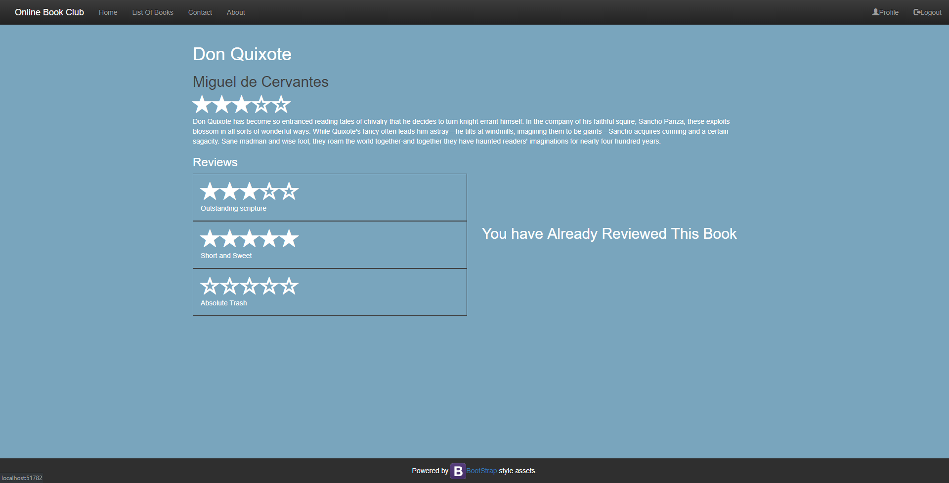

Book View If the user is logged in and has already Submitted a Review

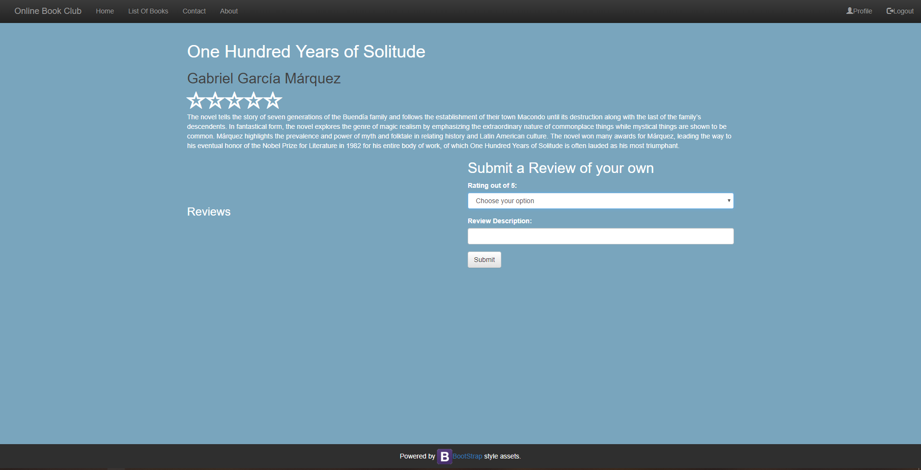

Book View if the user is logged in but has not submitted a review