The problem: Distance between two points
A geodesic curve describes a line in a curved surface, this is ideal for calculating the distance between cities knowing their coordinates. If we consider the earth as sphere and not as an ellipsoid we can apply the cosine law between the points:
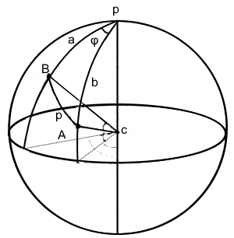

cos p = cos a cos b + sin a sin b cos φ

(One possible) solution: Given the coordinates in latitude and longitude of A and B we can calculate:
a = 90Â° – lat(B)
b = 90Â° – lat(A)
φ = lon(A) – lon(B)

Given the coordinates of two cities:
53.297975, -6.372663
41.385101, -81.440440
And knowing that the radius of the earth is R = 6371 km the approximate distance is 5536.338682266685 km.
The Task: Re-factor the provided solution to apply SOLID principles and design patterns, with a focus on Domain Driven Design.
Adding unit tests is a plus.
Note: to make use of Swagger UI run the solution and navigate to https://localhost:5001/swagger/index.html using the browser of your choice.

Technical environment
In order to run the solution you need to use Visual Studio 2017 or later (Community edition is free to download here https://visualstudio.microsoft.com/) – it uses .Net Core 2.1
If you get the following message while openning the solution, click OK.

Make sure you have Internet access before buiding the solution, so the Nuget packages can be downloaded.
Once the solution is successfully built, run it by hitting F5 or clicking the Run button as in the picture below


