**Watershed White Paper**

**Table of Content:**

1. Project description
2. Technical Details of Recommendation to Enter the Short-Term Rental Market
3. Analysis Summary
4. Analysis Assumptions and Sensitivity Analysis Ranges
5. Predictive Modeling Details
6. Final presentation for the stakeholders ([link](https://www.screencast.com/t/tzSuytoO))
7. Dashboard in Tableau ([link](https://public.tableau.com/profile/michal3816#!/vizhome/IncreasingRealEstateManagementProfitsHarnessingDataAnalytics/Dashboard1?publish=yes))
8. **Project description**

Project was made as a final project at Increasing “Real Estate Management Profits: Harnessing Data Analytics” course prepared by Duke University.

**The project’s goal**

The project’s goal is to create recommendations whether Watershed – properties managing company, should pursue moving into the short-term rental market or not, and if so, which properties should they convert and what would be the expected implications for cash flow and profits in the conversion year and the year following conversion.

**The project’s structure**

The project contains of three parts:

* **Part 1: Tableau Dashboard**

A dynamically-updated dashboard that allows stakeholders to test the robustness of your model through sensitivity analysis.

* **Part 2: White Paper**

Explained details of the analysis methods and results.

* **Part 3: Recorded Presentation**

Recorded presentation with recommendations to Watershed executives: should they pursue moving into the short-term rental market or not, and if so, which properties should they convert and what would be the expected implications for cash flow and profits in the conversion year and the year following conversion.

**Project’s assumptions**

* Analysis should be constrained to the 244 properties owned by the one client.
* The occupancy rate of those 244 properties is 97.3% (or 36/37 months) when they are managed as long-term rentals.
* The initial capital required to convert a long-term rental property to a short-term rental property is $30,000 (for furnishings, linens, etc.). That capital expenditure will depreciate over 5 years.
* $6000 in cash will be needed for each property each year after the first (conversion) year to cover items that wear out quickly. This amount is treated as an expense and is not depreciated.
* Utilities will be $300 a month for each property, or $3600 a year.
* The hospitality fee (variable cost) for each visit (for key service, cleaning, etc.) will be $100, regardless of the actual number of days of a visit.
* The average short-term stay is 3 nights.
* All the properties have the same capital expenditure and fixed costs.
* 10% of the rental fee should be budgeted for potential regulatory and legal fees.
* 20% of the rental fee should be budgeted for the online short-term rental provider (like Airbnb).
* The two fees above are also combined and called the "transaction fee" in some spreadsheets and questions. The total default transaction fee is 30%.
* All clients pay their rent on time.
* Impact of any point listed below should be ignored:
  + weekly or seasonal changes in rent or occupancy rate,
  + marketing strategies, like discounts or coupons,
  + pecial events during the year that might affect the rentals in one specific location,
  + loss in rent during the time interval when properties are being converted to short-term rental properties.
* Watershed is ready to invest maximum $500,000 in the project

1. **Technical Details of Recommendation to Enter the Short-Term Rental Market**

**I recommend that Watershed** enter the short term rental market. The company should do it in 4 stages with 16 properties. Each stage represents different state: stage 1 – 6 properties in Florida, stage 2 – 5 properties in Texas, stage 3 – 4 properties in California, stage 4 – 1 property in New York.

**The analysis that serves as the basis of my recommendation indicates that Watershed and its client would benefit from $890 000 of increased profits during the first year, and yearly profits of $790 000 every year thereafter if my recommendation is enacted. The initial capital investment needed to implement my recommendation would be $480 000.** This analysis is based on financial assumptions that were confirmed by company and industry experts, but sensitivity analyses indicate that Watershed should enter the short-term rental market with their client, even if these initial assumptions need to be revised. Below, I describe the analyses I used to arrive at my conclusion, and report the results of my sensitivity analysis that assesses how expected profits and needed capital expenditure would change if my assumptions are modified.

1. **Analysis Summary**

I modeled the relationship between nightly rental price and occupancy rate for short-term rental properties using data from current short-term rentals managed by other companies and owners. I used this model to predict the short-term rental price that would maximize profits from each of Watershed’s client’s properties if it were managed as a short-term rental property. The metrics I report are based on the sum of the forecasted profits that would be gained and the forecasted capital investment that would be needed if my recommendation is followed, after the following are taken into account: (1) initial furnishing costs, (2) upkeep costs, (3) internet service fees, (4) regulatory fees, (5) hospitality charges (including key service and cleaning), (6) typical duration of stay, and (7) utilities. The details of the assumptions I used are provided below (Table 1), followed by a description of the results of my sensitivity analysis.

1. **Analysis Assumptions and Sensitivity Analysis Ranges**

Table 1

|  |  |  |  |  |  |
| --- | --- | --- | --- | --- | --- |
| **Consideration** | **Assumed Value** | **Source of Original Assumed Value** | **Minimum Value Tested** | **Maximum Value Tested** | **Rationale for Range of Values Tested** |
| Additional profit needed for a property to be considered “more profitable as a short-term rental” | $6,000 | Watershed Financial Department | $3,000 | $41,000 | Minimum value – 50% below the assumed value; Maximum value – value defined by holding the constraint about cost of conversion below $500,000 |
| Cost to convert property to short-term rental (includes furnishing and decorating) | $30,000 | Watershed Marketing Department | $20,000 | $40,000 | Plus and minus 33% of recommended value (1 bedroom apartment vs. 2 bedroom house) |
| Years to depreciate capital expenditures | 5 | Watershed Financial Department | 3 | 7 | Plus and minus 2 years from recommended value |
| Yearly upkeep | $6,000 | Watershed Marketing Department | $5,000 | $7,000 | Plus and minus $1,000 from recommended value |
| Service fees to short-term stay website (e.g. Airbnb) | 20% | Watershed Marketing Department | 15% | 25% | Plus and minus 5% from recommended value |
| Regulatory fees (taxes and potential legal fees) | 10% | Watershed Financial Department | 5% | 15% | Plus and minus 5% from recommended value |
| Hospitality charges (key service, cleaning, re-stocking) | $100 | Watershed Financial Department | $80 | $120 | Plus and minus 20% of recommended value |
| Typical stay duration (days) | 3 | Watershed Marketing Department | 2 | 4 | Plus and minus one day from recommended value |
| Monthly utilities per property | $300 | Watershed Financial Department | $250 | $350 | Plus and minus $50 from recommended value |

As agreed upon at the beginning of the project, some issues were NOT incorporated into the analysis, but could be incorporated in the future to help optimize short-term rental rates or to further refine projected profits (Table 2):

Table 2

|  |  |
| --- | --- |
| **Factor not included in analysis** | **Reason for exclusion from analysis** |
| Weekly or seasonal changes in rental prices/occupancy rates | Instructions from Project Manager |
| Promotions, coupons, or special events | Instructions from Project Manager |
| Loss in rental income while property is converted | Instructions from Project Manager |
| Differences in utility rates across properties | Instructions from Watershed Financial Department |

I have created a dashboard that illustrates the effects of changing these assumptions on predicted profits and required capital investment that is available to anybody on the team by request. **The minimum additional profits Watershed could earn when the assumptions were modified within the ranges described above was $200,000**, if all the properties that are “more profitable” as a short-term rental are converted. **The maximum additional profits Watershed could earn when the assumptions were modified within the ranges described above was $3,020,000 (we didn’t include constraint about $500,000 limit for cost of conversion, with constraint included we would change profit cut-off to $41,000 and then maximum profit would be equal to $1,130,000)**, if all the properties that are “more profitable” as a short-term rental are converted. The modified set of parameters associated with this minimum and maximum value are provided below (Table 3). Overall, the parameter that affected profits most was Transaction fee.

Table 3

|  |  |  |
| --- | --- | --- |
| **Consideration** | **Value in Assumption Set that led to Minimum Profits** | **Value in Assumption Set that led to Maximum Profits** |
| Additional profit needed for a property to be considered “more profitable as a short-term rental” | $41,000 | $3,000 ($41,000 with conversion cost limit) |
| Cost to convert property to short-term rental (includes furnishing and decorating) | $40,000 | $20,000 |
| Years to depreciate capital expenditures | 3 | 7 |
| Yearly upkeep | $7,000 | $5,000 |
| Service fees to short-term stay website (e.g. Airbnb) | 25% | 15% |
| Regulatory fees (taxes and potential legal fees) | 15% | 5% |
| Hospitality charges (key service, cleaning, re-stocking) | $120 | $80 |
| Typical stay duration (days) | 2 | 4 |
| Monthly utilities | $350 | $250 |

1. **Predictive Modeling Details**

I was provided with four types of information about short-term rentals of the same type (number of bedrooms, apartment or house, kitchen availability, unshared property) and in the same location as Watershed’s client’s 244 properties: a typical short-term nightly rental rate, the corresponding occupancy rate for the property with that rental rate, the 10th percentile nightly rental rate, and the 90th percentile nightly rental rate. When the typical rental prices were expressed in terms of percentiles relative to properties of the same type and in the same location—but not when they were analyzed as raw dollar values—they correlated linearly with occupancy rates:

**Linear Regression Line:**

y = -0.79x + 0.85  
R² = 0.52

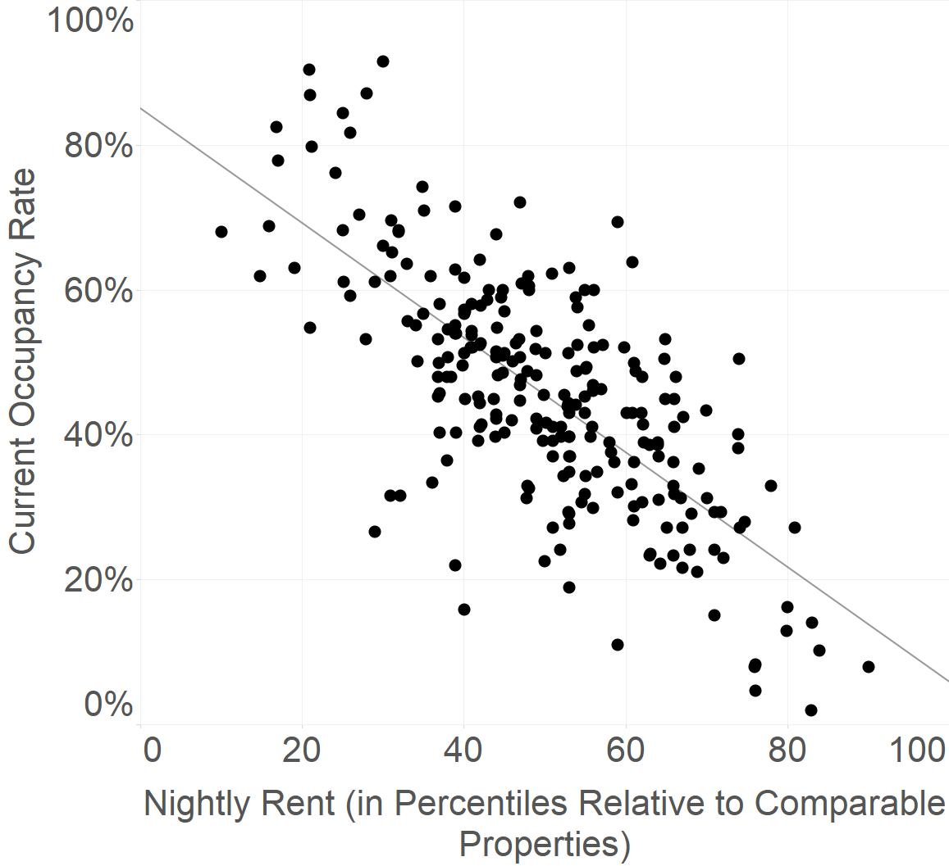

I used the parameters of the regression line and Excel’s Solver optimization function to find the rental price and occupancy rate that would maximize the profits expected from each of Watershed’s client’s 244 properties. Any optimized price below the 10th percentile rate was replaced with the 10th percentile rate, and any optimized price above the 90th percentile rate was replaced with the 90th percentile rate, in order to account for lack of data outside of these ranges in the linear model. These optimized rental rates were entered into a financial cash flow and profit model that computed the expected revenue from each property based on its projected occupancy rate, and the expected costs according to the financial assumptions described above.

1. **Final presentation for the stakeholders**

Please find the record of the final presentation for stakeholders under this link: [**https://www.screencast.com/t/tzSuytoO**](https://www.screencast.com/t/tzSuytoO) **.**

1. **Dashboard in Tableau**

Please find the interactive dashboard created in Tableau under this link:

[**https://public.tableau.com/profile/michal3816#!/vizhome/IncreasingRealEstateManagementProfitsHarnessingDataAnalytics/Dashboard1?publish=yes**](https://public.tableau.com/profile/michal3816#!/vizhome/IncreasingRealEstateManagementProfitsHarnessingDataAnalytics/Dashboard1?publish=yes) **.**