Project: Job Board

1. Project Concept and Problem Statement
The project is a job board web application designed to connect job seekers with employers in a simple, efficient, and accessible way. Many small and medium-sized businesses struggle to reach suitable candidates, while job seekers often face difficulty navigating multiple platforms, outdated listings, or unclear application processes. Existing solutions can be overly complex, expensive, or not tailored to specific communities or entry-level users.

2. User Personas
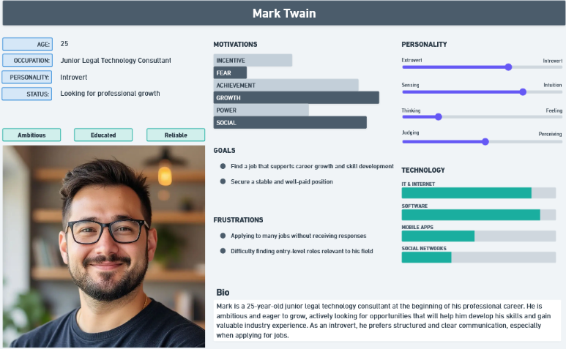
Persona 1: Job Seeker
- Goals: Find relevant job opportunities quickly and apply for them with minimal effort
- Needs: A clear and intuitive dashboard, the ability to search and filter job offers by location and category, and a system to track application status.
- Behaviours: Logs in regularly to check new job postings, searches for jobs in their area, uploads and updates their CV, and applies to multiple positions.
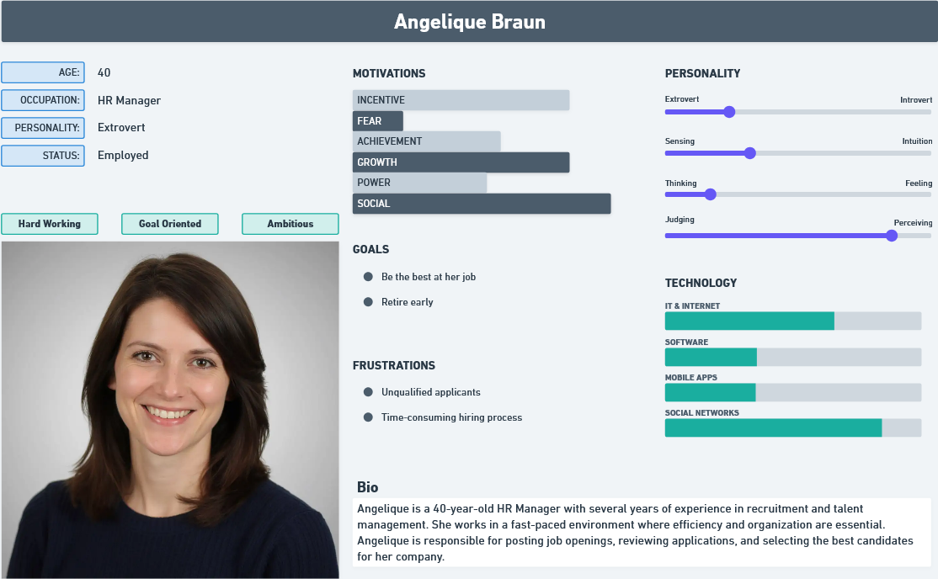
Persona 2: HR manager
- Goals: Find the most suitable candidates for open job positions efficiently.
- Needs: The ability to post job openings, track the number of applications, review candidate details (such as CVs), and easily contact shortlisted candidates.
- Behaviours: Visits the platform whenever there is a job opening, creates and publishes job listings, reviews incoming applications, evaluates candidate profiles, and contacts candidates who pass the initial screening process.

3. User Flows / Task Journeys
HR Manager Flow:
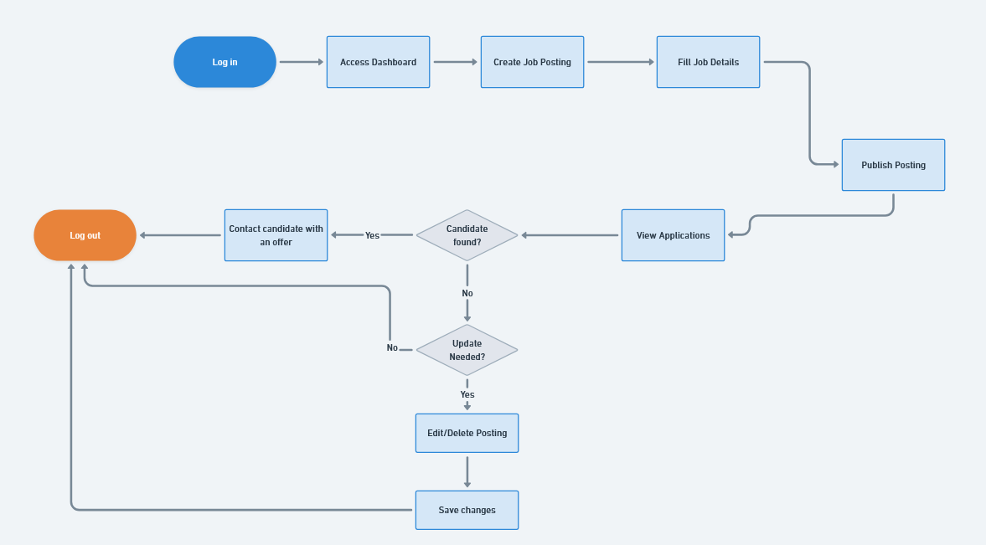
Log in → Access dashboard → Create a job Posting → Fill in job details → Publish posting → View applications → Edit or delete a posting → Log out.

Job seeker Flow:
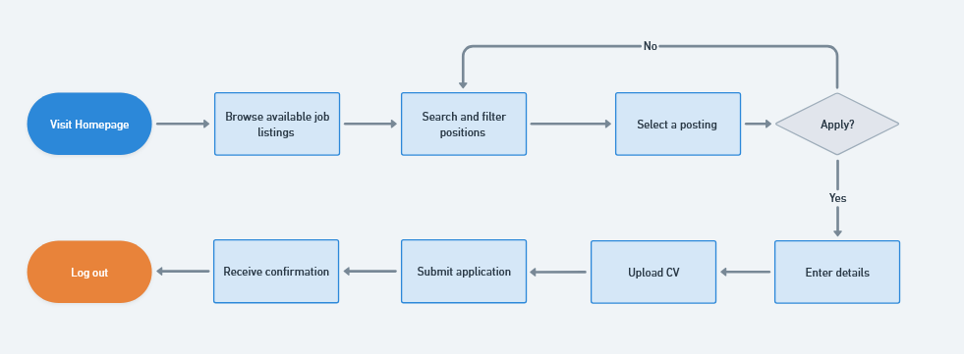

Visit homepage → Browse available job listings → Search and filter positions → Select a posting → Enter personal details → Upload CV → Apply → Receive confirmation.

4. Low-Fidelity Wireframes
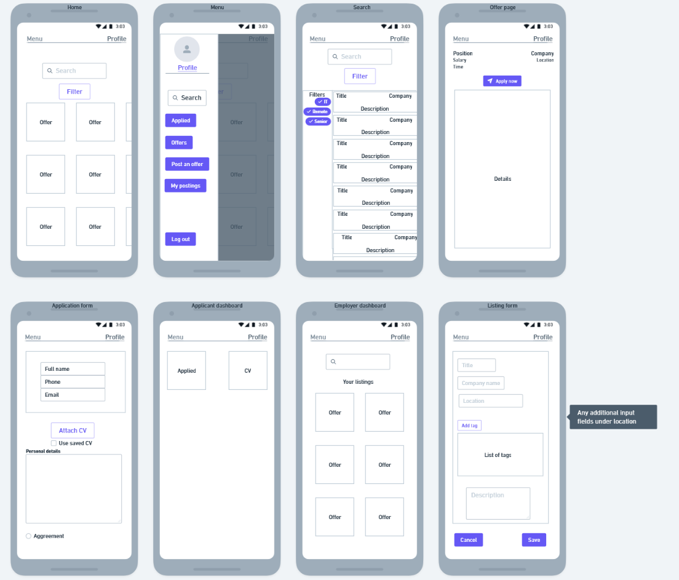
Low-fidelity wireframes were created to outline the basic layout and interactions for key pages, including the homepage, job listing page, employer dashboard, applicant dashboard, posting creation form and application form. Wireframes don’t represent styling, only page layout.

5. Project Scope
Included Features
- User authentication for HR managers and applicants
- CRUD functionality for job postings
- Public job postings and event detail pages
- Form validation and error handling
- Job search and filtering
- User dashboard
- Employer dashboard
- Basic notification system

Excluded Features
- Advanced analytics and reporting tools
- Multi-language support
- Real-time chat between employers and applicants

