Problem 1:

|  |  |  |  |  |  |  |  |  |
| --- | --- | --- | --- | --- | --- | --- | --- | --- |
|  | index | student | balance | income | default prediction LOG | default prediction LDA | default prediction QDA | default prediction KNN |
| 1 | 1 | Yes | 911.8313 | 16603.36 | No | No | No | No |
| 2 | 2 | No | 171.9919 | 30733.33 | No | No | No | No |
| 3 | 3 | Yes | 771.704 | 13711.96 | No | No | No | No |
| 4 | 4 | No | 754.6104 | 40701.96 | No | No | No | No |
| 5 | 5 | No | 618.7979 | 59501.38 | No | No | No | No |
| 6 | 6 | No | 510.0996 | 49837.1 | No | No | No | No |
| 7 | 7 | No | 886.262 | 52852.43 | No | No | No | No |
| 8 | 8 | No | 831.1603 | 39944.24 | No | No | No | No |
| 9 | 9 | Yes | 400.9718 | 15317.38 | No | No | No | No |
| 10 | 10 | No | 1092.282 | 45468.86 | No | No | No | No |
| 11 | 11 | No | 0.17976 | 41724.94 | No | No | No | No |
| 12 | 12 | Yes | 996.9293 | 20057.01 | No | No | No | No |
| 13 | 13 | No | 376.3587 | 25420.12 | No | No | No | No |
| 14 | 14 | No | 654.0181 | 54844.04 | No | No | No | No |
| 15 | 15 | No | 1109.101 | 45525.52 | No | No | No | No |
| 16 | 16 | No | 937.2591 | 56696.03 | No | No | No | No |
| 17 | 17 | Yes | 184.3792 | 14995.35 | No | No | No | No |
| 18 | 18 | No | 710.9218 | 53003.81 | No | No | No | No |
| 19 | 19 | No | 747.1609 | 19649.92 | No | No | No | No |
| 20 | 20 | No | 852.5277 | 58628.33 | No | No | No | No |
| 21 | 21 | No | 1567.919 | 36668.33 | No | No | No | No |
| 22 | 22 | Yes | 187.4985 | 16885.93 | No | No | No | No |
| 23 | 23 | Yes | 1490.886 | 17899.42 | No | No | No | No |
| 24 | 24 | Yes | 2204.542 | 14309.7 | Yes | Yes | Yes | Yes |
| 25 | 25 | Yes | 1777.708 | 20363.12 | No | No | No | No |
| 26 | 26 | No | 1877.122 | 48977.54 | Yes | No | No | No |
| 27 | 27 | Yes | 1902.551 | 20575.27 | No | No | No | No |
| 28 | 28 | Yes | 1571.806 | 14911.16 | No | No | No | No |
| 29 | 29 | No | 1968.999 | 39084.55 | Yes | Yes | Yes | No |
| 30 | 30 | No | 1526.13 | 30008.75 | No | No | No | No |
| 31 | 31 | No | 1641.559 | 46818.25 | No | No | No | No |
| 32 | 32 | No | 2004.546 | 42163.04 | Yes | Yes | Yes | No |
| 33 | 33 | No | 1550.449 | 56258.1 | No | No | No | No |
| 34 | 34 | No | 1327.839 | 34719.57 | No | No | No | No |
| 35 | 35 | No | 1700.298 | 30458.13 | No | No | No | No |
| 36 | 36 | Yes | 1118.11 | 21884.13 | No | No | No | No |
| 37 | 37 | No | 1132.525 | 37242.38 | No | No | No | No |
| 38 | 38 | No | 1980.73 | 28134.7 | Yes | Yes | No | No |
| 39 | 39 | No | 1708.702 | 38350.59 | No | No | No | No |
| 40 | 40 | No | 1457.012 | 58698.1 | No | No | No | No |
| 41 | 41 | No | 1767.16 | 46209.69 | No | No | No | No |
| 42 | 42 | Yes | 1759.108 | 15980.12 | No | No | No | No |

Problem 2:

**With stopwords words:**

$`FALSE`

Min. 1st Qu. Median Mean 3rd Qu. Max.

-483.50 -170.20 -146.40 -151.80 -128.20 99.56

$`TRUE`

Min. 1st Qu. Median Mean 3rd Qu. Max.

-98.08 -5.97 62.80 234.90 183.00 33230.00

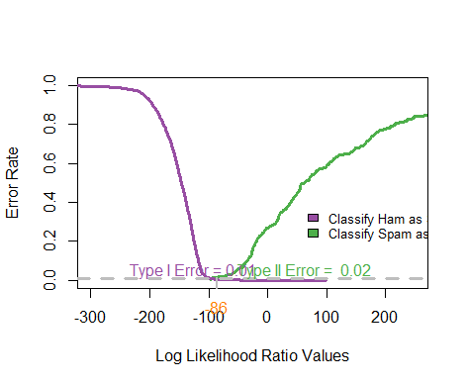

Threshold = -86

**Without stopwords words:**

$`FALSE`

Min. 1st Qu. Median Mean 3rd Qu. Max.

-351.10 -185.90 -165.00 -168.10 -149.60 94.87

$`TRUE`

Min. 1st Qu. Median Mean 3rd Qu. Max.

-135.80 -35.20 27.53 112.60 159.70 2503.00

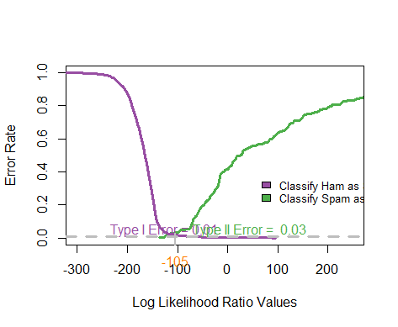

Threshold = -105