马的疝病分析报告

姓名：蔡鑫奇 学号：2620160006

# 一、数据摘要

#### 1. 标称属性

对于21个标称属性，每个可能取值的频数如下：

| 创建的输出 | | 12-4月-2017 22时50分23秒 |
| --- | --- | --- |
| 注释 | |  |
| 输入 | 数据 | G:\1研究生文件\第二学期学习\数据挖掘\课程作业（一）\Horse Colic database\Data Folder\horse-colic.sav |
| 活动的数据集 | 数据集1 |
| 过滤器 | <none> |
| 权重 | <none> |
| 拆分文件 | <none> |
| 工作数据文件中的 N 行 | 300 |
| 缺失值处理 | 对缺失的定义 | 用户定义的丢失值作为丢失对待。 |
| 使用的案例 | 统计量的计算将基于所有包含有效数据的案例。 |
| 语法 | | FREQUENCIES VARIABLES=V1 V2 V3 V7 V8 V9 V10 V11 V12 V13 V14 V15 V17 V18 V21 V23 V24 V25 V26 V27 V28  /ORDER=ANALYSIS. |
| 资源 | 处理器时间 | 00 00:00:00.047 |
| 已用时间 | 00 00:00:00.046 |

[数据集1] G:\1研究生文件\第二学期学习\数据挖掘\课程作业（一）\Horse Colic database\Data Folder\horse-colic.sav

**频率表**

| **1. surgery** | | 频率 | 百分比 | 有效百分比 | 累积百分比 |
| --- | --- | --- | --- | --- | --- |
| 有效 |  | 1 | .3 | .3 | .3 |
| Yes, it had surgery | 180 | 60.0 | 60.0 | 60.3 |
| It was treated without surgery | 119 | 39.7 | 39.7 | 100.0 |
| 合计 | 300 | 100.0 | 100.0 |  |

| **2. Age** | | 频率 | 百分比 | 有效百分比 | 累积百分比 |
| --- | --- | --- | --- | --- | --- |
| 有效 | Adult horse | 276 | 92.0 | 92.0 | 92.0 |
| Young | 24 | 8.0 | 8.0 | 100.0 |
| 合计 | 300 | 100.0 | 100.0 |  |

| **3. Hospital Number** | | 频率 | 百分比 | 有效百分比 | 累积百分比 |
| --- | --- | --- | --- | --- | --- |
| 有效 | 518476 | 1 | .3 | .3 | .3 |
| 521399 | 1 | .3 | .3 | .7 |
| 521681 | 1 | .3 | .3 | 1.0 |
| 522979 | 1 | .3 | .3 | 1.3 |
| 523190 | 1 | .3 | .3 | 1.7 |
| 526639 | 1 | .3 | .3 | 2.0 |
| 526802 | 1 | .3 | .3 | 2.3 |
| 527365 | 1 | .3 | .3 | 2.7 |
| 527463 | 1 | .3 | .3 | 3.0 |
| 527518 | 1 | .3 | .3 | 3.3 |
| 527524 | 1 | .3 | .3 | 3.7 |
| 527544 | 2 | .7 | .7 | 4.3 |
| 527563 | 1 | .3 | .3 | 4.7 |
| 527677 | 1 | .3 | .3 | 5.0 |
| 527698 | 1 | .3 | .3 | 5.3 |
| 527702 | 1 | .3 | .3 | 5.7 |
| 527706 | 1 | .3 | .3 | 6.0 |
| 527709 | 1 | .3 | .3 | 6.3 |
| 527734 | 1 | .3 | .3 | 6.7 |
| 527758 | 1 | .3 | .3 | 7.0 |
| 527829 | 1 | .3 | .3 | 7.3 |
| 527883 | 1 | .3 | .3 | 7.7 |
| 527916 | 2 | .7 | .7 | 8.3 |
| 527927 | 1 | .3 | .3 | 8.7 |
| 527929 | 1 | .3 | .3 | 9.0 |
| 527933 | 1 | .3 | .3 | 9.3 |
| 527940 | 1 | .3 | .3 | 9.7 |
| 527957 | 1 | .3 | .3 | 10.0 |
| 528006 | 1 | .3 | .3 | 10.3 |
| 528019 | 1 | .3 | .3 | 10.7 |
| 528031 | 1 | .3 | .3 | 11.0 |
| 528047 | 1 | .3 | .3 | 11.3 |
| 528134 | 1 | .3 | .3 | 11.7 |
| 528151 | 2 | .7 | .7 | 12.3 |
| 528169 | 1 | .3 | .3 | 12.7 |
| 528178 | 1 | .3 | .3 | 13.0 |
| 528179 | 1 | .3 | .3 | 13.3 |
| 528183 | 1 | .3 | .3 | 13.7 |
| 528214 | 1 | .3 | .3 | 14.0 |
| 528247 | 1 | .3 | .3 | 14.3 |
| 528248 | 1 | .3 | .3 | 14.7 |
| 528298 | 1 | .3 | .3 | 15.0 |
| 528299 | 1 | .3 | .3 | 15.3 |
| 528305 | 1 | .3 | .3 | 15.7 |
| 528355 | 1 | .3 | .3 | 16.0 |
| 528461 | 1 | .3 | .3 | 16.3 |
| 528469 | 2 | .7 | .7 | 17.0 |
| 528503 | 1 | .3 | .3 | 17.3 |
| 528523 | 1 | .3 | .3 | 17.7 |
| 528548 | 1 | .3 | .3 | 18.0 |
| 528570 | 1 | .3 | .3 | 18.3 |
| 528590 | 1 | .3 | .3 | 18.7 |
| 528620 | 1 | .3 | .3 | 19.0 |
| 528630 | 1 | .3 | .3 | 19.3 |
| 528638 | 1 | .3 | .3 | 19.7 |
| 528641 | 1 | .3 | .3 | 20.0 |
| 528653 | 1 | .3 | .3 | 20.3 |
| 528668 | 1 | .3 | .3 | 20.7 |
| 528682 | 1 | .3 | .3 | 21.0 |
| 528702 | 1 | .3 | .3 | 21.3 |
| 528729 | 2 | .7 | .7 | 22.0 |
| 528742 | 1 | .3 | .3 | 22.3 |
| 528743 | 1 | .3 | .3 | 22.7 |
| 528800 | 1 | .3 | .3 | 23.0 |
| 528804 | 1 | .3 | .3 | 23.3 |
| 528812 | 1 | .3 | .3 | 23.7 |
| 528872 | 1 | .3 | .3 | 24.0 |
| 528890 | 2 | .7 | .7 | 24.7 |
| 528904 | 2 | .7 | .7 | 25.3 |
| 528931 | 2 | .7 | .7 | 26.0 |
| 528964 | 1 | .3 | .3 | 26.3 |
| 528977 | 1 | .3 | .3 | 26.7 |
| 528996 | 2 | .7 | .7 | 27.3 |
| 529045 | 1 | .3 | .3 | 27.7 |
| 529126 | 1 | .3 | .3 | 28.0 |
| 529135 | 1 | .3 | .3 | 28.3 |
| 529160 | 1 | .3 | .3 | 28.7 |
| 529172 | 1 | .3 | .3 | 29.0 |
| 529183 | 1 | .3 | .3 | 29.3 |
| 529272 | 1 | .3 | .3 | 29.7 |
| 529296 | 1 | .3 | .3 | 30.0 |
| 529304 | 1 | .3 | .3 | 30.3 |
| 529340 | 1 | .3 | .3 | 30.7 |
| 529373 | 1 | .3 | .3 | 31.0 |
| 529386 | 1 | .3 | .3 | 31.3 |
| 529388 | 1 | .3 | .3 | 31.7 |
| 529399 | 1 | .3 | .3 | 32.0 |
| 529424 | 2 | .7 | .7 | 32.7 |
| 529427 | 1 | .3 | .3 | 33.0 |
| 529428 | 1 | .3 | .3 | 33.3 |
| 529461 | 2 | .7 | .7 | 34.0 |
| 529475 | 1 | .3 | .3 | 34.3 |
| 529483 | 1 | .3 | .3 | 34.7 |
| 529493 | 1 | .3 | .3 | 35.0 |
| 529498 | 1 | .3 | .3 | 35.3 |
| 529518 | 1 | .3 | .3 | 35.7 |
| 529528 | 1 | .3 | .3 | 36.0 |
| 529607 | 1 | .3 | .3 | 36.3 |
| 529628 | 1 | .3 | .3 | 36.7 |
| 529640 | 1 | .3 | .3 | 37.0 |
| 529642 | 1 | .3 | .3 | 37.3 |
| 529663 | 1 | .3 | .3 | 37.7 |
| 529667 | 1 | .3 | .3 | 38.0 |
| 529685 | 1 | .3 | .3 | 38.3 |
| 529703 | 1 | .3 | .3 | 38.7 |
| 529729 | 1 | .3 | .3 | 39.0 |
| 529736 | 1 | .3 | .3 | 39.3 |
| 529764 | 1 | .3 | .3 | 39.7 |
| 529766 | 1 | .3 | .3 | 40.0 |
| 529777 | 1 | .3 | .3 | 40.3 |
| 529796 | 2 | .7 | .7 | 41.0 |
| 529812 | 1 | .3 | .3 | 41.3 |
| 529821 | 1 | .3 | .3 | 41.7 |
| 529827 | 1 | .3 | .3 | 42.0 |
| 529840 | 1 | .3 | .3 | 42.3 |
| 529849 | 1 | .3 | .3 | 42.7 |
| 529865 | 1 | .3 | .3 | 43.0 |
| 529888 | 1 | .3 | .3 | 43.3 |
| 529893 | 1 | .3 | .3 | 43.7 |
| 529960 | 1 | .3 | .3 | 44.0 |
| 530001 | 1 | .3 | .3 | 44.3 |
| 530002 | 1 | .3 | .3 | 44.7 |
| 530028 | 1 | .3 | .3 | 45.0 |
| 530034 | 1 | .3 | .3 | 45.3 |
| 530051 | 1 | .3 | .3 | 45.7 |
| 530101 | 1 | .3 | .3 | 46.0 |
| 530157 | 1 | .3 | .3 | 46.3 |
| 530170 | 1 | .3 | .3 | 46.7 |
| 530233 | 1 | .3 | .3 | 47.0 |
| 530239 | 1 | .3 | .3 | 47.3 |
| 530242 | 1 | .3 | .3 | 47.7 |
| 530251 | 1 | .3 | .3 | 48.0 |
| 530254 | 1 | .3 | .3 | 48.3 |
| 530255 | 1 | .3 | .3 | 48.7 |
| 530276 | 1 | .3 | .3 | 49.0 |
| 530294 | 1 | .3 | .3 | 49.3 |
| 530297 | 1 | .3 | .3 | 49.7 |
| 530301 | 1 | .3 | .3 | 50.0 |
| 530310 | 1 | .3 | .3 | 50.3 |
| 530319 | 1 | .3 | .3 | 50.7 |
| 530334 | 1 | .3 | .3 | 51.0 |
| 530354 | 1 | .3 | .3 | 51.3 |
| 530360 | 1 | .3 | .3 | 51.7 |
| 530366 | 1 | .3 | .3 | 52.0 |
| 530381 | 1 | .3 | .3 | 52.3 |
| 530384 | 1 | .3 | .3 | 52.7 |
| 530401 | 1 | .3 | .3 | 53.0 |
| 530402 | 1 | .3 | .3 | 53.3 |
| 530431 | 1 | .3 | .3 | 53.7 |
| 530438 | 1 | .3 | .3 | 54.0 |
| 530439 | 1 | .3 | .3 | 54.3 |
| 530478 | 1 | .3 | .3 | 54.7 |
| 530526 | 2 | .7 | .7 | 55.3 |
| 530544 | 1 | .3 | .3 | 55.7 |
| 530561 | 1 | .3 | .3 | 56.0 |
| 530612 | 1 | .3 | .3 | 56.3 |
| 530624 | 1 | .3 | .3 | 56.7 |
| 530670 | 1 | .3 | .3 | 57.0 |
| 530693 | 2 | .7 | .7 | 57.7 |
| 532110 | 1 | .3 | .3 | 58.0 |
| 532349 | 2 | .7 | .7 | 58.7 |
| 532985 | 1 | .3 | .3 | 59.0 |
| 533692 | 1 | .3 | .3 | 59.3 |
| 533696 | 1 | .3 | .3 | 59.7 |
| 533697 | 1 | .3 | .3 | 60.0 |
| 533723 | 1 | .3 | .3 | 60.3 |
| 533736 | 1 | .3 | .3 | 60.7 |
| 533738 | 1 | .3 | .3 | 61.0 |
| 533750 | 1 | .3 | .3 | 61.3 |
| 533793 | 1 | .3 | .3 | 61.7 |
| 533836 | 1 | .3 | .3 | 62.0 |
| 533847 | 1 | .3 | .3 | 62.3 |
| 533871 | 1 | .3 | .3 | 62.7 |
| 533885 | 1 | .3 | .3 | 63.0 |
| 533886 | 1 | .3 | .3 | 63.3 |
| 533887 | 1 | .3 | .3 | 63.7 |
| 533902 | 1 | .3 | .3 | 64.0 |
| 533928 | 1 | .3 | .3 | 64.3 |
| 533942 | 1 | .3 | .3 | 64.7 |
| 533968 | 1 | .3 | .3 | 65.0 |
| 533983 | 1 | .3 | .3 | 65.3 |
| 534004 | 1 | .3 | .3 | 65.7 |
| 534053 | 1 | .3 | .3 | 66.0 |
| 534069 | 1 | .3 | .3 | 66.3 |
| 534073 | 1 | .3 | .3 | 66.7 |
| 534092 | 1 | .3 | .3 | 67.0 |
| 534115 | 1 | .3 | .3 | 67.3 |
| 534135 | 1 | .3 | .3 | 67.7 |
| 534145 | 1 | .3 | .3 | 68.0 |
| 534157 | 1 | .3 | .3 | 68.3 |
| 534163 | 1 | .3 | .3 | 68.7 |
| 534183 | 1 | .3 | .3 | 69.0 |
| 534197 | 1 | .3 | .3 | 69.3 |
| 534280 | 1 | .3 | .3 | 69.7 |
| 534293 | 1 | .3 | .3 | 70.0 |
| 534324 | 1 | .3 | .3 | 70.3 |
| 534403 | 1 | .3 | .3 | 70.7 |
| 534478 | 1 | .3 | .3 | 71.0 |
| 534491 | 1 | .3 | .3 | 71.3 |
| 534519 | 1 | .3 | .3 | 71.7 |
| 534556 | 1 | .3 | .3 | 72.0 |
| 534572 | 1 | .3 | .3 | 72.3 |
| 534579 | 1 | .3 | .3 | 72.7 |
| 534597 | 1 | .3 | .3 | 73.0 |
| 534615 | 1 | .3 | .3 | 73.3 |
| 534618 | 1 | .3 | .3 | 73.7 |
| 534624 | 1 | .3 | .3 | 74.0 |
| 534626 | 1 | .3 | .3 | 74.3 |
| 534644 | 1 | .3 | .3 | 74.7 |
| 534719 | 1 | .3 | .3 | 75.0 |
| 534753 | 1 | .3 | .3 | 75.3 |
| 534756 | 1 | .3 | .3 | 75.7 |
| 534784 | 1 | .3 | .3 | 76.0 |
| 534787 | 1 | .3 | .3 | 76.3 |
| 534788 | 1 | .3 | .3 | 76.7 |
| 534817 | 1 | .3 | .3 | 77.0 |
| 534833 | 1 | .3 | .3 | 77.3 |
| 534857 | 1 | .3 | .3 | 77.7 |
| 534885 | 1 | .3 | .3 | 78.0 |
| 534899 | 1 | .3 | .3 | 78.3 |
| 534917 | 1 | .3 | .3 | 78.7 |
| 534925 | 1 | .3 | .3 | 79.0 |
| 534933 | 1 | .3 | .3 | 79.3 |
| 534938 | 1 | .3 | .3 | 79.7 |
| 534963 | 1 | .3 | .3 | 80.0 |
| 534998 | 1 | .3 | .3 | 80.3 |
| 535029 | 1 | .3 | .3 | 80.7 |
| 535031 | 1 | .3 | .3 | 81.0 |
| 535043 | 1 | .3 | .3 | 81.3 |
| 535054 | 1 | .3 | .3 | 81.7 |
| 535085 | 1 | .3 | .3 | 82.0 |
| 535130 | 1 | .3 | .3 | 82.3 |
| 535137 | 1 | .3 | .3 | 82.7 |
| 535158 | 1 | .3 | .3 | 83.0 |
| 535163 | 1 | .3 | .3 | 83.3 |
| 535166 | 1 | .3 | .3 | 83.7 |
| 535176 | 1 | .3 | .3 | 84.0 |
| 535196 | 1 | .3 | .3 | 84.3 |
| 535208 | 1 | .3 | .3 | 84.7 |
| 535240 | 1 | .3 | .3 | 85.0 |
| 535246 | 1 | .3 | .3 | 85.3 |
| 535292 | 1 | .3 | .3 | 85.7 |
| 535314 | 1 | .3 | .3 | 86.0 |
| 535330 | 1 | .3 | .3 | 86.3 |
| 535338 | 1 | .3 | .3 | 86.7 |
| 535364 | 1 | .3 | .3 | 87.0 |
| 535381 | 1 | .3 | .3 | 87.3 |
| 535392 | 1 | .3 | .3 | 87.7 |
| 535407 | 1 | .3 | .3 | 88.0 |
| 535415 | 1 | .3 | .3 | 88.3 |
| 5262541 | 1 | .3 | .3 | 88.7 |
| 5262543 | 1 | .3 | .3 | 89.0 |
| 5275212 | 1 | .3 | .3 | 89.3 |
| 5277409 | 1 | .3 | .3 | 89.7 |
| 5278331 | 1 | .3 | .3 | 90.0 |
| 5279441 | 1 | .3 | .3 | 90.3 |
| 5279442 | 1 | .3 | .3 | 90.7 |
| 5279822 | 2 | .7 | .7 | 91.3 |
| 5281091 | 1 | .3 | .3 | 91.7 |
| 5282839 | 1 | .3 | .3 | 92.0 |
| 5283431 | 1 | .3 | .3 | 92.3 |
| 5287179 | 1 | .3 | .3 | 92.7 |
| 5287279 | 1 | .3 | .3 | 93.0 |
| 5288249 | 1 | .3 | .3 | 93.3 |
| 5289419 | 1 | .3 | .3 | 93.7 |
| 5290409 | 1 | .3 | .3 | 94.0 |
| 5290481 | 1 | .3 | .3 | 94.3 |
| 5290482 | 1 | .3 | .3 | 94.7 |
| 5290759 | 1 | .3 | .3 | 95.0 |
| 5291329 | 1 | .3 | .3 | 95.3 |
| 5291409 | 1 | .3 | .3 | 95.7 |
| 5291719 | 1 | .3 | .3 | 96.0 |
| 5292489 | 1 | .3 | .3 | 96.3 |
| 5292929 | 1 | .3 | .3 | 96.7 |
| 5294369 | 1 | .3 | .3 | 97.0 |
| 5294539 | 1 | .3 | .3 | 97.3 |
| 5297159 | 1 | .3 | .3 | 97.7 |
| 5297379 | 1 | .3 | .3 | 98.0 |
| 5299253 | 1 | .3 | .3 | 98.3 |
| 5299603 | 1 | .3 | .3 | 98.7 |
| 5299629 | 1 | .3 | .3 | 99.0 |
| 5301219 | 1 | .3 | .3 | 99.3 |
| 5305129 | 1 | .3 | .3 | 99.7 |
| 5305629 | 1 | .3 | .3 | 100.0 |
| 合计 | 300 | 100.0 | 100.0 |  |

| **7. temperature of extremities** | | 频率 | 百分比 | 有效百分比 | 累积百分比 |
| --- | --- | --- | --- | --- | --- |
| 有效 |  | 56 | 18.7 | 18.7 | 18.7 |
| Normal | 78 | 26.0 | 26.0 | 44.7 |
| Warm | 30 | 10.0 | 10.0 | 54.7 |
| Cool | 109 | 36.3 | 36.3 | 91.0 |
| Cold | 27 | 9.0 | 9.0 | 100.0 |
| 合计 | 300 | 100.0 | 100.0 |  |

| **8. peripheral pulse** | | 频率 | 百分比 | 有效百分比 | 累积百分比 |
| --- | --- | --- | --- | --- | --- |
| 有效 |  | 69 | 23.0 | 23.0 | 23.0 |
| normal | 115 | 38.3 | 38.3 | 61.3 |
| increased | 5 | 1.7 | 1.7 | 63.0 |
| reduced | 103 | 34.3 | 34.3 | 97.3 |
| absent | 8 | 2.7 | 2.7 | 100.0 |
| 合计 | 300 | 100.0 | 100.0 |  |

| **9. mucous membranes** | | 频率 | 百分比 | 有效百分比 | 累积百分比 |
| --- | --- | --- | --- | --- | --- |
| 有效 |  | 47 | 15.7 | 15.7 | 15.7 |
| normal pink | 79 | 26.3 | 26.3 | 42.0 |
| bright pink | 30 | 10.0 | 10.0 | 52.0 |
| pale pink | 58 | 19.3 | 19.3 | 71.3 |
| pale cyanotic | 41 | 13.7 | 13.7 | 85.0 |
| bright red / injected | 25 | 8.3 | 8.3 | 93.3 |
| dark cyanotic | 20 | 6.7 | 6.7 | 100.0 |
| 合计 | 300 | 100.0 | 100.0 |  |

| **10. capillary refill time** | | 频率 | 百分比 | 有效百分比 | 累积百分比 |
| --- | --- | --- | --- | --- | --- |
| 有效 |  | 32 | 10.7 | 10.7 | 10.7 |
| < 3 seconds | 188 | 62.7 | 62.7 | 73.3 |
| >= 3 seconds | 78 | 26.0 | 26.0 | 99.3 |
| 3 | 2 | .7 | .7 | 100.0 |
| 合计 | 300 | 100.0 | 100.0 |  |

| **11.pain** | | 频率 | 百分比 | 有效百分比 | 累积百分比 |
| --- | --- | --- | --- | --- | --- |
| 有效 |  | 55 | 18.3 | 18.3 | 18.3 |
| alert, no pain | 38 | 12.7 | 12.7 | 31.0 |
| depressed | 59 | 19.7 | 19.7 | 50.7 |
| intermittent mild pain | 67 | 22.3 | 22.3 | 73.0 |
| intermittent severe pain | 39 | 13.0 | 13.0 | 86.0 |
| continuous severe pain | 42 | 14.0 | 14.0 | 100.0 |
| 合计 | 300 | 100.0 | 100.0 |  |

| **12.peristalsis** | | 频率 | 百分比 | 有效百分比 | 累积百分比 |
| --- | --- | --- | --- | --- | --- |
| 有效 |  | 44 | 14.7 | 14.7 | 14.7 |
| hypermotile | 39 | 13.0 | 13.0 | 27.7 |
| normal | 16 | 5.3 | 5.3 | 33.0 |
| hypomotile | 128 | 42.7 | 42.7 | 75.7 |
| absent | 73 | 24.3 | 24.3 | 100.0 |
| 合计 | 300 | 100.0 | 100.0 |  |

| **13.abdominal distension** | | 频率 | 百分比 | 有效百分比 | 累积百分比 |
| --- | --- | --- | --- | --- | --- |
| 有效 |  | 56 | 18.7 | 18.7 | 18.7 |
| none | 76 | 25.3 | 25.3 | 44.0 |
| slight | 65 | 21.7 | 21.7 | 65.7 |
| moderate | 65 | 21.7 | 21.7 | 87.3 |
| severe | 38 | 12.7 | 12.7 | 100.0 |
| 合计 | 300 | 100.0 | 100.0 |  |

| **14.nasogastric tube** | | 频率 | 百分比 | 有效百分比 | 累积百分比 |
| --- | --- | --- | --- | --- | --- |
| 有效 |  | 104 | 34.7 | 34.7 | 34.7 |
| none | 71 | 23.7 | 23.7 | 58.3 |
| slight | 102 | 34.0 | 34.0 | 92.3 |
| significant | 23 | 7.7 | 7.7 | 100.0 |
| 合计 | 300 | 100.0 | 100.0 |  |

| **15.nasogastric reflux** | | 频率 | 百分比 | 有效百分比 | 累积百分比 |
| --- | --- | --- | --- | --- | --- |
| 有效 |  | 106 | 35.3 | 35.3 | 35.3 |
| none | 120 | 40.0 | 40.0 | 75.3 |
| > 1 liter | 35 | 11.7 | 11.7 | 87.0 |
| < 1 liter | 39 | 13.0 | 13.0 | 100.0 |
| 合计 | 300 | 100.0 | 100.0 |  |

| **17.rectal examination** | | 频率 | 百分比 | 有效百分比 | 累积百分比 |
| --- | --- | --- | --- | --- | --- |
| 有效 |  | 102 | 34.0 | 34.0 | 34.0 |
| normal | 57 | 19.0 | 19.0 | 53.0 |
| increased | 13 | 4.3 | 4.3 | 57.3 |
| decreased | 49 | 16.3 | 16.3 | 73.7 |
| absent | 79 | 26.3 | 26.3 | 100.0 |
| 合计 | 300 | 100.0 | 100.0 |  |

| **18.abdomen** | | 频率 | 百分比 | 有效百分比 | 累积百分比 |
| --- | --- | --- | --- | --- | --- |
| 有效 |  | 118 | 39.3 | 39.3 | 39.3 |
| normal | 28 | 9.3 | 9.3 | 48.7 |
| other | 19 | 6.3 | 6.3 | 55.0 |
| firm feces in the large intestine | 13 | 4.3 | 4.3 | 59.3 |
| distended small intestine | 43 | 14.3 | 14.3 | 73.7 |
| distended large intestine | 79 | 26.3 | 26.3 | 100.0 |
| 合计 | 300 | 100.0 | 100.0 |  |

| **21.abdominocentesis appearance** | | 频率 | 百分比 | 有效百分比 | 累积百分比 |
| --- | --- | --- | --- | --- | --- |
| 有效 |  | 165 | 55.0 | 55.0 | 55.0 |
| clear | 41 | 13.7 | 13.7 | 68.7 |
| cloudy | 48 | 16.0 | 16.0 | 84.7 |
| serosanguinous | 46 | 15.3 | 15.3 | 100.0 |
| 合计 | 300 | 100.0 | 100.0 |  |

| **23.outcome** | | 频率 | 百分比 | 有效百分比 | 累积百分比 |
| --- | --- | --- | --- | --- | --- |
| 有效 |  | 1 | .3 | .3 | .3 |
| lived | 178 | 59.3 | 59.3 | 59.7 |
| died | 77 | 25.7 | 25.7 | 85.3 |
| was euthanized | 44 | 14.7 | 14.7 | 100.0 |
| 合计 | 300 | 100.0 | 100.0 |  |

| **24.surgical lesion** | | 频率 | 百分比 | 有效百分比 | 累积百分比 |
| --- | --- | --- | --- | --- | --- |
| 有效 | Yes | 191 | 63.7 | 63.7 | 63.7 |
| No | 109 | 36.3 | 36.3 | 100.0 |
| 合计 | 300 | 100.0 | 100.0 |  |

| **25.lesion1** | | 频率 | 百分比 | 有效百分比 | 累积百分比 |
| --- | --- | --- | --- | --- | --- |
| 有效 | 00000 | 56 | 18.7 | 18.7 | 18.7 |
| 00300 | 1 | .3 | .3 | 19.0 |
| 00400 | 5 | 1.7 | 1.7 | 20.7 |
| 01111 | 1 | .3 | .3 | 21.0 |
| 01124 | 1 | .3 | .3 | 21.3 |
| 01400 | 8 | 2.7 | 2.7 | 24.0 |
| 02111 | 3 | 1.0 | 1.0 | 25.0 |
| 02112 | 5 | 1.7 | 1.7 | 26.7 |
| 02113 | 6 | 2.0 | 2.0 | 28.7 |
| 02124 | 9 | 3.0 | 3.0 | 31.7 |
| 02205 | 13 | 4.3 | 4.3 | 36.0 |
| 02206 | 4 | 1.3 | 1.3 | 37.3 |
| 02207 | 3 | 1.0 | 1.0 | 38.3 |
| 02208 | 20 | 6.7 | 6.7 | 45.0 |
| 02209 | 11 | 3.7 | 3.7 | 48.7 |
| 02300 | 1 | .3 | .3 | 49.0 |
| 02305 | 1 | .3 | .3 | 49.3 |
| 02322 | 2 | .7 | .7 | 50.0 |
| 03025 | 2 | .7 | .7 | 50.7 |
| 03111 | 33 | 11.0 | 11.0 | 61.7 |
| 03112 | 3 | 1.0 | 1.0 | 62.7 |
| 03113 | 1 | .3 | .3 | 63.0 |
| 03115 | 1 | .3 | .3 | 63.3 |
| 03124 | 2 | .7 | .7 | 64.0 |
| 03133 | 1 | .3 | .3 | 64.3 |
| 03205 | 29 | 9.7 | 9.7 | 74.0 |
| 03207 | 1 | .3 | .3 | 74.3 |
| 03209 | 4 | 1.3 | 1.3 | 75.7 |
| 03300 | 1 | .3 | .3 | 76.0 |
| 03400 | 1 | .3 | .3 | 76.3 |
| 04111 | 1 | .3 | .3 | 76.7 |
| 04122 | 1 | .3 | .3 | 77.0 |
| 04124 | 3 | 1.0 | 1.0 | 78.0 |
| 04205 | 11 | 3.7 | 3.7 | 81.7 |
| 04206 | 1 | .3 | .3 | 82.0 |
| 04207 | 1 | .3 | .3 | 82.3 |
| 04300 | 4 | 1.3 | 1.3 | 83.7 |
| 05000 | 1 | .3 | .3 | 84.0 |
| 05111 | 2 | .7 | .7 | 84.7 |
| 05124 | 2 | .7 | .7 | 85.3 |
| 05205 | 1 | .3 | .3 | 85.7 |
| 05206 | 2 | .7 | .7 | 86.3 |
| 05400 | 4 | 1.3 | 1.3 | 87.7 |
| 06111 | 2 | .7 | .7 | 88.3 |
| 06112 | 2 | .7 | .7 | 89.0 |
| 06209 | 1 | .3 | .3 | 89.3 |
| 07111 | 7 | 2.3 | 2.3 | 91.7 |
| 07113 | 1 | .3 | .3 | 92.0 |
| 07209 | 3 | 1.0 | 1.0 | 93.0 |
| 07400 | 1 | .3 | .3 | 93.3 |
| 08300 | 1 | .3 | .3 | 93.7 |
| 08400 | 2 | .7 | .7 | 94.3 |
| 09000 | 1 | .3 | .3 | 94.7 |
| 09400 | 2 | .7 | .7 | 95.3 |
| 11124 | 2 | .7 | .7 | 96.0 |
| 11300 | 1 | .3 | .3 | 96.3 |
| 11400 | 1 | .3 | .3 | 96.7 |
| 12208 | 1 | .3 | .3 | 97.0 |
| 21110 | 1 | .3 | .3 | 97.3 |
| 31110 | 7 | 2.3 | 2.3 | 99.7 |
| 41110 | 1 | .3 | .3 | 100.0 |
| 合计 | 300 | 100.0 | 100.0 |  |

| **26.lesion2** | | 频率 | 百分比 | 有效百分比 | 累积百分比 |
| --- | --- | --- | --- | --- | --- |
| 有效 | 00000 | 293 | 97.7 | 97.7 | 97.7 |
| 01400 | 1 | .3 | .3 | 98.0 |
| 03111 | 3 | 1.0 | 1.0 | 99.0 |
| 03112 | 1 | .3 | .3 | 99.3 |
| 06112 | 1 | .3 | .3 | 99.7 |
| 07111 | 1 | .3 | .3 | 100.0 |
| 合计 | 300 | 100.0 | 100.0 |  |

| **27.lesion3** | | 频率 | 百分比 | 有效百分比 | 累积百分比 |
| --- | --- | --- | --- | --- | --- |
| 有效 | 00000 | 298 | 99.3 | 99.3 | 99.3 |
| 000000 | 1 | .3 | .3 | 99.7 |
| 02209 | 1 | .3 | .3 | 100.0 |
| 合计 | 300 | 100.0 | 100.0 |  |

| **28.cp_data** | | 频率 | 百分比 | 有效百分比 | 累积百分比 |
| --- | --- | --- | --- | --- | --- |
| 有效 | Yes | 99 | 33.0 | 33.0 | 33.0 |
| No | 201 | 67.0 | 67.0 | 100.0 |
| 合计 | 300 | 100.0 | 100.0 |  |

#### 2. 数值属性

最大、最小、均值、中位数、四分位数及缺失值的个数统计结果如下：

| **统计量** | | | | | | |
| --- | --- | --- | --- | --- | --- | --- |
|  | | rectal temperature | pulse | respiratory rate | nasogastric reflux PH | packed cell volume |
| N | 有效 | 240 | 276 | 242 | 53 | 271 |
| 缺失 | 60 | 24 | 58 | 247 | 29 |
| 均值 | | 38.1679 | 71.91 | 30.42 | 4.7075 | 46.2952 |
| 中位数 | | 38.2000 | 64.00 | 24.50 | 5.0000 | 45.0000 |
| 极小值 | | 35.40 | 30 | 8 | 1.00 | 23.00 |
| 极大值 | | 40.80 | 184 | 96 | 7.50 | 75.00 |
| 百分位数 | 25 | 37.8000 | 48.00 | 18.00 | 3.0000 | 38.0000 |
| 50 | 38.2000 | 64.00 | 24.50 | 5.0000 | 45.0000 |
| 75 | 38.5000 | 88.00 | 36.00 | 6.5000 | 52.0000 |

| **统计量** | | | |
| --- | --- | --- | --- |
|  | | total protein | abdomcentesis total protein |
| N | 有效 | 267 | 102 |
| 缺失 | 33 | 198 |
| 均值 | | 24.4569 | 3.0196 |
| 中位数 | | 7.5000 | 2.2500 |
| 极小值 | | 3.30 | .10 |
| 极大值 | | 89.00 | 10.10 |
| 百分位数 | 25 | 6.5000 | 2.0000 |
| 50 | 7.5000 | 2.2500 |
| 75 | 57.0000 | 3.9500 |

数据可视化结果下：

**直方图**

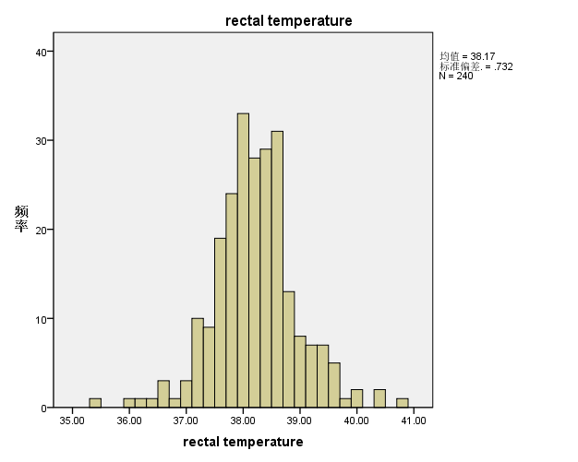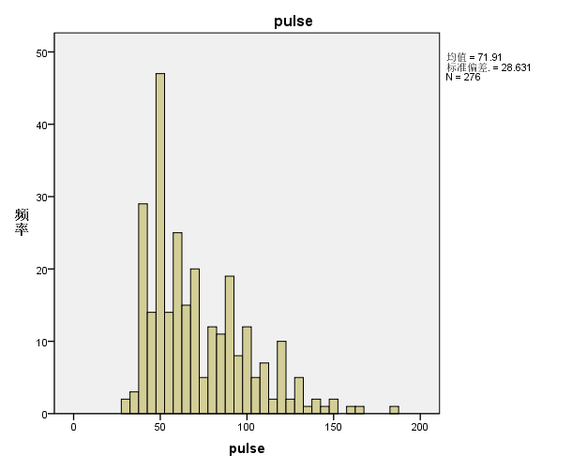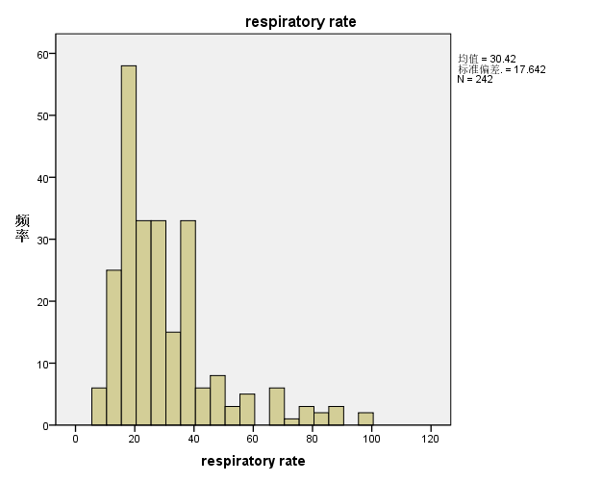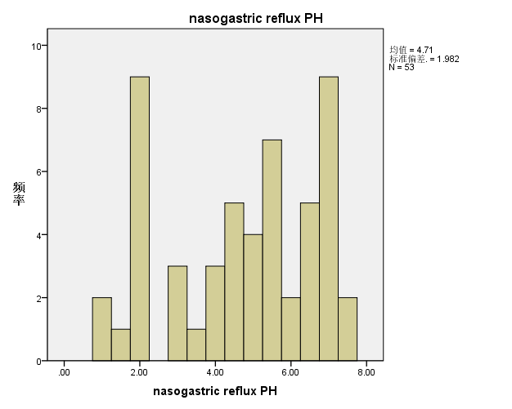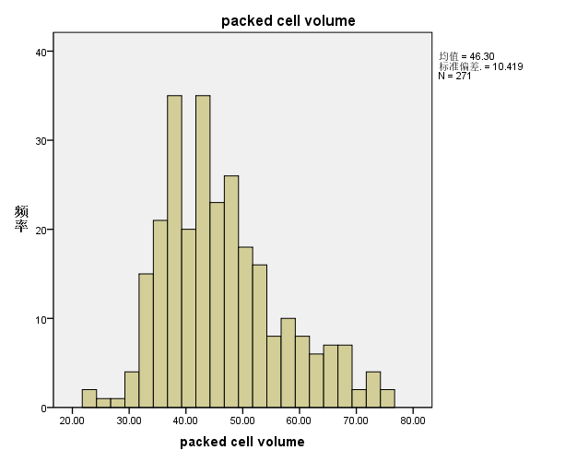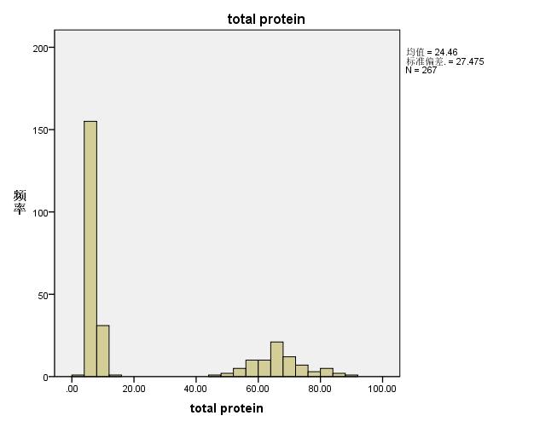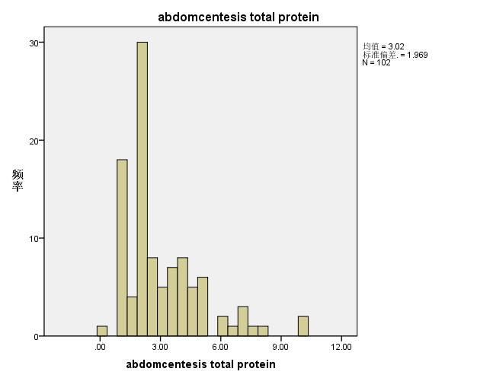

**Q-Q检验过程及结果如下：**

| **模型描述** | | |
| --- | --- | --- |
| 模型名称 | | MOD_1 |
| 序列或顺序 | 1 | rectal temperature |
| 2 | pulse |
| 3 | respiratory rate |
| 4 | nasogastric reflux PH |
| 5 | packed cell volume |
| 6 | total protein |
| 7 | abdomcentesis total protein |
| 转换 | | 无 |
| 非季节性差分 | | 0 |
| 季节性差分 | | 0 |
| 季节性期间的长度 | | 无周期性 |
| 标准化 | | 未应用 |
| 分布 | 类型 | 正态 |
| 位置 | 估计 |
| 标度 | 估计 |
| 部分排序估计方法 | | Blom |
| 为结指定秩 | | 同数的值的秩均值 |
| 正在应用来自 MOD_1 的模型指定。 | | |

| **估计的分布参数** | | | | | | | | |
| --- | --- | --- | --- | --- | --- | --- | --- | --- |
|  | | rectal temperature | pulse | respiratory rate | nasogastric reflux PH | packed cell volume | total protein | abdomcentesis total protein |
| 正态分布 | 位置 | 38.1679 | 71.9130 | 30.4174 | 4.7075 | 46.2952 | 24.4569 | 3.0196 |
| 标度 | .73229 | 28.63056 | 17.64223 | 1.98231 | 10.41933 | 27.47501 | 1.96857 |

**Q-Q图如下：**

rectal temperature

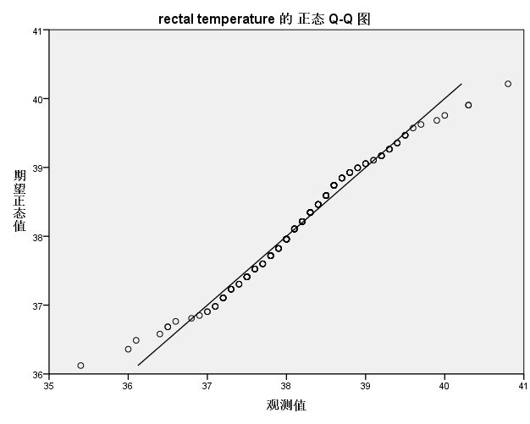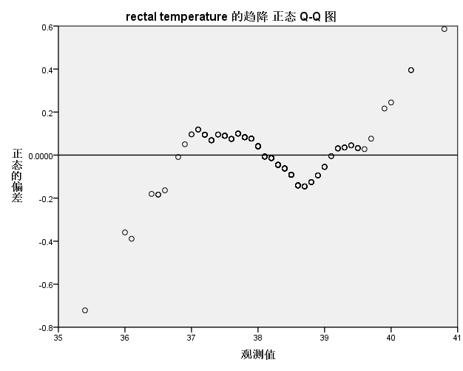

近似服从正态分布

pulse

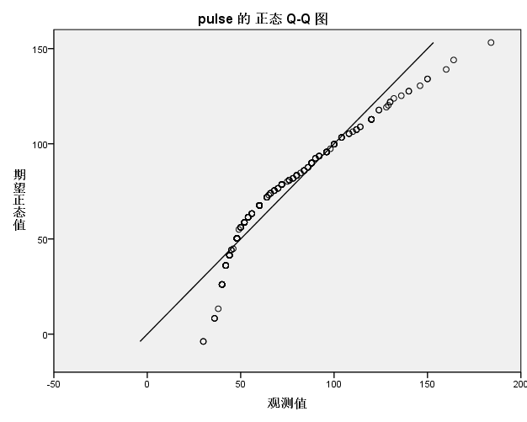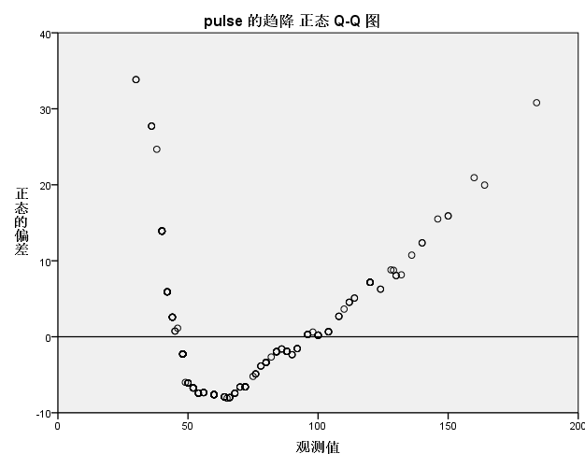

不服从正态分布

respiratory rate

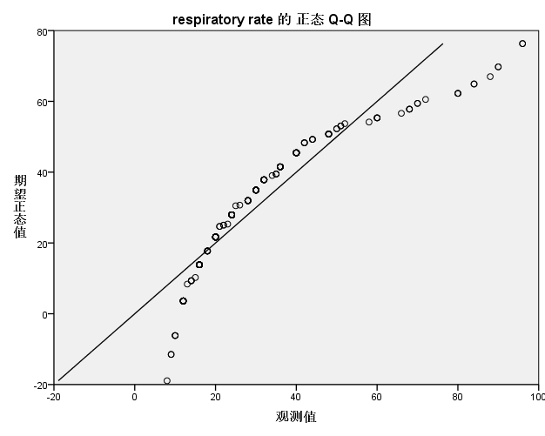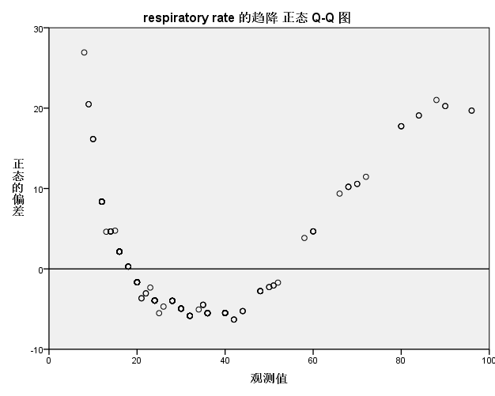

不服从正态分布

nasogastric reflux PH

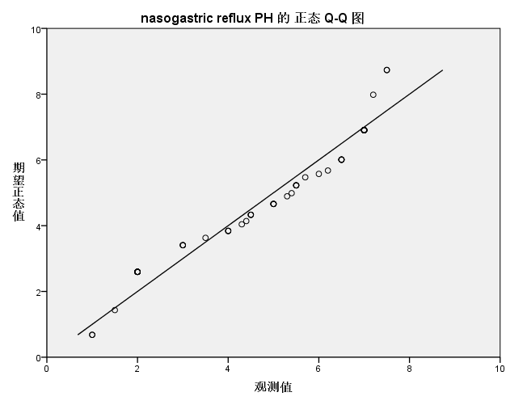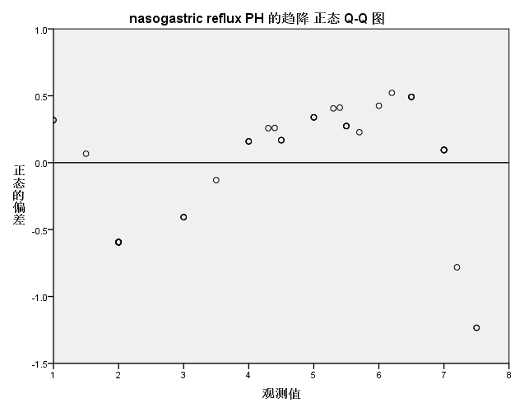

近似服从正态分布

packed cell volume

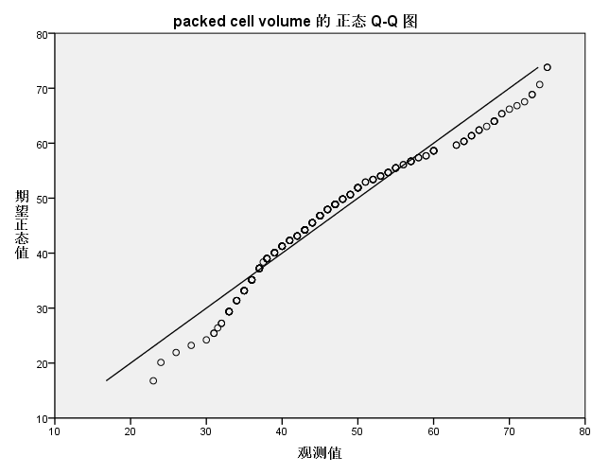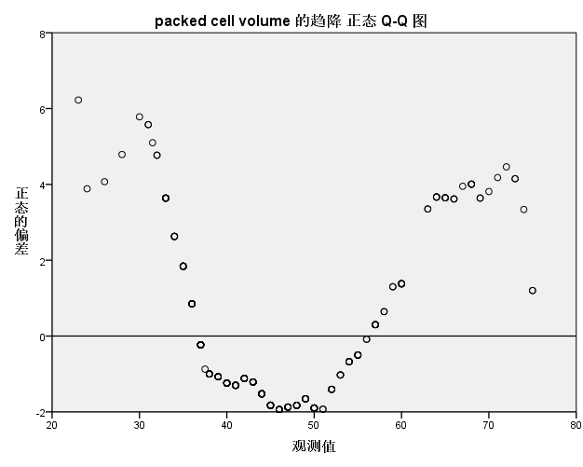

近似服从正态分布

total protein

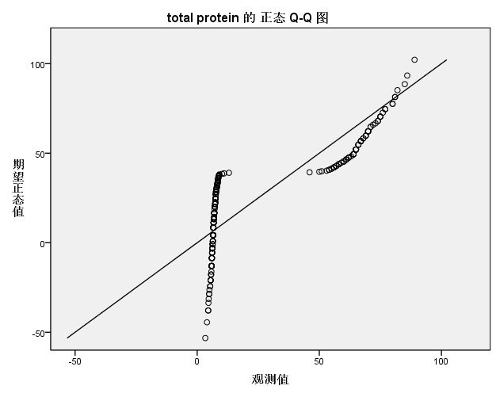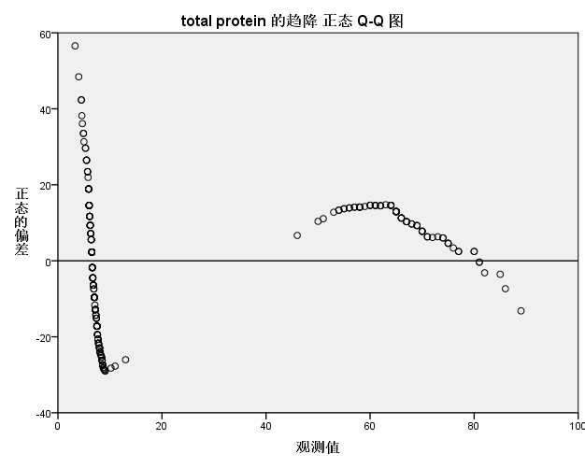

不服从正态分布

abdomcentesis total protein

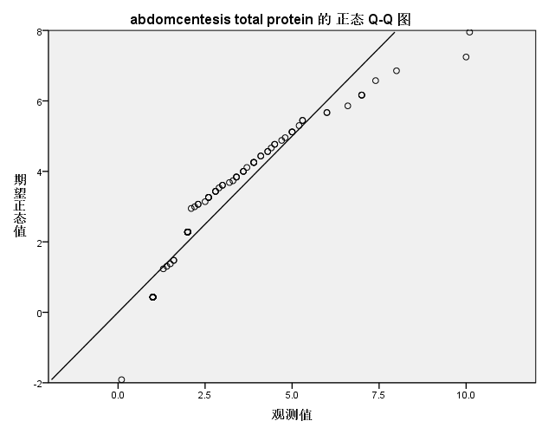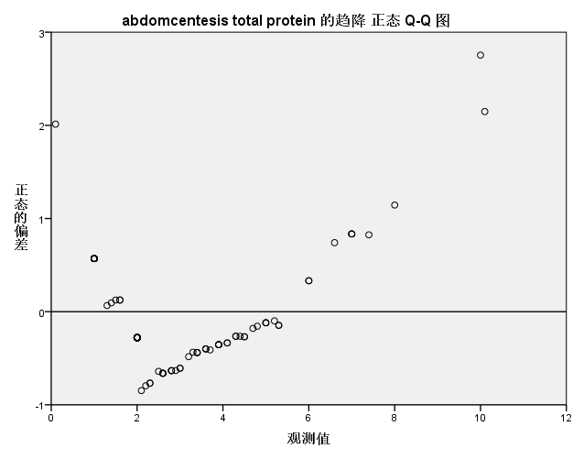

近似服从正态分布

**盒图如下：**

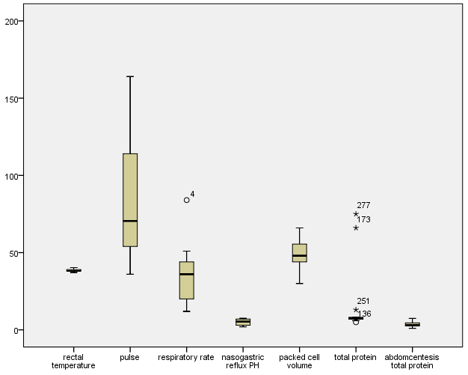

# 二、数据缺失的处理

(1) 前面所得到的数据可视化结果即是在将缺失部分剔除的条件下绘出的统计结果。

(2) 用最高频率值填补

前面所得到的数据可视化结果即是在将缺失部分剔除的条件下绘出的，下面采取用最高频率值替换缺失值的方法，得到的统计结果如下：

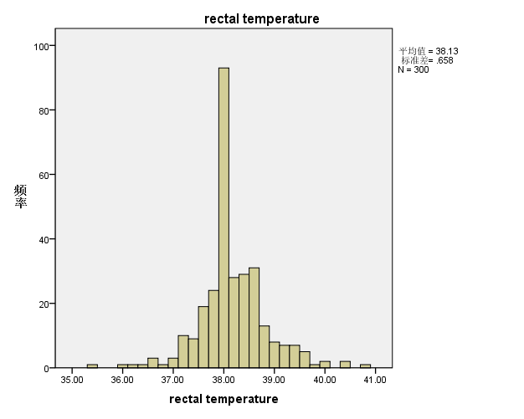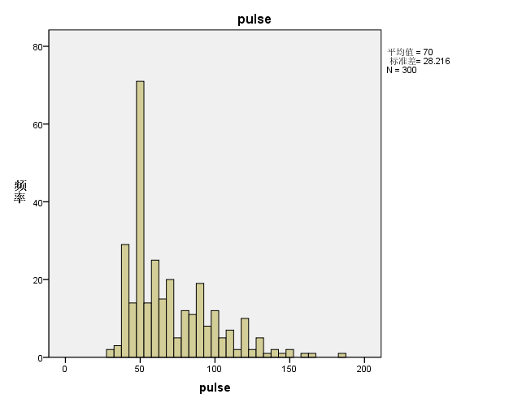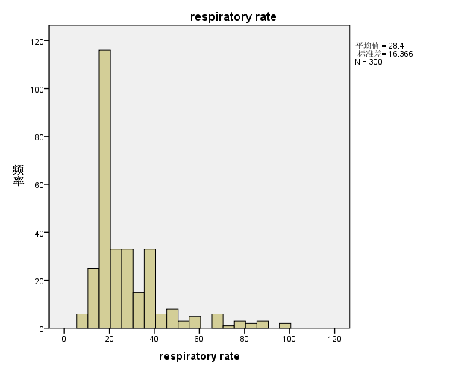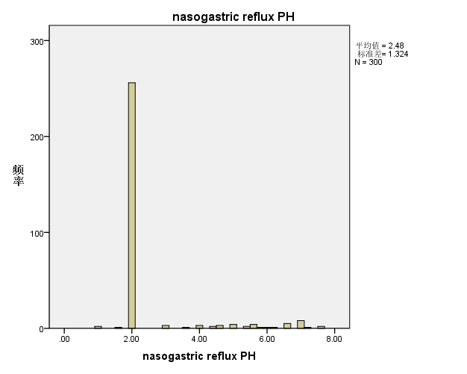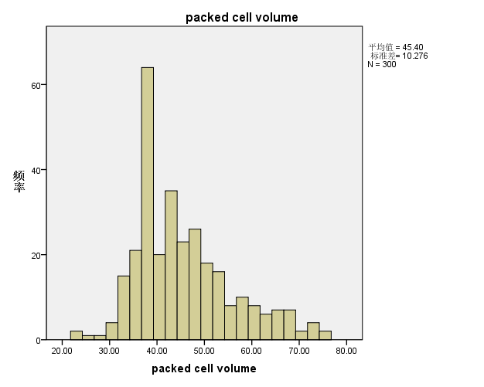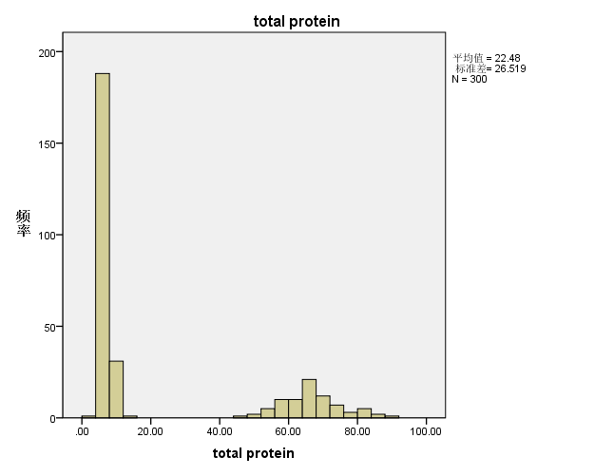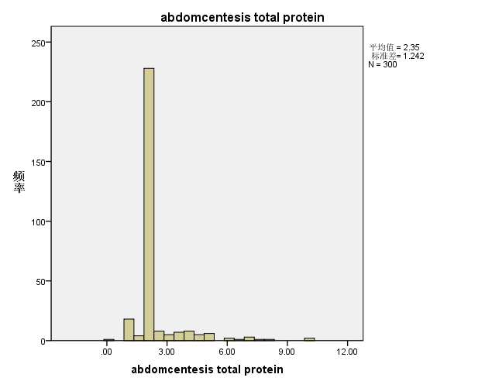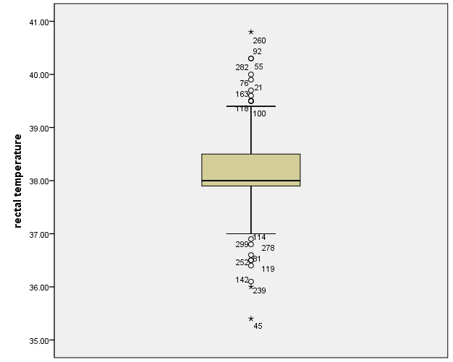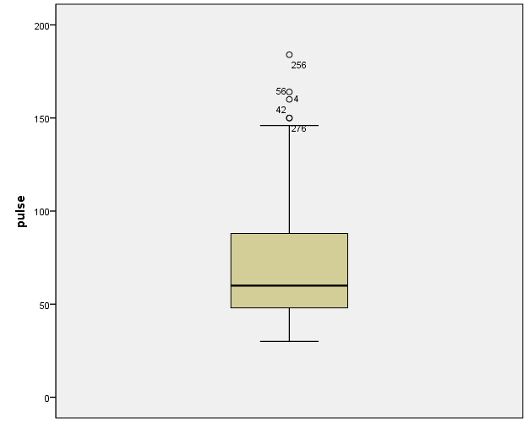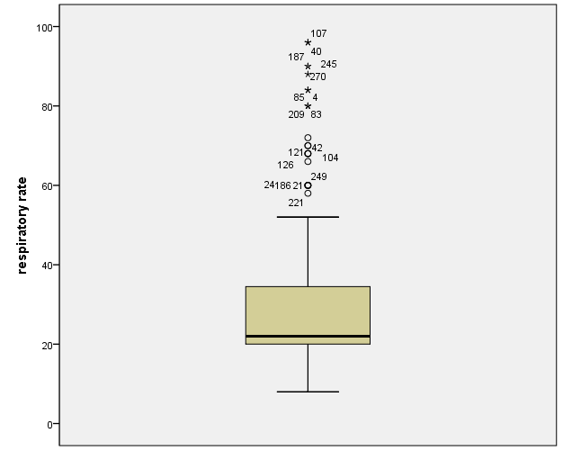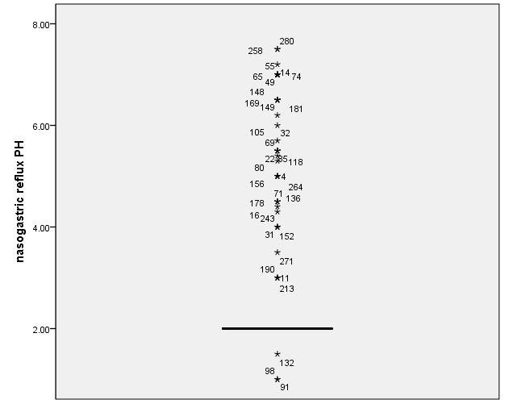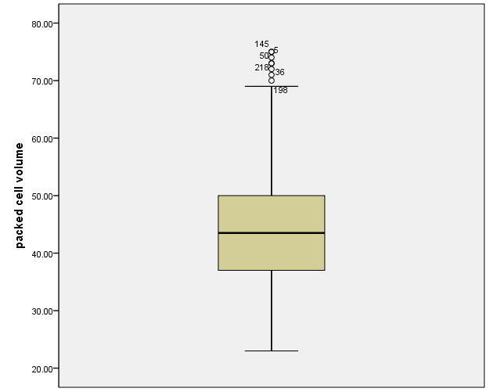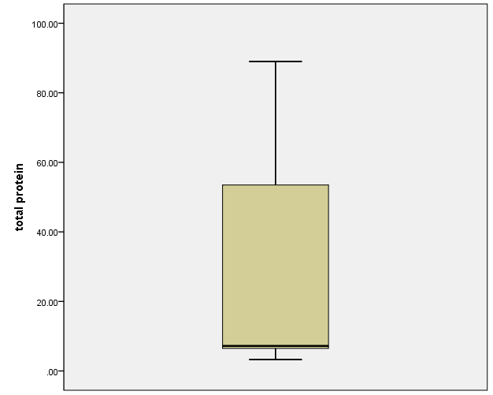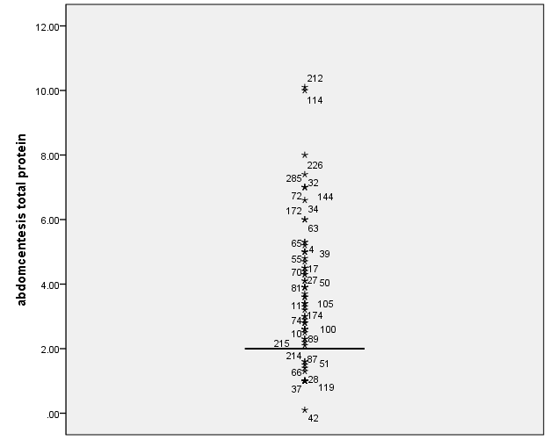

(4) 通过数据对象之间的相似性来填补

对于个别数据缺失的问题，考虑到同一种群中个体之间大致是相似的，因此对不同个体可以采用线性插值的方法对缺失数据进行填补，得到的结果如下：

