# DECLARATION

I DAVID MICHEAL, declare that this Technical report is a report of my activities and experienced acquired during the SIWES period. This report is written by me under the supervision of Prof. Francisca O. Oladipo. The information derived from the literature was been duly acknowledged in the text and a list of references provided.

________________ ___________________

Signature Date

# CERTCAIFITION

I certify that this Technical report is a report of SIWES activities undertaken by DAVID MICHEAL at NATIONAL INLAND WATERWAYS AUTHORITY (NIWA) LOKOJA, KOGI STATE.

________________________ _________________

Dr Isah Yinusa Date

Institutional SIWES Co-ordinator

________________________ _________________

MRS Fati Oiza Ochepa Date

Departmental SIWES Co-ordinator

# ACKNOWLEDGEMENT

Above all, I thank God for giving me the grace to participate in this SIWES, as it has only been God all through from the beginning even to this end.

To the AGM (RPE) the person of Mr Amola Joseph E. I will also give my appreciation for he took me as a child and it has been a big ground for me to be able to do even a lot for myself and the organization, a big appreciation too for all of the Officers in (RPE) as they have all done a lot to see I achieve my aim of going into the organization.

Specially to my HOD and Institutional base supervisor Prof Francisca O. Oladipo I appreciate the good works which has affected my life in the positive direction of making a good career, also to my lecturer Mr Malik Adeiza Rufai I can’t end my appreciation for the supports and also the eye opening advice which has brought a lot of knowledge to me and added to my personality as a person.

After all, I will have to appreciate my Dear Mom.

Thank you message to my Institutional base and Departmental SIWES coordinator as I can’t mention everybody but I’m sending a THANK YOU message to everyone involved and to JetBrains Academy.

Thank you.

# ABSTRACT

**SIWES** is an acronym for Student’s Industrial Work Experience Scheme. **SIWES** was established in the year 1973 in order to improve the standard of education in Nigeria in order to achieve the needed technological advancement, SIWES aim at empowering labour and industrialists to be self-reliant through acquisition training in sciences, engineering and technology. The scheme is a catalyst for industrial growth and productivity, during my SIWES, during my SIWES period I assist the organization in mass production of valuable documents and also learn through an online internship with JetBrains Academy which was introduced to me by my industry base supervisor, I experienced a lot and which have given me the knowledge of been a Backend developer using Python and Django Framework, I’ve learnt and gotten a lot of experience during the SIWES that has put me in space of computer programmer and a software developer.

Table of Contents

DECLARATION 4

CERTCAIFITION 5

ACKNOWLEDGEMENT 6

ABSTRACT 7

CHAPTER ONE 10

INTRODUCTION 10

CHAPTER TWO 11

1.0 HISTORICAL REVIEW 11

1.1 DEFINITION AND ORIGIN OF SIWES 11

1.2 OBJECTIVES 12

1.3 BODIES INVOLVED IN THE MANAGEMENT OF SIWES 12

1.4 BRIEF HISTORY OF NIWA 13

1.5 OBJECTIVES OF NIWA 13

1.6 VISION OF NIWA 13

1.7 MISSION OF NIWA 13

1.8 ORGANOGRAM OF NIWA 14

CHAPTER THREE 15

3.0 ACTIVITIES DURING SIWES 15

3.1COMPUTER NETWORKING 15

3.2 PYTHON 16

3.3 PYTHON (DJANGO FRAMEWORK) 17

CHAPTER FOUR 24

SUMMARY, CONCLUSION AND RECOMKMENDATION 24

4.0 SUMMARY 24

4.1 CONCLUSION 24

4.2 RECOMMENDATIONS 24

References 25

List of Figures

Figure 1.0 Organisational Organogram 13

Figure 2.0 Hangman game source code1 15

Figure 3.0 Hangman game source code2 15

Figure 4.0 admin login page for NIWAREG 19

Figure 5.0 Reg information 20

Figure 6.0 Reg information 2 20

Figure 7.0 admin logout view 21

Figure 8.0 NIWA registration page 21

Figure 9.0 NIWA registration page 2 22

Figure 10.0 Id generated 22

# 

# CHAPTER ONE

## INTRODUCTION

This report contains the activities carried out by me (David Micheal) during the SIWES period which I took in the National Inland Waterways Authority (NIWA) in the department of Research Planning and Environment (RPE), I undergo my training in the Research unit of RPE, where I learnt about the organization and its activities, how the provision of navigable waterways in Nigeria are been carried out, the regulation of the Inland Waterways in the country.

I learnt about networking fundamentals the HTTP, TCP/IP, the World Wide Web (www), networking protocols and layers with NetworkDirections.

Also I was able to lean about research and how they are being done.

Then Python, which I took the lecture with JetBrains Academy under the directive of my industrial base supervisor, I started with the track Python for beginners which after I complete the track I proceed to study Django Framework in Python.

The report contains in detail all of the activities, the learning procedures and the projects I worked on during the SIWES period.

# CHAPTER TWO

## HISTORICAL REVIEW

### 1.1 DEFINITION AND ORIGIN OF SIWES

The Student Industrial Work Experience Scheme (SIWES) was established by the industrial Training Fund (ITF) 1973 to enable students of tertiary institution have basic technical knowledge of industrial works base on their course of study before the completion of their program in their respective institutions. It was established to solve the problem of lack of adequate practical skills preparatory for employment in industries by Nigeria graduates of tertiary institutions.

The scheme exposes students to industry based skills necessary for a smooth transition from classroom to the world of work. It affords students of tertiary institutions the opportunity of being familiarized and exposed to the needed experience in handling machinery and equipment which are usually not available in the educational institutions.

One of the primary goals of the SIWES is to help students integrate leadership development into experiential learning process. Students are expected to learn and develop basic non-profit leadership skills through a mentoring relationship with innovative non-profit leaders.

The major benefits accruing to students who participate conscientiously in Students Industrial Work Experience Scheme (SIWES) are the skills and competencies they acquire. The relevant production skills remain a part of the recipients of industrial training as life-long assets which cannot be taken away from them. This is because the knowledge and skills acquired through training area internalized and become relevant when required to perform jobs or functions.

Operators – The ITF, the coordinating agencies (NUC, NCCE, NBTE). Employers of labour and the institutions Funding – The Federal Government of Nigeria.

### 1.2 OBJECTIVES

The Industrial Training Fund’s policy Document No.1 of 1973 which established SIWES outlined the objectives of the scheme. The objectives are as follows:

* Prepare students for industrial work situations that they are likely to meet after graduation.
* Provide an avenue for students in higher institutions of higher learning to acquire industrial skills and experiences during their course of study.
* Expose students to industrial work methods and techniques in handling equipment and machinery that may not be available in their institutions.
* Make the transition from school to the world of work easier and enhance students contact for later job placements.
* Provide students with the opportunities to apply their educational knowledge in real work situations, thereby bridging the gap between theory and practice.
* Enlist and strengthen employers’ involvement in the entire educational process through SIWES
* To expose students to latest developments and technological innovations in their chosen professions.

### 1.3 BODIES INVOLVED IN THE MANAGEMENT OF SIWES

The bodies involved are: The Federal Government, Industrial Training Fund (ITF). Other supervising agents are: National University Commission (NUC), National Board for Technical Education (NBTE) and National Council for Colleges of Education (NCE) The functions of these agencies above include among others to:

* Ensure adequate funding of the scheme;
* Establish SIWES and accredit SIWES unit in the approved institutions;
* Formulate policies and guideline for participating bodies and institutions as well as appointing SIWES coordinators and supporting staff;
* Supervise students at their places of attachment and sign their lob-book and IT forms.

### 1.4 BRIEF HISTORY OF NIWA

NIWA was formerly the Inland Waterways Department (IWD), which was the oldest Operational Department in the Ministry of Transport from 1956 up to late 1997. It is a statutory body, 100% owned by the Federal Government of Nigeria as a parastatal under the Federal Ministry of Transport. NIWA was established through Decree No. 13 of 1997 and commenced operations fully in 1998.

The decree vest in NIWA the power of exclusive management, direction and control on the Nigerian inland waterways. This power is exercise on Nigeria’s 10000km of Navigable inland waterways from the Nigeria/Niger and Nigeria/Cameroon borders to the Atlantic Ocean.

The inland waterways of Nigeria comprise the main river system (River Niger and Benue) which form a confluence at Lokoja, creeks, lagoons, lakes and intracoastal waters. Early merchant’s missionaries and educationist took advantage of the Nigerian river system to embark on expeditions on the River Niger.

Towards the development of the Nigerian inland waterways, NIWA encourages private investments on the inland waterways in pursuit of government’s policy of Public Private-Partnership (PPP)

### 1.5 OBJECTIVES OF NIWA

* improve and develop inland waterways for navigation:
* provide an alternative mode of transportation for the evacuation of economic goods and persons: and
* execute the objectives of the national transport policy as they concern inland waterways

### ****1.6 VISION OF NIWA****

To make Nigeria the leader in inland water Transportation, development and management in Africa.

1.7 MISSION OF NIWA  
To provide regulatory, economical and operational leadership in the Nation’s Inland Waterways system and develop infrastructural facilities for an efficient intermodal transportation system in line with global best practices that is safe, seamless and affordable.

### 1.8 ORGANOGRAM OF NIWA

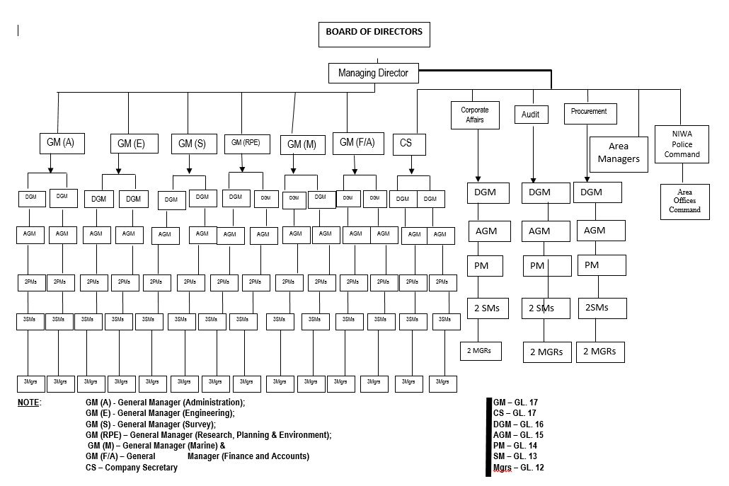

Figure 1.0 Organisational Organogram

# CHAPTER THREE

## ACTIVITIES DURING SIWES

### 3.1COMPUTER NETWORKING

I was able to learn Network fundamentals during my SIWES. I learnt about Hypertext Transfer Protocol (HTTP), how systems have to obey the same rules in order to enable them communicate with each other also Transfer Control Protocol (TCP) that enables security and allows a call back for lost data during the transfer of data from one computer to another.

LAN, the Local Area Network which comprise of small space network where some small amount of computers are connected together for data transfer and possessing.

WAN, Wide Area Network, this is a type of computer networking that happens in a wide range of environment, up till this moment, a clear definition haven’t be given to the WAN because of it polymorphic character.

I learnt about cable and cords too which can be used for computer networking, many might thought cable and cords might just be for the LAN alone but cables can also be used for WAN too, imaging a network that sends cables through countries, we call that pipelining in Network.

Router and Switch, most people see this two facilities as equal whereas they both mean something different, in the early days of Computer Networking we use the system called Network Switching, where some people called operators sit in a room to perform the switching of cables into port to pass and receive information (Requests), as Networking improves and demand for communication rises this method of switching cables by human become seriously inefficient, we need something better now, so the introduction of Packet Switching came in at this point we rout with routers but routers are old now, we have the Switch can help us pass our request to the server and to other computers very fast and easy.

Request is been sent by the initiator (Computer) the request contains the computers IP address and the destinations IP address, Switch receives this request, update the Initiator’s IP address with its own and send a broadcast message to the remaining computers then the computer with the destination’s IP address respond to the message and the Switch sends the data through to the destination, this happens for the first time not after the switch now have every IP address saved, this time it does send message direct to the destination.

### 3.2 PYTHON

After getting little knowledge of Computer Networking from NetworkDirection my industry base supervisor told me about JetBrains Academy where I can learn Python for free at least for the first 5 months.

I started learning Python with JetBrains Academy with track (Python for beginners), during this period I was introduced to Python programming language after which I learnt about Variable, Data types, Conditional statements, Control Structures, Loops, Functions, Class etc. in Python during this period of learning I built some amount of projects among which are Hangman game, Tic Tac Toe game, Loan calculator, Loyalty app and more of them all on my github page (MichealDavid1).

For more clarity, here is my source code for the Hangman game:

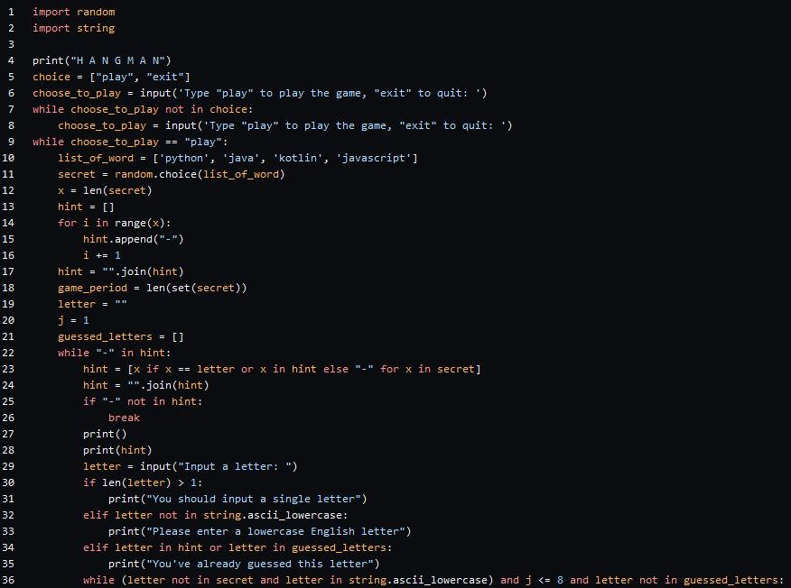

Figure 2.0 Hangman game source code1

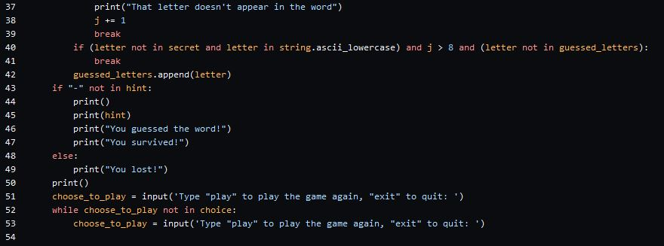

Figure 3.0 Hangman game source code2

### 3.3 PYTHON (DJANGO FRAMEWORK)

After completing the track Python for beginners on JetBrains Academy I proceed to learning Django Framework for Web development yet with JetBrains Academy, this track Django Web development thought me about HTML, SQL database and a little introduction to CSS.

I also learnt Django Templating Language (DTL), Model View Protocol (MVP) which Django now interprets to Model View Template (MVT) etc.

Framework is a skeleton building of a project it set rule for developers to follow while building their projects, unlike Library, Framework calls your code to perform the given task, Django Framework is very popular, you might want to work with a popular Framework because you will easily get solution to problems when you encounter them, Django is widely accepted because of it security and high level of encryption, many popular organizations uses Django and does have a large community for discussion, Django is an open source Framework just like Python, this means it is free to use and you can also join in making it better.

With Django Framework I was able to build a unique Identity generator for NIWA apart from other projects me and my co-intern worked on for the organization, this Id Gen as called it is a project I did on my own for the organization, before I attach the image of NIWA Id Gen I will like to talk about some of the Knowledge I got from learning Django (HTML, CSS, SQL).

#### **3.3.1 HYPER TEXT MARKUP LANGUAGE (HTML)**

Hypertext Mark-up Language (HTML) is the backbone of any website development process, without which a web page doesn't exist. Hypertext means that text has links, termed hyperlinks, embedded in it. When a user clicks on a word or a phrase that has a hyperlink, it will bring another web-page. A markup language indicates text can be turned into images, tables, links, and other representations. It is the HTML code that provides an overall framework of how the site will look.

Below is an example of HTML used to define a basic webpage with a title and a single paragraph of text

<!DOCTYPE html>

<html>

<head>

<meta charset =”UTF – 8”

<title>About Report</title>

</head>

<body>

<p> Hello this is my SIWES Report </p>

</body>

</html>

The first line defines what type of contents the document contains. "<!DOCTYPE html>" means the page is written in HTML5. Properly formatted HTML pages should include <html>, <head>, and <body> tags, which are all included in the example above. The page title, metadata, and link to referenced files are placed between the <head> tags. The actual contents of the page go between the <body> tags.

#### **3.3.2 CASCADING STYLE SHEETS (CSS)**

CSS stands for "Cascading Style Sheet." Cascading style sheets are used to format the layout of [Web pages](https://techterms.com/definition/webpage). They can be used to define text styles, table sizes, and other aspects of Web pages that previously could only be defined in a page's [HTML](https://techterms.com/definition/html).

CSS helps Web developers create a uniform look across several pages of a Web site. Instead of defining the style of each table and each block of text within a page's HTML, commonly used styles need to be defined only once in a CSS document. Once the style is defined in cascading style sheet, it can be used by any page that references the CSS file. Plus, CSS makes it easy to change styles across several pages at once. If the pages all reference the same style sheet, the text size only needs to be changed on the style sheet and all the pages will show the larger text.

While CSS is great for creating text styles, it is helpful for formatting other aspects of Web page layout as well. For example, CSS can be used to define the cell padding of table cells, the style, thickness, and color of a table's border, and the padding around images or other objects. CSS gives Web developers more exact control over how Web pages will look than HTML does. This is why most Web pages today incorporate cascading style sheets.

#### **3.3.3 DATABSASE (SQL)**

Database is the collection of related information stored in an organized way. A database is a collection of records. One of the major tasks in a computer system is to store and manage data. To handle this task, you need a specialized computer software known as a Database Management System (DBMS). Database management systems are designed to maintain large volumes of data. Management of data involves:

* Defining structures for data storage
* Providing mechanisms for data manipulation
* Providing data security against unauthorized access

With Django Templating Language (DTL) codes on HTML are been optimized in the sense that you don’t need to code a lot on the HTML but it actually does a lot and when you inspect the site it looks like magic how every element represents in the HTML format.

The Database, in SQL data are presented in tables with columns and rows where it uses the CRUD method, Create, Read, Update and Delete all of this can be done too with Django but though there is difference in syntax.

In Django, table are representing with classes and its class instances as the column.

Though NIWA have an offline registration form that they give to Vessel owners to fill, in order to register their vessel but not yet online and no unique identity for them yet, according to the research I carried out, they’re in the process of making it happen.

Diagrams and detail for NIWA Id Gen: **NOTE**: The project is bigger than this.

This is the Admin’s login page, where the admin can log in to access registered information

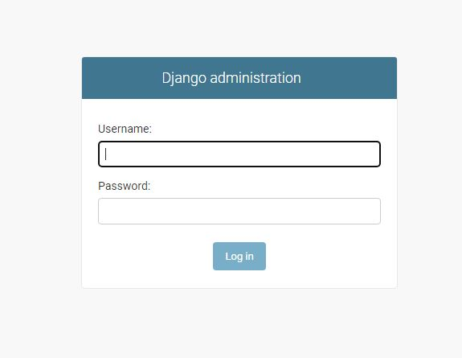

Figure 4.0 admin login page for NIWAREG

This is the admin’s page where the admin can access registered user’s information, make changes to them if there is need, here the admin can Create, Read, Update and Delete information as they need after logging in

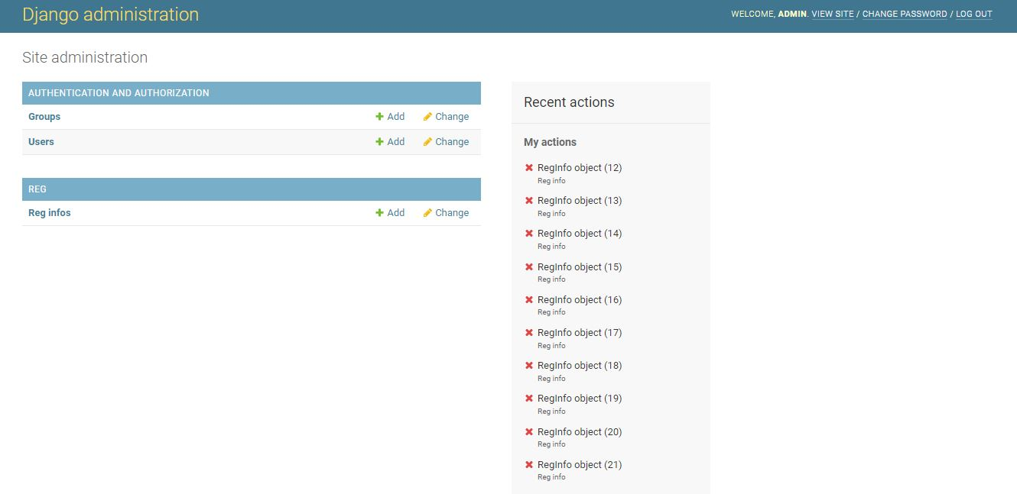

Figure 5.0 Reg information

This is the page that keeps all of the information registered by the users

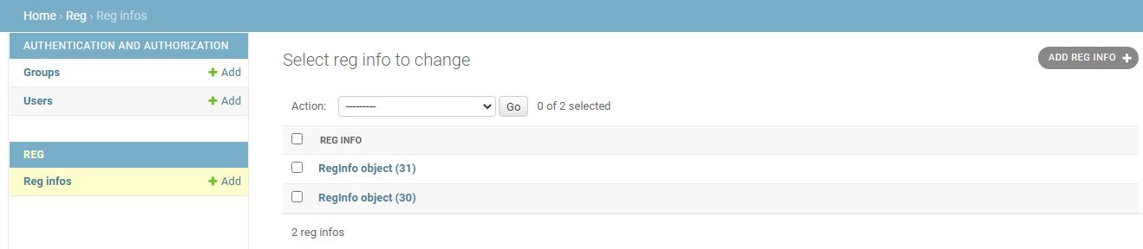

Figure 6.0 Reg information 2

This is the logout page, as the admin logout there is a redirect to this page and as you can see, the admin might still choose to login again.



Figure 7.0 admin logout view

This is the home page where user can register their Vessels and after filling the form, a unique identity will be generated for the registered Vessel.

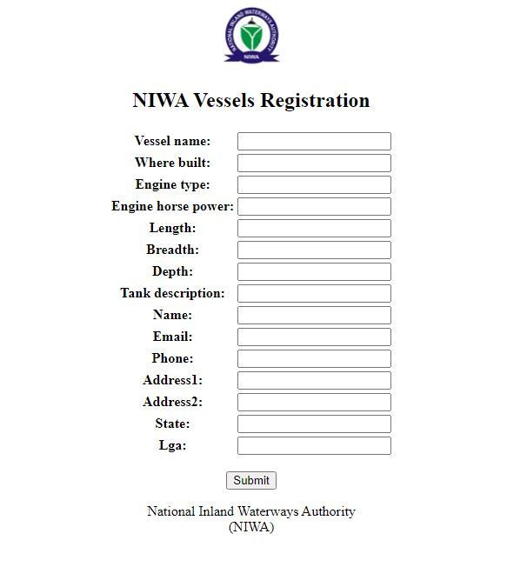

Figure 8.0 NIWA registration page

When a user register with the following in formation

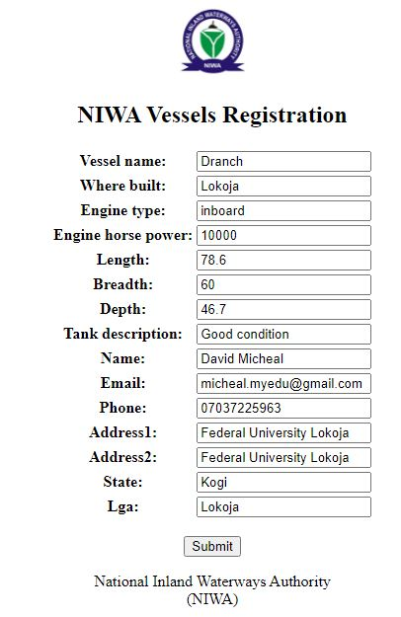

Figure 9.0 NIWA registration page 2

After submitting the form, a unique identity will be given



Figure 10.0 Id generated

This project is much bigger than this as it demands a lot of data to finish the project, but with the Agile principle, I have been able to provide this and it is subject to update.

# CHAPTER FOUR

## SUMMARY, CONCLUSION AND RECOMKMENDATION

### 4.0 SUMMARY

In this report I have been able to do the following:

1. Definition and origin of SIWES
2. Give the Objectives of SIWES
3. Tell a Brief history of NIWA
4. Give the Objectives, Vision and Mission of NIWA
5. State the NIWA organogram
6. Report the activities I engaged in during my SIWES period in NIWA

### 4.1 CONCLUSION

My SIWES period at NIWA brought a life changing experience to me as I was able to meet with industrial workers so I also create relationship with many, this has taught me how to co-exist with people in a working environment and even how to manage people with different characters.

### 4.2 RECOMMENDATIONS

For NIWA, I recommend the organization should put more in technology, as NIWA is a big organization that handles big data, they should do more by bringing in competent and exposed workers who understand technology to help in handling most of the job for them.

For ITF, my recommendations are as follows:

* Allowance should be paid to students during the programme.
* I recommend that the Nigerian educational system should be reviewed as what is taught in the classroom does not meet with the standard of what is needed in the actual work place.

# References

*Federal University Lokoja SIWES guidelines*

*About SIWES.* Retrieved from: <http://wikipedia.com>

Saliu, K. M. *about NIWA:* Industrial base supervisor

*NIWA logo.* Retrieved from: http://niwa.gov.ng

*Computer Networking.* Learnt in: http://networkdirections.com

Learn Python and Django in *JetBrains Academy:* <http://hyperskills.org>

*Python 3.x,* Downloaded from:<http://python.org>

*Pycharm community edition:* downloaded from. <http://jetbrains.com>

*Programming problem solutions.* From: http://stackoverflow.com