**AWS-EC2-Target-Group-Load-Balancer-Auto-Scaling-Group**

**CloudFormation Stack Setup**

**Step 1: EC2 Instances**

**Edit ec2-instances.yaml**

AWSTemplateFormatVersion: '2010-09-09'

Resources:

EC2Instance1:

Type: 'AWS::EC2::Instance'

Properties:

ImageId: ami-xxxxxxxxxxxxxxxxx # Specify your AMI ID

InstanceType: t2.micro

EC2Instance2:

Type: 'AWS::EC2::Instance'

Properties:

ImageId: ami-xxxxxxxxxxxxxxxxx # Specify your AMI ID

InstanceType: t2.micro

**Deploy EC2 Instances**

* Using the CLI

aws cloudformation create-stack --stack-name EC2InstancesStack --template-body file://ec2-instances.yaml

* Using the Management Console

1. Open the AWS Management Console.
2. Navigate to the **CloudFormation** service.
3. Choose **Create Stack**.
4. In the **Select Template** section, choose **Upload a template file** and upload the ec2-instances.yaml file.
5. Choose **Next**.
6. Enter a stack name (e.g., EC2InstancesStack) and provide any required parameters.
7. Choose **Next** and follow the on-screen instructions to create the stack.

**Step 2: Target Group**

**Edit target-group.yaml**

AWSTemplateFormatVersion: '2010-09-09'

Resources:

MyTargetGroup:

Type: 'AWS::ElasticLoadBalancingV2::TargetGroup'

Properties:

Port: 80

Protocol: HTTP

VpcId: vpc-xxxxxxxxxxxxxxxxx # Specify your VPC ID

**Deploy Target Group**

* Using the CLI

aws cloudformation create-stack --stack-name TargetGroupStack --template-body file://target-group.yaml

* Using the Management Console

1. Open the AWS Management Console.
2. Navigate to the **CloudFormation** service.

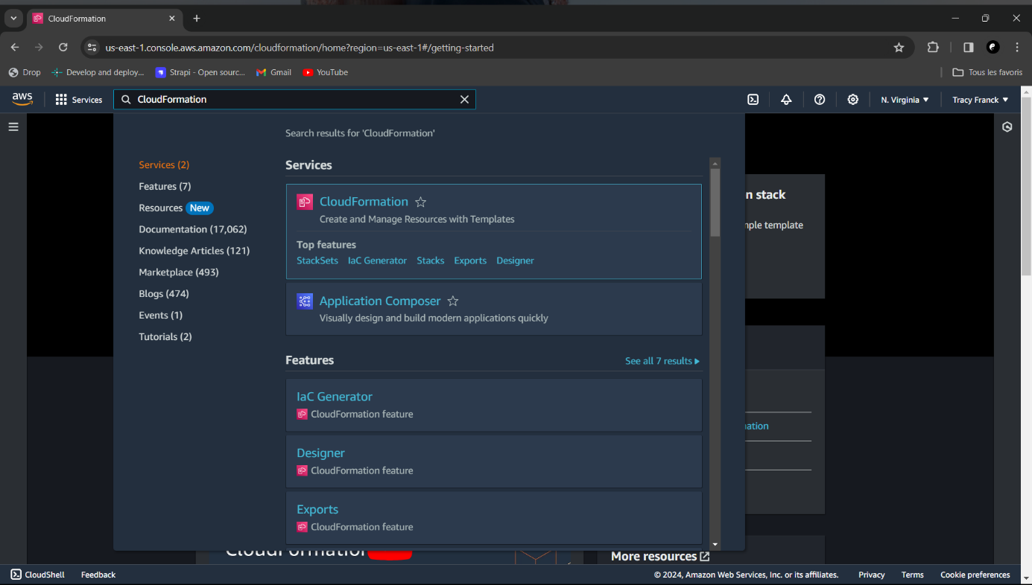

1. Choose **Create Stack**.

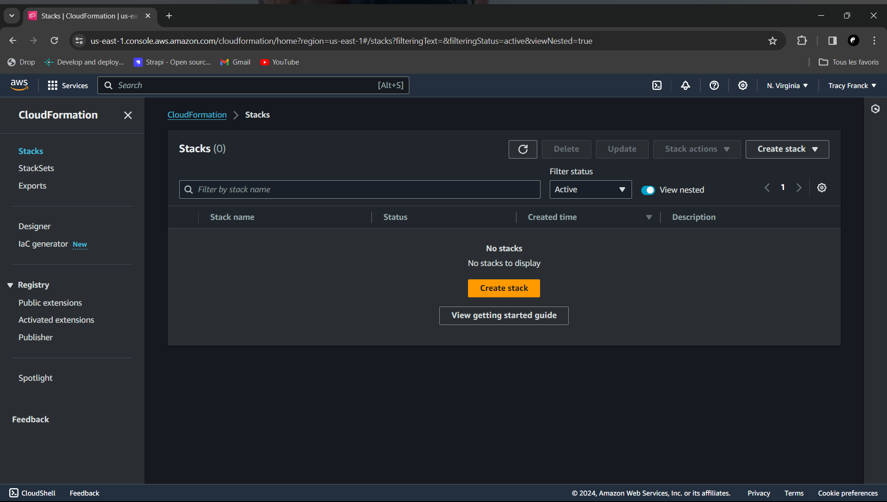

1. In the **Select Template** section, choose **Upload a template file** and upload the target-group.yaml file.

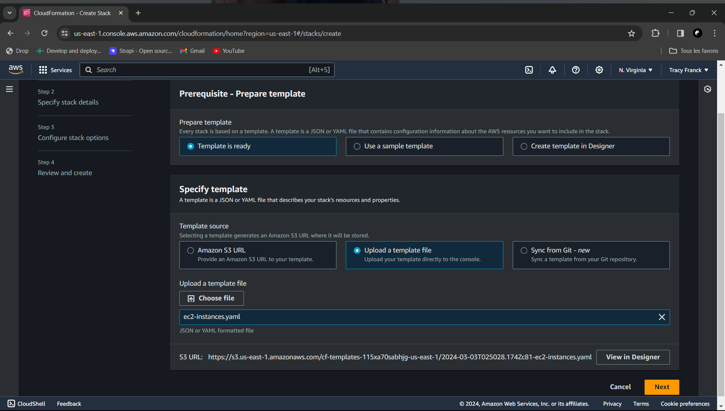

1. Choose **Next**.
2. Enter a stack name (e.g., TargetGroupStack) and provide any required parameters.
3. Choose **Next** and follow the on-screen instructions to create the stack.

**Step 3: Load Balancer**

**Edit load-balancer.yaml**

AWSTemplateFormatVersion: '2010-09-09'

Resources:

MyLoadBalancer:

Type: 'AWS::ElasticLoadBalancingV2::LoadBalancer'

Properties:

Subnets:

- subnet-xxxxxxxxxxxxxxxxx # Specify your subnet ID

- subnet-yyyyyyyyyyyyyyyyy # Specify your subnet ID

SecurityGroups:

- sg-xxxxxxxxxxxxxxxxx # Specify your security group ID

LoadBalancerAttributes:

- Key: idle_timeout.timeout_seconds

Value: '60'

Name: MyLoadBalancer

**Deploy Load Balancer**

* Using the CLI

aws cloudformation create-stack --stack-name LoadBalancerStack --template-body file://load-balancer.yaml

* Using the Management Console

1. Open the AWS Management Console.
2. Navigate to the **CloudFormation** service.
3. Choose **Create Stack**.
4. In the **Select Template** section, choose **Upload a template file** and upload the load-balancer.yaml file.
5. Choose **Next**.
6. Enter a stack name (e.g., LoadBalancerStack) and provide any required parameters.
7. Choose **Next** and follow the on-screen instructions to create the stack.

**Step 4: Auto Scaling Group**

**Edit auto-scaling-group.yaml**

AWSTemplateFormatVersion: '2010-09-09'

Resources:

MyAutoScalingGroup:

Type: 'AWS::AutoScaling::AutoScalingGroup'

Properties:

LaunchConfigurationName: MyLaunchConfig

MinSize: 2

MaxSize: 5

DesiredCapacity: 2

VPCZoneIdentifier:

- subnet-xxxxxxxxxxxxxxxxx # Specify your subnet ID

- subnet-yyyyyyyyyyyyyyyyy # Specify your subnet ID

**Deploy Auto Scaling Group**

* Using the CLI

aws cloudformation create-stack --stack-name AutoScalingGroupStack --template-body file://auto-scaling-group.yaml

* Using the Management Console

1. Open the AWS Management Console.
2. Navigate to the **CloudFormation** service.
3. Choose **Create Stack**.
4. In the **Select Template** section, choose **Upload a template file** and upload the auto-scaling-group.yaml file.
5. Choose **Next**.
6. Enter a stack name (e.g., AutoScalingGroupStack) and provide any required parameters.
7. Choose **Next** and follow the on-screen instructions to create the stack.

**Step 5: Clean Up**

**Delete CloudFormation Stacks**

* Using the CLI

aws cloudformation delete-stack --stack-name EC2InstancesStack

aws cloudformation delete-stack --stack-name TargetGroupStack

aws cloudformation delete-stack --stack-name LoadBalancerStack

aws cloudformation delete-stack --stack-name AutoScalingGroupStack

* Using the Management Console

1. Open the AWS Management Console.
2. Navigate to the **CloudFormation** service.
3. Select the stacks created (EC2InstancesStack, TargetGroupStack, LoadBalancerStack, AutoScalingGroupStack).
4. Choose **Delete** and confirm the deletion.