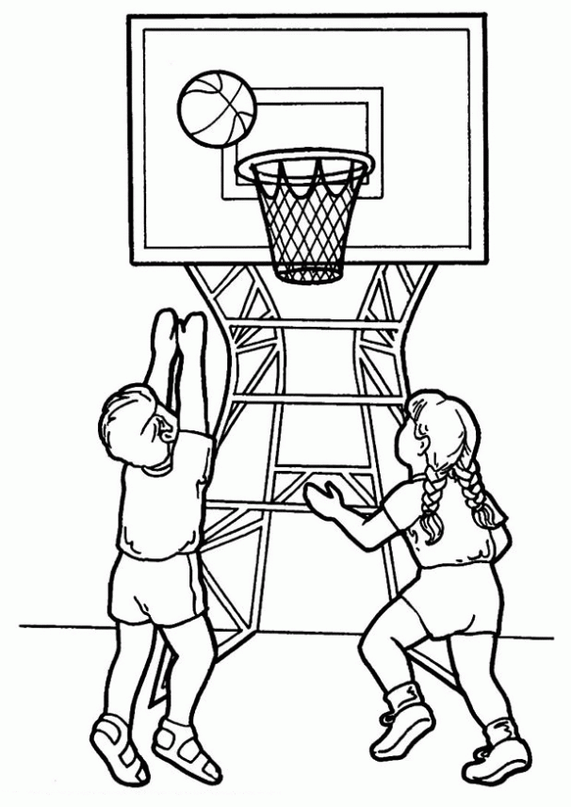I was playing basketball at noon yesterday when I jumped for the ball…

When I was falling my foot blend and i shouted for the pain

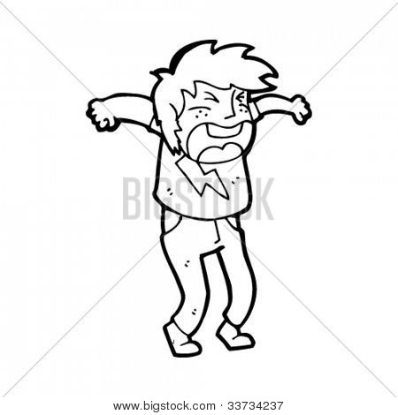

My brother liestened and he came to see me

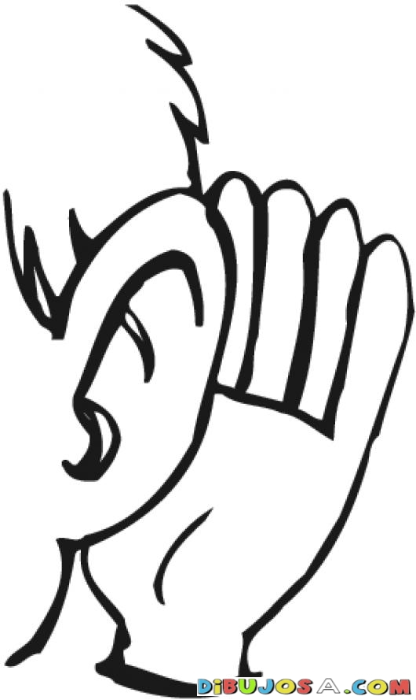

And help me but i couldn’t stand up

After that…

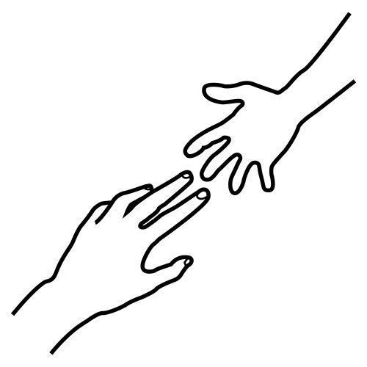

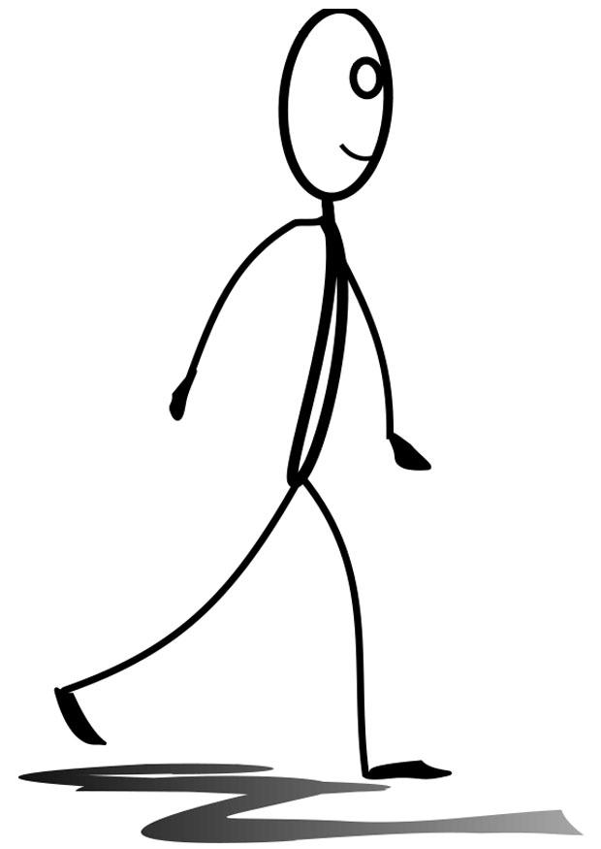I was walking and i tried to moved my foot but i couldn’t…

And that is my history about an injury i had

