# ../../../Downloads/Screenshot_20161230-181319.pngConnect to the WIFI:

# “DISCO-MATCH”

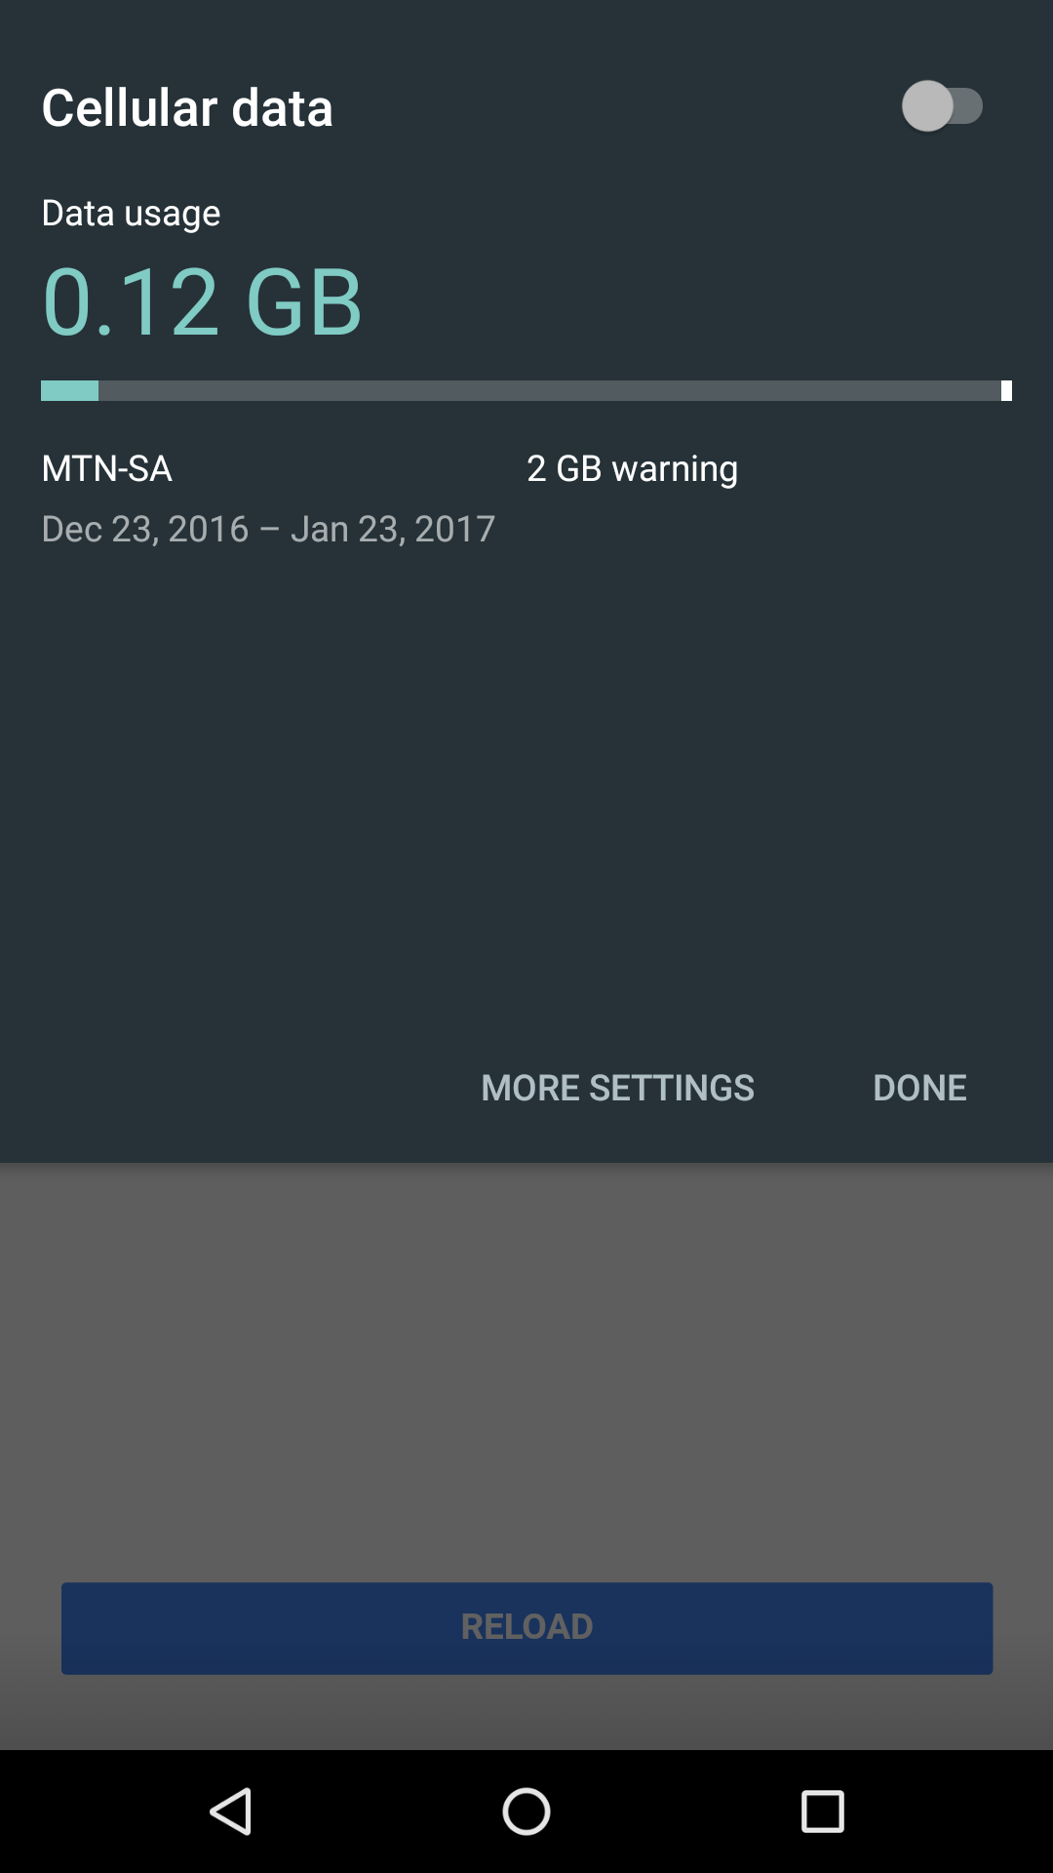

Deactivate your data

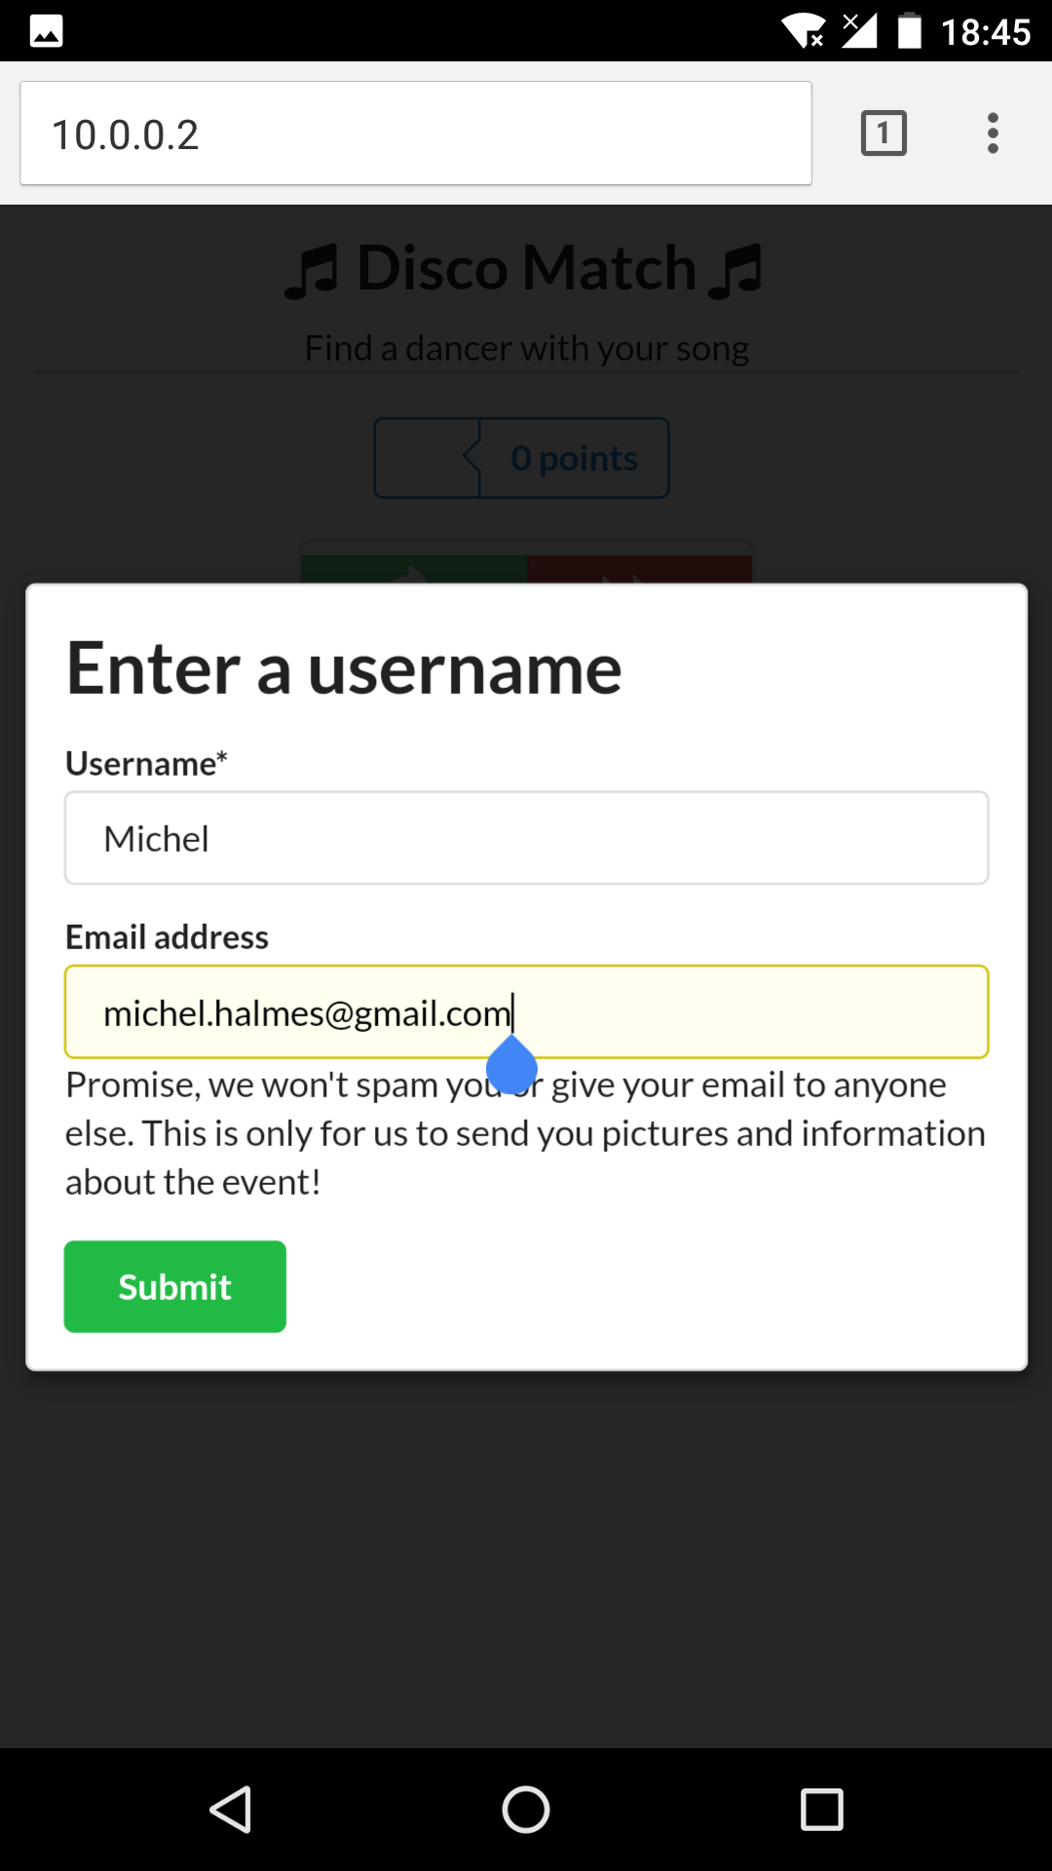

Open Chrome (or your browser) and got to “10.0.0.2”

This may take some time!

Then enter your name (email is optional)

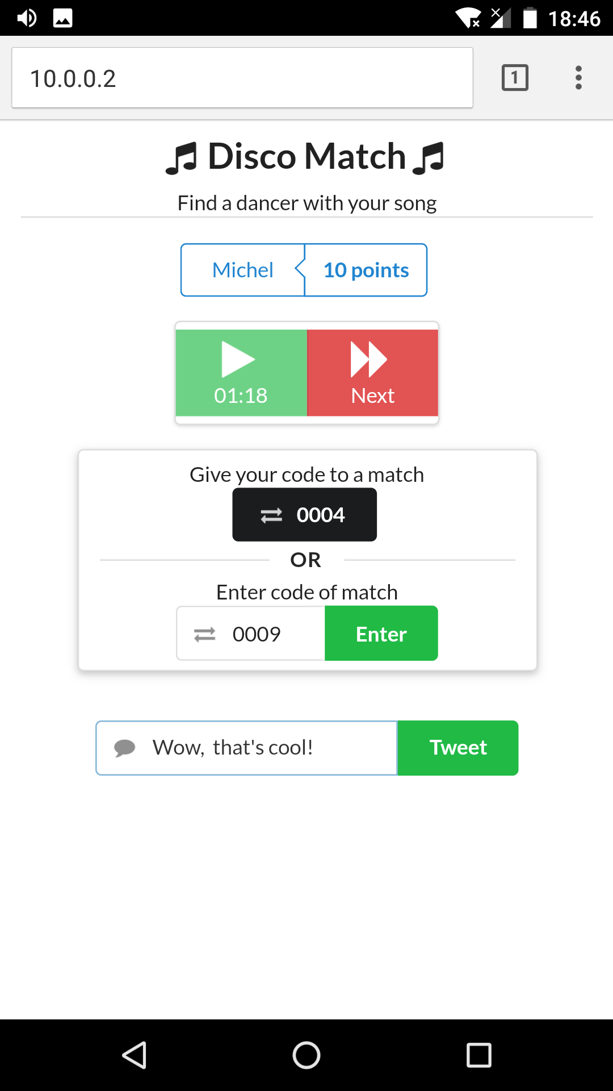

Find players with the same song and exchange codes (one of you is enough)

Tweet a message!