Before answering, let's add some background, explaining what this HEAD is.

***First of all what is HEAD?***

HEAD is simply a reference to the current commit (latest) on the current branch.  
There can only be a single HEAD at any given time (excluding git worktree).

The content of HEAD is stored inside .git/HEAD and it contains the 40 bytes SHA-1 of the current commit.

***detached HEAD***

If you are not on the latest commit - meaning that HEAD is pointing to a prior commit in history it's called ***detached HEAD***.

[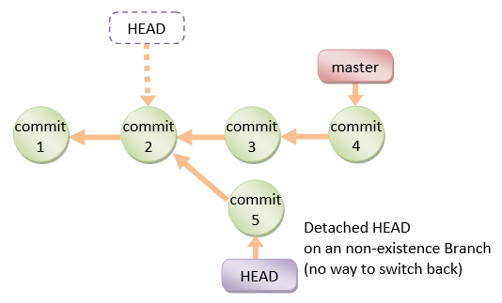](https://i.stack.imgur.com/OlavO.png)

On the command line, it will look like this - SHA-1 instead of the branch name since the HEAD is not pointing to the tip of the current branch:

[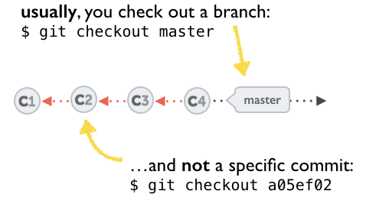](https://i.stack.imgur.com/qplvo.png)

[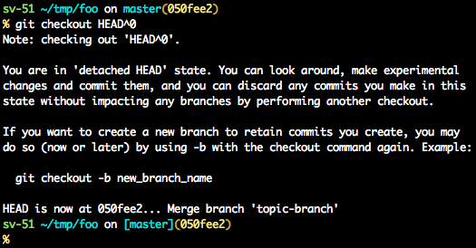](https://i.stack.imgur.com/U0l3s.png)

A few options on how to recover from a detached HEAD:

[git checkout](https://git-scm.com/docs/git-checkout)

git checkout <commit_id>

git checkout -b <new branch> <commit_id>

git checkout HEAD~X // x is the number of commits to go back

This will checkout new branch pointing to the desired commit.  
This command will checkout to a given commit.  
At this point, you can create a branch and start to work from this point on.

# Checkout a given commit.

# Doing so will result in a `detached HEAD` which mean that the `HEAD`

# is not pointing to the latest so you will need to checkout branch

# in order to be able to update the code.

git checkout <commit-id>

# Create a new branch forked to the given commit

git checkout -b <branch name>

[git reflog](https://git-scm.com/docs/git-reflog)

You can always use the reflog as well.  
git reflog  will display any change which updated the HEAD and checking out the desired reflog entry will set the HEAD back to this commit.

**Every time the HEAD is modified there will be a new entry in the reflog**

git reflog

git checkout HEAD@{...}

This will get you back to your desired commit

[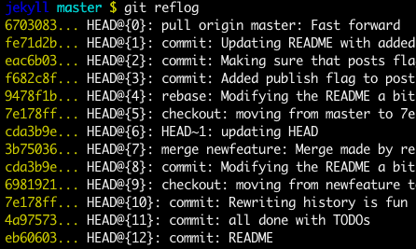](https://i.stack.imgur.com/atW9w.png)

[***git reset --hard <commit_id>***](https://git-scm.com/docs/git-reset)

"Move" your HEAD back to the desired commit.

# This will destroy any local modifications.

# Don't do it if you have uncommitted work you want to keep.

git reset --hard 0d1d7fc32

# Alternatively, if there's work to keep:

git stash

git reset --hard 0d1d7fc32

git stash pop

# This saves the modifications, then reapplies that patch after resetting.

# You could get merge conflicts if you've modified things which were

# changed since the commit you reset to.

* Note: ([Since Git 2.7](https://github.com/git/git/blob/master/Documentation/RelNotes/2.7.0.txt)) you can also use the git rebase --no-autostash as well.

[***git revert <sha-1>***](https://git-scm.com/docs/git-revert)

"Undo" the given commit or commit range.  
The reset command will "undo" any changes made in the given commit.  
A new commit with the undo patch will be committed while the original commit will remain in the history as well.

# Add a new commit with the undo of the original one.

# The <sha-1> can be any commit(s) or commit range

git revert <sha-1>

This schema illustrates which command does what.  
As you can see there, reset && checkout modify the HEAD.

[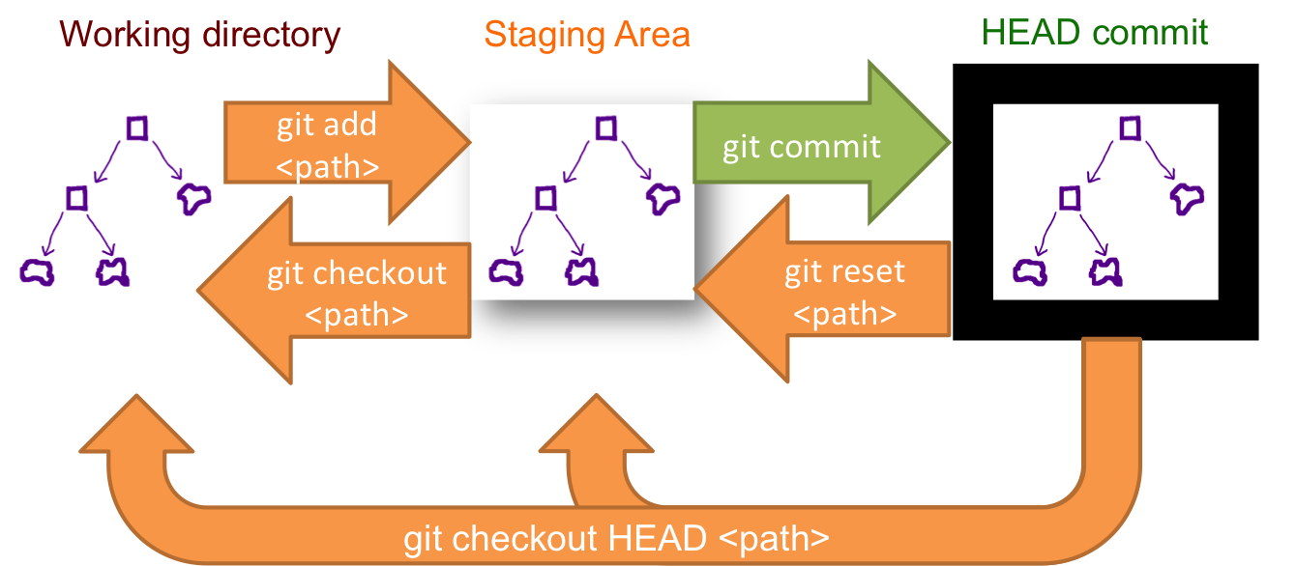](https://i.stack.imgur.com/NuThL.png)