Network Architecture Diagram
The following diagram illustrates the microservices architecture deployed across three availability zones. Each service communicates via gRPC with TLS mutual authentication.
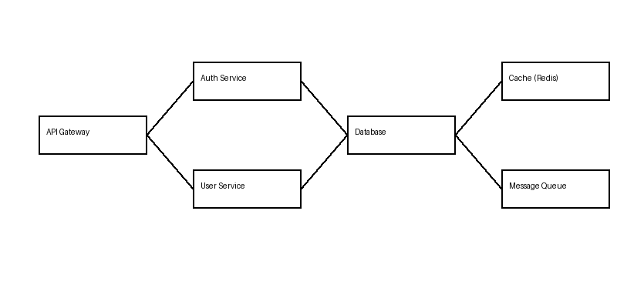

Service Descriptions
- API Gateway
Routes external requests to internal services. Handles rate limiting, request validation, and response caching. Implemented with Envoy Proxy.
- Auth Service
Manages user authentication and authorization. Issues JWT tokens with configurable expiration. Integrates with OAuth2 providers including Google, GitHub, and Okta.
- User Service
Core user management: registration, profile updates, preferences storage. Emits events to message queue for downstream consumers (analytics, email notifications, audit logging).

