## Twitter Bot for Trends

## Problem Statement

With the current popularity with social media, it acts as a platform for the spreading of fake news without the verification. A bot is required to verify this information and thus prevent the spreading of false information. Before propagating the information it would need to generate meaningful sentences are there aren't many platforms to achieve this.

## Motivation

* **Power of Bots**

Bots are used all over the internet for various purposes such as entertainment and customer service, but can be used in many more places.

* **Mumbai Police**

The Mumbai police department has a widespread and highly effective twitter account that benefits a lot of citizens with up-to-date news and a platform to file complaints.

* **Why Twitter-bots?**
  + Unbiased
  + Reduces the chance of error
  + Eliminates work redundancy

## Scope of the Project

The output of the project will be a Twitter-bot that will post summarised tweets about topics that are trending on Twitter every day. Approximately thirty percent of the implementation of the project will be completed by November 2019. The remaining will be completed by March 2020. The included modules will be for (1) fetching the current trends from Twitter, (2) verifying the information from reliable sources, (3) paraphrasing the sentence, (4) tweeting the generated sentence along with a link to a reliable source.

This project has the potential to spread information to thousands of people about the current trends on social media, may it be related to actual news, a fad or even a popular song. It may only verify a small hashtag and post a tweet related to it, but this small tweet will reach many.

## Project Details

### Planned Architecture

The planned architecture for the project mainly consists of 3 parts.

1. The server on which the bot with primarily be run.
   * It will call the API using the appropriate libraries which in turn will either retrieve or post information to Twitter.
   * It will operate the web automation and scraping which will be used to acquire more details about the trends and verify them as well.
   * All NLP tasks will also run on the server based on the information retrieved from the web scraping.
2. Twitter as a platform from which we can get the trends as well as post tweets.
3. A news source to obtain more information on the trend.

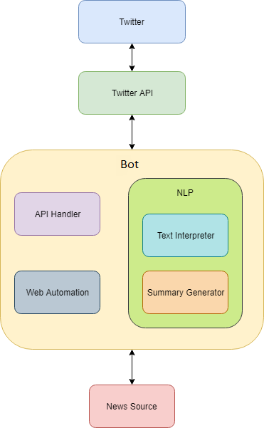

### Implementation Approach

**Twitter API**

## Resource URL

## https://api.twitter.com

We can use this API to retrieve the ongoing trends at any particular geographic location, thus available for use. This Twitter official API is available for use and needs input parameter as Location in terms of latitude and longitude.

Using this we can get the particular tweets of a trend or a hashtag, also we can use this API to tweet our own produced tweets.

We can also get the trend volume, I.e the number of tweets done using that particular trend.

#### API Resource Information

|  |  |
| --- | --- |
| Response formats | JSON |
| Requires authentication? | Yes |
| Rate limited? | Yes |
| Requests / 15-min window (user auth) | 75 |
| Requests / 15-min window (app auth) | 75 |

#### Twitter API Interface Library

There are a variety of twitter interface libraries in a variety of languages and platforms. We plan to implement this project in python and hence have decided to use one of the following libraries

1. Tweepy
2. TwitterAPI
3. python-twitter

#### Natural Language Processing

The majority of natural language processing will be done using the Selenium library to retrieve the information and the NLTK (Natural Language ToolKit).

Tokenization, lemmatization, gathering weighted occurrences and getting sentence scores are some of the steps that we may be used for summarization of articles.

Scikit for python may also be used to understand the contextual meaning of sentences and work hand in hand with other modules to give accurate results.

**Text Summarization**

One of the approaches to text summarization is extracting parts of the document that are classified as interesting by some metric and combine them to form a short summary. Algorithms written with this approach in mind are called extractive summarization.

### Deliverables and Timeline

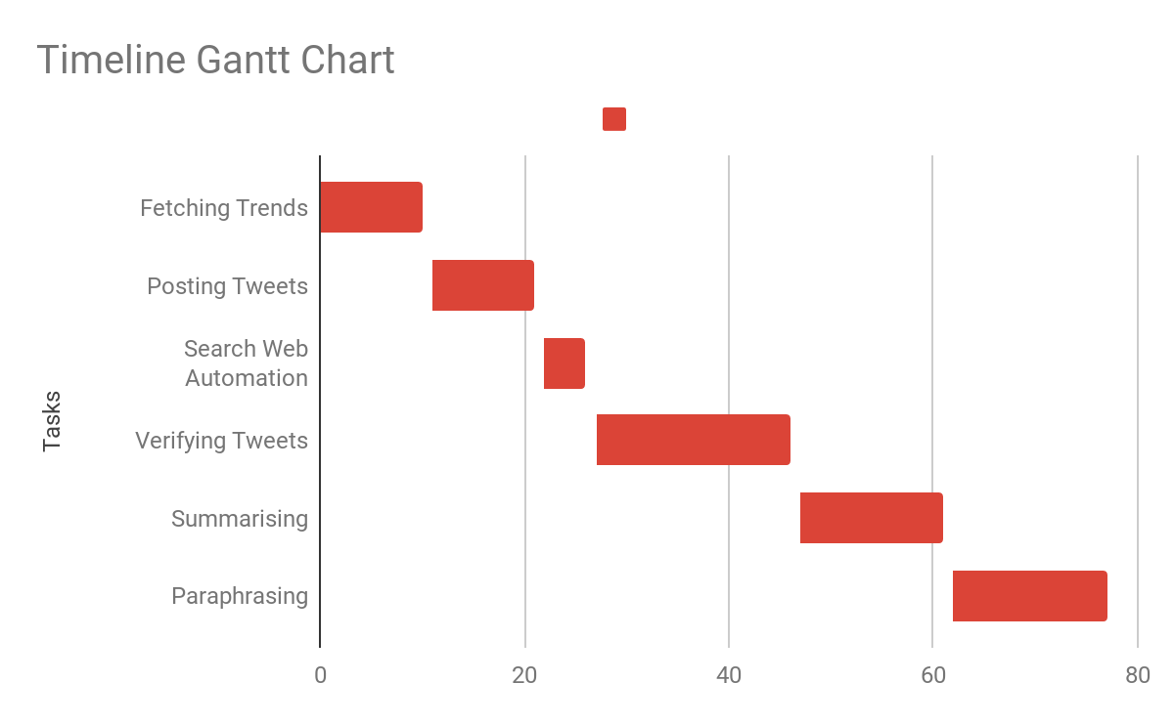

## Impact

The aim of this twitter bot is provide people with a daily source of news that does not necessarily pertain to the general understanding of news but instead gives information regarding social trends as well.

This bot will enable people who are not extremely socially active online but want to keep up with trends and will also help people who want to increase their general awareness. The bot will be a one stop solution for information on twitter in a short summary while also providing a link to a more legitimate source.

## References

1. Arkaitz Zubiaga, Damiano Spina , Raquel Martiınez , Victor Fresno, "Real-Time Classification of Twitter Trends", in *Journal of the American Society for Information Science and Technology*, 2013.
2. Regina Barzilay and Lillian Lee, "Learning to Paraphrase: An Unsupervised Approach Using Multiple-Sequence Alignment", in *Proceedings of HLT-NAAC Main Papers*, 2013.
3. D. Rofrío et al., "Presidential Elections in Ecuador: Bot Presence in Twitter," at *Sixth International Conference on eDemocracy & eGovernment (ICEDEG), Quito, Ecuador*, 2019.
4. Stefanie Haustein, Timothy D. Bowman1, Kim Holmberg2, Andrew Tsou3, Cassidy R. Sugimoto3 & Vincent Larivière, "Tweets as impact indicators: Examining the implications of automated “bot” accounts on Twitter" at *Journal of the Association for Information Science and Technology 67*, 2014.
5. <https://arxiv.org/pdf/1707.02268.pdf>
6. <https://www.cl.cam.ac.uk/~szuhg2/docs/papers/p781-gilani.pdf>
7. <https://ai.googleblog.com/2016/08/text-summarization-with-tensorflow.html>
8. <https://developer.twitter.com/en/docs/trends/locations-with-trending-topics/api-reference/get-trends-closest.html>
9. https://stackabuse.com/text-summarization-with-nltk-in-python/
10. [https://fedoramagazine.org/learn-build-twitter-bot-python](https://fedoramagazine.org/learn-build-twitter-bot-python/)/