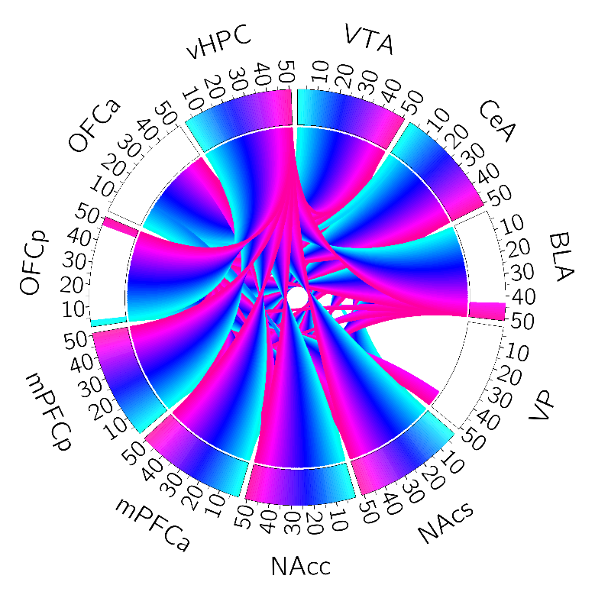

Mc2_20220812_ngtvothers

Threshold 0.08

Mc2_20220812_ngtvothers

Threshold 0.02

Mc2_20220812_ngtvothers

Threshold 0.05