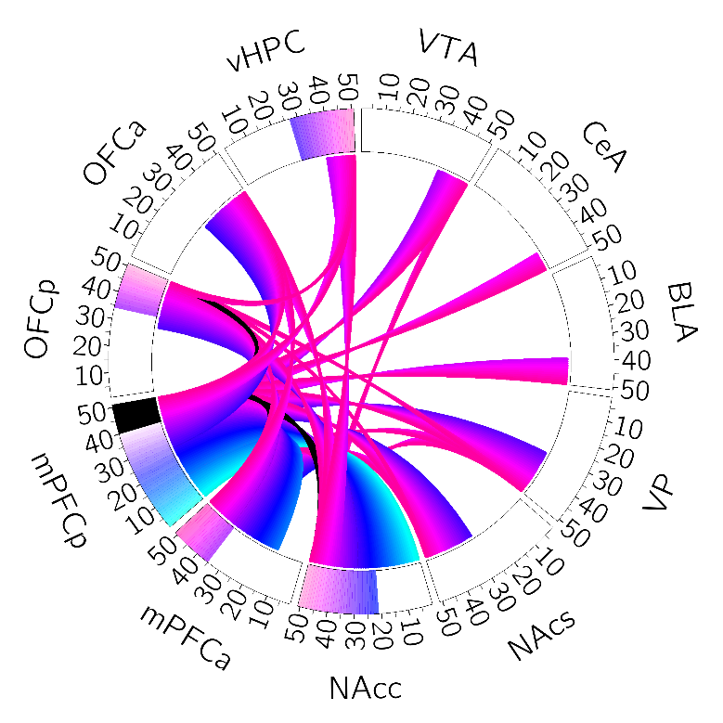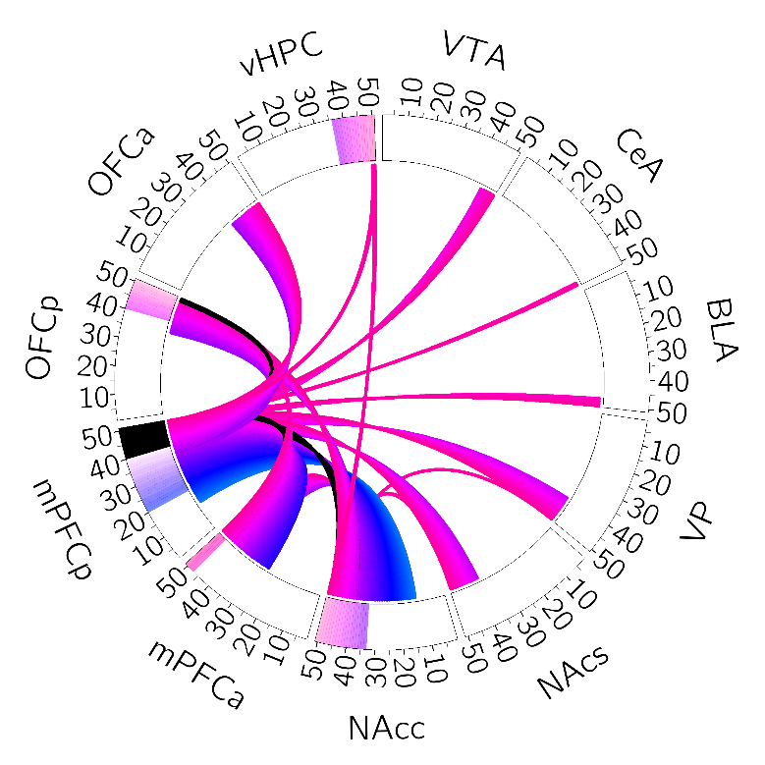

Mc2_20220815_ngtvothers

Threshold 0.05

Mc2_20220815_ngtvothers

Threshold 0.10

Mc2_20220815_ngtvothers

Threshold 0.14