Clouds Course

Assignment 2 Deliverable

**Name:**

Michele Ferrero

**Email:**

ferrerom@eurecom.fr

**Run Locust for 3 minutes each on (i) locally deployed numericalintegral, (ii) VM scaleset with 2 VMs where you shutdown the VM running the workload after 1 minute, (iii) autoscale webapp initially configured with 1 instance and max 3, (iv) autoscale function. Save locust output. Plot a graph of number of successful requests/seconds with one line for each of the four cases above. Paste the graph below.**

*Your answer:*

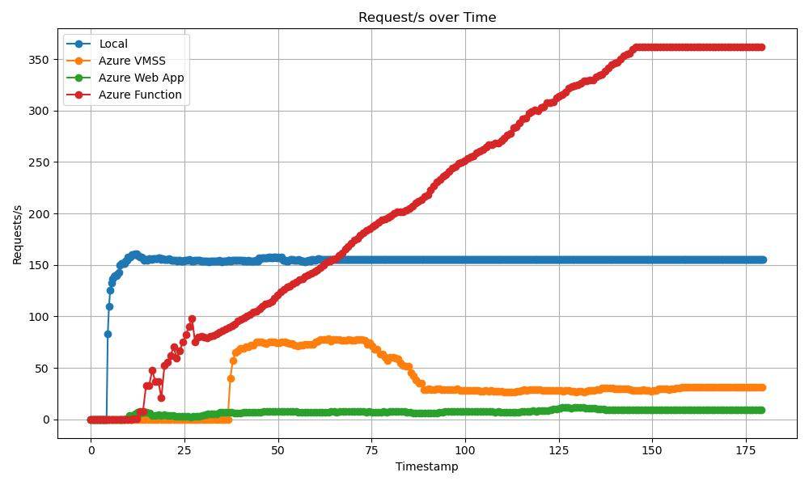

**What is the address of the numerical integrap webapp where we can access your site?**

*Your answer: microservicewebappintegral.azurewebsites.net  
Example: https://microservicewebappintegral.azurewebsites.net/numericalintegralservice/0/3.14159*

**What is the address of the numerical integrap function deployment?**

*Your answer:* [*https://integralazurefunction.azurewebsites.net*](https://integralazurefunction.azurewebsites.net)

*Example:*

*https://integralazurefunction.azurewebsites.net/api/numericalintegralservice/0/3.14159*

**What is the address of the mapreduce durable function deployment where can invoke it?**

*Your answer:* [*https://mapreducefunctionmicheleferrero.azurewebsites.net*](https://mapreducefunctionmicheleferrero.azurewebsites.net)

*Example: https://mapreducefunctionmicheleferrero.azurewebsites.net/api/orchestrators*

**What is the gitlab URL where you have saved your assignment code?**

*Your answer: https://gitlab.eurecom.fr/ferrerom/code_lab_2*