Social centers in Rome

by Michele Gava

February 2021

Coursera Data Science Capstone Project

Table of contents

Table of contents 2
Introduction 2
Background 3
Data 4
Methodology 7
Data acquisition 7
Explorative data analysis 9
Cluster analysis 12
Results 17
Discussion 19
Conclusions 20
References 20

Introduction

Suppose a social cooperative providing social services for the city of Rome (Italy)

This organization is in charge by Rome's administration to supply services to prevent youth discomfort.

They decided to open social centers in various locations of the city, to provide places where young people can meet and find informations and support

Due to budget limitations, the organization needs to find the areas of the city where this service is needed the most, in order to concentrate their limited financial rescources.

So they reached our Data Science Team and toghether we decided to work on the following question:

Can we find Rome's neighboroods where a social center is most needed?

As we will see in more details in the Results section, we will be able to:

- identify a big cluster of zones with highest discomfort profile (60 zones out of 155)
- suggest the following 5 zones to start our customer's project:
- S. Alessandro
- Magliana
- Barcaccia
- Infernetto
- Lucrezia Romana

Background

Rome is the capital and biggest city of Italy, with a population of 2,808,293 at 01.01.2021 (source: www.istat.it) and a territory of 1,285 km²

It has several administrative subdivision; one of them is the subdivion in "Zone urbanistiche di Roma" ("Rome's urbanistic zones"), which can approximate the concept of neighborhood, establised in 1977 for statistical and territorial planning reasons. This divides Rome's territory in 155 Zones (= Neighborhoods), grouped in 15 "Municipi" (=Boroughs)

You can find more on Wikipedia: https://it.wikipedia.org/wiki/Zone_urbanistiche_di_Roma (I apologize for been only in italian) and on google maps: https://www.google.com/maps/d/u/0/viewer?mid=1E4TpQ9oftDIBneEK4KzDFwQfbvQ&ll=41.89062981328977%2C12.346966041866727&z=11

The following image (taken from Wikipedia page) shows the map of Rome's urbanistic zones

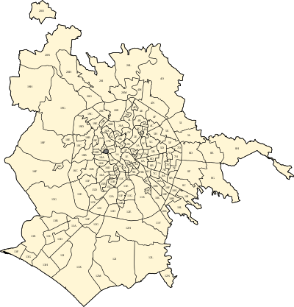
For the objective of our analyses, we look for a method to create "profiles" of Rome's neighborhoods, such that we can create groups (clusters) of neighborhoods which are similar with respect of:
- socio-demographic factors:
economic and social situation can be seen as a factor of discomfort, so we want a neighborhood's profile to take account of it
- density of venues:
shortage of venues where people can meet (including bars, restaurants, cinemas, theatres, museums, and so on) can motivate the needing of a social center as an alternative for young people

The underlying idea is that if we can find the clusters where the above-mentioned factors are low, than those neighborhoods that belong to these clusters are those who requires our service the most.

Data

As stated in the background section, we need both socio-demographic and location data

1. socio-demographic data

For this category of data, we can rely on a paper from Italian National Institute of Statistics ("Istat")

This paper reports a set of socio-economic indicators for all of the 155 Zones of Rome. It's available only in PDF format from ISTAT's site, but we can leverage tabular-py Python's library to scape the tables of data from the document (https://pypi.org/project/tabula-py/)

The document in only in Italian, but We'll provide description of all relevant features.

In this image we show a preview of the data available in the paper:

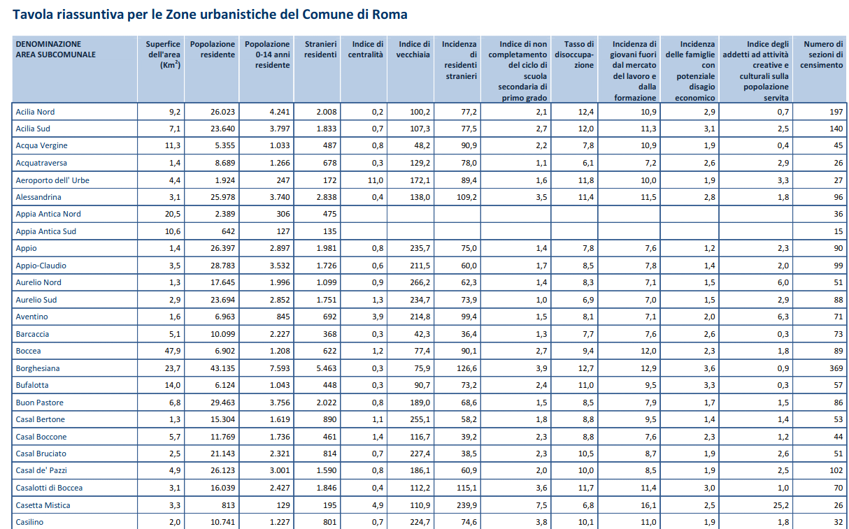
In the first column, we find the name of each zone (in the image we see only the first zones in alphabetical). Subsequent columns represent an indicator that we will map to a feature in a Pandas data frame:
- Surface (squared km)
- Population
- Pop0-14 (Population with age less or equal 14 years)
- Foreigners (Number of)
- Centrality index (ratio between exiting commuters and incoming commuters)
- Old Age Index (Population 65+ old over total population)
- School Dropout Rate
- Unemployment Rate
- Neet Rate (Percentage of population aged 15-29 not working, not studying, not looking for a job)
- Economic Discomfort Index (Percentage of families with sons, with no member with a job)
- Cultural Employees Index

(Note: data from 2011 Italian Census)

2. location data

For this category of data, we can leverage Foursquares APIs in order to retrieve:
- venues in every neighborhood, using the explore endpoint and the coords retrieved on previews step
- category of each venue from the response, in order to build the venues profile of each neighborhood
- as we are not intrested in detailed venues categories, we will perform our analysis on macro-categories of venues, as defined on Foursquare categories page
- for geo-localization of the zones, we will use the shapefiles of Rome's territory provided by the web-site #mapparoma: https://www.mapparoma.info/zone-urbanistiche/, witch we will handle through geopandas geo-spatial plotting library and folium

Methodology

Data acquisition

As stated, we extract socio-economic data from the cited paper and store data on a Pandas dataframe. This is a preview of the results:

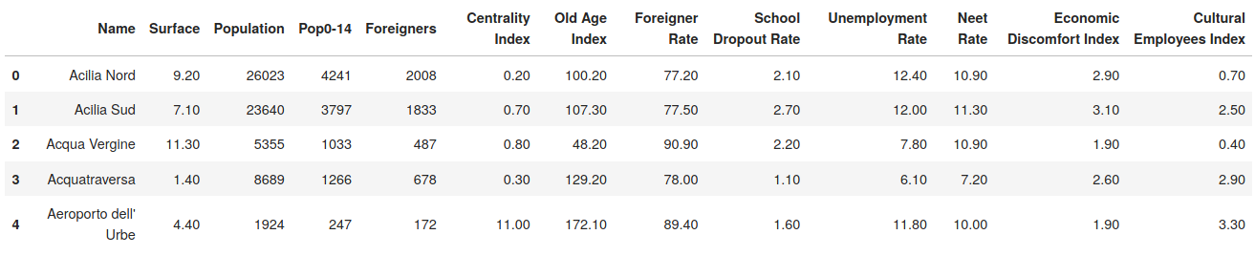
Next, we retrieve geo-localization data (coordinates) for each zone in the data set, by downloading shapefiles from www.mapparoma.info and using geopandas Python library to read the file and calculate centroids for each zone:

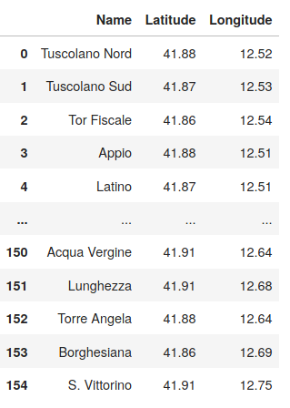

For venues data, we use Foursquare explore API which provides venues near to the centroids of each zone, with category for each venue. Then, we collapse categories to each ancestor “macro category” as defined by Foursquare, as we do not need detailed analysis on sub-categories
Here’s a preview of the resulting data frame:

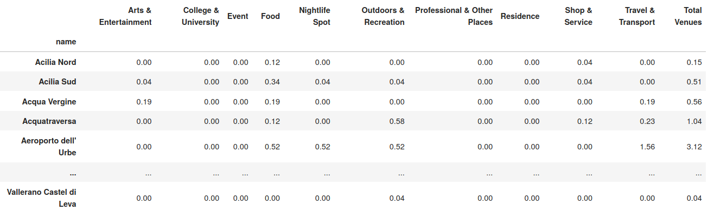

Explorative data analysis

First, we show summary statistics on socio-demographic features:
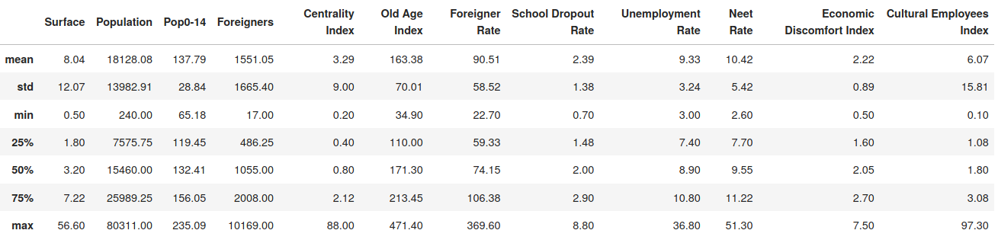 Summary statistics of socio-demographic features
Next, we display histograms of their distributions:

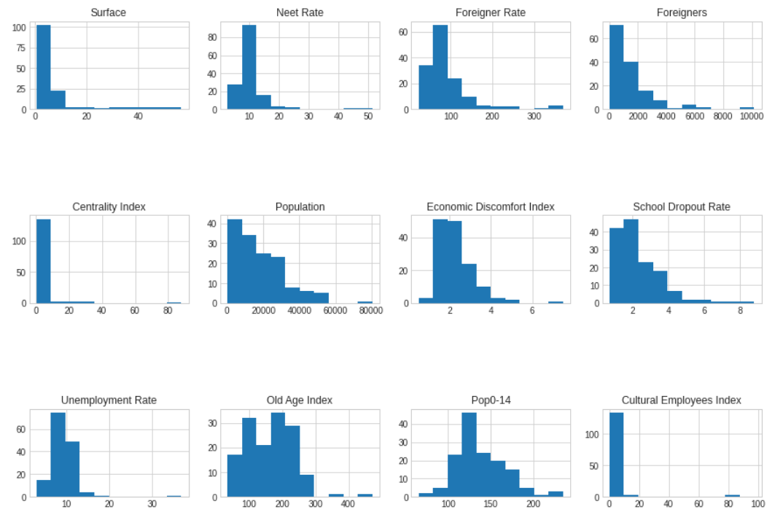Distributions of socio-demographic features

Observations:
- We see high variability in Size and population
- Age indicators are also very variable, with a median of 132 pop 0-14 per 1,000 residents, but with minimum of 65 through a maximum of 235. This means we have very young zones beside very old ones
- Economic indicators such as Unemployment Rate, Neet Rate, Economic Discomfort Index, tend to be less dispersed, but show very high spikes that would need some further investigation (left for projects to come...)

Territorial distribution is shown in figures below:

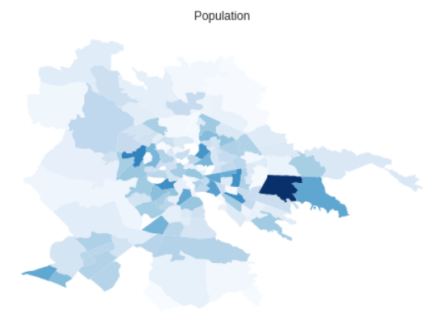
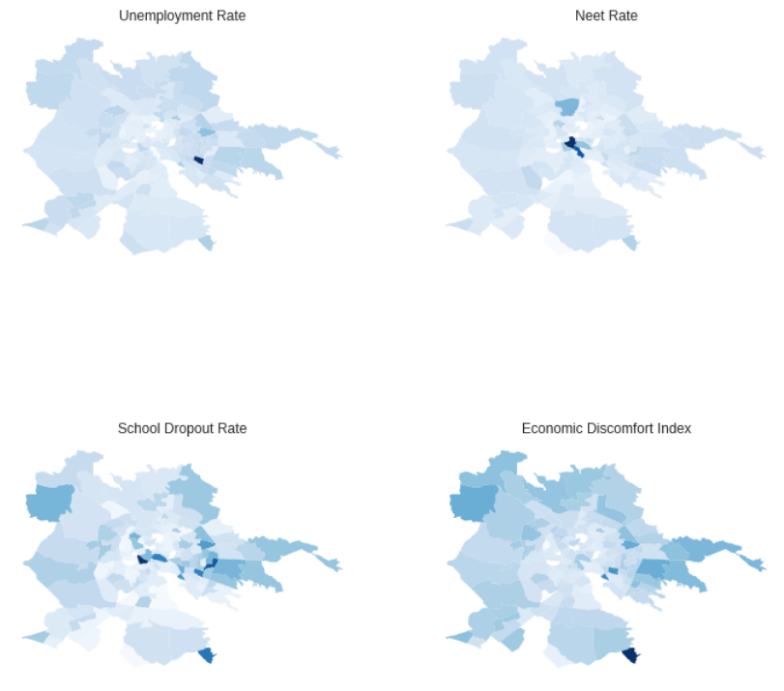
Here we see as economic indicators tend to perform worst on periphery zones, with some interesting exceptions.

For venues data, unfortunately they tend to be generally very low. So, in the next sections, we’ll concentrate on "Total Venues" feature

Here we present some summaries:

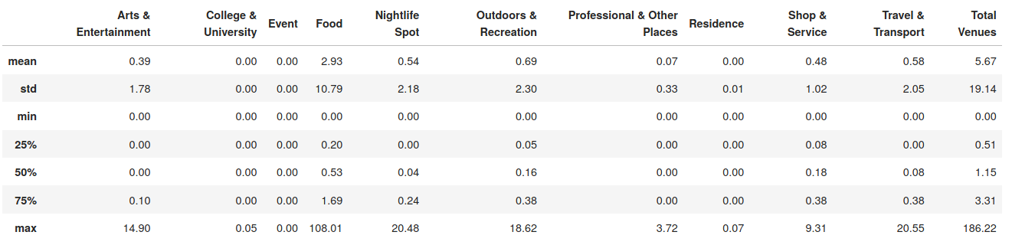Summary statistics on venues data
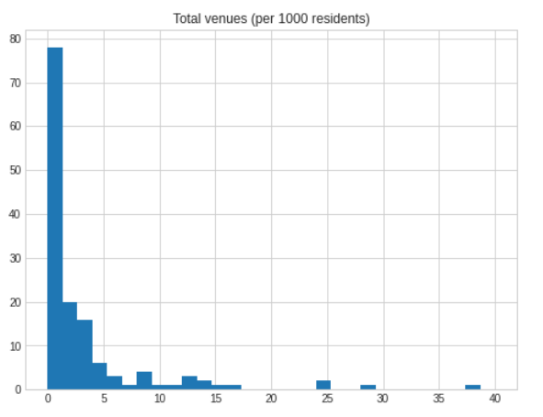Distribution of total venues per 1,000 residents

Cluster analysis

For our main purpose, we choose to perform Cluster analysis on our zones data set
As pre-processing step, we decided to:
- remove Latitude, Longitude and Surface features, as they are of no interest for this task
- remove Foreigners feature, as this feature is collinear with Foreigner Rate and Population
- perform standardization on remaning features via scikitlearn's Standard Scaler class ((X - µ ) / σ )

As clustering Algorythm, we opted for K-Means clustering.

In order to find the best number of clusters, we performed 10 runs of clustering with increasing value of k (1..10), calculated Inertia and Silhouette score metrics for each k in (1..10) and evaluated results via visual inspection of the resulting plots (“elbow” method)

In the next figure, we show the metrics results (Inertia and Silhouette):

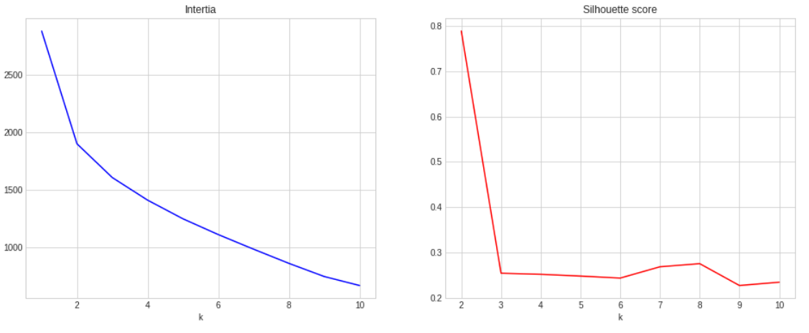
Observations:
- Applying the elbow method on Inertia plot doesn't provide istantaneous result, but we can say that the optimal number of cluster lies between 2 and 4
- Silhouette scores show that there are 2 clear clusters, but for our purposes this number is too low
Further experiments (we don't show here these results) showed that we can choose 3 as the optimal number of clusters, so we go on with clustering our zones in 3 clusters
Next, we present results of the clustering procedure:
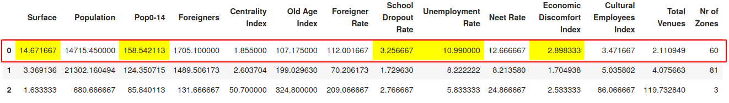Summaries of cluster analysis
Observations:

> We can see that our zones are bucked in three distinct groups:
* "Cluster 0": poor socio-economic indicators and shortage of available venus
* "Cluster 1": better socio-economic indicators and venues availability
* "Cluster 2": a very tiny cluster, with only 3 zones with very low population and sufrace and singular behaviour
> For our purposes, we can say that
* Cluster 2 has no interest, as it's probably composed of singular zones that can be left apart for our analysis
* Cluster 0 is what we are looking for, as it's a huge cluster of zones sharing these characteristics:
* High surface
* Relatively young population
* Low centrality (periphery zones)
* School Droput, Unemployment and Economic Discomfort above the mean
* Venues availability below the mean

So, considering only clusters 0 and 1, we can plot their respective profiles:
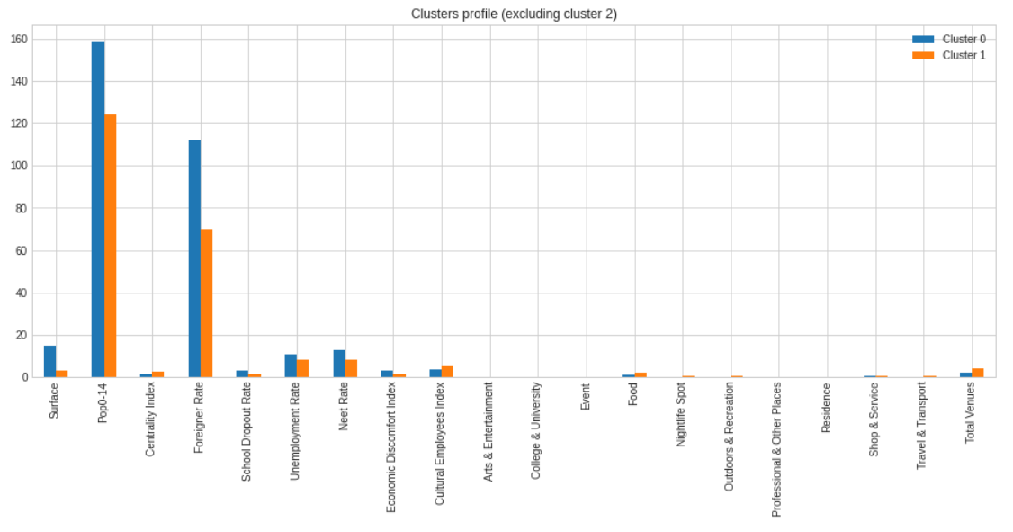
We see that the plot confirms our first impression
Now, let’s take a look of the territorial distribution of our clusters
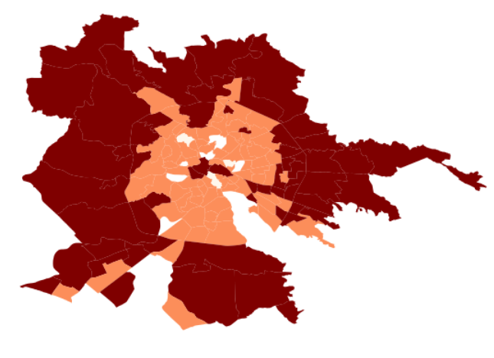Territorial distribution of clusters
There’s a quite strong evidence that zones in cluster 0 (dark colored) are mostly localized at the periphery of the city
Having decided to point our attention on Cluster 0, it has to be sad that this is still a huge cluster with 60 zones.
So, it's of much interest to find a further criterion to sub-divide cluster 0 and find most interesting zones inside it
This can be a task for other clustering algorythms, such as Hyerarchical (agglomerative) clustering. But for now, we keep it simple: as our customer's target is younger people, we simply sort our cluster on Pop0-14 rate and conclude suggesting the 5 youngest zones, as shown below:

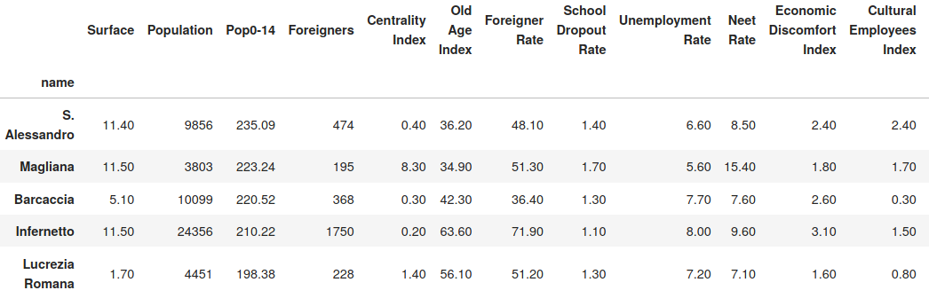Five zones in cluster 0 with highest youth index
Geo-location of these five zones is shown in the map below:
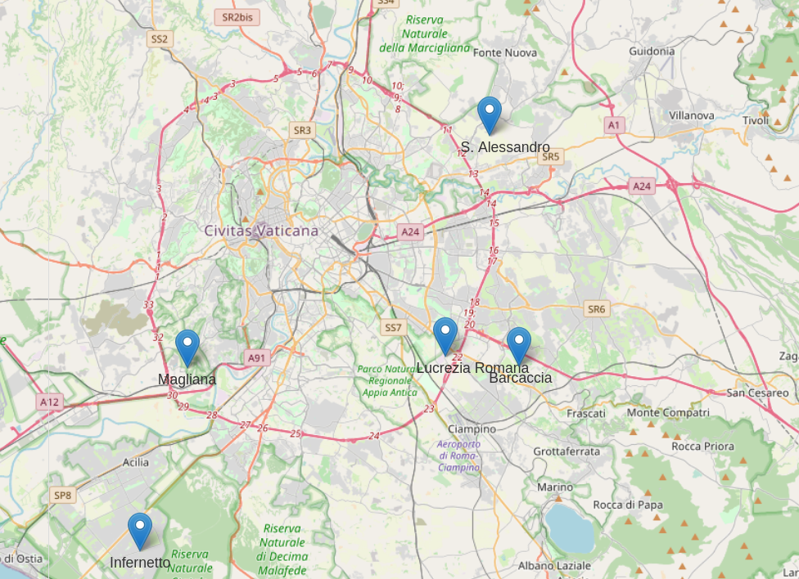Geolocation of the 5 youngest zone in cluster 0

Results

As primary result, we identified a main cluster (Cluster "0") of Rome's urbanistic zones (“neighborhoods”) which we find particulary suitable for a social center

The 60 zones in this cluster are shown below:

Acilia Nord, Acilia Sud, Acqua Vergine, Alessandrina, Barcaccia, Boccea, Borghesiana, Bufalotta, Casalotti di Boccea, Casetta Mistica, Castelluccia, Centro Direzionale Centocelle, Centro Storico, Cesano, Corviale, Decima, Esquilino, Fidene, Fogaccia, Giardinetti-Tor Vergata, Gregna, Grottarossa Ovest, Infernetto, La Rustica, La Storta, Labaro, Lucrezia Romana, Lunghezza, Magliana, Malafede, Massimina, Mezzocammino, Omo, Ostia Antica, Ostia Nord, Ottavia, Pantano di Grano, Ponte Galeria, Porta Medaglia, Prima Porta, Quadraro, Romanina, S. Alessandro, S. Basilio, S. Cornelia, S. Maria della Pietà, S. Maria di Galeria, S. Vittorino, Santa Palomba, Settecamini, Tor Cervara, Tor Fiscale, Tor S. Giovanni, Tor Sapienza, Torre Angela, Torre Maura, Torrespaccata, Trastevere, Tufello, Vallerano Castel di Leva

These are the main statistics on this cluster

Mean values for cluster 0

Among these 60 zones, we further recommend to begin opening social centers in these 5 zones, which show the highest rate of young population:

- S. Alessandro
- Magliana
- Barcaccia
- Infernetto
- Lucrezia Romana

And this is the location of these zones

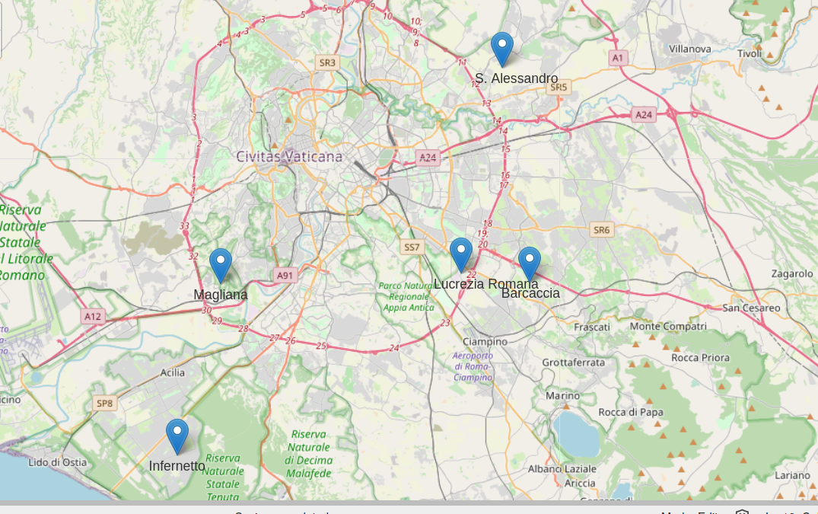

Discussion

There are some points of improvement that are wortn-noting:
- First of all, we can retrieve more data on economic factors. For example, scraping from www.mercato-immobiliare.info (a web-site providing house prices for Italy at a very fine-grained territorial level) we can retrive sales price and rent price for houses and apartements.
- As stated in Methodology section, our Cluster 0 is still a very big cluster, with 60 zones. We can try an alternative clustering approach, such as Hyerarchical agglomerative clustering in order to find more narrow clusters where to point our attention
- The choice of top 5 recommended zones was done based on arbitraty sorting by youth rate. We can think about a better criterion
- Clustering algorythms don't tell us the whole story. It would be very interesting (especially when more features will become available) to implement some analytic technique which can provide more insights. A good candidate is Factor Analysis, which can be useful in finding hidden factors describing our data
- scraping venues data from Foursquare hasn't provided great results. We can try with other sources of venues data such as Google's

Conclusions

In this project we were able to identify a big cluster of neighborhoods in the city of Rome where the need for a social center is particularly high.

We scraped data from a paper published by Italian Institute of Statistics (Istat) to retrieve socio-demographic information on the 155 Urbanistic zones, using tabula-py Python library for pdf scraping, and retrieved informations on venues available in each zone using Fousquare explore API. Furthermore, we used shapefiles from www.mapparoma.info, geopandas and folium Python libraries to geo-locate the zones and display geo-located results

We applied k-means cluster analysis using scikitlearn's cluster module as clustering algorythm and grouped Rome's neighbohoods in 3 clusters. One of these clusters ("Cluster 0") was identified as the most suited for our customer's purpose

Finally, we selected the 5 most suitable zones among Cluster 0 by simply sorting by youth rate, and provide this zones as recommended zones where to start-up our customer's project

In the discussion section, we also provided suggestions for further development and investigation

References

- Istituto nazionale di statistica: www.istat.it

- Mapparoma: https://www.mapparoma.info/

- On cluster analyses: https://en.wikipedia.org/wiki/Cluster_analysis

- gitHub repo of this project: https://github.com/MicheleGava/battle_of_neighborhoods_w1

