JavaScript Project Proposal – DRAFT 1
- Oct. 31, 2017, Michele Mussatto

“Michele’s Art” Selector - Fave Holder - Interest Email Generator

Purpose

Allow users to search my 100+ pieces of artwork by Category, Subject Matter and Medium. This will be a web application that will reside on my personal portfolio website to generate emails from people who might be interested in my work.

Actions Users Will Take

Users will choose options from 3 pull down menus and then click a “Go” button to bring up a random piece of art within those search parameters. With buttons below they will be able to pick a different piece or save the piece to their “My Faves” box. Or they can put in different search parameters to search again. Users will be able to click art in their My Faves box to generate an email message to me with a generic message saying “I am interested in buying this art, or commissioning you to make me one like it!”, along with a text area where they can put additional questions or contact info.

Data Source

The data source will be created by me, and will contain artwork items with the following values: jpg of piece, name of piece, category, subject matter, and medium.

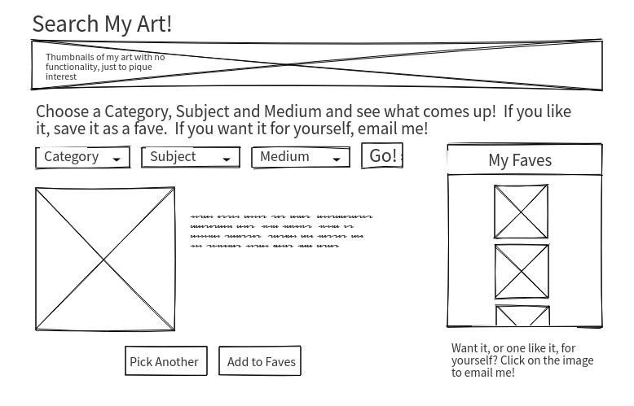
Categories

Fine Art
Logos
Graphic Design
Photography
Illustration

Subject

Faces
Still Life
Music
Sex
Nature
Promo
Instructional

Medium

Silkscreen
Lithography
Photography
Pencil
Ink
Watercolor
Digital

Color Scheme

https://color.adobe.com/create/color-wheel/?base=2&rule=Custom&selected=2&name=ScottIanAnthraxKillthraxTour%2020171&mode=rgb&rgbvalues=0.013654171320493402,0.01278980905585695,0.1,0.6218452715112968,0.6747546400256228,0.8823529411764706,0.8392156862745098,0.36787898492060733,0.33242238657423145,0.47843137254901963,0.435810531180677,0.3338996179531757,0.29411764705882354,0.20812704530859627,0.123362743541286&swatchOrder=0,1,2,3,4

dark blue: 030319
light blue: 9FACE1
light red: D65E55
dark beige: 7A6F55
medium brown: 4B351F

Google Font
Questrial
https://fonts.google.com/?utm_source=google&utm_medium=cpc&utm_campaign=1001467+|+Material.IO+|+Global+|+en+|+Hybrid+|+Text+|+BKWS&utm_term=%7Bkeyword%7D&gclid=CjwKCAjwhOvPBRBxEiwAx2nhLm39mltzX9zWsC8u0n5U-0gqVtEo9cTUjm_wIQdX6LpEPuJBgq_MIBoCy7wQAvD_BwE&selection.family=Questrial

