School : Computer Science
Institution : University of Windsor
Term : Fall 2026
Course : Comp-3150 (03-60-315-1) : Database Management Systems
Instructor : Dr. C. I. Ezeife
Assignment #2: Total : 50 marks
Handed Out: Thurs. Oct. 1, 2026; Due Thurs. Oct. 29, 2026

Objective of Assignment: To test on knowledge and design of relational model constraints, relational database schemas, functional dependencies and normalization of relational databases.
Scope: Assignment covers materials from Chapters 5 and 14 of book discussed in class.
Electronic Assignment Submission: Done through http://brightspace.uwindsor.ca.
Marking Scheme : The mark for each of the questions is indicated beside each question.
Academic Integrity Statement : Remember to submit only work that is yours and include the following confidentiality agreement and statement at the beginning of your assignment.

CONFIDENTIALITY AGREEMENT & STATEMENT OF HONESTY
I confirm that I will keep the content of this assignment/examination confidential.
I confirm that I have not received any unauthorized assistance in preparing for or doing this assignment/examination. I confirm knowing that a mark of 0 may be assigned for copied work.
________________________________________ ________________________________________
Student Signature Student Name (please print)
________________________________________ ________________________________________
Student I.D. Number Date

Marking Scheme : The mark for each question and sub question is shown with the question below. Place your solutions in tables where possible.

For office Use only
Question | Mark
1 | /20
2 | /10
3 | /10
4 | /10
Total | /50

CHAPTER 5: THE RELATIONAL DATA MODEL AND RELATIONAL DATABASE CONSTRAINTS

- (Total marks 20) Given the same simple 2026 FIFA World cup soccer database schema, which contains three files/tables described as follows, answer the following questions with regards to this database.
(Total for que 1 is 10 marks)
Country (Coid: integer, Name: string, Population: integer, Regionid: integer)
Plays (Coid1: integer, Coid2: integer, Playdate: string, Result: string)
RegionFIFA (Regionid: integer, Regionname: string, Numcountry: integer)
Note : Coid, Name, Population and Regionid represent the countrid id, name, population in millions of people and region or continent id of the country respectively. Also, when there are more than one Coid attributes appearing in the same file/table as in Plays, for uniqueness purposes, they are given unique names of Coid1 and Coid2 to represent a statement like Country id 1 plays with country id 2 on playdate (pick a date in June/July 2026. It may not be the actual play date) to achieve a result by country 1 of win, loss, or NA. The file/table RegionFIFA provides more information about the region or continent such as Asia, Africa, North America, South America, Antarctica, Europe and Australia that each of the countries in the database comes from. The variable Numcountry records the number of countries in the stated region or continent. To fill your instance, you may use any web page with such data or try this link: https://www.adda247.com/school/country-names/.
Assume that an update operation (a general term in this chapter, for an insert, a modify or a delete operation) is to be made to this database to enter information about a new country (e.g., Mexico, England, France) not already in the database but which also played in this world cup tournament. Answer the following questions on what specific relations, attributes and operations (eg. insert, modify, delete) that need to be done for this update to be implemented in the entire database. This is not SQL query yet.

Provide your answers both in descriptive sentence and using the formal (not SQL) database operations of INSERT, MODIFY, DELETE as used in Chapter 5 of book with specific attributes and relations when possible. An example formal insert of a country record into the Country table is:
INSERT < Coid, Name, Population, Regionid> into Country // for new Country record.
And an example descriptive sentence is:
do an insert operation for a new country record into the Country table.
(a) Give the set of needed insert, modify or delete operations for this update operation scenario described above. 5 marks
(b) What types of integrity constraints (explain using attributes, e.g., COID of relevant files) would you expect to check for this update to be done? 5 marks
(c) Which of these integrity constraints are key, entity integrity, and referential (foreign key) integrity constraints and which are not? 5 marks
(d) Specify all the referential integrity (foreign key) constraints on this database in the format Referring_Relation.Attribute --> Referred_Relation.Attribute. 5 marks
(Total for que 1 is 20 marks)
Solution:
Question | Answers
a. Give the operations for this update.  5 marks | One possible set of operations for the given update is the following:  i. Insert a new record for Mexico into the Country relation. Mexico is assigned a new unique Coid of 5 and uses Regionid 10 because Mexico belongs to North America.  ii. Insert a new record into the Plays relation to show a match involving Mexico. For example, Mexico (Coid 5) plays Canada (Coid 1) on June 18, 2026, with a result of Win for Mexico.  These operations can be specified in more formal English (not SQL) operations as follows:  INSERT <5, Mexico, 130, 10> into Country  INSERT <5, 1, 18-Jun-2026, Win> into Plays  No DELETE operation is required. No modification to RegionFIFA is required because Regionid 10 for North America already exists.
b. What types of integrity constraints would you expect to check? (explain using attributes, eg, Ssn of relevant files)  5 marks | The following integrity constraints should be checked when adding the new country and its match:  1. Key constraint: The new Country.Coid must be unique. Therefore, Coid 5 must not already exist in Country. RegionFIFA.Regionid must also be unique, and the combination (Coid1, Coid2, Playdate) in Plays must uniquely identify a match.  2. Entity integrity constraint: Primary key attributes cannot be NULL. Therefore, Country.Coid cannot be NULL, RegionFIFA.Regionid cannot be NULL, and the primary-key attributes Coid1, Coid2 and Playdate in Plays cannot be NULL.  3. Referential integrity constraint: Country.Regionid must refer to an existing RegionFIFA.Regionid. Therefore, Mexico's Regionid 10 must already exist in RegionFIFA. Plays.Coid1 and Plays.Coid2 must also refer to existing Country.Coid values.  4. Domain constraint: Attribute values must belong to their correct domains. Coid, Population and Regionid must be integers, Name must be a string, and Plays.Result must have an allowed value such as Win, Loss, or NA.  5. Semantic constraint: A country should not play against itself in one match; therefore Plays.Coid1 must not be equal to Plays.Coid2.
c. Which of these integrity constraints are key, entity integrity, and referential integrity constraints and which are not?  5 marks | The constraints can be classified as follows:  Key constraints:  Country.Coid is the key of Country and must be unique. RegionFIFA.Regionid is the key of RegionFIFA and must be unique. The combination (Coid1, Coid2, Playdate) is the key of Plays and must be unique.  Entity integrity constraints:  Primary key values cannot be NULL. Therefore Country.Coid, RegionFIFA.Regionid, and the primary-key attributes Coid1, Coid2 and Playdate of Plays cannot be NULL.  Referential integrity constraints:  Country.Regionid must refer to an existing RegionFIFA.Regionid. Plays.Coid1 and Plays.Coid2 must each refer to an existing Country.Coid.  Not key, entity, or referential integrity constraints:  The requirement that Plays.Result be Win, Loss, or NA is a domain constraint. The requirement that Plays.Coid1 must not equal Plays.Coid2 is a semantic constraint.
d. Specify all the referential integrity constraints on this database.  5 marks | We will write a referential integrity constraint as R.A --> S.A (or R.(X) --> T.A) whenever attribute A (or the set of attributes X) of relation R form a foreign key that references the primary key of relation S (or T).  Country.Regionid --> RegionFIFA.Regionid  Plays.Coid1 --> Country.Coid  Plays.Coid2 --> Country.Coid

- (total marks 10) Using your own 2026 FIFA World cup soccer database schema instance from assignment 1, login to the SQL query processor on our cs server, called Oracle Sqlplus to create the three database tables and insert the tuples in your database state with the following sequence of instructions. The entity tabes need to be created first before the relationship tables that are referencing them or it will complain. Thus, follow your table creation in the order given in the instructions. Note that this exercise is to get you beginning to connect to SQLplus while preparing to learn full SQL language syntax in Chapters 6 and 7. You will be given the instructions to use now. Show the result of this exercise through a Unix script file you will attach as a .txt file. (Total for que 2 is 10 marks)
i. First connect to our cs.uwindsor.ca through either Bitvise SSH client or NoMachine. You need to connect to global protect before connecting to any campus server. Check course web site and brightspace pages for more details on how.
- Then hand in a Unix script file to capture your Unix session when you connect to Sqlplus after your instructions for creating your database are working. You can create your Unix script file using the following sequence of instructions on a Unix terminal on our cs server. You need to transfer this script file to your personal computer using a file transfer protocol (eg. Bitvise SFTP or Filezilla) in order to attach it in your assignment submission.

>script username_assn2que2.txt
>sqlplus <username>
>password
SQL> CREATE TABLE REGIONFIFA(
REGIONID NUMBER(3) NOT NULL,
REGIONNAME VARCHAR2(20),
NUMCOUNTRY NUMBER(3),
PRIMARY KEY(REGIONID));

SQL> CREATE TABLE COUNTRY
(
COID NUMBER(3) NOT NULL,
NAME VARCHAR2(20) NOT NULL,
POPULATION NUMBER(3),
REGIONID NUMBER(3) NOT NULL,
PRIMARY KEY (COID),
FOREIGN KEY(REGIONID) REFERENCES COUNTRY(REGIONID));

SQL> CREATE TABLE PLAYS
(
COID1 NUMBER(3) NOT NULL,
COID2 NUMBER(3) NOT NULL,
PLAYDATE DATE,
RESULT VARCHAR2(10),
PRIMARY KEY(COID1, COID2, PLAYDATE),
FOREIGN KEY(COID1) REFERENCES COUNTRY(COID),
FOREIGN KEY(COID2) REFERENCES COUNTRY(COID));

SQL> -- A sample insert of a record into each of the 3 tables is given below
SQL> INSERT INTO REGIONFIFA VALUES (1, ‘Asia’, 48);
SQL> INSERT INTO COUNTRY VALUES(7, ‘Argentina’, 45, 4);
SQL> INSERT INTO PLAYS VALUES (24, 32, ‘02-jul-26’, ‘NA’);
SQL> COMMIT;
// Repeat similar INSERT instructions for all the data in all your tables
// starting with the entity tables first, eg, RegionFIFA, Country before Plays.

SQL> select * from cat; // to show all the objects in your catalogue

SQL> select * from Country; // to show the contents of this table

SQL> exit //to exit sqlplus

>exit // to exit and create Unix script file to hand in

** More Hint: While in Sqlplus, if you want to delete data from your tables and drop them before issuing your instructions for creating your Unix script file for handing in, you can use the following instructions for each table to first delete the data from the table and then drop the table.
delete from REGIONFIFA;
delete from COUNTRY;
delete from PLAYS;
commit;
drop table PLAYS cascade constraints;
drop table COUNTRY cascade constraints;
drop table REGIONFIFA cascade constraints;
commit;
***
Also Note: you can start creating a script file only after you have created your tables correctly and inserted data in the tables. In that case, you cannot re-create existing tables. Then, you can just run the desc table (eg. Desc Country) command for each table to show the structure of each table before using (for example), the (select * from Country;) to show the tuples of each table or delete data and drop the tables as explained above so you can re-create the tables more correctly.
Solution: (10 marks)
An attached Unix script file showing execution of CREATE TABLE instructions and INSERT INTO tablename VALUES instructions with the few SELECT instructions to show contents of the catalogue and all tables (your database instance).

CHAPTER 14: Database Design Theory: Introduction to Normalization Using Functional and Multivalued Dependencies
3. (total marks 10) Consider the following relation:
Enrolled(Studid, Crsid, SName, Score, Lettergrade)
Assume that a student (Studid) may be enrolled in multiple courses (Crsid) and hence
{Studid, Crsid } is the primary key.
Thus, the following functional dependency exists:
{Studid, Crsid } -> {SName, Score, Lettergrade}
Additional functional dependencies are:
Studid -> SName
Score -> Lettergrade

Based on the given primary key,
- is this relation in 1NF, 2NF, or 3NF? Why or why not?
- If not in 2NF at least, normalize it completely into 2NF and 3NF? Provide your answers by first showing the tables when first normalized into the 2NF and next when normalized in the 3NF showing the functional dependencies (FDs) of the normalized tables at each stage.. (Total for que 3 is 10 marks)
Solution (i): (5 marks)
Answer:

Given the relation schema
Enrolled (Studid, Crsid, SName, Score, Lettergrade)

with the functional dependencies
{Studid, Crsid } -> {SName, Score, Lettergrade}
Studid -> SName

Score -> Lettergrade
(i) is this relation in 1NF, 2NF, or 3NF? Why or why not?

The relation Enrolled is in 1NF, assuming that all attribute values are atomic and single-valued. However, it is not in 2NF and therefore it is also not in 3NF.
The primary key is the composite key {Studid, Crsid}. The functional dependency Studid -> SName shows that SName depends on only part of the composite primary key, Studid, rather than on the whole key {Studid, Crsid}. Therefore, SName has a partial dependency on the primary key, which violates 2NF.
In addition, {Studid, Crsid} -> Score and Score -> Lettergrade create a transitive dependency from the primary key to Lettergrade through Score. Therefore, the original relation also does not satisfy 3NF.
Hence, the highest normal form of the original Enrolled relation is 1NF.

Solution (ii) (5 marks)
(ii) If not in 2NF at least, normalize it completely into 2NF and 3NF? Provide your answers by first showing the tables when first normalized into the 2NF and next when normalized in the 3NF showing the functional dependencies (FDs) of the normalized tables at each stage.
Normalization into 2NF
The partial dependency Studid -> SName is removed by decomposing the original relation into the following two relations:
STUDENT(Studid, SName)
Primary key: Studid
FD: Studid -> SName
ENROLLED_2NF(Studid, Crsid, Score, Lettergrade)
Primary key: {Studid, Crsid}
FDs:
{Studid, Crsid} -> {Score, Lettergrade}
Score -> Lettergrade
In ENROLLED_2NF, Score and Lettergrade depend on the complete primary key {Studid, Crsid}; therefore there is no partial dependency on only Studid or only Crsid. The relations are therefore in 2NF.
However, ENROLLED_2NF is not yet in 3NF because Score -> Lettergrade creates a transitive dependency.
Normalization into 3NF
ENROLLED_2NF still contains the transitive dependency Score -> Lettergrade. This dependency is removed by decomposing it further into the following relations:
STUDENT(Studid, SName)
Primary key: Studid
FD: Studid -> SName
ENROLLMENT(Studid, Crsid, Score)
Primary key: {Studid, Crsid}
FD: {Studid, Crsid} -> Score
GRADE(Score, Lettergrade)
Primary key: Score
FD: Score -> Lettergrade
These relations are in 3NF because all non-key attributes depend on the key, the whole key, and nothing but the key. There are no partial or transitive dependencies remaining.

4. (total marks 10) What (i) update, (ii) delete and (iii) insertion anomalies occur in the DEPARTMENT_PROJECT relation obtained by doing a natural join of the two relations DEPARTMENT and PROJECT of Fig 14.2 on page 463 of book? Explain with examples using this database and the DEPARTMENT_PROJECT relation schema with state given below as Figures 4.1 and 4.2 below. (Total for que 4 is 10 marks)

Note: 3 marks for correct discussion of each anomaly and 1 mark for attempt.

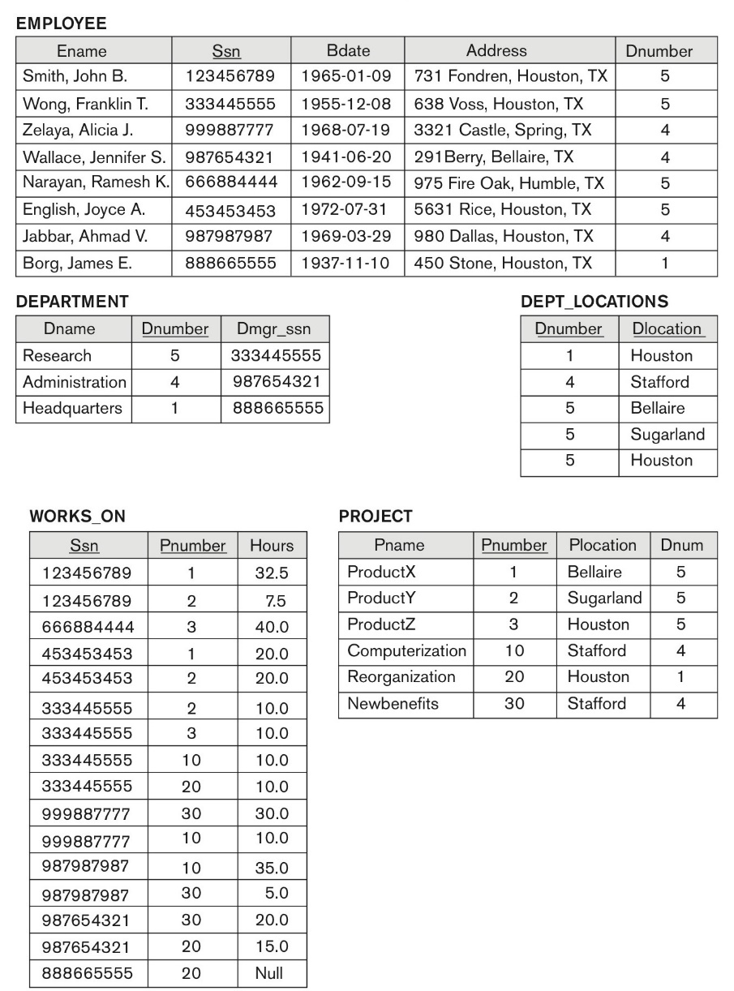
Figure 14.2 (book): Sample database state for a simplified COMPANY relation DB
****

Fig 4.1: DEPARTMENT_PROJECT DB schema suffering from update anomalies
Dnumber Pnumber Dname Dmgr_ssn Pname Plocation
FD1
FD2
FD3

***
Fig 4.2: A database state of the DEPARTMENT_PROJECT DATABASE derived from Fig 14.2
DNUMBER PNUMBER DNAME DMGR_SSN PNAME PLOCATION
-------------- ---------------- ----------- --------------- ------------- -------------------
5 3 Research 333445555 ProductZ Houston
5 10 Research 333445555 Computerize Stafford
5 20 Research 333445555 Reorganize Houston
5 30 Research 333445555 Nbenefits Stafford
5 1 Research 333445555 ProductX Bellair
5 2 Research 333445555 ProductY Sugarland
4 3 Administration 987654321 ProductZ Houston
4 10 Administration 987654321 Computerize Stafford
4 20 Administration 987654321 Reorganize Houston
4 30 Administration 987654321 Nbenefits Stafford
4 1 Administration 987654321 ProductX Bellair
4 2 Administration 987654321 ProductY Sugarland
1 3 Headquarters 888665555 ProductZ Houston
1 10 Headquarters 888665555 Computerize Stafford
1 20 Headquarters 888665555 Reorganize Houston
1 30 Headquarters 888665555 Nbenefits Stafford
1 1 Headquarters 888665555 ProductX Bellair
1 2 Headquarters 888665555 ProductY Sugarland

18 rows selected.
Solution: (3 + 3 + 3 + 1 marks)
- Update Anomalies:
An update anomaly occurs because department and project information is repeated in many tuples of DEPARTMENT_PROJECT. If one fact changes, every copy of that fact must also be changed.
For example, department number 5, Research, with manager SSN 333445555 appears in six different tuples. If the department name changes from Research to Research and Development, all six tuples must be updated. If only some tuples are updated, the database would contain inconsistent department names for the same Dnumber.
Similarly, project number 1, ProductX, with location Bellair appears in three tuples, one for each department. If the location of ProductX changes, all three tuples must be modified. Failure to update every copy would create inconsistent data.
- Delete Anomalies: : A delete anomaly occurs because information about departments and projects is stored together in the same relation. Deleting tuples representing one fact can unintentionally remove all stored information about another fact.
For example, if all tuples involving department number 1 are deleted in order to remove its project associations, all information about the Headquarters department and its manager 888665555 would also disappear from DEPARTMENT_PROJECT, even if the department itself should still remain in the database.
Similarly, if all tuples containing project number 30 are deleted, all information about the Nbenefits project and its Stafford location would disappear. Thus, deleting relationship information can accidentally delete department or project information.
- Insertion anomaly:
An insertion anomaly occurs because a department and a project cannot easily be entered independently into the combined DEPARTMENT_PROJECT relation.
For example, suppose a new department with Dnumber 7, Dname Sales, and manager SSN 111111111 is created but has not yet been assigned a project. The department cannot be inserted properly because values for Pnumber, Pname and Plocation would also be required.
Conversely, suppose a new project with Pnumber 40, Pname AIProject, and Plocation Detroit is created but has not yet been assigned to a department. The project cannot be inserted properly without also providing Dnumber, Dname and Dmgr_ssn.
Therefore the combined relation causes an insertion anomaly because information about a department or project cannot be stored independently.

