Intro_to_RMarkdown_Session1

Michelle Laker

2024-11-29

# Abstract

Some text here

I just love to write and talk (blah blah blah …)

## Subheading signified by double hashes

Some more text here

### More sections

text goes here

**in bold**

*this should be in italics* superscripted

This is where the Methods Section link # Data and Methods {#section-methods}

# Lists

1. My paper has a neural network
2. It has 3 parameters
3. I love it
4. code
5. data
6. everything is available



R Logo

# Tables

| A | B | C | D | E |
| --- | --- | --- | --- | --- |
| 0 | 2 | 0 | 2 | 0 |
| 1 | 0 | 0 | 0 | 1 |
| 0 | 1 | 0 | 1 | 1 |

# How to include code blocks

print("Hello world")  
x <- 2+3  
print(x)

## R Markdown

This is an R Markdown document. Markdown is a simple formatting syntax for authoring HTML, PDF, and MS Word documents. For more details on using R Markdown see <http://rmarkdown.rstudio.com>.

When you click the **Knit** button a document will be generated that includes both content as well as the output of any embedded R code chunks within the document. You can embed an R code chunk like this:

summary(cars)

## speed dist   
## Min. : 4.0 Min. : 2.00   
## 1st Qu.:12.0 1st Qu.: 26.00   
## Median :15.0 Median : 36.00   
## Mean :15.4 Mean : 42.98   
## 3rd Qu.:19.0 3rd Qu.: 56.00   
## Max. :25.0 Max. :120.00

## Including Plots

You can also embed plots, for example:



Note that the echo = FALSE parameter was added to the code chunk to prevent printing of the R code that generated the plot.

# headings  
  
cat("Hello world")

## Hello world

z = 6/2  
cat(z)

## 3

download.file(url="https://raw.githubusercontent.com/cambiotraining/reproducibility-training/master/data/gapminder_data.csv", destfile="data/gapminder_data.csv")

My paper has a section [text]

## Warning: package 'tidyverse' was built under R version 4.3.2

## Warning: package 'dplyr' was built under R version 4.3.2

## ── Attaching core tidyverse packages ──────────────────────── tidyverse 2.0.0 ──  
## ✔ dplyr 1.1.4 ✔ readr 2.1.4  
## ✔ forcats 1.0.0 ✔ stringr 1.5.0  
## ✔ ggplot2 3.4.4 ✔ tibble 3.2.1  
## ✔ lubridate 1.9.3 ✔ tidyr 1.3.0  
## ✔ purrr 1.0.2   
## ── Conflicts ────────────────────────────────────────── tidyverse_conflicts() ──  
## ✖ dplyr::filter() masks stats::filter()  
## ✖ dplyr::lag() masks stats::lag()  
## ℹ Use the conflicted package (<http://conflicted.r-lib.org/>) to force all conflicts to become errors

## Warning: package 'kableExtra' was built under R version 4.3.3

##   
## Attaching package: 'kableExtra'  
##   
## The following object is masked from 'package:dplyr':  
##   
## group_rows

## Warning: package 'ggpubr' was built under R version 4.3.3

## Rows: 1704 Columns: 6  
## ── Column specification ────────────────────────────────────────────────────────  
## Delimiter: ","  
## chr (2): country, continent  
## dbl (4): year, pop, lifeExp, gdpPercap  
##   
## ℹ Use `spec()` to retrieve the full column specification for this data.  
## ℹ Specify the column types or set `show_col_types = FALSE` to quiet this message.

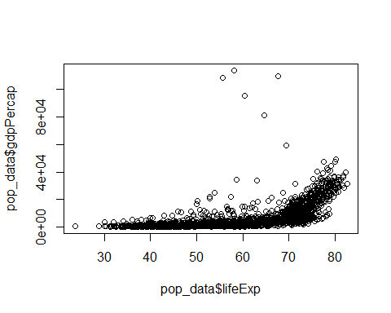

##Challenge Attempt  
euro_data$year <- as.factor(euro_data$year)  
euro_plot <- ggplot(data = euro_data, mapping = aes(x = year, y = lifeExp)) + geom_violin()  
  
uk_data <- filter(pop_data, country == "United Kingdom")  
uk_plot <- plot(uk_data$year, uk_data$lifeExp)

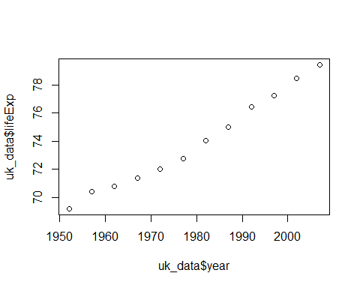

ggarrange(euro_plot, uk_plot, ncol = 2, nrow = 1)

