Name: Chen Liao

CWID: 10436441

1. **Map Program:**

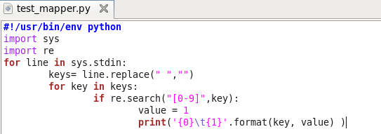

1. **The K\V pairs emitted by mapper**: (can’t see all of them, just a small part)

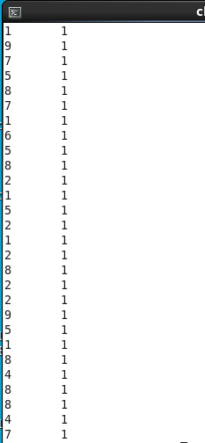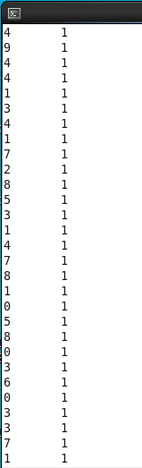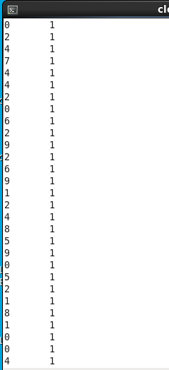

1. **Reducer Program:**

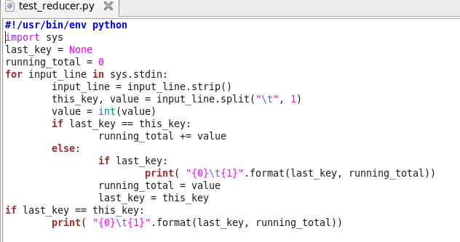

1. **The K/V pairs emitted by reducer:**

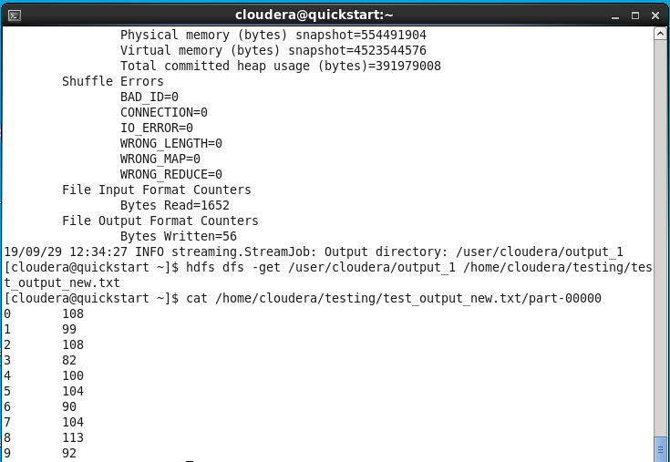

1. **The Answers** (I wrote a program to compute the answers, ran locally):

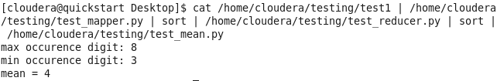

Max occurrence digit: 8

Min occurrence digit: 3

Mean: 4

Program for computing the mean:

