**Smart Bag Instructions**

This document guide is meant to help the user set up and effectively use your Smart Bag to track the items through NFC technology.

**Components Overview**

* Power Bank: Powers the NFC reader.
* NFC Reader: Detects and tracks items with NFC chips.
* NFC Chips/Stickers: Attach these to items you wish to track.

**Getting Started**

1. Ensure that raspberry pi, your laptop, and your phone are connected to the same network. (The Network the product was tested in is samba1 If you you want to change it open ./CovaliBagApp/components/Menu.js and change the ip to the new ip of raspberry pi)
2. Charge Your Bag: Ensure the power bank is fully charged before use.
3. Power On: Turn on the NFC reader using the power switch.
4. Once you installed the Covali bag folder on your computer, navigate to ‘CovaliBag > CovaliBagApp’
   1. Hold ‘Shift’ and right click in the folder, an option to open up the terminal should be available
   2. Press the terminal and type in “code .”
   3. once you’re in the code, on the top left, press the ‘Terminal’ option and press ‘New Terminal’
   4. Type in the bottom terminal “npx expo start”, a QR code should appear after

4.1

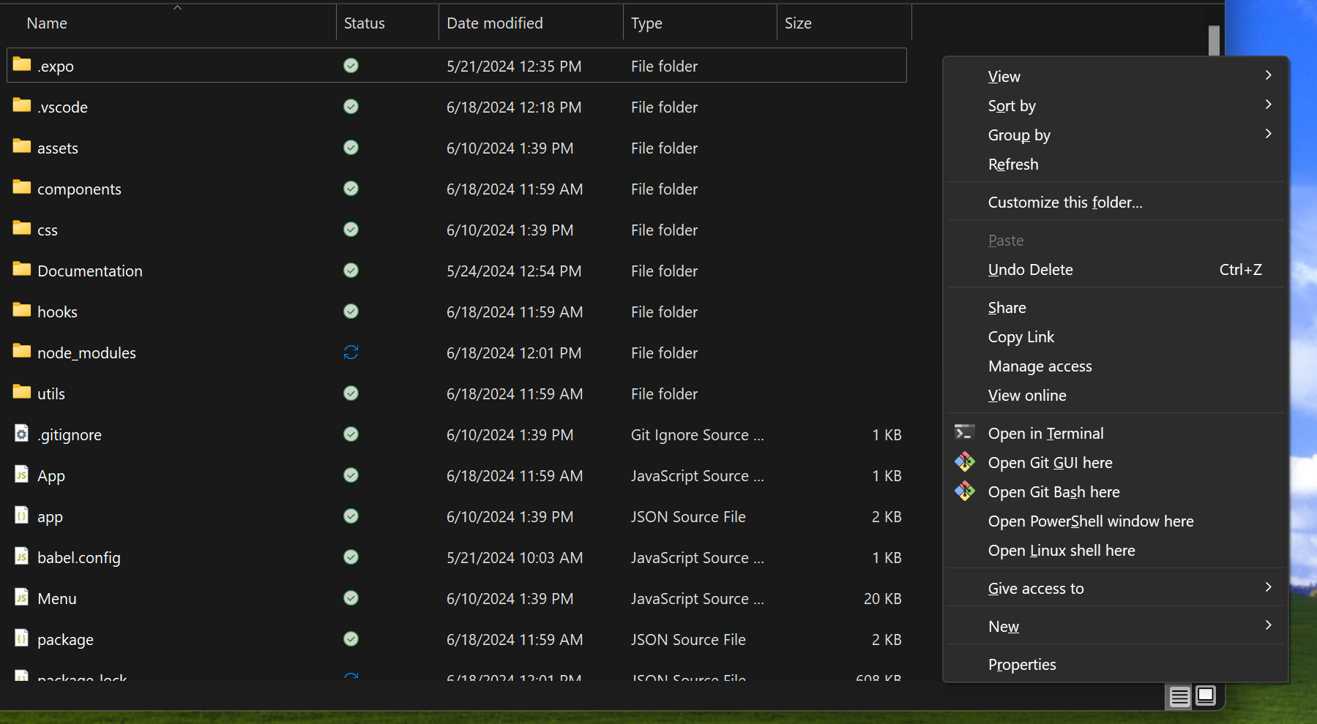



4.2

4.3

4.4

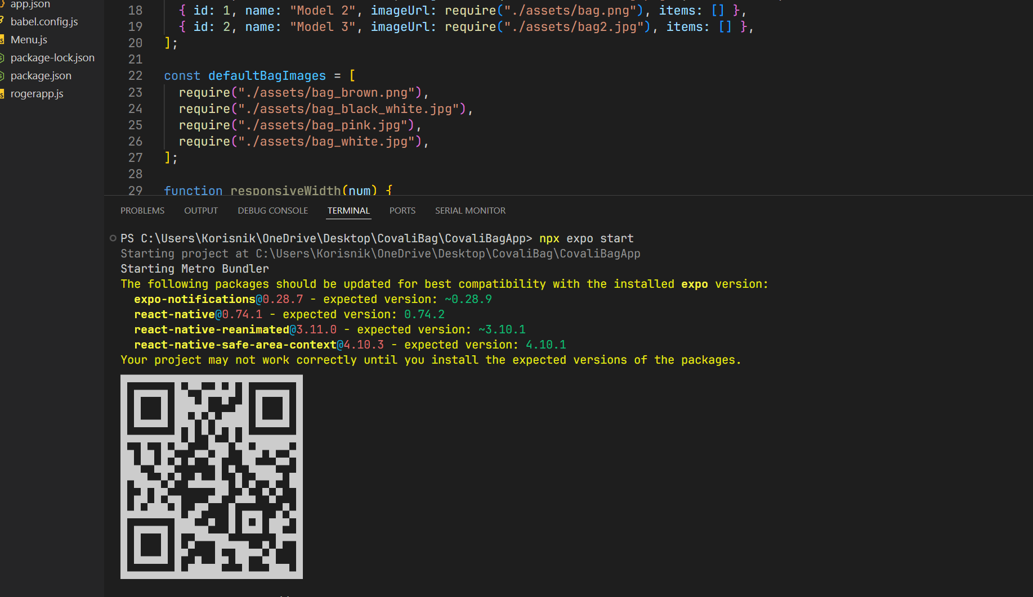

**Connecting to the App**

1. Download Expo: Available on iOS and Android.
2. Connect to WiFi: Ensure your smartphone is connected to WiFi (samba1) for initial setup.
3. Open Expo Go: Launch the application on your smartphone.
   1. Press ‘Scan QR code’
   2. Scan the QR code that is given to you from the code terminal
4. Add Your Bag:
   1. Tap the plus (+) button in the app.
   2. Confirm the addition to see your bag appear in the app.

1. 2.

3.

Adding Items

1. Place Your Item: Put the item with the NFC chip into the bag.

2.App Detection: The app will automatically detect the item.

3. Name Your Item: Enter a name for your item when prompted.

4. Item Status:

- Green Switch: Item is in the bag.

- Gray Switch: Item is not in the bag.

**Managing Items and Bags**

- View Items: Items are displayed in the app with their current status.

- Delete Items: Use the delete button to remove items from the bag.

- Add Multiple Bags: Add additional bags by pressing the plus (+) button and scroll horizontally to view different bags.

**App Features**

- Light and Dark Mode: Choose your preferred display mode for aesthetic reasons.

**Visual Guide to App Buttons**

This outline provides a structured way to help users understand and operate the Smart Bag effectively. Feel free to adjust the content according to the specifics of your application and user needs. Providing a clear and comprehensive guide will enhance the user experience and ensure they can make the most out of their smart technology.