[Library System] Requirements Specification

August 15, 2014

#### 1. Project overview:

Develop a Java GUI application using Java Swing and Collections API to maintain a books library.

#### 2. Requirements:

**2.1 Functional requirements:**

The system must have the following basic features:

- Adding, Updating and Deleting of Books

- Adding, Updating and Deleting of customers

- Customer to view the list of books available and take it on rental basis. There is no rental fee charged but the book must be returned by due date. If not, a penalty amount per day must be paid. This renting of a book is called as transaction.

- Customer should be able to view his current books taken from library and mark for returning

- Admin to notify all the customers when a new book arrives to library

- Different categories of books can be created so that each category can have many books

- Customer can opt for notifications about new books arrivals category-wise

- An image of book can as well be displayed when the customer is browsing the list of books available.

- Admin to view the following reports:

- List of customers

- List of books/category

- List of books rented out

- List of books which are yet to be rented out

- List of books overdue from customers

**2.2 Interface Requirements**

-A login interface for user to input name and password.

-An admin interface for admin to manage books and users dynamically.

-A customer interface for rent/return books, view history.

#### 3. Interface design

1. login:

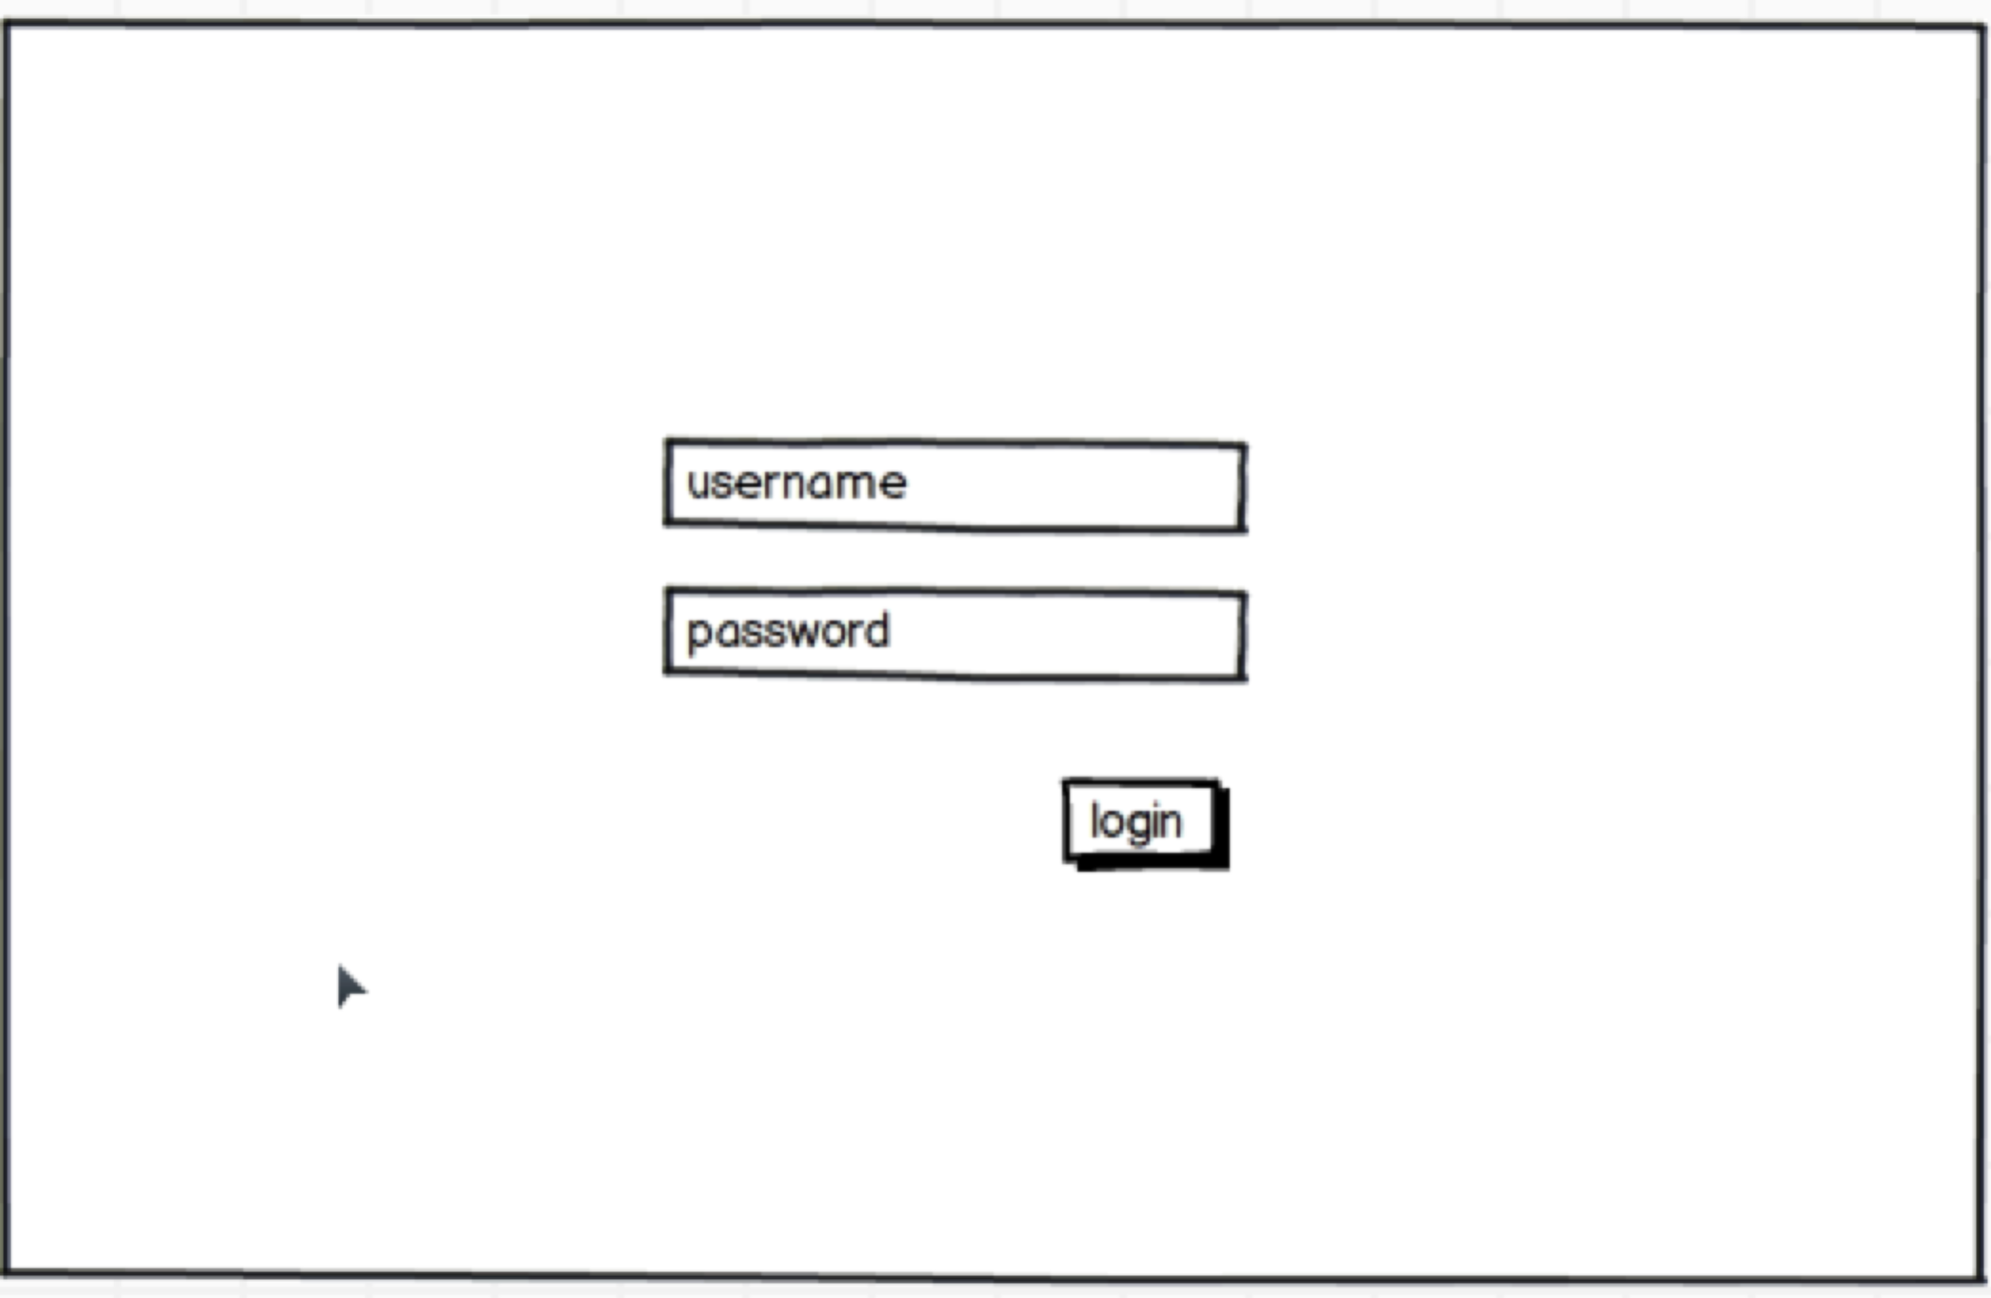

2. Admin: user management

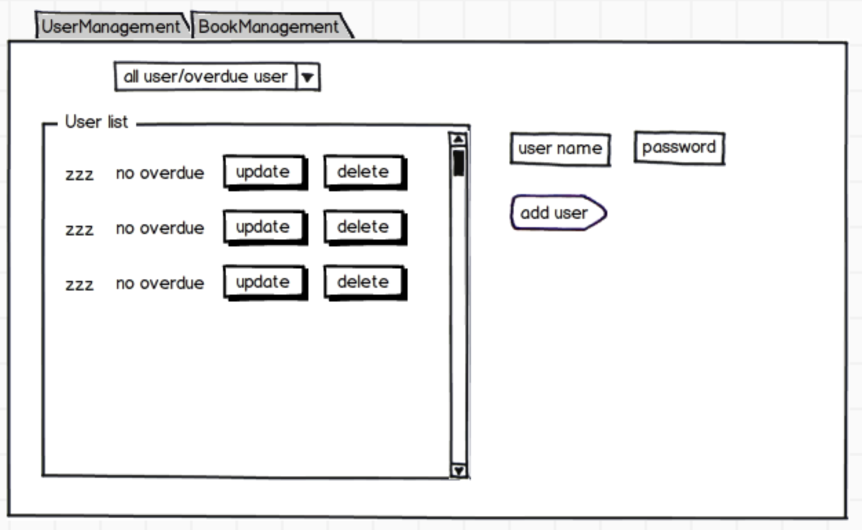

3. Admin : Book management

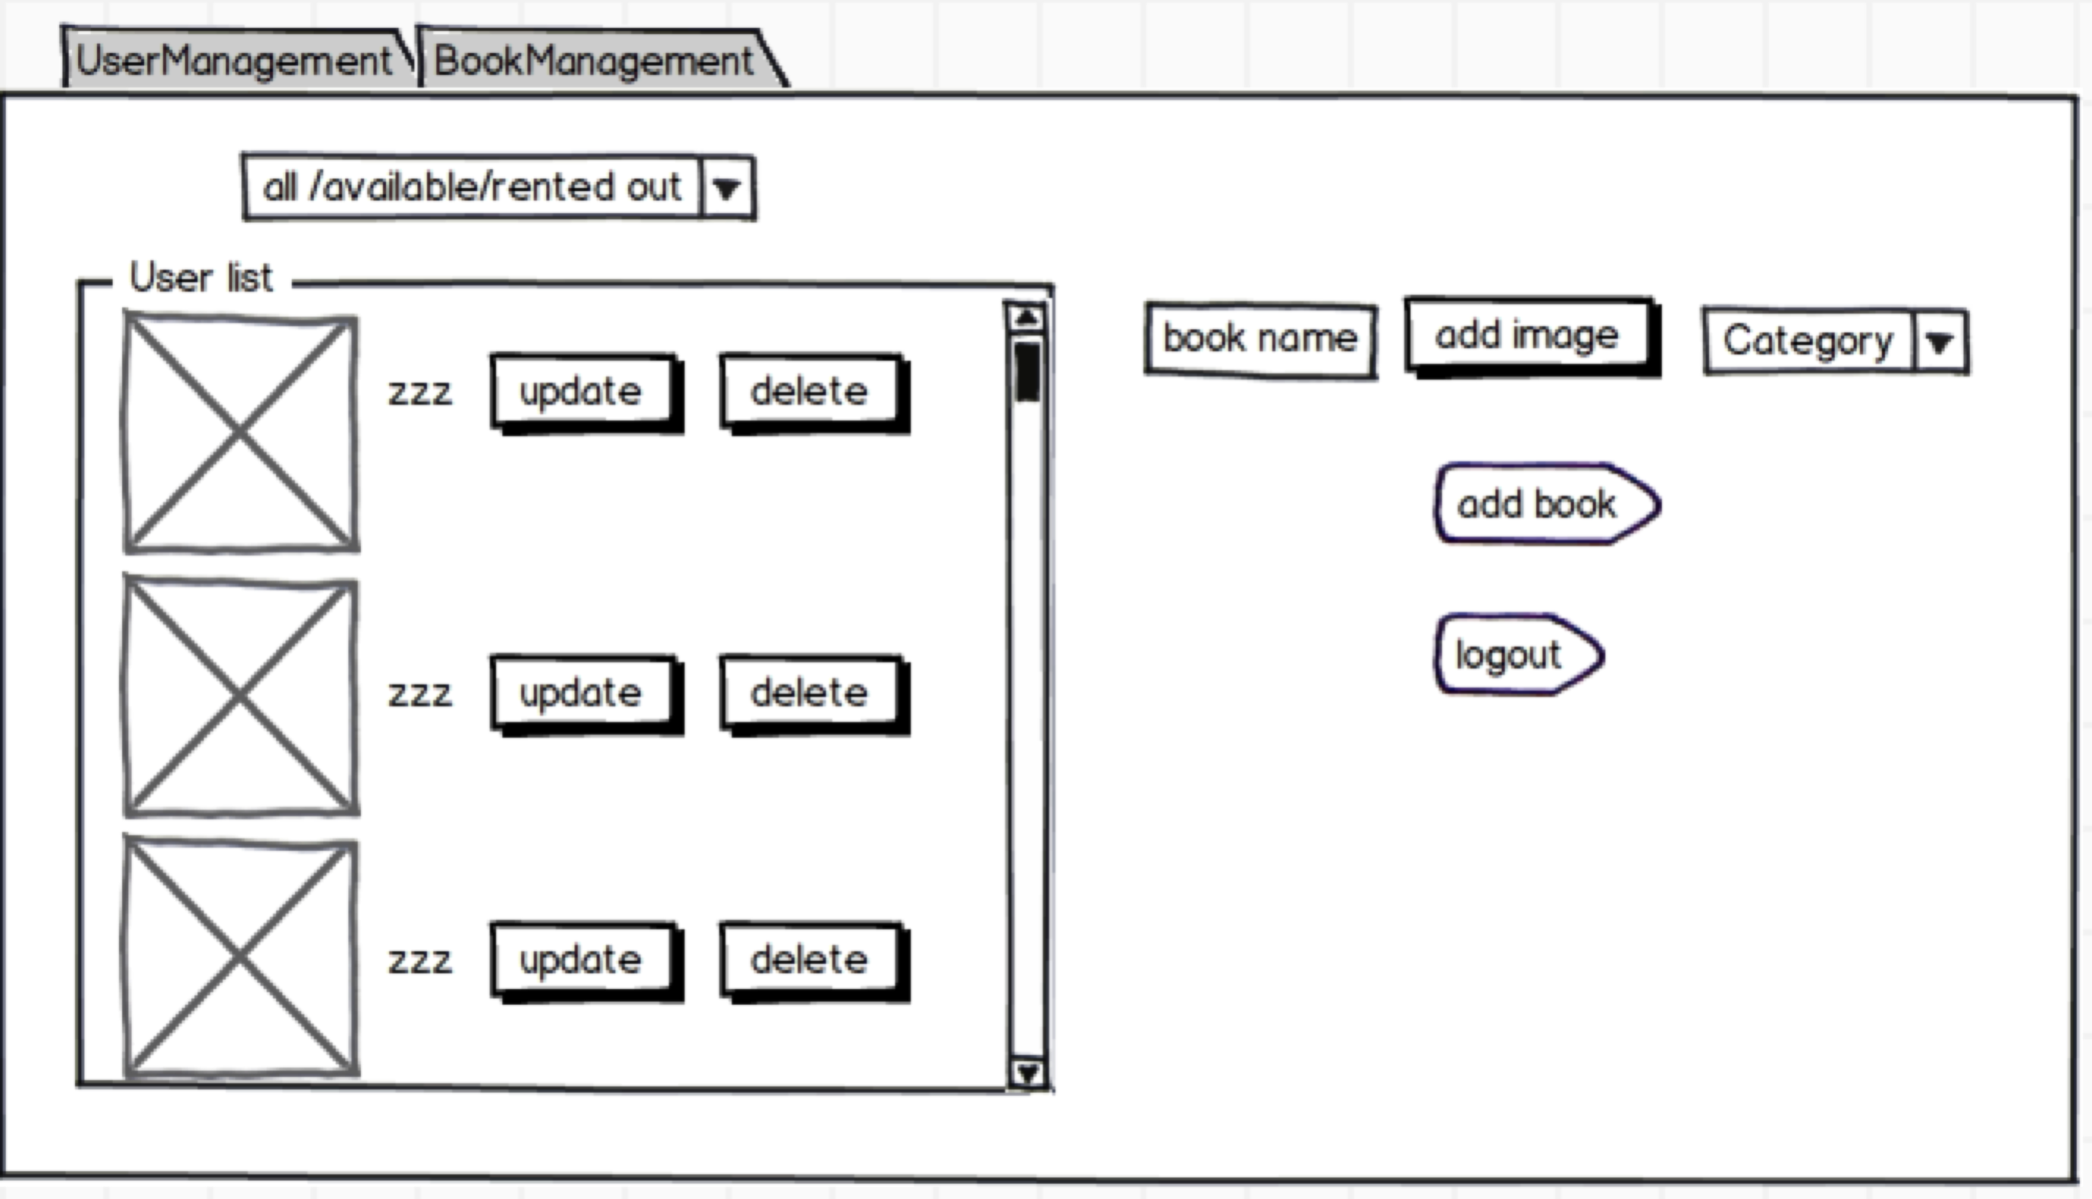

4. User history

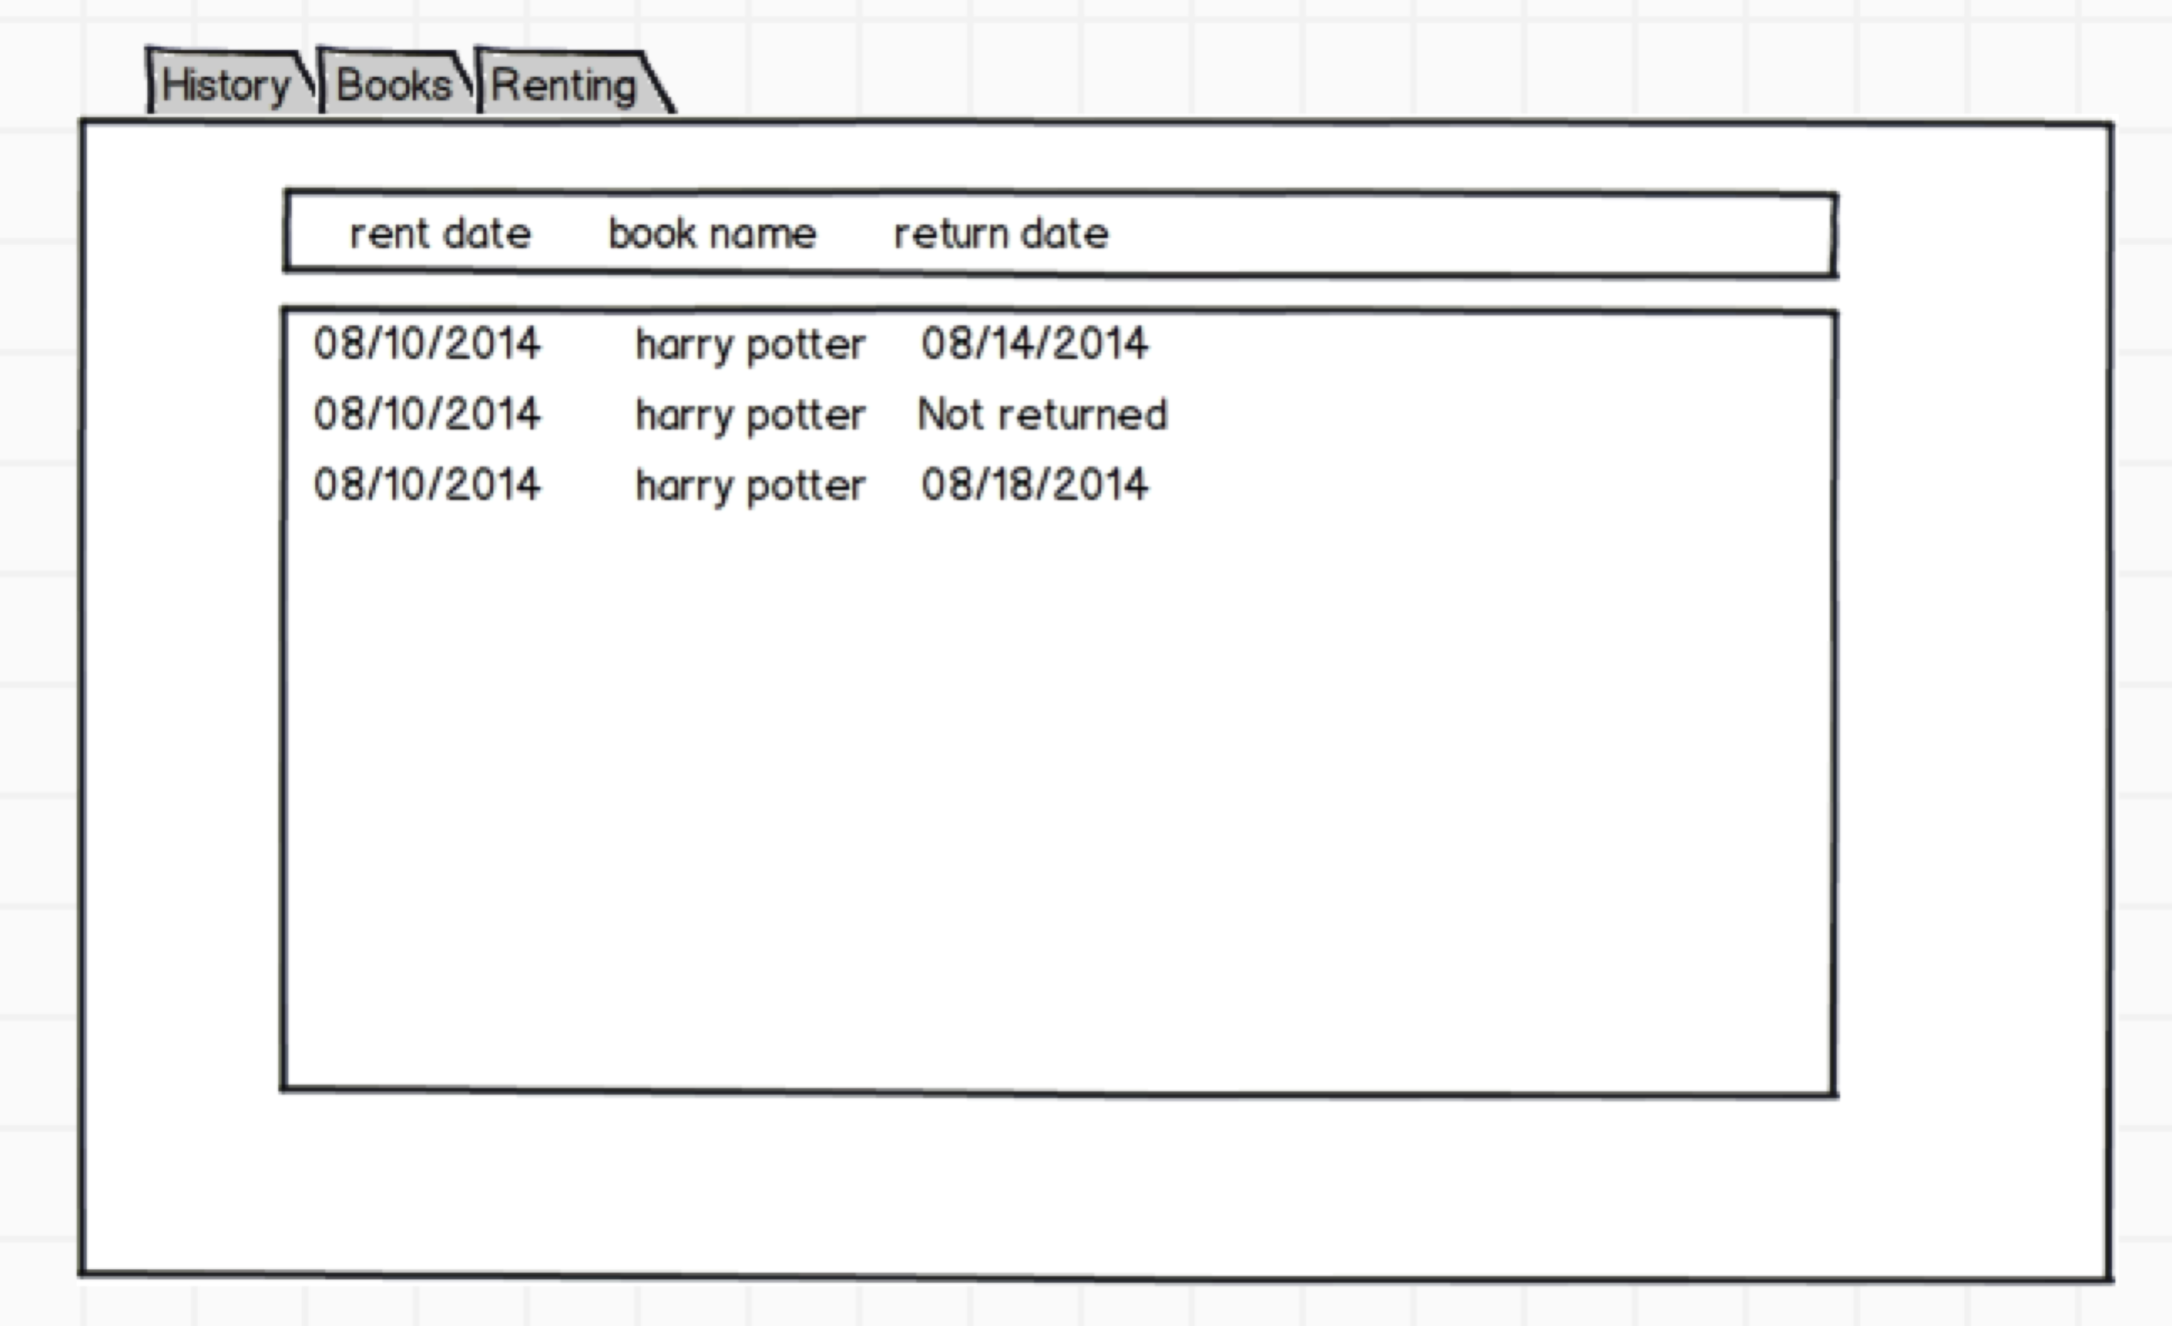

5.User:rent/return book

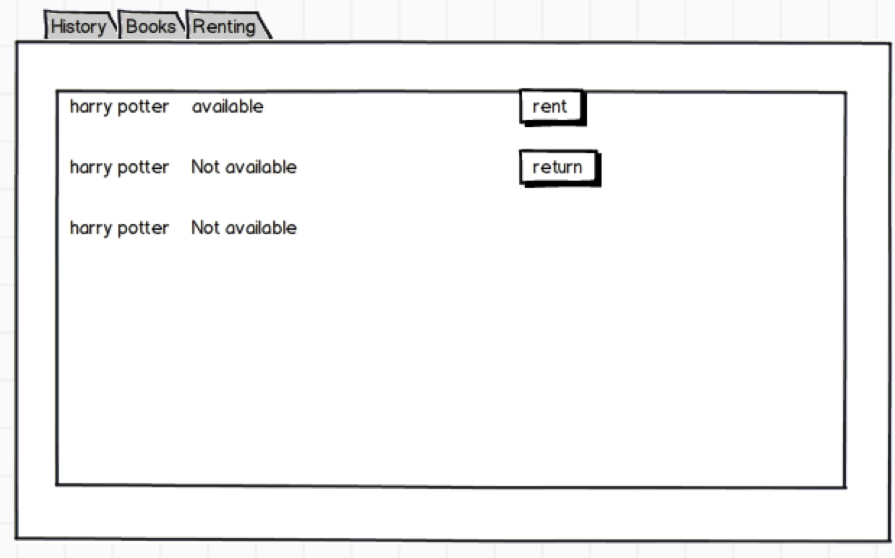

6. User is renting:

#### 4. Class diagram:

**User class:**

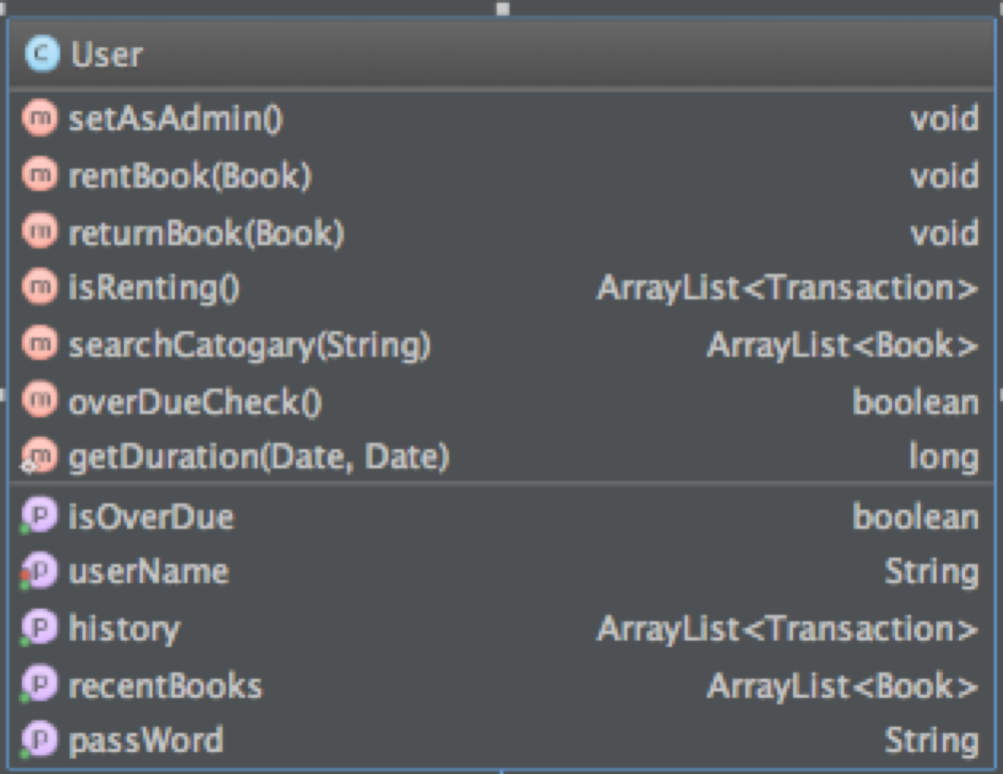

**Admin class:**

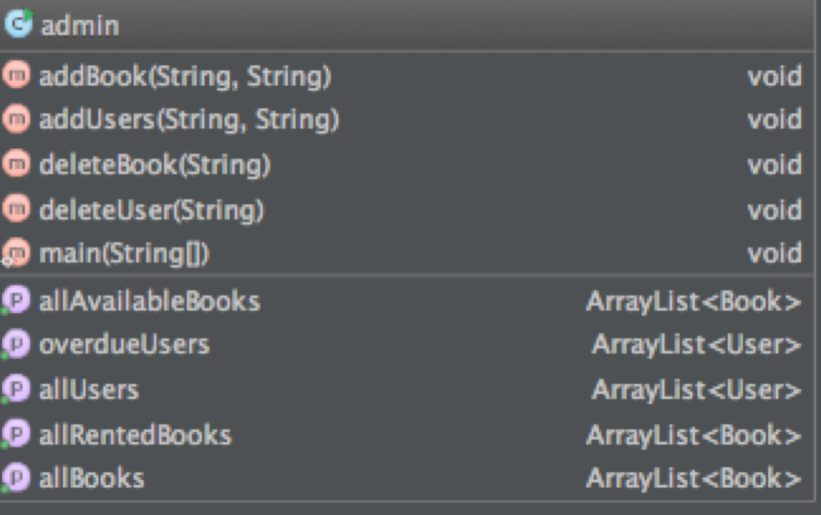

**Admin Tab class:**

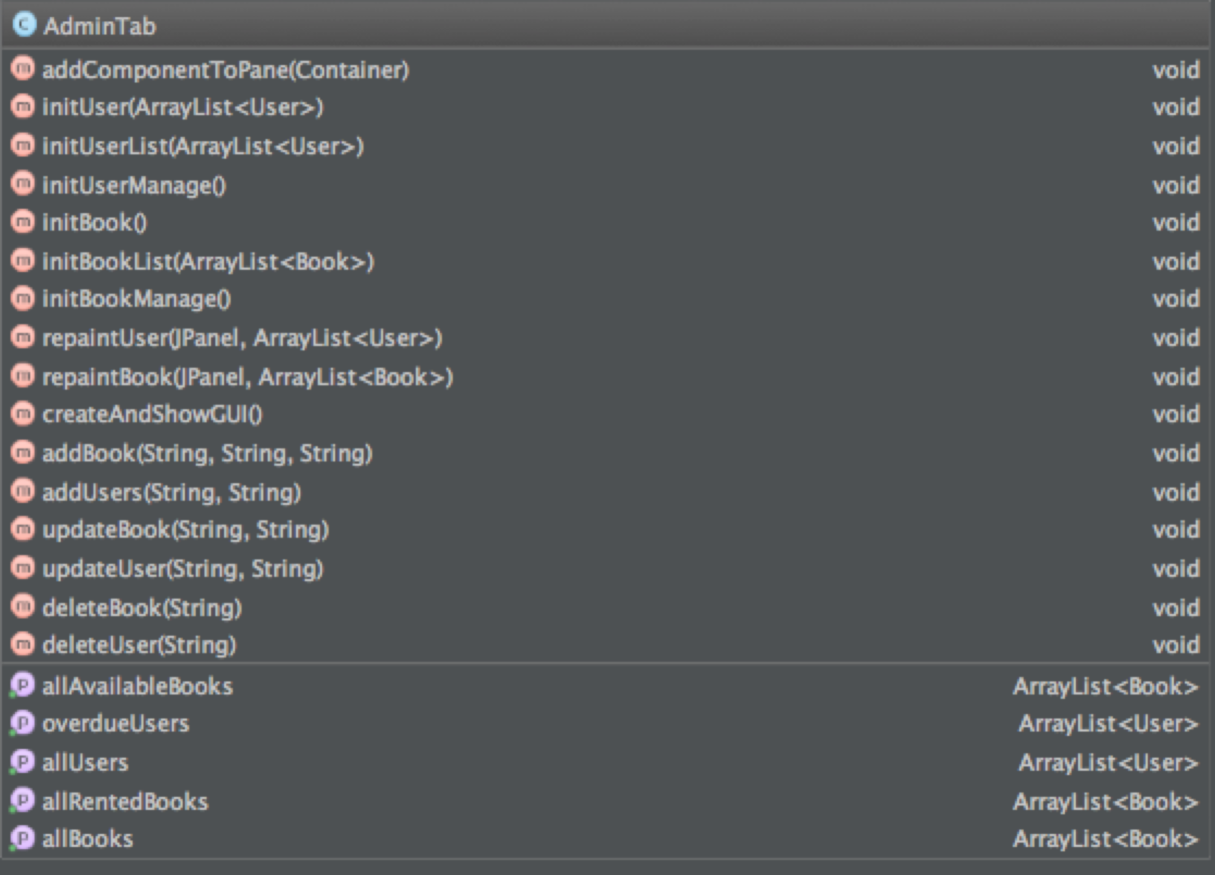

**Book class:**

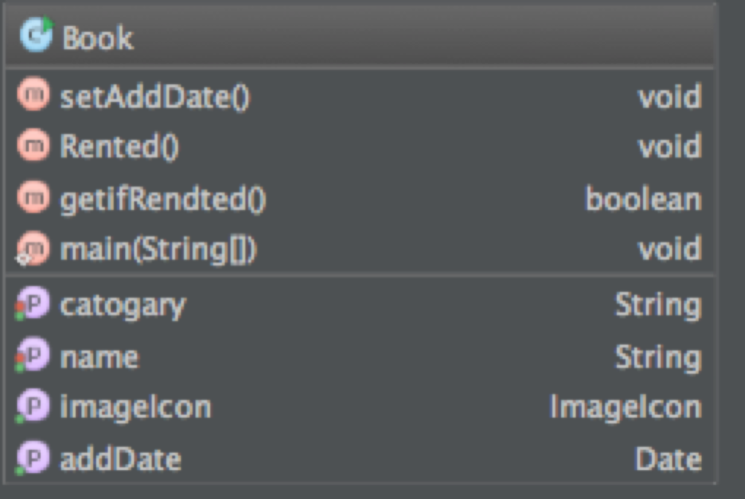

**Library class:**

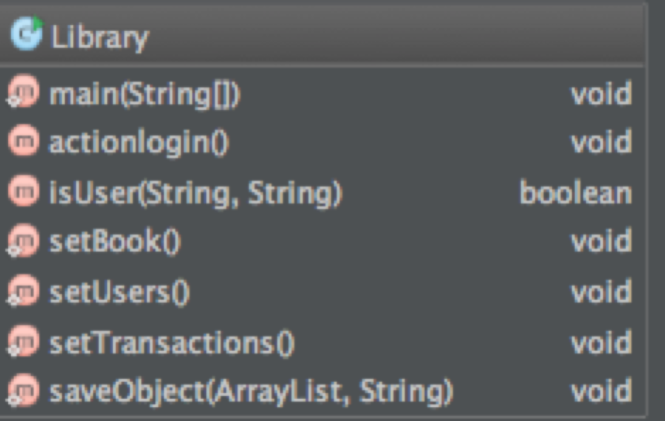

#### 5. Files

users.dat

transactions.dat

books.dat