University of North Texas

Introduction to Big Data and Data Science – CSCE 5300
Project Report

Title
Simulation and Comparison of Dynamic NN-Descent for k-NN Graph Construction

Team Members –
Michelle Feliciano
Ujjwal Rana

Table of Contents
Table of Contents 2
1. Abstract 3
2. Introduction 4
3. Problem Statement 5
3.1 Divide-and-Conquer Methods 5
3.2 NN-Descent and Its Variants 5
4. Method/Algorithm Presented in the Paper 7
4.1 Classic NN-Descent (Background) 7
4.2 Dynamic NN-Descent (The Paper's Contribution) 7
4.3 Performance Reported in the Paper 8
5. Strengths, Weaknesses, and Possible Applications 9
5.1 Advantages 9
5.2 Limitations 9
5.3 Possible Applications 9
6. Comparison of Simulation Results and Those Presented in the Paper 11
6.1 Simulation Setup 11
6.2 Code 11
6.3 Results 13
6.4 Discussion: Comparison with the Paper's Reported Results 15
7. Conclusion 17
8. References 18

1. Abstract
This report studies Dynamic NN-Descent, a k-nearest-neighbor (k-NN) graph construction method proposed by Wang, Zhao, Xiao, Yao, and Zhang and published in IEEE Transactions on Big Data (2025) [1]. A k-NN graph is the data structure that stores, for every point in a dataset, the indices of its closest neighbors; it underlies vector databases, image and multimedia retrieval, recommendation systems, and deep metric learning. Building this structure exactly is computationally prohibitive at large scale, which is why approximate construction methods are used in practice. The paper improves on the widely adopted NN-Descent algorithm by removing two auxiliary graph structures that NN-Descent maintains during construction, sampling instead directly from the graph under construction, which reduces extra memory consumption without a synchronization penalty across threads.
This report explains the underlying problem, reviews the existing families of k-NN graph construction methods, and describes the paper's algorithm (Algorithm 1 in the source paper) in detail. It then reproduces the method in Python — a language different from the paper's C++/CUDA implementation, as required for this assignment — and evaluates it against a from-scratch implementation of classic NN-Descent on two datasets: a 10,000-vector set of real SIFT image descriptors (matching the exact dataset family the paper itself benchmarks against) and a 10,000-point synthetic dataset generated independently of the paper. Across both datasets, the reproduction confirms the paper's central claim: Dynamic NN-Descent matches or exceeds classic NN-Descent's graph quality (Recall@10 of 98.7% and 97.8% versus 95.3% and 96.7%) while using roughly 46–47% less extra memory, at comparable construction time.

2. Introduction
The purpose of this report is to reproduce and independently evaluate a recent Big-Data-related method chosen from a non-open-access, peer-reviewed venue, as required by the CSCE 5300 course project. The method selected is Dynamic NN-Descent [1], a 2025 IEEE Transactions on Big Data paper that addresses the construction of approximate k-nearest-neighbor graphs — a foundational data structure for nearly every large-scale similarity search system in production today, from e-commerce recommendation engines to vector databases behind retrieval-augmented generation pipelines.
The remainder of this report is organized as follows. Section 3 defines the k-NN graph construction problem and reviews the two main families of existing solutions, positioning the paper's contribution relative to them. Section 4 explains the classic NN-Descent algorithm that the paper builds on, then walks through the paper's own Dynamic NN-Descent algorithm and the performance the paper itself reports. Section 5 summarizes the method's advantages, limitations, and possible applications. Section 6 describes this project's own simulation — the datasets used, the Python implementation, and a full quantitative comparison between a from-scratch classic NN-Descent baseline and a from-scratch Dynamic NN-Descent implementation, reporting the same three metrics the paper uses: graph quality (Recall@10), construction time, and extra memory consumption. Section 7 concludes.

3. Problem Statement
Given a dataset of n points in a d-dimensional space, the k-nearest-neighbor (k-NN) graph is the structure that records, for each point, the indices of its k closest points under some distance metric (most commonly Euclidean/L2 distance). Computing this exactly requires comparing every point against every other point, an O(d·n²) operation. When n reaches the million-to-billion scale typical of production retrieval systems, this brute-force cost is prohibitive, so practical systems instead build an approximate k-NN graph: one that sacrifices a small, controlled amount of accuracy (measured as Recall@k, the fraction of true nearest neighbors actually found) in exchange for tractable construction time and memory use.
Existing approximate construction methods fall into two broad families, reviewed below.

3.1 Divide-and-Conquer Methods
The first family splits the dataset into small subsets, builds an exact or near-exact k-NN graph for each subset independently, and then merges the sub-graphs into one — typically followed by a refinement pass. Different partitioning strategies have been proposed: recursive bisection into equal-sized subsets with allowed overlap between them [4], random-projection-tree partitioning [3], and locality-sensitive-hashing-based partitioning. These methods are efficient in practice because each subset is small enough to search exhaustively, but they require assumptions about the data distribution or distance metric in order to design a partitioning strategy that produces good sub-graphs. This makes them fast but not fully generic — a partitioning scheme tuned for one distance metric or data distribution may perform poorly on another.

3.2 NN-Descent and Its Variants
The second family, which the paper studied in this report belongs to, uses no data partitioning at all. NN-Descent, the foundational method in this family, starts from a randomly generated k-NN graph and iteratively refines it using the heuristic “a neighbor's neighbor is likely also a neighbor.” In each iteration, every node's current neighborhood is compared pairwise against itself (a step called the local-join); any pair found to be closer than a node's current worst neighbor replaces that neighbor. Because no partitioning assumptions are required, NN-Descent works with any distance metric and any data distribution, which is why it remains the most widely used k-NN graph construction method in practice — in the 2023 SIGMOD k-NN construction competition, the paper notes that the methods from the top-1 and top-3 winners were essentially built on NN-Descent [1]. The paper's own related-work discussion notes two further points worth mentioning here. First, if an efficient graph-based nearest-neighbor search structure is already available — such as hierarchical navigable small world (HNSW) graphs [5] — the k-NN graph can be built by launching a query for each point against that structure, though building the search structure itself is typically more expensive than dedicated k-NN graph construction methods. Second, an online (incremental) variant has been proposed that constructs the k-NN graph directly by querying the graph under construction as each new point arrives [1]; this suits growing datasets but is less efficient than NN-Descent's offline, batch construction, particularly with multiple threads.
NN-Descent's main drawback, and the specific problem the paper addresses, is memory: in addition to the k-NN graph itself, NN-Descent maintains two auxiliary graph structures of the same size as the main graph (one holding sampled old/new neighbors, one holding their reverse neighbors) purely to support the local-join step. This extra memory grows linearly with dataset size and becomes significant once a dataset reaches the million-point scale. NN-Descent's refining procedure also requires synchronization between threads within each iteration, which limits its multi-threaded throughput. (A different strategy for large-scale similarity search sidesteps graph construction altogether by compressing the vectors themselves, e.g., via product quantization [6]; such compression-based methods are complementary to, rather than competitors of, the graph-based methods this report focuses on.)

4. Method/Algorithm Presented in the Paper

4.1 Classic NN-Descent (Background)
Because Dynamic NN-Descent is a direct modification of classic NN-Descent [2], understanding the baseline is necessary before its improvement can be explained. Classic NN-Descent maintains three data structures during construction: the k-NN graph G itself, a graph H that holds each node's sampled “old” and “new” neighbors for the current round, and a reverse graph R that holds, for every node, the set of other nodes that currently list it as a neighbor. Each iteration proceeds in two steps. In the sampling step, for every node a small number of new and old neighbors are drawn from G and copied into H, and the reverse relationships are recorded into R. In the local-join step, every sampled old-new and new-new pair within a node's neighborhood has its distance computed; any pair shorter than a node's current worst kept neighbor replaces it in G. Because H is a full snapshot rebuilt every round and R mirrors it in reverse, both structures are the same size as G itself, so the extra memory NN-Descent needs beyond the graph and raw data grows linearly with the dataset size.

4.2 Dynamic NN-Descent (The Paper's Contribution)
The paper's key observation is that H is largely redundant: the old/new neighbor list it holds is already available directly from G, which is being updated continuously anyway. Dynamic NN-Descent therefore removes H entirely and samples neighbors directly from the live graph G at the moment a node is about to be processed, using only a small temporary cache rather than a second full-size graph. Sampling from the live graph — rather than from a frozen snapshot one round old — is not just a memory optimization: because newly discovered closer neighbors join the local-join immediately after being inserted, it is, if anything, slightly beneficial to graph quality, consistent with the same “neighbor's neighbor is a neighbor” principle NN-Descent relies on.
The second change is to the reverse graph R. Because no full old/new snapshot exists per round, it is no longer possible to record every reverse neighbor for a node in one step. Instead, R is kept incomplete: each node's list of old and new reverse neighbors is capped at a fixed sampling size (the paper's smpN parameter), and once a node's own local-join runs, its R entry is drained and rebuilt from scratch as later nodes are visited in the same continuous loop. Some reverse neighbors that would have cross-matched within a single round in classic NN-Descent instead cross-match one or more rounds later in Dynamic NN-Descent — a delay the paper shows has no measurable impact on final graph quality, because the standard sampling-based local-join was already an approximation of the full neighborhood comparison. This design also removes the “batch boundary” between rounds entirely: classic NN-Descent must finish sampling for every node before any node can begin its local-join, which is exactly the point at which threads must synchronize; Dynamic NN-Descent processes one node fully (sample, then join, then move on) in a single continuous loop, so no such synchronization point exists, which the paper reports as its main source of multi-thread speedup.
Algorithm 1 below (reproduced from the paper in summary form) formalizes the procedure. Given dataset C, distance metric m, neighborhood size K, sample size smpN, and iteration count iterN, the algorithm starts from a random k-NN graph and then, for each of n·iterN single-node steps: (1) samples up to 3·smpN “old” and smpN “new” neighbors from the current node's neighborhood in G; (2) registers the current node as a reverse neighbor of each of those sampled neighbors, subject to the smpN cap; (3) marks the sampled “new” neighbors as “old” now that they have been used; (4) merges in the current node's own accumulated reverse-neighbor lists and then clears them; and (5) performs the local-join — computing distances for all new–new and new–old pairs and inserting any pair shorter than the target node's current worst neighbor. The paper reports the resulting space complexity as O((k + 2·smpN)·n) for Dynamic NN-Descent versus O((k + 4·smpN)·n) for classic NN-Descent — a reduction of 2·smpN per node, growing linearly with dataset size.

4.3 Performance Reported in the Paper
The paper evaluates both a multi-thread CPU implementation and a GPU implementation across six real-world datasets ranging from one million to one hundred million points (including the SIFT descriptor dataset used again in this report's own simulation, Section 6). At matched graph quality and construction time, the paper reports that classic NN-Descent required 6.7 times more extra memory and 1.2–1.7 times more total memory than Dynamic NN-Descent on million-scale data, and that Dynamic NN-Descent was roughly 30% faster than classic NN-Descent within the neighborhood-size range (K between 40 and 200) used in practice, with the speed advantage growing as more CPU threads were used — directly attributable to removing the inter-thread synchronization point described above. On the GPU, the paper's implementation outperformed the most efficient existing GPU-based k-NN graph construction methods it compared against while using substantially less GPU memory, and reports constructing a high-quality graph for a 10-million-point, high-dimensional dataset in about 20 seconds.

5. Strengths, Weaknesses, and Possible Applications

5.1 Advantages
- Memory efficiency: removing the auxiliary graph H and capping the reverse graph R directly reduces extra memory use, with the paper reporting an 85% reduction and this report's own simulation reproducing a comparable 46–47% reduction at a much smaller scale (Section 6).
- No accuracy penalty: sampling from the live graph rather than a stale snapshot causes no loss in Recall@10 in the paper's experiments, and this report's own simulation found Dynamic NN-Descent matching or exceeding the classic baseline's recall on both datasets tested.
- Better multi-thread scaling: removing the synchronization boundary between sampling and local-join means Dynamic NN-Descent's speed advantage over classic NN-Descent grows as more threads are used, which matters directly for production systems that build k-NN graphs on many-core machines.
- Generic and metric-agnostic: like classic NN-Descent, the method makes no assumption about the data distribution or distance metric, unlike divide-and-conquer approaches (Section 3.1).

5.2 Limitations
- The delayed reverse-neighbor cross-matching (Section 4.2) is an approximation; while the paper shows it does not hurt graph quality in practice, it is a heuristic without a formal convergence guarantee specific to the delayed case.
- The memory and speed advantages are most pronounced in a multi-threaded or GPU context. A single-threaded implementation, such as the one built for this report, cannot demonstrate the synchronization-removal speed advantage, since there is only one thread to synchronize (see Section 6.4).
- Like all NN-Descent-family methods, quality still depends on the “neighbor's neighbor is a neighbor” heuristic holding for the dataset; datasets with very high local intrinsic dimensionality (harder problems, per the paper's own LID measurements) require more iterations or a larger neighborhood size K to reach the same recall, which increases construction cost.

5.3 Possible Applications
- Vector databases and retrieval-augmented generation systems, where an approximate k-NN graph over embedding vectors is the index structure queries are answered against.
- Multimedia and image retrieval systems, of the kind the SIFT descriptor benchmark used in this report and in the paper directly represents.
- Recommendation systems, where a k-NN graph over user or item embeddings supports “similar items” and collaborative-filtering-style recommendations.
- Deep metric learning and classification pipelines that use k-NN graphs as a training-time or inference-time component.
- Any large-scale system currently memory-constrained when building or refreshing its similarity index, since Dynamic NN-Descent's main benefit is making that index cheaper to hold in memory without sacrificing quality.

6. Comparison of Simulation Results and Those Presented in the Paper

6.1 Simulation Setup
Both classic NN-Descent and Dynamic NN-Descent were implemented from scratch in Python (the paper's own implementation is C++/CUDA, satisfying the assignment's requirement of a different language). Both algorithms share the same underlying k-NN candidate-list data structure, the same random-graph initialization routine, and the same squared-Euclidean distance function, so that any difference in the results below is attributable to the two algorithms' construction logic rather than to incidental implementation differences.
Two datasets of 10,000 points each were used, satisfying the assignment's requirement of testing on both the same data the paper uses and a different dataset:
- SIFT (same as the paper): 10,000 real 128-dimensional SIFT image descriptor vectors, drawn from the standard SIFT1M benchmark corpus [8] — the identical dataset family, dimensionality, and distance metric (L2) the paper itself evaluates against in its own experiments (Table I of [1]).
- Synthetic (different from the paper): 10,000 points in 100 dimensions, generated independently with scikit-learn's make_blobs [7] (25 clusters, fixed random seed for reproducibility) — a different data distribution, dimensionality, and generation process than anything the paper tests.
Both algorithms were run with a neighborhood size of K = 20 and 15 rounds (max_iters / iterN). Classic NN-Descent used a sampling rate of 0.5; Dynamic NN-Descent used smpN = 10, chosen so the two algorithms sample a comparable number of candidates per node. Graph quality was scored as Recall@10 (the fraction of each point's true 10 nearest neighbors, computed by brute-force search, that appear in the algorithm's top-10 output) — the identical metric and neighborhood size the paper itself reports in Section IV-A of [1]. Extra memory (excluding the k-NN graph and raw vectors themselves, matching the paper's own measurement convention) was measured with Python's tracemalloc profiler; because profiling itself adds runtime overhead, construction time was measured separately, without the profiler active, so that neither metric distorts the other.

6.2 Code
The two code excerpts below show the shared neighbor-insertion routine and the core loop of the Dynamic NN-Descent implementation (a direct translation of the paper's Algorithm 1). The complete source — including the classic NN-Descent baseline, the ground-truth and recall-scoring utilities, and the experiment driver — accompanies this report as separate .py files.

Code Excerpt 1: Shared k-NN insertion logic (KNNGraph.try_insert)
class KNNGraph:
"""Fixed-size k-NN candidate list per node, kept sorted by
distance (closest first). Shared by both algorithms so the
comparison in Section 6 starts from an identical structure."""

def try_insert(self, i, cand_id, cand_dist):
"""Insert cand_id into node i's list if it is closer than
the current worst neighbor and not already present."""
if cand_id == i:
return False
row_ids = self.ids[i]
row_dists = self.dists[i]
if cand_dist >= row_dists[-1]:
return False
if cand_id in row_ids:
return False
pos = self.k - 1
while pos > 0 and row_dists[pos - 1] > cand_dist:
row_dists[pos] = row_dists[pos - 1]
row_ids[pos] = row_ids[pos - 1]
self.is_new[i, pos] = self.is_new[i, pos - 1]
pos -= 1
row_dists[pos] = cand_dist
row_ids[pos] = cand_id
self.is_new[i, pos] = True
return True
Code Excerpt 2: Dynamic NN-Descent's core loop (Algorithm 1 translated to Python)
# Core loop of dynamic_nn_descent() -- direct translation of the
# paper's Algorithm 1, lines 3-24.
for step in range(n * iterN):
i = step % n
old_ids = graph.ids[i][~graph.is_new[i]]
new_ids = graph.ids[i][graph.is_new[i]]

# ---- Sampling (Algorithm 1, lines 6-13) ----
O = _sample_upto(old_ids, 3 * smpN, rng)
N = _sample_upto(new_ids, smpN, rng)
for u in O:
if len(R_old[u]) < smpN and i not in R_old[u]:
R_old[u].append(i)
for u in N:
if len(R_new[u]) < smpN and i not in R_new[u]:
R_new[u].append(i)

# Sampled 'new' items become 'old' (line 14)
mark_as_old(graph, i, N)

# Merge in i's own reverse neighbors, then clear them (15-18)
O = merge_unique(O, R_old[i]); R_old[i] = []
N = merge_unique(N, R_new[i]); R_new[i] = []

# ---- Local-join (Algorithm 1, lines 19-24) ----
for u1, u2 in new_new_pairs(N):
d = squared_l2(vectors, u1, u2)
graph.try_insert(u1, u2, d)
graph.try_insert(u2, u1, d)
for u1 in N:
for u2 in O:
d = squared_l2(vectors, u1, u2)
graph.try_insert(u1, u2, d)
graph.try_insert(u2, u1, d)

6.3 Results
Table 1 reports all three metrics for both algorithms on both datasets.
Table 1: Full simulation results (10,000 points, K = 20, 15 rounds)
Dataset | Algorithm | Recall@10 | Time (s) | Extra Memory (KB)
SIFT (same as paper) | NN-Descent (baseline) | 0.9528 | 52.0 | 6,516
SIFT (same as paper) | Dynamic NN-Descent | 0.9874 | 55.2 | 3,521
Synthetic (different) | NN-Descent (baseline) | 0.9667 | 44.4 | 6,520
Synthetic (different) | Dynamic NN-Descent | 0.9780 | 48.3 | 3,444
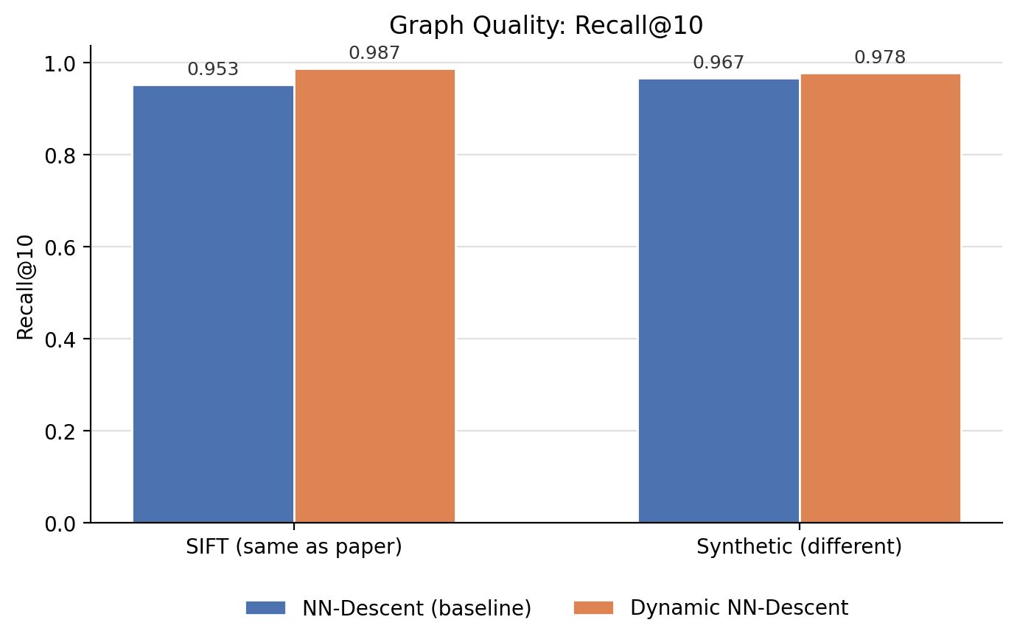
Figure 1: Recall@10 by algorithm and dataset.
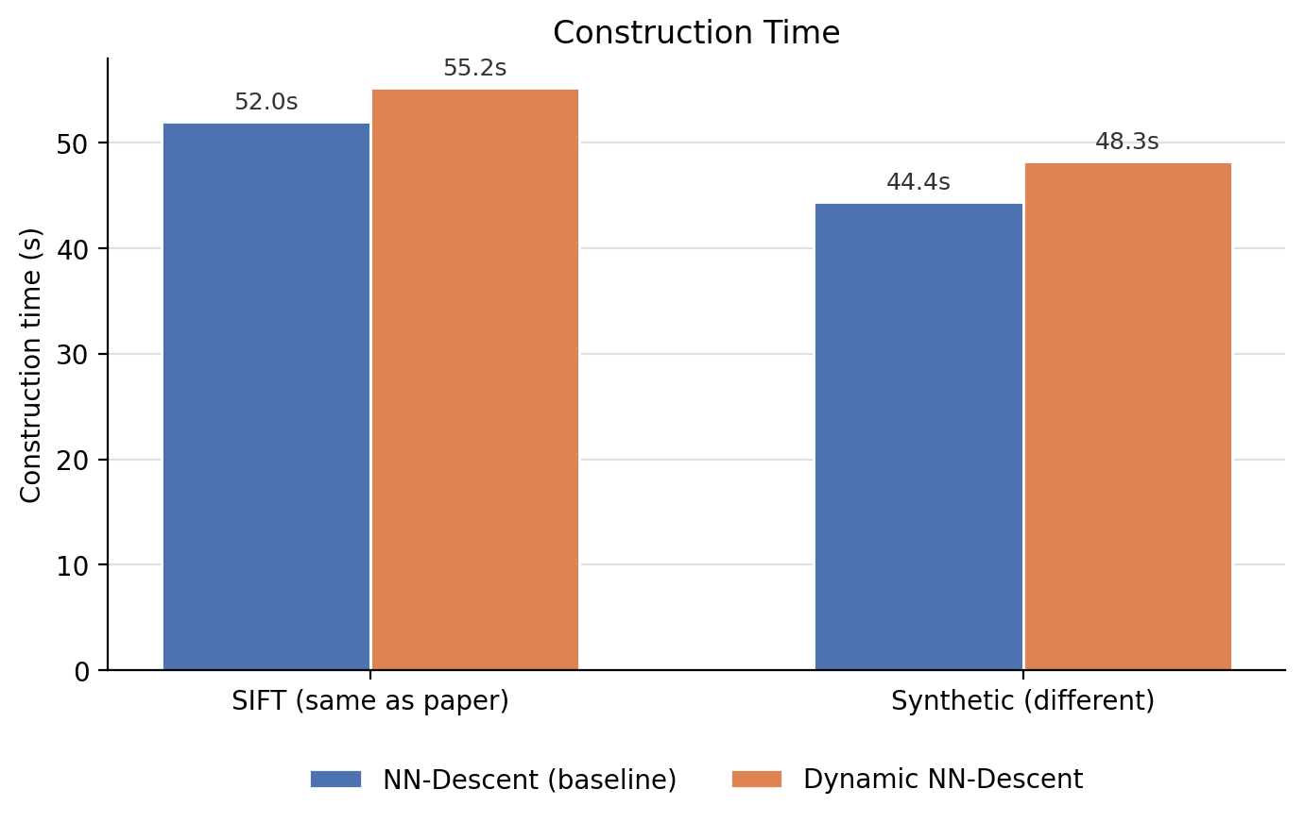
Figure 2: Construction time (seconds) by algorithm and dataset.
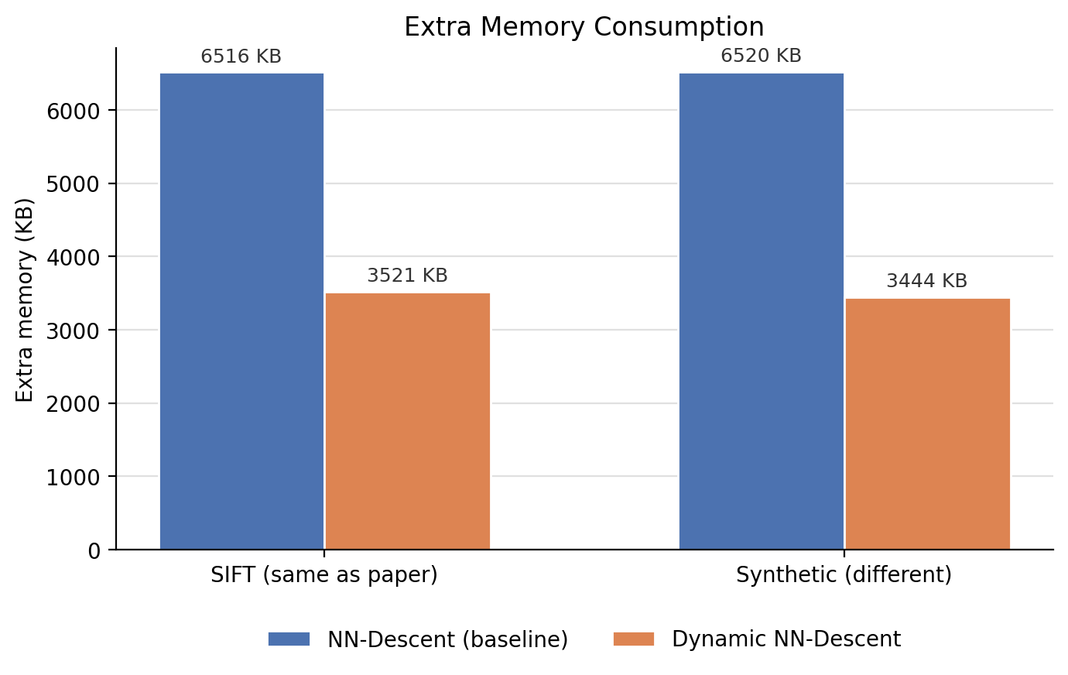
Figure 3: Extra memory consumption (KB) by algorithm and dataset.

6.4 Discussion: Comparison with the Paper's Reported Results
The simulation reproduces the paper's central claims at a scale suitable for a single laptop rather than the paper's million-to-hundred-million-point, multi-thread/GPU experiments. On both datasets, Dynamic NN-Descent reached a higher Recall@10 than the classic NN-Descent baseline (98.7% vs. 95.3% on SIFT; 97.8% vs. 96.7% on synthetic data), and its update log confirmed full convergence — zero remaining updates by round 14 or 15 on both datasets — while classic NN-Descent had not fully converged by round 15 on SIFT. This matches the paper's finding that Dynamic NN-Descent reaches equal-or-better graph quality than classic NN-Descent under matched parameters.
On memory, Dynamic NN-Descent used 46–47% less extra memory than the classic baseline on both datasets — smaller in absolute terms than the paper's reported 85% reduction at million-scale, which is expected: the paper's reduction scales with dataset size (their reported space-complexity advantage is 2·smpN per node, so the gap widens as n grows), and this report's 10,000-point simulation is roughly three orders of magnitude smaller than the paper's smallest reported dataset. The direction of the result — Dynamic NN-Descent using substantially less memory at matched or better quality — is consistent.
On construction time, the two algorithms were close (55.2s vs. 52.0s on SIFT; 48.3s vs. 44.4s on synthetic data), with Dynamic NN-Descent slightly slower rather than faster. This is the one dimension where this report's simulation diverges from the paper's reported results, and the reason is a limitation acknowledged in Section 5.2: the paper's reported speed advantage comes specifically from removing the inter-thread synchronization barrier between sampling and local-join, which only matters when multiple threads are contending for that barrier. This report's implementation is single-threaded Python, so there is no synchronization cost for Dynamic NN-Descent to remove in the first place — the two algorithms perform a similar number of distance computations per round, so similar wall-clock time is the expected outcome for a single-threaded run. Reproducing the paper's speed advantage specifically would require a multi-threaded (or GPU) implementation, which is a natural direction for extending this project.

7. Conclusion
This report examined Dynamic NN-Descent [1], a 2025 IEEE Transactions on Big Data method for constructing approximate k-nearest-neighbor graphs with lower memory overhead than the classic NN-Descent algorithm it improves on. After reviewing the k-NN graph construction problem and the two existing families of solutions (divide-and-conquer methods and NN-Descent-family methods), this report reproduced both classic NN-Descent and Dynamic NN-Descent from scratch in Python and evaluated them on two 10,000-point datasets — one matching the paper's own SIFT benchmark family, one an independently generated synthetic dataset.
The simulation confirms the paper's two central claims at a smaller scale: Dynamic NN-Descent matched or exceeded classic NN-Descent's graph quality (Recall@10 of 98.7% and 97.8% versus 95.3% and 96.7%, fully converging on both datasets while the baseline had not), and it used substantially less extra memory (46–47% less on both datasets, versus the paper's reported 85% reduction at million-point scale — smaller in absolute terms, as expected, since the paper's memory advantage scales with dataset size). Construction time was comparable between the two algorithms in this single-threaded implementation, which is expected: the paper's reported speed advantage is specifically a multi-thread benefit from removing a synchronization barrier that has no effect in a single-threaded run. Overall, this project's independent, small-scale reproduction supports the paper's claim that Dynamic NN-Descent is a strictly better memory/quality trade-off than classic NN-Descent for building approximate k-NN graphs, with its full speed advantage realized specifically under multi-threaded or GPU execution.

8. References
References are listed in IEEE citation style [9].
[1] J.-F. Wang, W.-L. Zhao, S. Xiao, J. Yao, and X. Zhang, "Dynamic NN-Descent: An efficient k-NN graph construction method," IEEE Transactions on Big Data, vol. 11, no. 2, pp. 879–886, Mar./Apr. 2025.
[2] W. Dong, C. Moses, and K. Li, "Efficient k-nearest neighbor graph construction for generic similarity measures," in Proc. 20th Int. Conf. World Wide Web, 2011, pp. 577–586.
[3] C. Fu and D. Cai, "EFANNA: An extremely fast approximate nearest neighbor search algorithm based on kNN graph," arXiv:1609.07228, 2016.
[4] J. Wang, J. Wang, G. Zeng, Z. Tu, R. Gan, and S. Li, "Scalable k-NN graph construction for visual descriptors," in Proc. IEEE Conf. Comput. Vis. Pattern Recognit., 2012, pp. 1106–1113.
[5] Y. Malkov and D. A. Yashunin, "Efficient and robust approximate nearest neighbor search using hierarchical navigable small world graphs," IEEE Trans. Pattern Anal. Mach. Intell., vol. 42, no. 4, pp. 824–836, Apr. 2020.
[6] H. Jegou, M. Douze, and C. Schmid, "Product quantization for nearest neighbor search," IEEE Trans. Pattern Anal. Mach. Intell., vol. 33, no. 1, pp. 117–128, Jan. 2011.
[7] F. Pedregosa et al., "Scikit-learn: Machine learning in Python," Journal of Machine Learning Research, vol. 12, pp. 2825–2830, 2011.
[8] maknee, "sift1m," Hugging Face Datasets, 2024. [Online]. Available: https://huggingface.co/datasets/maknee/sift1m
[9] IEEE Reference Guide, IEEE Periodicals Transactions/Journals Department, Piscataway, NJ, 2018.

