



Plot-purrfect:

User Guide

Version Date: May 2018

**Plot-Purrfect: User Guide**

**Introduction**

Plot-Purrfect is my solution to the limited support of PowerGraph. It is a tool used by the SPIE team to format Perfmon logs and automatically draw Excel graphs. PowerGraph needed to be replaced as it was only supported on older Operating Systems which limited its installation range.

Unlike its predecessor, Plot-Purrfect can run on any operating system with .Net 4.5.2 installed. Microsoft Excel isn't required on the machine because it uses its own library to format and create Excel files. It is advised that a connection to the metrics database is available as data is logged during every execution of the tool, however this is not necessary since the application will log stats to a log file if a connection can't be made.

Plot-Purrfect currently supports Perfmon, Visual Studio csv logs and Mobile text files formatted for Android6-8 and IOS. However, it will be updated as new formats are identified.

Special thanks to Samantha Kogel for the logo.



Table of Contents

1 Initial Setup 3

1.1 Necessary files 3

1.2 Changes to the config file 4

2 Using the GUI 5

2.1 Main Page 5

2.1.1 Menu options 5

2.2 Perfmon file 6

2.2.1 Create the Summary Tables page 8

2.2.2 Continue Window 10

2.3 Visual Studio file 10

2.4 Mobile Files 10

2.4.1 IOS Reports 10

2.4.2 Android 6 and 7 10

2.5 Create Single-line Graphs 14

2.6 Create Multi-Line Graphs 15

2.6.1 Add/Edit graphs 16

2.7 Compare two Test Cycles 17

3 Common issues 19

3.1 Can’t input the number of CPUs – Number is too big 19

3.2 My Perfmon log has a different time interval 19

3.3 The ramp interval for service tests has changed 19

3.4 The application just crashed without warning 20

# Initial Setup

The PP application should run on any machine that has .NET 4.5.2 installed on it as it is a C# WPF application and requires this version of .NET. Microsoft Excel is not necessary to create Excel files.

## Necessary files

In order to install the application you will need the **setup.exe** found in the following location:

[<blank>](https://dersvn05/repos/IQLSPIERepo/Empirical/C%23/Plot-Purrfect/)

Once run on your machine it will install the following files in the following location:

C:\Program Files (x86)\Derivco\Plot-Purrfect

* The Plot-Purrfect.exe (The Application)
* The Plot-Purrfect.exe.config (The config file)
* ExcelHelper.dll (A helper library I created)
* PerformanceReportHelper.dll (A helper library I created)
* SQLHelper.dll (A helper library I created)
* A folder called “SQL Queries” which contains:
  + Query_LoggingDetails.sql
* A folder called “Logs” where logs will be saved
* The files necessary for creating an Excel doc[1]:
  + EPPlus.dll
* The file MobileHeaders.xml which is a config for Mobile reports
* Other dlls for the GUI components of the window. All the necessary dlls should be installed by default.

**NOTE:** The folder name can be changed as long as Plot-Purrfect.exe.config points to the correct folder. However, don’t change the names of the sql scripts. They are hard coded in the app and the queries won’t run if they are renamed.

**NOTE:** The application now checks for an intranet connection to my logging database before logging information. If a connection can’t be made it then logs the information to a log file.

## Changes to the config file

The config file contains many default settings used to general GUI components and reports. The <appSettings> section contains all the default values for the app:

* If you renamed the “SQL Queries” folder you will need to go to the Plot-Purrfect.exe.config and edit the tag:



This value can’t be left blank so your scripts must be contained in a folder.

* If the logging database has been moved you will need to edit “MachineLog” and/or “ConnectionLog”
* “bytesConversion” is the default conversion ratio for all report types except Android Mobile. Note that the conversion from bytes to Mbytes was redefined to be 1000000 bytes = 1 Mbyte recently. To change conversions for Mobile please change the “Conversions” section tag in the MobileHeaders.xml
* “maxCPUs” is the highest number of CPUs the GUI will accept. I set the max in the config so that it can be altered in future.
* “ServiceRamp” is the default time for a ramp up of a service test. This just sets where the slidecontrol adjusts itself to and can still be altered outside the config file.
* “PerfmonInterval” is the time between each data collection. Usually the interval is set to every 15 seconds. This can be changed in the config however you need to remember that it will change the generation of the “Elapsed Time” column for all report types which generate this column e.g. Perfmon and Mobile.
* “MobileSystemFile” is the default name that PP will search for in the list of Mobile input files. The system file gets treated differently to the rest of the input files which is why I need the name specified.
* “ApplicationName” is the name which the app will try to log to in the database. This shouldn’t ever be change!

# Using the GUI

The following section outlines the different pages and features of the app:

## Main Page

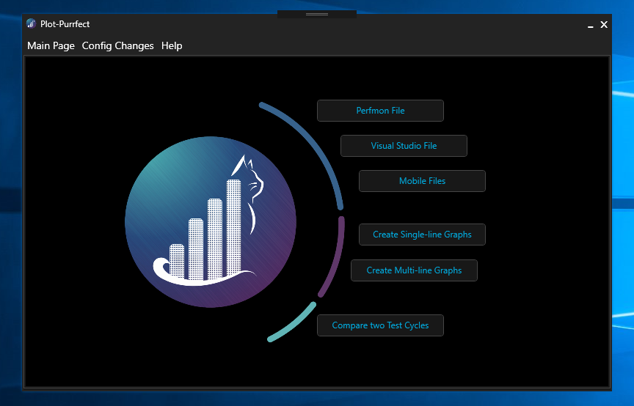

2.2

2.3

2.7

2.6

2.4

2.5

This is the main page of the app. It is the first page you will see when you open the application and it is the page you are taken to if you click on the menu item “Main Page”.

From here you can access all the features of the app by clicking on their respective buttons.

### Menu options

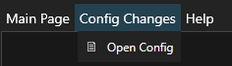

* “Main Page” will take you back to the main page regardless of where you are in the process
* “Config Changes” allows you to either edit the config file in notepad. Note: if the config file is edited in notepad you will need to restart the app for changes to be pulled through.
* “Help” will open the help window which provides a link to the confluence page.

## Perfmon file

This button will take you through the main function of Plot-Purrfect. You will see the following page (note that I have already included a file in the list)

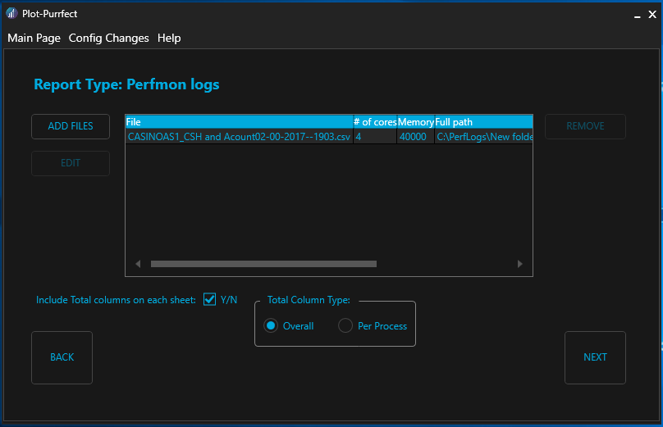

3

5

7

1

2

4

6

The “Report Type” will change depending on which report type you chose.

1. This button allows you to add files to the list of files to extract. Note: you can select more than one file at once.
2. This button is only enabled when a file has been highlighted. If you select to edit a file the following window will open:

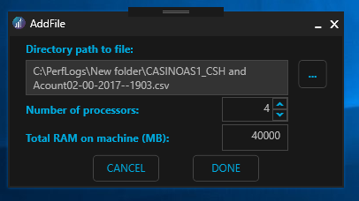

This is where you can change the default details of the file. Changes are only accepted if you click “DONE”. Any changes will be lost if you select “CANCEL”

NOTE: If you double-click on the file row this window will also appear.

1. This button allows you to remove a file from the list.
2. This checkbox allows you to choose whether the data includes “Total” columns or not. Client performance testing usually requires the creation of “Total” columns.
3. These options allow you to customize the “Total” columns. The default is “Overall” which is what Client tests will need. Only two columns are created. The “Per Process” option allows you to group the totals based on the process type e.g. Veyron (group all Veyron instances together.
4. This button allows you to go back to the “Main Page”. All changes are lost.
5. This button allows you to go to the next stage of formatting a performance report. Once the button is clicked each of the data files will be extracted, formatted and saved to the specified Save Path. This may take longer when more than one file is being formatted.

### Create the Summary Tables page

There are certain averages and stats that need to be calculated for performance reports. This page takes the details needed to create these reports.

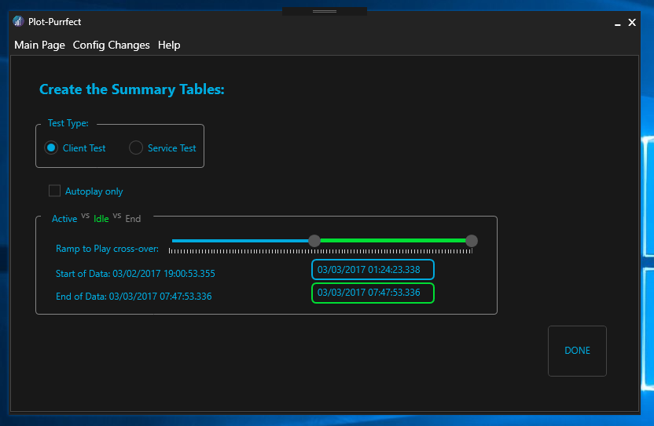

You can select between:

1. Client Test
2. Service Test

Client tests require averages for the whole run, the autoplay and idle sections. If Total columns are included in the data these values are only calculated for the Total columns, otherwise they are calculated for each and every column.

Service tests require stats for each service type. Previous versions of PP had a list of accepted services in the config file. The latest version looks at the column headers and finds all the unique processes. Tables are created based on the services found

NOTE: There is a slider which corresponds to the end of the test. Sometimes Perfmon isn’t turned off the minute the test ends. The data recorded is just a lot of zeros which will mess up averages. If your data contains these zeros you can leave this data out of calculations (and graphs). Remember that this data won’t be deleted, it will only be excluded from averages and graphs.

Client Test example data:

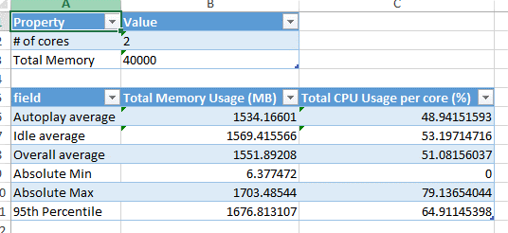

Service Test example data:

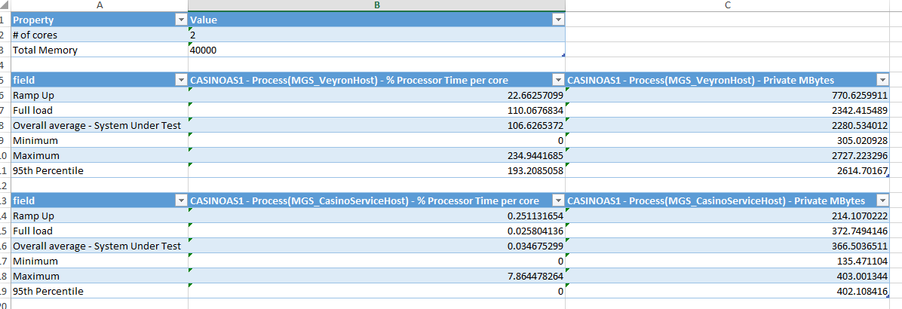

When the tables are created you will notice that the cells don’t contain a value. They contain a formula which corresponds to the column and cells that need to be used. This allows users to edit this range once the Excel file is created, e.g.

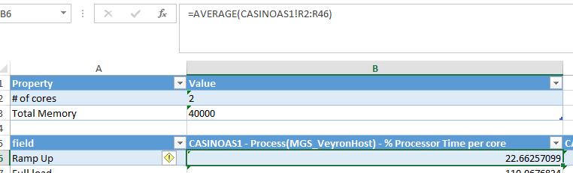

Once you click DONE the summary tab will be created in the Excel file and the required data populated. You will then be given the opportunity to continue to create graphs. This follows a similar process to “Create Single-line Graphs” except the input data will be taken directly from the Excel file recently created.

### Continue Window

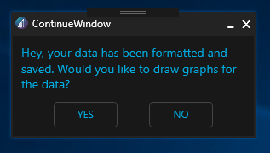

This window is displayed after Perfmon and Visual Studio has been formatted. If you click yes then you will be taken to the “Create Single-line Graphs” page and if you click no you will be taken to the “Main Page” and your Excel file will be opened for you to view it.

## Visual Studio file

The same process as Perfmon file except the reader will only accept files formatted from Visual Studio.

## Mobile Files

Clicking on the “Mobile Files” button will prompt you to choose whether the data is for Android or IOS.

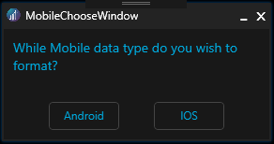

### IOS Reports

The IOS button will take the user to a similar page as Perfmon and Visual Studio. The difference is once the data has been inputted the user won’t be taken to the Summary Table page. The user will instead be given the option to draw graphs of the data.

### Android 6 and 7

Pressing the Android button will take the user to the following page:

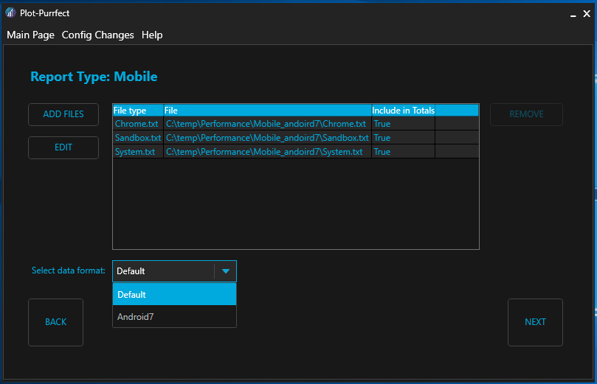

6

7

4

5

1

3

2

1. This button allows you to add files to the list of files to extract. Note: you can select more than one file at once.
2. This button is only enabled when a file has been highlighted. If you select to edit a file the following window will open:

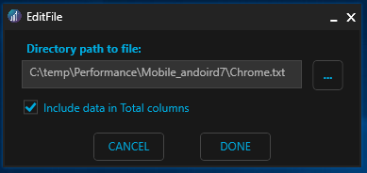

This is where you can change the default details of the file. Changes are only accepted if you click “DONE”. Any changes will be lost if you select “CANCEL”

NOTE: If you double-click on the file row this window will also appear.

1. This button allows you to remove a file from the list.
2. Is a new column which specifies whether an input file needs to be included in the Total column calculations. “True” will include the column in the calculation. The data will still appear in the spreadsheet.
3. This dropdown allows the user to select the input data format. These formats need to be included in the new “MobileHeaders.xml” file.

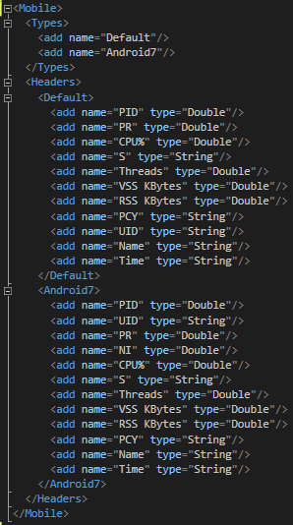

The name needs to be specified in the Types section for it to appear as an option in the GUI.

The tag name in the Headers section needs to match the name that appears in the Types section.

Column names need to appear in the order that they appear in the data.

Column types need to of the base C# type. I suggest only using String and Double to avoid errors.

1. This button allows you to go back to the “Main Page”. All changes are lost.
2. This button will process each of the data files, convert columns, calculate averages and create graphs in the Excel file. If the data list doesn’t contain a “system.txt” file an error will be thrown and you won’t be able to move forward until the file is added.

**NOTE:** There must always be one system.txt file. There mustn’t be any repeated datafiles.

Once the report is created, the user will be taken to the “Create Multi-line Graphs” page. Templates for the standard Mobile reports will already be created. These can be edited as discussed in Section 2.6.

This is what the final report will look like:

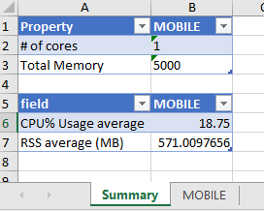

Mobile tab:

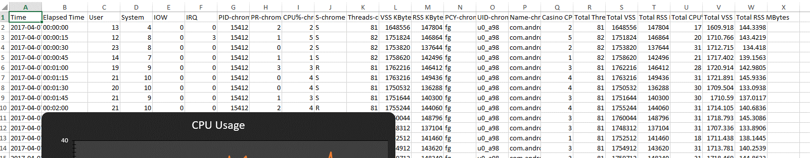

Total Columns

System.txt

Other files

The other files will be sorted according to the process e.g. chrome. The process name will appear at the end of the column header e.g. Name-chrome or UID-sandboxed_process1.

Total columns obey the following rules:

* Casino CPU% – all the “CPU%” columns are added together*
* Total %Mem – all the “%Mem” columns are added together* ^
* Total CPU% – adds the “User” and “System” columns
* Total Threads – all the “Threads” columns are added together* ^
* Total VSS Mbytes – all the “VSS Mbytes” columns are added together*
* Total RSS Mbytes – all the “RSS Mbytes” columns are added together*
* Total Shared Memory Mbytes – all the “Shared Memory Mbytes” columns are added together* ^

*Data files whose details set “Include in Totals” to false aren’t included in these calculations.

^If these columns are present in the data

There are only a few standard graph templates created for Mobile reports:

* “CPU Usage” – Casino CPU% and Total CPU%
* “Total RSS Mbytes”
* “Total VSS Mbytes”
* “Total Threads” ^
* “Total %Mem” ^

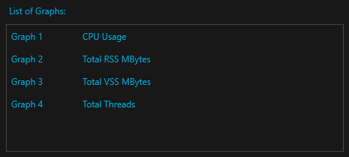

## Create Single-line Graphs

If you click on the “Create Single-line Graphs” button you will be taken to the following page:

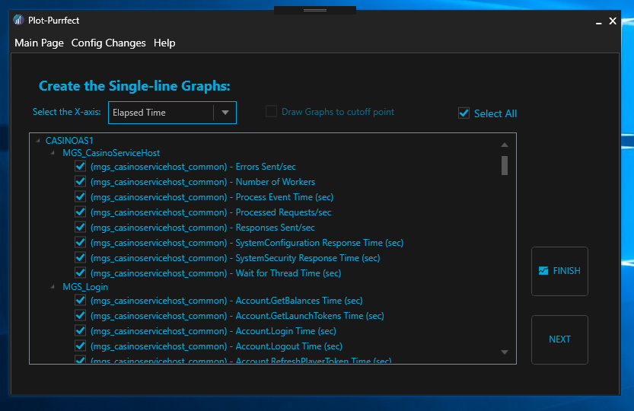

1

2

The Excel file that you want to draw graphs for will be loaded. You can select the x-axis you want for all graphs. Every sheet that is present in the Excel file will be loaded. Columns are grouped by: sheet name, process name and counter name. Total columns are grouped together as well.

Formatted Perfmon data will have three options for the x-axis while Visual Studio data will only have one.

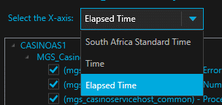

You can either select to draw all graphs or tick the graphs you wish to draw.

There are two buttons which initiate the drawing of graphs:

1. FINISH will draw the graphs in the Excel file and then take the user back to the “Main Page”.
2. NEXT will draw the graphs in the Excel file and then take the user to the “Create Multi-line Graphs” page.

**NOTE:** If you decide that you made a mistake and you don’t actually want to draw any graphs you can click on the “Main Page” menu option which will discard all progress.

## Create Multi-Line Graphs

If you click on the “Create Multi-Line Graphs” button you will be taken to the following page:

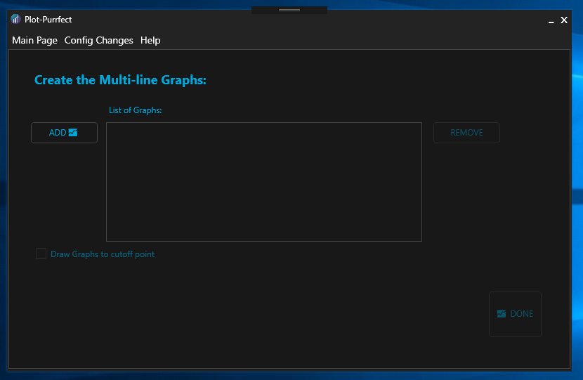

2

1

4

3

Here you can create custom graphs for PP to draw.

1. “ADD” button allows you to add a graph to the draw list. This button will display the customise window.
2. “Draw Graphs to cutoff point” checkbox is like the option on the Single-line Graphs page. This is only enabled when the user specified a cut-off to the data for the Summary Table page.
3. “REMOVE” button removes the selected graph from the list.
4. “DONE” button will create the graphs in the Excel file.
5. If you select a graph in the list it will automatically open the edit window for easy editing.

### Add/Edit graphs

When graphs need to be added or edited the following window will open:

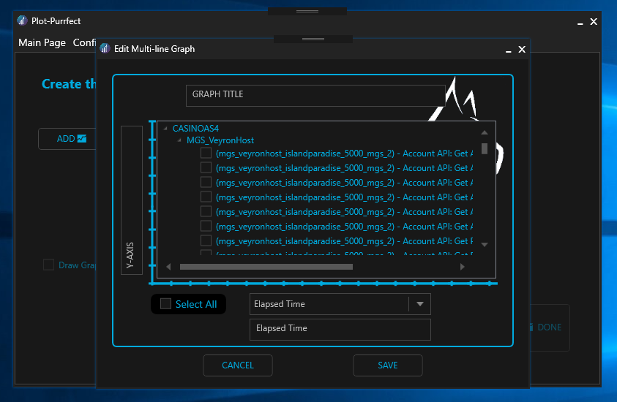

6

3

4

5

1

2

You can edit the following properties of the graph:

1. The Title
2. The Y-axis title
3. Select all shortcut
4. The data columns to include (not no error checking for including Bytes and Mbytes datasets in the same graph)
5. The X-axis dataset
6. The X-axis title

The “CANCEL” button will close this window without adding the graph to the list or accepting changes. The “SAVE” button will either add the graph to the list or save the changes made to the graph.

**NOTE:** If you decide that you made a mistake and you don’t want to draw any graphs you can click on the “Main Page” menu option which will discard all progress.

## Compare two Test Cycles

If you click on the “Compare two Test Cycles” button you will be taken to the following page:

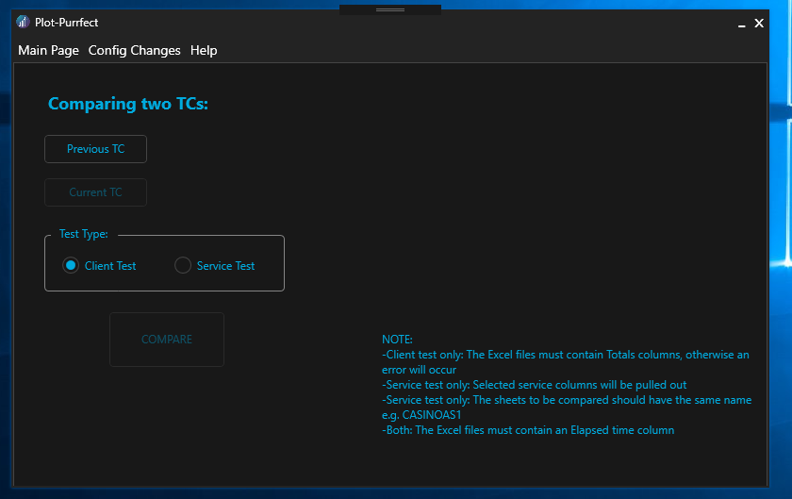

You can select the two formatted Excel files you wish to compare by clicking on the “Previous TC” and “Current TC” buttons. Once you have selected two files the “COMPARE” button will be enabled.

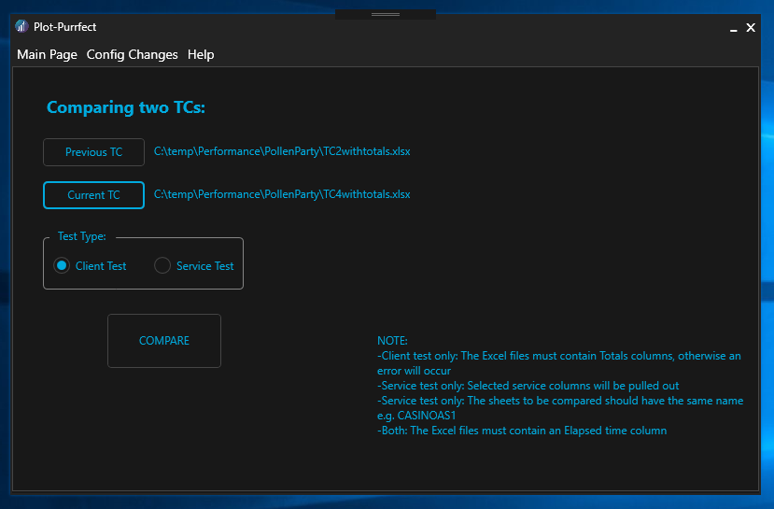

Take note of the notes on this page:

* If you wish to compare for a client test both datasets need to have Total columns and only contain one sheet (besides the summary sheet)
* If you wish to compare for a service test both datasets must contain the same tab sheet names. Sheets with the same name will be compared
* All datasets must contain the “Elapsed Time” column i.e. the data needs to have been processed by PP or the user must add a column named “Elapsed Time” in the leftmost column of each sheet.

The final data will look like this:

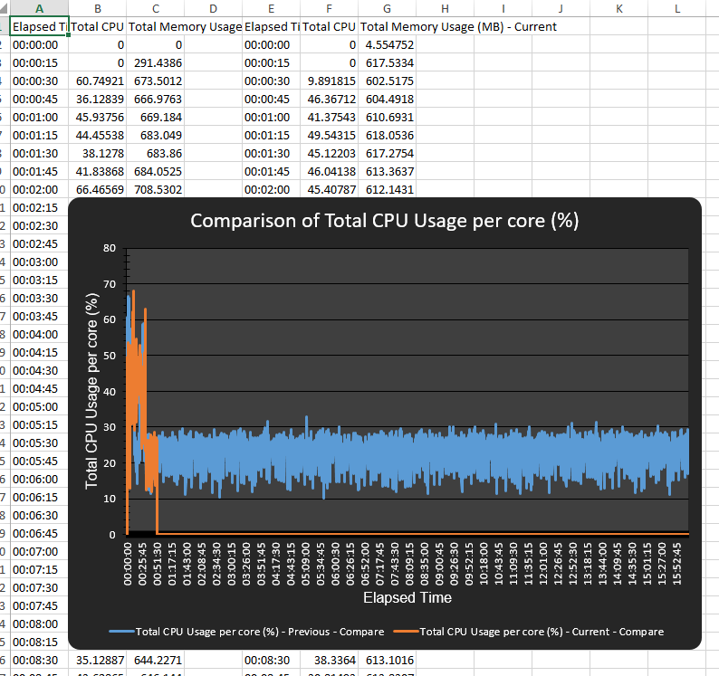

Graphs comparing each column will be created e.g. column B and F. Note: there will be more columns for service tests as it will compare columns for each service found in the input files.

# Common issues

This section outlines issues users commonly experience.

## Can’t input the number of CPUs – Number is too big

When inputting the number of CPUs there is a maximum e.g. 20 CPUs. The arrow button will grey out:

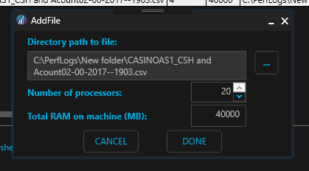

This is because I set the maximum CPUs in the config file. In order to increase this maximum, you will need to edit the following tag in the config file:



For obvious reasons, the minimum number of CPUs is 1.

NOTE: Changes will only take affect if you restart the application.

## My Perfmon log has a different time interval

The current time interval is set to 15 seconds but this can be changed in the config file. Just edit the following tag:



NOTE: Changes will only take affect if you restart the application.

## The ramp interval for service tests has changed

The current time interval is 20 minutes but this can be changed in the config file. Just edit the following tag:



NOTE: Changes will only take affect if you restart the application.

## The calculation has changed for Total CPU% in Mobile reports

In Android 6 and 7 the “Total CPU%” column was calculated by adding the user% and the system%, however in Android 8 it is calculated by adding the user%, sys% and nice%.

To make this extensible going forward I have created a “TotalCPUIncludedColumns” tag in the MobileHeaders.xml file.

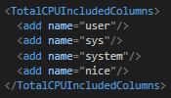

If there are new columns to be included or the column names change, please update this section. The App will only add the columns that exist in the data.

## New Total column type in Mobile reports

Total columns are only created for columns mentioned in the MobileHeaders.xml file.

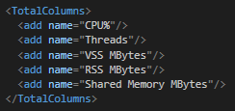

If a column name is present in the data, then the Total column is created e.g. Android 8 doesn’t contain a Threads column but does contain “Shared Memory” columns.

If new Total columns are needed you just need to update this list.

## Data isn’t in the correct format after PC rebuild/new PC

Plot Purrfect usually handles data that is separated by commas and floats contain full-stops. So if PP was previously working on your system but it now gives the following error:

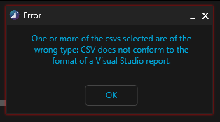

Then the Region & Language settings for your machine have been altered.

To fix this issue:

1. Open “Region & language settings”
2. Under the related settings section click on “Additional date, time, & regional settings”
3. Click on “Change date, time, or number formats”
4. Click on the “Additional settings…” button
5. Change the “Decimal symbol:” to full-stop

All data recording going forward will be in the correct format for PP. You will, however, need to resave any existing csv data.

## The application just crashed without warning

Although I have tried to handle many scenarios, there will be some errors that slip through. When this happens, the error should be logged to a log file in the route folder of the application. Please send the error to me or the supporting developer.

1. Due to the way the Application was created, Plot-Purrfect doesn’t require the hosting PC to have Microsoft Excel installed to save the data in an Excel file. It makes use of the EPPlus library to create the doc allowing data saving on machines that don’t have Microsoft Excel installed.