**Module 7 Challenge Pewlett-Hackard Analysis**

1. **Overview of the analysis:**

There were two deliverables for this assignment that will help the manager prepare for the upcoming "silver tsunami”. The deliverables were:

1. Create a table and export a cvs file that determined the number of retiring employees per title and
2. Create a table and export a cvs file that identified employees who are eligible to participate in a mentorship program.
3. **Results:**

Deliverable 1

* A query is written and executed to create a Retirement Titles table for employees who are born between January 1, 1952 and December 31, 1955.

--Module_7 Challange Deliverable 1

SELECT e.emp_no,

e.first_name,

e.last_name,

t.title,

t.from_date,

t.to_date

INTO retirement_titles

FROM employees as e

INNER JOIN titles as t

ON(e.emp_no= t.emp_no)

WHERE (birth_date BETWEEN '1952-01-01' AND '1955-12-31')

ORDER BY e.birth_date;

* The Retirement Titles table is exported as retirement_titles.csv: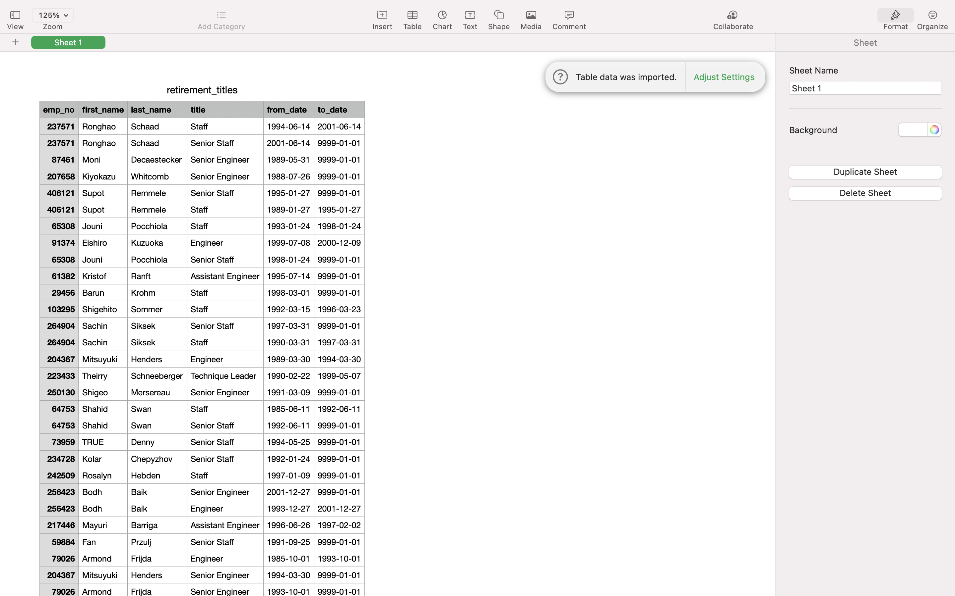
* A query is written and executed to create a Unique Titles table that contains the employee number, first and last name, and most recent title.

--Employees by most recent title

SELECT DISTINCT ON (emp_no) rt.emp_no,

rt.first_name,

rt.last_name,

rt.title

INTO unique_titles

FROM retirement_titles as rt

ORDER BY emp_no, to_date DESC;

* The Unique Titles table is exported as unique_titles.csv:

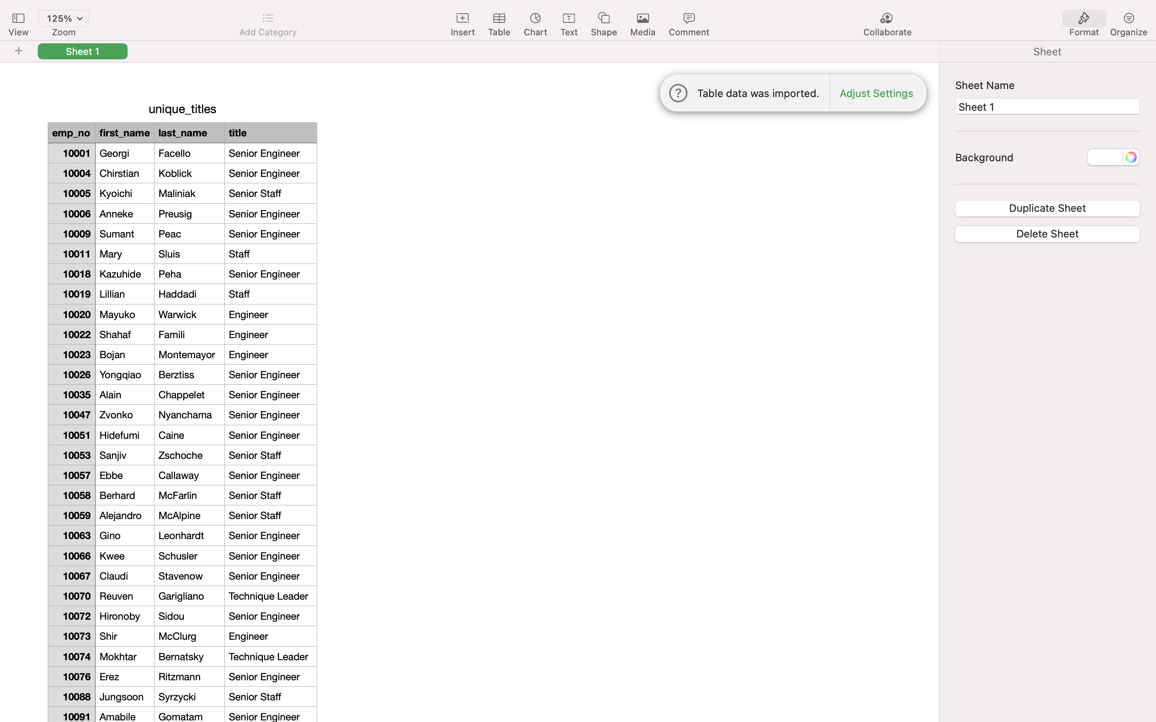

* A query is written and executed to create a Retiring Titles table that contains the number of titles filled by employees who are retiring

--count number of titles from unique_titles table

SELECT COUNT (ut.title)

INTO retiring_titles

FROM unique_titles as ut

GROUP BY (ut.title)

ORDER BY ut.title DESC;

The Retiring Titles table is exported as retiring_titles.csv:

**Deliverable 2**

* A query is written and executed to create a Mentorship Eligibility table for current employees who were born between January 1, 1965 and December 31, 196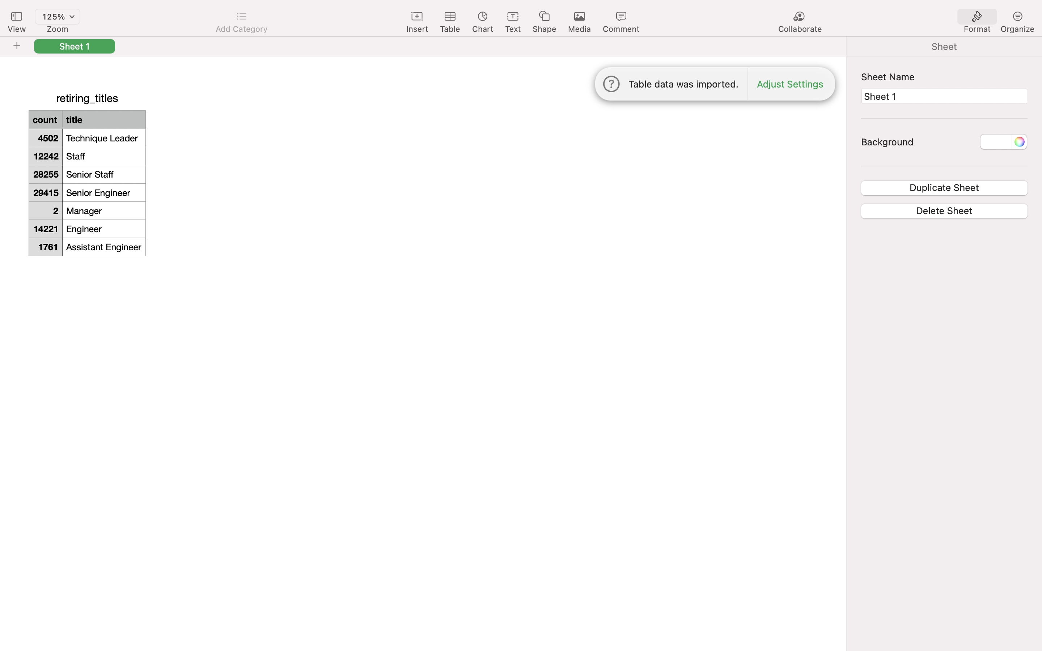5.

--Deliverable 2: The Employees Eligible for the Mentorship Program

SELECT DISTINCT ON (emp_no) e.emp_no,

e.first_name,

e.last_name,

e.birth_date,

de.from_date,

de.to_date,

t.title

INTO mentorship_eligibility

FROM employees as e

INNER JOIN dept_emp as de

ON(e.emp_no = de.emp_no)

INNER JOIN titles as t

ON(e.emp_no = t.emp_no)

WHERE (birth_date BETWEEN '1965-01-01' AND '1965-12-31')

GROUP BY (e.emp_no, de.to_date, de.from_date, t.title)

ORDER BY emp_no;

The Mentorship Eligibility table is exported and saved as mentorship_eligibilty.csv: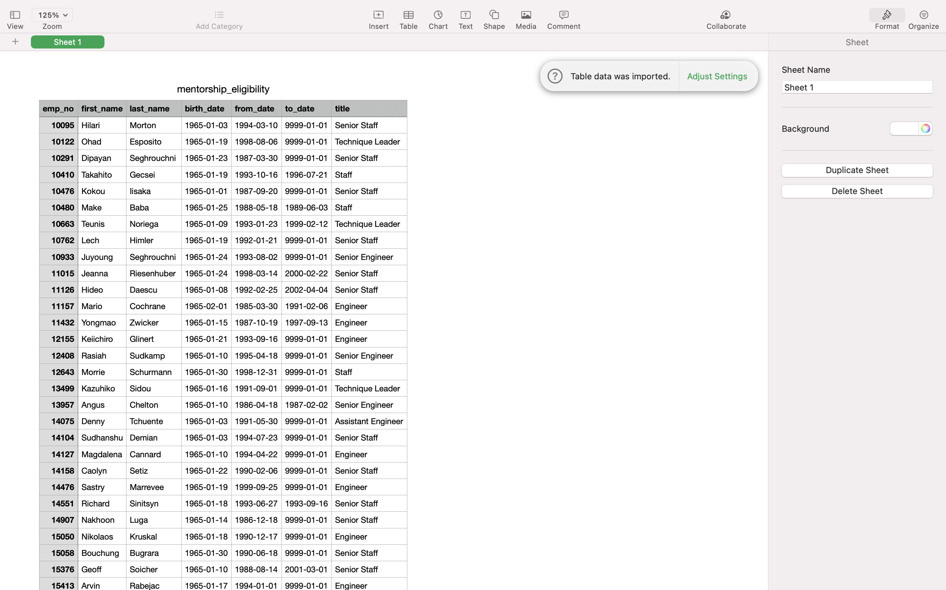

1. **Summary:**

* How many roles will need to be filled as the "silver tsunami" begins to make an impact?
* Using the following query returned a total of 90, 398 roles that will need to be filled:

--count number of titles from unique_titles table

SELECT SUM (count)

FROM retiring_titles;

Are there enough qualified, retirement-ready employees in the departments to mentor the next generation of Pewlett Hackard employees?

* Using the following query returned a total of 1,940 employees that are mentorship ready.

SELECT COUNT (emp_no)

FROM mentorship_eligibility;