43008: Reinforcement Learning
Assignment 3, Part-B:
Design, Development/Implementation Plan

Project Title and number (Refer to Dashboard): Autonomous drone hoop flying with reinforcement learning (DJI Tello) [TBC: project number from the dashboard]

Team Name: [TBC: fill in from the dashboard]

Team Members:
Student Name | Student ID | Email ID

Dataset/Environment Details (Optional, if available/planned):
The project does not use a fixed dataset. The agent learns by interacting with simulated environments that we built to mirror a real 2 × 2 × 2 m netted cage with a blue foam-noodle ring (30 cm opening, centre about 1.2 m high) hanging near its centre. The final target is a real DJI Tello drone flying through the ring using only its own front camera, then looping round the outside and re-entering, as many times as possible.
Environments
Environment | What it is | Role
PyBullet quadrotor (gym-pybullet-drones, HoverAviary) | Physics simulator of a Crazyflie CF2X; public: github.com/utiasDSL/gym-pybullet-drones | First milestone: learn to hover (sanity check of the RL pipeline)
HoopNetAviary (our env, scripts/hoop_net_env.py) | PyBullet cage + ring built from a phone 3D scan of the real cage. Ring position, facing and size randomised every episode; prop-wash pushes the ring away; residual wind swing; touching the net ends the episode | Full-state task (drone position known) to design the reward / MDP and train a privileged policy
Onboard-camera simulator (our env, hardware/onboard/sim.py + gym_env.py) | Fast lightweight simulator of the Tello: drone dynamics, pinhole camera, ring detector model, 15 Hz control. Observation = what the real drone can measure (ring detection + telemetry) | Main training environment for the policy that flies the real drone
Real cage + DJI Tello | 2 × 2 × 2 m net, foam ring, Tello controlled over Wi-Fi with djitellopy | Deployment and sim-to-real testing

Data we collect
• Phone 3D scan of the real cage (assets/3D_net&hoop.glb) used to place and size the simulated ring (fitted centre (+0.04, +0.07, 1.29) m, tube radius 0.18 m).
• Real-cage measurements: ring opening 30 cm, noodle 6 cm, Tello width 14 cm, so only about 8 cm of clearance each side.
• Demonstrations for imitation learning: a scripted visual-servo expert in simulation, human keyboard flights on the real Tello, and labels from a privileged teacher (DAgger).
• Real flight logs (telemetry + camera at every tick) used to measure the sim-to-real gap and to calibrate the simulator (yaw direction, turn and climb rates, velocity noise).

Interface/Deployment platform and plan:
Deployment platform: robot (small quadrotor drone). The trained policy runs on a laptop and flies a DJI Tello over Wi-Fi at 15 Hz. Each tick it reads the Tello's camera frame and telemetry, detects the blue ring with OpenCV, builds the observation, runs the policy and sends a 4-channel stick command (left/right, forward/back, up/down, yaw).
Software interface: a local web dashboard (FastAPI backend + HTML/JavaScript/Three.js front end, opened at http://localhost:8000). Planned features:
• Environment tab: 3D view of the simulated cage and ring, randomise / wind-sway previews, and an overlay of the phone scan of the real cage to check the sim matches reality.
• Simulator tab: choose algorithm (PPO, A2C, SAC, TD3, DQN), environment options and reward weights, start/stop training, live 3D view and drone camera, reward / passes chart, replay of the current or best policy.
• Drone tab: fly the real Tello (or a simulated one for dry runs) in staged modes (hover test, alignment, bounded approach, full flight, keyboard flight, trained policy), with live camera, flight events and safety buttons (land, emergency motor cut).
• History tab: compare runs; every run is also logged to ClearML for experiment tracking.
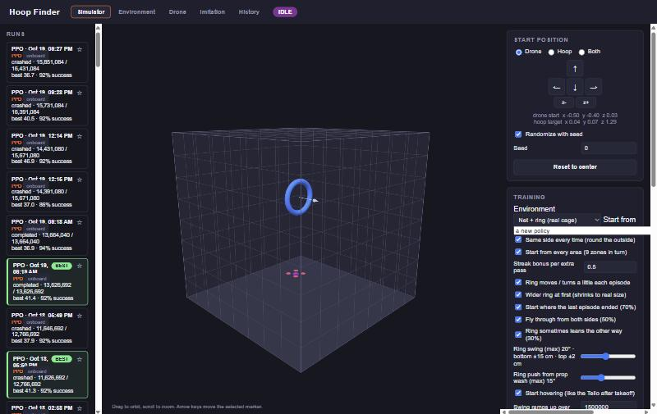
Figure 1. Planned dashboard, Simulator tab: run list, 3D cage with the ring and the drone, training options.
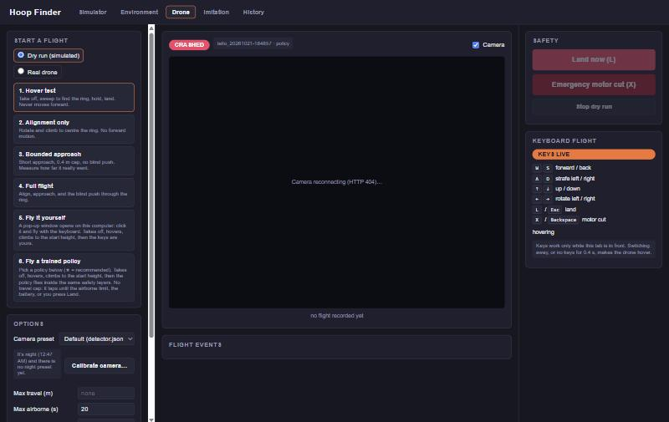
Figure 2. Drone tab: staged real-drone flight modes, camera view, keyboard flight and safety controls.
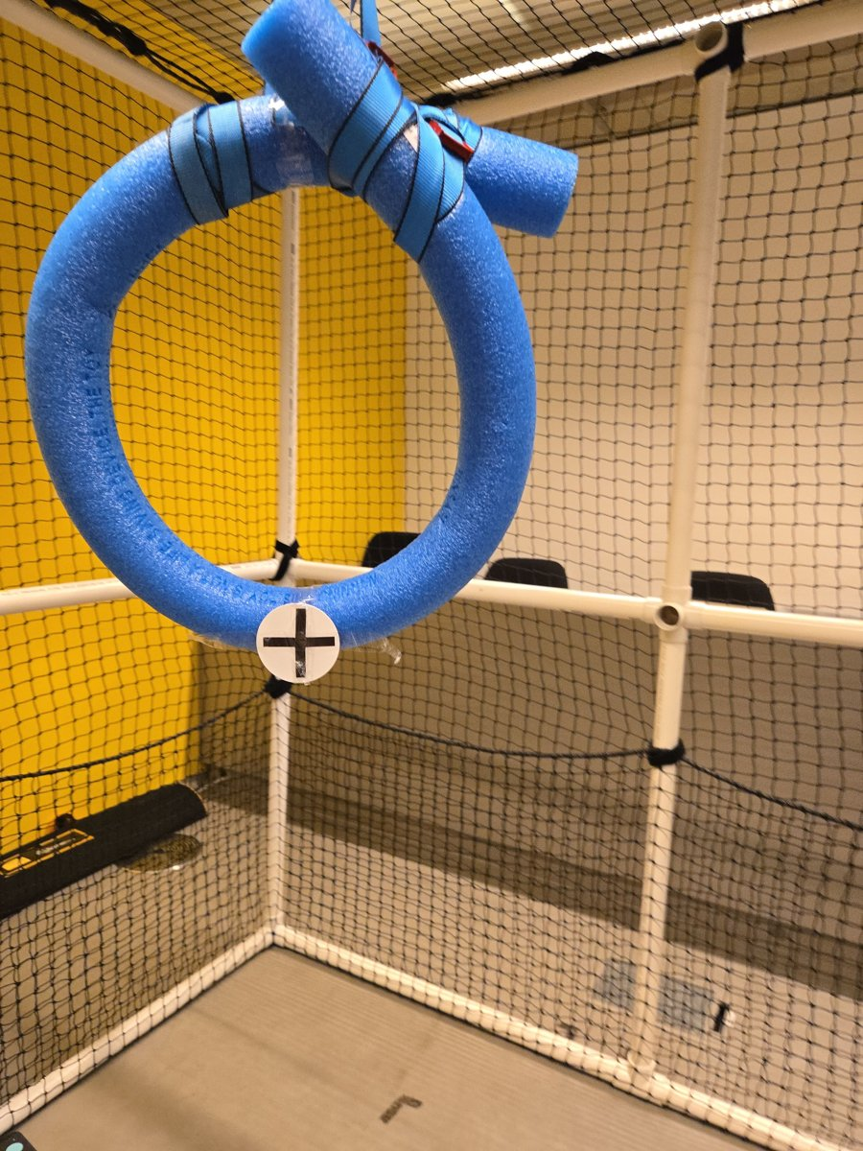
Figure 3. The real deployment environment: 2 × 2 × 2 m net cage with the blue foam ring the drone must fly through.

Implementation plan:
Techniques / methods to explore
• PPO (Stable-Baselines3) as the main algorithm: stable on continuous actions and easy to run with many parallel simulators on a CPU. Hover first, then the hoop task.
• Comparison algorithms available from the dashboard: A2C, SAC, TD3, and DQN through a discrete-action wrapper.
• Reward / MDP design: shaped progress along and towards the ring axis, bonus per pass, penalties for hitting the ring, the net or leaving the cage, and a time cost. Iterate the MDP when the agent finds loopholes (for example hovering in front of the ring).
• Imitation learning to speed up exploration: behaviour cloning from a scripted expert and human flights; DAgger with a privileged teacher that sees the true sim state; DAPG (PPO plus a kept imitation term).
• Partial observability: memory of past frames (frame history) and a ring tracker so the drone remembers where the ring is when it is out of view; an asymmetric actor-critic (critic gets privileged sim state, actor only gets real-drone inputs).
• Sim-to-real: domain randomisation (drone dynamics, ring position and swing, detector noise and lag), a simulator profile fitted to real flight logs, and curricula (wind and ring size ramp up).
Training strategy
• Staged curriculum: hover → reach the ring → fly through once → loop round the outside and re-enter.
• Parallel environments (4–8 subprocess simulators), long runs continued from the best previous checkpoint.
• Several experiments raced side by side; clear losers are stopped early, the winner is trained longer.
• Hyperparameters tuned for stability (small learning rate, target_kl trust-region brake, large batch).
Testing plan
• Evaluation protocol: deterministic policy on fixed episode layouts, starts from all 9 zones of the cage, full randomisation. Metrics: passes (laps) per 90 s episode, % episodes with 1+ and 2+ passes, and oblique-entry success from slanted starts near the ring.
• Automated tests (pytest) for the environments, observation layout, reward, simulator and safety logic; an observation-parity check between the simulator and the real-drone code.
• Staged real flights: dry runs in the simulated drone first, then hover test, alignment only, bounded approach and finally full flights with the trained policy.
Error handling plan
• Flight safety layers: battery, temperature, height window, frame watchdog, airborne time limit; land / emergency motor-cut keys and flag files from the dashboard; the drone always lands on exit.
• Training robustness: checkpoints saved at every evaluation and every 15 min; crashed runs resume from their last save; memory checks before starting new runs.
• Policy compatibility: each saved policy records its observation layout; the loader refuses a policy from another task, and exported policies are re-loaded and checked to give the same actions.
Tentative timeline
Weeks / dates | Milestone
Week 7 (early Sep) | Set up PyBullet + Stable-Baselines3; PPO hover baseline
Weeks 8–9 | Hoop environment in a 2 × 2 × 2 m cage; web dashboard; multi-algorithm training
Week 9–10 | Tello hardware bridge, safety layers, onboard-camera simulator; reward / MDP iterations
Week 10–11 | Imitation learning (BC, DAgger), memory policies; first real flights; sim calibration
Week 11–12 | Long training runs, sim-to-real fixes (corner entries, lighting), final evaluation
Final week | Real-drone demo, results analysis, report and presentation

[CHECK: adjust the week numbers to the subject calendar and the submission dates.]

