43008: Reinforcement Learning
Assignment 3, Part-D
Environment/Interface Design

Project Title and number (Refer to Dashboard): Autonomous drone hoop flying with reinforcement learning (DJI Tello) [TBC: project number from the dashboard]

Team Name: [TBC: fill in from the dashboard]

Team Members:
Student Name | Student ID | Email ID

Environment chosen: a real 2 × 2 × 2 m netted cage with a hanging blue foam ring, flown by a DJI Tello drone, plus two custom simulators of it used for training.
GUI/Environment Type: Robot (DJI Tello quadrotor) + custom simulated environments, controlled through a custom web dashboard.
Component | Details
Real environment | 2 × 2 × 2 m net cage (PVC frame). Blue pool-noodle ring hung from a rope near the centre: 30 cm opening, 42 cm outer diameter, centre about 1.2 m high, sways slightly and is pushed by the drone's prop wash. Only ~8 cm clearance each side for the 14 cm Tello
Robot | DJI Tello: front camera 960 × 720 at 30 Hz, telemetry (height, attitude, velocity, battery) at ~10 Hz, controlled over Wi-Fi with 4 rc stick channels at 15 Hz (djitellopy)
Simulator 1: PyBullet | gym-pybullet-drones (Crazyflie model) with our HoopNetAviary: the cage and ring placed from a phone 3D scan of the real cage, ring randomised every episode, wind sway and prop wash
Simulator 2: onboard camera | Our fast Tello simulator (hardware/onboard/sim.py): drone dynamics fitted to real flight logs, pinhole camera and ring-detector model, domain randomisation. Wrapped as a Gymnasium environment; this is where the deployed policy is trained
Task | Take off, find the ring, fly through it, loop round the outside and re-enter from the same side, as many times as possible in 90 s

Screen shot(s) of the actual GUI/Environment:
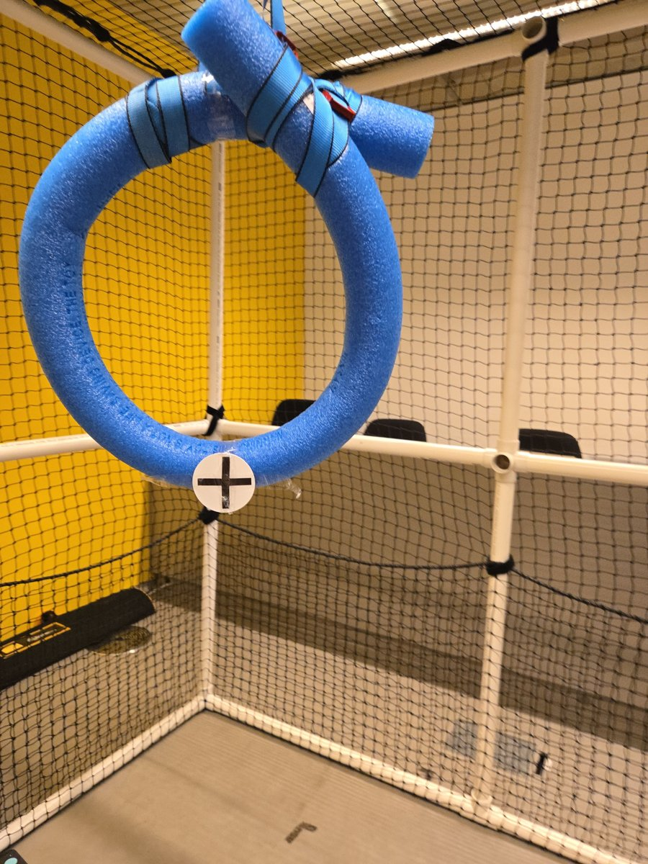
Figure 1. The real environment: the 2 × 2 × 2 m net cage and the blue foam ring the Tello must fly through.
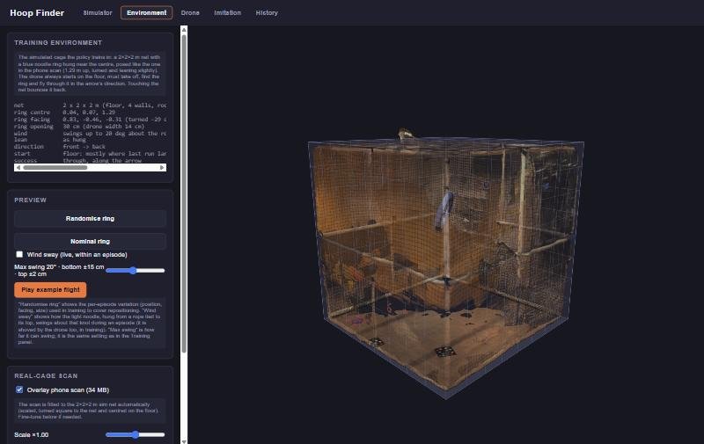
Figure 2. Dashboard, Environment tab with the phone 3D scan of the real cage overlaid on the simulated net, used to check the simulator matches the real cage.
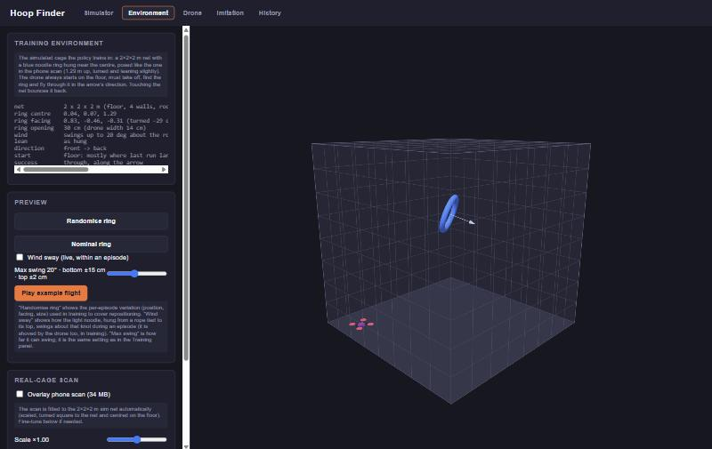
Figure 3. Environment tab: the simulated cage and ring (with its facing arrow). Buttons randomise the ring, preview wind sway and play an example flight.
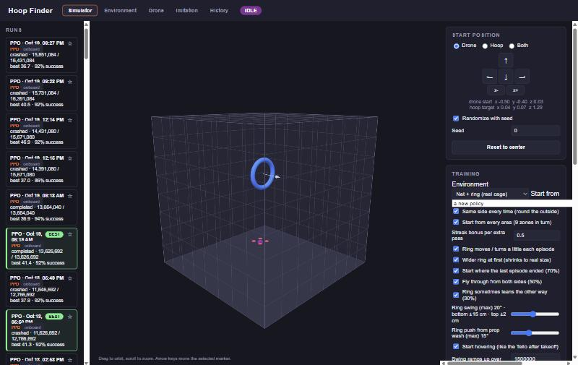
Figure 4. Simulator tab: list of training runs (left), 3D view of the drone and ring (centre) and the training options: environment, same-side laps, start zones, streak bonus, ring swing and prop-wash push (right).
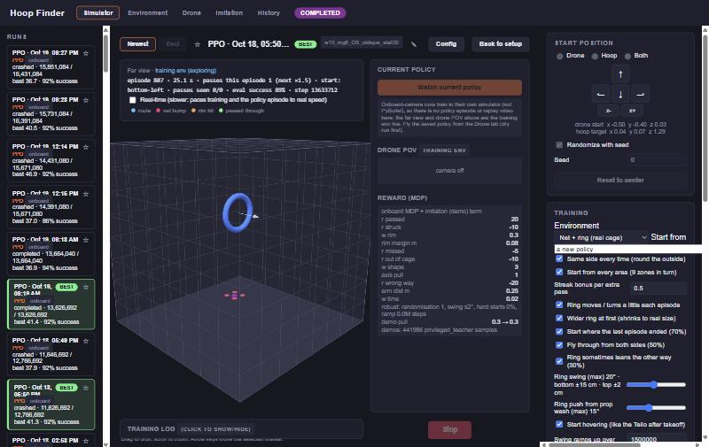
Figure 5. A training run open in the Simulator tab: live far view with the episode, passes and evaluation success, the 'Watch current policy' button, the drone camera panel and the reward (MDP) weights used by the run.
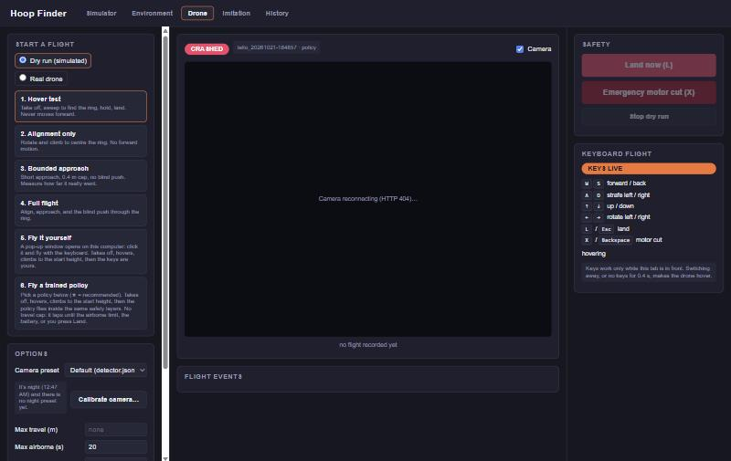
Figure 6. Drone tab: flight modes from a hover test to flying a trained policy (real drone or simulated dry run), live camera, keyboard flight and safety buttons (land now, emergency motor cut).
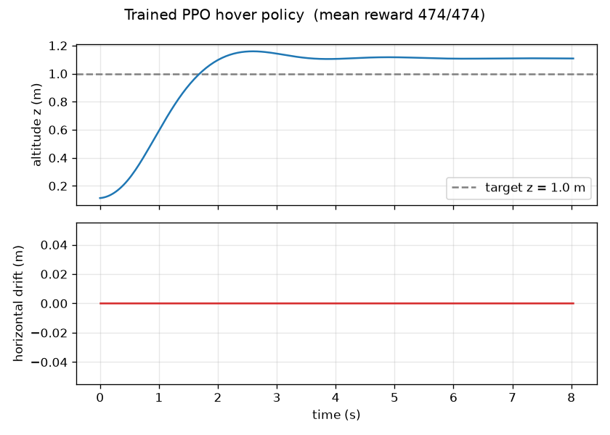
Figure 7. First milestone in PyBullet: the trained PPO hover policy climbs to 1.0 m and holds it.

