Heuristic Evaluation  
Interface Design

By Michelle McGinty

R00122053

DWEB2

Chosen Website: *Blackboard*

04/11/15

Word Count: 1,205

Heuristic evaluation is done as a systematic inspection of a user interface design for usability. The goal of heuristic evaluation is to find the usability problems in the design so that they can be attended to as part of an iterative design process.

Heuristic evaluation involves having a small set of evaluators examine the interface and judge its compliance with recognized usability principles (the “heuristics”).  
**And I have chosen to do my project on blackboard.**

1. Introduction

Blackboard is a virtual learning environment and course management system developed by Blackboard Inc. It is Web-based server software which features course management, customizable open architecture, and scalable design that allows integration with student information systems and authentication protocols.

From using the website in the last year and a half I have encountered some usability problems.

2. Visibility of system status

The visibility and system status of blackboard is very much easily understood, the modules you are taking are easily seen and I had no problem navigating through them and the rest of the website.

3. Match between system and real world

Overall, the match between system and real world for blackboard was good, there was no words I didn’t understand, no jargon I had to learn. Overall it was a good experience.

4. User control and freedom

From what I have seen from the last year and a half the user control and freedom is fair, I often navigate with the back and forward buttons on the browser if I come into trouble as blackboard doesn’t support undo and redo.

5. Consistency and standards

I have come across the double use of the same icon for the home page and module page.

I’ve explained it in more detail below in Aesthetic and Minimalist design.

The main home page and the module home page have the same icon.

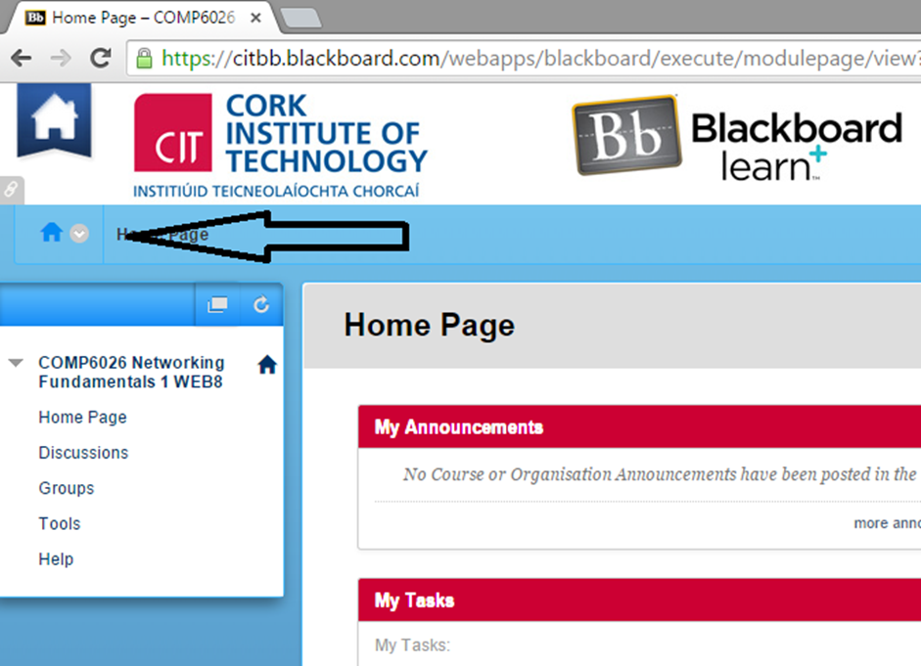

You can see the main home button in the top left corner and the module home button underneath, where the arrow is pointing to.

Many times when I go to click the module home button I click the main home button by mistake or vice versa. They are situated to close to each other and look too alike.

6. Error prevention

When uploading my files to the assignments page I saw a problem, you can only upload one file at a time.

When browsing and selecting the files I wanted, many times I clicked the wrong file to upload which meant I had to delete it from the submission list and browse again for the file.

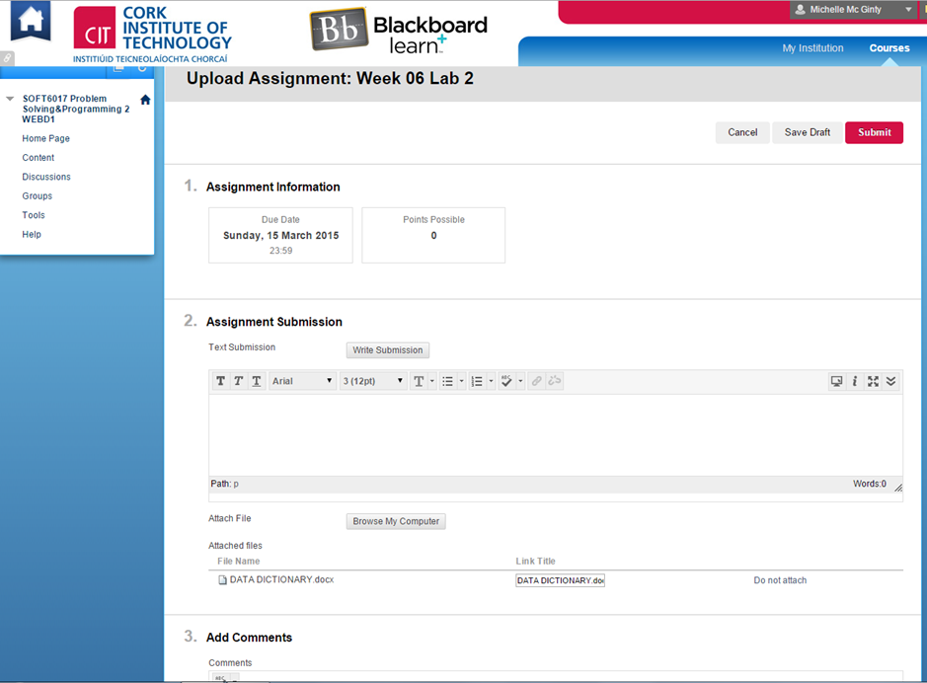

*Use Case Scenario:*

1. I clicked which module I wanted from the main menu.

2. I was brought to the module page, I clicked content, it is found on the left hand side of the page.

3. I was brought to the content page, I clicked which assignment I wanted to submit.

4. In the Upload Assignment page I had to browse the computer for the files, and you have to do that every time you want to upload a file.

This is also used in Flexibility and Efficiency of Use, see below.

7. Recognition rather than recall

I’ve seen when I was submitting my work in the assignments page that you cannot copy and paste your work (eg. Using word) straight into the text submission page, a warning appears saying you have to use a different method to copy and paste.

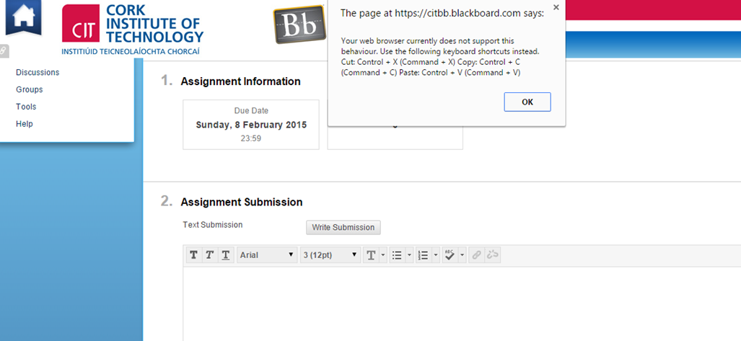

*Use Case Scenario:*

1. I highlighted my work and right-clicked on the work and pressed copy.

2. I logged in to my blackboard.

3. I clicked which module I wanted from the main menu.

4. When in the module page, I clicked content, found on the left hand side.

5. When in the content page, I clicked which assignment I wanted to submit.

6. I scrolled down to the text submission box.

7. I wasn’t allowed to paste directly to the box.

To paste my work into the text editor I had to learn a new way to copy and paste.

When using the new method of copy and paste I often mixed up the keyboard shortcuts, which meant I had to google the shortcuts to find out what they were again and had to go back to Microsoft word and copy it again.

8. Flexibility and efficiency of use

When I was uploading my files for my assignments you must go to content in the module page and submit the assignment file one at a time.

I had to browse for each file on the computer and upload it one by one, there was no shortcut or an application where I could select how many files I wanted. With my assignments at the moment there are rather a few files to upload. This is rather time consuming and very inefficient to select each file one by one.

9. Aesthetic and minimalist design

I’ve seen a problem with the main home button the top left corner.

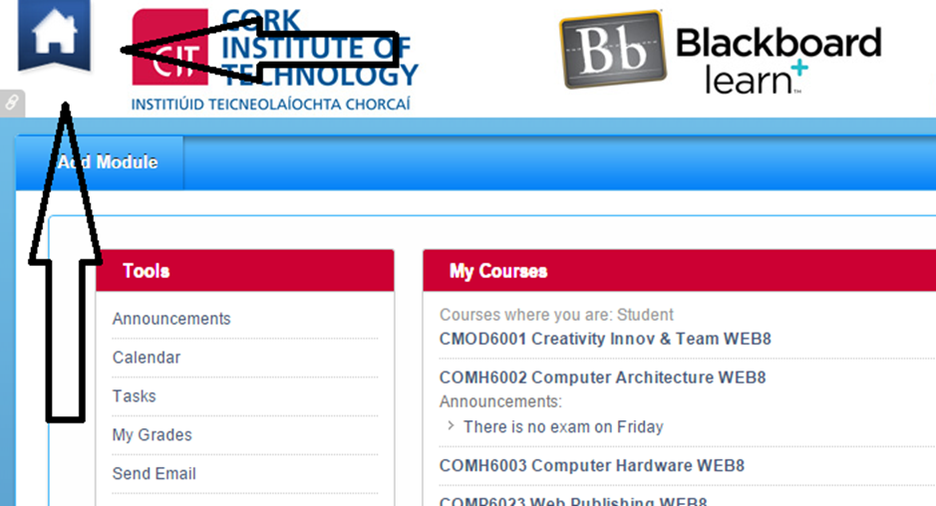

Every time I click the main home page button it appears in another new tab with the home page open, this is very frustrating and leads to many unnecessary unused tabs. Yes it is a shortcut but a new tab every time you click it is rarely needed and can crowd the browser.

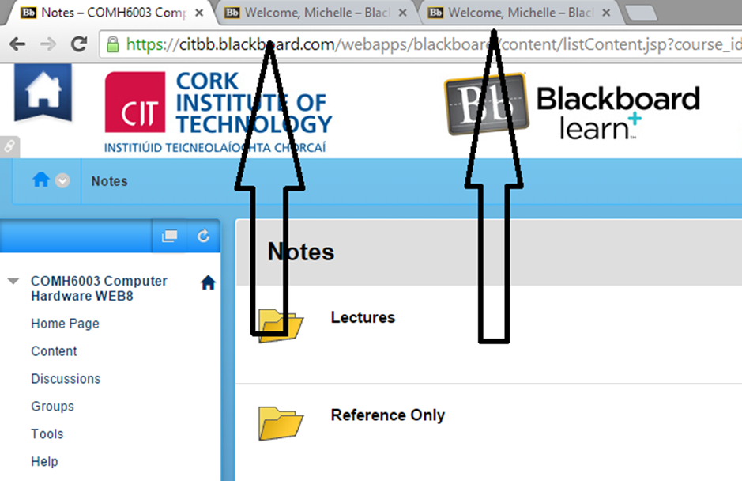

You can see the needless and wasteful tabs here.

10. Help users recognise, diagnose and recover from errors

When I tried to paste my work into the text editor in the assignments page I got an error.



As you can see it was presented in plain sight an easy to read, I quickly learned from my error with the new shortcuts.

11. Help and documentation

Trying to find help and documentation was a bit of a challenge, in the main home page you have to select the grey bar in the top right corner and the help button is that little question mark on the bottom of the menu.

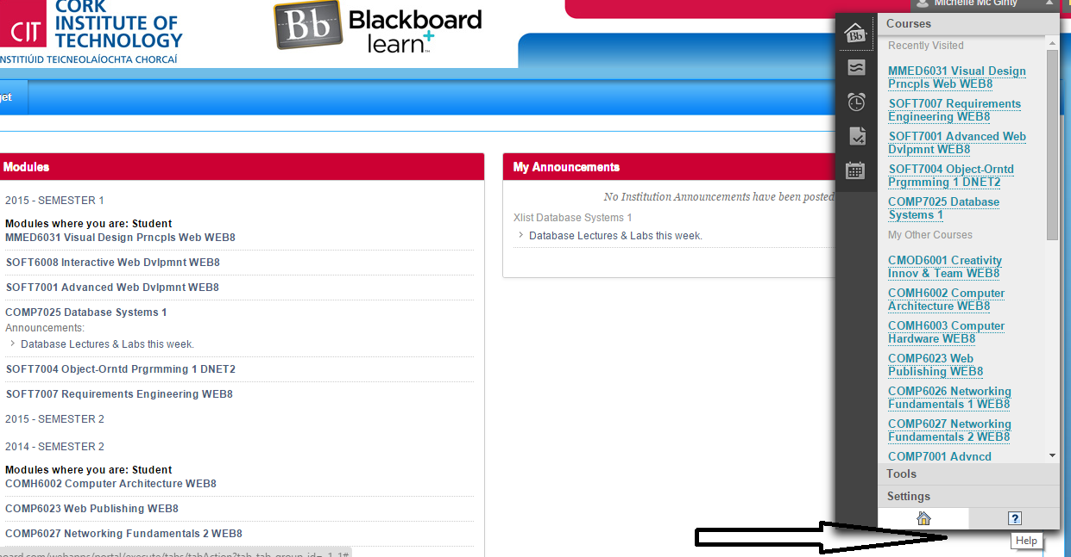

But once you open the help button there is a big quantity to choose from, you would easily find the solution to your problem.

On the other hand the help button for the modules page it is really easy to find.

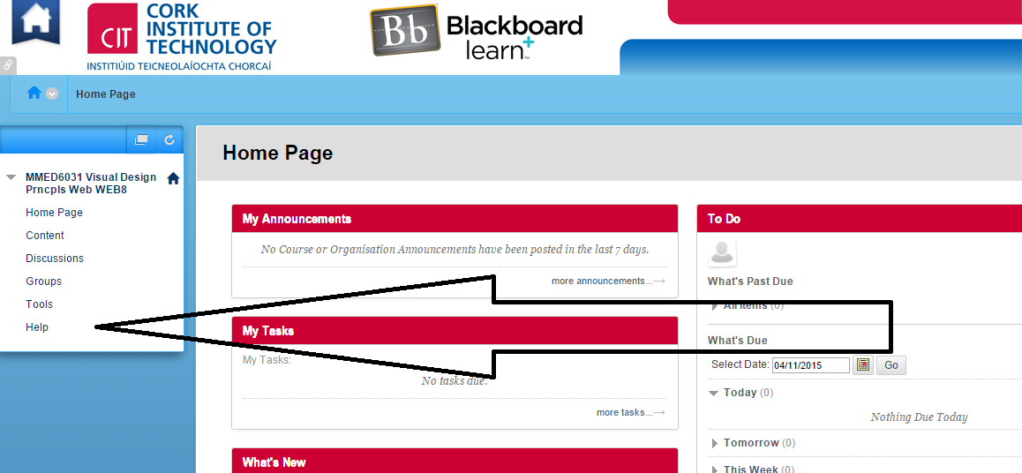

Again you are brought to a menu with plenty of information to choose from.

12. Conclusion

From using blackboard for the last year and half and also from doing this project I have gotten a good insight to the User Interface.  
I think there are a lot of errors that the developers could work on and could be easily fixed to make it a much more usable website.

Like e.g. for the double use of home buttons make a different icon for the module home button so the user can differentiate between them and to get rid of the needless extra tabs any time you click the main home button.

And also with uploading files to the assignments page, you can only upload one file at a time. A solution for this would to let the user browse the computer and let them select how many files they want at once.

With these simple solutions it would make backboard much more user friendly.

Thank you for reading.