**Production menu**

1. Driving – Commitment file - e_commit – tab PROC RISK PART1

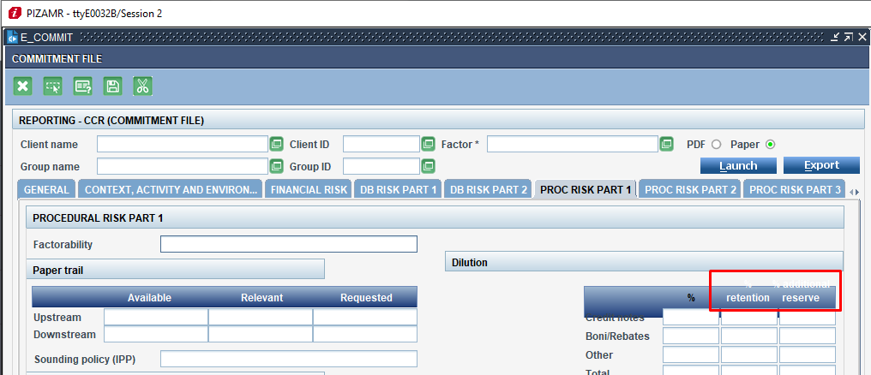

1. Screen: e_aff_commit **OK transferred to PIZAMR**

a) Label ID: 103520

Key: "pct_retenue"

Before EN:

%

retention

Corrected EN: % retention

Before FR:

%

Retenue

Corrected FR: % retenue

_________________________________

b) Label ID: 103521

Key: pct_reservesuppldt

Before EN:

% additional

reserve

Corrected EN: % additional reserve

Before FR:

% réserve

suppl.

Corrected FR: % réserve suppl.

1. Group of contracts - e_grp_ctr – button Involved party

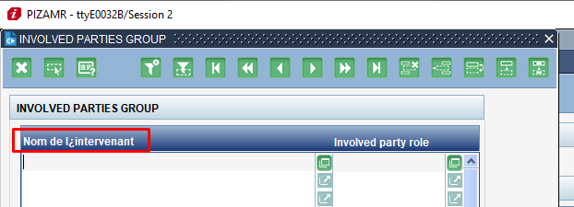

2. Screen e_grp_ctr

FR label "Nom de l'intervenant" is correct on TRAD, however it is displayed with broken apostrophe on instance PIZAMR (both V8 and V9). Can this be fixed somehow?

The label needs to be fixed only for V9 on PIZAMR, therefore the corresponding RID is 151062.

1. Mass capture – Enter payments - e_mvt

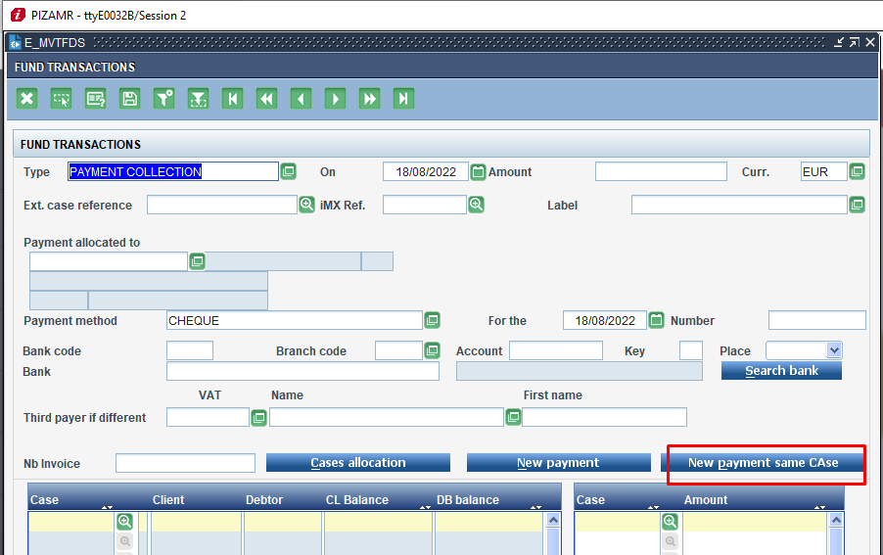

3. Screen e_mvtfds **OK transferred to PIZAMR**

The button was missing, so it is now added:

Label ID: 5762593

NEW Key: "andnew_payment_same_case"

EN: &NEW PAYMENT SAME CASE

FR: NOUVEL ENCAISS MÊME DOSS

1. iMX forms translation - e_trad_ecrans – tab Forms translation – sub tab Step1

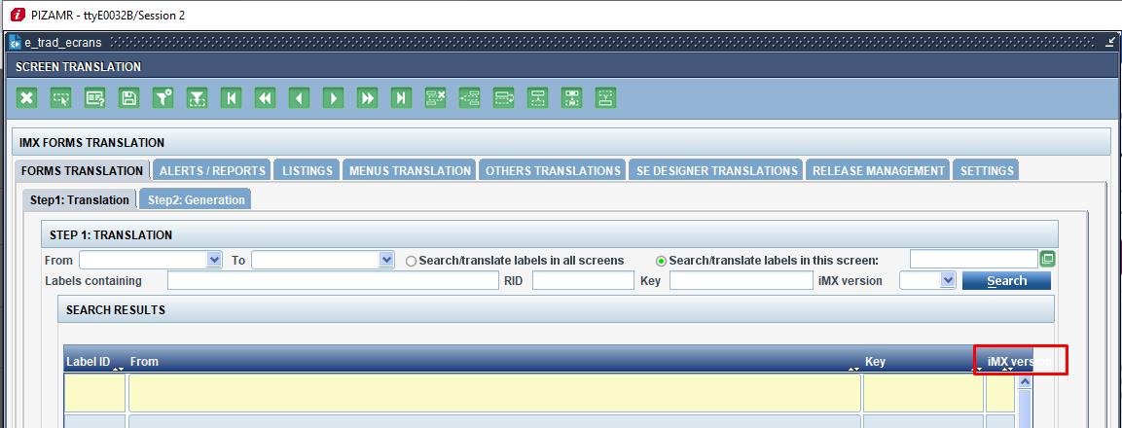

4. Screen e_trad_ecrans **OK transferred to PIZAMR**

The issue here is that the label text is not fully visible, therefore the solution is to make it fall on 2 rows.

Label ID: 149352

Before EN: iMX version

Corrected EN: iMX

version

FR: correct (on 2 rows)

Added V9 record in both EN and FR.

**Enterprise menu**

1. Value list – Financial elements - e_saelemfi

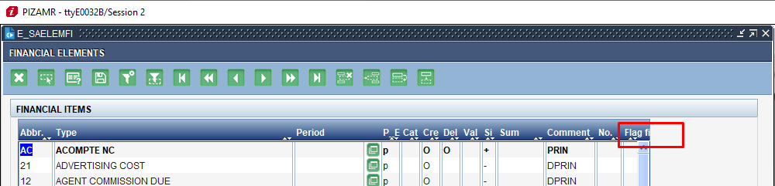

5. Screen e_saelemfi

Same issue with the label not fully visible: translation dropped on 2 lines.

Label ID: 151113

Before EN:

Flag

fi

Corrected EN: Flag fi

Before FR:

Flag

fi

Corrected FR: Flag fi

V9 record added for both EN and FR.

I am not really sure how to fix the arrows issue - seems to be a technical thing.

RID: 151113

Key: flag_fi

Before EN:

Flag

fi

Corrected EN: Flag fi

1. Value list – Invoice param per BU - e_pfac_m

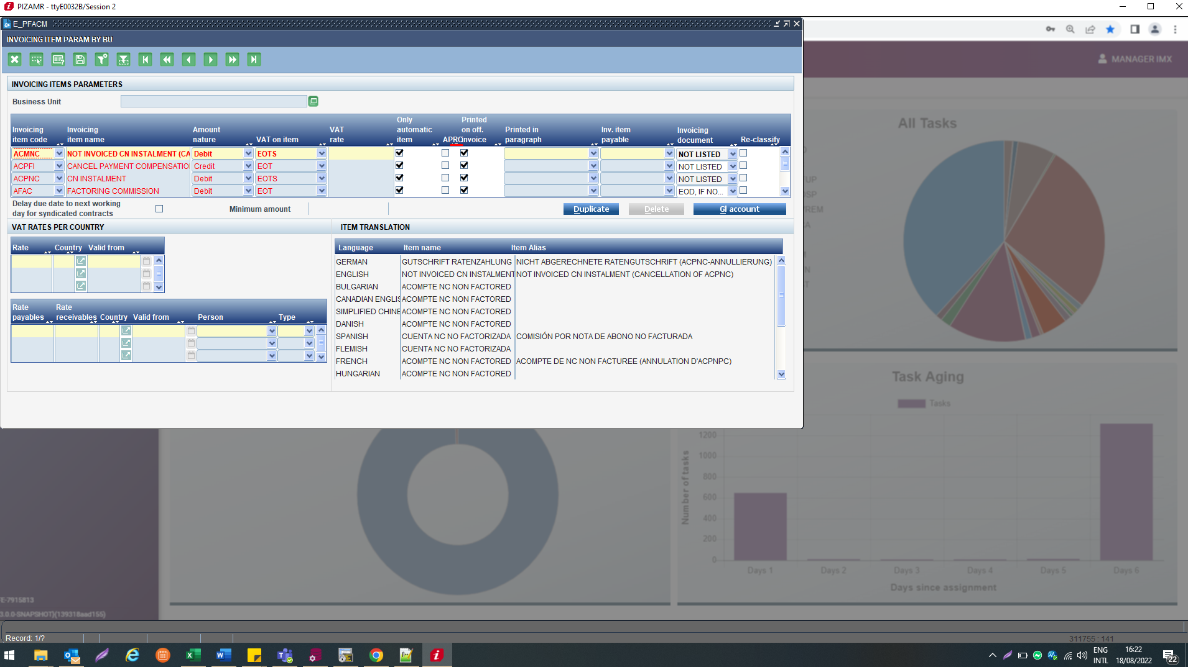

6. Screen e_pfacm

This is not exactly a translation related issue, but rather a technical one: not enough space to accommodate the label text

The label is correct on the screen e_pfacm on TRAD.

Label ID: 18167

EN: APRC

FR: APRC

1. The company and staff – Public holidays

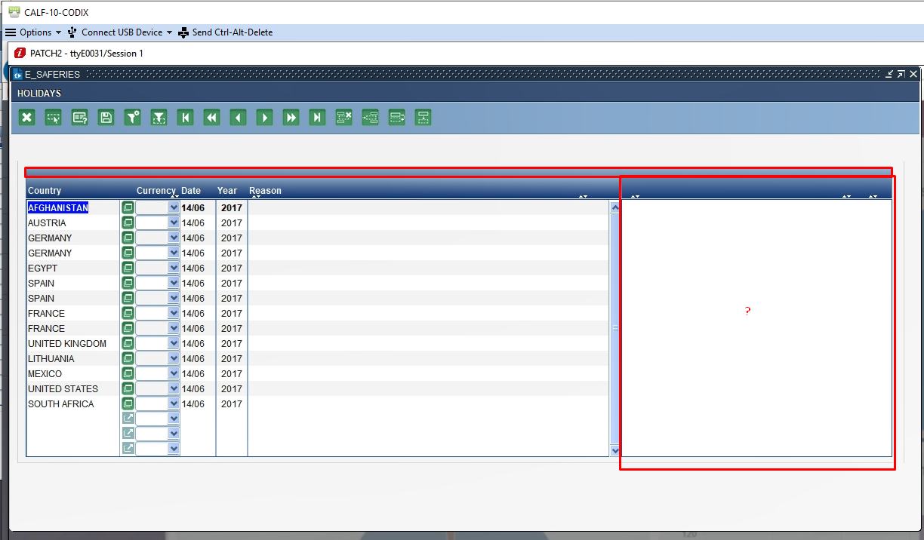

We don’t have an issue on PIZAMR

7. Screen e_saferies

The reported issue seems to be related to the LoV "pays" applicable only for V8 - again, technical issue not related to TRAD/translation.

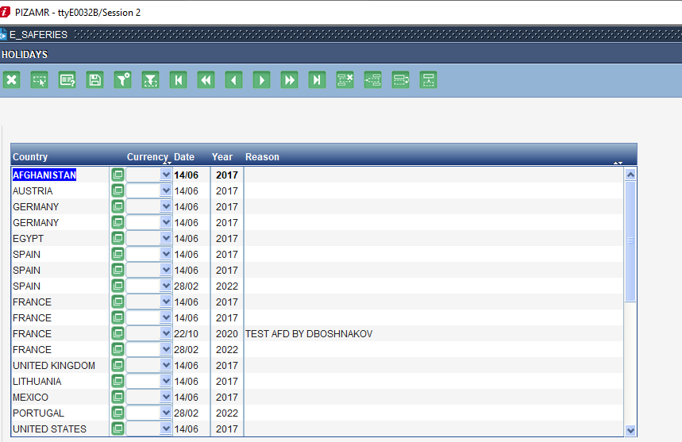

**Menu Accounting**

1. Management of the account param – OPCODE param – e_lsparam

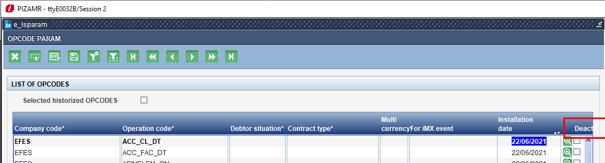

8. Screen e_lsparam **OK transferred to PIZAMR**

The correct label is "Hist."

Label ID: 51047

Key: deactdt

Before EN: Deact.

EN corrected: Hist.

Before FR: Deact.

FR corrected: Hist.

Before ES: Desact.

ES corrected: Hist.

Added V9 records for EN, FR and ES.