Screen: e_aff_doscli1: OK

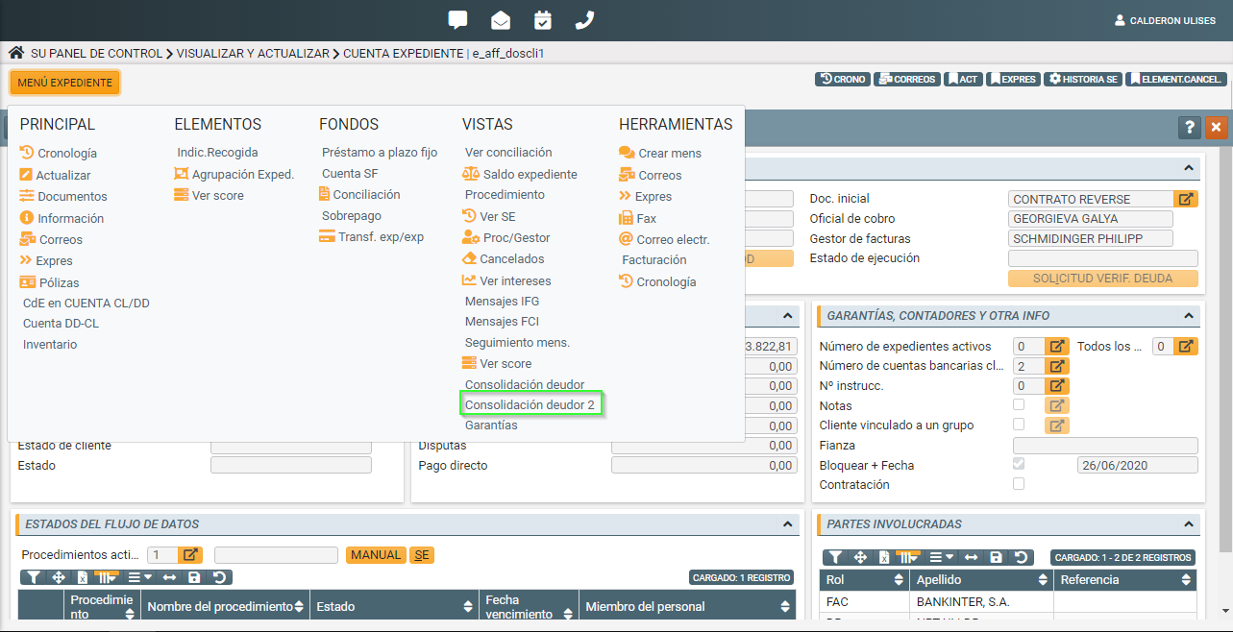

Screen: e_vichrodv: NOK

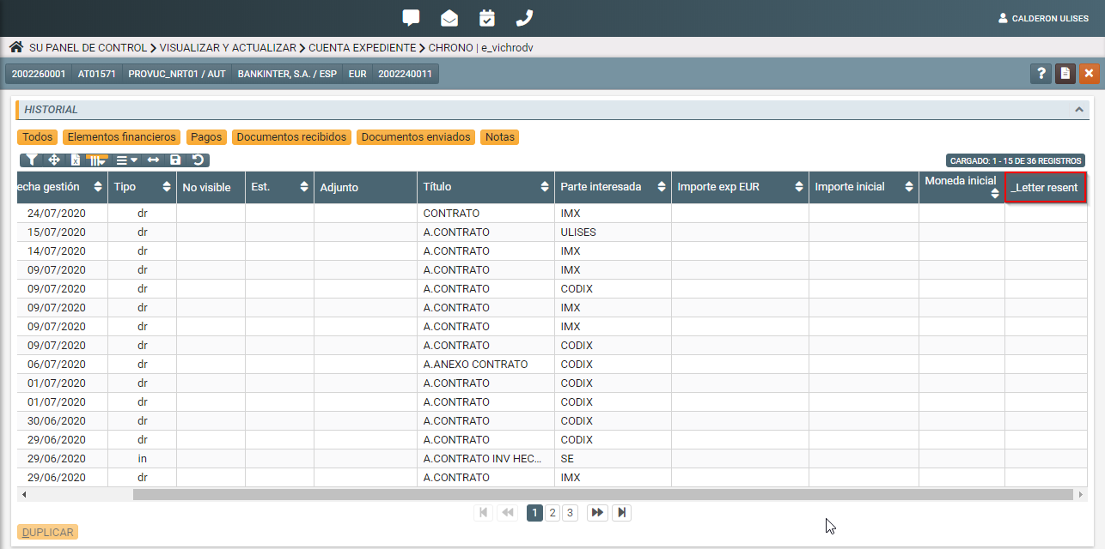

E_majctdv: OK

