**Theme = 14 IVR**  
-Stratif A : 2111220004 ----OK, sum soldedb_dos = 100 EUR is played

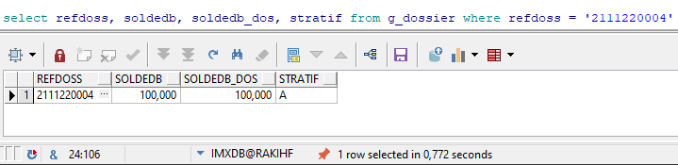

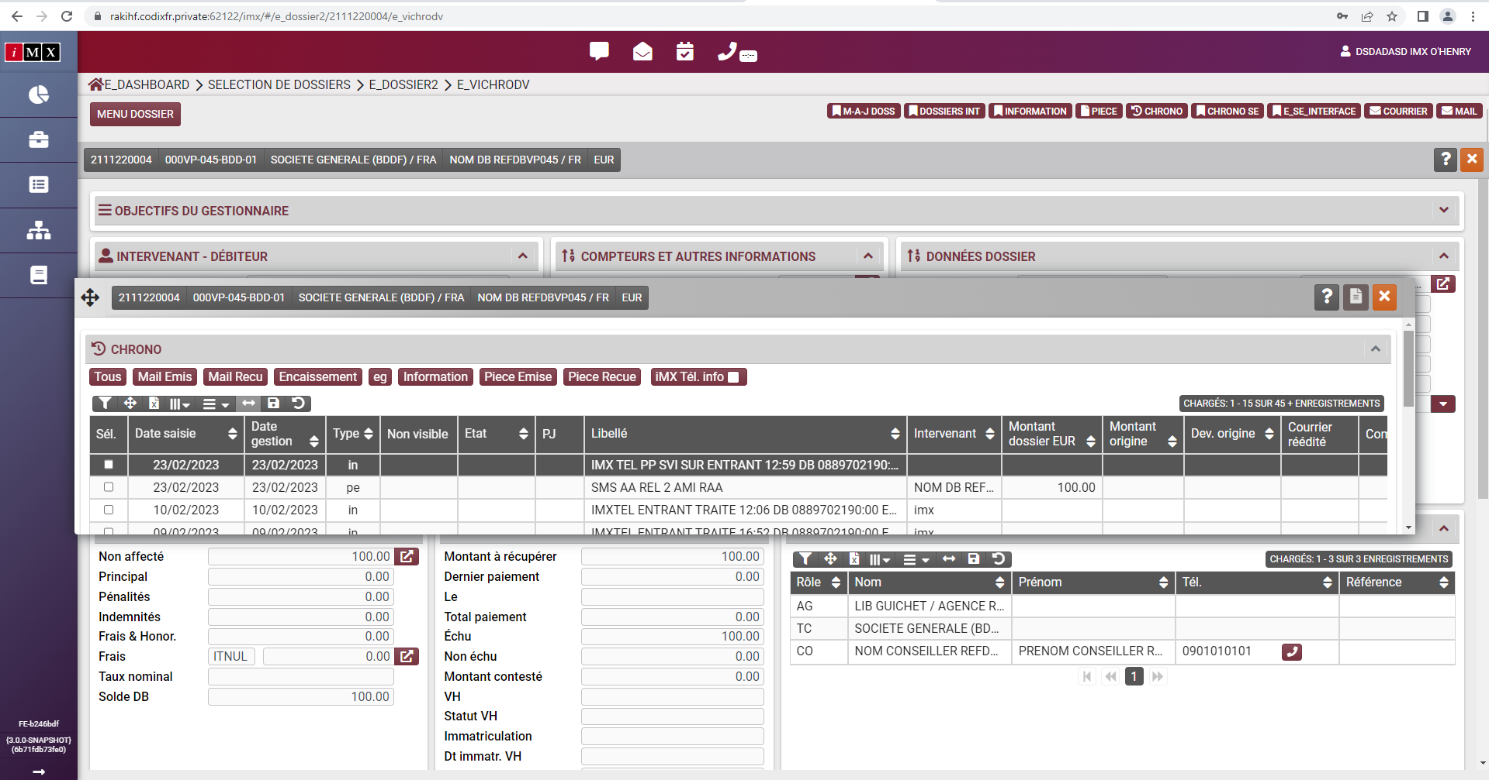

-line 'sd' : 2111180001 - does not play sum (soldedb_dos) at the end

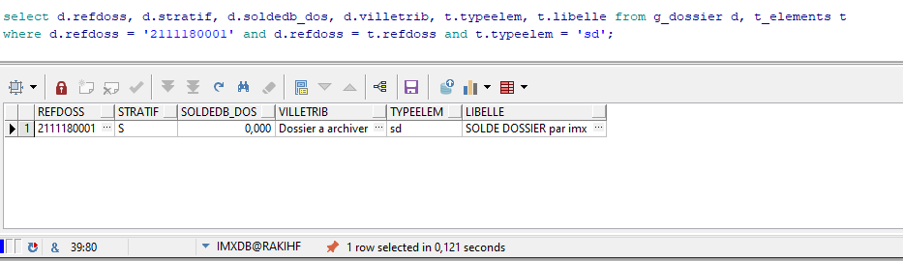

-record in T_ARCHDOS : 1911140022 - does not play sum (soldedb_dos) at the end

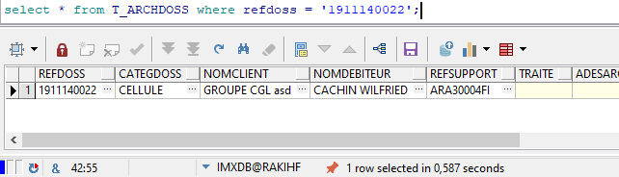

-solde = '0' : 2111190009 - does not play sum (soldedb_dos) at the end

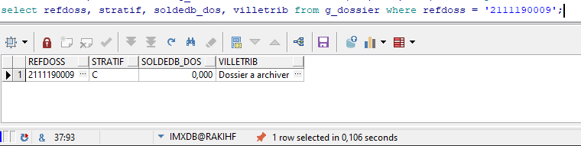

-stratif = 'C' : 2111190009 - does not play sum (soldedb_dos) at the end



-stratif = 'S' : 2111180001 - does not play sum (soldedb_dos) at the end

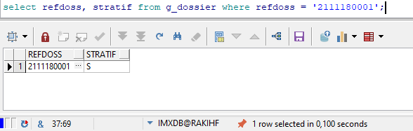

-filiere SOL (contexte C) --- 2111170034 - does not play sum (soldedb_dos) at the end

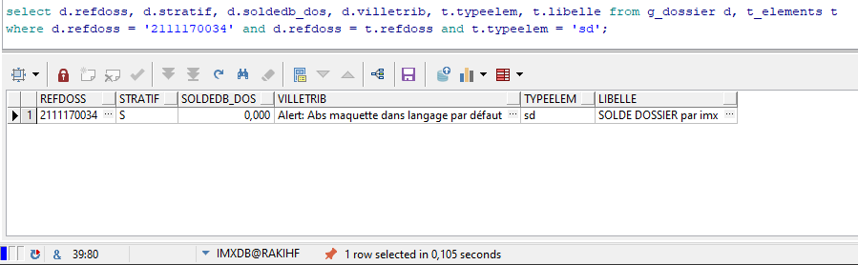

-filiere IRR (contexte C) : 2111010063 - does not play sum (soldedb_dos) at the end

