1. Install TortoiseSVN

2. Create source folder on C:\

3. right click on source folder, choose SVN checkout ...

4. config repo:

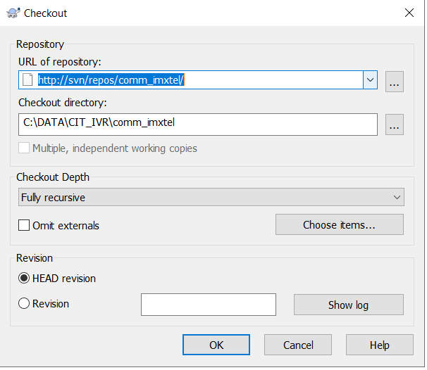

5. click ok