Apple Return Volatility Forecasting
ECMT 674 - Economic Forecasting | Homework 4
Michael Shannon

Project Objective
Analyze Apple daily stock-price returns from January 2015 through April 2025, diagnose volatility clustering and ARCH effects, compare ARCH and GARCH specifications using the Schwarz Information Criterion (SIC), and produce 26 one-step-ahead conditional-volatility forecasts for a held-out test period.

Analytical Workflow
- Imported daily Apple Open, High, Low, and Close data from APPL.xlsx.
- Calculated daily log returns from Close prices and scaled them to basis points.
- Used ndiffs() to verify that the return series required no additional differencing.
- Fit an ARIMA mean model to the 2,554-observation training sample.
- Inspected squared residuals with ACF/PACF diagnostics.
- Regressed squared residuals on four lags to test for ARCH behavior.
- Compared ARCH(2), ARCH(3), and ARCH(4) models using SIC.
- Compared GARCH(1,1), GARCH(1,2), GARCH(2,1), and GARCH(2,2) models using SIC.
- Generated 26 one-step-ahead conditional-standard-deviation forecasts and compared them with an absolute-residual volatility proxy.

Submitted Findings
The submitted write-up reported strong ARCH effects in Apple returns. The four-lag squared-residual regression was highly significant (F-statistic approximately 79.7, p < 2.2e-16), with lags 1, 2, and 4 statistically significant.
Among the reported ARCH models, ARCH(4) had the smallest SIC (approximately 13.075) versus ARCH(3) at 13.087 and ARCH(2) at 13.104.
The submitted write-up reported GARCH(1,1) as the preferred GARCH specification after comparing GARCH(1,1), GARCH(1,2), GARCH(2,1), and GARCH(2,2). The report also stated that the selected model left no meaningful remaining ARCH effect according to the residual diagnostics.

Selected Submitted Figures
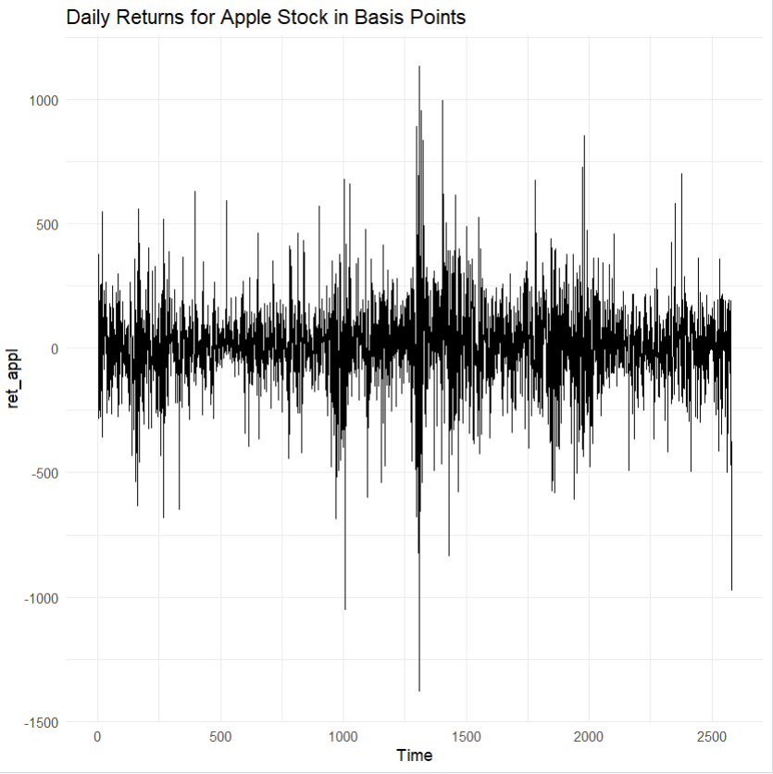
Daily Apple Returns in Basis Points
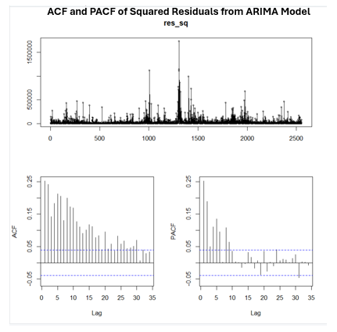
Squared-Residual ACF/PACF Diagnostics
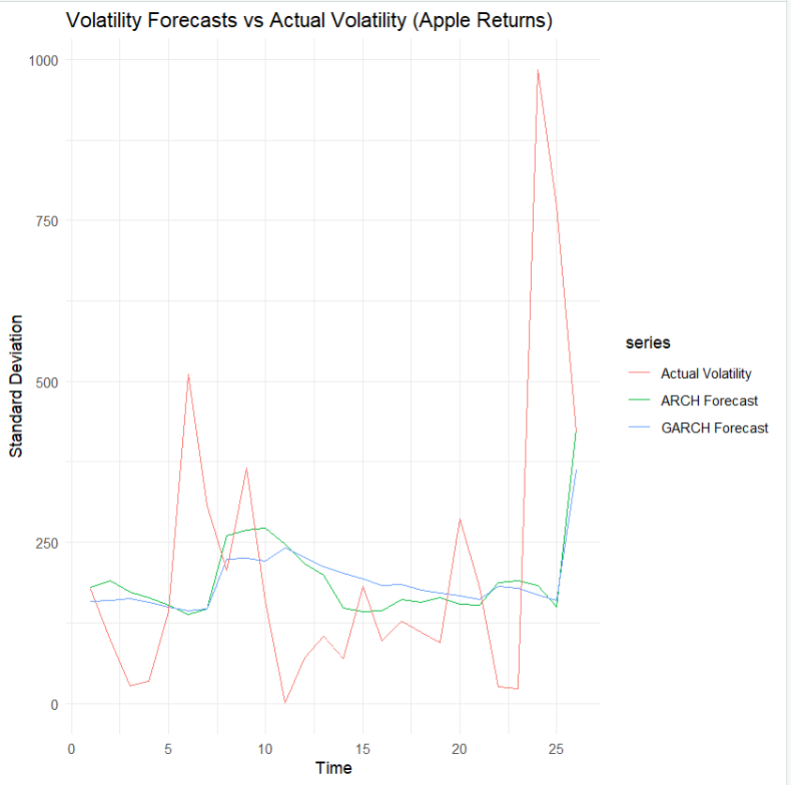
ARCH and GARCH Volatility Forecasts vs. Actual-Volatility Proxy

Portfolio Note
This public summary omits the university identification number contained in the original course submission. The repository preserves the original analytical choices but flags several code/report inconsistencies for a later reproducibility correction pass rather than silently rewriting the submitted work.

