Rice Futures Nearby Series Programming
ECMT 673 - SAS Programming Project
Michael Shannon

Project Objective
The project used SAS to ingest multiple rough-rice futures contract files, combine the contract-level records, construct a submitted Nearby settlement-price series, export the result to Excel, and visualize the series over time.

Submitted Time-Series Output
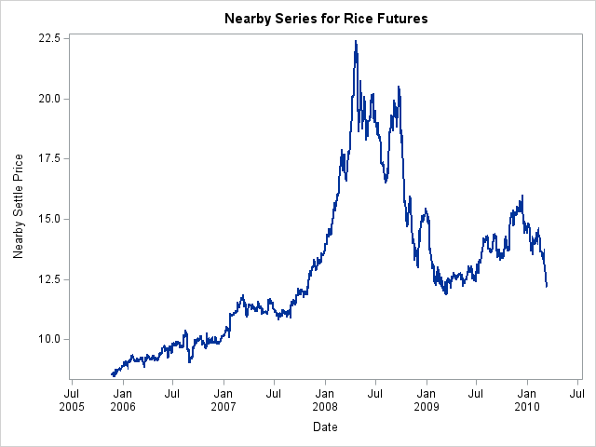
Nearby Series for Rice Futures - submitted project output

Programming Components
- Imported contract-level CSV files with SAS DATA steps, INFILE, INPUT, DSD, and MISSOVER.
- Defined contract symbols, dates, OHLC prices, settlement prices, volume, and open interest.
- Sorted contract datasets by trading date and stacked them into a combined dataset.
- Used retained variables, temporary arrays, string parsing, and BY-group processing in the submitted Nearby workflow.
- Exported the resulting dataset to Excel using PROC EXPORT.
- Created the time-series visualization with PROC SGPLOT.

First-Difference / Rollover Consideration
The submitted project noted that first differences in a continuous futures series require special care around contract rollovers. A large change from one date to the next may reflect not only a true market-price movement, but also the transition from one delivery contract to another. For that reason, rollover dates and contract continuity should be reviewed before interpreting large first differences or volatility spikes.

Public Repository Note
This public-facing project summary omits the university identification number contained in the original course submission. The original raw 20 contract CSV files were not retained in the current artifact set, and the submitted rollover logic is scheduled for validation during the final repository correction pass. The GitHub repository therefore preserves the submitted code and output while documenting those limitations transparently.

Repository Files
- Submitted SAS code, redacted for public use
- GitHub-portable SAS code with relative file paths
- Retained Nearby_Series.xlsx output
- Submitted time-series plot
- Methodology, data dictionary, reproducibility notes, and upload guide

