

Planify

Plan your future

Name: Moga Eduard Mihai

Group: 4

Table of Contents

Deliverable 1 2

Project Specification 2

Functional Requirements 3

Use Case Model 3

Use Cases Identification: 3

UML Use Case Diagrams 4

Supplementary Specification 5

Non-functional Requirements 5

Design Constraints 5

Glossary 6

Deliverable 2 6

Domain Model 6

Architectural Design 7

Conceptual Architecture 7

Package Design 7

Component and Deployment Diagram 7

Deliverable 3 8

Design Model 8

Dynamic Behavior 8

Class Diagram 10

Data Model 11

System Testing 11

Future Improvements 11

Conclusion 11

Bibliography 11

# Deliverable 1

## Project Specification

Planify is a Web App that lets you plan your feature to achieve it. You can notebooks that let’s you track the path to your destinations. Each day you can bring your challenges to the table and the app you’ll come in our help at the end of the week with statistics and improvements. For each dream you will have the notebook ask for a resolution you want to achieve, to motivate you to reach the heights. When needed you can ask the AI for more information about how you can work your way through. At the end of the week, you will get all the results for your notebook in the archive so you can see when needed. All the work you put in will be rewarded with achievements you can see in the Achievements tab.

## Functional Requirements

1. Create user through register
2. Admin manages the users
3. Access the application through login
4. Create, modify, delete notebooks
5. Sort notebooks after its type
6. Get achievements
7. Join groups
8. Get recommendations from the AI

## Use Case Model

### Use Cases Identification:

Use case: Manage users

* **Level**: Admin Interaction
* **Primary Actor**: Super System User (Admin)
* **Main success scenarios**:
  + Admin should navigate through the users
  + Admin should be able to delete users, modify and add super users
  + Admin should be able to see all the achievements
  + Admin should be able to moderate the groups

Use case: Login / Register

* **Level:** User Interaction
* **Primary Actor:** User
* **Main success scenarios:**
  + Users should register with the required fields
  + Users should login with the email username and password
* **Failures success scenarios:**
  + Users should be notified of the right error and be redirected to the specified page

Use case: Manage notebook

* **Level:** User Interaction
* **Primary Actor:** User
* **Main success scenarios:**
  + Users should choose between the types of the notebook and complete with the required and related fields
  + Users should be able to sort the notebooks, search the notebooks, delete and update with relevant information
  + Users should be able to view the older notebook as well as the archives with the relevant analysis made by the AI

Use case: Group action

* **Level**: User Interaction
* **Primary** **Actor**: User
* **Main** **success** **scenarios**:
  + Users should be able to join and leave community groups for the same relevant hobbies and resolution
  + Users should be able to communicate between them in the dedicated servers

Use case: Achievements

* **Level:** System Interaction
* **Primary Actor:** User
* **Main success scenarios:**
  + Users should get achievements based on their performance and metrics set by the SUPER ADMIN / SYSTEM CONFIGURATION and view progress.

### UML Use Case Diagrams

IN DRAW.IO FORMAT

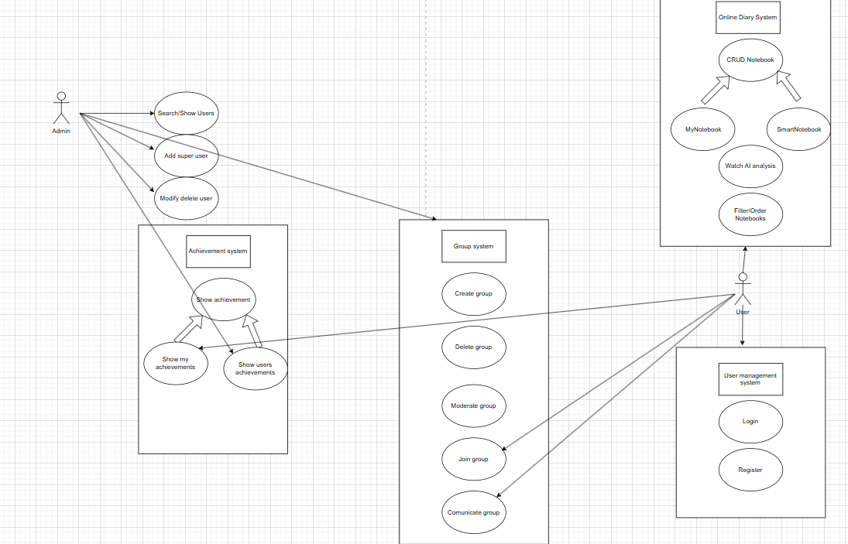

## Supplementary Specification

### Non-functional Requirements

* ***Performance***: Ensures the fast response of the *AI*, *analyzes* the *group* communication without delay but also a seamless *login* and *register* *experience*
* ***Scalability***: By following the right principles and *architectural* *designs* scalability of the system can be assured in the right context for multiple *users* doing *various* *tasks*.
* ***Security*** of the system: *Encryption* of the data is a necessity, also the prevention of *unauthorized* access.
* ***Usability***: The ease of use should be a priority for a seamless *user* *experience*, achieved by simplifying various processes.

### Design Constraints

* **Backend**: *Java* (Language)
  + Framework: Spring Boot
* **Frontend**: JavaScript, HTML, CSS (Language), Thymeleaf (Java – template engine)
  + Framework: NextJS
  + Library: ReactJS
* **Tool Manager:** Maven
* **Database:** MySQL (MySQL workbench)
* **IDE:** IntelliJ
* **Architectural Constraints:** 
  + *MVC – model view control* architectural design with the Spring package separation in repository, model, controller, templates, service

## Glossary

# Deliverable 2

## Domain Model

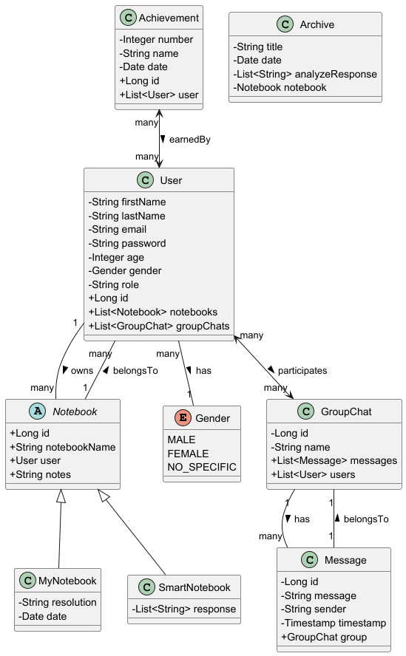

## Architectural Design

### Conceptual Architecture

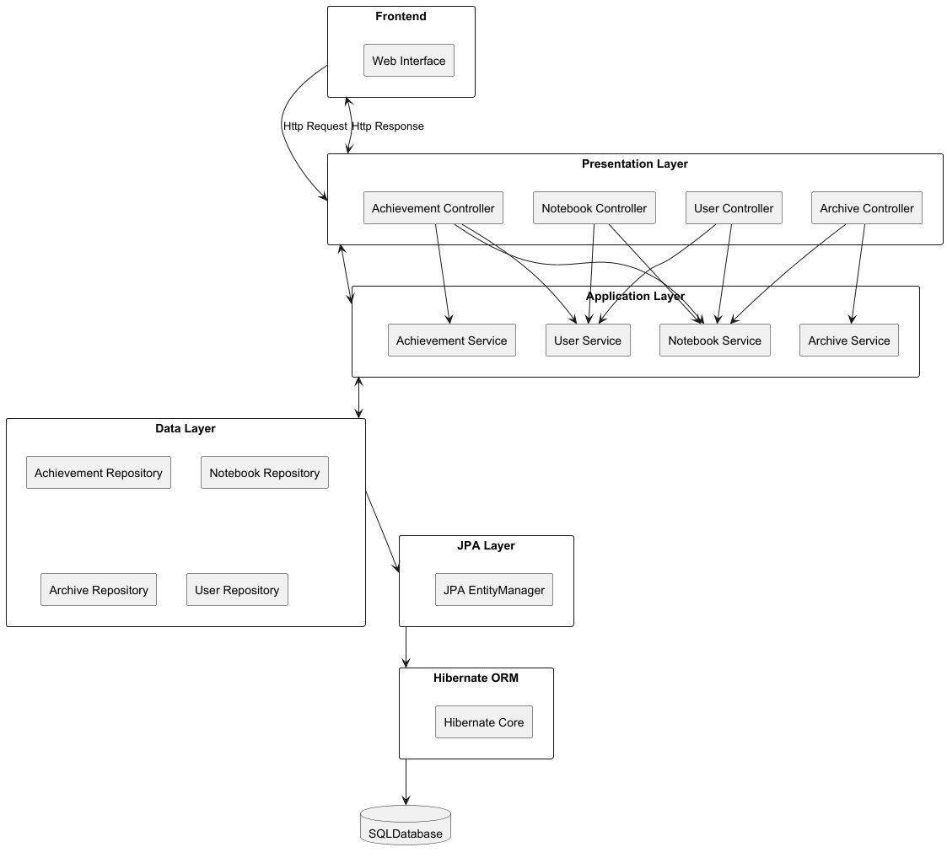

### Package Design

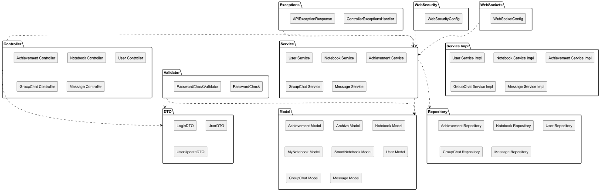

### Component and Deployment Diagram

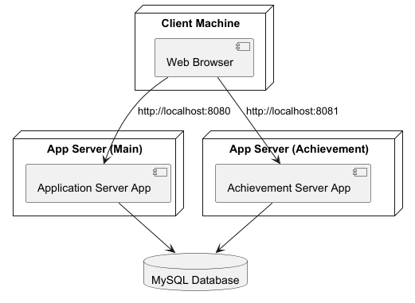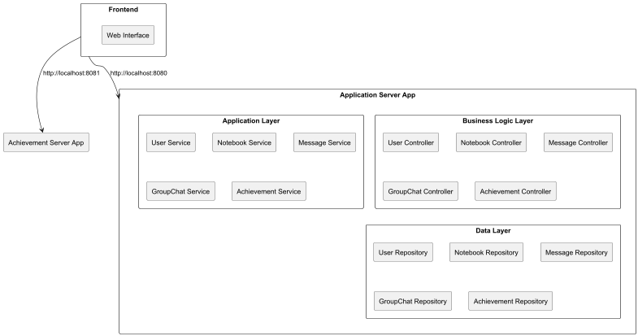

# Deliverable 3

## Design Model

### Dynamic Behavior

Sequence diagram for login, register, forgot password and enter as a guest.

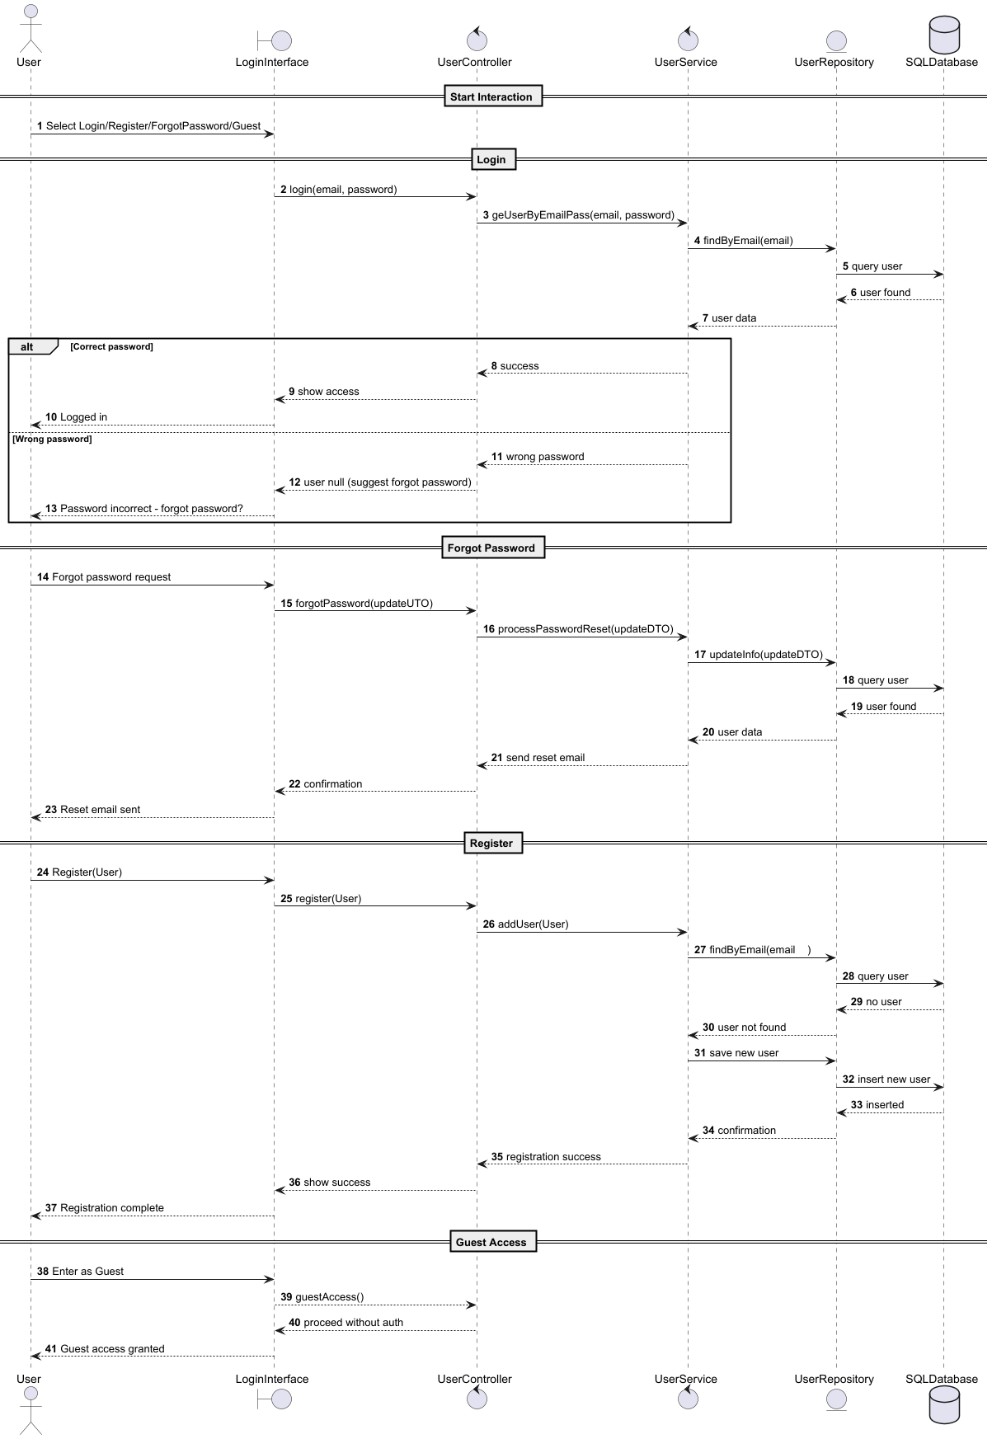

### Class Diagram

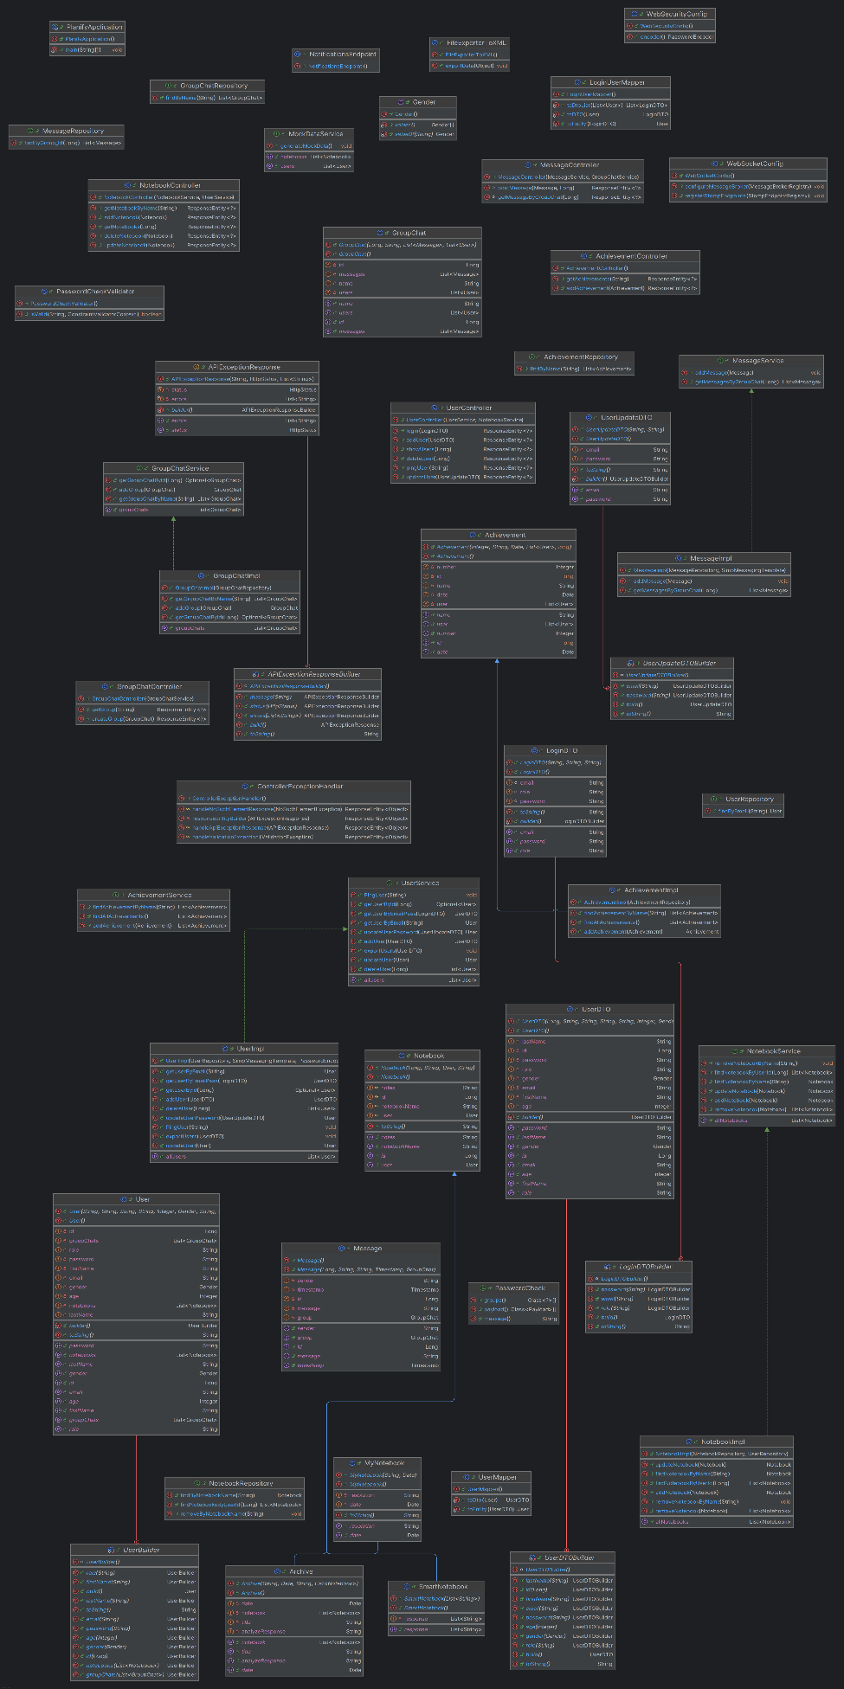

## Data Model

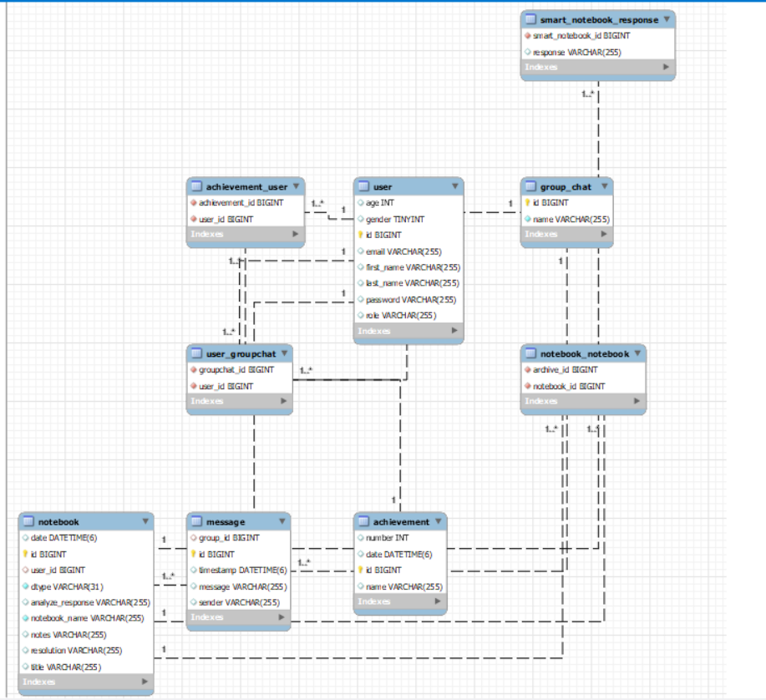

# System Testing

Login feature in which you can login with email and password

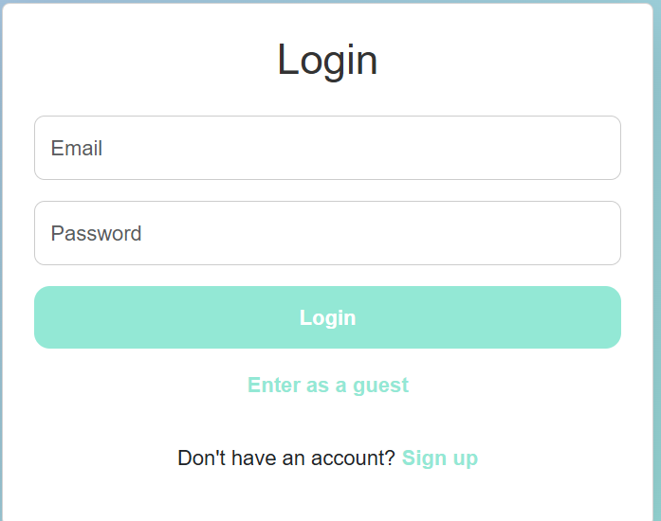

You need valid email and password, or you will get validation error.

You can add notebooks.

Name and resolution must be not blank or a pop up will occur:

If completed the notebook will successfully be added.

Dashboard for admins only.

On group chat you can chat with others by greating a group!

The group name must not be blank.

# Future Improvements

The Planify app will be improved in several practical ways.

First, an AI tool will be added to help analyze content. For example, it can summarize notes, detect the tone of messages, or suggest better names for notebooks. This will make the app smarter and more useful when handling content.

Security will be upgraded by using Spring Security. This means users will log in more safely, and only authorized users will be able to access certain parts of the app. The system will use secure tokens and roles to manage who can do what.

The chat feature will also be expanded. Users will be able to chat one-on-one in addition to group chats. There will also be dedicated groups people can join, making communication more organized and private.

The user interface will be improved to make the app easier and more pleasant to use. The homepage will become more useful by showing relevant content like tips, updates, or data pulled from online APIs.

Achievements will become more meaningful. The app will track what users accomplish and rank them based on their activity. This adds a competitive element and encourages users to stay active.

Finally, the login system will be expanded with new options, including OCR (Optical Character Recognition). This means users might be able to scan something like an ID or a QR code to log in more easily.

These updates aim to make Planify more secure, smarter, easier to use, and more fun.

# Bibliography

<https://spring.io/>

<https://www.baeldung.com/spring-pathvariable>

<https://www.geeksforgeeks.org/spring/>

<https://chatgpt.com/>

<https://react-bootstrap.netlify.app/>

<https://refactoring.guru/design-patterns>

<https://www.geeksforgeeks.org/software-design-patterns/>

<https://developer.mozilla.org/en-US/docs/Web/HTTP/Guides/CORS>

<https://www.techtarget.com/whatis/definition/monolithic-architecture>

<https://www.geeksforgeeks.org/microservices/>

<https://react.dev/reference/react/createContext>

<https://legacy.reactjs.org/>

<https://www.w3schools.com/react/react_useeffect.asp>

<https://www.w3schools.com/css/>