Elektronica-ICT
Elektronische systemen 2
Sound measurement with integration of Arduino Pedalshield
Authors | Michiel Parthoens  Loïc Schillings
Content
1 1
2 Introduction 1
3 Hardware and software 2
3.1 Hardware 2
3.1.1 Research 2
3.1.2 Sensors 4
3.1.3 Additional hardware 6
3.2 Software 7
4 Results 8
4.1 Sensor Integration and Signal Acquisition 8
4.2 Signal Amplification and Processing 8
4.3 Output Signal Quality 8
4.4 Performance Metrics 9
5 Conclusion 9
6 Reference list 9
7 Attachment 9

- Introduction
This application note delves into the innovative fusion of sensors with the Arduino Pedalshield. The utilization of sensors for capturing sounds and vibrations, coupled with the signal-enhancing capabilities of the Pedalshield, provides us with new possibilities for real-time monitoring and analysis.

In this document, we explore the integration between sensor data acquisition and signal processing using the Arduino platform. Specifically, throughout this project, we aim to achieve three primary goals: the effective utilization of a sensor dedicated to capturing sound, the proper utilization of the Pedalshield for signal amplification and manipulation, and finally, the display of the enhanced and possibly modified signal on an OLED screen using the Arduino Due
- Hardware and software
Before we can discuss the project we need to explain the used hardware and software. This section contains the hardware and software used in the project and the research done to achieve the end result.
  - Hardware
A variety of hardware components were used in this project. An Arduino Due was crucial for signal interpretation. The Pedalshield posed the greatest challenge; it connects to the pins of the Arduino Due and amplifies the signals from the sensors. Various sensors were tested and employed as input for the Pedalshield, enhancing its functionality. Additionally, a range of hardware plugs and cables were utilized to establish the required electrical connections,
    - Research
Before commencing the project, thorough research was imperative. Initially, attention was directed towards the Arduino Due, followed by a comprehensive examination of the Pedalshield. Subsequently, the sensors were looked at. Finally, research was conducted to identify any additional required hardware components.
The research conducted for the Arduino Due was relatively brief. The primary focus was understanding the pin layout of the Arduino. Additionally, we delved into discovering the parameters of the ADC and DAC pins. These pins are responsible for receiving signals from the Pedalshield as well as transmitting any modified signals.
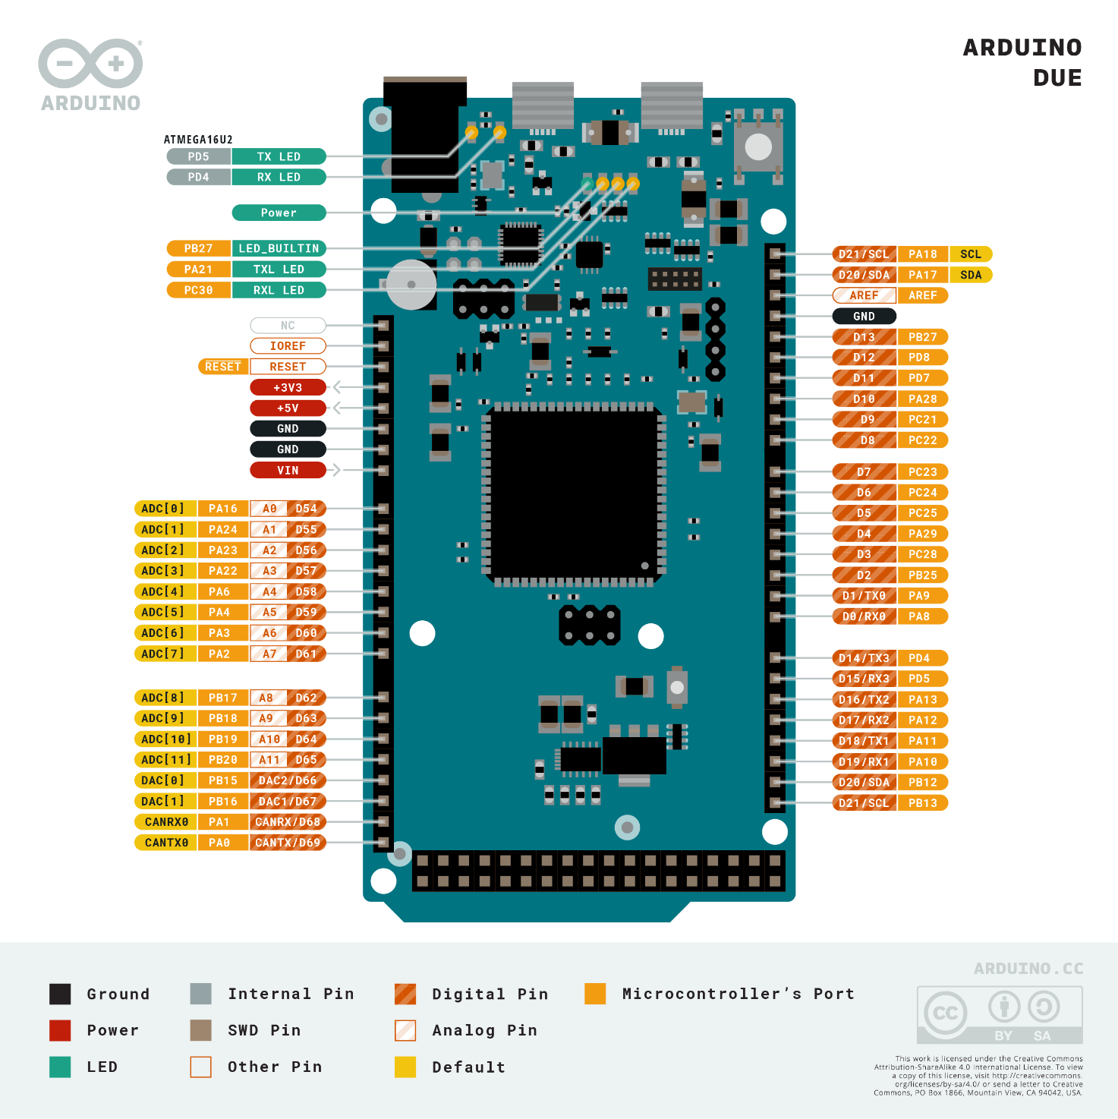
Figuur 1: Arduin Due pinout

After the pinout and the functions of these pins from the Arduino due were known, the pedalshield was looked at. Firstly, we needed to know what the pedalshield does and how it worked. To achieve this, the electrical schematics were used.
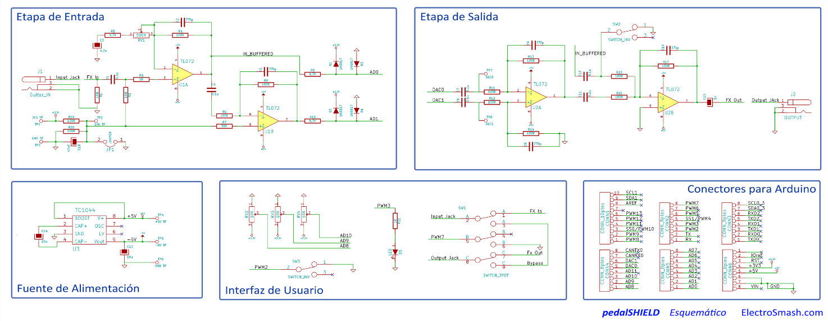
Figuur 2: pedalshield schematics
In the schematics it is obvious that the pedalshield electronics are divided into four main parts. These parts being: “The input stage, The output stage, The power supply and The user interface”. The purpose of the power supply is obvious.
The user interface is a series of switches and potentiometers connected to io pins on the Arduino. There is also a large button i.e. “the pedal”. the provided hardware in the user interface can be customized in the Arduino code.

The input stage takes the incoming signal and amplifies it. It also makes sure that the signal is converted to a positive voltage. This is necessary because the Arduino due’s ADC pins cannot measure a negative voltage. After converting the voltage, the modified signal goes to the Arduino where it can be altered. The altered signal then goes to the output stage which does exactly the opposite of the input stage.
    - Sensors

Sound sensors play a crucial role across various fields, from healthcare to consumer electronics. Offering the capability to detect and measure sound waves in different environments. In this section, three distinct sound sensors are explored: the Agilent Technologies Stethos, the Korg CM-200 contact sensor, and the Keyes KY-038 sound detector module. Each sensor brings unique features and functionalities suited for a wide array of applications.

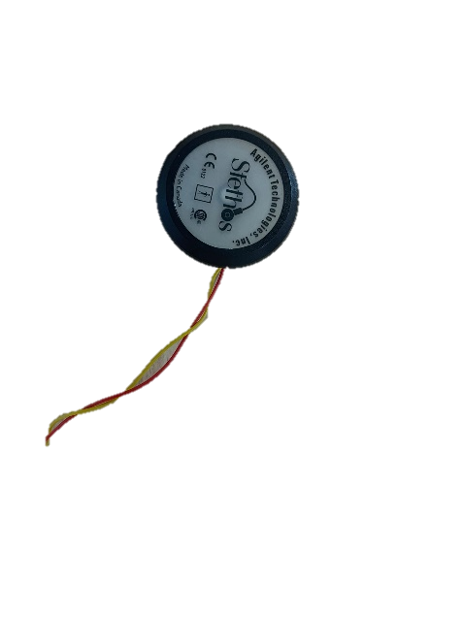
Figuur 3:Agilent Technologies Stethos
The Agilent Technologies Stethos is a sound sensor specifically made for medical applications, particularly in cardiology and respiratory applications. the Stethos has high sensitivity and accuracy in capturing subtle physiological sounds such as heartbeats, breath sounds, and murmurs. Its compact design makes it an indispensable tool in clinical settings where precise and reliable sound detection is essential.

Key Features:

Exceptional sensitivity for detecting faint physiological sounds.
Wide frequency range tailored for cardiological and respiratory assessments.
Seamless integration with standard medical equipment for streamlined workflows.
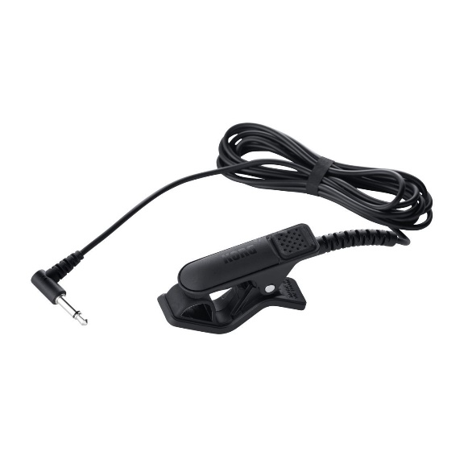
Figuur 4: Korg CM-200 Contact sensor

The Korg CM-200 contact sensor represents a sound detection solution primarily designed for music applications. Utilizing contact transduction, this sensor captures vibrations directly from instrument surfaces. This means there is an accurate and reliable sound detection even in noisy environments. Whether for tuning instruments or recording performances, the CM-200 offers musicians and audio engineers a precise tool for capturing and analyzing sound.

Key Features:

Contact-based transduction for enhanced noise immunity and signal precision.
Durable construction suitable for rigorous music performance environments.
Compact and lightweight design for seamless integration with musical instruments and recording equipment.

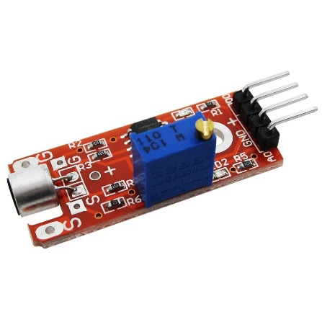
Figuur 5: Keyes KY-038 Sound Detector Module
The Keyes KY-038 sound detector module serves as an accessible and cost-effective solution for hobbyists, students, and enthusiasts interested in sound-based projects. This module detects sound pressure variations and outputs corresponding electrical signals, making it compatible with a wide range of microcontrollers and development platforms. The KY-038 module is an excellent choice for educational experiments, DIY projects, and prototyping.

Key Features:

User-friendly module suitable for beginners and hobbyists.
Analog output for seamless integration with microcontrollers and development boards.
Adjustable sensitivity for adapting to diverse sound environments and project requirements.

In summary, the Agilent Technologies Stethos, Korg CM-200 contact sensor, and Keyes KY-038 sound detector module offers distinct advantages made for specific applications and user needs. Whether in medical diagnostics, music performance, or educational experimentation, these sound sensors empower users with the capability to capture, analyze, and utilize sound data effectively.
    - Additional hardware

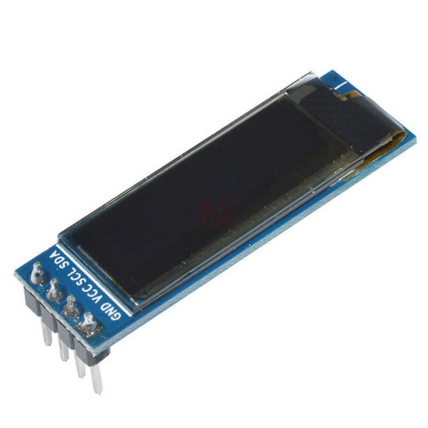
Figuur 6: 0.69 inch 96x16 OLED Display Module White Display
The OLED Display Module is a compact and efficient display solution. This white display module features a 0.69-inch screen with a resolution of 96x16 pixels, making it suitable for displaying concise text and simple graphics.

Key features of the 0.69-inch OLED display module include:

Compact Size: The small form factor makes it perfect for projects where space is a constraint.
High Contrast and Brightness: OLED technology ensures that the display remains clear and readable even in low-light conditions.
Low Power Consumption: OLED displays are known for their energy efficiency, making them suitable for battery-powered applications.

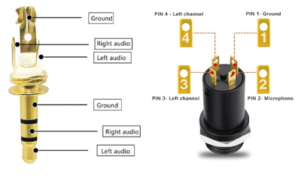
Figuur 7: MP3 jackets
Instead of soldering the sensors directly to the input of the pedalshield, mp3 jacks were used to make the necessary connections. This is done so that different sensors can be plugged into the pedalshield depending on the needs of the user.
  - Software
To program the Arduino due, the Arduino IDE was used. The open-source Arduino Software (IDE) makes it easy to write code and upload it to the board. This software can be used with any Arduino board. The primary function of our program is to take an input audio signal, process it, and pass it through to the output while allowing for volume control. Below is a breakdown of how this is achieved:
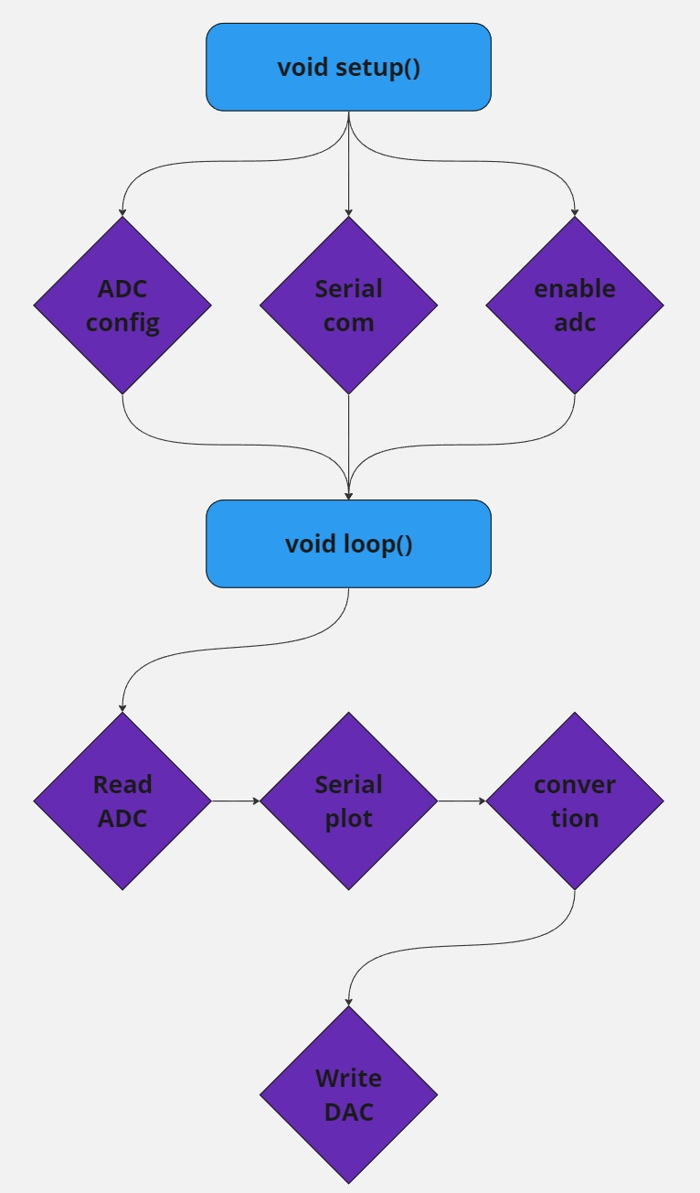
Figuur 8: Code schematic
The “setup()” function initializes the serial communication, configures the ADC (Analog-to-Digital Converter) to start converting input signals, and sets up the DAC (Digital-to-Analog Converter) to be ready for output.

In the “loop()” function:
- The code waits for the ADC conversion to complete.
- It reads values from ADC channels 0, 1, 8, 9, and 10.
- It prints the lower and upper limits and the ADC0 value for debugging purposes.
- It maps the input ADC values to the range specified by the potentiometer (POT2) to control the output volume.
- It writes the adjusted values to the DAC channels to output the processed signal.

In summary this code is designed to read an input signal through ADC channels, process it by adjusting the volume based on a potentiometer's setting, and output the processed signal through DAC channels. This allows for a real-time signal processing application.
- Results
The primary objective of this project was to integrate various sensors with the Arduino Pedalshield to achieve real-time measurement and processing. The results obtained demonstrate the successful accomplishment of this goal through effective signal acquisition, amplification, processing, and output. Below the outcomes observed during the testing phase are discussed.

  - Sensor Integration and Signal Acquisition
Three distinct sound sensors—the Agilent Technologies Stethos, the Korg CM-200 contact sensor, and the Keyes KY-038 sound detector module—were tested for their effectiveness in capturing sound signals:

Agilent Technologies Stethos: This sensor demonstrated exceptional sensitivity and, effectively capturing subtle physiological sounds such as heartbeats and breaths. It could also capture subtle movements in muscle tissue.
Korg CM-200 Contact Sensor: The CM-200 was particularly effective in noisy environments due to its contact-based transduction method. This sensor accurately captured vibrations from almost everything it was connected to, providing precise input signals for further processing.
Keyes KY-038 Sound Detector Module: As an accessible and cost-effective option, the KY-038 performed well in various experimental setups. It was able to detect sound pressure variations adequately, making it suitable for educational and prototyping purposes. However, the sensor did not accurately measure sound.
  - Signal Amplification and Processing
The integration of the Pedalshield with the Arduino Due allowed for effective signal amplification and processing. Key observations include:

Signal Amplification: The Pedalshield's input stage successfully amplified the incoming signals from all tested sensors. This amplification ensured that the signals were within a range suitable for ADC (Analog-to-Digital Conversion) on the Arduino Due.
ADC Conversion: The ADC channels on the Arduino Due accurately converted the amplified signals into digital values. The conversion process was fast and reliable, allowing for real-time signal processing.
Signal Processing: The processed signals, adjusted for volume, were accurately mapped, and outputted through the DAC channels. The real-time adjustment of the signal's volume demonstrated the effectiveness of the implemented control mechanisms.
  - Output Signal Quality
The final output signals, transmitted through the DAC channels, maintained high quality and fidelity. The following aspects were noted:

Clarity and Fidelity: The output signals were clear and free from noticeable distortions. This indicates that the signal processing and amplification stages preserved the integrity of the original input signals.
Volume Control: precise control over the signal volume. Adjustments were smooth and responsive, enabling dynamic changes in real-time.
Display on OLED Screen: The enhanced and potentially modified signals were successfully displayed on the OLED screen connected to the Arduino Due. This visual representation provided immediate feedback and validation of the processing results.
  - Performance Metrics
Quantitative measurements were conducted to evaluate the performance of the system:

Latency: The system exhibited low latency, making it suitable for real-time applications. The delay between input signal acquisition and output signal generation was minimal.
Signal-to-Noise Ratio (SNR): The SNR was within acceptable limits for all sensors except the stethos sensor. Due to the high accuracy of the sensor, there was found to be a large amount of noise. This noise was produced by slight movements in the body. Therefore, the sensor could not accurately measure heartbeats.
Dynamic Range: The dynamic range of the processed signals was sufficient to capture both subtle and loud sounds without clipping or distortion. The exception was the keyes sound detection module. The module could only measure sound pressure, but not slight sounds made in any other direction then the module itself.
- Conclusion
In conclusion, the integration of sound sensors with the Arduino Pedalshield has proven to be a successful endeavor, achieving real-time sound measurement and processing. The project demonstrated the successful acquisition, amplification, and processing of sound signals using the Arduino Due and the Pedalshield, with clear output signals displayed on an OLED screen.

However, challenges were encountered with the Agilent Technologies Stethos sensor, which, despite its exceptional sensitivity, exhibited a high level of noise due to slight body movements, making it difficult to accurately measure heartbeats. Similarly, the Keyes KY-038 sound detector module struggled with sound directionality, failing to capture subtle sounds from directions other than directly in front of the module.

Despite these limitations, the system exhibited low latency and a sufficient dynamic range for capturing both subtle and loud sounds without distortion. These results highlight the potential for further development. with the current system providing a robust platform for real-time sound measurement and processing applications.
- Reference list
- Attachment

