Linking Words/Connectives Instructional Routine: Crazy Sentences Game

Sample Crazy Sentences Games (connectives)
Common Core State Standard
- CCSS.ELA-LITERACY.W.5.1.C Link opinion and reasons using words, phrases, and clauses (e.g., consequently, specifically).
Overview
Crazy Sentences game is a 10-15 minute game that challenges students with the task of linking two vocabulary words using connectives in one sentence. Through collaboration with their peers, they are encouraged to deepen their repertoire of connective words by a restriction of not using the connective ‘and’ in their sentences, practicing their use of connectives that they can effectively use in their own writing and speaking.

Symbol Key


Explicit Instruction


Opportunities to Respond


Feedback

Sample Lesson
Instructions
Materials
- Picture cards (2 cards, each depicting two content elements from the CKLA Unit 5: Geology, such as fossils, eruption, magma, volcano, etc.)
- Timer (set to 20 seconds)
- Whiteboard or chart paper for writing down example sentences
- Point score sheet for tracking team progress

Introduce the definition of a linking word

“A linking word is a word that shows the relationships between ideas. For example, linking words can build on ideas, compare ideas, or give examples.”

Read the word, the definition, and then use the word in a sentence to the class.
- After
  - In the time following an event or period of time
- And
  - Used to connect words
- Finally
  - Used to introduce a final point
- First
  - Used to introduce a point
- Instead
  - As an alternative or substitute

I do:

Pick up two picture cards and show them to the class:
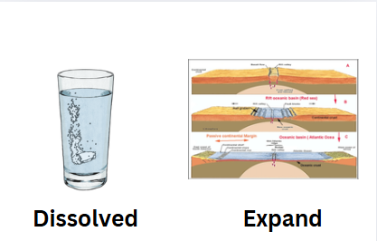

Ask students what “dissolved” and “expand” mean. The picture cards will be vocabulary that is part of the science curriculum.

"To connect the words ‘dissolved’ and ‘expand’ I need to use a linking word. However, the challenge is that I cannot use the word ‘and’ in this game. One example is; First the sugar expanded in the water, then it dissolved.”

Make sure you are placing an emphasis on the words ‘first’ and ‘then’ to indicate that those are linking words. Ask students what linking words did you use in the sentence. Explain that the linking words ‘first’ and ‘then’ show the order of events that occurred.

We do
Show two new picture cards to the class. Have students turn to a neighbor and come up with a sentence that uses linking words to connect the two words.
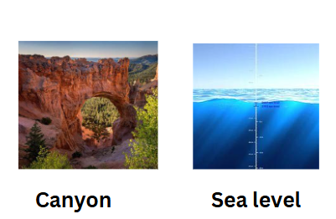
Ask students to share their sentences with the class. Talk about the relationship that the linking words create in the sentences.

You do
Divide the class into teams of 3-4 students. Each team will receive a set of picture cards. Each card will have two different content elements related to geology (e.g. fossils + eruption, volcano + magma, fossils + rocks, etc.).

- Step-by-Step Process for Each Round:
  - A team selects two picture cards at random (each card with two elements from the geology theme).
  - They have 20 seconds to formulate a grammatically correct sentence connecting all four elements.
  - After 20 seconds, each team presents their sentence to the class.
  - If the sentence is grammatically accurate and does not contain the word "and," they earn one point.
  - The teacher provides feedback and helps refine students' use of connectives as needed.
- Repeat for 5-6 rounds, rotating the picture cards among teams so that they work with different combinations of geology-related elements.

When students finish the activity, ask them reflective questions about the game:
- Which linking words were the most helpful?
- What challenges did you face when trying to create complex sentences?

Ask students to share some examples of well-formed sentences with the class. Ask them to identify which linking words were used and how they helped convey the meaning clearly.

