Spelling Instructional Routines
Common Core State Standard:
- CCSS.ELA-Literacy.L.4.2 and CCSS.ELA-Literacy.L.5.2: Demonstrate command of the conventions of standard English capitalization, punctuation, and spelling when writing.
Overview
In this sample instructional routine, you will note adaptations for emergent English speakers, (in other words, bilingual students). The intent is to support teachers who have bilingual students in their classroom that may need additional support in making meaning of English words to understand how to spell them. Sample lesson 1 shows a sample lesson for English-only speakers, and sample lesson 2 show the integration of translanguaging for a classroom that has one or more bilingual students that have Spanish as a home language. Translanguaging means using and allowing a student’s home language to support learning and making meaning. This lesson can be adapted to any home language.
Symbol Key
 Explicit Instruction
 Opportunities to Respond
 Feedback

Sample Lesson 1 [English only]
Week 1, Day 1: Monday
Long vowel: /ā/ Target Spelling Pattern: ai
Vowel Teams
Spelling List for instruction: afraid, explain, paint, training, sailor
SWBAT identify and encode correct ai patterns in words that correspond to /ā/
Spelling List for post-check: Jamaica, regain, sustain, terrain, attain
Spelling List for pre-check: waiter, detail, braid, complain, detain
Instructions
Introduce spelling pattern for the week
Being pre-check on worksheet (): Read the word, say the meaning, then use the word in a sentence:
- Waiter
someone that brings your food in a restaurant
- Detail
a particular way to describe something
- Braid
A hairstyle or to weave something
- Complain
A way to show you don’t like something
- Detain
to hold someone back
Once all the words have been dictated, correct the assessment with students based on letter sequences* and have them mark their score on their spelling sheet.
Remind students of the spelling pattern.
I do (3-5 minutes):

Draw 5 spaces for the word afraid on the board. As you write each space, say aloud each sound of the word, but do not write the letters/sounds, yet:
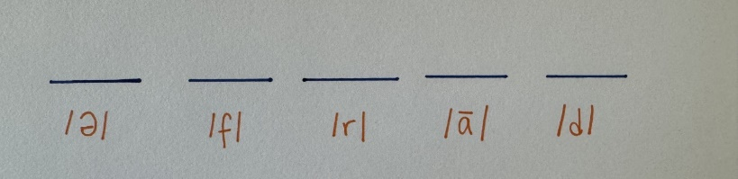
Ask students what does the word afraid mean and take responses/explain what it means:
- Afraid is when you have fear of something! Like being afraid of the dark.
Finally in the lines, write the letters of the word afraid in each space, making sure you are saying the sounds aloud to demonstrate:
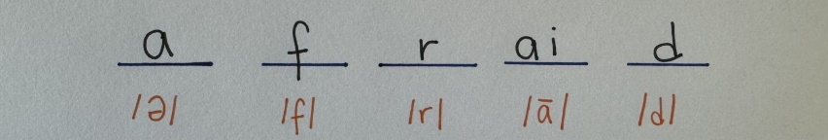

Ask students what they notice about how you wrote the word. Make sure they notice that <ai> is together in one space.
Explain that <ai> is a team and putting <a> and <i> together, they make the long /a/ sound, so they have to stick together.

Have students write the word afraid next to number 1 on the practice panel in the middle of the worksheet.

We do (5 minutes):
Have students pull out their spelling worksheet. In the middle panel (), dictate to students the next word (explain).
Together, you and the students will draw the spaces for the word explain practicing saying the sounds aloud together on number 2 of their practice panel of their worksheet:
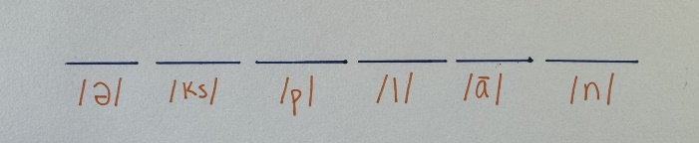

Ask students what the word explain means:
- Explain is to show what we mean, to make something more clear so we can understand.

Finally in the lines, write the letters of the word explain in each space and have students to the same, making sure you are saying the sounds aloud and urge students to do the same:
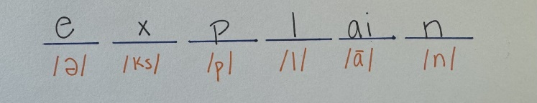
Ask students what they notice again: the <ai> together again.

You do (5-7 minutes):
For the remainder of the practice section of the worksheet have students work independently.
Monitor the class and support students as needed.

For the rest of the words (numbers 3-5 on the middle practice panel of their worksheet), do the following:
- Dictate each word for the students, saying the meaning. Tell students you will give them 10 seconds to respond and then you will write the correct word on the board. Students will check and fix their words if needed.
- Make sure to model drawing the spaces and filling in the spaces as students did before.
- Do this for the following words:
  - Paint
-To cover a wall with paint.
  - Training
- To practice a skill
  - Sailor
- A person that works on a boat or a ship
When students finish the activity, guide them to the post-check panel of their worksheet. Explain this is an opportunity to show you what they learned in the spelling pattern for today. Let them know they can use whatever strategy is most helpful to them, an old one they know or the new ones they just learned with the drawing lines.
- Read one word at a time for students to spell. For each word, read the word and say an example sentence.
- Jamaica
- I am going to Jamaica to see their beautiful beaches.
- Regain
-I have to regain my energy to run again
- Sustain
-Water helps sustain a plant’s life
- Terrain
-I want to ride my bike on rough terrain.
- Attain
-I want to attain better grades
Once all the words have been dictated, have students turn it in for your review, grading and feedback.
*Correct letter sequences (CLS) is when you correct the word based on each correct letter. For example, in the word stop, the correct sequences are: s, st, to, op, and p (a score of 5 CLS).This helps students track spelling progress beyond just right or wrong words. At the beginning, there is a correct sequence before the first letter (s in stop), and at the end, there's a correct sequence after the last letter (p). In between, each correct pair of letters (st, to, op) forms a sequence.

Sample Lesson 2 [English and Spanish]
Week 1, Day 1: Monday
Long vowel: /ā/ Target Spelling Pattern: ai
Vowel Teams
Spelling List for instruction: afraid, explain, paint, training, sailor
SWBAT identify and encode correct ai patterns in words that correspond to /ā/
Spelling List for post-check: Jamaica, regain, sustain, terrain, attain
Spelling List for pre-check: waiter, detail, braid, complain, detain
Instructions
Introduce spelling pattern for the week
Being pre-check on worksheet (): Read one word at a time for students to spell. For each word, read the word in English, say the meaning. Then, say the word in Spanish and say the meaning. Finally, read the word in English again and allow students to write the word.
- Waiter (garzón)
someone that brings your food in a restaurant
(una persona que te trae comida en un retaurante)
- Detail (detalle)
a particular way to describe something
(una forma particular de describir algo)
- Braid (tranza)
A hairstyle or to weave something
(un peinado o tejer algo)
- Complain (reclamar/quejarse)
A way to show you don’t like something
(una forma de demolnstra que no te gusta algo)
- Detain (detener)
to hold someone back
(parar una persona)
Once all the words have been dictated, correct the assessment with students based on letter sequences and have them mark their score on their spelling sheet.
Remind students of the spelling pattern.
I do (4-6 minutes):

Draw 5 spaces for the word afraid on the board. As you write each space, say aloud each sound of the word, but do not write the letters/sounds, yet:

Ask students what does the word afraid mean and take responses/explain what it means (do this also in Spanish if you have bi/multilingual learners in your class:

- Afraid is when you have fear of something! Like being afraid of the dark.
- Afraid in Spanish can be asustado or miedo. So if I said, “tenía miedo de la oscuridad” (I was afraid of the dark), or “estaba asustada!” (I was afraid), it means the same thing as afraid.

Finally in the lines, write the letters of the word afraid in each space, making sure you are saying the sounds aloud to demonstrate:


Ask students what they notice about how you wrote the word. Make sure they notice that <ai> is together in one space.
Explain that <ai> is a team and putting <a> and <i> together, they make the long /a/ sound, so they have to stick together.

Have students write the word afraid next to number 1 on the practice panel in the middle of the worksheet.

We do (6 minutes):
Have students pull out their spelling worksheet. In the middle panel (), dictate to students the next word (explain).
Together, you and the students will draw the spaces for the word explain practicing saying the sounds aloud together on number 2 of their practice panel of their worksheet:


Ask students what the word explain means:
- Explain is to show what we mean, to make something more clear so we can understnad.
- For bi/multilingual learners, explicar. So when I say “Te explico como hacer la tarea” (I explained how do the homework) is explain.

Finally in the lines, write the letters of the word explain in each space and have students to the same, making sure you are saying the sounds aloud and urge students to do the same:

Ask students what they notice again: the <ai> together again.
For Spanish speakers, you can write explicar that explain that it kind of looks the same and the English word. They can use this strategy to help them spell too.

You do (6-8 minutes):
For the remainder of the practice section of the worksheet have students work independently.
Monitor the class and support students as needed.

For the rest of the words (numbers 3-5 on the middle practice panel of their worksheet), do the following:
- Dictate each word for the students, saying the meaning (in English and in Spanish if necessary). Tell students you will give them 10 seconds to respond and then you will write the correct word on the board. Students will check and fix their words if needed.
- Make sure to model drawing the spaces and filling in the spaces as students did before.
- Do this for the following words:
  - Paint ® pintar
-Covering a wall with paint.
-Cubrir una pared con pinta
  - Training®entrenamiento
- To practice a skill
-Practicar una habilidad
  - Sailor ® marinero
- A person that works on a boat or a ship
-Una persona que trabaja en un barco o en un buque
When students finish the activity, guide them to the post-check panel of their worksheet. Explain this is an opportunity to show you what they learned in the spelling pattern for today. Let them know they can use whatever strategy is most helpful to them, an old one they know or the new ones they just learned with the drawing lines.
- Read one word at a time for students to spell. For each word, read the word in English, say an example sentence. Then if needed, say the word in Spanish and the example sentence. Finally, read the word in English again and allow students to write the word.
- Jamaica = Jamaica
- I am going to Jamaica to see their beautiful beaches.
-Voy a Jamaica para ver sus playas hermosas
- Regain ® recuperar
-I have to regain my energy to run again
-Tengo que recuperar my energia para volver a correr.
- Sustain® mantener
-Water helps sustain a plant’s life
-El agua ayuda a mantener la vida de una planta
- Terrain® terreno
-I want to ride my bike on rough terrain.
-Quiero montar my bicicleta en terreno difícil.
- Attain® obtener
-I want to attain better grades
-Quiero obtener mejores calificaciones.

Once all the words have been dictated, have students turn it in for your review, grading and feedback.

Materials
