Typing Fluency Instructional Routine
Common Core State Standard
- CCSS.ELA-LITERACY.W.6.6: Use technology, including the Internet, to produce and publish writing as well as to interact and collaborate with others; demonstrate sufficient command of keyboarding skills to type a minimum of three pages in a single sitting.
Overview
This typing fluency instructional routine is 10-15 minutes where students will practice their typing, building on strong knowledge of typing basics. Through consistent practice, they are encouraged to develop their typing skills so that they can effectively communicate their thoughts digitally.

Other times to fit in typing fluency
- During the holiday break, if everyone logs at least X total minutes practicing typing, the class gets a free pass on Y.
- For students with a low TIDE score and low typing fluency, add typing practice to independent activity time and/or as a reward activity.
Symbol Key

Explicit Instruction
Opportunities to Respond
 Feedba
Sample Lesson: Typing Fluency
Instructions
Materials
- Computers
- Typing test website (Typing.com)
- Timer
*Before the activity, create an instructor account on Typing.com.
*Before the activity, print out copies of this image. There should be one for every pair of students.
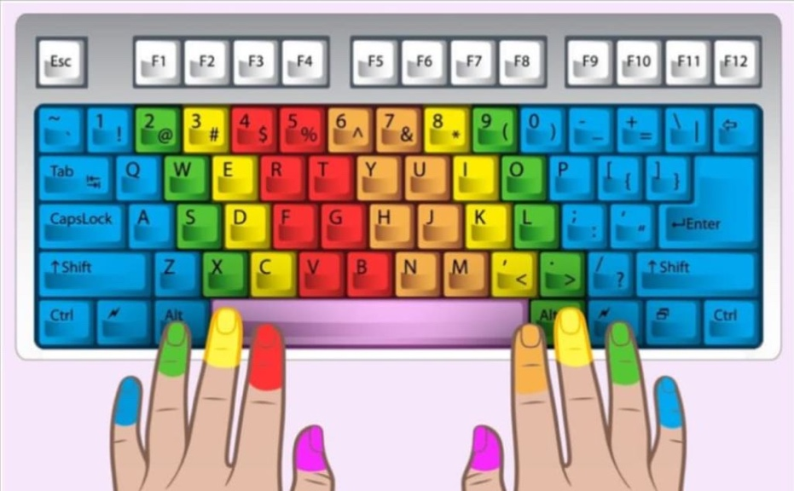

Have students sit up straight with their feet flat on the floor and their elbows at a 90-degree angle. Demonstrate this typing posture or display the visual down below to the students and explain that this position can improve typing speed and accuracy and takes care of our body.

Additional explicit instructions to fold in:
- Feel the texture on the f and j keys to help you find the home row keys and keep your fingers anchored to the home row keys.
- Use your pinky finger to hold the shift key while you type a capital letter.

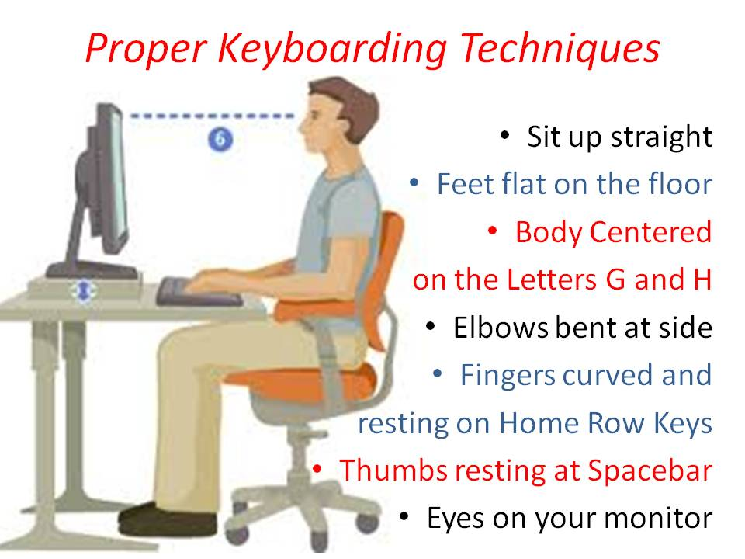
I do
While in the correct typing posture, log on to Typing.com and pull up the 1:00 minute typing test. Project your fingers typing on a screen to the class. Point out to your students how you are typing with your eyes on the screen, and not on the keyboard. Point out that certain fingers are only hitting certain keys.

When you are done with the typing test, ask your students what they noticed when you typed. Display this visual to the class. 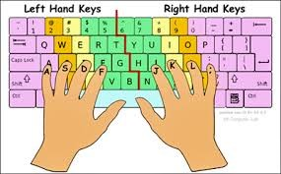
Point out how your two index fingers only typed on the green keys, your middle fingers only typed on the yellow keys, your ring fingers only typed on the orange keys, and your pinkies only typed on the purple keys.

We do
Instruct students to open up Typing.com and create an account through Google in order to save progress.

Have the students pair up and choose which student will be typing first. Instruct the student that will be typing first to go to the ‘Game’ tab on the website and click the ‘Type Toss’ game. Instruct them to choose the easy difficulty level and the home row lesson type; you can modify this as the students' progress in their skills. Have the student that is not typing yet to hold up the visual (pictured below) right above the other person’s fingers. This aims to discourage students who use the ‘hunt and peck’ method. After the student finishes one round of ‘Type Toss,’ have the partners switch places.



You do
Have students complete a timed typing test each time they work on typing. Typing.com offers many types of typing tests (1:00, 3:00, 5:00, 1 page, 2 page, 3 page) that can be offered depending on the grade level of your students. Pick the 3:00 typing test, it is located on the ‘Test’ tab at the top of the website. The test will give insight on the words per minute (WPM) and accuracy level of your students, and you can set benchmark goals throughout the year to improve both accuracy and WPM. Encourage students to focus on accuracy and proper finger placement instead of speed. “Remember, accurately typing out the sentences with the proper finger placement is more important than typing these sentences very fast with a lot of mistakes. Try not to look at the keyboard.”

After the students are done with the typing test, tell the whole class to document their words per minute and accuracy in the Word Template (last page of this document) and add the date to track progress.

Then, have students complete the typing lessons on these websites. Once again, encourage students to prioritize accuracy and focus on typing without looking at their hands or the keyboard. Set a timer for 5 minutes.
The students can choose from beginner, intermediate, and advanced typing levels that build upon their prior skills. If most of your class has little to no experience with typing, start at beginner level. The first lesson will be on the ‘J, F, and Space.’ The website guides the lessons so that you have to finish one lesson to move onto the next.

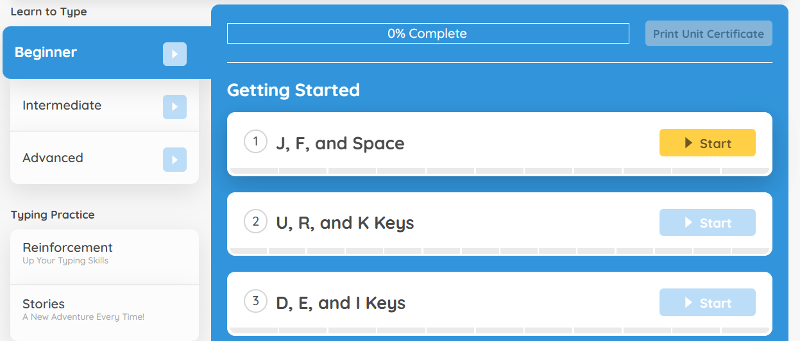

When students finish the activity, tell the whole class to open the Word document that has their words per minute and accuracy that they opened at the beginning. Have the students set a personal goal for the next session (e.g., increase words per minute by 5, improve accuracy to 90%). Encourage your students to continue practicing outside of class if possible.

Differentiation Options:
- For students who use the ‘hunt and peck’ method:
  - Limit typing sessions to 10-15 minutes to prevent frustration, followed by a short break.
  - Provide auditory cues (e.g., key sounds or positive reinforcement when a key is pressed correctly) or visual aids (color-coding keys) to reinforce learning.
- For students with fine motor skills challenge:
  - Provide larger or more accessible keyboards, such as alternative keyboards (e.g., one-handed, large key, or switch-adapted keyboards). Voice-to-text software like Google Voice Typing or Dragon NaturallySpeaking can also help bypass the need for physical typing.
  - Attach keyguards or use keyboard overlays to help students target the correct keys more easily.
- For advanced learners:
  - Encourage students to increase their typing speed while maintaining accuracy, using websites like 10FastFingers or TypeRacer. They can compete against others or beat their own records.
  - Challenge students to practice typing in various contexts, such as writing essays, creating summaries, or typing code for programming students.

Sample WPM and Typing Accuracy Document

Name: | Date:
Words Per Minute (WPM): | Accuracy:
WPM Goal: | Accuracy Goal:

Name: | Date:
Words Per Minute (WPM): | Accuracy:
WPM Goal: | Accuracy Goal:

Name: | Date:
Words Per Minute (WPM): | Accuracy:
WPM Goal: | Accuracy Goal:

Name: | Date:
Words Per Minute (WPM): | Accuracy:
WPM Goal: | Accuracy Goal:

Name: | Date:
Words Per Minute (WPM): | Accuracy:
WPM Goal: | Accuracy Goal:

Name: | Date:
Words Per Minute (WPM): | Accuracy:
WPM Goal: | Accuracy Goal:

Name: | Date:
Words Per Minute (WPM): | Accuracy:
WPM Goal: | Accuracy Goal:

Name: | Date:
Words Per Minute (WPM): | Accuracy:
WPM Goal: | Accuracy Goal:

Name: | Date:
Words Per Minute (WPM): | Accuracy:
WPM Goal: | Accuracy Goal:

