Typing Fluency Instructional Routine
Common Core State Standard
- CCSS.ELA-LITERACY.W.6.6: Use technology, including the Internet, to produce and publish writing as well as to interact and collaborate with others; demonstrate sufficient command of keyboarding skills to type a minimum of three pages in a single sitting.
Overview
This typing fluency instructional routine is 10-15 minutes where students will practice their typing, building on strong knowledge of typing basics. Through consistent practice, they are encouraged to develop their typing skills so that they can effectively communicate their thoughts digitally.

Other times to fit in typing fluency
- During the holiday break, if everyone logs at least X total minutes practicing typing, the class gets a free pass on Y.
- For students with a low TIDE score and low typing fluency, add typing practice to independent activity time and/or as a reward activity.
Symbol Key

Explicit Instruction
Opportunities to Respond
 Feedback

General Instructional Routine
Case Background (Teacher Preparation)
- Select target key(s)
- Choose vocabulary word(s) that:
  - Can be meaningfully connected to current learning (e.g., home row keys, typing posture, words per minute (WPM), accuracy)
- Create a class/join code on a typing website (Optional)
  - Typing website example: Typing.com
- Provide a typing progress sheet showing accuracy and WPM (Optional)
Step 1: Introduction (2-3 minutes)
Connect to Previous Learning (if applicable):
- Review previous learning that applies to current lesson
- Reference recent discussions about current lesson

Preview
- Set the scene/Connect to students’ lives:
  - Provide a real-world analogy or example of when typing skills are relevant
- Provide purpose(s)/learning target(s) for students
- Explain real-world importance

Activate Prior Knowledge
- Ask questions to activate background knowledge:
  - What do you already know about typing?
  - What comes to mind when you hear the term “_____”? (insert word(s) e.g., home row keys, typing posture, words per minute (WPM), accuracy)
  - How does the focus of today’s lesson remind you of something we’ve talked about/learned before?
Review Key Terms
- Define or review key vocabulary words used in lesson
  - E.g. home row keys, typing posture, words per minute (WPM), accuracy
Step 2: Typing Demonstration (4-6 minutes)
Initial Instruction
- Present the correct typing posture to students. Copy the picture below; sit up straight with feet flat on the floor, have elbows bent at side, index fingers resting on f and j keys, thumbs resting at Spacebar, and eyes on the computer.
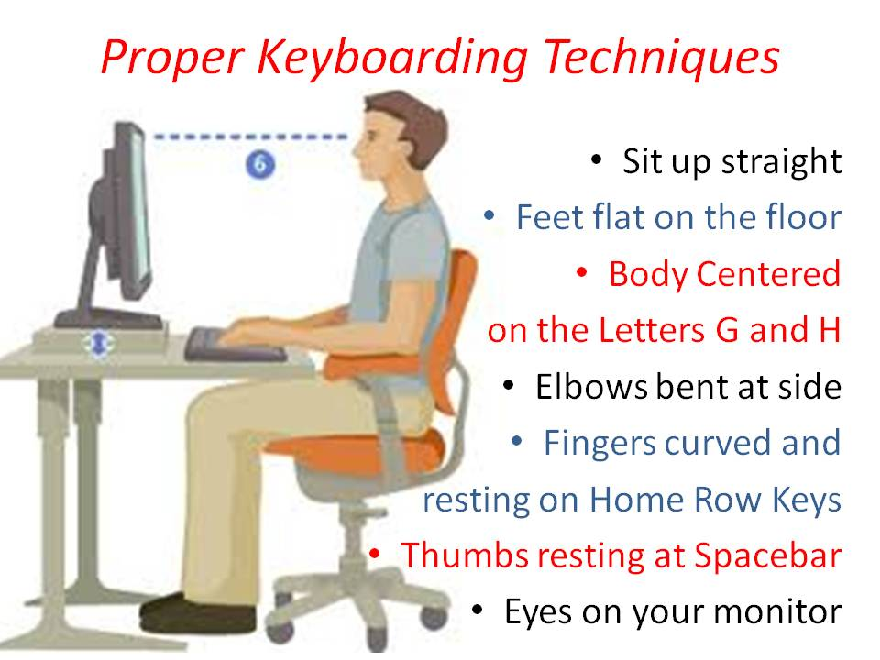

Teacher Think-Aloud
- Model think-aloud process
  - Example:
    - “First, I notice...”
    - “Now, I see...”
    - “This reminds me of...”

Guided Pattern Discovery
- Walk through types of typing patterns with class and show this visual:
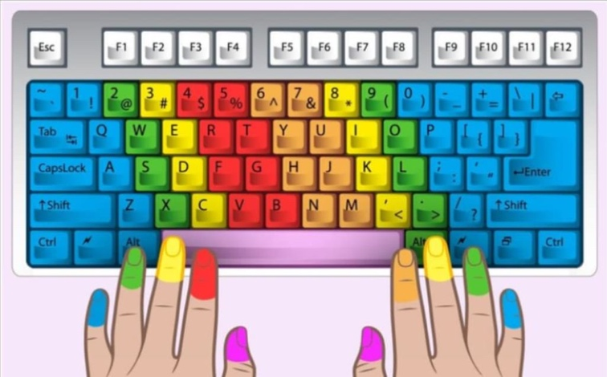
  - Example:
    - Index finger keys (Left index: red keys. Right index; orange keys)
    - Middle finger keys (Yellow keys)
    - Ring finger keys (Green keys)
    - Pinky finger keys (Blue keys)
    - Thumb keys (Space bar)

Engagement Check
- Ask questions to check for comprehension
  - “What patterns are we seeing?”
  - “Is there anything you are unfamiliar with or don’t understand?”
  - “Why might someone use specific fingers for specific keys?”
Step 3: Partner Practice (3-5 minutes)
- Pair students for collaborative thinking
- Review partnership expectations
- Partners work together to:
  - Practice typing words with the correct finger placements
    - Have partners take turns checking finger placement
    - Pick vocabulary related to target keys (i.e., Dad had a fall; Lad asks Jill)
Teacher Support
- Circulate among partners to:
  - Monitor discussions
  - Offer feedback
  - Provide scaffolded prompts
  - Support struggling teams
Team Discussions
- Have pairs:
  - Share discoveries with class
Step 4: Individual Practice (5-7 minutes)
Instruct students to go to a typing website (i.e. Typing.com) on their computers where they will:
- Create an account/Join a class
  - Remind students to focus on finger placement and accuracy instead of speed
  - Work on the target lesson(s)
  - Circulate the classroom and offer feedback to help refine students’ typing skills
Step 5: Reflection (2-3 minutes)
- Have students set goals for typing (i.e., home row keys, words per minute, accuracy)
- Discuss when they can practice typing in their own free time
  - Encourage consistent typing practice

Differentiation Options:
- For students who use the ‘hunt and peck’ method:
  - Limit typing sessions to 10-15 minutes to prevent frustration, followed by a short break.
  - Provide auditory cues (e.g., key sounds or positive reinforcement when a key is pressed correctly) or visual aids (color-coding keys) to reinforce learning.
- For students with fine motor skills challenge:
  - Provide larger or more accessible keyboards, such as alternative keyboards (e.g., one-handed, large key, or switch-adapted keyboards). Voice-to-text software like Google Voice Typing or Dragon NaturallySpeaking can also help bypass the need for physical typing.
  - Attach keyguards or use keyboard overlays to help students target the correct keys more easily.
- For advanced learners:
  - Encourage students to increase their typing speed while maintaining accuracy, using websites like 10FastFingers or TypeRacer. They can compete against others or beat their own records.
  - Challenge students to practice typing in various contexts, such as writing essays, creating summaries, or typing code for programming students.

Sample WPM and Typing Accuracy Document

Name: | Date:
Words Per Minute (WPM): | Accuracy:
WPM Goal: | Accuracy Goal:

Name: | Date:
Words Per Minute (WPM): | Accuracy:
WPM Goal: | Accuracy Goal:

Name: | Date:
Words Per Minute (WPM): | Accuracy:
WPM Goal: | Accuracy Goal:

Name: | Date:
Words Per Minute (WPM): | Accuracy:
WPM Goal: | Accuracy Goal:

Name: | Date:
Words Per Minute (WPM): | Accuracy:
WPM Goal: | Accuracy Goal:

Name: | Date:
Words Per Minute (WPM): | Accuracy:
WPM Goal: | Accuracy Goal:

Name: | Date:
Words Per Minute (WPM): | Accuracy:
WPM Goal: | Accuracy Goal:

Name: | Date:
Words Per Minute (WPM): | Accuracy:
WPM Goal: | Accuracy Goal:

Name: | Date:
Words Per Minute (WPM): | Accuracy:
WPM Goal: | Accuracy Goal:

