Vocabulary Instructional Routine: The Frayer Model

Common Core State Standards:
- CCSS.ELA-Literacy.L.4.6: Acquire and use accurately grade-appropriate general academic and domain-specific words and phrases, including those that signal precise actions, emotions, or states of being (e.g., quizzed, whined, stammered) and that are basic to a particular topic (e.g., wildlife, conservation, and endangered when discussing animal preservation).
- CCSS.ELA-Literacy.RI.4.4: Determine the meaning of general academic and domain-specific words or phrases in a text relevant to a grade 4 topic or subject area.

Overview
The Frayer Model is a 10-15 minute instructional routine that provides context-rich vocabulary instruction to help students to construct deep and nuanced word knowledge.
Teachers can use this routine to preteach vocabulary words that will appear in future readings, allowing students to focus on comprehending the text.

Symbol Key
 Explicit Instruction
 Opportunities to Respond
 Feedback

Sample Lesson 1
Vocabulary with the Frayer Model: “The Pygmy Tyrant Mystery”
Common Core State Standard: CCSS.ELA-Literacy.L.4.6 & RI.4.4 – Use knowledge of grade appropriate vocabulary when writing, speaking, reading, or listening
Focus: Vocabulary
- CCSS.ELA-Literacy.L.4.6: Acquire and use accurately grade-appropriate general academic and domain-specific words and phrases, including those that signal precise actions, emotions, or states of being (e.g., quizzed, whined, stammered) and that are basic to a particular topic (e.g., wildlife, conservation, and endangered when discussing animal preservation).
- CCSS.ELA-Literacy.RI.4.4: Determine the meaning of general academic and domain-specific words or phrases in a text relevant to a grade 4 topic or subject area.
Materials
- Frayer Model (displayed on board or chart paper)
- Vocabulary Notebooks (individual journals/pencils or whiteboards/markers)
- Target vocabulary word(s) selected from the text
- Student-friendly definitions for target word(s)
- Examples and non-examples of the target word(s)
- Optional: texts (books, magazines, websites) that include target word(s)
Teacher Preparation
- Select target vocabulary word(s) from the text
  - Text: “The Pygmy Tyrant Mystery”
  - Target words: unique
- Is the vocabulary word(s):
✔ | Important to an understanding of the paragraph, argument, plot, theme, or mood of the text? | - “Unique” is key to the main idea that there are no known dinosaur fossils that match Jane.  - It is also used multiple times in the text.
✔ | Unlikely to be heard in everyday conversation? | - “Unique” is more likely to be written than it is spoken.
✔ | Used frequently across the disciplines? | - “Unique” has high utility because it is not specific to a single content area. It is on the Academic Words List.
 | Likely to be misunderstood? (Does it have multiple meanings?) | - “Unique” is unlikely to be mixed up with other words
 | Conceptually related to the main idea of the text? (Use when there are no good word candidates within the text.) | - “Unique” was chosen from the text, so this question does not apply.
Note: The guidelines above are meant to support critical consideration from multiple angles. Target words may not meet all the criteria.
Investigation Procedure
Step 1: Briefing (2-3 minutes)
Connect to Previous Learning (if applicable):
- Review previous investigation of vocabulary words
- Reference recent discussions about how word choice varies by situation
- Connect to ongoing thematic unit

Investigation Preview
- Set the scene/Connect to students’ lives:
  - “Imagine you’re telling a story about a hot summer day. You want to explain how you felt after playing outside for hours, but you can’t remember the word ‘thirsty.’ Do you think it would be harder to get your friends to understand how you felt if you couldn’t use that word?”
  - “Our words help us be specific about what we’re thinking or how we’re feeling. A new word is powerful because it can help others understand what we want to say.”
- Share today’s focus:
  - “We’re investigating some powerful new words that a professional writer chose to help us understand their story.”
- Explain real-world importance:
  - “Understanding the difference between similar words helps us communicate effectively in different situations.”

Activate Prior Knowledge
- Explain how the topic of the text to be read fits into the theme of the unit
- Explain how the word fits into the theme of the unit (if applicable)

Step 2: Frayer Model Demonstration (7-8 minutes)
Initial Instruction
Introduce the Word(s)
- Present the target word, the student-friendly definition, and the characteristics of the word in a Frayer Model on chart paper or the whiteboard.
  - Target Word: unique
  - Student-friendly Definition: something that is special because there is nothing like it
  - Characteristics:
    - Describes a noun (person, place, or thing)
    - Is different in a way that other things are similar
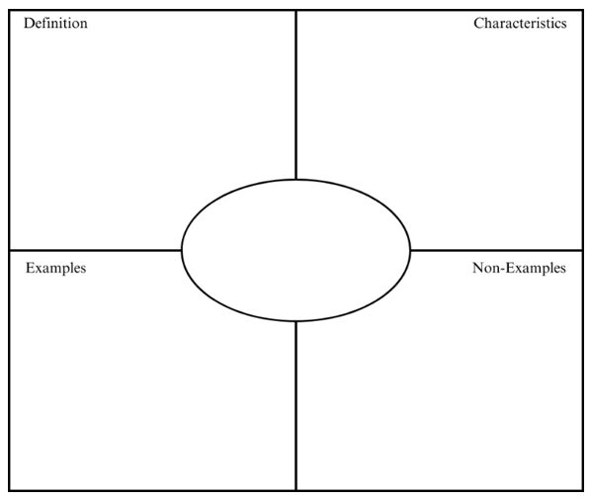
Unique
- Describes a noun (person, place or thing)
- Is different in a way that other things are similar
Something that is special because there is nothing like it

Word Characteristics Think-Aloud
- Introduce an example of a situation where the target word(s) could be used.
  - Each snowflake has a different shape or pattern.
-  Model situation analysis during think-aloud process:
  - “First, I notice the word different...”
  - “This reminds me of other shapes we see in nature, like leaves on trees or water droplets...”
  - “I’m wondering whether snowflakes might be unique because they make different shapes while leaves on trees all have the same shape…”

Guided Word Work
- Walk through initial example with class:
  - “What word in the sentence could be described as unique?”
  - “Do snowflakes fit the definition of unique?”
  - “Are snowflakes different in a way that other things are similar?”
- Write snowflake in the examples box.
- Repeat this process with a non-example
  - There were two yellow frogs in a pond of green frogs.
Engagement Check
- Ask questions to check for comprehension & engage students:
  - “Is there anything you are unfamiliar with or don’t understand?”
  - “What other words can you think of that are similar to unique?”
  - “Why might the author choose the word unique?”

Step 3: Partner/Group Activity (10-12 minutes)
Teacher-Guided Practice
Activity Partnerships
- Pair students (or create small groups) for collaborative investigation
- Review partnership expectations

Guided Analysis
- Partners/groups work together to:
- Draw a Frayer Model in their vocabulary notebooks and copy what is written on the board
- You can have students:
  - Sort additional scenarios (written on the board) into either the “examples” or “nonexamples” boxes.
    - My aunt makes a spaghetti sauce with blueberries instead of tomatoes.
    - Unlike his friends, Sam doesn’t like pepperoni on his pizza.
  - Create their own examples and non-examples
Teacher Support
- Circulate among partners/small groups to:
  - Monitor discussions
  - Offer feedback
  - Provide scaffolded prompts
  - Support struggling teams

Team Discussions
- Have detective pairs:
- Explain sorting choices to each other
- Compare findings with nearby teams/groups
- Share discoveries with class

Step 4: Solo Investigation (5-7 minutes)
Independent Practice
Choose an activity/activities for students to practice:
- See Resources for mentor texts

Individual Word Work
- Students can independently:
  - Create new examples and non-examples
  - Use target words in their own writing

Finding Real-World Examples
- Look through poems, stories, etc. to find new examples of target word(s)
- Extension:
  - Students can discuss in small groups why the target word(s) were chosen by the author.
  - They can compare the author’s use of the word with their definition and characteristics.

Using the Word Bank
  - Students can create visual representations of target words
  - Students can create semantic maps with connected words
    - Connected words could also be used for a compare/contrast activity

While students are working (either independently or in small groups), make sure you are circulating or meeting with them to:
- Ensure understanding (provide additional examples as needed),
- Answer questions,
- Provide feedback (including celebrating successful word use!),
- Scaffold learning,
- Address common misconceptions, etc.

Step 5: Closing (3-5 minutes)
Maintenance
Vocabulary Notebook Entry
- In Vocabulary Notebooks, have students:
  - Add examples from individual and group work
Future Practice
- Discuss how students might use the word in their own writing
- Set a purpose for using the word orally or in writing over the upcoming week

Adaptations
Support
Plan for Support
- Schedule follow-up with students who are struggling
- Plan ongoing review opportunities
Supportive Structures
- Provide sentence frames for discussion and practice
- Use visual supports to show relationships
- Allow think time before discussion
- Accept various forms of participation (verbal, written, gestural)
- Build on students’ home language knowledge when possible

Extension Activities
For Advanced Wordsmiths
- Develop their own examples and non-examples to add to the Frayer Model
- Describe when they would use the target vocabulary word instead of a synonym
- Collect evidence of the target word being used in multiple contexts

Materials

Notebook Entry Template

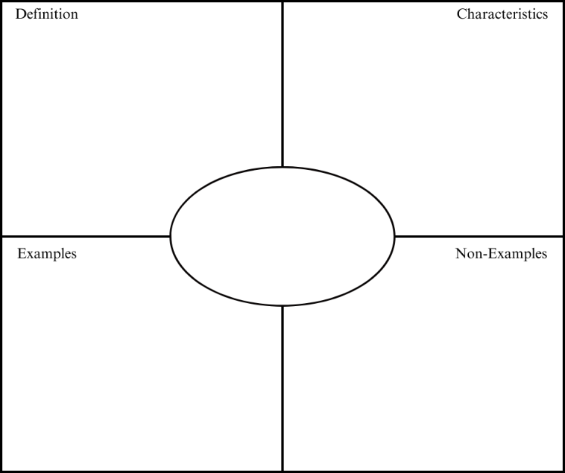

My own examples:
- ___________________________________________________
- ___________________________________________________

Resources
Question Stems
- “What do you notice about...?”
- “Why might the author have chosen...?”
- “What would happen if we changed...?”
- “Where could you use this in your writing?”
- “How does this help the reader understand...?”

Activity Ideas
  - Writing
    - Spark Creativity: Video Journals
    - Smekens: Acrostic Poems
  - Visualizing
    - Spark Creativity: Vocabulary Tattoo Design
    - The Teacher Toolkit: Pictionary
  - Contextualizing
    - Reading Rockets: Word Maps
    - Reading and Writing Haven: 3 Truths and a Lie
  - Comparing
    - Reading and Writing Haven: Bumper Words
    - Around the Kampfire Teaching: Shades of Meaning

