Vocabulary Instructional Routine: The Frayer Model

Common Core State Standards:
- CCSS.ELA-Literacy.L.4.6: Acquire and use accurately grade-appropriate general academic and domain-specific words and phrases, including those that signal precise actions, emotions, or states of being (e.g., quizzed, whined, stammered) and that are basic to a particular topic (e.g., wildlife, conservation, and endangered when discussing animal preservation).
- CCSS.ELA-Literacy.RI.4.4: Determine the meaning of general academic and domain-specific words or phrases in a text relevant to a grade 4 topic or subject area.

Overview
The Frayer Model is a 10-15 minute instructional routine that provides context-rich vocabulary instruction to help students to construct deep and nuanced word knowledge.
Teachers can use this routine to preteach vocabulary words that will appear in future readings, allowing students to focus on comprehending the text.

Symbol Key
 Explicit Instruction
 Opportunities to Respond
 Feedback

General Instructional Routine
Teacher Preparation
- Select target vocabulary words from the text to be read
- Choose vocabulary word(s) that:
- Are important to understanding the paragraph, argument, plot, theme or mood of the text
- Are unlikely to be learned from everyday conversation
- Can be used in multiple contexts across the disciplines
- Have multiple meanings or is likely to be misunderstood
- Are conceptually related to the main idea of the text (if there are no good candidates within the text)
- Develop student-friendly definitions for the target words
- Student-friendly definitions:
  - Use language that is easy for students to understand. These definitions often use the words “something” or “somebody.”
  - Explain how the word is usually used. Rather than accounting for every possible flavor or context, consider what is common or central to the word.
  - Create space between the most important words in the definition. This helps students to read the definition as a whole rather than focusing on specific words.
    - For example, rather than “running quickly and effortfully,” “running quickly and using a lot of effort” helps students to focus attention on both important descriptive words: quickly and effortful.
  - Avoid language that could be misinterpreted.
- Develop defining characteristics for the target words:
- Word characteristics should consider:
  - What distinguishes the word from its synonyms
  - Literal, figurative, concrete, and abstract applications
- Identify examples and non-examples of when the target word could be used.
- Good non-examples:
  - Fit some but not all of the word characteristics
  - Address common misunderstandings
- Good examples:
  - Show the diverse ways in which the word can be used
  - Always fit the definition and all of the characteristics

Investigation Procedure
Step 1: Briefing (2-3 minutes)
Connect to Previous Learning (if applicable):
- Review previous learning that applies to current lesson
- Reference recent discussions about current lesson
- Connect to ongoing analysis in larger unit of study

Preview
- Set the scene/Connect to students’ lives:
  - Provide a real-world analogy or example of when the focus or vocabulary term of the lesson may be relevant
- Provide purpose(s)/learning target(s) for students
- Explain real-world importance

Activate Prior Knowledge
- Ask questions to activating background knowledge:
  - What do you already know about this topic?
  - What comes to mind when you hear the word ________?
  - How does the focus of today’s lesson remind you of something we’ve talked about/learned before?

Step 2: Frayer Model Demonstration (7-8 minutes)
Initial Instruction
Introduce the Word(s)
- Present the word(s), definition, and characteristics to class

Word Characteristics Think-Aloud
- Introduce an example of a situation where the target word(s) could be used.
- Model situation analysis during think-aloud process
  - Example:
    - “First, I notice…”
    - “Now, I see…”
    - “This reminds me of…”
    - “I’m wondering…”

Guided Word Work
- Walk through an initial example with class
  - Compare the situation against the definition and word characteristics to support
  - Consider whether the word could match the situation in an abstract or figurative way
- Repeat this process with a non-example

Engagement Check
- Ask questions to check for comprehension
  - “Why might an author choose this word?”
  - “Is there anything you are unfamiliar with or don’t understand?”
  - “What other words can you think of that are similar?”
  - “How is this word different from those words?”

Step 3: Partner/Group Activity (10-12 minutes)
Teacher-Guided Practice
Activity Partnerships
- Pair students (or create small groups) for collaboration
- Review partnership expectations

Guided Analysis
- Partners/groups work together to:
  - Draw a Frayer Model in their vocabulary notebooks
  - Sort additional scenarios (written on the board) into either the “examples” or “non-examples” boxes
  - Collect real-world examples of how the target word is used from different sources (books, magazines, websites)

Teacher Support
- Circulate among partners/small groups to:
  - Monitor discussions
  - Offer feedback
  - Provide scaffolded prompts
  - Support struggling teams

Team Discussions
- Have pairs/groups:
- Explain sorting choices to each other
- Compare findings with nearby teams/groups
- Share reasoning with class

Step 4: Solo Activity (5-7 minutes)
Independent Practice
Choose an activity/activities for students to practice:
- Provide opportunities for students to play with the target word(s)
- Activities might include:
  - Comparing and contrasting synonyms and their use
  - Discussing how meaning changes with different word choices
  - Finding the target word in other text(s)
  - Creating visual interpretations of target words
  - Building networks of connected words
  - Using the target word in their own writing

Step 5: Closing (3-5 minutes)
- Add the target word(s) to a class reference wall or individual vocabulary notebook
- Have students connect to their own writing
- Discuss where they might use the target word in their work
- Set a purpose for using the word in upcoming writing

Materials

Notebook Entry Template

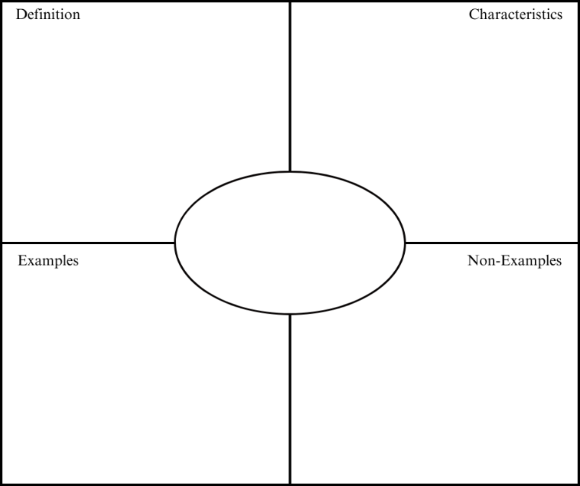

My own examples:
- ___________________________________________________
- ___________________________________________________

Resources
Question Stems
- “What do you notice about...?”
- “Why might the author have chosen...?”
- “What would happen if we changed...?”
- “Where could you use this in your writing?”
- “How does this help the reader understand...?”

Activity Ideas
  - Writing
    - Spark Creativity: Video Journals
    - Smekens: Acrostic Poems
  - Visualizing
    - Spark Creativity: Vocabulary Tattoo Design
    - The Teacher Toolkit: Pictionary
  - Contextualizing
    - Reading Rockets: Word Maps
    - Reading and Writing Haven: 3 Truths and a Lie
  - Comparing
    - Reading and Writing Haven: Bumper Words
    - Around the Kampfire Teaching: Shades of Meaning

