# Macintosh HD:Users:sgowtham:git_work:MichiganTechIT:LaTeX_Superior:Images:MichiganTech.png

Superior

superior.research.mtu.edu

Designing proactive paradigms to leverage orchestrated cutting-edge visionary channels with matrix dynamic functionalities by employing high performance computing infrastructure

Katherine Miller

Associate Professor, Cognitive Learning and Sciences

Chem. Sci. 737 · (906)487-1234 · [kamiller@mtu.edu](mailto:kamiller@mtu.edu)

Resume

Education 2

Professional Appointments 2

Research Interests 2

Relevant Publications 3

Project

Abstract 4

User Population 5

Data Sets 5

Preliminary Results 5

Resources 7

Source of Funding 7

References 8

**Katherine Miller**

Associate Professor Chem. Sci. 737

Cognitive Learning and Sciences (906) 487-1234

Michigan Technological University [kamiller@mtu.edu](mailto:kamiller@mtu.edu)

# Education

1. PhD, Kinesiology and Integrative Physiology, Yale University, New Haven, CT, 2001.
2. MS, Linguistics, Pennsylvania State University, State College, PA, 1997.
3. BS, Psychology, Gonzaga University, Spokane, WA, 1995

# Professional Appointments

1. Associate Professor

Cognitive Learning and Sciences, Michigan Tech, Houghton, MI, 2009 - present.

1. Assistant Professor

Cognitive Learning and Sciences, Michigan Tech, Houghton, MI, 2004 - 2009.

1. Research Scientist

Social Sciences, University of Oregon, Eugene, OR, 2001 - 2004.

# Research Interests

1. Quis nostrud exercitation ullamco laboris nisi ut aliquip ex ea commodo consequat.
2. Duis aute reprehenderit in voluptate velit esse cillum dolore eu fugiat nulla pariatur.
3. Excepteur cupidatat non proident, sunt culpa qui officia deserunt mollit est laborum.
4. Et harum quidem rerum facilis est et expedita distinctio. Temporibus autem quibusdam et aut officiis debitis aut rerum necessitatibus saepe eveniet ut et voluptates repudiandae sint et molestiae non recusandae.
5. Itaque earum rerum hic tenetur a sapiente delectus, ut aut reiciendis voluptatibus maiores alias consequatur aut perferendis doloribus asperiores repellat

# Relevant Publications

1. *Sed ut perspiciatis unde omnis iste natus error sit*

K. Miller and A. Johnson and B. Peters

Journal of Lorem Ipsum **B**, vol. 109, p. 14836, 2012.

1. *Accusantium doloremque laudantium, totam rem aperiam*

K. Miller and A. Johnson and R. Sanders

Journal of Lorem Ipsum **C**, vol. 431, p. 358, 2012.

1. *Nemo enim ipsam voluptatem quia voluptas sit aspernatur aut odit aut fugit*

K. Miller and A. Johnstone and C. Peterson

Journal of Lorem Ipsum **C**, vol. 948, p. 31, 2011.

1. *Ducimus qui blanditiis praesentium voluptatum deleniti*

C. Peterson and K. Miller and M. Miyagi and L. Paterson

Journal of Lorem Ipsum **A**, vol. 345, p. 21, 2010.

1. *Quis autem vel eum iure reprehenderit qui in ea voluptate*

A. Johnson and K. Miller and L. Paterson

Journal of Lorem Ipsum **F**, vol. 576, p. 22, 20

# Abstract

Lorem Ipsum is simply dummy text of the printing and typesetting industry. Lorem Ipsum has been the industry’s standard dummy text ever since the 1500s, when an unknown printer took a galley of type and scrambled it to make a type specimen book. It has survived not only five centuries, but also the leap into electronic typesetting, remaining essentially unchanged. It was popularized in the 1960s with the release of Letraset sheets containing Lorem Ipsum passages, and more recently with desktop publishing software.

Description

*What is the motivation for this project?* Contrary to popular belief, Lorem Ipsum is not simply random text [1–3]. It has roots in a piece of classical Latin literature from 45 BC, making it over 2000 years old. Richard McClintock, a Latin professor at Hampden-Sydney College in Virginia, looked up one of the more obscure Latin words, consectetur, from a Lorem Ipsum passage, and going through the cites of the word in classical literature, discovered the undoubtable source[4, 5]. Lorem Ipsum comes from sections 1.10.32 and 1.10.33 of de Finibus Bonorum et Malorum (The Extremes of Good and Evil) by Cicero, written in 45 BC. This book is a treatise on the theory of ethics, very popular during the Renaissance.

*A brief description of the computational methodology.* Sed ut perspiciatis unde omnis iste natus error sit voluptatem accusantium doloremque laudantium, totam rem aperiam, eaque ipsa quae ab illo inventore veritatis et quasi architecto beatae vitae dicta sunt explicabo. Nemo enim ipsam voluptatem quia voluptas sit aspernatur aut odit aut fugit, sed quia con- sequuntur magni dolores eos qui ratione voluptatem sequi nesciunt. Neque porro quisquam est, qui dolorem ipsum quia dolor sit amet, consectetur, adipisci velit, sed quia non numquam eius modi tempora incidunt ut labore et dolore magnam aliquam quaerat voluptatem.

*What is the expected outcome of this project?* It is a long established fact that a reader will be distracted by the readable content of a page when looking at its layout [6]. The point of using Lorem Ipsum is that it has a more-or-less normal distribution of letters, as opposed to using Content here, content here, making it look like readable English. Many desktop publishing packages and web page editors now use Lorem Ipsum as their default model text, and a search for lorem ipsum will uncover many web sites still in their infancy [7]. Various versions have evolved over the years, sometimes by accident, sometimes on purpose (injected humor and the like).

# 

# User Population

1. Katherine Miller (kamiller)

Associate Professor, Cognitive Learning and Sciences, Michigan Tech

1. Nicholle Schneider (ncschnei)

Assistant Professor, Social Sciences, Michigan Tech

1. Justin Hendricks (jzhendri)

Research Scientist, Cognitive Learning and Sciences, Michigan Tech

1. Amy Bernard (abbernar)

Research Scientist, Cognitive Learning and Sciences, Michigan Tech

1. Joshua Melvinson (jkmelvin)

Graduate Student, Cognitive Learning and Sciences, Michigan Tech

1. Managato Miyagi

Professor, Kinesiology, University of Michigan

# Data Sets

The project involves data sets received from a federal funding agency with sensitive and con- fidential health care information, and Health Insurance Portability and Accountability Act (HIPAA) regulations. Agency has indicated that we seek help from Information Technology Services, if need be, to securely download the data to the computing infrastructure.

# Preliminary Results

There are many variations of passages of Lorem Ipsum available, but the majority have suffered alteration in some form, by injected humor, or randomized words which don’t look even slightly believable. If you are going to use a passage of Lorem Ipsum, you need to be sure there isn’t anything embarrassing hidden in the middle of text. All the Lorem Ipsum generators on the Internet tend to repeat predefined chunks as necessary, making this the first true generator on the Internet. It uses a dictionary of over 200 Latin words, combined with a handful of model sentence structures, to generate Lorem Ipsum which looks reasonable.

Several simulations, using minimalized public versions of the aforementioned data sets, were performed in our research lab workstations using NAMD [8] to test the methodology as well as to get timing measurements. Figure 1 schematically represents the results from various phases in our methodology. Figure 2 not only represents timing measurements but also provides justification to the resources we request in the following section.

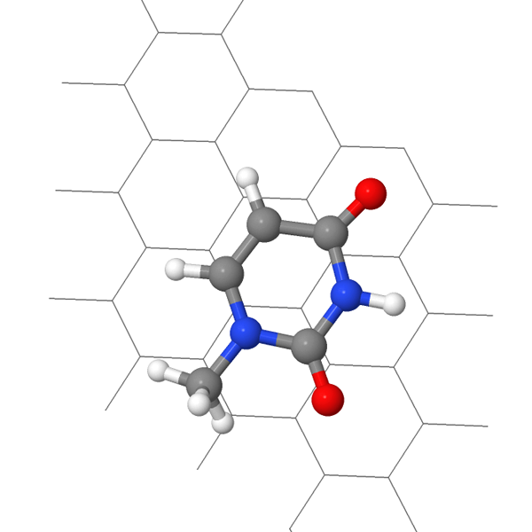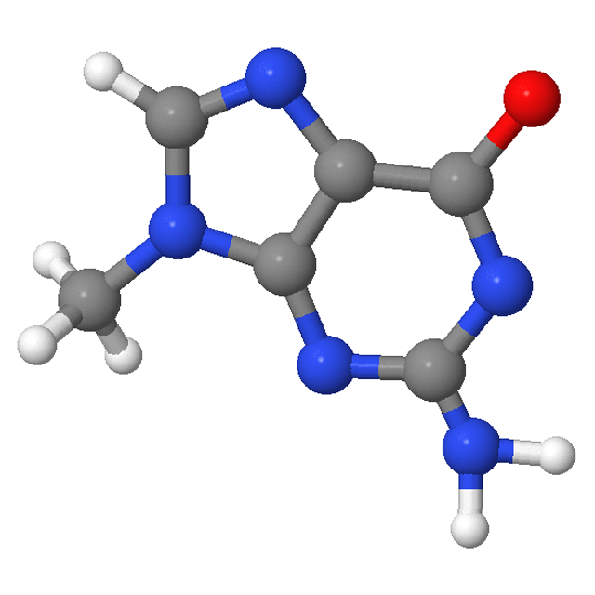

Figure 1: A snapshot from each of the three phases

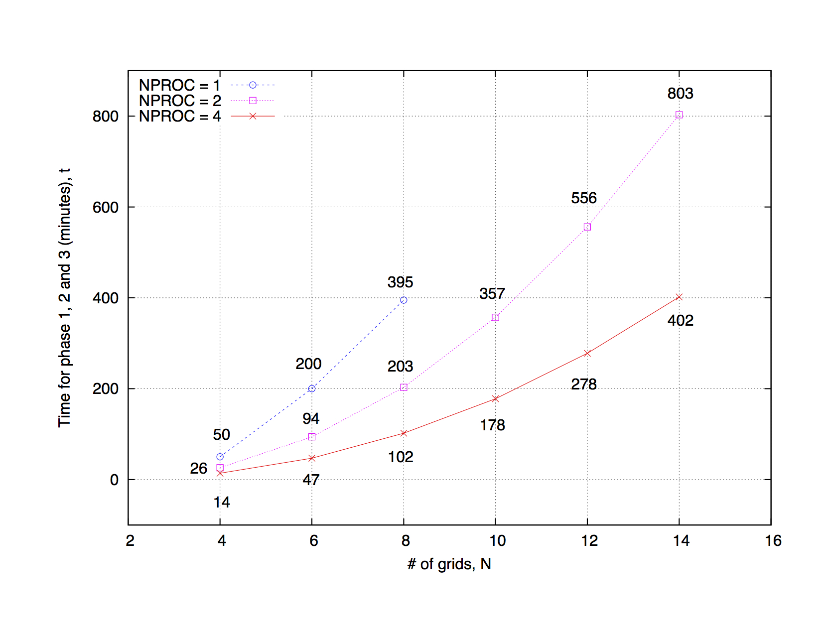

Figure 2: Timing measurements using 1, 2 and 4 processors

# Resources

A curve fit for the data in Figure 2 results in the following expressions, indicating linear scaling exhibited by our software suite:

$$t= \left(63.06/NPROC\right) \exp^{0.233 x N}$$

Using these equations, one can estimate the time required for simulations using a finer grid (N = 48) and larger number of processors (N P ROC = 8). A general outline of various simulations in our project is as follows:

1. 2 sets of 24 runs each.
2. In a given set, the first run has to complete before a subsequent run can be started.
3. Each run will use 8 CPU cores and last about 240 hours.
4. Workflow is CPU and memory intensive, and involves data in the order of 20 GB. Any temporary/scratch files and folders created will be automatically deleted at the end of each run. Also, the software suite automatically checkpoints at set intervals during a given run.

# Source of Funding

The project is funded by a federal agency through the grant # **XSF-2012-A4538** and will cover all expenses to acquire necessary software and/or compilers.

# 

# References

1. K. Miller and J. Anderson and M. Miyagi and P. Anderson, “*Et harum quidem rerum facilis est et expedita distinction I*,” Journal of Lorem Ipsum **C**, vol. 145, p. 436, 2007.
2. K. Miller and M. Miyagi and L. Paterson and A. Johnson, “*Et harum quidem rerum facilis est et expedita distinction II*,” Journal of Lorem Ipsum **D**, vol. 133, p. 258, 2008.
3. C. Peterson and K. Miller and M. Miyagi and L. Paterson, “*Ducimus qui blanditiis prae- sentium voluptatum deleniti*,” Journal of Lorem Ipsum **A**, vol. 345, p. 21, 2010.
4. A. Johnson and K. Miller and L. Paterson, “*Quis autem vel eum iure reprehenderit qui in ea voluptate*,” Journal of Lorem Ipsum F, vol. 576, p. 22, 2010.
5. K. Miller and A. Johnson and B. Peters, “*Sed ut perspiciatis unde omnis iste natus error sit*,” Journal of Lorem Ipsum **B**, vol. 109, p. 14836, 2012.
6. K. Miller and A. Johnson and R. Sanders, “*Accusantium doloremque laudantium, totam rem aperiam*,” Journal of Lorem Ipsum **C**, vol. 431, p. 358, 2012.
7. K. Miller and A. Johnstone and C. Peterson, “*Nemo enim ipsam voluptatem quia voluptas sit aspernatur aut odit aut fugit*,” Journal of Lorem Ipsum **C**, vol. 948, p. 31, 2011.
8. J. C. Phillips, R. Braun, W. Wang, J. Gumbart, E. Tajkhorshid, E. Villa, C. Chipot, R. D. Skeel, L. Kale, and K. Schulten, “*Scalable Molecular Dynamics with NAMD*,” J. Comp. Chem., vol. 26, p. 1781, 2005.

Proposal Check List

* Resume
* Proposal
  + Abstract
  + Description
  + User population - list of users, their status and affiliation
  + Data sets
    - Type (e.g., health care, financial, etc.)
    - Classification (e.g., sensitive/confidential, private, public, etc.)
    - Regulations (e.g., ITAR/EAR, HIPAA, FERPA, etc.)
  + Preliminary results, if available
  + Resources being requested
    - # of CPU/GPU
    - RAM/memory Storage
    - Time
    - Software
    - Compilers
  + Software
    - CPU intensive
    - Memory intensive
    - Storage intensive
    - Runs only in serial fashion (one CPU core)
    - Runs only in serial fashion but can use CUDA cores on a GPU
    - Runs in parallel but does not scale well
    - Runs in parallel and scales well up to few tens of CPU cores
    - Runs in parallel and scales well up to few hundreds of CPU cores
    - Runs in parallel and scales well up to few thousands of CPU cores
  + Source of funding for
    - Project, if applicable
    - Software, compilers, etc., if commercial