


CalorAI: a Calorie Tracking Application for Malaysian Local Cuisine using AI Image Recognition and Personalized Recommendations.

By
Chan Zheng Yao
TP070601
APD3F2511(SE)

A report submitted in partial fulfilment of the requirements for the degree of
Bachelor of Software Engineering (Hons) at Asia Pacific University of Technology and Innovation.

Supervised by: Dr. Vazeerudeen Abdul Hameed
2nd Marker: Ts. Dr. Vinothini A/P Kasinathan
2026

Acknowledgement
I would like to express my gratitude to Asia Pacific University of Technology and Innovation for providing me with the academic resources which made it possible to complete this investigation report. I would also like to thank my supervisor, Dr. Vazeerudeen Abdul Hameed, for his continuous guidance, constructive feedback, and patience throughout the development of this investigation report. I also appreciate the respondents who gave their time to answer my questionnaire and provide me insights that made it possible to complete the paper. Finally, I would like to thank my family and friends for their unwavering support, encouragement, and patience throughout this journey because their belief in my abilities kept me motivated during the more challenging stages of completing this investigation report.

Abstract
Malaysia is currently facing a growing public health crisis which is linked to rising obesity rates and diet-related non-communicable diseases. While there exist calorie tracking apps to help with dietary self-monitoring, these apps often only offer western-centric food databases which is not suitable for Malaysian cuisine. This investigation report documents the development justification for CalorAI, a calorie tracking application which is designed for Malaysian cuisine using AI image recognition and a recommendation chatbot powered by Gemini API which grounds the nutritional data in the Malaysian Food Composition Database (MyFCD). A comprehensive literature review was conducted to evaluate the accuracy limitation of existing tracking apps, advances in Multimodal Large Language Models for food recognition, the credibility and structure of MyFCD, personalized dietary recommendation systems, and the relationship between dietary self-monitoring and obesity in Malaysia. 5 similar systems were also evaluated to identify gaps in the market along with a survey which collected responses from 36 respondents regarding demand for photo-based meal logging with user confirmation, a localized verified food database, and goal-oriented chatbot guidance. Taken together, the findings show that CalorAI's proposed approach of combining Gemini API with MyFCD is feasible and closely matched to what real Malaysian users need.

Keywords: Calorie Tracking, Malaysian Cuisine, AI Image Recognition, Gemini API, MyFCD, Personalized Dietary Recommendations, AI Chatbot

SDG Goal 3: Good Health and Well-being

Table of Contents
Acknowledgement 2
Abstract 3
Chapter 1: Introduction 9
1.1 Introduction 9
1.2 Problem Background 10
1.3 Project Aim 11
1.4 Project Objectives 11
1.5 Project Scope 12
1.5.1 Inside Scope 12
1.5.2 Outside Scope 12
1.6 Potential Benefits 13
1.6.1 Tangible Benefits 13
1.6.2 Intangible Benefits 13
1.6.3 Target Users 13
1.6.4 Functionalities / Deliverables 13
1.7 Overview of the IR 15
1.8 Project Plan 16
Chapter 2: Literature Review 18
2.1 Domain Research 18
2.1.1 Accuracy Limitations of Existing Calorie Tracking Applications 18
2.1.2 Multimodal Large Language Models (MLLMs) for Food Image Recognition and Portion Size Estimation 23
2.1.3 Malaysian Food Composition Data & Databases (MyFCD) 26
2.1.4 Personalized Dietary Recommendation Systems and AI Chatbots for Health & Diet Coaching 28
2.1.5 Dietary Self-Monitoring & Weight Management relations with Obesity & NCD Prevalence in Malaysia 30
2.2 Similar Systems / Works 33
2.2.1 MyFitnessPal 33
2.2.2 Cronometer 36
2.2.3 CalCam 39
2.2.4 SnapCalorie 42
2.2.5 MyDietCam 44
2.2.6 Conclusion 47
2.3 Technical Research 49
2.3.1 System Requirements Analysis 49
2.3.2 Programming language chosen 51
2.3.3 IDE chosen 53
2.3.4 Database Management System chosen 54
2.3.5 Tools / libraries / APIs used 56
2.3.6 Operating System Chosen 57
Chapter 3: Methodology 58
3.1 System Development Methodology 58
3.1.1 Introduction 58
3.1.2 Methodology Choice and Justification 58
3.1.3 Activities and Processes in Each Phase of the RAD Methodology 60
3.2 Data Gathering Design 63
3.2.1 Data Collection Method 63
3.2.2 Comparison 63
3.2.3 Survey Structure 64
3.2.4 Questions Objectives 64
3.3 Analysis 69
3.3.1 Demographic Analysis 69
3.3.2 Current Calorie Tracking Habits 76
3.3.3 Malaysian Food Logging Pain Points 80
3.3.4 Photo-Based Logging (AI Image Recognition Acceptance) 88
3.3.5 Database Trust and Transparency 94
3.3.6 Recommendations, Chatbot, and Actionable Guidance 98
3.3.7 Feature Prioritization 104
3.3.8 Summary 116
Chapter 4: Conclusion 118
4.1 Achievement 118
4.2 Future Improvements and Further Work 119
References 121
Appendices 126
Appendix A: Project Title Proposal 126
Appendix B: Project Ethics Form 127
Appendix C: Log Sheet 130
Appendix D: Gantt Chart 132
Appendix E: Demographic Profile 132

Figure 1: Correlation (r) Between Mobile App Estimates and Reference Methods (Fallaize, Zenun Franco, Pasang, Hwang, & Lovegrove, 2019) 17
Figure 2 Difference in macronutrient measurements from 3-day diets in 1 week. (Ferrara, Kim, Lin, Hua, & Seto, 2019) 18
Figure 3 plot of calorie difference. 19
Figure 4 MLLM Performance Benchmarks (Food-101 & Nutrition5k) (Jiao, et al., 2024) 22
Figure 5 The prevalence of undiagnosed diabetes mellitus, undiagnosed high blood pressure, and undiagnosed hypercholesterolemia stratified by central obesity status among the Malaysian adults (n = 12,978). (Koo, Tan, Lim, Kee, & Omar, 2023) 28
Figure 6 The prevalence of undiagnosed diabetes mellitus, undiagnosed high blood pressure, and undiagnosed hypercholesterolemia stratified by general obesity status among the Malaysian adults (n = 13,024). (Koo, Tan, Lim, Kee, & Omar, 2023) 29
Figure 7 MyFitnessPal App 1 Figure 8 MyFitnessPal App 2 31
Figure 9 Cronometer App 1 Figure 10 Cronometer App 2 34
Figure 11 CalCam App 1 Figure 12 CalCam App 2 Figure 13 CalCam App 3 37
Figure 14 SnapCalorie App 1 Figure 15 SnapCalorie App 2 40
Figure 16 MyDietCam App 1 42
Figure 17 MyDietCam App 2 43
Figure 18 Data for survey question 1 64
Figure 19 Data for survey question 2. 65
Figure 20 Data for survey question 3. 66
Figure 21 Data for survey question 4. 67
Figure 22 Data for survey question. 68
Figure 23 Data for survey question 6. 69
Figure 24 Data for survey question 7. 70
Figure 25 Data for survey question 8. 71
Figure 26 Data for survey question 9. 72
Figure 27 Data for survey question 10. 73
Figure 28 Data for survey question 11. 74
Figure 29 Data for survey question 12. 75
Figure 30 Data for survey question 13. 76
Figure 31 Data for survey question 14\ 77
Figure 32 Data for survey question 15. 78
Figure 33 Data for survey question 16. 79
Figure 34 Data for survey question 17. 80
Figure 35 Data for survey question 18 81
Figure 36 Data for survey question 19 82
Figure 37 Data for survey question 20 83
Figure 38 Data for survey question 21 84
Figure 39 Data for survey question 22 85
Figure 40 Data for survey question 23 86
Figure 41 Data for survey question 24 87
Figure 42 Data for survey question 25 88
Figure 43 Data for survey question 26 89
Figure 44 Data for survey question 27 90
Figure 45 Data for survey question 28 91
Figure 46 Data for survey question 29 92
Figure 47 Data for survey question 30 93
Figure 48 Data for survey question 31 94
Figure 49 Data for survey question 32 95
Figure 50 Data for survey question 33 96
Figure 51 Data for survey question 34 97
Figure 52 Data for survey question 35 98
Figure 53 Data for survey question 36 99
Figure 54 Data for survey question 37 100
Figure 55 Data for survey question 38 101
Figure 56 Data for survey question 39 102
Figure 57 Data for survey question 40 103
Figure 58 Data for survey question 41. 104
Figure 59 Data for survey question 42 105
Figure 60 Data for survey question 43 106
Figure 61 Data for survey question 44 107
Figure 62 Data for survey question 45 108
Figure 63 Data for survey question 46 109
Figure 64 Data for survey question 47 110

Table 1Tangible Benefits 13
Table 2 Intangible Benefits 13
Table 3 Project Plan 16
Table 4 Similar System Comparison 47
Table 5 Data collection comparison 63
Table 6 Survey Structure 64
Table 7 Question Objective 64

Chapter 1: Introduction

1.1 Introduction
Malaysia has been facing a public health crisis related to the increase in obesity and unhealthy weight gain. National health surveys and related academic studies have consistently reported that high levels of obesity among the general population will increase the long-term risk of illnesses such as diabetes, hypertension and much more. Preventing these issues is crucial and one strategy that can be applied is to help people understand and manage their daily caloric intake and energy expenditure by consistently tracking it (Tat Chong, et al., 2022).
Calorie tracking applications have become a popular tool for users who want to monitor their health and caloric intake. However, their impact is limited due to the many friction points that come with using the application. The first issue is the requirement for manual entry for data logging such that users are required to weigh the foods to know exactly the number of calories it contains. Furthermore, the database on these applications often fail to provide an accurate representation of local Malaysian cuisine and its caloric content forcing users to select the closest substitute. This introduces larger errors compared to if the correct type of food is provided which reduces the trust in the application and reduces the odds of the application being used consistently (Harvey, Krukowski, Priest, & West, 2019).
To address the issues stated above, the project proposes CalorAI which is an app that is designed for the local Malaysian cuisine which integrates AI-based image recognition to automate the food logging process and provides recommendations and alternatives to guide users to healthier food choices in the long term. The app helps to reduce logging friction and improves the local food coverage using data provided by the Ministry of Health (MOH). CalorAI aims to make dietary tracking smoother and more accessible which would in turn motivate more Malaysians to seek healthier lifestyles and improve their knowledge regarding the correlation between food and weight gain (Liangzi, Andreja, Boshuizen, & Ocké, 2021).

1.2 Problem Background
A key limitation of existing calorie tracking applications is the reliance on the users manually entering their meals. On many existing applications, the users will have to search for their type of food or something similar to it, then estimate the portion or weight of the food they are consuming which is a time-consuming process which discourages the users from using the app. This process is repetitive and is one of the main reasons users do not use the application consistently and causes users to abandon the app altogether (Harvey, Krukowski, Priest, & West, 2019).
Another issue for current calorie tracking apps out in the market is the lack of localization for Malaysian cuisine. Malaysian cuisines are often different from the meals that are found in other countries and dishes with the same name can have vastly different ingredients and portion sizes. Many global calorie tracking apps are built around western cuisine and food compositions which lead to missing foods, inconsistent nutrient values and inaccurate serving sizes for Malaysian cuisine. When users choose substitutes for their meal, the calorie estimates may be different compared to the actual calorie count making recording irrelevant (Liangzi, Andreja, Boshuizen, & Ocké, 2021).
A third reason is that the application functions primarily as a logbook rather than an assistant helping with making smarter choices. Users may know the calorie count of all their foods but may not know how many calories they would need to consume to achieve the goal they want. With an AI assistant available in the app, the users will be able to receive actionable steps and information to achieve their goal whether it is to lose weight or to gain muscle (Chew, Koh, Ng, & Tan, 2022). The AI assistant would also be able to help by recommending healthier alternatives to the usual meals the user eats, to help lead a healthier lifestyle based on their current goal (Orue-Saiz, Kazarez, & Mendez-Zorrilla, 2021).
Lastly, the recent advances in computer vision and AI enable the use of image dietary logging instead of only allowing for manual data entry. Users will be able to take a photo of the meal, and the system will be used to detect and determine the food type and portion. This feature will reduce the typing and searching required to log the users’ meals making tracking easier. By applying this along with a localized Malaysian food database, the data will be more accurate compared to only using one of the options (Prasad, 2021).

1.3 Project Aim
To develop CalorAI, a calorie tracking application for Malaysian local cuisine that uses AI image recognition to reduce manual food logging and provides personalized dietary recommendations to support healthier eating decisions.

1.4 Project Objectives
- To design and develop a user interface that allows users to log a meal in 30 seconds or less using a photo-based input.
- To integrate an AI image recognition system capable of identifying Malaysian cuisine with at least 80% top 5 accuracy on a defined test dataset
- To implement a calorie estimation workflow that includes portion estimation and achieves an average error of less than 150 calories compared to reference test dataset.
- To implement a chatbot based recommendation feature that will provide meal suggestions based on user caloric and health goals that achieves a System Usability Scale (SUS) score of ≥ 68.

1.5 Project Scope

1.5.1 Inside Scope
CalorAI will be developed for mobile use as a mobile application built using the flutter framework with dart as the language. Android will be the primary platform that the app is developed for and will include a user account system with registration system and login functionality powered by Firebase. Each user will have a personalized account containing user profile information such as height, weight, age and more along with their primary health goal. Users will also have the ability to set their daily caloric target which can be automatically calculated based on goals or be manually inserted by the user. Users will also be allowed to enter their macronutrient goals if they prefer it over general caloric target. The core feature of CalorAI will be the AI-powered food logging system that uses images captured by the user to identify the dish and its components and compare them to MyFCD to ground the data to a reliable source. The user will be prompted to confirm the dish and portion size before the tool will process and outputs the calories within the dish along with the macronutrients. If the automatic selection is wrong, the user can manually search for the dish to correct the log. User submitted images will be used and fed into the Gemini API for analysis and deleted promptly after maintaining user privacy.
CalorAI will also include a conversational chatbot powered by Gemini API that functions as a dietary assistant providing non-medical and goal-based guidance to users. The chatbot will be designed to use user information to make decisions such as user caloric goals, recent meals, and user goals. Users can request healthier alternatives to foods they already eat and to generate a simple meal plan that fits within their caloric target. The application will also have a dashboard for user progress such as past caloric intake trends, weight change trends, and past meal types.

1.5.2 Outside Scope
The project scope excludes the deployment of the application onto the google play store or apple app store and will remain a prototype until further notice. CalorAI will also not be deployed as a website or train its own machine learning model for food detection and will strictly be using Gemini API for its AI capabilities.

1.6 Potential Benefits

1.6.1 Tangible Benefits
Table 1 Tangible Benefits
Benefits | Description
Faster meal logging | Photo-based logging removes manual searching and typing time which reduces the friction for meal recording compared to existing applications.
Improved accuracy for Malaysian foods | Localized database such as MyFCD reduces reliance on foreign substitutes and keeps the calorie estimates accurate.
Better decision support | The chatbot provides goal relevant recommendations which provides users with better guidance and actionable steps to reach their goals
Tracking and Progress visibility | A personal dashboard allows users to monitor trends in their daily caloric intake, weight change and meal consistency to better analyze their progress

1.6.2 Intangible Benefits
Table 2 Intangible Benefits
Benefits | Description
Increased nutrition awareness | Consistent calorie tracking teaches users about food macro breakdown and to estimate calories more accurately.
Higher motivation to continue tracking | Receiving practical and actionable feedback encourages users to continue tracking and notice improvements.
Higher trust in calorie estimates | Using a trusted food database such as MyFCD reduces the distrust and confusion of knowing if the calorie estimates are correct.
Encourages healthier choices | The recommendation system suggests healthier food alternatives which allow users to improve their diet without any drastic changes to their eating habits.

1.6.3 Target Users
- General Malaysian population - individuals aiming to manage weight or improve eating habits.
- Health-conscious individuals - users who monitor calories/macros.

1.6.4 Functionalities / Deliverables
CalorAI will allow General Users to:
- Register and login using email/password.
- Create and manage a personal profile (height, weight, age, activity level)
- Set a primary health goal (lose weight, maintain, gain muscle, eat healthier)
- Log meals by uploading or capturing a photo of their food.
- Set daily calorie targets (auto-calculated or manual)
- Adjust portion size using Small/Medium/Large or manual gram input.
- View a daily calorie summary (consumed vs target)
- Log meals manually via text-based food search when photo logging is not suitable.
- View a history of logged meals with food names, portions, and calories.
- Ask the chatbot general nutrition questions about Malaysian dishes.
- Request a meal plan based on their calorie target and Malaysian foods.
CalorAI will allow Health-conscious / Fitness-focused Users to:
- Set macronutrient targets (protein, carbohydrates, fats) in addition to calorie targets.
- View macronutrient breakdown per meal and per day (protein/carbs/fats charts)
- Request goal-aligned suggestions from the chatbot (e.g., higher-protein alternatives, lower-calorie swaps, bulking meal ideas)
- View progress trends over time to support bulking/cutting phases.

1.7 Overview of the IR
This investigation report is organized into 4 main chapters. Chapter 1 introduces the background of calorie tracking applications in Malaysia and explains the project aim, objectives, scope and potential benefits of CalorAI. Chapter 2 presents the literature review that covers the limitations of existing calorie tracking applications, recent advances in AI-based food recognition and portion estimation, Malaysian food composition databases, and personalized recommendation systems, followed by an analysis of similar applications. Chapter 3 picks a system development methodology which is RAD, the data gathering design, and the analysis of survey findings for user requirements. Chapter 4 concludes the project by summarizing the main achievements of the investigation and identifying potential gaps and opportunities to improve CalorAI.

1.8 Project Plan
Table 3 Project Plan
Task ID | Task Description | Duration | Start Date | End Date | Status
1.1 | Project planning and topic confirmation | 3 days | 02/12/2025 | 04/12/2025 | Completed
1.2 | Project Proposal Form (PPF) preparation | 3 days | 03/12/2025 | 05/12/2025 | Completed
1.3 | Ethics form preparation | 3 days | 08/12/2025 | 10/12/2025 | Completed
1.4 | Chapter 1 drafting | 10 days | 08/12/2025 | 17/12/2025 | Completed
2.1 | Literature search and source collection | 14 days | 10/12/2025 | 23/12/2025 | Completed
2.2 | Domain research writing | 18 days | 24/12/2025 | 10/01/2026 | Completed
2.3 | Similar systems analysis | 8 days | 05/01/2026 | 12/01/2026 | Completed
2.4 | Technical research | 7 days | 11/01/2026 | 17/01/2026 | Completed
3.1 | Methodology selection and writing | 7 days | 15/01/2026 | 21/01/2026 | Completed
3.2 | Questionnaire design and refinement | 8 days | 20/01/2026 | 27/01/2026 | Completed
3.3 | Ethics approval finalization | 4 days | 28/01/2026 | 31/01/2026 | Completed
3.4 | Survey distribution and data collection | 18 days | 01/02/2026 | 18/02/2026 | Completed
3.5 | Data cleaning and analysis | 10 days | 19/02/2026 | 28/02/2026 | Completed
3.6 | User requirement derivation and summary | 5 days | 25/02/2026 | 01/03/2026 | Completed
4.1 | Chapter 4 drafting | 5 days | 02/03/2026 | 06/03/2026 | Completed
5.1 | References checking and formatting | 4 days | 05/03/2026 | 08/03/2026 | Completed
5.2 | Appendices compilation | 4 days | 06/03/2026 | 09/03/2026 | Completed
5.3 | Final proofreading and report completion | 3 days | 09/03/2026 | 11/03/2026 | Completed

Chapter 2: Literature Review
This chapter reviews the existing literature and related works which are relevant to the development of CalorAI and is organized into 3 main sections which are domain research, existing systems, and technical research. Domain research focuses on 5 topics which are identifying the accuracy limitations of existing calorie tracking applications, the use of Multimodal Large Language Models for food image recognition and portion estimation, the Malaysian Food Composition Database (MyFCD), personalized dietary recommendation systems and AI chatbots for health coaching, and the relationship between dietary self-monitoring and obesity and NCD prevalence in Malaysia. Similar systems focus on 5 calorie tracking applications which are MyFitnessPal, Cronometer, CalCam, SnapCalorie, and MyDietCam to identify their strengths, weaknesses, and the gaps they have for CalorAI to address. Lastly, technical research focuses on the choices of technology used to implement and complete CalorAI listing the reasons and justifications for using those technologies.

2.1 Domain Research

2.1.1 Accuracy Limitations of Existing Calorie Tracking Applications
A consistent finding across much of the literature is that calorie tracking apps can produce inconsistent nutrient estimation due to differences in food composition databases, user-generated entries, serving sizes and missing micronutrient fields. This section will review the evidence on accuracy limitations regarding existing calorie tracking apps including database quality, validation against references and user experience issues.
Multiple empirical evaluations on dietary tracking apps have shown that even the most popular consumer apps can overestimate or underestimate caloric consumption by a large amount compared to reference models. Studies have shown that energy intake was overestimated for western diets by an average of 1040kJ while underestimating Asian diets by an average of 1520kJ (Li, et al., 2024). An example is when (Tosi, et al., 2021) compared widely used apps to country specific reference databases and found a consistent underestimation pattern in the tracking and highlighted problems with non-local databases. Similarly, (Fallaize, Zenun Franco, Pasang, Hwang, & Lovegrove, 2019) compared popular nutrition apps against UK reference material and found significant disagreements and limits of agreements across nutrients supporting that the same meals can yield different results depending on the app users use.
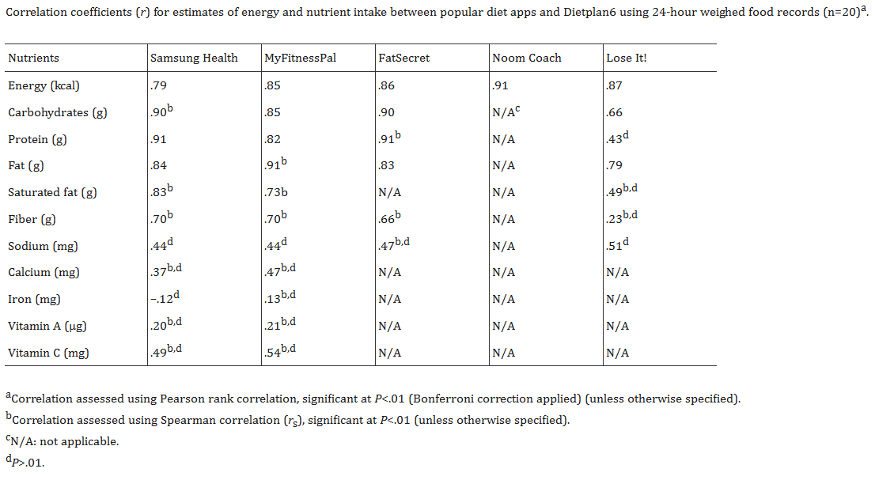
Figure 1: Correlation (r) Between Mobile App Estimates and Reference Methods (Fallaize, Zenun Franco, Pasang, Hwang, & Lovegrove, 2019)
When individual apps are validated against reference tools, discrepancies can be found regarding their nutrient calculations such as when (Evenepoel, et al., 2020) compared MyFitnessPal’s nutrient calculations against the Belgian Nubel food composition database and found that while MyFitnessPal is accurate for total energy intake given the user entered the data correctly, it is not accurate for cholesterol and sodium. This is significant because Malaysian dishes such as sambal, curry and many other dishes often contain a higher amount of sodium and would not be optimal for users who use this for dietary monitoring.
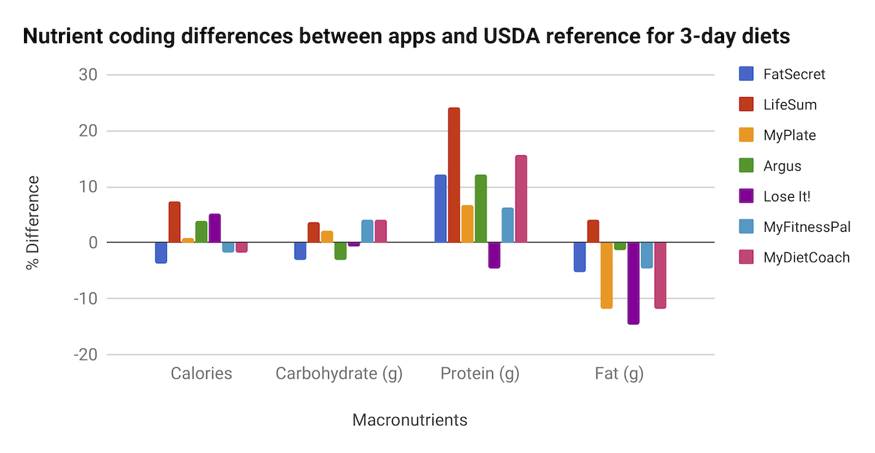
Figure 2 Difference in macronutrient measurements from 3-day diets in 1 week. (Ferrara, Kim, Lin, Hua, & Seto, 2019)
(Ferrara, Kim, Lin, Hua, & Seto, 2019) did research on smartphone diet tracking apps regarding its usability, functionality, coherence with behavior change theory and comparative validity. The review found that even though most apps offer basic calorie tracking capabilities, they lack the coherence with established behavior change theories which would lead to a larger variance in their caloric estimates (Ferrara, Kim, Lin, Hua, & Seto, 2019). This means even if data is entered by the users, the app does not help encourage a sustained behavior change which is a limitation that CalorAI aims to address and overcome.
(Tosi, et al., 2021) evaluated the accuracy of calorie tracking apps in their research paper by comparing them to 3-day food diaries and came to the conclusion that over 65% of calorie trackers are overestimating or underestimating the caloric intake of users when compared to established dietary standards. Similarly, (Fallaize, Zenun Franco, Pasang, Hwang, & Lovegrove, 2019) compared popular calorie tracking apps against a UK reference method and found that apps will vary widely regarding their reference nutrient values with some apps performing acceptably for calories but not for the micronutrients.
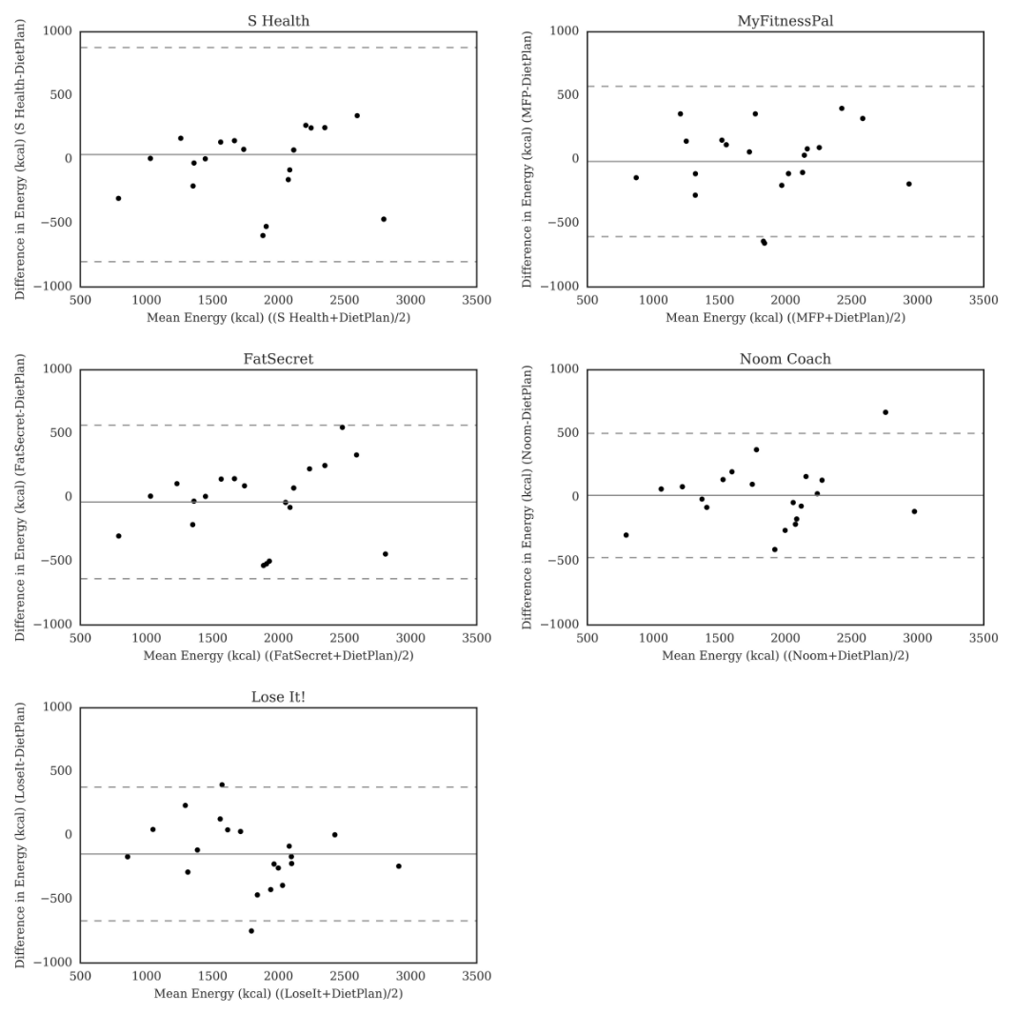
Figure 3 plot of calorie difference.
In terms of user experience perspective, (Zečević, Mijatović, Kos Koklič, Žabkar, & Gidaković, 2021) analyzed user reviews of many calorie tracking apps and identified common complaints including issue with inaccurate food databases, difficulty logging local foods and frustration with portion size estimations. A study from (Blanchard, et al., 2021) that researched PIQNIQ, a mobile application for tracking caloric intake using image assisted methods proved that image-based recording can improve the effectiveness and accuracy of calorie tracking compared to purely text-based logging. (Banerjee, Mendu, Korrapati, & Gavaravarapu, 2019) also showed that while calorie trackers improve nutritional awareness, the effectiveness of it is limited by databases available specifically for south Indian foods which is a similar issue we have in Malaysia.
In summary, the evidence collected is consistent and demonstrates that existing calorie tracking apps suffer from database inaccuracies, western centric food databases, inconsistent portions, and poor coverage of Asian cuisine.

2.1.2 Multimodal Large Language Models (MLLMs) for Food Image Recognition and Portion Size Estimation
The application of artificial intelligence into food image recognition has evolved significantly in the past decade. The traditional way of food image recognition relies on convolutional neural networks (CNNs) trained on labeled food image datasets, but recent advances in multimodal large language models (MLLMs) have changed the way that food image recognition can be done along with ingredient decomposition and nutritional estimation. All these can be done with a single image without the need for a custom model or special training. This section of domain research will review the evidence on MLLMs for food recognition and portion estimation to discuss the implications for CalorAI and its API based architecture.
Many recent studies directly researched the use of MLLMs for food image recognition. A peer reviewed evaluation of 3 leading LLMs which are ChatGPT-4o, Claude Sonnet, and Gemini 1.5 pro for nutritional content estimation have found that while all models have shown promise, the protein estimations exceed 60% Mean Absolute Percentage Error (MAPE) across all models which could be due to difficulty distinguishing protein-rich components or estimating density (Fridolfsson, Sjöberg, Thiwång, & Pettersson, 2025).
(Yan, et al., 2025) presented DietAI24 through a research paper. It is a framework that combines the use of MLLMs with Retrieval Augmented Generation (RAG) technology to ground the LLMs visual recognition in authoritative nutrition databases rather than relying on the model’s internal knowledge to make decisions. Using this approach, DietAI24 enables LLMs to make a more accurate caloric estimation without extensive data collection or model training. The RAG architecture is the exact same as CalorAI’s proposed design which was to use Gemini API for visual food identification and to cross reference the foods with MyFCD for verified Malaysian nutritional data.
(Khlaisamniang, et al., 2025) has also proposed a 2-step prompting framework that was inspired by nutrition experts that consists of a few steps and the first step is to break down the dish into its major components and listing them. They also estimate the portion size and cooking details before moving to the second step which is to compute the total calorie and macronutrients based on the listed ingredients and portions. By applying this approach to allows for better control without needing to heavily fine tune the LLM and a reliance on large ingredient database. CalorAI can adopt a similar approach of decomposition strategy in the app with the Gemini API to manage complex Malaysian dishes.
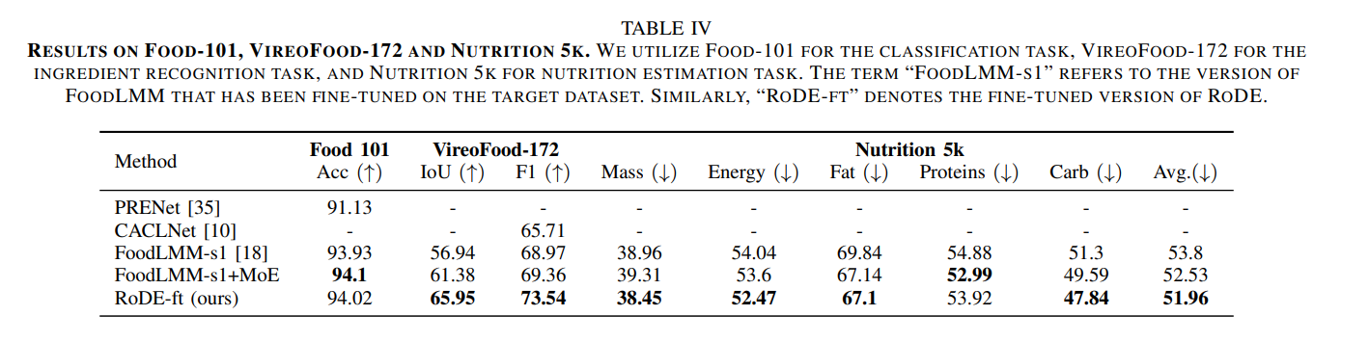
Figure 4 MLLM Performance Benchmarks (Food-101 & Nutrition5k) (Jiao, et al., 2024)
(Kim, Kim, Jo, & Won, 2024) explored multimodal food image classification using LLMs and showed that by combining the visual features with a language model reasoning can lead to improved classification for diverse food categories. (Yin, et al., 2023) also introduced FoodLMM, which is a food assistant that functions using a large multimodal model which is capable of food recognition, ingredient identification and nutritional analysis bundled into 1 framework. Lastly, (Belkhouribchia & Pen, 2025) claim in their research that even though LLMs show promise in terms of dietary assessment and recommendations, the output require validation against established nutritional databases to keep them grounded and reduce inaccuracies.
Estimation of food portion sizes are also a key factor to harnessing the full ability of a calorie tracking app. (Dehais, Anthimopoulos, Shevchik, & Mougiakakou, 2017) explored the use of two-view 3D reconstruction to estimate the volume of food and demonstrated that having a depth aware approach can improve the accuracy of the reading. This requires specialized hardware such as stereo cameras which are currently impractical for everyday mobile use but is a technology which can be implemented at a later time. For CalorAI, which relies on Gemini API along with monocular images, exact volumes will not be feasible but will instead implement a guided portion selection workflow. This would allow the user to enter values such as small, medium, or large based on their experience combining with MyFCD values to calculate the estimated calories.
Lastly, a critical consideration for CalorAI is the documented bias in calorie tracking applications towards more western oriented cuisine. (Min, et al., 2025) noted that models usually reflect a western centric view of diet which results in inaccurate dietary advice for people from diverse backgrounds. This bias manifests in many ways such as lower recognition accuracy, incorrect ingredient assumptions or inaccurate portion sizes. This amplifies the necessity of CalorAI’s localization strategy to pair Gemini API with a Malaysian food database for a culturally appropriate prompt that specifies Malaysian cooking method, ingredients and serving sizes.

2.1.3 Malaysian Food Composition Data & Databases (MyFCD)
Accurate calorie tracking for Malaysian cuisine requires a locally validated source of nutritional information which would come from the Malaysian Food Composition Database (MyFCD). CalorAI will use MyFCD and related research on Malaysian food nutrient profiling to form the foundational data for CalorAI’s calorie estimation system.
The Malaysian Food Composition Database (MyFCD) was created in 1980 by the Institute for Medical Research (IMR) under the Ministry of Health Malaysia. The first phase was the provision of a FCD table in 1982 which created a list of Malaysian foods and was followed up with the analysis of essential nutrients for the foods in the list (MyFCD, 2026). The current version of MyFCD has 29 mandatory and 11 optional nutrients needed in one’s diet. It also contains 441 raw and processed foods and 668 prepared foods in the database and is separated into 3 separate sub-databases which are 1997, current and industry with newer databases containing roughly 1100 food items categorized into 34 food groups (Kong, Moy, Ong, Tahir, & Loo, 2023).
There are multiple studies which have contributed to identifying specific nutrient data for Malaysian foods and were incorporated into MyFCD. One of them is the profiling of sugar content within Malaysian foods. (Mustafa Khalid, et al., 2018) did a study and determine the sugar content on 83 Malaysian foods and noted that many of the prepared dishes and beverages contained a considerable amount more sugar than expected which can lead to negative health effects. (Norizan, et al., 2025) further elaborated regarding the lack of data on sugar content data on a wide range of foods in the current MyFCD as an important signifier that more research is needed to determine the sources of sugar in the daily diet all across the country.
The food composition efforts are not limited to Malaysia but throughout Southeast Asia. (Hulshof, et al., 2018) documented the contribution of the SMILING (Strengthening and Improving Micronutrient Intake through Linking) project to food composition tables across Southeast Asia and claimed that the regional harmonization of food composition data remains a challenge for researchers due to the difference in research method used and food preparation styles of each country.
(Kong, Moy, Ong, Tahir, & Loo, 2023) which developed MyDietCam, the food recognition and dietary monitoring app which integrated MyFCD as its nutritional reference noted that users often questioned the credibility of local food databases in other diet applications which motivated them to use MyFCD as their main source of data. CalorAI will follow the same principles such that instead of relying on generic databases, MyFCD will be used as the primary nutritional reference.

2.1.4 Personalized Dietary Recommendation Systems and AI Chatbots for Health & Diet Coaching
Many calorie tracking applications are used solely as a passive logbook for the meals that users consume on a daily basis. These applications are most often used for data recording but do not provide guidance to help users improve their diet. A personalized dietary recommendation can be very helpful when trying to manage chronic conditions and to support weight management goals. (Trang Tran, Atas, Felfernig, & Stettinger, 2017) provided data regarding a recommender system within the healthy food domain in their study. They documented approaches for better recommendations such as content-based filtering, collaborative filtering, and knowledge-based methods. They also noted that most systems rely on nutrient constraint satisfaction which will only recommend foods which fit within the specification of the user such as specific calorie, protein or fiber goals.
(Orue-Saiz, Kazarez, & Mendez-Zorrilla, 2021) also conducted a systematic review of nutritional recommendation systems and found that even though there are a large number of apps available with personalization, not many contain detailed personalization for users. The literature reviews identified gaps in terms of the cultural adaptation, user preference logic, or historical dietary choice onto their recommendations which CalorAI plans to overcome.
The large-scale adoption of large language models has further expanded the possibilities for dietary guidance of users. A systematic review done by (Wang, Sun, Xue, & An, 2025) found that AI based dietary chatbots have led to user adherence at a rate 32% higher when compared to conventional counseling and was attributed to AI’s ability to offer continuous, context and emotionally adaptive feedback to users. However, the review also mentioned that most AI nutrition tools that were developed were targeting the western demographic and context which may not be as accurate for interpreting traditional meals from Asia, Africa or Latin America. This is a major consideration for CalorAI to ensure that the chatbot recommendation system is grounded based on Malaysian cuisine and food options.
(Papastratis, Konstantinidis, Daras, & Dimitropoulos, 2024) showed that AI nutritional recommendation systems that implemented deep generative models combined with ChatGPT can produce plausible meal plans but the accuracy of it completely depends on the quality of the food data and user profiles. An investigation by (Kassem, et al., 2025) highlighted that while AI can assist with meal planning, nutrient analysis, and dietary education, the outputs AI generates need to be assessed and validated against established nutritional standards and databases to avoid errors.
Systematic review on ChatGPT’s potential for meal planning and dietary recommendations found that by leveraging low complexity and an almost infinite pool of meals from the internet, ChatGPT can be used to make dietary recommendations. However, even though ChatGPT can be used in that way, it is still prone to errors particularly in terms of portion awareness and cultural appropriateness (Guo, Liu, Xiang, & An, 2025). The larger pool of LLMs have also been researched by (Azimi, Qi, Wang, Rahmani, & Li, 2025) showed that prompt engineering and knowledge retrieval techniques can significantly improve LLM performance specifically on nutrition related questions. This study suggests that having a well-designed prompt may be able to partially compensate for the model knowledge gaps and improve on the performance of the LLMs.
With this information, CalorAI’s chatbot, which is powered by using Gemini API will be able to function as a dietary assistant to provide healthier meal alternatives, and to provide meal plans based on user goals. Based on the literature reviewed, the chatbot should apply a structured prompting approach to ground the AI to use MyFCD as its database, and to incorporate user dietary history and goals to personalize the responses.

2.1.5 Dietary Self-Monitoring & Weight Management relations with Obesity & NCD Prevalence in Malaysia
Malaysia has experienced a significant rise in obesity over the past 30 years and a temporal analysis by (Subramaniyan, 2026) found a trend from 1990 to 2023 which showed a 5-times increase in obesity prevalence from 8.4% to 21.8% obesity rate. The paper also noted that there are sex-based inequalities in obesity distribution which is confirmed by NHMS. (Chan, et al., 2017) analyzed data from NHMS 2015 and found that there is a significant association between physical inactivity and the odds of being overweight or obese among Malaysian adults. (Koo, Tan, Lim, Kee, & Omar, 2023) explored further when their study found that obesity is significantly associated with undiagnosed diabetes mellitus, high blood pressure, and hypercholesterolemia in the NHMS 2019 population. This proves that many Malaysians with obesity related non-communicable diseases (NCD) remain unaware of the condition they are in (Koo, Tan, Lim, Kee, & Omar, 2023). 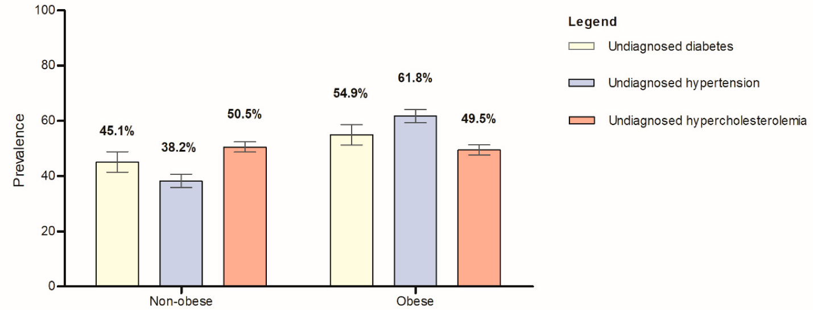
Figure 5 The prevalence of undiagnosed diabetes mellitus, undiagnosed high blood pressure, and undiagnosed hypercholesterolemia stratified by central obesity status among the Malaysian adults (n = 12,978). (Koo, Tan, Lim, Kee, & Omar, 2023)
Getting a better understanding regarding the average Malaysian diet is important when trying to get context for calorie tracking tools. (Lee & Wan Muda, 2019) studied the correlation between dietary intake and obesity among Malaysian adults and found that poor dietary intake is major contributor to the development of obesity and many NCD in adults across Malaysia. The study above mentioned that the main reason for this is due to the excessive energy intake of the average adult compared to their lifestyle that consists of low physical activity. The high consumption of refined carbohydrates and sugary beverages leads to a high caloric intake which leads to many negative health effects that won’t be seen immediately.
Dietary monitoring or calorie tracking has shown to be a strong method of weight management. A systematic review conducted by (Burke, Wang, & Sevick, 2011) found that self-monitoring of caloric intake is the best way to manage weight loss and is the key to behavioral weight loss intervention programs. They found a consistent association between monitoring frequency and weight change outcome across multiple study designs. (Raber, et al., 2021) found that the majority of studies using both high and low intensity self-monitoring lead to a statistically significant weight loss in groups compared to the control while conducting their systematic review. The use of dietary self-monitoring in behavioral weight loss intervention has a proven positive effect on weight loss. (Patel, Wakayama, & Bennett, 2021) focused on the effectiveness of self-monitoring with the use of wearables and found that there is meaningful weight loss among adults who are obese or overweight.
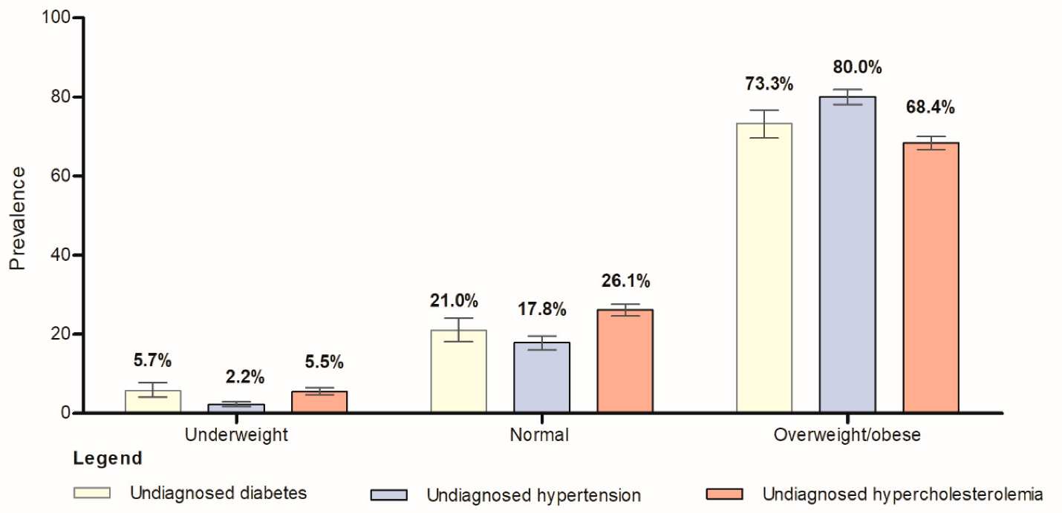
Figure 6 The prevalence of undiagnosed diabetes mellitus, undiagnosed high blood pressure, and undiagnosed hypercholesterolemia stratified by general obesity status among the Malaysian adults (n = 13,024). (Koo, Tan, Lim, Kee, & Omar, 2023)
Lastly, a systematic review done by (Chew, Koh, Ng, & Tan, 2022) regarding weight loss sustainability through the use of smartphones and found that apps can produce modest sustained weight loss but requires engagement features such as coaching, progress tracking and feedback to maintain long term retention of users. (Kong, Moy, Ong, Tahir, & Loo, 2023) found when developing MyDietCam for Malaysia that traditional diet monitoring has been linked to improved eating habits and positive health outcomes for users and led to prevention of obesity, it is often unsustainable as it places a high burden on both participants and researchers. On the other hand, the digitization of diet monitoring has made it more accessible and has greatly reduced the barriers for the average person to pick up the skill and improve their health (Kong, Moy, Ong, Tahir, & Loo, 2023)

2.2 Similar Systems / Works

2.2.1 MyFitnessPal
MyFitnessPal is one of the most widely used calorie tracking applications that is recognized worldwide. It offers food diary, exercise log, and weight tracking. The large food database MyFitnessPal has helps to calculate the daily caloric intake and allow users to log meals through a manual search or barcode scanning. The app calculates the user’s recommended daily calorie intake based on the user’s profile information such as height, weight, age, activity level and health goal. The app then tracks the user progress as meals are logged. MyFitnessPal has a food database which is largely built through user contribution such that registered users can upload food entries into the database with its corresponding nutritional information. This feature has resulted in the platform gathering a reported 14 million food entries over the many years it has operated.
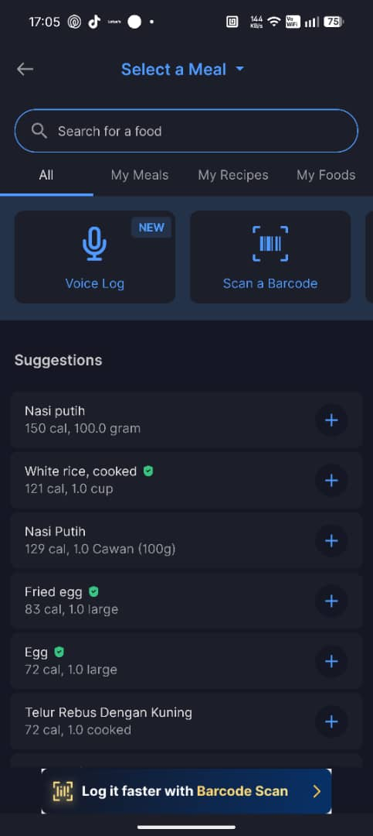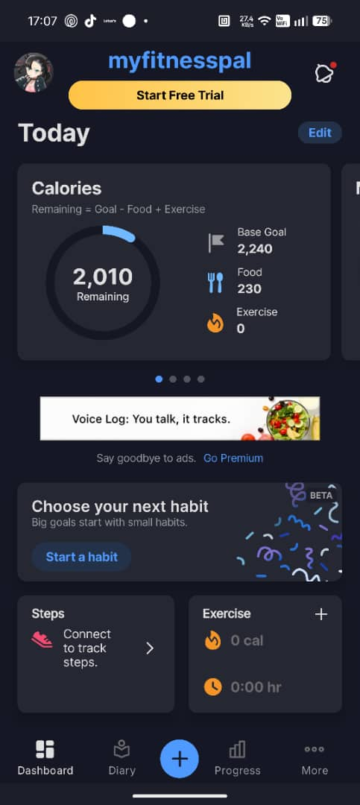
Figure 7 MyFitnessPal App 1 Figure 8 MyFitnessPal App 2

The prominent feature of MyFitnessPal is the vast database that it has gathered after many years it has been active making it the largest consumer database available in any calorie tracking application. The app provides a macro breakdown for users to know the protein, carbohydrate and fat within the meals they are consuming. The barcode scanning feature is available and can be used for products sold on store shelves to track the calories consumed. This feature is convenient but is gated behind a premium subscription. Users can also create custom food entries and import recipes from the internet which provides them with the ability to track foods which are not already in the database. Furthermore, MyFitnessPal also has the ability to integrate wearable devices such as the Apple Watch, Garmin watch or Fitbit to the app as an all-in-one health application. Lastly, MyFitnessPal has a social feature where you have a friends list, news feed and a community form as a motivational support system for users.

Strengths:
- It has the largest consumer database with over 14 million food entries.
- Polished user interface refined over nearly 20 years of development.
- Integration with many fitness trackers and third-party health apps.
- Allow custom recipes imported by users into the database.
- Has a community feature built into the application.
- Provides a macro breakdown for users per meal.
Weaknesses:
- Database entries rely on unverified user submissions which create inconsistencies and potential inaccuracies.
- Barcode scanning and ad-free experience requires a paid Premium subscription.
- Malaysian local dishes are inconsistently represented and may have completely different calorie counts for the same dish.
- No AI image recognition capability for food logging in the core product.
- Validation studies have shown weaker performance for micronutrients such as sodium and cholesterol (Evenepoel, et al., 2020)

2.2.2 Cronometer
Cronometer is a calorie tracking application which specializes in maintaining high data quality and professional grade curation. Unlike most apps that allow user submissions, Cronometer only allows data to be submitted by verified laboratories and lab-analyzed databases including NCCDB (Nutrition Coordinating Center Database), USDA Standard Reference, and other professional references. The food entries submitted by users will need to go through a review process by Cronometer to ensure the information is accurate which significantly reduces the risk of inaccuracies or duplicated entries. This app is primarily used by healthcare professionals, registered dietitians, and researchers due to the accuracy of the data they possess.
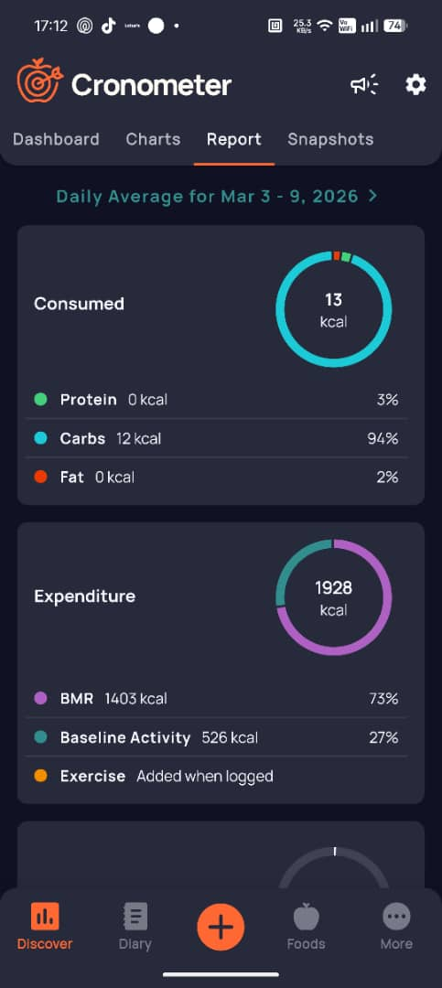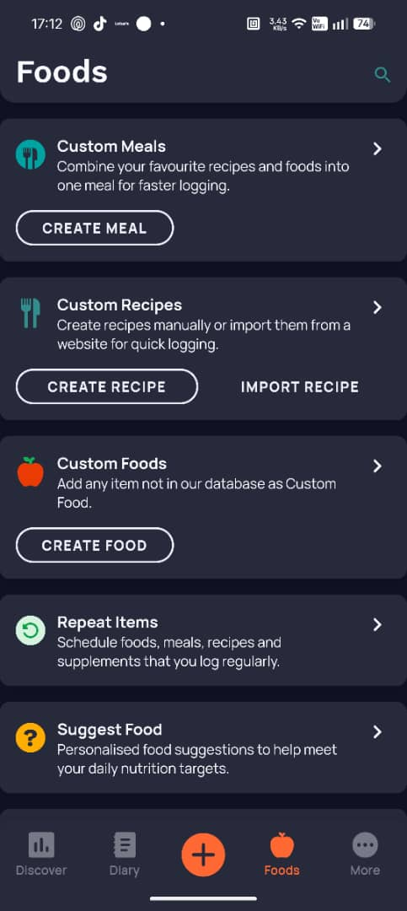
Figure 9 Cronometer App 1 Figure 10 Cronometer App 2

Cronometer has the ability to track up to 84 different nutrients, making it the most comprehensive nutrition tracker on the market. It is the first choice for users who want to monitor vitamins, minerals and micronutrients in their food along with the macro nutrients. The application also provides an Oracle daily nutrition summary which gives users an overall snapshot of the nutrients they consumed in a single view. Users also have the option to build their own entry for foods not already in the database allowing them to track their meals even if it is not in the database. A data export feature built into the application also allows users to share their data with healthcare providers, making it suitable and convenient for clinical and research purposes. Cronometer also has a premium tier which is targeted towards users who would like an advanced reporting and professional grade analysis tool for deeper insight into their dietary pattern.
Strengths
- Verified data models with lab-analyzed sources significantly reduce inaccuracies from crowdsourced entries.
- Tracks up to 84 micronutrients.
- Cronometer team reviews all user submissions before publication to maintain database integrity.
- Data export functionality makes it useful in clinical and research settings.
- Detailed micronutrient tracking is valuable for users monitoring specific dietary restrictions such as sodium, iron, or vitamin D.
Weaknesses
- Interface appears overwhelming and complex for casual or new users.
- Malaysian hawker food coverage is extremely limited.
- Manual recipe creation is time-consuming and requires deep nutritional knowledge.
- No AI image recognition for food logging
- No chatbot or recommendation feature to guide users on dietary improvements.
- Does not reference any Malaysian nutritional database such as MyFCD.
- Premium features including advanced reporting require a paid subscription.

2.2.3 CalCam
CalCam is a calorie tracking application developed by Polyverse built on MLLM technology rather than a traditional database system. The application uses Google Gemini API as its core technology for image-based food recognition which allows users to take a photo of their meal to receive an AI generated analysis of their meal. CalCam’s core functionality is built upon Gemini’s multimodal capabilities to understand and analyze food images and to return nutritional breakdowns for the user (Dharmadhikari, 2025). CalCam is most relevant to CalorAI due to the real-world use of Gemini API and the feasibility of building an application which the same core architecture.
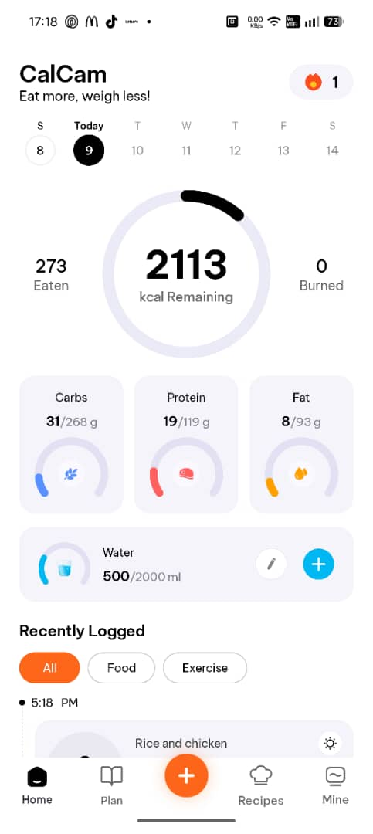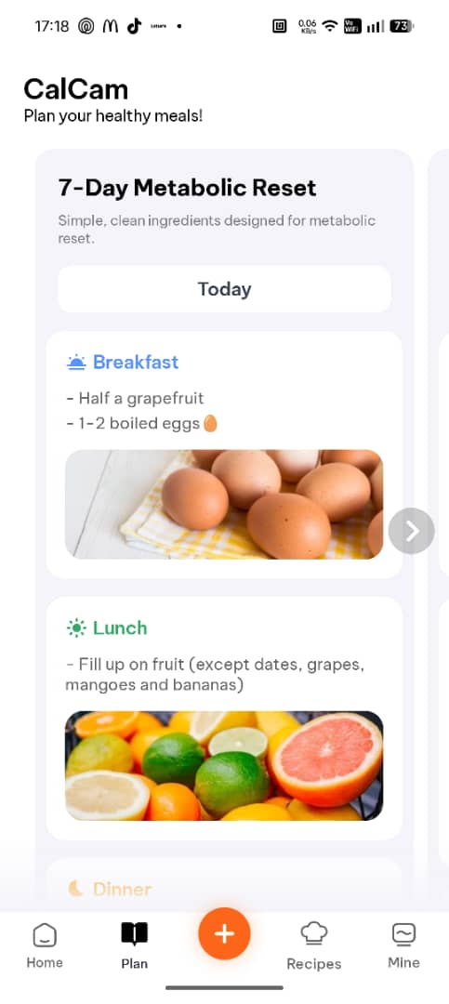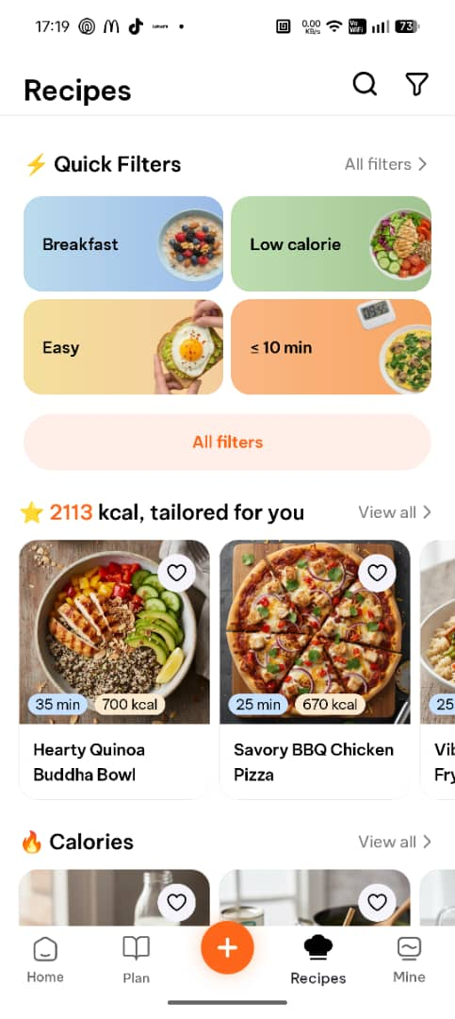
Figure 11 CalCam App 1 Figure 12 CalCam App 2 Figure 13 CalCam App 3

CalCam’s core feature is the AI-powered workflow converting images into a meal breakdown. Users can simply take a photo of their meal and receive the calories and macronutrients within their food generated by Gemini API. The app also provides nutritional breakdown such health score for the meal and guidance to healthy eating choices. CalCam have reported that they received a 20% user satisfaction increase after changing from an older LLM to the new Gemini 2.0 Flash and demonstrating that improvements to the LLM can directly improve user experience.
Strengths
- Validates the technical feasibility of building a calorie tracker on the Gemini API without custom model training.
- Photo-based workflow significantly reduces manual effort compared to traditional text-search logging.
- Provides contextual health rating and guidance beyond raw calorie numbers.
- Demonstrates that a practical consumer application can be built using Gemini's multimodal capabilities without specialized food recognition infrastructure.
Weaknesses
- Not localized for any specific regional cuisine including Malaysian food
- Rely entirely on Gemini's internal knowledge for nutritional estimation with no grounding in a verified food composition database.
- Gemini's food recognition performance has been shown to be weaker than some competing models, and can produce inaccurate or hallucinated nutritional values when not grounded in authoritative databases (Fridolfsson, Sjöberg, Thiwång, & Pettersson, 2025)
- Documented Western-centric bias in AI food recognition systems leading to lower accuracy for Asian cuisines including Malaysian food (Min, et al., 2025)
- No chatbot-based meal recommendation or planning feature.
- No user confirmation or correction workflow documented for when the AI identifies the wrong food.

2.2.4 SnapCalorie
SnapCalorie is an AI-powered calorie tracker that focuses on reducing the manual entry friction by allowing users to log their meals through photos or voice notes integrated with AI to provide instant calorie estimations. it uses computer vision not only to provide calorie estimation but to estimate portion sizes and identify the specific food items. SnapCalorie is relevant to CalorAI due to the way it uses the LLM to manage the calorie estimation differently and it is a real-world example of a consumer application which uses photo-based data entry for a calorie tracker.
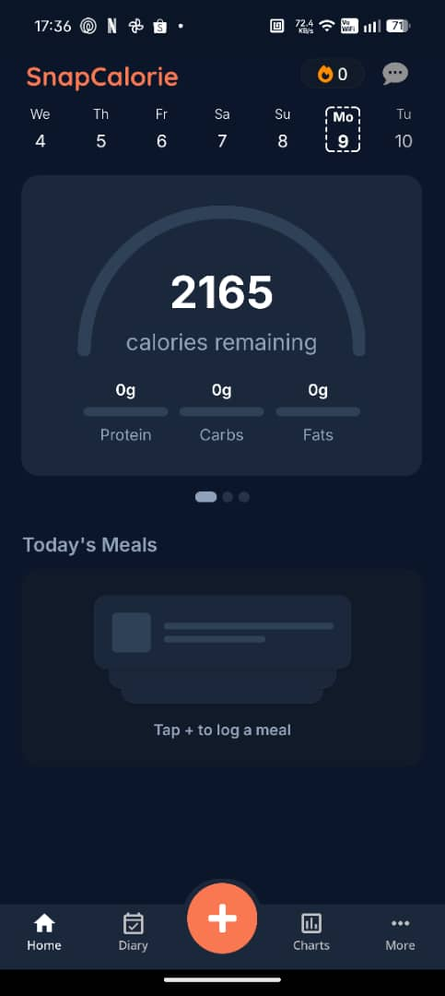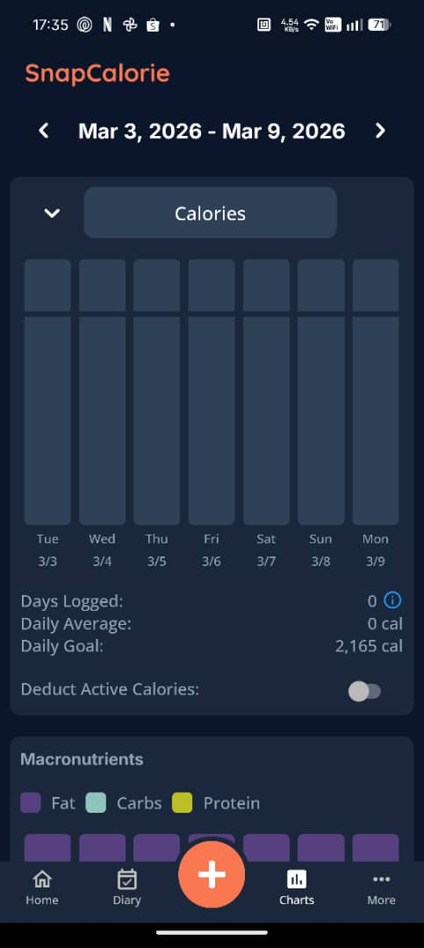
Figure 14 SnapCalorie App 1 Figure 15 SnapCalorie App 2

The primary feature of SnapCalorie is the nutrition workflow integrated into the application for users to simply take a photo and have a log and breakdown of their current meal in seconds. This application also does not only track calories, but macro and micronutrients within the food providing nutritional detail that is beyond many other calorie trackers. Another stand out feature of SnapCalorie is that it uses the lidar sensor available on some smartphones to create a depth map of the food for more precise and accurate predictions compared to an image only approach. If users find that the AI image recognition mislabeled the food, they are able to manually enter and correct the entry or send it back to Snap Calorie’s team for further review. Aside from photo logging, the app also allows for voice notes where users can describe the food they ate and have it be translated into an entry for the database. Lastly, the application retrieves food data from the USDA database which is its primary source of nutritional reference.
Strengths
- Reports 15% mean caloric error which is lower than the 20% tolerance permitted on nutrition labels (SnapCalorie, 2024)
- Depth sensor (LiDAR) integration on supported iPhone Pro models adds a volume-based dimension to portion estimation.
- Voice note logging provides an additional low-friction input method beyond photo capture.
- Tracks over 100 micronutrients beyond basic calories and macros, providing detailed nutritional visibility for health-conscious users.
Weaknesses
- Nutrition data is grounded in the USDA database which is Western-centric.
- Depth sensor (LiDAR) advantage is exclusive to iPhone Pro models.
- Proprietary AI algorithm which required significant engineering resources

2.2.5 MyDietCam
MyDietCam is a Malaysian-developed mobile calorie tracker that integrates food recognition technology with the Malaysian Food Composition Database (MyFCD). The mobile application was developed at the University of Malaya by (Kong, Moy, Ong, Tahir, & Loo, 2023) and is specifically designed for general healthy Malaysian adults. MyDietCam was created in response to findings from earlier research where users questioned the credibility and localization of food databases used in other applications. The application has the same target as CalorAI plans to address which is the lack of localization and credible calorie tracking tool for Malaysian cuisine making it the strongest existing product to validate the need for CalorAI and the approach for identifying areas of improvement.
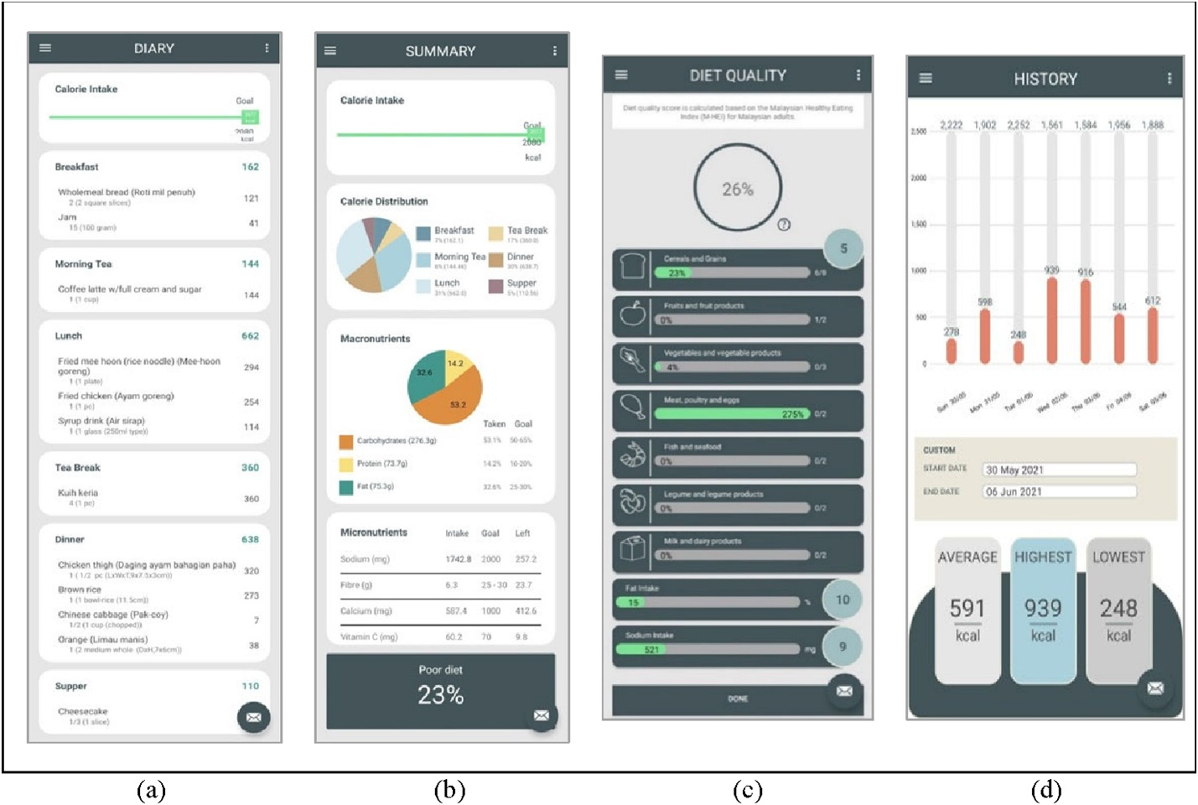
Figure 16 MyDietCam App 1
MyDietCam is the first Malaysian mobile application used for calorie tracking to implement food recognition technology aimed at general adults. The applications nutritional reference is built upon MyFCD and is supplemented by the Atlas of Food Exchanges and Portion Sizes published by the Malaysian Dietitians' Association and Singapore's Food Composition System (FOCOS) database for additional coverage. MyDietCam’s food recognition model is built using a custom CNN-based machine learning pipeline which managed to achieve 72% accuracy on real world Malaysian food. This result proves that automated recognition of local dishes is feasible despite the complexity of food found in Malaysia. It also generates a Malaysian Healthy Eating Index (M-HEI) score which will provide the user with an overall diet quality based on Malaysian dietary guidelines rather than generic international standards. The food names in the app are available in both English and Malay which would allow for the app to reach a wider audience.
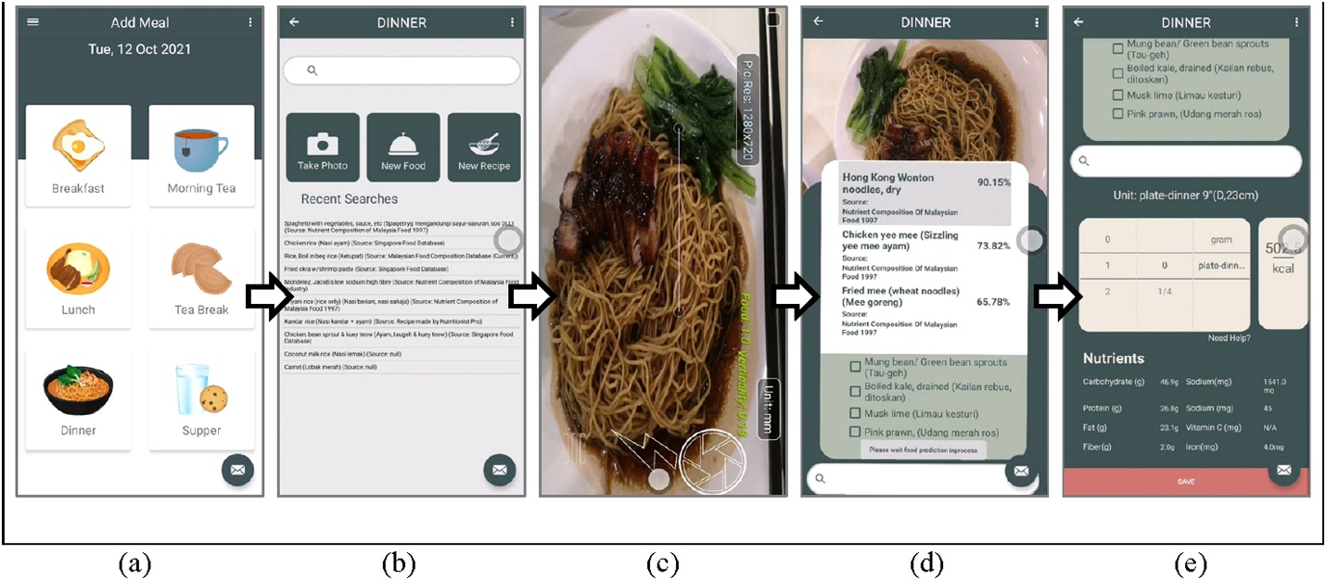
Figure 17 MyDietCam App 2
Strengths
- Validates CalorAI's core premise that Malaysian users value and benefit from a database grounded in local nutritional references (MyFCD)
- First Malaysian mobile diet application with integrated food recognition technology for general healthy adults
- Multi-source nutritional database combining MyFCD, Atlas of Food Exchanges and Portion Sizes, and FOCOS ensures local food coverage with government-validated credibility.
- 72% food recognition accuracy on real-world Malaysian food images demonstrates feasibility of automated local dish recognition.
- M-HEI diet quality score adds a valuable assessment dimension beyond simple calorie counting.
- Both English and Malay food names improve searchability for bilingual Malaysian users
Weaknesses
- Food recognition model required custom CNN-based machine learning training with significant effort in dataset collection, annotation, and training, creating a scalability bottleneck for adding new dishes.
- Users reported wanting improved database coverage, noting that not all commonly eaten Malaysian dishes were available in the system.
- Users specifically requested easier portion estimation methods, indicating that the existing portion workflow was a friction point.
- Application features only available in English due to manpower, validation, and time constraints
- No conversational chatbot or dietary recommendation feature
- Not yet publicly available at the time of publication

2.2.6 Conclusion
The review of MyFitnessPal, Cronometer, CalCam, SnapCalorie, and MyDietCam has shown several consistent patterns and gaps commonly found in current calorie tracking applications which CalorAI aims to address. Table 1 below summarizes the key features across all 5 systems evaluated and CalorAI.
Table 4 Similar System Comparison
Feature | MyFitnessPal | Cronometer | CalCam | SnapCalorie | MyDietCam | CalorAI (Proposed)
AI Image Recognition | No | No | Yes | Yes | Yes (Custom) | Yes (Gemini API)
Malaysian Food Database | Limited | No | No | No | Yes (MyFCD) | Yes (MyFCD)
Verified Nutritional Data | No | Yes (Lab Verified) | No (AI Generated) | Yes (USDA) | Yes (MyFCD) | Yes (MyFCD)
Chatbot / Recommendations | No | No | No | No | No | Yes (Gemini API)
Portion Estimation | Manual only | Manual only | AI-based | AI + LiDAR | Manual only | AI + Guided Selection
Macro Breakdown | Yes | Yes | Yes | Yes | Yes | Yes
User Correction Workflow | Yes | Yes | No | Yes | Yes | Yes
Publicly Available | Yes | Yes | Yes | Yes | No | No
Among the 5 systems that were reviewed, none of the existing applications combined all 3 core components that CalorAI aims to implement which is AI-powered image recognition, locally verified Malaysian food database and a conversational chatbot that provides dietary recommendations and guidance. MyFitnessPal and Cronometer offer strong databases but lack AI-based food logging and are not localized for Malaysian cuisine while CalCam and SnapCalorie demonstrate the feasibility of AI-powered photo logging but rely entirely on western-centric databases and do not ground their estimates in verified nutritional references. MyDietCam is the closest comparable system, as it integrates food recognition with MyFCD, but it required a custom-trained CNN model which created scalability limitations and did not include a chatbot or recommendation system.
CalorAI can be positioned to fill the identified gaps by combining the use of Gemini API for image recognition and chatbot functionality while cross referencing MyFCD as the verified nutritional reference. By applying this approach, CalorAI can avoid the need for custom model training and leverage the multimodal capabilities of the latest LLMs to ensure that calorie estimates are grounded in authoritative local databases.

2.3 Technical Research

2.3.1 System Requirements Analysis
A system requirement analysis is essential to ensure that CalorAI meets its functional requirements and delivers optimal user experience, and the section below outlines the necessary hardware and software requirements for both development and client devices.
Minimum Hardware Requirements (Development Machine):
- Processor: A minimum of a quad-core 2.0 GHz processor or higher to support Flutter SDK compilation, Android emulator execution, and concurrent IDE operation.
- Memory (RAM): At least 8 GB of RAM to handle the Android emulator, Flutter SDK, and IDE running simultaneously.
- Storage: A minimum of 256 GB of internal storage to accommodate the Flutter SDK, Android SDK, IDE installations, project files, and emulator images.
- Network Connectivity: Stable broadband internet connection for accessing Firebase backend services and the Gemini API during development and testing.
Minimum Hardware Requirements (Client/User Device):
- Processor: A minimum of a quad-core 1.4 GHz processor or higher for smooth application performance.
- Memory (RAM): At least 3 GB of RAM to handle the application and background processes.
- Storage: A minimum of 64 GB of internal storage to accommodate the application, its updates, and local data caching.
- Camera: Integrated rear camera with a minimum resolution of 8 MP for capturing meal photos for AI image recognition.
- Network Connectivity: 4G LTE or better to ensure seamless data transfers with Firebase and real-time AI processing via the Gemini API.
Minimum Software Requirements:
- Operating System:
  - Android: Version 8.0 (Oreo, API level 26) or higher, supporting Flutter SDK minimum requirements and camera API access.
- Supporting Software:
  - Google Play Services for Firebase Authentication and Cloud Firestore functionality.

2.3.2 Programming language chosen
CalorAI will be developed using Dart as the primary programming language within the Flutter framework as it can be used to develop web applications, mobile applications, servers, and desktop applications from a single codebase without affecting the performance and appearance of native applications. What makes Flutter a popular choice is that it is not just a framework or library but a complete software development kit.
Advantages of Dart with Flutter:
- Cross-Platform Development from a Single Codebase: Flutter allows users to create applications which can be supported on multiple platforms such as Android, iOS, web, or desktop with minimal modifications to the original codebase. This is important for CalorAI due to the primary platform being android with a potential to port to iOS in the future with minimal refactoring of the application.
- High Performance: Flutter apps are compiled directly into native code, with no need for intermediate code interpretation steps. This is different compared to other cross platform development applications such as React Native that require bridges between their code and native elements. By using flutter, it is possible to eliminate additional processing steps that decrease performance of the app and ensure smooth camera-based food logging and quick AI chatbot interactions within the application.
- Seamless Firebase Integration: Flutter offers extensive compatibility with popular backend frameworks like Firebase, AWS, or custom APIs, which allows for smooth data handling and secure communication. This simplifies the implementation of CalorAI’s authentication, database, and AI features within the same ecosystem.
- Strong Adoption: Flutter has been the most used multi-platform app framework since 2021, and nearly 30% of all new free iOS apps in 2024 were built with it (Stackoverflow, 2024).
Comparison with Alternative Frameworks:
The first alternative to flutter will be React Native. React Native is a cross-platform framework developed by Meta and is often marketed as a cross-platform solution for developers but falls short of providing unified experience in real world development. Although it allows for sharing codebases between iOS and Android using JavaScript, many developers have complained that they need to write platform specific logic when developing with React Native. Compared to React Native that requires bridges between code and native elements, Flutter eliminates additional processing steps that decrease performance.
The second alternative to flutter is Kotlin which is the native Android development platform. Kotlin provides the highest possible performance and access to all android specific APIs which can help a lot during development. While this allows for UI that matches the user experience of most users on Android, the development on multiple platforms requires organization and to create multiple codebases for each device with its own version of the app. This creates additional costs and extends the timeline for development, which is impractical.
Thus, Dart with Flutter was selected for CalorAI for the ability to develop cross platform from a single codebase and allows for the android prototype to be ported to iOS without rewriting the application. Flutter apps also compile directly into native code which eliminates intermediate code interpretation steps and additional processing that decrease performance of the app. The increased performance allows for camera-based food logging and AI chatbot interaction work more seamlessly. Flutter also offers compatibility with Firebase and allows for smooth data handling with secure communication, simplifying the implementation of CalorAI’s backend services.

2.3.3 IDE chosen
CalorAI will be developed using both Visual Studio Code (VS Code) and Android Studio as integrated development environments. VS Code is a lightweight open-source code editor developed by Microsoft and supports Flutter and Dart development through the use of an extension that provides syntax highlights, code completion, debugging and integrated terminal access. VS Code is light weight which makes it suitable for day-to-day coding and consumes fewer system resources compared to a full IDE which makes it advantageous when running an Android emulator. Android Studio on the other hand is the official IDE for Android development which is developed by Google and built on the JetBrains IntelliJ IDEA platform. Android Studio includes the Android SDK Manager and AVD (Android Virtual Device) Manager, which are required for configuring emulators, managing SDK versions, and building the final APK for testing on physical devices.
Using both VS Code and Android Studio provides a practical workflow where VS Code serves as the primary code editor for the Flutter development due to its speed and low resource usage while Android Studio is used for emulator management, device deployment, performance profiling and building the final application package. Both IDEs have first party Flutter and Dart support which ensures that the development will be done under full compatibility with CalorAI’s developmental workflow.

2.3.4 Database Management System chosen
CalorAI will use Firebase Cloud Firestore as its primary database management system. Firestore is a NoSQL serverless database which has real time notification capabilities and is integrated with the firebase ecosystem. Firestore also has the benefit of greatly simplifying the common app development challenges while letting the application developer focus primarily on business logic and user experience. The key features of cloud Firestore will be listed below.
- Fully Managed Serverless Service: Cloud Firestore ships with mobile and web SDKs and a comprehensive set of security rules without the need for a dedicated server (Firebase, Cloud Firestore | Store and sync app data at global scale, 2026).
- Document-Based Data Model: data is stored in documents, which are organized into collections and each document contains a set of key-value pairs. Cloud Firestore is optimized for storing large collections of small documents. This model naturally fits CalorAI’s data structure where user profiles, meal logs, and food entries can be represented as documents within collections.
- Real-Time Synchronization and Offline Support: Like Firebase Realtime Database, it keeps the application data coordinated across client apps through real-time listeners and offers offline support for mobile and web so you can build responsive apps that work regardless of network latency or Internet connectivity.
- Integrated Security: Firestore has declarative security language which allows developers to restrict data access based on user identity data, pattern matching on your data, and more. Cloud Firestore also integrates with Firebase Authentication to give you simple and intuitive user authentication (Firebase, Cloud Firestore | Store and sync app data at global scale, 2026).
- Scalability: Cloud Firestore is a NoSQL document database that lets you easily store, sync, and query data for your mobile and web apps (Firebase, Cloud Firestore | Store and sync app data at global scale, 2026).
Comparison of Alternative Database Systems:
MySQL is an open-source relational database management system which for CalorAI’s use case requires the set up a separate backend server. This leaves CalorAI rigid and less flexible for variable format meal logging and does not provide real time synchronization or offline mobile support.
MongoDB is a NoSQL document-based database which is suitable for CalorAI’s data model but was not selected because it requires server infrastructure or MongoDB atlas as a managed service. This is not feasible due to the added complexity.
Justification:
Cloud Firestore was chosen due to it having a comprehensive set of security rules and the mobile and web SDK which allows access to the database without needing to set up and host a server eliminating infrastructure maintenance. Firestore also has document-based data model which fits CalorAI’s data structure and keeps the data in sync across client apps through real-time listeners and offers offline support for mobile and web applications (Firebase, 2026). Firestore also integrates with Firebase Authentication to give simple user authentication service. Lastly, both Firestore and Flutter are Google products which allows for easy and seamless integration between all applications and databases.

2.3.5 Tools / libraries / APIs used
- Flutter SDK: Flutter SDK is the core framework for building CalorAI’s user interface and application logic. Flutter allows developers to build features once and deploy to both iOS and Android, while also providing widget library, rendering engines, and development tools for ease of development.
- Firebase Authentication: Firebase Authentication will be used to implement CalorAI’s user registration and login system with email/password authentication. It protects access to data in Cloud Firestore with Firebase Authentication and Cloud Firestore Security Rules (Firebase, 2026).
- Cloud Firestore (Firebase): Firestore serves as CalorAI’s primary database for storing user profiles, meal logs, calorie targets, and MyFCD reference data.
- Gemini API (Google): Gemini API is the core AI engine powering CalorAI’s image recognition and chatbot features. Gemini models are multimodal and can be utilized for image processing and computer vision tasks including but not limited to image captioning, visual questions and answering, image classification, object detection and segmentation. Gemini can reduce the need to use specialized ML models. CalorAI will use Gemini’s multimodal capabilities to analyze food images uploaded by users and return dish identification with ingredient decomposition and power the conversational chatbot for dietary recommendations.
- MyFCD (Malaysian Food Composition Database): MyFCD is the authoritative nutritional reference for CalorAI’s calorie estimation system. MyFCD data will be stored in Cloud Firestore and used to validate nutritional values returned by the Gemini API, ensuring calorie estimates are based on locally verified data (MyFCD, 2026).

2.3.6 Operating System Chosen
CalorAI will be developed primarily for the Android operating system due to 70.26 percent of the mobile operating system market in Malaysia being Android based as of 2024 (Statista, 2025). This dominant market share ensures that CalorAI reaches the widest possible audience among its target users. The minimum supported Android version will be Android 8.0 (Oreo, API level 26), which provides access to camera APIs required for photo-based meal logging and supports the Flutter SDK’s minimum requirements and ensures compatibility with the vast majority of Android devices currently in use in Malaysia.

Chapter 3: Methodology

3.1 System Development Methodology

3.1.1 Introduction
Choosing the appropriate system development methodology for CalorAI is important to have successful implementation and completion of software development. Choosing the right methodology provides structure that will guide the planning, development, and delivery process of the application. This section will compare relevant methodologies that can be used and justify the selection for the implementation when developing CalorAI.

3.1.2 Methodology Choice and Justification
For the development of CalorAI, the methodology Rapid Application Development (RAD) will be used instead of Waterfall or Agile because RAD is a methodology that focuses on fast development and frequent releases of working software (GeeksforGeeks, 2018). RAD emphasizes iterative development, quick user feedback and flexibility which allows changes to be incorporated quickly and easily during the development process. The 4 rapid application development phases are requirements planning, user design, rapid construction, and cutover.
Justification:
The waterfall methodology follows a linear sequential process where each phase must be completed before the next step can begin. This requirement makes Waterfall methodology rigid and makes it difficult to accommodate changes once the development process starts thus making it less suitable for CalorAI’s use case. Due to the features that CalorAI plans to add such as AI image recognition and chatbot features needing iterative changes, this leaves waterfall methodology less than suitable for this scenario.
Agile (Scrum) methodology is an iterative framework that uses fixed length sprints which usually lasts for 2 to 4 weeks at a time along with defined roles such as Scrum Master, Product Owner, and Development Team. Scrum also consists of ceremonies such as daily stand-ups, sprint planning, sprint review, and sprint retrospective. Even though RAD shares similarities with agile methodologies such as iterative development and user involvement, its priorities are on rapid prototyping and delivering working software quickly which means it is more flexible than the rigid sprint structure of Scrum. For a single developer project, the fixed sprints or ceremonies are unnecessary.
RAD is the most suitable when the software needs to be delivered quickly within a short time frame and for projects which are not too large and can be handled by a small team of developers. CalorAI, being a single developer project with a fixed timeline, makes RAD the preferred methodology. RAD allows developers to minimize the planning stage and maximize the prototype development and makes it possible to more accurately measure progress and react to issues or changes in real time. CalorAI is also implementing Gemini API for food recognition and chatbot interaction which would require continuous testing and refinement that cannot be planned upfront which makes RAD a suitable choice. The constant iteration allows for food recognition, portion estimation workflow, and chatbot response to be perfected before proceeding to the next development cycle.

3.1.3 Activities and Processes in Each Phase of the RAD Methodology
The RAD methodology is executed in phases where developers build and refine prototype applications through continuous testing and feedback to refine the requirement for future improved prototypes. This development cycle continues until the application reaches the final state and is ready to be deployed.
Phase 1: Requirements Planning
In the requirements planning phase, the groundwork for the project is laid out and the developers, supervisors, and target users will define the project scope, identify key requirements, and establish objectives before starting the project. The example of this in terms of CalorAI’s requirements planning is to conduct a literature review on calorie tracking limitations, AI food recognition, and Malaysian food databases. Then design and distribute questionnaires to target users and analyze five similar systems for strengths, weaknesses, and gaps. After compiling the findings from the survey, the project scope, objectives and measurable targets will be determined.
Phase 2: User Design
The user design phase is what separates RAD from other methodologies. The user design phase of RAD starts with the design of the prototype and compares it to the requirements found in the step before. It is then iterated on until it fits the set requirements, which allows the developers to refine the design until it is satisfactory. For CalorAI, this phase will involve designing the UI for all screens including the registration and login page, home dashboard, photo-based meal logging workflow, manual food search, chatbot interface, and progress tracking dashboard. The cloud Firestore database schema will also be designed during this phase including the format of the collections structure for users, meals, and MyFCD food entries. Gemini API prompt structure will also be determined for use in the food identification and chatbot interactions workflow along with all the data flow between Gemini API, Firestore and the application UI. Phase 3: Rapid Construction
This stage is carried out after the design from the previous stage has been finalized and the development of the application moves into rapid construction. The developer of the application will build iteratively though multiple construction cycles, each focusing on a specific functional module and implementing feedback collected.
The CalorAI development will be divided into 4 main construction stages, one of which will be the focus on user authentication and profile management service for the application. This involves implementing user registration and login using Firebase Authentication, building the profile creation, and editing screens for height, weight, age, activity level, and health goal, and implementing the daily calorie target calculation for both automatic and manual modes. The application UI will be connected to Cloud Firestore for data storage and retrieval, and the authentication flows will be tested on a physical device. After this stage is done, a working user account system will be available complete with a profile management system.
The second developmental stage will be the AI image recognition and meal logging flow which is the core feature of CalorAI which involves implementing a photo capture system and an image submission system to Gemini API. The submission to Gemini API will require a structured prompt for Malaysian food identification, ingredients decomposition and MyFCD cross referencing logic to ground the AI to real and accurate nutritional data. A portion size workflow will also be implemented which users can pick from along with a manual food search for backup user input if the photo logging does not work as intended. The food recognition workflow will be tested against Malaysian dishes and Gemini API prompts will be refined to improve overall accuracy together with the calorie estimation which will be compared with MyFCD database reference values. The final output of this stage will be a working meal logging system with an AI based photo input and manual user entry which returns accurate results.
The third developmental stage will be to develop and refine the chatbot and recommendation features within CalorAI. This involves implementing the conversational chatbot interface which uses Gemini API to build the meal suggestion and meal plan generation features and retrieves user data from the Firestore such as user goals, recent meals, and MyFCD data. The chatbots responses will be compared and tested for relevance, accuracy, and the prompt engineering will be iterated upon to improve the quality of responses. The final output of this stage will be a working assistant and chatbot with accurate goal-based recommendation which follows user goals.
The fourth and last developmental stage will be to complete the dashboard and progress tracking portion of the application. This step will involve implementing the daily calorie summary view showing consumed versus target, building the macronutrient breakdown per meal and per day, and implementing the calorie intake trends and weight change tracking which all should be available on the user dashboard. The user dashboard will be connected to Firestore, and the data visualization accuracy will be tested against stored records from users’ previous entries. The final output of this stage will be a working user dashboard which will display accurate user information based on user data and past trends.
Phase 4: Cutover
The cutover phase of RAD is where all the testing, evaluation and deployment of the application will be done. When compared to traditional methodologies, this phase is severely compressed due to most of the testing and evaluation being done in phase 3 of RAD. For CalorAI, this phase will include conducting a System Usability Scale (SUS) evaluation with target users, testing image recognition accuracy against a defined test dataset of Malaysian dishes targeting at least 80% top 5 accuracy, testing calorie estimation accuracy against MyFCD reference values targeting less than 150 calories average error and measuring meal logging time targeting 30 seconds or less per photo-based log. The final outputs are the completed CalorAI prototype, documented testing results, evaluation analysis, and the complete project report.

3.2 Data Gathering Design

3.2.1 Data Collection Method
The primary data collection method for CalorAI is a questionnaire survey. Questionnaires are an efficient way of gathering data from a large number of respondents in a short time and allow for the collection of both quantitative and qualitative data from the respondents. The questionnaire is designed to collect data on calorie tracking habits, pain points with existing applications, attitudes towards AI-powered features, and feature preferences among Malaysian users.

3.2.2 Comparison
Table 5 Data collection comparison
Method | Advantages | Disadvantages
Questionnaire | reaches a large audience, standardized data, easy to analyze | Limited depth of responses, potential for low response rates
Interviews | In-depth data allows clarification, flexible | Time-consuming, resource-intensive, limited sample size
Focus Groups | Rich qualitative data, interactive, explores topics in depth | Requires skilled moderation, potential for groupthink, time-consuming
A questionnaire is the most practical method of data collection for this project which allows for collection of relevant data from a broad range of respondents to validate the problem background and to get information on feature prioritization for CalorAI.

3.2.3 Survey Structure
Section | No. of Questions | Purpose
Consent and Eligibility | 1 | Confirm respondent is 18+ and consents to participate
Demographics | 7 | Understand respondent profile
Current Calorie Tracking Habits | 4 | Identify apps used, logging frequency, reasons for stopping, satisfaction
Malaysian Food Logging Pain Points | 8 | Measure confidence in calorie estimation, difficulty finding Malaysian dishes, agreement with logging friction statements
Photo-Based Logging Acceptance | 6 | Assess willingness to use AI image recognition, preferred portion input methods
Database Trust and Transparency | 4 | Measure trust in official Malaysian nutrition sources, preference for editable entries
Recommendations and Chatbot | 6 | Assess demand for chatbot features, meal suggestions, goal-based recommendations
Feature Prioritization | 12 | Rate importance of key features
Table 6 Survey Structure

3.2.4 Questions Objectives
Table 7 Question Objective
Question | Objective
Demographics
What is your age group? | This question is asked to how determine calorie tracking habits and preferences vary across age groups
What is your gender? | Identify if there are differences in dietary tracking behaviors across genders
What best describes your current occupation? | To categorize respondents by professional background
Which best describes your main health/fitness goal? | To identify the primary health goals driving interest in calorie tracking
What is your typical eating pattern? | To understand the balance between home-cooked and eating out, which affects logging difficulty
How often do you eat local Malaysian dishes? | Asked to find out the relevance of a Malaysian-specific food database to respondents
Have you ever used a calorie tracking application? | To segment respondents into current users, past users, and non-users
Current Calorie Tracking Habits
Which calorie tracking application(s) have you used? | To identify the most commonly used apps among Malaysian users
How frequently did/do you log your meals? | To assess logging consistency among existing users
If you stopped using the app, what were the main reasons? | To identify the primary friction points causing app abandonment
How would you rate your overall satisfaction? | To gauge baseline satisfaction with existing calorie tracking solutions
Malaysian Food Logging Pain Points
How confident are you in estimating calorie content of Malaysian food? | To quantify the difficulty of calorie estimation for Malaysian cuisine
Have you experienced difficulty finding a Malaysian dish in an app? | To validate the localization gap in existing apps
When you cannot find the exact dish, what do you typically do? | To identify coping strategies and their impact on tracking accuracy
Manual food logging takes too much time (Likert) | To validate the manual logging friction problem
Estimating portion size for Malaysian food is difficult (Likert) | To validate the portion estimation difficulty
Existing apps do not represent Malaysian local foods accurately (Likert) | To validate the database localization gap
I often choose closest substitutes which may not be accurate (Likert) | To quantify the impact of missing foods on tracking accuracy
When unsure of calorie accuracy, I am more likely to stop tracking (Likert) | To validate that inaccuracy leads to abandonment
Photo-Based Logging Acceptance
If an app could suggest foods from a meal photo, I would track more consistently (Likert) | To validate demand for AI image recognition
I would be comfortable uploading meal photos (Likert) | To assess privacy comfort with photo uploads
I prefer AI to suggest and let me confirm/edit (Likert) | To validate the user-in-the-loop correction workflow
I want the app to show multiple suggestions (Top 3–5) (Likert) | To inform you of the number of suggestions to display
I want portion selection options after choosing the dish (Likert) | To validate the guided portion selection workflow
Which portion input method would you prefer most? | To determine the preferred portion input method
Database Trust and Transparency
I trust calorie estimates more if from an official Malaysian source (Likert) | To validate the value of grounding estimates in MyFCD
I want the app to show the source of its calorie values (Likert) | To inform the transparency feature design
I want to be able to edit the food entry when the AI is wrong (Likert) | To validate the user correction workflow requirement
I want an uncertainty indicator when the AI is not sure (Likert) | To assess demand for a confidence indicator feature
Recommendations and Chatbot
I want the app to recommend healthier alternatives (Likert) | To validate demand for recommendation features
I want a chatbot that can answer "What should I eat?" (Likert) | To validate demand for the chatbot feature
I want recommendations based on my goal (Likert) | To validate goal-based personalization
I want recommendations based on what I have eaten recently (Likert) | To validate history-based recommendations
I would use a meal plan suggestion feature (Likert) | To validate demand for meal plan generation
Which chatbot features would you find most valuable? (Select up to 3) | To rank and prioritize chatbot functionalities
Feature Prioritization
Rate each of 10 features from Not Important to Extremely Important | To quantify the perceived importance of each CalorAI feature
Choose the top 5 features you want most | To identify the highest priority features for development
Overall, I would use CalorAI if it supports Malaysian foods and is fast to log (Likert) | To assess overall intent to adopt CalorAI

3.3 Analysis
The analysis section examines the data collected through the use of a questionnaire for the purpose of gathering information regarding the Malaysian population’s calorie tracking habits, Malaysian food logging pain points, acceptance of AI-powered features, and feature prioritization for CalorAI. This questionnaire collected a total of 36 responses and all 36 respondents confirmed that they are 18 years or above and have consented to participate.

3.3.1 Demographic Analysis
The demographic analysis provides an understanding of the respondent profiles and establishes context for interpreting the survey findings.

Question 1: What is your age group?
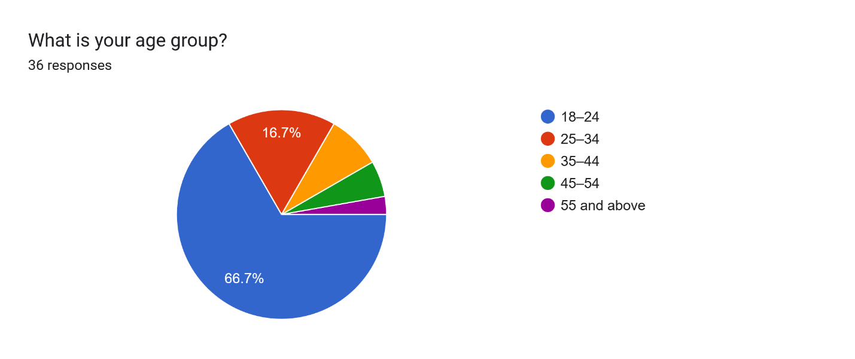
Figure 18 Data for survey question 1
The age distribution of the 36 respondents in figure 7 shows that the largest group of respondents are between the ages of 18-24 at 66.7% (24 respondents) followed by ages of 25-34 at 16.7% (6 respondents), 35-44 at 8.3% (3 respondents), 45-54 at 5.6% (2 respondents), and 55 and above at 2.8% (1 respondent). This demographic is relevant to CalorAI as young adults are more likely to adopt mobile health applications.

Question 2: What is your gender?
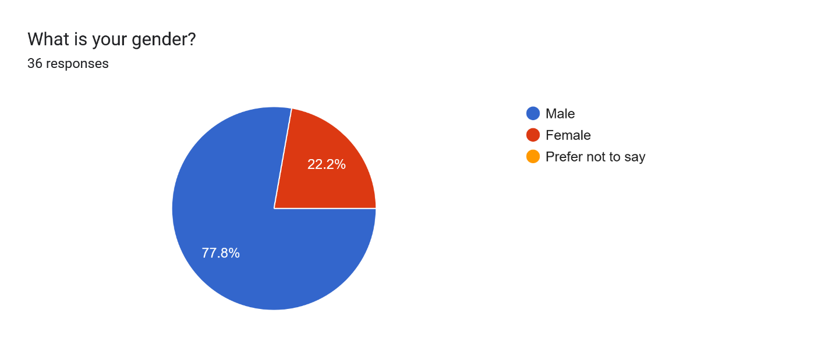
Figure 19 Data for survey question 2.
The gender distribution of the 36 respondents shows that 77.8% (28 respondents) are male, 22.2% (8 respondents) are female and no respondents selected "Prefer not to say." The male-dominant sample should be noted when interpreting the results, as dietary tracking behaviors may vary across genders.

Question 3: What best describes your current occupation?
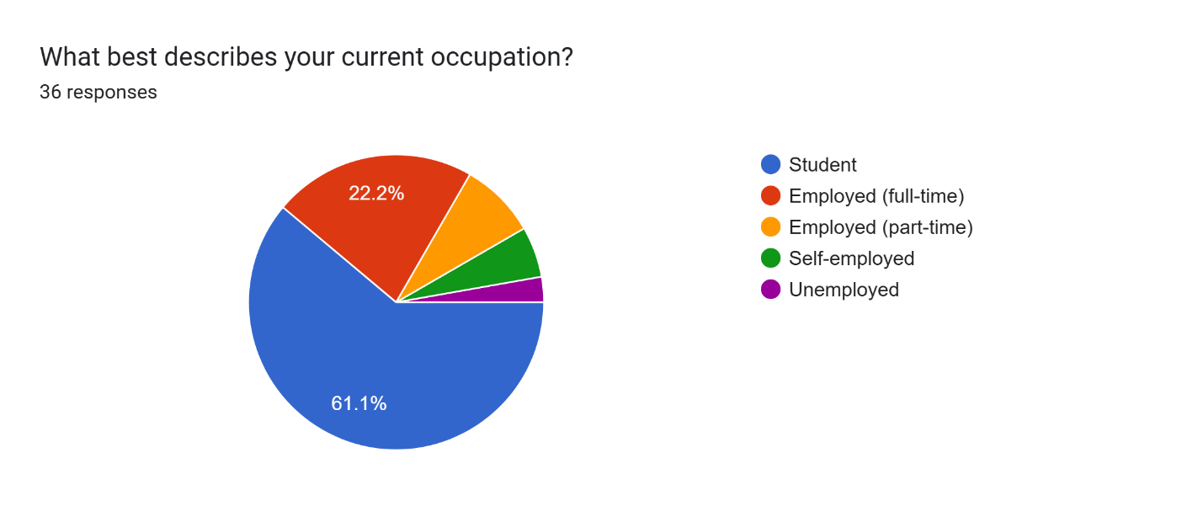
Figure 20 Data for survey question 3.
The largest group consists of students at 61.1% (22 respondents), followed by employed full-time at 22.2% (8 respondents), employed part-time at 8.3% (3 respondents), self-employed at 5.6% (2 respondents), and unemployed at 2.8% (1 respondent). The student-majority sample aligns with the age distribution and represents a key segment of CalorAI’s target audience who are often budget-conscious and eat out frequently.

Question 4: Which of the following best describes your main health/fitness goal?
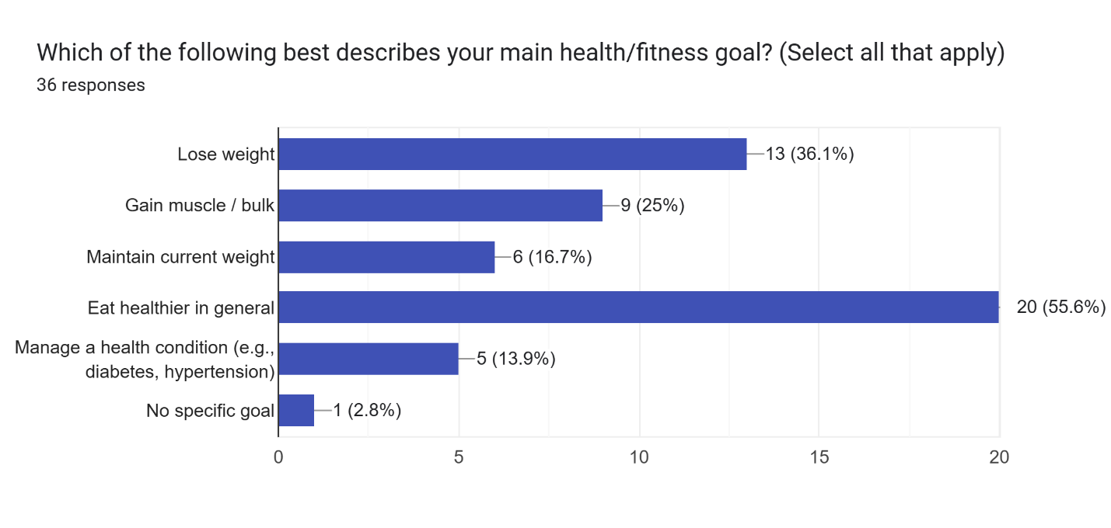
Figure 21 Data for survey question 4.
Based on the response collected from the questionnaire, respondents chose to eat healthier in general at 55.6% (20 respondents), followed by lose weight at 36.1% (13 respondents), gain muscle/bulk at 25% (9 respondents), maintain current weight at 16.7% (6 respondents), manage a health condition at 13.9% (5 respondents), and no specific goal at 2.8% (1 respondent). This result shows that different respondents have different priorities and goals and proves that CalorAI needs to support multiple goals for users.

Question 5: What is your typical eating pattern?
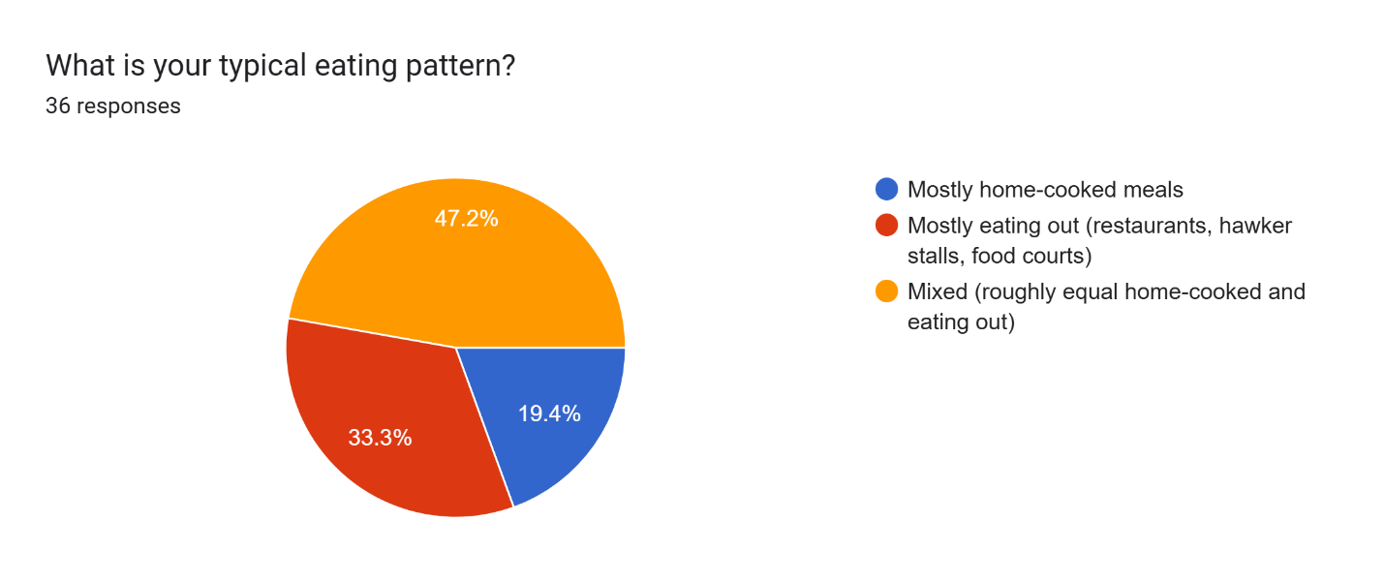
Figure 22 Data for survey question 5.
Almost half of respondents 47.2% (17 respondents) reported a mixed eating pattern of roughly equal home-cooked and eating out while 33.3% (12 respondents) mostly eat out and 19.4% (7 respondents) mostly eat home-cooked meals. The data shows that Malaysians eat out more often than cooking at home which makes calorie estimation more difficult especially if they don’t know what is in the food.

Question 6: How often do you eat local Malaysian dishes?
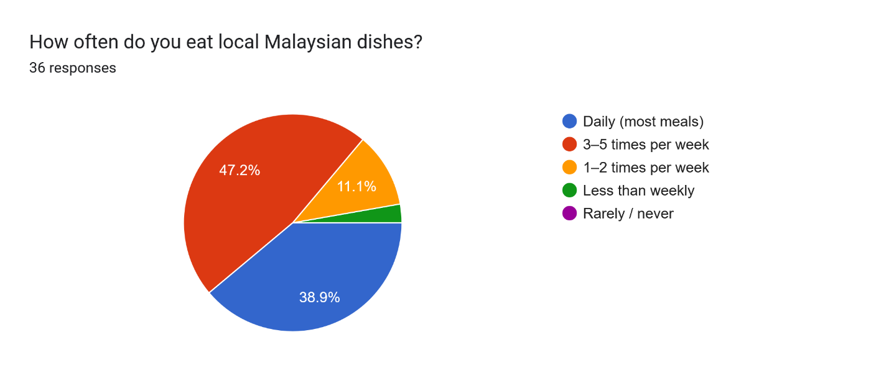
Figure 23 Data for survey question 6.
Based on Figure 23, 47.2% (17 respondents) eat local Malaysian dishes 3–5 times per week and 38.9% (14 respondents) eat them daily. Combined, 86.1% of respondents eat Malaysian food 3 or more times per week and only 11.1% (4 respondents) eat Malaysian food 1–2 times per week while 2.8% (1 respondent) less than weekly. No respondents selected "Rarely / never." which enforces the universal consumption of Malaysian food among the general population and makes a local food database essential to keeping the calorie estimates accurate.

Question 7: Have you ever used a calorie or diet tracking application?
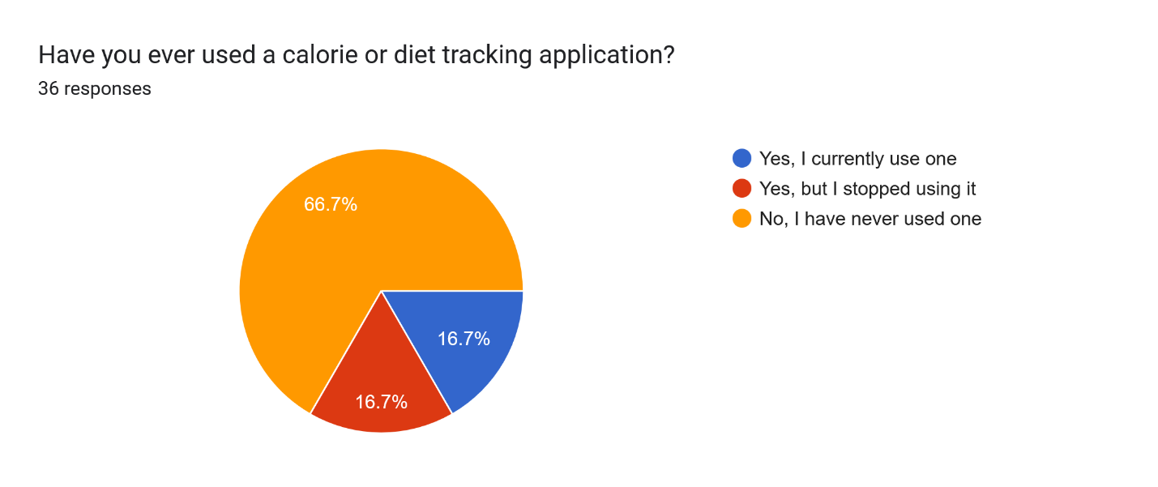
Figure 24 Data for survey question 7.
A significant majority of 66.7% (24 respondents) have never used a calorie tracking application. Equal proportions of 16.7% (6 respondents each) currently use one or have stopped using one. This leaves a large market of users who have never tried a calorie tracking app and that friction points regarding existing calorie tracking apps may have led users to not try or stop using the apps.

3.3.2 Current Calorie Tracking Habits
This section analyzes responses from the 12 respondents who have used a calorie tracking application (current users and past users).

Question 8: Which calorie tracking application(s) have you used?
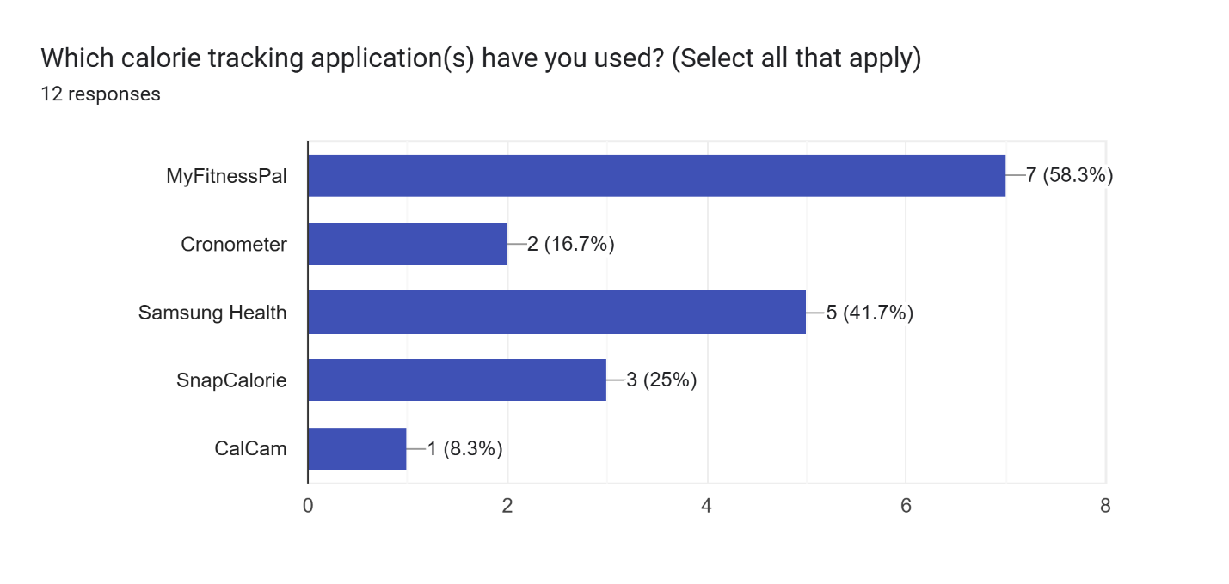
Figure 25 Data for survey question 8.
Among the 12 respondents with tracking experience, MyFitnessPal was the most commonly used at 58.3% (7 respondents), followed by Samsung Health at 41.7% (5 respondents), SnapCalorie at 25% (3 respondents), Cronometer at 16.7% (2 respondents), and CalCam at 8.3% (1 respondent). MyFitnessPal remains the most popular and widely adopted app based on the sample collected.

Question 9: How frequently did/do you log your meals?
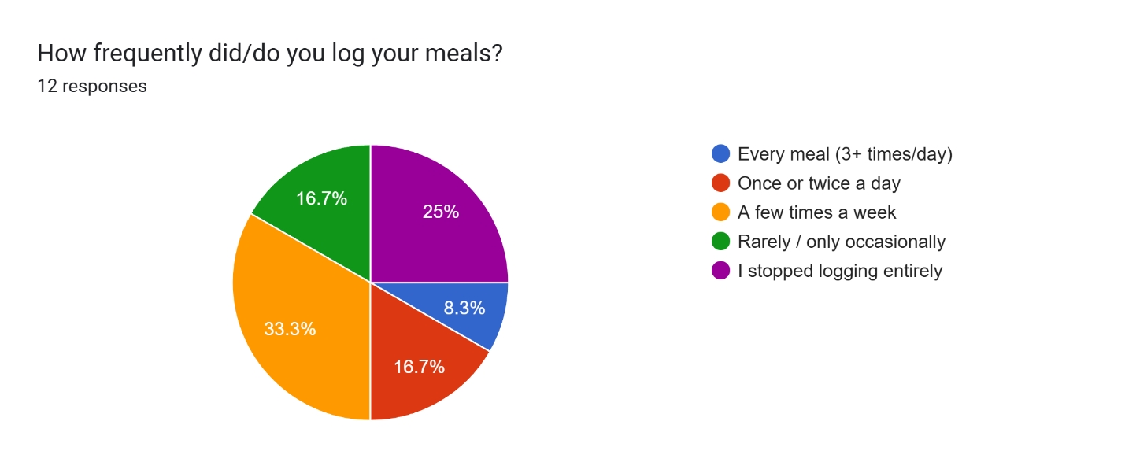
Figure 26 Data for survey question 9.
The most common logging frequency was a few times a week at 33.3% (4 respondents), followed by stopped logging entirely at 25% (3 respondents), once or twice a day and rarely or only occasionally each at 16.7% (2 respondents each), and every meal at 8.3% (1 respondent). The data shows that a combined 75% of respondents who used calorie tracking apps either log inconsistently or have stopped, confirming that most calorie tracking apps fail to maintain daily user engagement.

Question 10: If you stopped using the app, what were the main reasons?
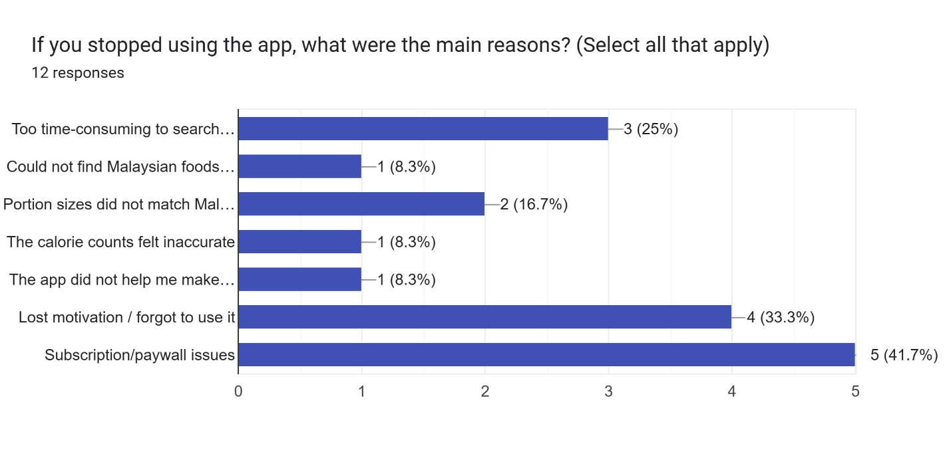
Figure 27 Data for survey question 10.
The most common reason for stopping or reducing app usage was subscription or paywall issues at 41.7% (5 respondents), followed by lost motivation or forgetting to use the app at 33.3% (4 respondents), manual entry being too time-consuming at 25% (3 respondents), portion sizes not matching Malaysian servings at 16.7% (2 respondents), and inability to find Malaysian foods, calorie counts feeling inaccurate, and the app not helping make better food choices each at 8.3% (1 respondent each). The emergence of paywall issues highlights an opportunity for CalorAI to provide its core features without putting it behind a paywall to reduce the friction of users.

Question 11: How would you rate your overall satisfaction with the calorie tracking app(s) you used?
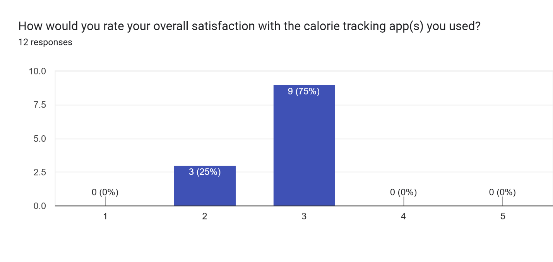
Figure 28 Data for survey question 11.
The satisfaction ratings among the 12 users show that 75% (9 respondents) rated their satisfaction at 3 out of 5 and 25% (3 respondents) rated it at 2 out of 5. No respondents rated their satisfaction at 1, 4, or 5, giving a mean satisfaction score of 2.75 out of 5. The average scores being below 3 means the average respondent feels that the tracking solution currently available does not meet a satisfactory standard.

3.3.3 Malaysian Food Logging Pain Points
This section analyzes all 36 respondents’ experiences and opinions regarding logging Malaysian food in calorie tracking applications.

Question 12: When eating Malaysian food, how confident are you in estimating the calorie content of your meal?
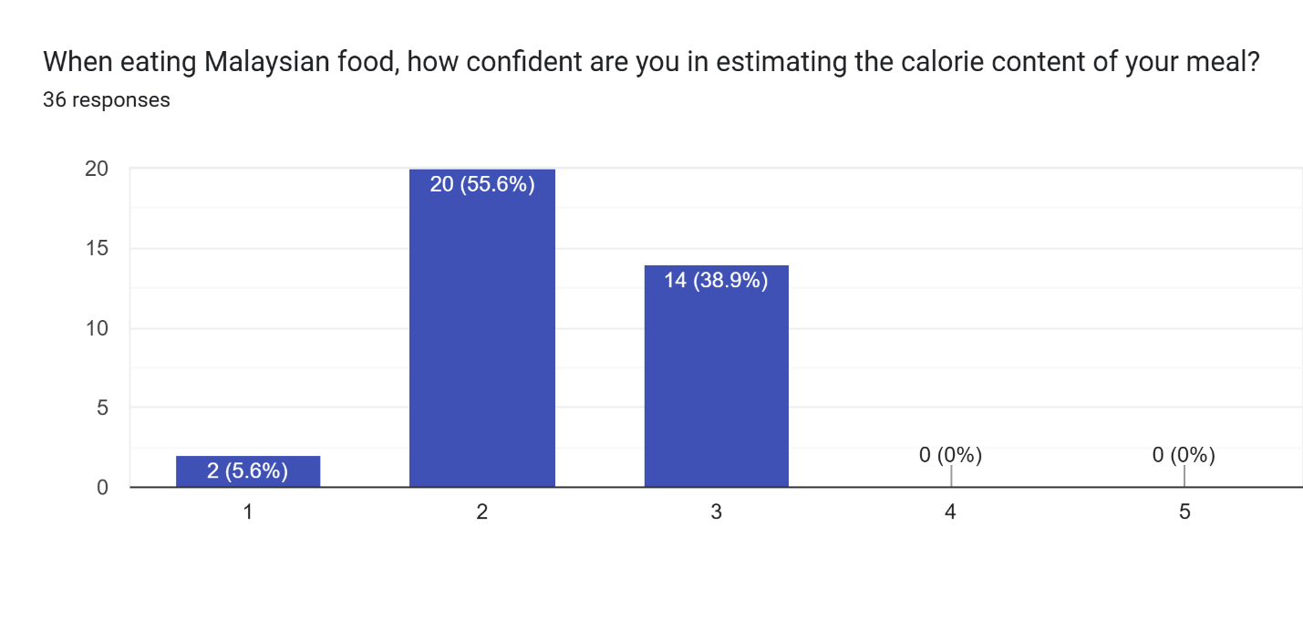
Figure 29 Data for survey question 12.
Out of 36 respondents, 55.6% (20 respondents) rated their confidence at 2 out of 5, 38.9% (14 respondents) at 3, and 5.6% (2 respondents) at 1. No respondents rated their confidence at 4 or 5, giving a mean confidence score of 2.33 out of 5. This means that the average respondents are not confident when estimating the calories they are consuming each meal.

Question 13: Have you ever experienced difficulty finding a Malaysian dish in a calorie tracking app?
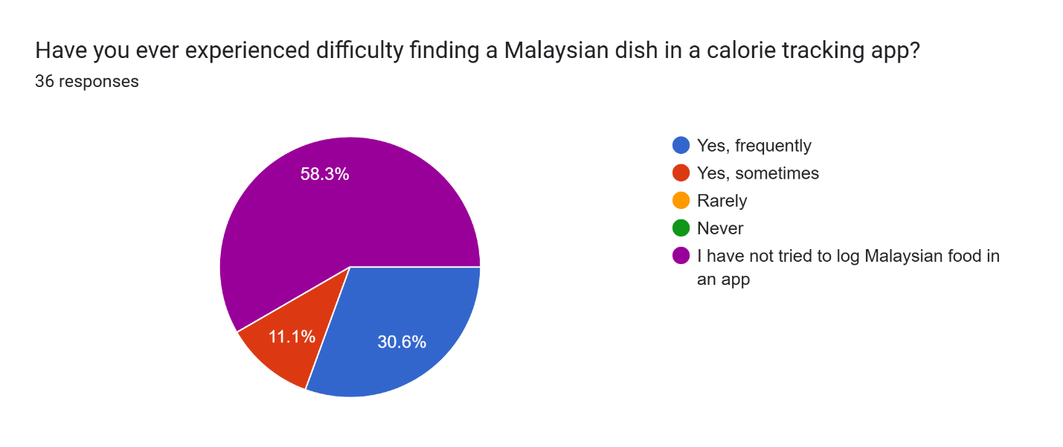
Figure 30 Data for survey question 13.
This data shows that 58.3% (21 respondents) have not tried to log Malaysian food in an app which is similar to the responses from an earlier question. Among the remaining 15 respondents who have attempted to log Malaysian food, 30.6% (11 respondents) experienced difficulty frequently and 11.1% (4 respondents) experienced it only sometimes. None of the respondents replied rarely or never which leads to the conclusion that the respondents who have tried logging food into a calorie tracker often finds issue with Malaysian food specifically.

Question 14: When you cannot find the exact Malaysian dish in an app, what do you typically do? 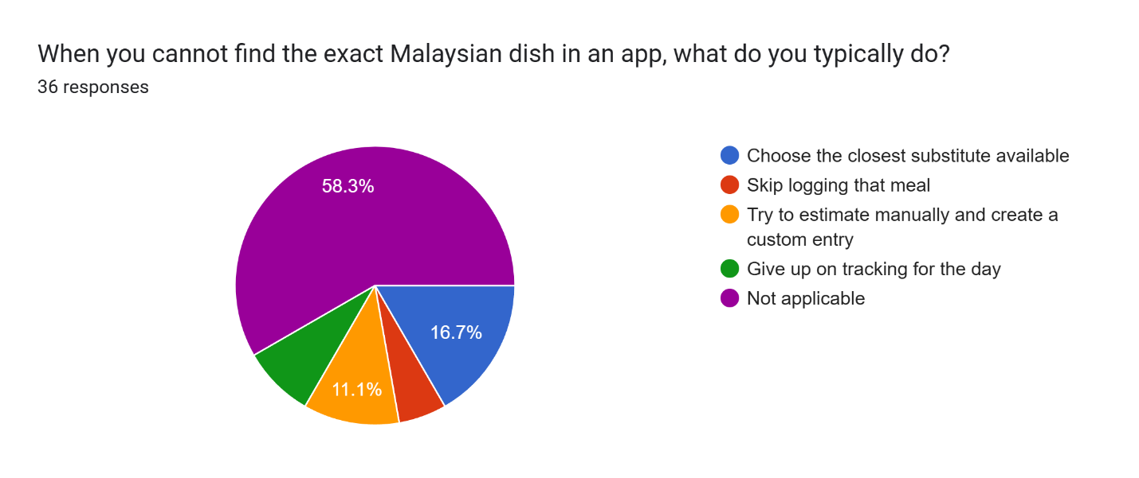
Figure 31 Data for survey question 14\
Based on the questionnaire, 30.6% (11 respondents) skip logging that meal and another 30.6% (11 respondents) try to estimate manually and create a custom entry. This was followed by give up on tracking for the day at 19.4% (7 respondents), choose the closest substitute at 13.9% (5 respondents), and not applicable at 5.6% (2 respondents).

Question 15: Manual food logging takes too much time.
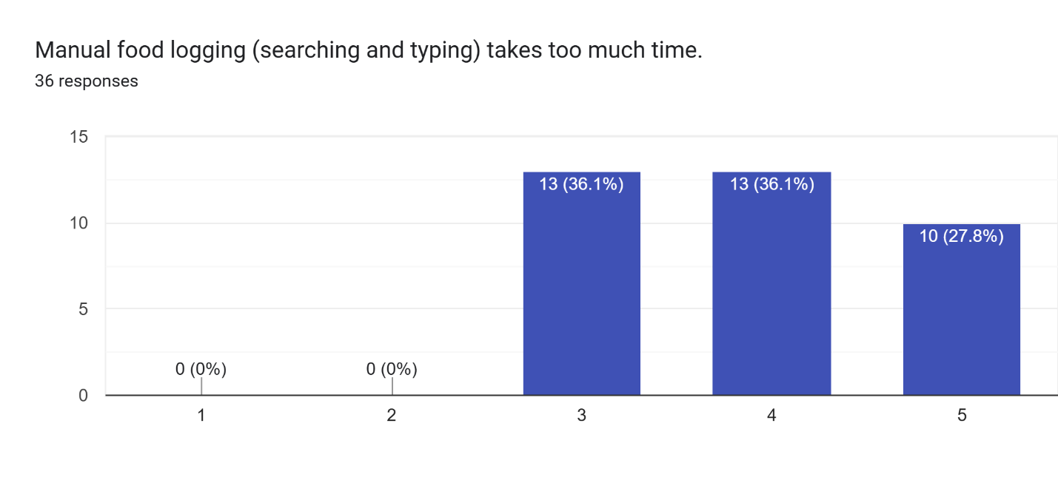
Figure 32 Data for survey question 15.
All 36 respondents rated this statement at 3 or above, with 36.1% (13 respondents) selecting 3, 36.1% (13 respondents) selecting 4, and 27.8% (10 respondents) selecting 5, giving a mean score of 3.92 out of 5. No respondents disagreed with the statement which implies that manual entry burden is consistently experienced across all calorie logging applications.

Question 16: Estimating portion size for Malaysian food is difficult.
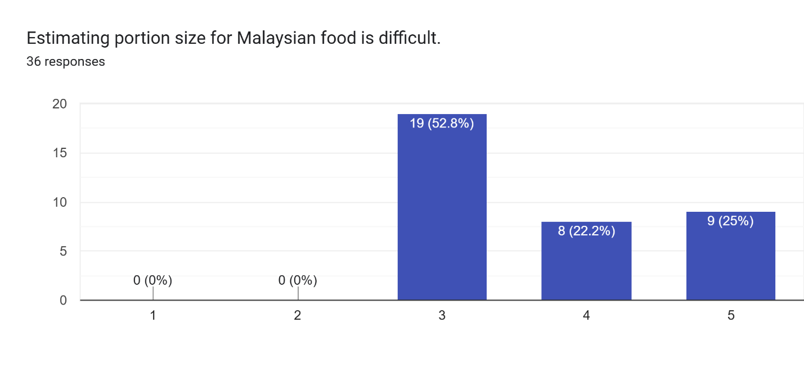
Figure 33 Data for survey question 16.
All 36 respondents rated this statement at 3 or above, with 52.8% (19 respondents) selecting 3, 22.2% (8 respondents) selecting 4, and 25% (9 respondents) selecting 5, giving a mean score of 3.72 out of 5. No respondents claimed that estimating food portions is easy thus proving that this is an important feature to be implemented to most calorie tracking applications.

Question 17: Existing apps do not represent Malaysian local foods accurately.
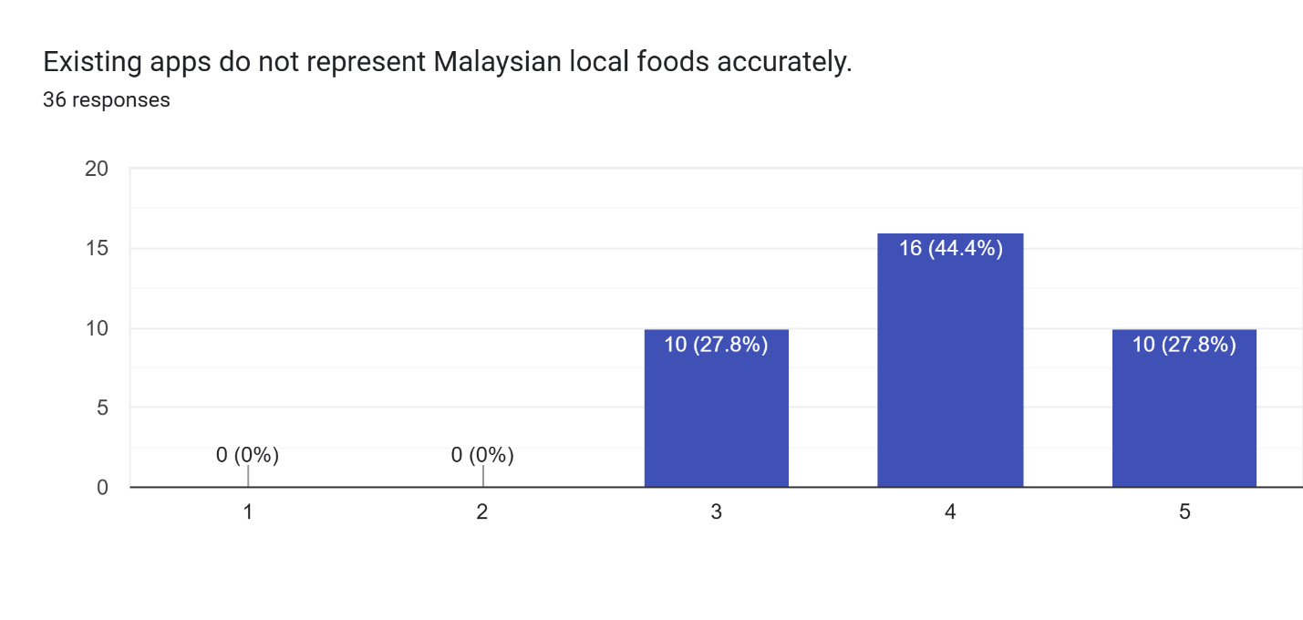
Figure 34 Data for survey question 17.
All 36 respondents rated this statement at 3 or above, with 27.8% (10 respondents) selecting 3, 44.4% (16 respondents) selecting 4, and 27.8% (10 respondents) selecting 5, giving a mean score of 4.00 out of 5. None of the respondents disagreed with the poor representation of Malaysian food in existing applications which reinforces the need for an application which supports it.

Question 18: I often choose closest substitutes which may not be accurate.
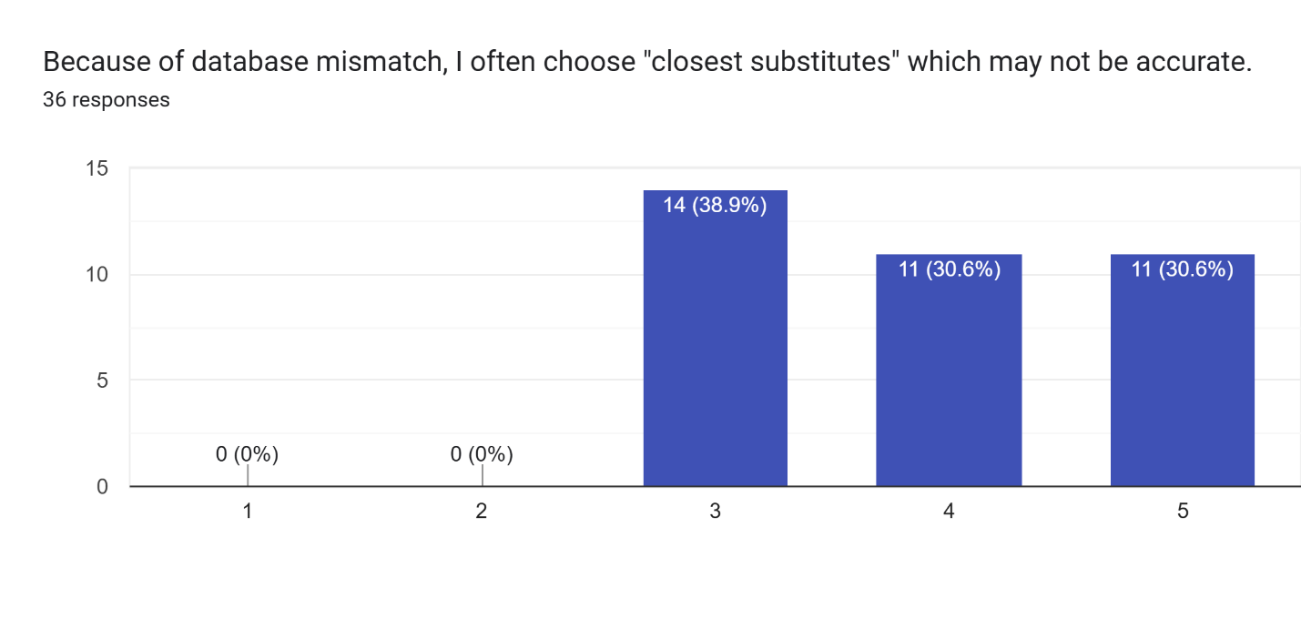
Figure 35 Data for survey question 18
All 36 respondents rated this statement at 3 or above, with 38.9% (14 respondents) selecting 3, 30.6% (11 respondents) selecting 4, and 30.6% (11 respondents) selecting 5, giving a mean score of 3.92 out of 5. None of the respondents disagreed about issues regarding database mismatch which proves that better food coverage needs to be done.

Question 19: When unsure of accuracy, I am more likely to stop tracking.
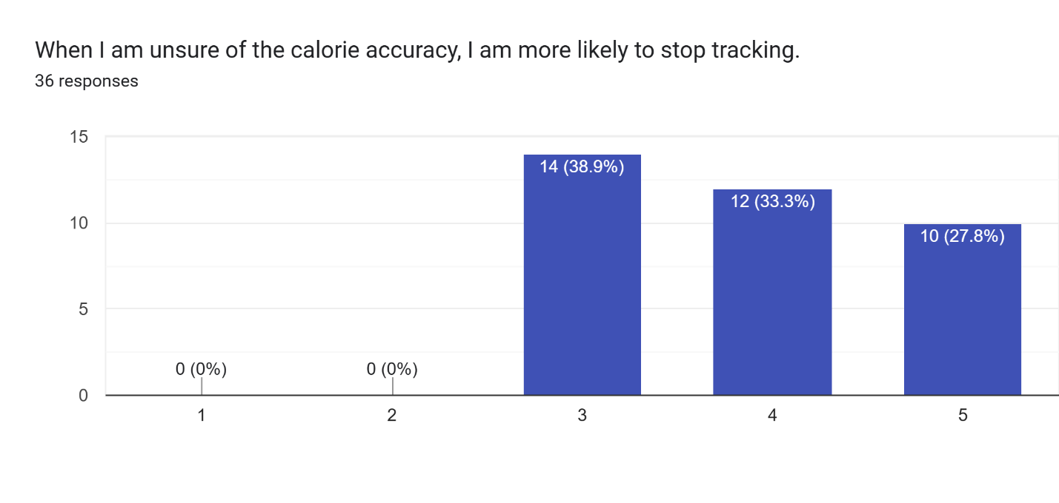
Figure 36 Data for survey question 19
All 36 respondents rated this statement at 3 or above, with 38.9% (14 respondents) selecting 3, 33.3% (12 respondents) selecting 4, and 27.8% (10 respondents) selecting 5, giving a mean score of 3.89 out of 5. This shows a direct link between the odds of the respondents tracking behavior and the accuracy of the calorie tracker.

3.3.4 Photo-Based Logging (AI Image Recognition Acceptance)
This section assesses respondents’ desire to adopt AI image recognition for meal logging.

Question 20: If an app could suggest foods from a meal photo, I would track more consistently.
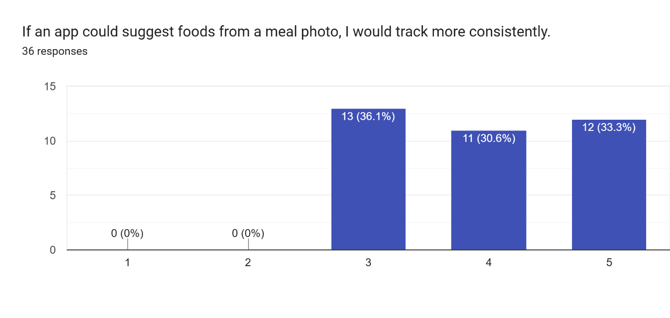
Figure 37 Data for survey question 20
All 36 respondents rated this statement at 3 or above, with 36.1% (13 respondents) selecting 3, 30.6% (11 respondents) selecting 4, and 33.3% (12 respondents) selecting 5, giving a mean score of 3.97 out of 5. This shows a correlation between the convenience of photo-based food entry and the consistency of respondent’s calorie tracking.

Question 21: I would be comfortable uploading meal photos for calorie logging.
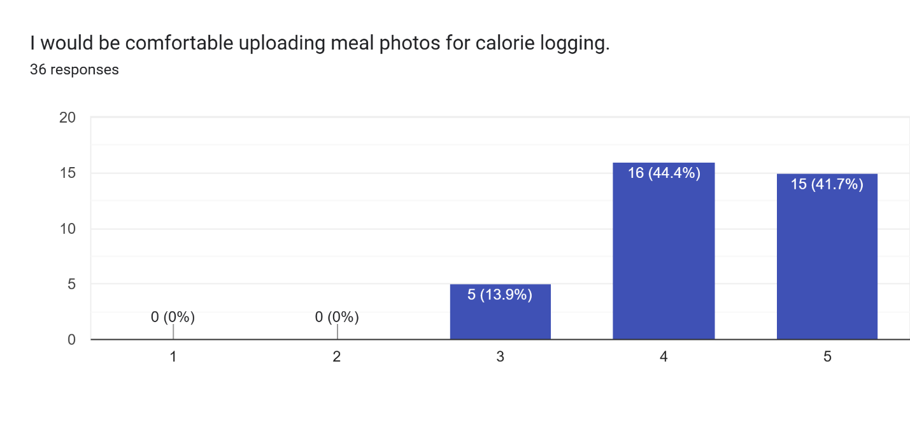
Figure 38 Data for survey question 21
All 36 respondents rated their comfort at 3 or above, with 13.9% (5 respondents) selecting 3, 44.4% (16 respondents) selecting 4, and 41.7% (15 respondents) selecting 5, giving a mean score of 4.28 out of 5. No respondents disagreed which indicates that most respondents do not feel that image submission of their meals will affect their choice when picking a calorie tracking app.

Question 22: I prefer the AI to suggest the food and let me confirm/edit, rather than fully automatic logging.
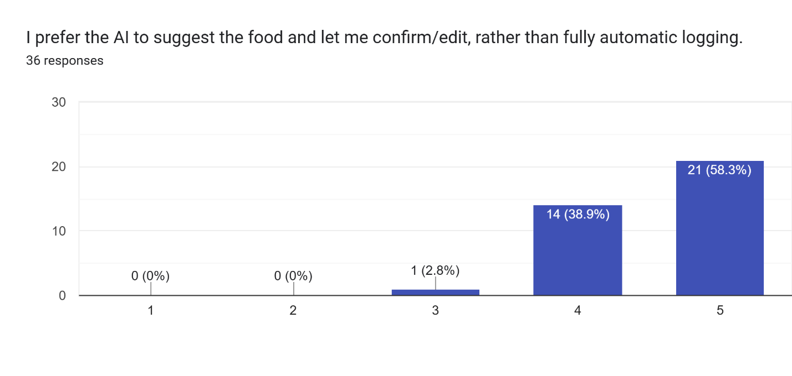
Figure 39 Data for survey question 22
The data collected shows that 97.2% of respondents rated it at 4 or 5, with 58.3% (21 respondents) selecting 5 and 38.9% (14 respondents) selecting 4. Only 2.8% (1 respondent) selected 3 and no respondent disagreed, giving a mean score of 4.56 out of 5. This strongly proves that the respondents prefer if they confirm the food before the entry is logged.

Question 23: I want the app to show multiple food suggestions (e.g., Top 3–5) so I can choose the correct one.
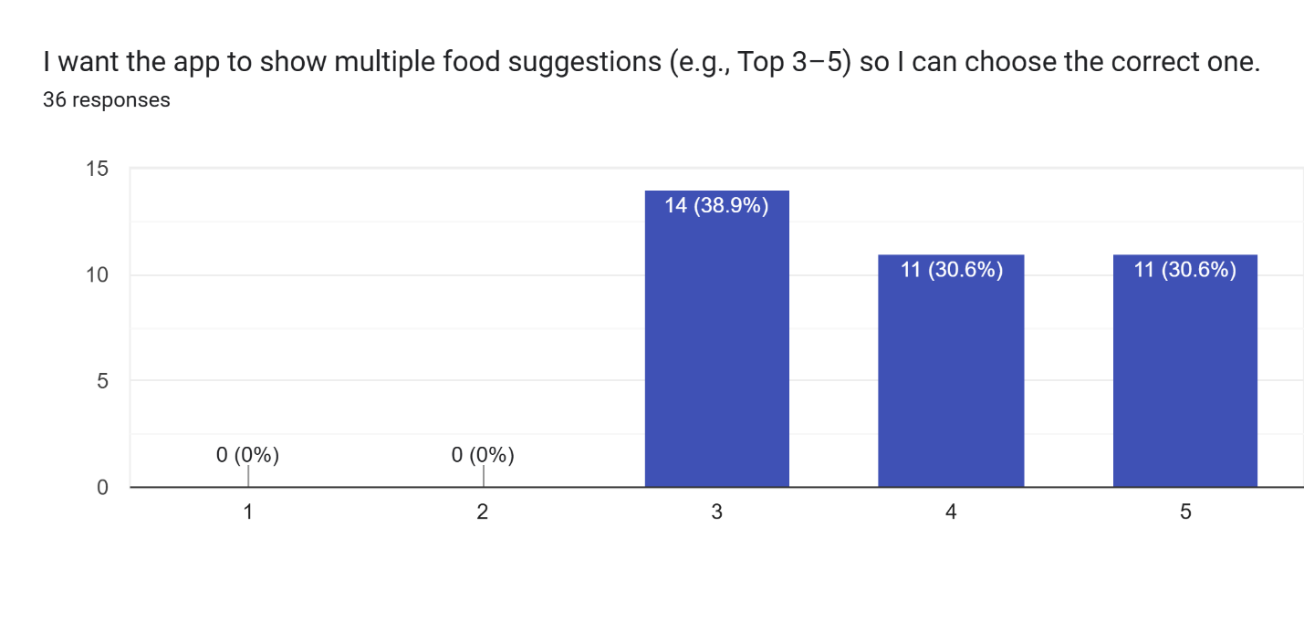
Figure 40 Data for survey question 23
All 36 respondents rated this statement at 3 or above, with 38.9% (14 respondents) selecting 3, 30.6% (11 respondents) selecting 4, and 30.6% (11 respondents) selecting 5, giving a mean score of 3.92 out of 5. No respondents disagreed, which confirms that the respondent would like to have a choice before submitting the entry to detect any mislabeling.

Question 24: I want portion selection options (e.g., small/medium/large AND grams) after choosing the dish.
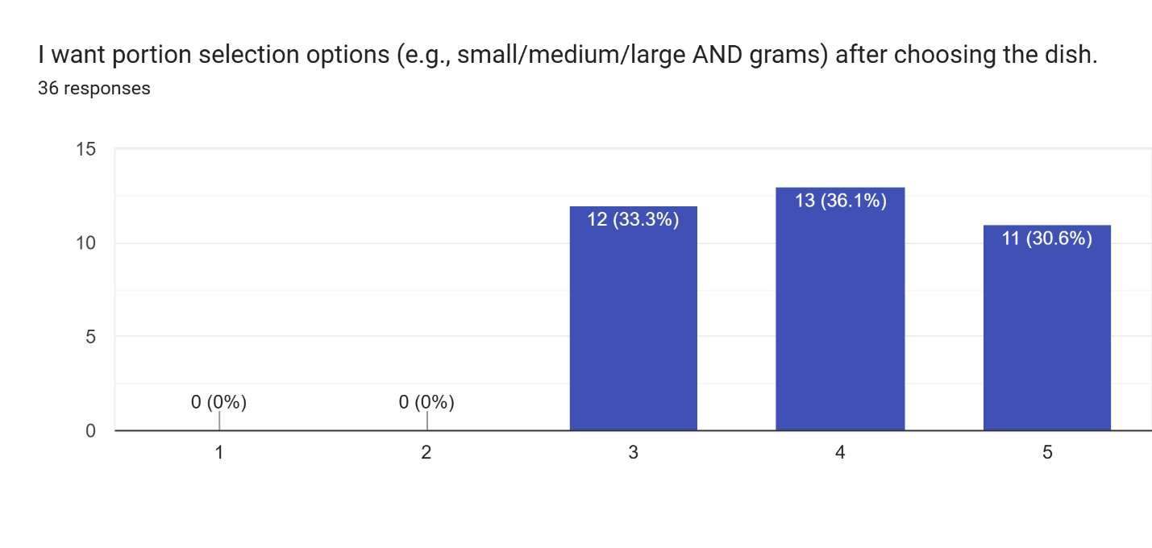
Figure 41 Data for survey question 24
All 36 respondents rated this statement at 3 or above, with 33.3% (12 respondents) selecting 3, 36.1% (13 respondents) selecting 4, and 30.6% (11 respondents) selecting 5, giving a mean score of 3.97 out of 5. The respondents confirm the demand for a flexible portion input for meals.

Question 25: Which portion input method would you prefer most?
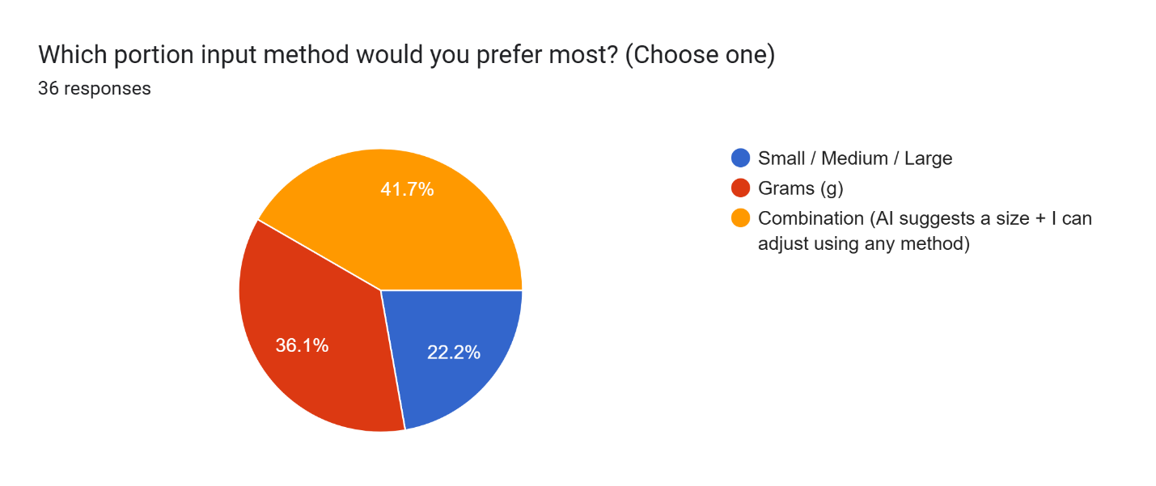
Figure 42 Data for survey question 25
Based on figure 31, 41.7% (15 respondents) prefer the combination approach where the AI suggests a size and the user can adjust using any method, 36.1% (13 respondents) prefer gram-based input, and 22.2% (8 respondents) prefer Small, Medium, and Large categories. This shows that respondents prefer if they have more options when entering the portion of their meal.

3.3.5 Database Trust and Transparency

Question 26: I trust calorie estimates more if they come from an official Malaysian nutrition source.
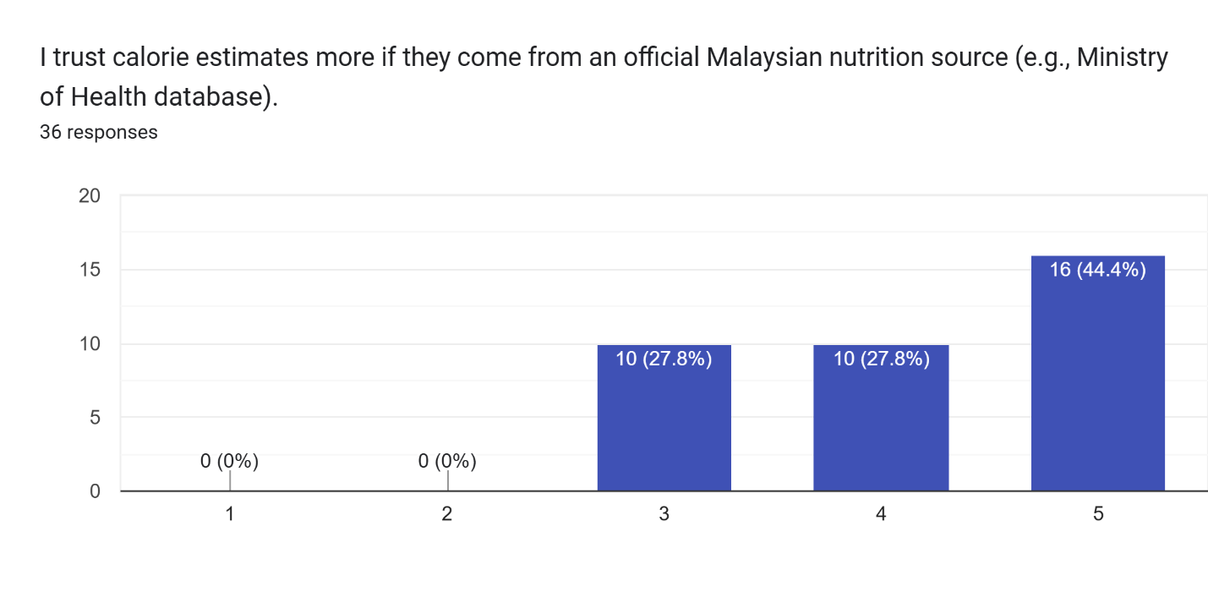
Figure 43 Data for survey question 26
All 36 respondents rated this statement at 3 or above, with 27.8% (10 respondents) selecting 3, 27.8% (10 respondents) selecting 4, and 44.4% (16 respondents) selecting 5, giving a mean score of 4.17 out of 5. This shows that the respondents are more likely to believe the estimations provided if they’re based on reliable information such as MyFCD compared to purely AI estimation.

Question 27: I want the app to show the source of its calorie values.
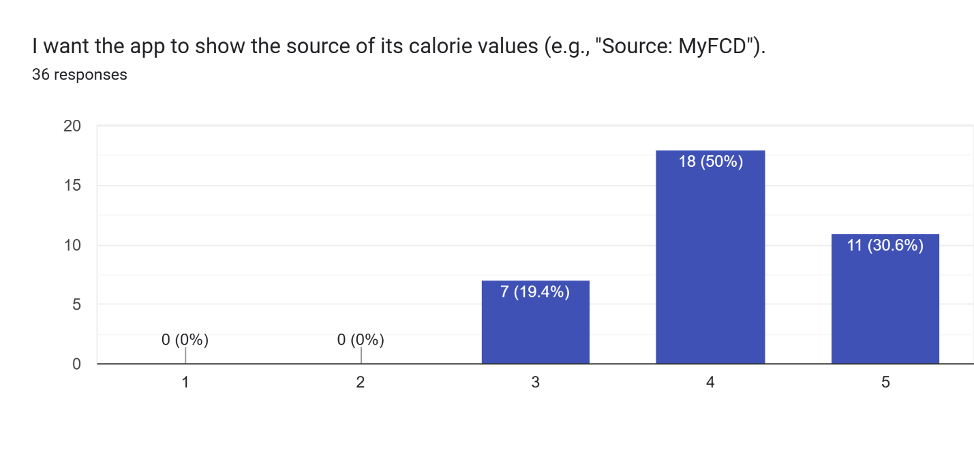
Figure 44 Data for survey question 27
All 36 respondents rated this statement at 3 or above, with 19.4% (7 respondents) selecting 3, 50% (18 respondents) selecting 4, and 30.6% (11 respondents) selecting 5, giving a mean score of 4.11 out of 5. This result proves that users would definitely want to know the caloric value of their meals and would like to have all the information available.

Question 28: I want to be able to edit the food entry when the AI is wrong.
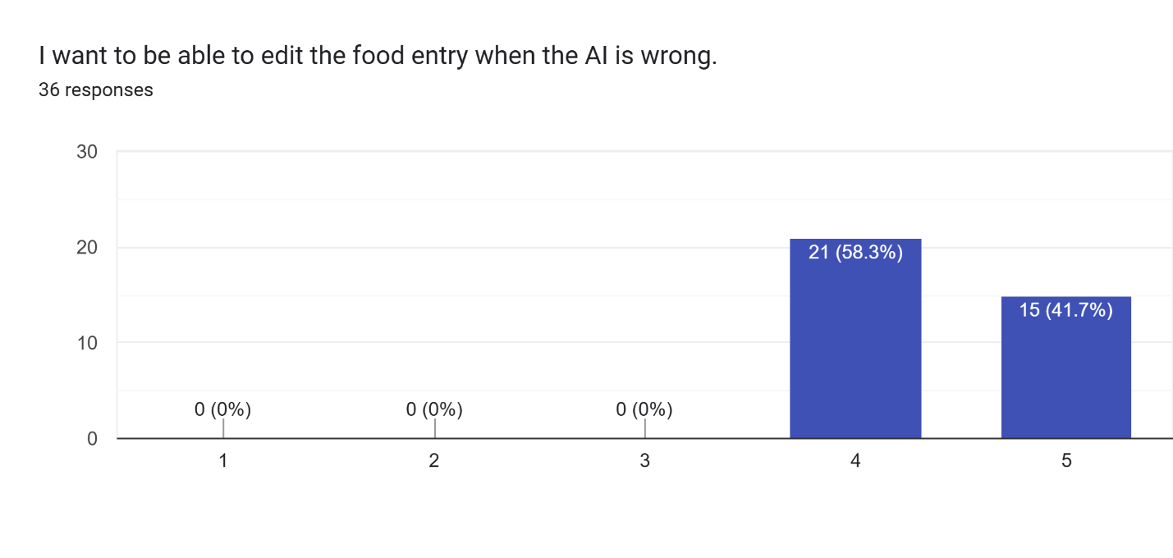
Figure 45 Data for survey question 28
This question is the only question where no respondent selected below 4. 58.3% (21 respondents) selected 4 and 41.7% (15 respondents) selected 5, giving a mean score of 4.42 out of 5. This result clearly shows that users will want control over the entry before it is saved if anything is wrong.

Question 29: I want an "uncertainty" indicator (e.g., low/medium/high confidence) when the AI is not sure.
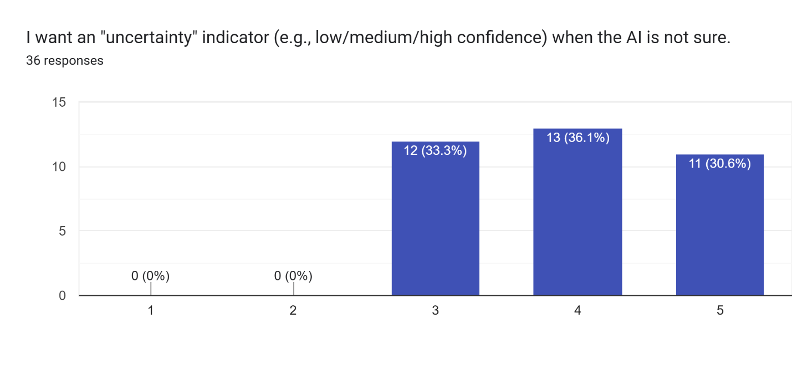
Figure 46 Data for survey question 29
All 36 respondents rated this statement at 3 or above, with 33.3% (12 respondents) selecting 3, 36.1% (13 respondents) selecting 4, and 30.6% (11 respondents) selecting 5, giving a mean score of 3.97 out of 5. This proves that users are aware of the limitations of AI and would like transparency regarding the detection.

3.3.6 Recommendations, Chatbot, and Actionable Guidance

Question 30: I want the app to recommend healthier alternatives for Malaysian meals.
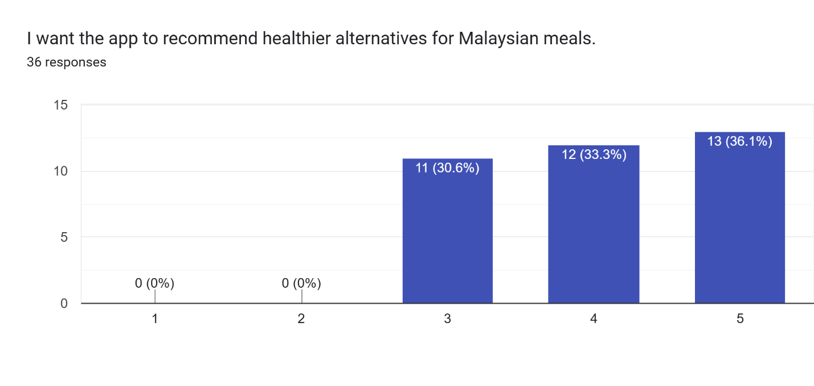
Figure 47 Data for survey question 30
All 36 respondents rated this statement at 3 or above, with 30.6% (11 respondents) selecting 3, 33.3% (12 respondents) selecting 4, and 36.1% (13 respondents) selecting 5, giving a mean score of 4.06 out of 5. No respondents disagreed regarding the implementation of a chatbot for recommendations for healthier alternatives.

Question 31: I want a chatbot that can answer questions like "What should I eat for dinner?”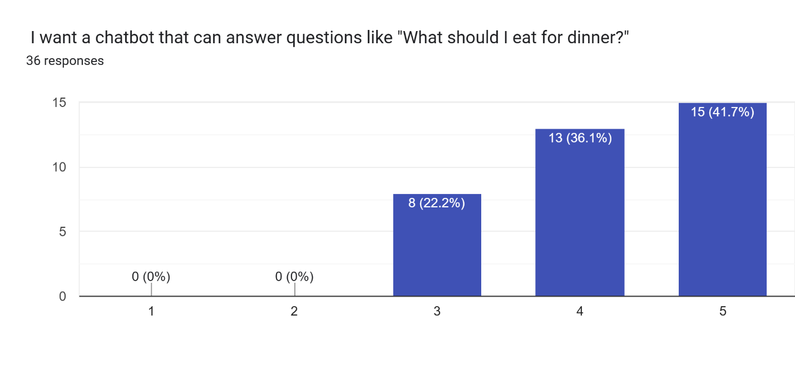
Figure 48 Data for survey question 31
All 36 respondents rated this statement at 3 or above, with 22.2% (8 respondents) selecting 3, 36.1% (13 respondents) selecting 4, and 41.7% (15 respondents) selecting 5, giving a mean score of 4.19 out of 5. This result shows that the respondents would like a conversational chatbot that can help them decide on a meal.

Question 32: I want recommendations based on my goal (e.g., lose weight, gain muscle, maintain). 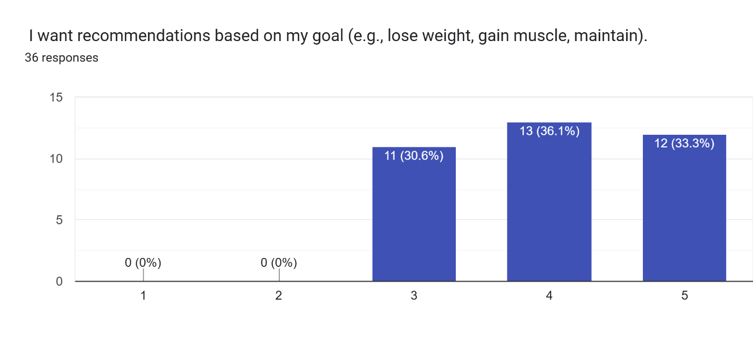
Figure 49 Data for survey question 32
All 36 respondents rated this statement at 3 or above, with 30.6% (11 respondents) selecting 3, 36.1% (13 respondents) selecting 4, and 33.3% (12 respondents) selecting 5, giving a mean score of 4.03 out of 5. The results agree with the expectation that the respondents would like responses which align with their personal goals.

Question 33: I want recommendations based on what I have eaten recently (this week/month). 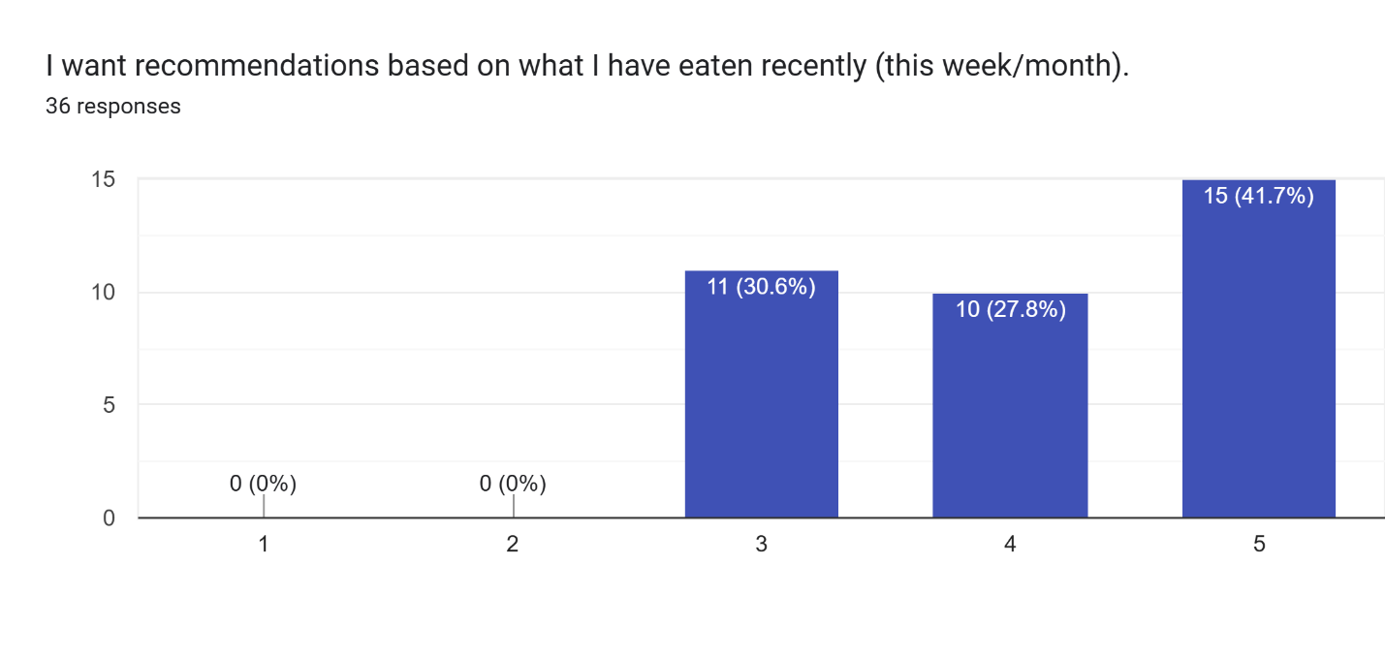
Figure 50 Data for survey question 33
All 36 respondents rated this statement 3 or above, with 30.6% (11 respondents) selecting 3, 27.8% (10 respondents) selecting 4, and 41.7% (15 respondents) selecting 5, giving a mean score of 4.11 out of 5. None of the respondents disagreed and would prefer the chatbot provides recommendations based on their past meals.

Question 34: I would use a meal plan suggestion feature if it fits my calorie target and includes Malaysian foods. 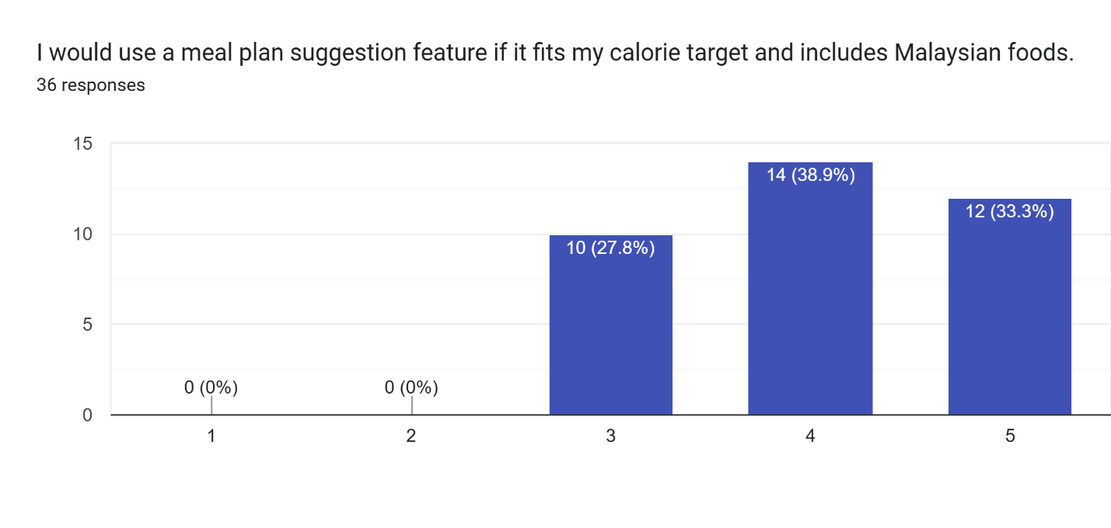
Figure 51 Data for survey question 34
All 36 respondents rated this statement at 3 or above, with 27.8% (10 respondents) selecting 3, 38.9% (14 respondents) selecting 4, and 33.3% (12 respondents) selecting 5, giving a mean score of 4.06 out of 5. the respondents agreed that a meal plan feature would be beneficial and well received.

Question 35: Which chatbot features would you find most valuable? 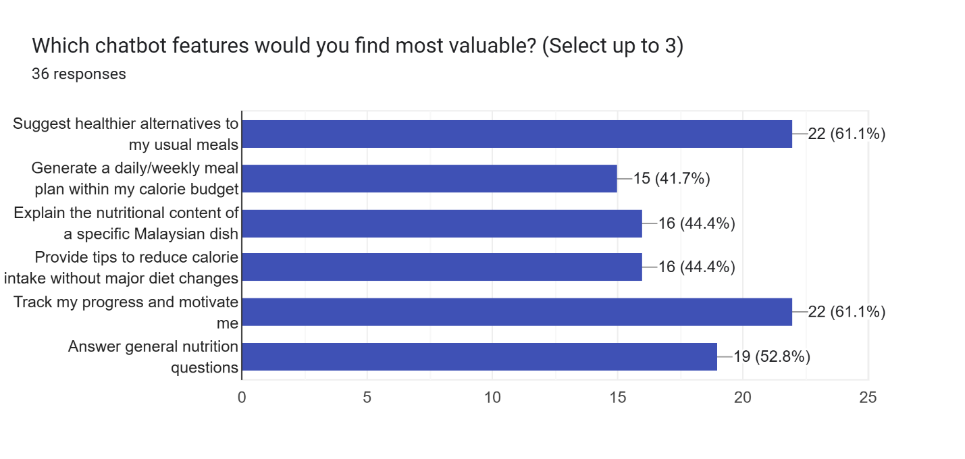
Figure 52 Data for survey question 35
This question asked respondents to select up to 3 most valuable chatbot features. Suggesting healthier alternatives to usual meals and tracking progress and motivation tied in first place at 61.1% each (22 respondents each), followed by answering general nutrition questions at 52.8% (19 respondents), explaining the nutritional content of a specific Malaysian dish and providing tips to reduce calorie intake without major diet changes tied at 44.4% each (16 respondents each), and generating a daily or weekly meal plan within the calorie budget at 41.7% (15 respondents). The most popular answer is healthier alternatives and to track progress which aligns with the implementation of a chatbot feature into CalorAI.

3.3.7 Feature Prioritization

Question 36: Photo-based meal logging (AI image recognition) 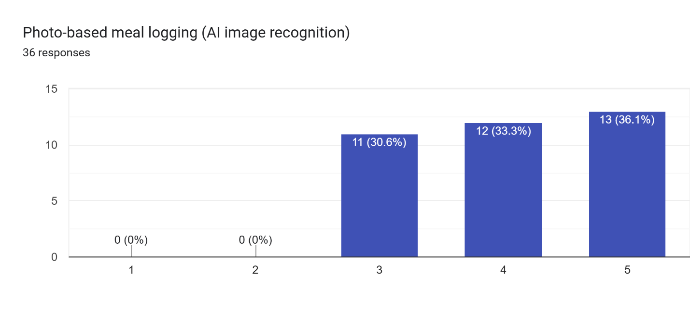
Figure 53 Data for survey question 36
All 36 respondents rated this feature at 3 or above, with 30.6% (11 respondents) selecting 3, 33.3% (12 respondents) selecting 4, and 36.1% (13 respondents) selecting 5, giving a mean score of 4.06 out of 5. None of them rejected the photo-based meal logging feature which makes it a good feature to implement.

Question 37: Comprehensive Malaysian food database 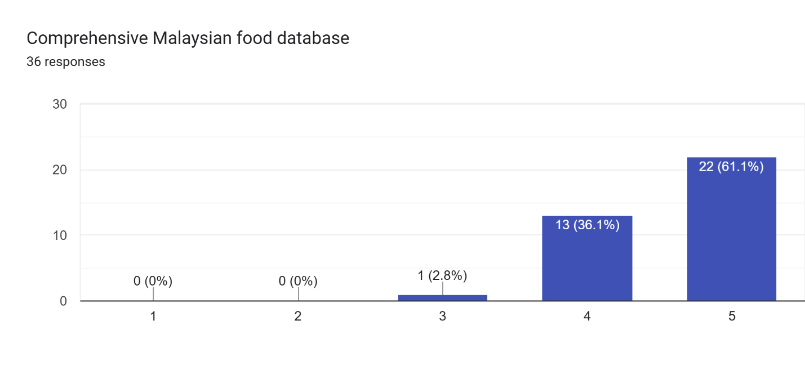
Figure 54 Data for survey question 37
The comprehensive Malaysian food database received the highest mean score among all individually rated features at 4.58 out of 5, with only 2.8% (1 respondent) selecting 3, 36.1% (13 respondents) selecting 4, and 61.1% (22 respondents) selecting 5. Majority of respondents would prefer for a comprehensive Malaysian food database to be integrated into the application.

Question 38: Macro breakdown (protein, carbs, fats) per meal/day 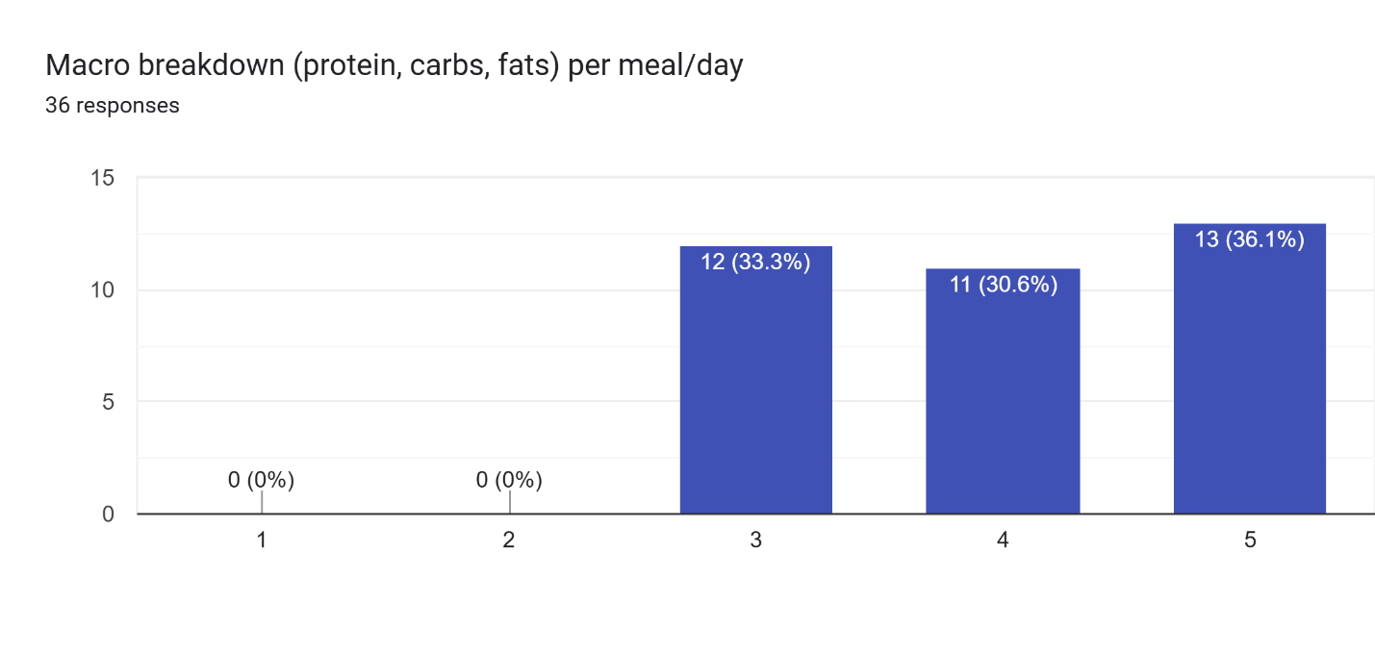
Figure 55 Data for survey question 38
All 36 respondents rated this feature at 3 or above, with 33.3% (12 respondents) selecting 3, 30.6% (11 respondents) selecting 4, and 36.1% (13 respondents) selecting 5, giving a mean score of 4.03 out of 5. Respondents would like macro breakdowns in the application.

Question 39: Daily/weekly calorie trend charts and dashboard 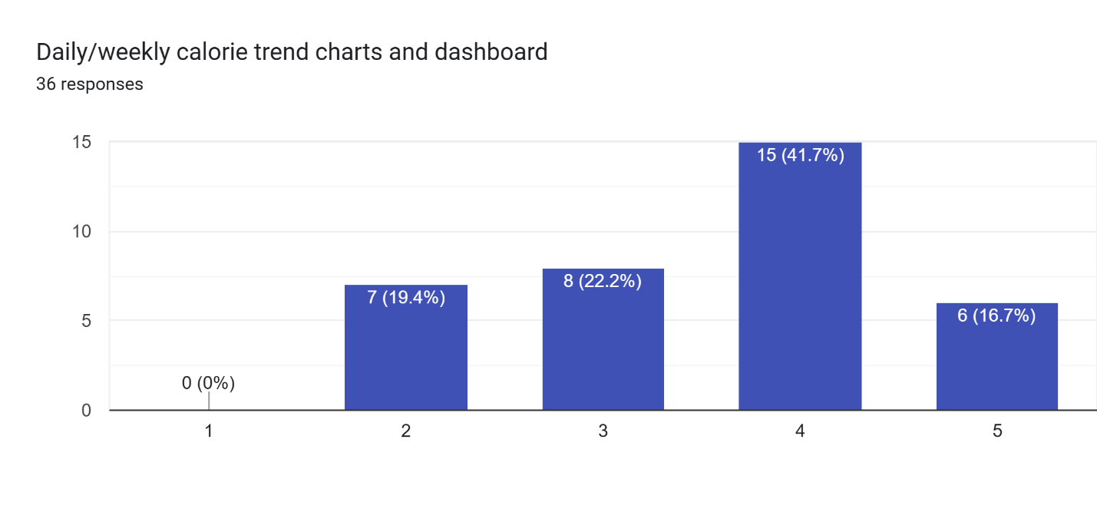
Figure 56 Data for survey question 39
This feature received the most varied ratings among all features, with 19.4% (7 respondents) selecting 2, 22.2% (8 respondents) selecting 3, 41.7% (15 respondents) selecting 4, and 16.7% (6 respondents) selecting 5, giving a mean score of 3.56 out of 5. The response collected made it so this feature would not be as important to implement, and focus should be transferred to other features of the application.

Question 40: AI chatbot for dietary recommendations 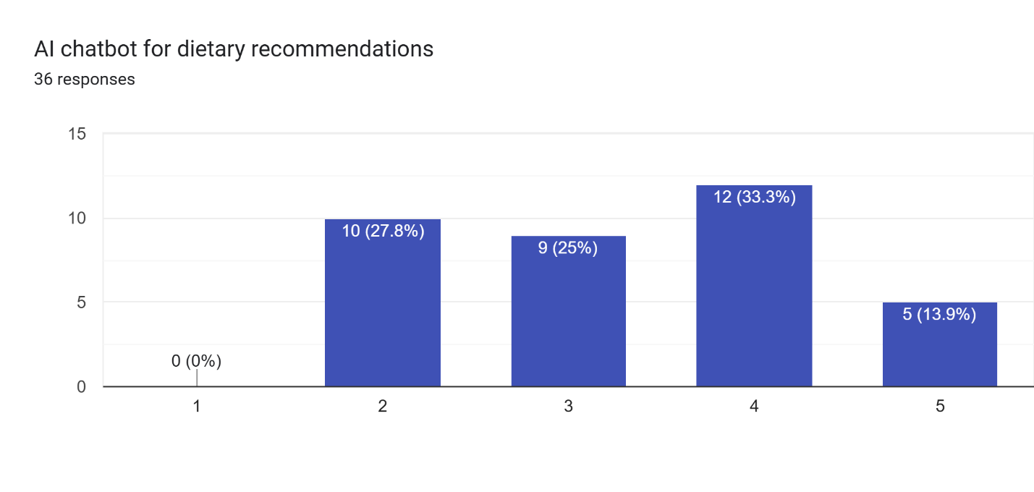
Figure 57 Data for survey question 40
The AI chatbot received the most mixed ratings and the lowest mean score among all features at 3.33 out of 5, with 27.8% (10 respondents) selecting 2, 25% (9 respondents) selecting 3, 33.3% (12 respondents) selecting 4, and 13.9% (5 respondents) selecting 5. This could be the case due to the users being uncertain about the value a chatbot can bring or their experience with AI chatbots. This indicates that even though the chatbot has many features that are wanted, they might not be comfortable using it.

Question 41: Meal plan generation based on calorie goals 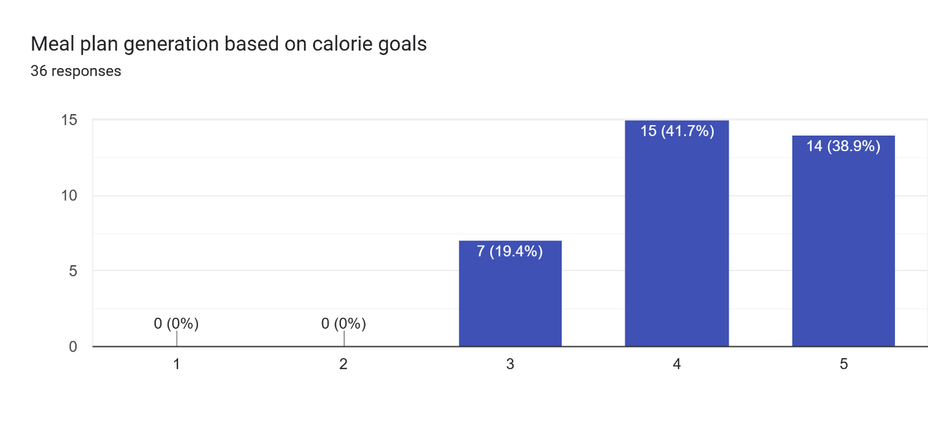
Figure 58 Data for survey question 41.
All 36 respondents rated this feature at 3 or above, with 19.4% (7 respondents) selecting 3, 41.7% (15 respondents) selecting 4, and 38.9% (14 respondents) selecting 5, giving a mean score of 4.19 out of 5. This result shows that respondents would like the ability to generate meal plans which fit their caloric goals which include Malaysian food options.

Question 42: User-friendly and simple interface 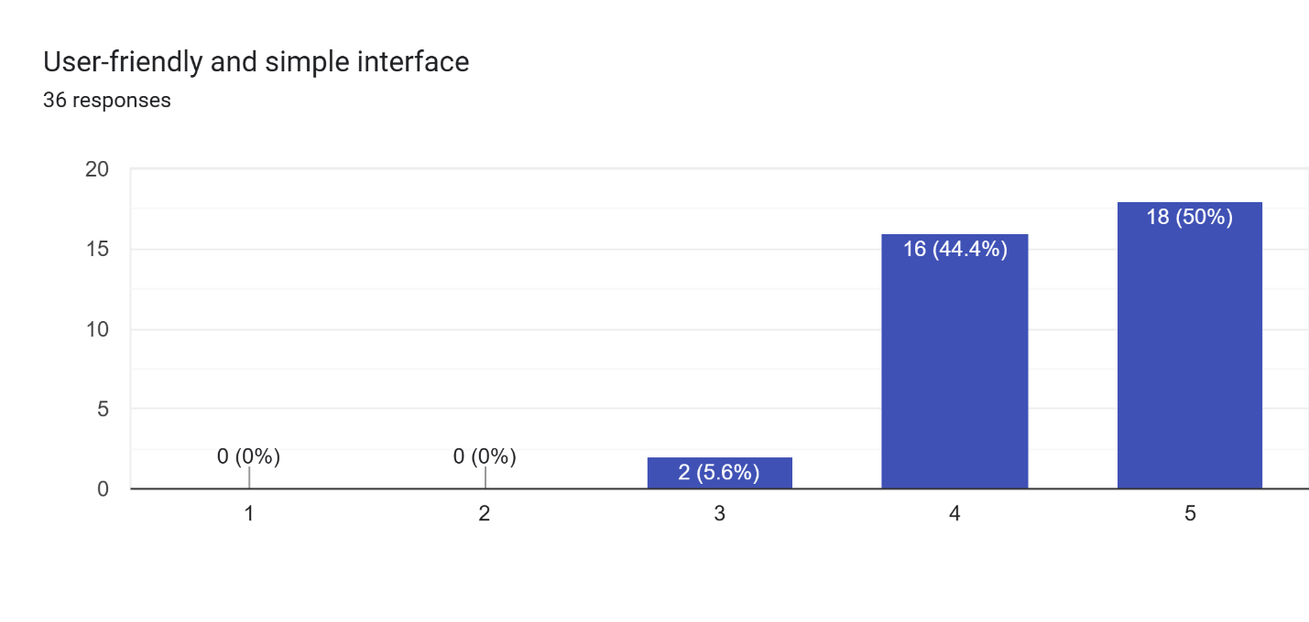
Figure 59 Data for survey question 42
The user-friendly and simple interface received consistently high ratings, with only 5.6% (2 respondents) selecting 3, 44.4% (16 respondents) selecting 4, and 50% (18 respondents) selecting 5, giving a mean score of 4.44 out of 5. None of the respondents disagreed and would strongly prefer a clean and user-friendly interface when interacting with the app.

Question 43: Portion size guidance using Malaysian serving sizes 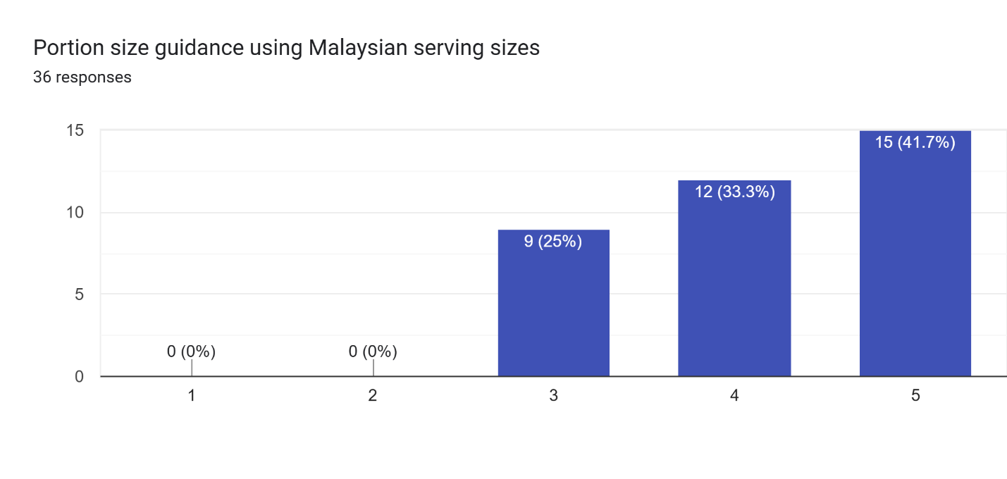
Figure 60 Data for survey question 43
All 36 respondents rated this feature at 3 or above, with 25% (9 respondents) selecting 3, 33.3% (12 respondents) selecting 4, and 41.7% (15 respondents) selecting 5, giving a mean score of 4.17 out of 5. This reveals that respondents would like to get more information regarding portion sizes and it is a valued feature.

Question 44: Goal setting (weight loss, maintenance, muscle gain) 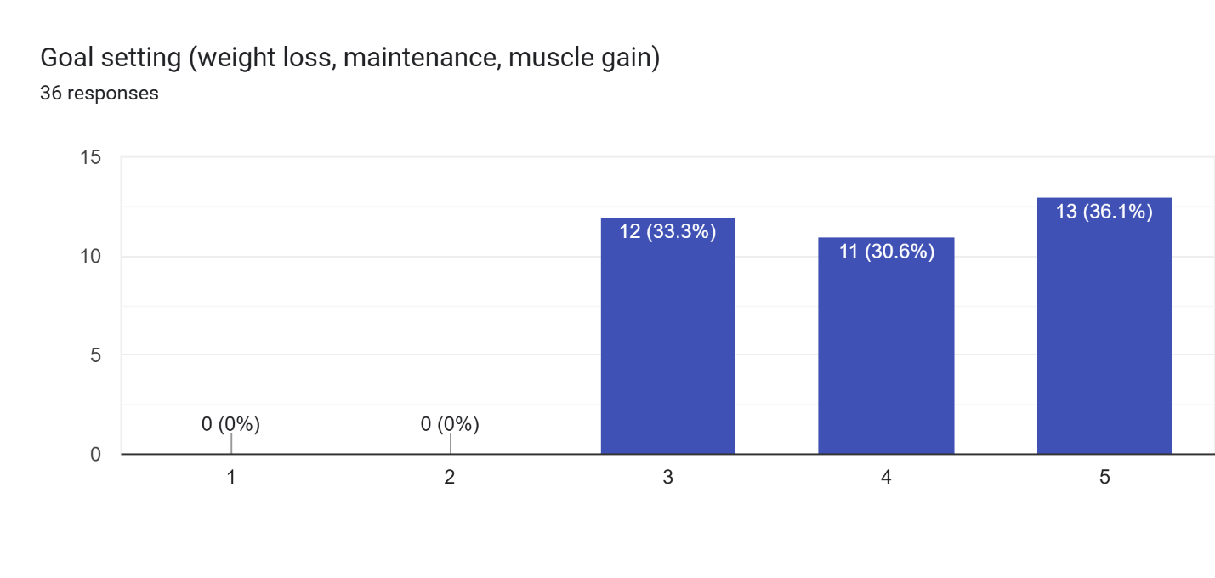
Figure 61 Data for survey question 44
All 36 respondents rated this feature at 3 or above, with 33.3% (12 respondents) selecting 3, 30.6% (11 respondents) selecting 4, and 36.1% (13 respondents) selecting 5, giving a mean score of 4.03 out of 5. No respondents disagreed with the feature and would prefer a way to set their goals for the chatbot recommendations.

Question 45: Manual food search as backup when photo doesn't work 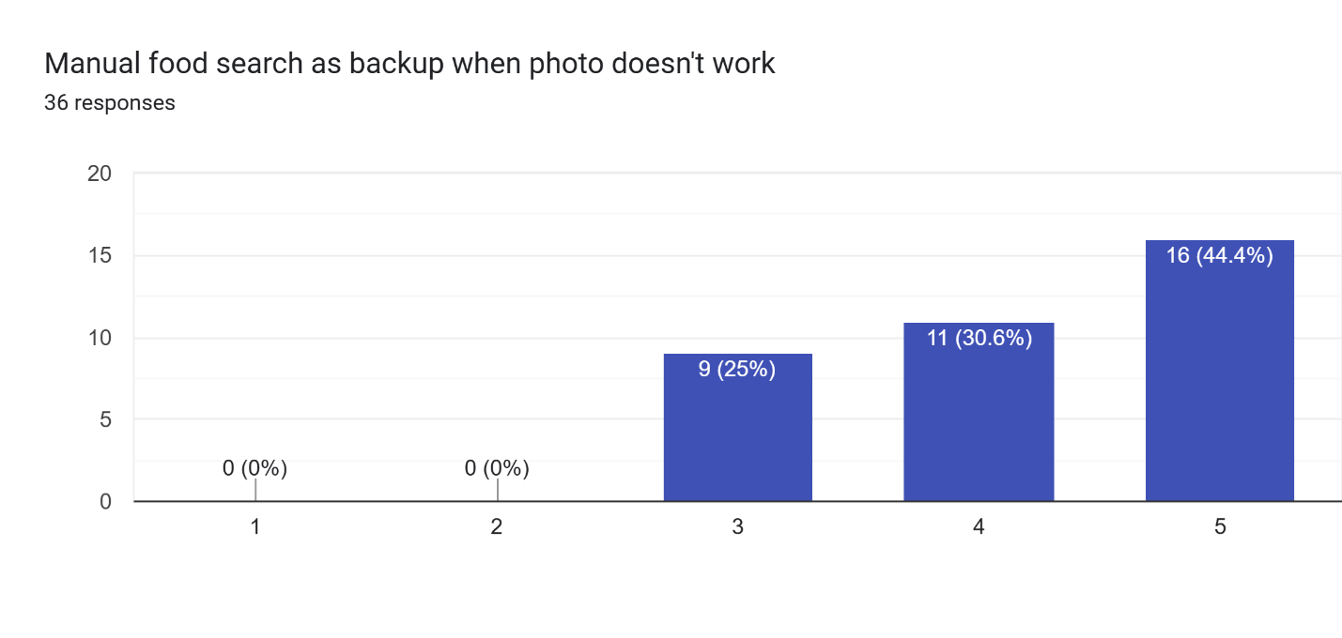
Figure 62 Data for survey question 45
All 36 respondents rated this feature at 3 or above, with 25% (9 respondents) selecting 3, 30.6% (11 respondents) selecting 4, and 44.4% (16 respondents) selecting 5, giving a mean score of 4.19 out of 5. This result proves that manual searching is an important feature to have even if the application has photo-based data entry.

Question 46: Choose the top 5 features you want most from the list above. 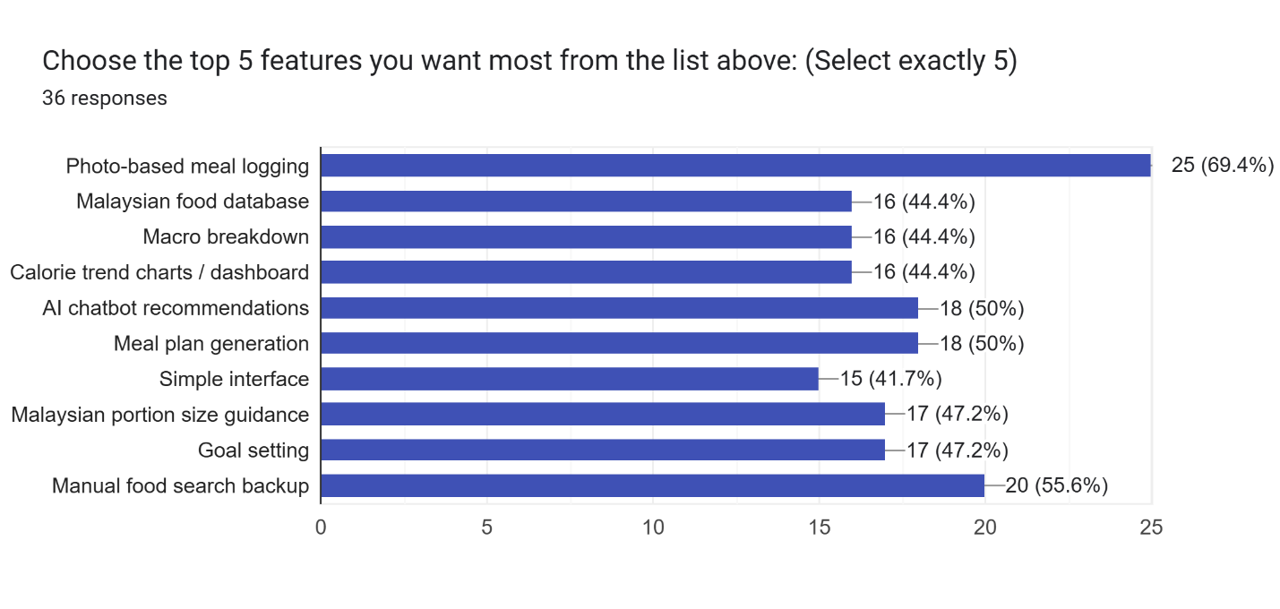
Figure 63 Data for survey question 46
When asked to select exactly 5 most desired features, photo-based meal logging ranked first at 69.4% (25 respondents), followed by manual food search backup at 55.6% (20 respondents), AI chatbot recommendations and meal plan generation tied at third with 50% each (18 respondents), Malaysian portion size guidance and goal setting tied at fifth with 47.2% each (17 respondents), Malaysian food database, macro breakdown, and calorie trend charts tied at 44.4% each (16 respondents), and simple interface at 41.7% (15 respondents). The top ranking features the users would prefer is photo-based meal logging which shows the respondents desire for a simple and quick way to log their meal and reduce manual entry.

Question 47: Overall, I would use CalorAI if it supports Malaysian foods and is fast to log.
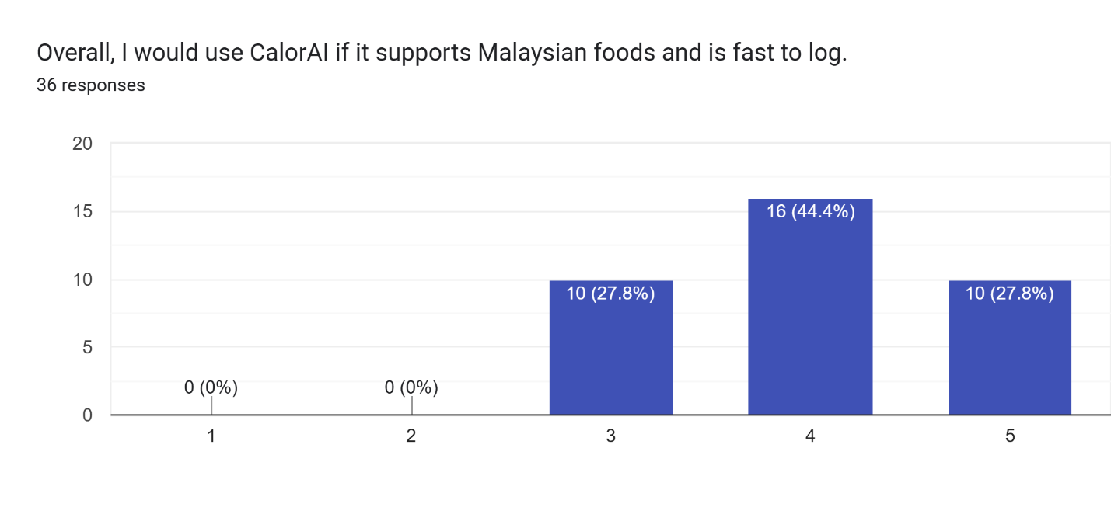
Figure 64 Data for survey question 47
Based on the response collected, 27.8% (10 respondents) rated their overall willingness to use CalorAI at 3, 44.4% (16 respondents) at 4, and 27.8% (10 respondents) at 5, giving a mean score of 4.00 out of 5. No respondent rated their willingness below 3 which means the respondents would not mind giving CalorAI a try. The combined 72.2% rating of 4 or 5 confirms that respondents would prefer a calorie tracking application which provides Malaysian food database support and fast logging.

3.3.8 Summary
In this section, multiple system development methodologies were compared against each other, and Rapid Application Development Methodology was selected as the most suitable approach for the development of CalorAI. A survey was also chosen as the preferred data collection methodology along with domain research and documentation analysis performed in the previous sections. A total of 36 responses were collected through the use of a questionnaire and were analyzed across 8 sections that covered demographics, calorie tracking habits, Malaysian food logging pain points, photo-based logging acceptance, database trust, chatbot preferences, and feature prioritization.
From the data collected, all respondents demonstrated strong knowledge regarding the limitations of existing calorie tracking applications and expressed clear demand for a localized, Malaysia specific calorie tracking application. Among the 12 respondents that claim to have used a calorie tracking application, all of them found some difficulties in logging Malaysian foods at some point. All respondents have a preference of an easier format for logging food using image recognition and a grounded database for data consistency. The overall response collected shows that users would prefer an application like CalorAI available for public use.
There are clear patterns that can be determined from the analysis of the responses collected. First is that although majority of the respondents claim to eat Malaysian food daily or near daily, very few were actually tracking their meals with a calorie tracking application and of those who are tracking them find it inaccurate when logging meals. This analysis confirms that this calorie tracking issue exists in the responses collected but they have not found any solution for this issue. The second pattern is that photo-based food logging is preferred over manual food entry across all respondents, and a majority of respondents claim that they would be more likely to track their meals if a photo could accurately identify the food and provide an accurate response.
Third pattern would be the trust in nutritional information provided by the application. The accuracy and source of the information is a significant factor to whether the respondents would rely on a calorie tracking application for dietary decision. Last pattern found would be the chatbot recommendation feature which was received positively particularly for the ability to request healthier meal alternatives to food they already consume or for a simple meal plan which fits the user’s caloric target. All these findings together confirm that the core features of CalorAI which are AI-powered image recognition, MyFCD integration, and dietary assistant chatbot, are something that real users would like in a calorie tracking application.
Requirements and additional functions summarized through the survey:
- Comprehensive Malaysian food database grounded in MyFCD as the primary nutritional reference.
- Photo-based meal logging with user confirmation before logging
- Suggestions displayed for user selection after photo capture.
- Multiple portion input method
- Manual food searches if photo logging is not suitable.
- Ability to edit food entries when AI recommendation is incorrect.
- AI confidence indicator is for when the system is uncertain about food identification.
- Source of nutritional data
- Goal-based chatbot recommendations
- Meal plan generation within user calorie targets
- Macro breakdown per meal and per day
- Simple and intuitive user interface prioritizing ease of use and fast logging

Chapter 4: Conclusion

4.1 Achievement
This investigation report was done to justify and build the design of CalorAI, a calorie tracking application for local Malaysian cuisine which combines the capabilities of AI-based image recognition, Malaysian food composition database, and a personalized dietary assistant into one app. In chapter 1, the report identified four key problems with current calorie tracking applications available in the market which are heavy reliance on manual logging, poor representation of Malaysian dishes, limited decision support beyond simple logging, and under-use of modern AI capabilities. These problems were translated into the project aim and project objectives which is what defines CalorAI and how it can help to reduce logging friction, improve localization, estimate calories more reliably, and provide goal-oriented recommendations.
Chapter 2 of the investigation report provides evidence that these problems are real and provides studies which showed that popular calorie apps can significantly over- or underestimate caloric intake, especially for Asian diets due to inaccurate or user-generated databases. Research on MLLMs proved that AI tools such as Gemini can recognize food and its nutritional content from images but need to be grounded in authoritative databases such as MyFCD. The review on Malaysian food composition showed that MyFCD offers a credible local reference for calorie tracking app developers, while studies on dietary self-monitoring, obesity and NCDs in Malaysia proved that tracking tools are needed to support behavior change.
The analysis on similar systems which were MyFitnessPal, Cronometer, CalCam, SnapCalorie and MyDietCam confirmed that none of the existing calorie tracking applications available combine all the features that CalorAI plans to integrate which are AI image recognition, a verified Malaysian food database and a conversational chatbot with recommendation features. Some of the systems reviewed have strong databases but have weak localization while others have AI image recognition but depend on only western food databases. The best match for an app that resembles CalorAI is MyDietCam which integrates food recognition with MyFCD but requires a custom CNN model which makes it hard to scale and lacks any guidance features. This gap supports the development of CalorAI using Gemini for recognition and reasoning while grounding calorie values in MyFCD.
Chapter 3 of the investigation report describes the system development methodology selected which was Rapid Application Development (RAD). RAD was selected because it supports the fast prototyping, iterative refinement of AI-related features and suits a single developer working within a fixed semester. This chapter also consists of the questionnaire designed and distributed to 36 Malaysian respondents to gather data from and for the data to be analyzed. The analyzed data shows that respondents frequently eat Malaysian foods but often struggle to estimate the calories contained within them. The data also shows that many respondents experience difficulty logging local dishes in existing apps and are frustrated by manual logging and portion estimation. These points along with the data that expressed strong interest in photo-based logging with user confirmation, transparency about data sources, and practical recommendations such as healthier alternatives and simple meal plans makes CalorAI’s development supported.
Altogether, the investigation report proved that there is a gap in the market for a Malaysian specific calorie tracker that reduces logging friction, improves local food coverage and offers meaningful guidance. It also demonstrated that integrating Gemini API with MyFCD for the use in a calorie tracking application is technically feasible and that the proposed feature set is aligned with real user preferences. These findings provide a clear foundation for designing and implementing the CalorAI prototype in the next phase of the project.

4.2 Future Improvements and Further Work
Although the investigation report has justified the development of CalorAI, there are still areas that can be improved in the future. One of the limitations of the current investigation is the limited sample size collected by the questionnaire which mostly consists of young adults and students. This sample size skews the findings and may not fully represent the Malaysian population as a whole and could use additional or extra data collection methods such as interviews or expert consultation Further research or a second round of questionnaires may involve larger groups of participants or adding more data collection methods could make the data more detailed and accurate, which would be a better reflection of the true results.
The AI based food recognition and calorie estimation software could also be improved further. Even though the current literature suggests that the use of Gemini API combined with MyFCD is feasible, the future might bring a more convenient method which reduces calorie estimation error, and average meal logging time under controlled testing conditions. Future works would also include a benchmark dataset of fixed and known calorie count to be used as a comparison to test the 80% top-5 accuracy and 150 kcal mean error targets set in the project objectives are achievable under real-world conditions Lastly, the chatbot and recommendation feature could also be further improved to provide better progress tracking, smarter portion guidance in addition to integration with smart wearable fitness trackers could make a big difference to the convenience of users in the future.

References
Azimi, I., Qi, M., Wang, L., Rahmani, A., & Li, Y. (2025). Evaluation of LLMs accuracy and consistency in the registered dietitian exam through prompt engineering and knowledge retrieval. Scientific Reports.
Banerjee, P., Mendu, V., Korrapati, D., & Gavaravarapu, S. (2019). Calorie counting smart phone apps: Effectiveness in nutritional awareness, lifestyle modification and weight management among young indian adults. Sage Journal.
Belkhouribchia, J., & Pen, J. (2025). Large language models in clinical nutrition: an overview of its applications, capabilities, limitations, and potential future prospects. frontiers.
Blanchard, C., Chin, M., Gilhooly, C., Barger, K., Matuszek, G., Miki, A., . . . Das, S. (2021). Evaluation of PIQNIQ, a Novel Mobile Application for Capturing Dietary Intake. ScienceDirect.
Burke, L., Wang, J., & Sevick, M. (2011). Self-Monitoring in Weight Loss: A Systematic Review of the Literature. Journal of the American Dietetic Association.
Chan, Y., Lim, K., Lim, K., Teh, C., Kee, C., Cheong, S., . . . Ahmad, N. (2017). Physical activity and overweight/obesity among Malaysian adults: findings from the 2015 National Health and morbidity survey (NHMS). BMC Public Health.
Chew, H., Koh, W., Ng, J., & Tan, K. (2022). Sustainability of Weight Loss Through Smartphone Apps: Systematic Review and Meta-analysis on Anthropometric, Metabolic, and Dietary Outcomes. Journal of Medical Internet Research.
Dehais, J., Anthimopoulos, M., Shevchik, S., & Mougiakakou, S. (2017). Two-View 3D Reconstruction for Food Volume Estimation. IEEE Xplore.
Dharmadhikari, V. (2025). CalCam: Transforming Food Tracking with the Gemini API. Retrieved from Googleblog.com: https://developers.googleblog.com/en/calcam-transforming-food-tracking-with-the-gemini-api/
Evenepoel, C., Clevers, E., Deroover, L., Van Loo, W., Matthys, C., & Verbeke, K. (2020). Accuracy of Nutrient Calculations Using the Consumer-Focused Online App MyFitnessPal: Validation Study. Journal of Medical Internet Research.
Fallaize, R., Zenun Franco, R., Pasang, J., Hwang, F., & Lovegrove, J. (2019). Popular Nutrition-Related Mobile Apps: An Agreement Assessment Against a UK Reference Method. JMIR.
Ferrara, G., Kim, J., Lin, S., Hua, J., & Seto, E. (2019). A Focused Review of Smartphone Diet-Tracking Apps: Usability, Functionality, Coherence With Behavior Change Theory, and Comparative Validity of Nutrient Intake and Energy Estimates. JMIR.
Firebase. (2026). Cloud Firestore | Store and sync app data at global scale. Retrieved from Firebase: https://firebase.google.com/products/firestore
Firebase. (2026). Firestore | Firebase. Retrieved from Firebase: https://firebase.google.com/docs/firestore/
Fridolfsson, J., Sjöberg, E., Thiwång, M., & Pettersson, S. (2025). Performance Evaluation of 3 Large Language Models for Nutritional Content Estimation from Food Images. PMC.
GeeksforGeeks. (2018). Rapid Application Development Model (RAD) Software Engineering. Retrieved from GeeksforGeeks: https://www.geeksforgeeks.org/software-engineering/software-engineering-rapid-application-development-model-rad/
Guo, P., Liu, G., Xiang, X., & An, R. (2025). From AI to the Table: A Systematic Review of ChatGPT’s Potential and Performance in Meal Planning and Dietary Recommendations. Dietetics.
Harvey, J., Krukowski, R., Priest, J., & West, D. (2019). Log Often, Lose More: Electronic Dietary Self‐Monitoring for Weight Loss. PMC.
Hulshof, P., Doets, E., Seyha, S., Bunthang, T., Vonglokham, M., Kounnavong, S., . . . Brouwer, I. (2018). Food Composition Tables in Southeast Asia: The Contribution of the SMILING Project. Springer Nature Link.
Jiao, P., Wu, X., Zhu, B., Chen, J., Ngo, C.-W., & Jiang, Y. (2024). RoDE: Linear Rectified Mixture of Diverse Experts for Food Large Multi-Modal Models. arXiv.
Kassem, H., Beevi, A., Basheer, S., Lutfi, G., Cheikh Ismail, L., & Papandreou, D. (2025). Investigation and Assessment of AI’s Role in Nutrition—An Updated Narrative Review of the Evidence. Nutrients.
Khlaisamniang, P., Kerdthaisong, K., Vorathammathorn, S., Yongsatianchot, N., Phimsiri, H., Chinkamol, A., . . . Saengja, T. (2025). Decomposing Food Images for Better Nutrition Analysis: a Nutritionist-Inspired Two-Step Multimodal Llm Approach. IEEE Xplore.
Kim, J.-H., Kim, N.-H., Jo, D., & Won, C. (2024). Multimodal Food Image Classification with Large Language Models. MDPI.
Kong, N., Moy, F., Ong, S., Tahir, G., & Loo, C. (2023). MyDietCam: Development and usability study of a food recognition integrated dietary monitoring smartphone application. SageJournals.
Koo, H., Tan, L., Lim, G., Kee, C., & Omar, M. (2023). Obesity and Its Association with Undiagnosed Diabetes Mellitus, High Blood Pressure and Hypercholesterolemia in the Malaysian Adult Population: A National Cross-Sectional Study Using NHMS Data. International Journal of Environmental Research and Public Health.
Lee, Y., & Wan Muda, W. (2019). Dietary intakes and obesity of Malaysian adults. Nutrition Research and Practice.
Li, X., Yin, A., Choi, H., Chan, V., Allman-Farinelli, M., & Chen, J. (2024). Evaluating the Quality and Comparative Validity of Manual Food Logging and Artificial Intelligence-Enabled Food Image Recognition in Apps for Nutrition Care. MDPI.
Liangzi, Z., Andreja, M., Boshuizen, H., & Ocké, M. (2021). A Systematic Review and Meta-Analysis of Validation Studies Performed on Dietary Record Apps. PubMed.
Min, W., Hong, X., Liu, Y., Huang, M., Jin, Y., Zhou, P., . . . Rui, Y. (2025). Multimodal Food Learning. ACM.
Mustafa Khalid, N., Md Noh, M., Mohd Nawi, M., Kehid, N., Abd Rashed, A., Wan Omar, W., . . . Selamat, R. (2018). Individual and Total Sugar Contents of 83 Malaysian Foods. Journal of Food Research.
MyFCD. (2026). History of Food Composition Database.
Norizan, N., Mustafa Khalid, N., Selamat, R., Adam, S., Abd Manap, N., Ishak, K., . . . Md Noh, M. (2025). Sugar content in Malaysian foods for updating the Malaysian food composition database. ScienceDirect.
Orue-Saiz, I., Kazarez, M., & Mendez-Zorrilla, A. (2021). Systematic Review of Nutritional Recommendation Systems. MDPI.
Papastratis, I., Konstantinidis, D., Daras, P., & Dimitropoulos, K. (2024). AI nutrition recommendation using a deep generative model and ChatGPT. Scientific Reports.
Patel, M., Wakayama, L., & Bennett, G. (2021). Self‐Monitoring via Digital Health in Weight Loss Interventions: A Systematic Review Among Adults with Overweight or Obesity. Obesity.
Prasad, M. (2021). Analysis of food recognition and calorie estimation using AI. AIP Publishing.
Raber, M., Liao, Y., Rara, A., Schembre, S., Krause, K., Strong, L., . . . Basen-Engquist, K. (2021). A systematic review of the use of dietary self-monitoring in behavioural weight loss interventions: delivery, intensity and effectiveness. Public Health Nutrition.
SnapCalorie. (2024). SnapCalorie. Retrieved from SnapCalorie: https://www.snapcalorie.com/faq.html
Stackoverflow. (2024). 2024 Stack Overflow Developer Survey. Retrieved from Stackoverflow.co: https://survey.stackoverflow.co/2024/
Statista. (2025). Malaysia: mobile OS market share 2025| Statista. Retrieved from Statista: https://www.statista.com/statistics/929845/malaysia-mobile-os-share/
Subramaniyan, V. (2026). Rising Obesity in Malaysia (1990–2023): A Comprehensive Analysis of Temporal Trends, Sex Inequalities, and Lifestyle Drivers. Public Health Reviews.
Tat Chong, C., Wai Kent, L., Zainuddin, A. A., Pardi, M., Syafinaz, S. M., & Ganap, S. S. (2022). Prevalence of Obesity and Its Associated Factors Among Malaysian Adults: Finding From the National Health and Morbidity Survey 2019. PubMed.
Tosi, M., Radice, D., Carioni, G., Vecchiati, T., Fiori, F., Parpinel, M., & Gnagnarella, P. (2021). Accuracy of applications to monitor food intake: Evaluation by comparison with 3-d food diary. Science Direct.
Trang Tran, T., Atas, M., Felfernig, A., & Stettinger, M. (2017). An overview of recommender systems in the healthy food domain. Retrieved from Springer Nature.
Vyshyvaniuk, K. (2025). Why Flutter Isn’t Ideal for Cross-Platform Development in 2026 - KITRUM. Retrieved from KITRUM: https://kitrum.com/blog/why-flutter-isnt-ideal-for-cross-platform-development/
Wang, X., Sun, Z., Xue, H., & An, R. (2025). Artificial Intelligence Applications to Personalized Dietary Recommendations: A Systematic Review. PMC. Retrieved from PMC.
Yan, R., Luo, H., Lu, J., Liu, D., Posluszny, H., Dhaliwal, M., . . . Hu, X. (2025). DietAI24 as a framework for comprehensive nutrition estimation using multimodal large language models. Communications Medicine.
Yin, Y., Qi, H., Zhu, B., Chen, J., Jiang, Y.-G., & Ngo, C.-W. (2023). FoodLMM: A Versatile Food Assistant using Large Multi-modal Model. arXiv.
Zečević, M., Mijatović, D., Kos Koklič, M., Žabkar, V., & Gidaković, P. (2021). User Perspectives of Diet-Tracking Apps: Reviews Content Analysis and Topic Modeling. PMC.
Zhao, Z., Wang, R., Liu, M., Bai, L., & Sun, Y. (2025). Application of machine vision in food computing: A review. ScienceDirect.

Appendices

Appendix A: Project Title Proposal
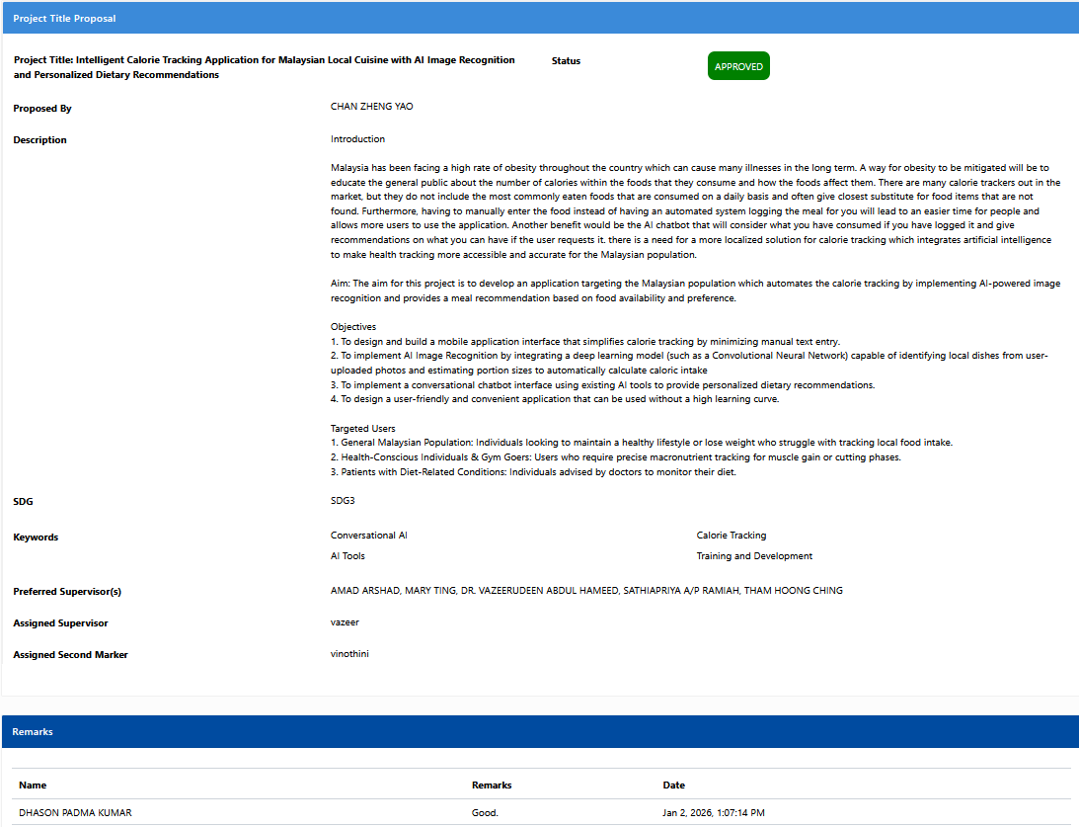

Appendix B: Project Ethics Form
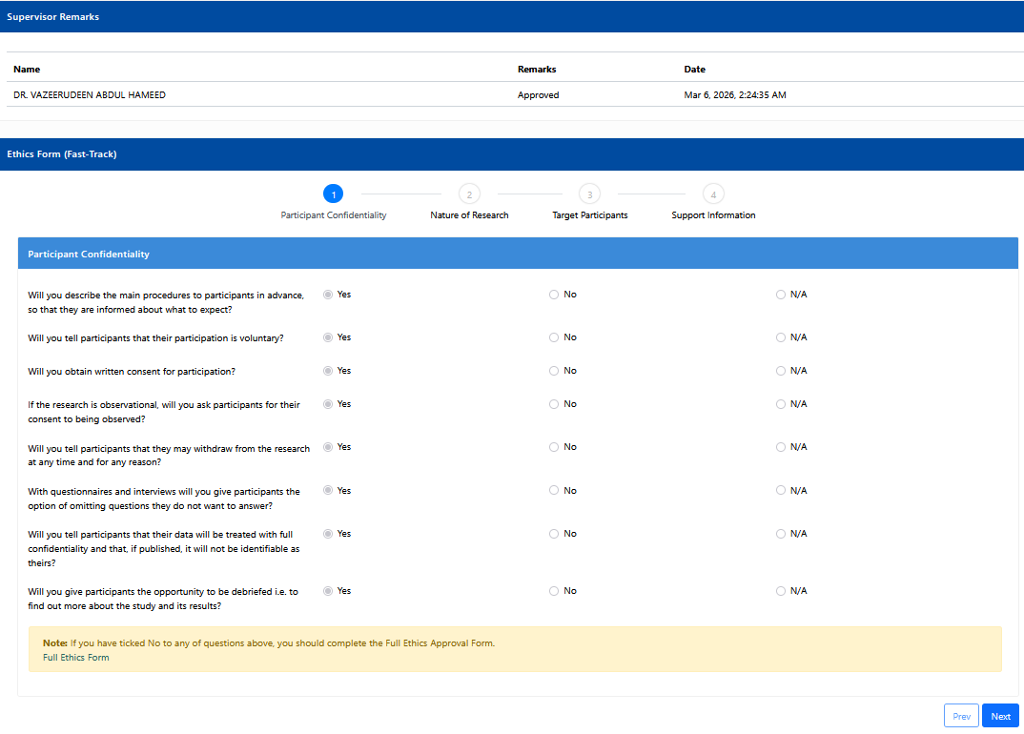
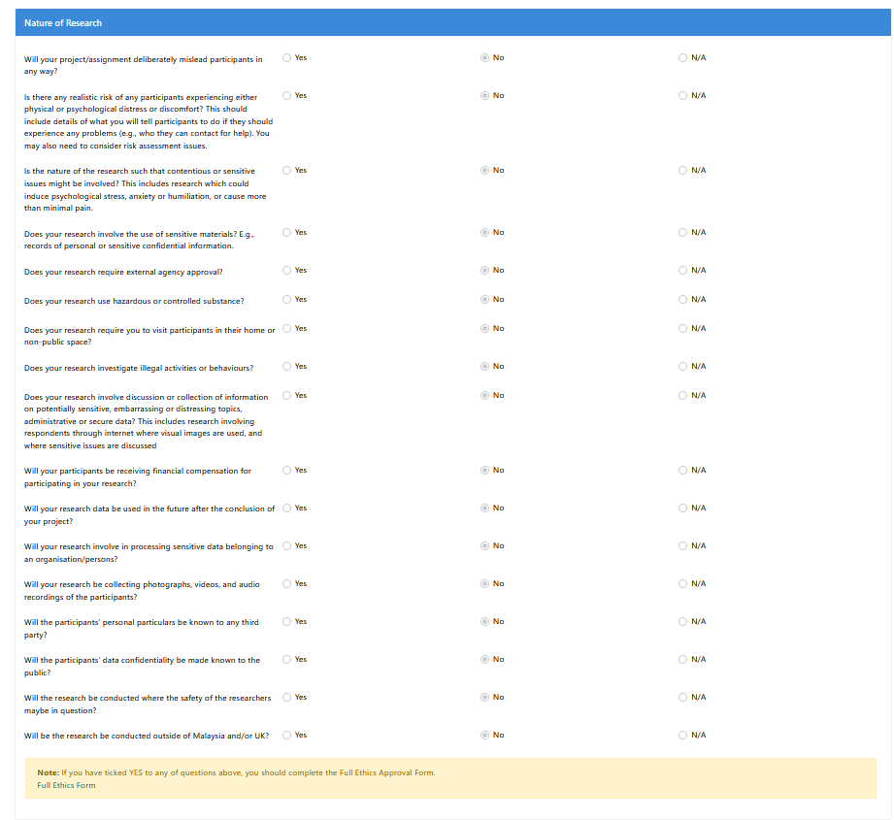
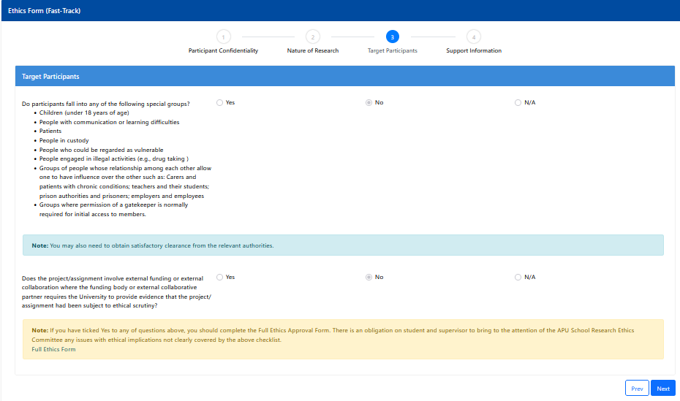
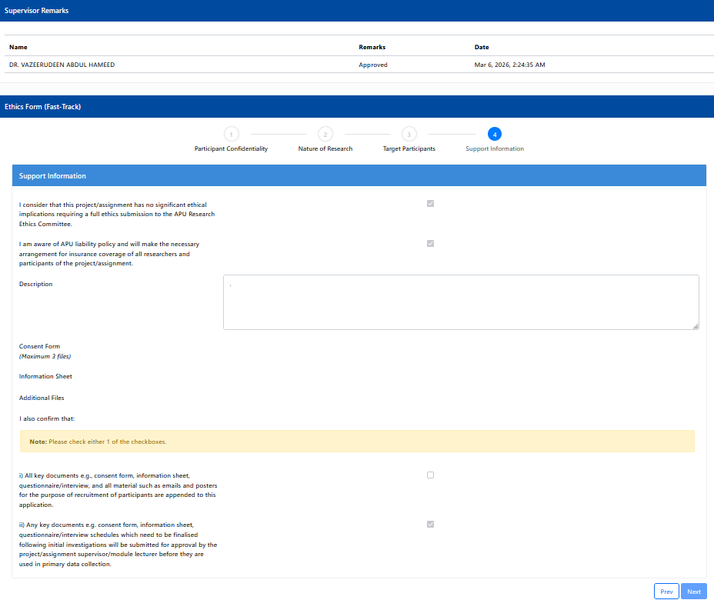

Appendix C: Log Sheet
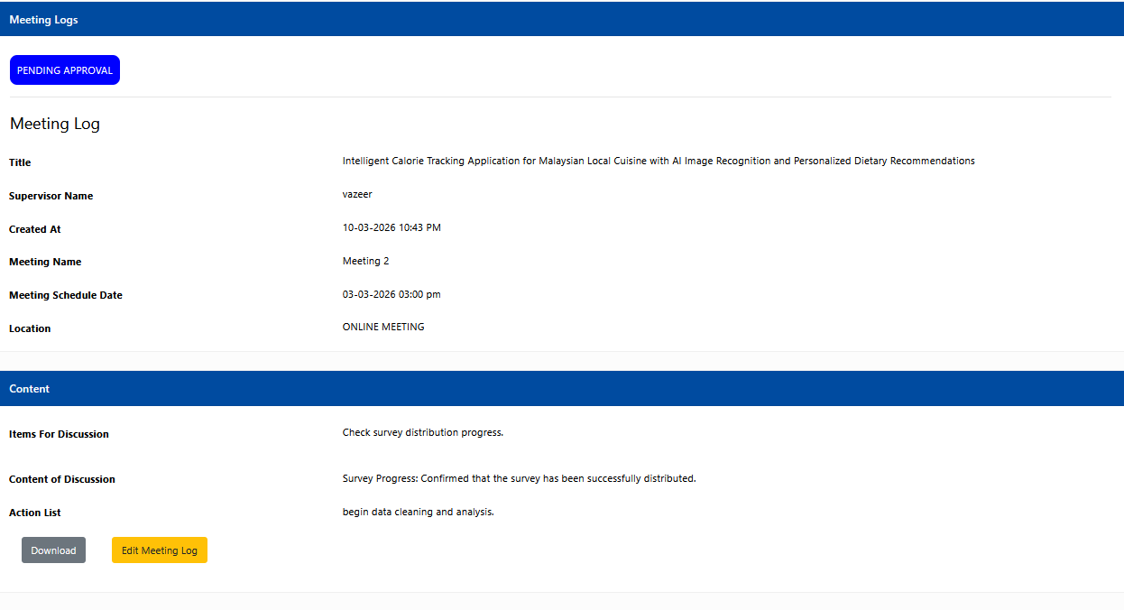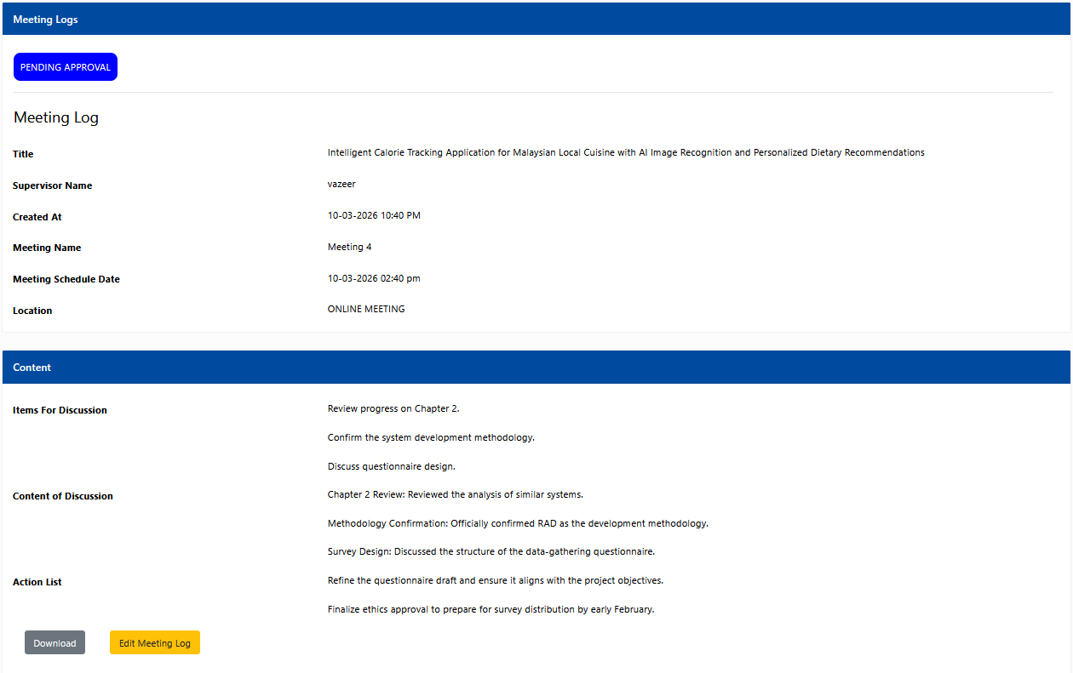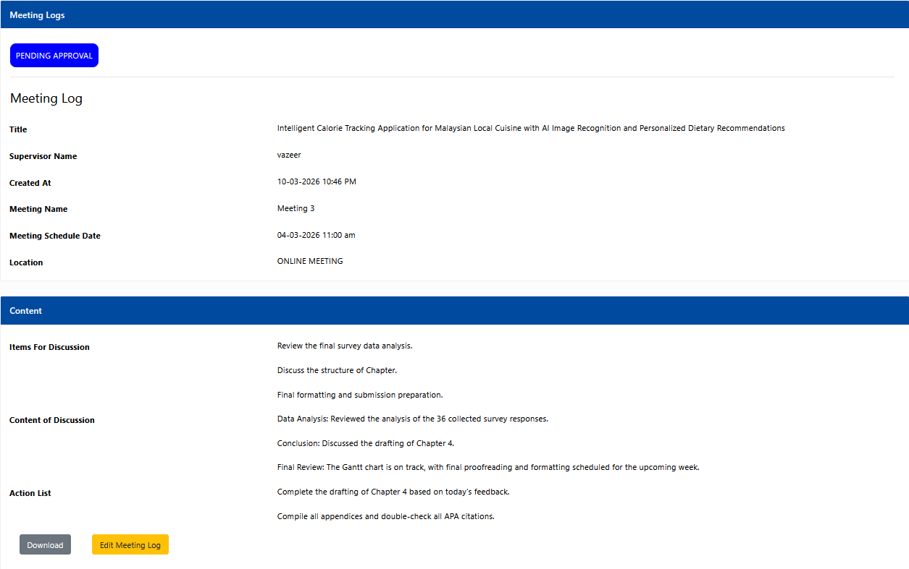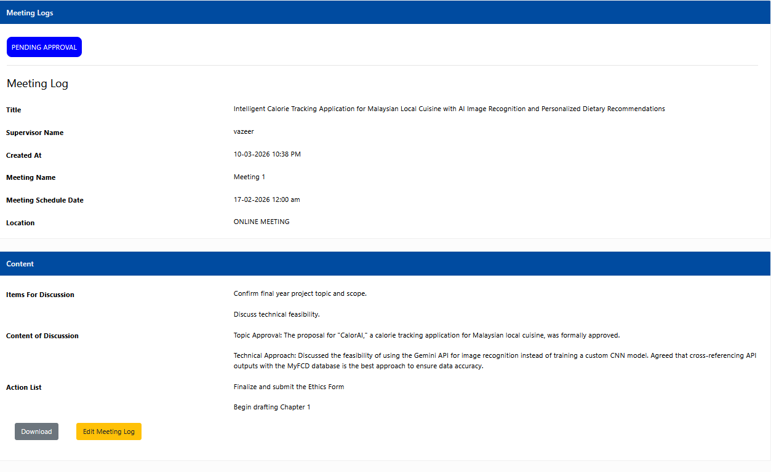

Appendix D: Gantt Chart
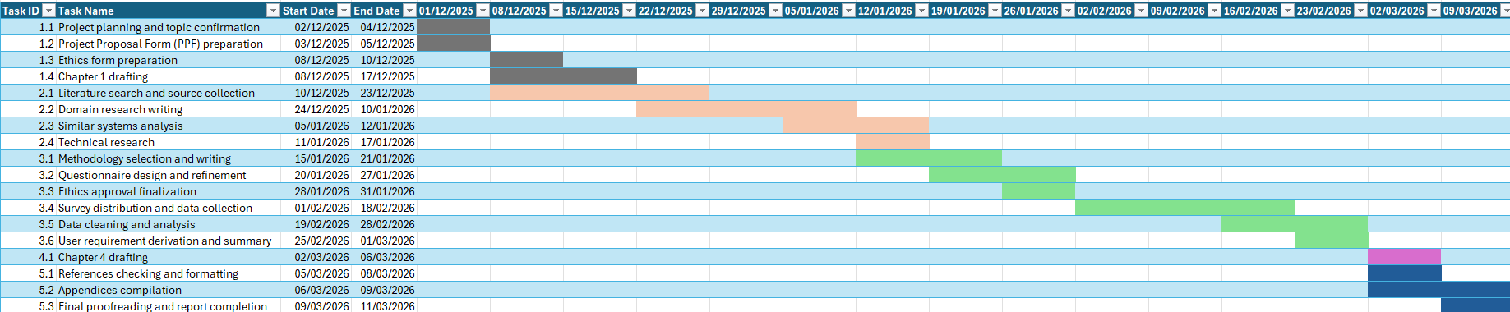

Appendix E: Demographic Profile
Gender | Age Group | Occupation
Male | 18-24 | Student
Male | 18-24 | Student
Female | 18-24 | Student
Male | 18-24 | Student
Male | 18-24 | Student
Male | 18-24 | Student
Male | 18-24 | Student
Female | 18-24 | Student
Male | 18-24 | Student
Male | 18-24 | Employed (part-time)
Female | 18-24 | Student
Male | 18-24 | Student
Male | 18-24 | Student
Male | 18-24 | Student
Male | 18-24 | Student
Male | 18-24 | Student
Female | 18-24 | Student
Male | 18-24 | Employed (part-time)
Male | 18-24 | Student
Male | 18-24 | Student
Male | 18-24 | Student
Female | 18-24 | Student
Male | 18-24 | Student
Male | 18-24 | Student
Male | 25-34 | Employed (full-time)
Female | 25-34 | Employed (full-time)
Male | 25-34 | Employed (full-time)
Male | 25-34 | Self-Employed
Male | 25-34 | Employed (full-time)
Male | 25-34 | Employed (full-time)
Male | 35-44 | Employed (full-time)
Male | 35-44 | Self-Employed
Female | 35-44 | Employed (full-time)
Male | 45-54 | Employed (full-time)
Female | 45-54 | Employed (part-time)
Male | 55+ | Unemployed

