Date : | 02/02/17
From : | Actia
Subject : | Tests commands for Generating/ Reading/ Confronting programs

I) Foreword

There are 3 programs : Generating frame / Reading frame and one to confront these frame between them.
The generation and the reception is done through the sockets can thanks to CAN bus.

Before, executing these later we have to respect an order :

- sourcing ( Generate a binary for ARM architecture / change the target) → Setting up SDK
  - Go to Wiki projet for imx6 , then click on Setting up a generated SDK
  - Run the source command : source ~/SDK/PCM_SDK/environment-setup-cortexa9hf-vfp-neon-oe-linux-gnueabi (in my case)

- compile with make (to place oneself in the right directory)

Result expected after compilation :

« Lire » : to depend the programs

II) Program 1 (Generating frame)

For this one, we have to respect instructions :

- There are arguments to pass to the function :
  - [-i] < CAN interface >
  - [-f] < file name > → file which allow to generate frame
  - [-t] < gap in microsecond >
  - [-z] < ptronbr > (default : CAN_RAW) → so not need to put this item
  - [-S] : if in the file, there are timestamps frame
- Now we can compile our program :

→ Run the command (in the right directory) : ./Generer -i can0 -f (file.txt) -t (.. in usec)
→ Add -S if the file contains timestamp

Result expected : (just one end)
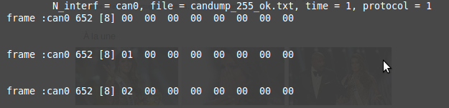

Result expected :With timestamp
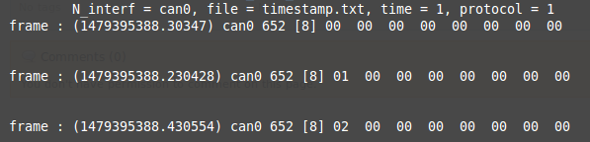

II) Program 2 (Reading frame)

For this one, we have to respect instructions :

- Options :
  - [-i] < CAN interface >
  - [-w] < way > path where the user want to create the file

- Now, we can compile our program :

→ Run the command (in the right directory) : ./Lire -i can0 -w (/way …)

